Vol. 12, No. 1, March 2019, pp. 1- 10 ISSN 2006-1781
Comfort Adeline Uno and Celebi Erbug (2019), Perception of Instructors in an European University on Computer-Based Test and Paper-Based Test

© 2019 Afr. J. Comp. & ICT – All Rights Reserved https://afrjcict.net

Perception of Instructors in an European University on Computer-Based Test and Paper- Based Test

Comfort Adeline Uno¹ and Çelebi, Erbuğ²
¹Department of Library and Information Technology, Federal University of Technology, Minna, Nigeria.
Email: Comfort.uno@futminna.edu.ng
&
2Department of Computer Engineering,
Cyprus International University, Nicosia,
North Cyprus
Email: ecelebi@ciu.edu.tr

____________________________________________________________________________________________________________________
ABSTRACT
Examination management system is an information system that enables an educational institution to be more effective and efficient in planning, execution, and monitoring of academic-related test. The research was focused on investigating the perception of the instructors from Business Administration Science and Engineering faculties of Cyprus International University Nicosia, North Cyprus and it was analyzed to ascertain which of the examination types, computer-based (CB) test or paper-based (PB) test, the instructors preferred and observed to be more suitable. The analyses showed that most instructors preferred the CB test although instructors from business admin seem to also prefer PB test. The total population of the instructors in both faculties was 69 and a total of 61 questionnaires were retrieved and found usable from the 69 questionnaires administered, which were analyzed and used in the design of the system. A new system which will allow lecturers to create and upload questions, and then students can assess the site URL with their provided login credentials giving to them by the admin office to answer questions was suggested. This web-based system will also serve as an information desk for students and lecturers to be informed on what is happening on campus.

Keywords- Examination; Computer-based Test; Paper-based Test; Instructor; European University

_________________________________________________
African Journal of Computing & ICT Reference Format:

Comfort Adeline Uno and Celebi Erbug (2019), Perception of Instructors in an European University on Computer-Based Test and Paper-Based Test,
Afr. J. Comp. & ICT, Vol.12, No. 1, pp. 1 - 10.

© Afr. J. Comp. & ICT, March 2019; ISSN 2006-1781

1

I. INTRODUCTION
Information systems today, in light of the unprecedented changes ongoing in and around us, most businesses and organizations both profit-making and non-profit making are embracing the computerbased system. This is because the computer-based system in a way keeps business ahead of their competitors by offering quality products and services. The information system can easily be defined as a process of and a tool for storing, managing, making timely decisions, collecting data and effective communication in an organization [1]. This is to make sure tasks are completed in time, quality services are rendered to clients/customers and have become the basic reason for the success or failure of the organization to compete effectively in business. This study is concerned with analyzing the perception of instructors from the faculty of business administration and engineering using the questionnaire survey method. Instructors are directly involved in any examination type and are the most suitable set of people with the knowledge of the exam type to use and how best to construct questions for the purpose of evaluating students. Two faculties were used due to their contracting concept and also because they are the two major faculties in the university. Also, an online examination system was designed for the institution using Human-based Activity Approach. The examination is created with the sole aim of formally testing a group of people or persons in their knowledge or skills in a given field [2]. There are two main forms of carrying out examination; paper-based examination and online examination system. Paper-based examination system is the printed examination which students are required to answer on paper with writing materials like pen or pencils. Online examination system involves the process of setting questions, answering them, marking exam, displaying results and storing of those result on the internet. All the processes involved in the examination are carried out on the internet. The two forms of examination have been observed to have certain challenges which will be discussed further in this research.

The study seeks to combine both forms of examination to give more flexibility to the system.

II. PROBLEM STATEMENT
The integrity, efficiency, and effectiveness of the examination system cannot be overemphasized in any institution either secondary or tertiary. In order to produce students who are capable of breaking new grounds in their fields and the society at large, the credibility of examination or any form of evaluation should be considered a necessity. Paper-based examination has been observed to incur cost, examination malpractice, record storage challenges and is also generally stressful most especially for the teachers as well as computer-based examination which was said to be a bit rigid in structure and also inuring cost [3]. Every institution considers examination very important but also strives to make the entire process cost-efficient, reliable, flexible and accurate. The present paper-based system exhibits some loopholes in ensuring a successful examination atmosphere.

III. LITERATURE REVIEW
Online examination is an examination solution provided by the internet which makes it possible for universities and other organizations to set up organize and manage examination online through internet, intranet or local area network [4]. The paper method of marking is a manual process where the entire process of marking and entering student score is stressful and prone to clerical error and also exhibits loss of exam script and improper maintenance of the answer script [5]. Bloomfield encourages the use of paper exam in accessing students because of its unique advantages such as students’ ability to express themselves and ability to evaluate indebt understanding of students. Although time, energy spent in the grading of the exam as well as accuracy was said to be a significant issue facing the system. Delay in getting the result by the students and also the need to keep accurate records of grades for future reference was another challenge identified in this system [6].

Some students, mostly from the English department found paper-based examination system to be less stressful to read questions, although was lacking immediate feedback and release of the result [7]. Jamil discovered in their research, that teachers’ perception on computer and paper-based exam varies from department to department, rank and computer
knowledge of the teachers. [8]
3.2. Similarities between PBT and CBT
Both forms of examination exhibit issues of cheating
They both have security concerns, as they both face problems of protecting their equipment and exam materials. [9].
3.3 Differences between PBT and CBT Enoch Morrison explained in his paper that the differences that are exhibited in the two exam forms are often a matter of preference, personality, and familiarity with the format. [10]
Some differences enumerated by Patidar & Kadam [11] include:

Table 1: Differences between CBT and PBT

It’s highly prone to human errors as the bulk of the process is done by humans. | It is less prone to mistake and more accurate in result computation.
Exhibit high level loss of exam records. | Records preservation can be guaranteed for future purposes.

IV. RESEARCH METHOD
This study used descriptive survey research design to elicit instructors’ perception of CB and PB examination. The population for this study was instructors in North Cyprus Universities. Specifically, the target population was instructors from two faculties, Engineering and Business Administrative Science from the Cyprus
International University. The instructors had a total population of sixty- nine (69), in which, twenty-one (21) in Business Administrative Science and fortyeight (48) in Engineering. A total of 69
questionnaires were physically administered and 61 questionnaires were retrieved and analyzed using statistical package for social sciences (SPSS) analytical tool.
PBT | CBT
Difficult to edit and make corrections when necessary. | It is easy to make corrections on  mistakes made while taking the exam.
It’s more stressful especially while transferring records from score sheets to a computer. | It is less stressful for both instructors and students to use.
In Table 2, the demographic category (aspect) of the questionnaire was analyzed and the lecturers were purposely selected from the Faculty of Business Administrative Sciences and were 20(32.8%) and faculty of Engineering which was 41(67.2%), and the percentage of those that had knowledge of the two systems was 61(100%), 27.9% of the total respondent were between the age of 0-30years, 50.8% were between the age of 31-39 and 21.3% were from 40 years and above. 13.1% of the respondents were with BSc qualification, 27.9% was MSc and 59.0% were Ph.D. and above. A total of 61 lecturers were used for the study.

V. RESULT

Table 2: Demographic Distribution

Demographic category Frequency
Percentage
Gender
Male(43) 70.5
Female(18) 29.5
Faculty
Engineering(41) 67.2
Bus & Administrative(20) 32.8
Knowledge about PB and CB
Yes(61) 100
Age
0-30(17) 27.9
31-39(31) 50.8
Above40(13) 21.3
Qualification
BSc (8) 13.1
MSc (17) 27.9
PhD Above(36) 59.0

Table 3 shows that out of the 61 Instructors, 54.1% (33) of respondent choose paper-based and 45.9% (28) choose computer-base for which system should be used to assess student, 59.0% (36) percent picked a paper base to exhibit more flaws and 41.0% (25) picked computer-based system. For the option of which of the system is more cost effective, 26.2% (16) choose paper-based while 73.8 (45) choose computerbase system, 19.7% (12) said the paper-based system is more likely to reduce teacher’s workload while 80.35% (49) choose computer-based system.

For accuracy in the result, 24.6% (15) chose paperbased system and 75.4% (46) chose computer based, while 34.4% (21) said the paper- base system has a positive influence on the education system and 65.6%
(40) said computer system has more influence. 62.3% (38) said paper-based examination consumes more time to conduct while 37.7% (23) said computer system does consume time, the percentage of risk involved was 31.1% (19) for paper-based and 68.9% (42) for computer exam system. For the system that has more benefit in all aspect, 34.4% (21) chose paper and 65.6% (40) choose computer system while 73.8% (45) said paper-based exam is more likely to pose more tension on students and 26.2% (16) said computer would pose tension on the students.

Table 3: Instructors’ perception on PB and CB

Questions | Responses(percentage in parentheses)
 | PB | CB
Question 1 | 33(54.1) | 28(45.9)
Question 2 | 36(59.0) | 25(41.0)
Question 3 | 16(26.2) | 45(73.8)
Question 4 | 12(19.7) | 49(80.35)
Question 5 | 15(24.6) | 46(75.4)
Question 6 | 21(34.4) | 40(65.6)
Question7 | 38(62.3) | 23(37.7)
Question 8 | 19(31.1) | 42(68.9)
Question 9 | 21(34.4) | 40(65.6)
Question 10 | 45(73.8) | 16(26.2)

In table 4, 82% (50) of instructors agreed that computer exam system makes it possible to access more students in a short time while 18% (11) did not agree. 59 % (36) said computer exam reduce cheating while 41% (25) said it doesn’t. About 82% (50) said computer exam system help to reduce clerical mistakes while 18% (11) declined and 41% (25) of instructors said the system has a negative effect on students thinking potential and 59% (36) disagreed with it.

Table 5: Instructors Perception on Computer Based Exam

Questions | Frequency | Percentage
Question 13  Yes | 50 | 82%
No | 11 | 18%
Question 14  Yes | 36 | 59%
No | 25 | 41%
Question 15
Yes No | 50  11 | 82%  18%
Question 16  Yes  No | 25  36 | 41%  59%

Using statistical package for social sciences (SPSS), the overall mean scores of the faculty of Business administrative sciences and Engineering Instructors’ concerns on their perception of paper-based and computer-based examination system were 1.7 (SD = 0.253) and 1.59 (SD = 0.33) respectively. This seems to indicate that the faculty of business administrative studies instructor’s had more positive concerns about computer-based system evaluation than the Engineering counterparts. The T-test results, however, showed that there was no statistically significant difference (T (59) = 1.279, p > 0.05) between the concerns of business administrative studies and Engineering instructors on their perception of computer and paper-based exam system. Thus, the hypothesis was accepted [12]. This means that the faculty difference does not affect the instructors’ choice of preference.

Table 6: Difference in Instructors’ Perception

Faculty | N | Mean | SD | T | Df | Sig
Bus. | 20 | 1.7 | 0.253 | 1.279 | 59 | 0.197
Eng. | 41 | 1.59 | 0.33

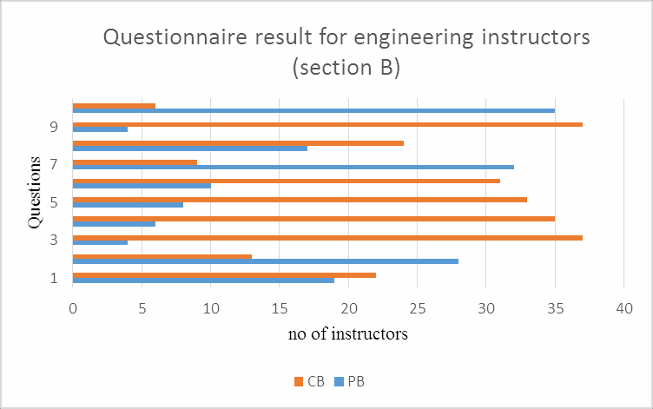

Figure 1. Bar chart representation for section B of the instructors in Engineering

Figure 1 shows a bar chart of the responses of instructors in engineering faculty of Cyprus international university to section B of the questionnaire.

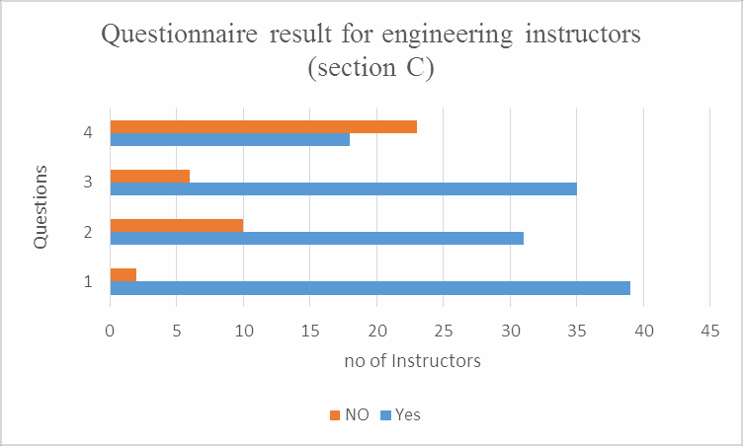

Figure 2. Bar chart Representation of Engineering Instructors for Section C.

Figure 2 shows a bar chart of the responses of instructors in engineering faculty of Cyprus international university to section C of the questionnaire.

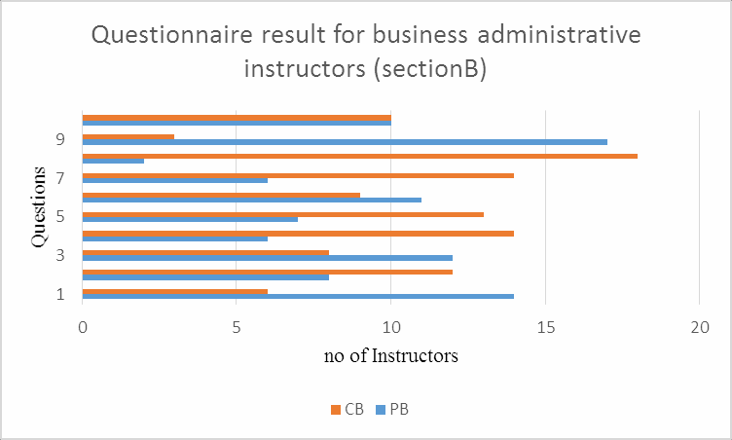

Figure 3. Bar chart Representation for Section B of the Instructors in Business
Administration.

Figure 3 shows a bar chart of the responses of instructors in Business administrative science faculty of Cyprus international university to section B of the questionnaire.

NO
2
1
10

NO OF
5
0

4

3

2

1

Questionnaire result for
business administrative
QUESTIONS

Figure 4. Bar chart Representation for Instructors in Business Administration for Section C.

Figure 4 shows a bar chart of the responses of instructors in Business administrative science faculty of Cyprus international university to section C of the questionnaire.

VI. DISCUSSION
The instructors from the faculty of engineering prefer CBT, as they were more of the opinion that the system curbs basic exam issues like; assessing large number of students in a shorter time frame and providing an accurate result. Although there was a slight difference in their thought concerning CBT having a negative effect on students thinking potential. This implies that a good number of them do not think it does. Business administrative science instructors agreed with the other instructors that CBT is accurate in result generation, reduces workload and doesn’t have a negative influence on students thinking potential. Although they felt it involves risk in conducting exam, time consuming and also cheating.

From the above discussion, it was deduced that instructors from engineering faculty preferred CBT while those from business admin acknowledge the benefit of CBT but still feel PBT should still be used in examining students.

1. CONCLUSION
The study investigates the perception of the instructors from the faculties of engineering and business administrative science in Cyprus International University. The analyses showed that most instructors preferred the CB test although instructors from business admin seem to also prefer PB test. The major discovery was that the instructors from business admin acknowledge that CB test was of great advantage but still not enough reason to completely wipe out the PB test. A design for a new system was suggested which is an online examination software for the institution; it is a web-based system that will allow the efficient and effective conduct of examinations in the university. The new system designed in this study is aimed at reducing some of the challenges of paper examination by evaluating, grading and recording of students’ examination. The system allows students to take the exam online and view their result online and immediately as well. The study was limited to just one institution in Northern Cyprus, there may be challenges expected in the development of the new examination management system, though some guide and suggestions have been provided to enable development of the system. This study was a master’s thesis research which was carried out in Cyprus International
University [13].

REFERENCES
- V. Zwass, “Information systems,”britannica.com, para 1, Dec. 28,
2017. [Online]. Available:
http://www.britannica.com/EBchecked/topic/2 8789 5/information-system. [Accessed April. 19, 2018].
- D. Ince, “Acoustic coupler,” in A Dictionary of the Internet. Oxford University Press, [online document], 2014. Available: Oxford
Reference Online,
http://www.oxforddictionaries.com/definition/e nglis h/examination [Accessed: April 19, 2017].
- O. E. Oduntan, O. O. Ojuawo & E. A. Oduntan, “A Comparative Analysis of Student Performance in Paper Pencil Test (PPT) and Computer Based Test (CBT) Examination
System,” Research Journal of Educational Studies and Review, vol. 1, no. 1, pp. 24-29, 2015.
- D. V. Kotwal, S. R. Bhadke, A. S. Gunjal, &
P. Biswas, “Online examination system. International Research Journal of Engineering and Technology,” vol. 3, no. 1, pp. 115-117, 2016.
- D. Coniam, “A comparison of onscreen and paper- based marking in the Hong Kong public examination system,” Educational Research and Evaluation, vol. 15, no. 3, pp. 243-263, 2009.
- A. Bloomfield, “Evolution of a digital paper exam grading system,” In Frontiers in Education Conference, 2010, pp. T1G-1.
- M. A. Al-Qdah,”Comparing Online and Paper Exams: Performances and Perceptions of
Saudi Students”, International Journal of Information and Education Technology, vol.13, no. 2, pp.106-110, 2017.
- M. Jamil, R. H. Tariq, P. A. Shami, & B.
Zakariys, “Computer-based vs paper-based examinations: Perceptions of university teachers,” TOJET: The Turkish Online Journal of Educational Technology, vol. 11, no. 4, 2012.
- O. A. Adebayo, “E- Exams System for Nigerian Universities with emphasis on security and result integrity,” International Journal of the Computer, the Internet and Management, vol. 18, no. 2, pp. 1- 11, 2014.
- E. Morrison, "computer test advantages," testprepreview.com,
May. 7, 2018. [Online].
Available:
http://www.testprepreview.com/computer_adv anta ges.htm. [Accessed Sept. 7, 2018].
- V. K. Patidar, “Analysis Process of Design and Development of online examination system,” International Journal of Innovative Research in Computer and communication engineering, pp. 1-5, 2016.
- P. Baldi, & A. D. Long, “A Bayesian framework for the analysis of microarray expression data: regularized t-test and statistical inferences of gene changes, “Bioinformatics, vol. 17, no. 6, pp. 509- 519, 2001.
- C. Uno, “Analysis and Design of Examination Management System,” M. S. thesis, Cyprus International University, Nicosia, North Cyprus, 2017.

BIODATA

Miss comfort Adeline Uno
(comfort.uno@futminna.edu.ng) is an Assistant Lecturer in the Department of Library and Information Technology, Federal University of Technology, Minna, Niger State, Nigeria.

Assoc. Prof. Dr. Erbug Celebi (ecelebi@ciu.edu.tr) is the Head, Department of Computer Engineering, Cyprus international University, Nicosia, North Cyprus.

APPENDIX RESEARCH QUESTIONNAIRE

Dear Respondent,

I am a master student of Department of Management
Information Systems and carrying out a survey on THE
PERCEPTION OF INSTRUCTORS IN AN EUROPEAN UNIVERSITY ON COMPUTER-BASED TEST AND PAPER-BASED TEST. I kindly request your voluntary participation by answering the questions in this questionnaire. The answers given here will be used solely for this survey, please read th e instructions and respond accordingly choosing the options that apply most to you.

This questionnaire was adopted from Jamil, M.; Tariq, R. H.; Shami, P. A.; & Zakariys, B. (2012). Computerbased vs paper-based examinations: Perceptions of university teachers. TOJET: The Turkish Online Journal of Educational Technology, 11(4).

Thank you.

Section A:
Please tick appropriate option.

- Gender: male [] female []
- Age: 0-30 [] 31-39 [] 40 and above []
- Faculty: Agriculture[] Art & Science[] Communication[]
Economics[] Education[] Engineering[] Fine Art[] Health Science[] Law[] Pharmacy[].
- Qualification: BSc [] MSc [] PhD and above []
- Are you familiar with the computer (online) examination? Yes [] no []
- Are you familiar with paper-based examination? Yes [] no []
Section B:
Choose the best option, where PB stands for paperbased and CB for computer-based system.
- Should students be assessed more often on: PB [] CB []
- Which of the examination system would exhibit flaws in conducting exam? PB [] CB []
- Which of the examination system is cost- effective? PB [] CB []
- Teachers’ workload is most likely to reduce in which exam system? PB [] CB []
- Which of the system do you think produces an accurate result? PB [] CB []
- Which of the exam types has a positive influence on the educational system? PB [] CB []
- Which of the system consumes time to assess students? PB [] CB []
- Which of the system is risk involved? PB [] CB []
- Which of the system have benefits in all respect? PB [] CB []
- Which of the system poses tension on students? PB [] CB []

Section C: Tick preferred option
- Does CB examination make accessing of a large number of students in a short time possible? Yes [] no [].
- Does CB examination reduce cheating during the examination? Yes [] no [].
- Using CB examination to generate and publish result help to reduce clerical mistakes? Yes [] no [].
- Does CB examination have a negative effect on students thinking potential? Yes [] no [].

