An Online Mechanical Design Application
Alkali Babawuya¹, Imran Saadullah², Agonga O. Fred¹, Justice Chikezie Onunuso¹, Nicholas Gukop³ and Enebe Vincent⁴
¹Department of Mechatronics Engineering, Federal University of Technology, Minna
²Department of Mechanical Engineering, Federal University of Technology, Minna
³Department of Mechanical Engineering, University of Jos, Jos.
⁴Department of Mechanical Engineering, Modibbo Adama Federal University of Tech., Yola
Corresponding Author: babawuya@futminna.edu.ng
ABSTRACT
An online application software for the quick design of mechanical components were develoed in this study. The data and information network is facilitating productivity including the design of mechanical components. Therefore, the implementation of the online application will give assess to designers and student of engineering and their by increase their access to design tool. The online application called BECOL were developed using an algorithms. The design alaysis of beam and column were coded HyperText Markup Language (HTML), Cascading Style Sheet (CSS) in conjunction with JavaScript (JS) and CSS developer software. The interface were loaded on a WAMP application server. The BECOL were tested with raw input data and the output results compared with numerical calculation and the results shows upto 98% agreement.

Keywords: BECOL, Engineering, Design, Beam, Column, Analysis
- INTRODUCTION
Today, there is a rapid shift from the traditional ways of doing things. This shift is called digitalization in which day-to-day activities like reading, learning, working, playing, and discussions are done with computers. This phenomenon is yet to be fully harvested for its potentials and one of the problems that lies in this is conversion of existing design procedures and formulas to computer programs and software that could be accessible globally to both students and engineers, thereby integrating the traditional procedures and formulas into the computerized medium, the internet
The era of networked information has emerged as the most powerful tool for an instant access to information and engineering design data. Information is now just a 'finger touch' distance away from the user and it would not be inappropriate to say that the internet has become the biggest global digital information library which provides the fastest access to the right kind of information in nanoseconds to the end-user anywhere in the world. The Internet has become the most extensively used information source that empowers the design engineer to get in roaming with the latest information. Today's users can no longer depend on conventional information sources and methods for engineering design.
The Internet has emerged as a powerful educational and research tool. With the increasing impact of information and communication technologies on the way we live, learn and perform tasks. Engineers, educationist and researchers are attempting to grasp how ICT could help in modernizing the process of designing, producing, teaching, learning and researching.
Engineering systems and their components require fast and reliable means of designing that is ICT compliant. Therefore online design tools for mechanical engineering will give access to design engineers all over the world including students of engineering who learning is almost ICT in nature.
The most frequent design components are beams, columns, and their joints. These engineering components form the major part of support structures and frames.
In software design, algorithm require design variable(s) (inputs), the processing formula of conditions and the output structure. The design of beams and columns that were given propriety in this online application required the determination of minimum safe structural dimensions for each components using existing formula
1.1 Theoretical Background
In all structural members (such as beams and column) that are subjected to internal or external loads load, stresses are developed. In the body, when the stress exists the materials on yield limits failure always occurs and a good design is focus on avoiding this.
Euler’s beam equation shows the relationship between beams shear force, body moment and deflection. Equation (i) is the basis of the beam design used in the developed application
$EIy^{ii}=M$ 1
in conjunction with the conditions of equilibrium, the maximum bending moment were extracted for the beam and used in equation (ii) to obtain the moment of inertia for the beam. The moment of inertial depends on the beam geometry.
$\frac{σ}{I}=\frac{M}{y}$ 2
Where
E – Elastic Modulus of beam material (GMPa)
I – Moment of Inertial of the beam (mm⁴)_
Y” – slope of the beam (degree)
M – Maximum bending moment of the beam (N.m)
$σ$ – Maximum shear stress of on the beam(MPa)
Short columns are designed using Euler’s column equation (3) while medium and long columns are designed using Rankine’s equations.
$P_{E}=\frac{Cπ^{2}EI}{L_{e}^{2}}$ 3
$P_{R}=\frac{P_{E}P_{CS}}{P_{E}+P_{CS}}= \frac{P_{CS}}{1+\frac{P_{CS}}{P_{E}}}$ 4
Where:
C – Column end condition as shown in table 1
L_{e} – Effective column length (see table 1)
P_{E} – Column crippling load by Euler
P_{CS} = Column crippling load by Rankine
P_{R} – Column crippling load by Rankine
Table 1: Relation between equivalent length ($l_{e}$) and actual length (l).
S. No. | End Condition | Relationship between equivalent length ($l_{e}$) and actual length (l)
1 | Both the ends hinged | $$l_{e}=1$$
2 | Both the ends fixed | $$l_{e}=\frac{1}{2}$$
3 | one end is fixed and the other hinged | $$l_{e}=\frac{1}{\sqrt{2}}$$
4 | one end is fixed and the other free | $$l_{e}=2l$$

2.0 Methodology
The implementation method as mentioned by (Alkali, Bako, Lawal, Lawal, & Mohammed, 2016) were adapted for the development of the online application.
-
2.1 Sample Beam and Column Analysis
2.1.1 Beam – Simply Supported Beam
Consider a simply supported beam in Figure 1 having beam of length L(m) and single point load P(N) and beam location X1(m) as a sample analysis used in the programming. The end condition are a roller support and fixed support.

Figure 1: Shear force and Bending Moment Diagram for a simply Support Beam
Considering the equilibrium of vertical and horizontal forces and the moment of the beam about a point, the global beam shear force and bending moment equation were derived and given in equation 5 - 10. The bending moment equation of a beam are substituted in equation 1 and 2, in other to obtain the dimensions of the beam.
$R_{1}=\frac{P\left(l-x\right)}{l}$ ₅
$R_{2}=P-\frac{P\left(l-x\right)}{l}=P-R_{1}$ ₆
$Q_{1}=\frac{P\left(l-x\right)}{l}= R_{1}$ ₇
$Q_{2}=\frac{P\left(l-x\right)}{l}-P= R_{1}-P$ ₈
$M_{1}= R_{1}*x$ ₉
$M_{2}= R_{1}*x-P\left(x-x_{1}\right)$ ₁₀
2.1.2 Column
Columns that carry axial loads failure by buckling, therefore, Euler’s equations 3 and Rankine’s equation 4 are relevant in the design analysis of the column as a components. The column’s end conditions stated in Table 1 affects the shape of the column’s effective length and deflection of the column. As stated by Khurmi and Gupta, (2008), the Euler’s column equation has a limitation and this were observed during the development of the application.

2.2 Program Algorithm
2.2.1 Algorithm for Beam Analysis
The flow chart of the algorithm adapted for the design of beams by the application is as presented in the figure 2.

Figure 2: Beam Analysis Flow Chart

2.2.1 Algorithm for Column Analysis
The flow chart of the algorithm adapted for the design of Columns by the application is as presented in the fig. 5
Figure 3: Flow Used For Column Design
2.3 Application Implementation
The algorithms shown in figures 4 and 5 were implemented using HyperText Markup Language (HTML), Cascading Style Sheet (CSS) in conjunction with JavaScript (JS) and CSS software. The user interface were fashioned in an interactive manner so as to ease the use of the application. The developed online mechanical design application for beams and column called BECOL were hosted WAMP serve application.
3.0 Results
3.1 The Interface
The result of the coding are display in Figures 4 and 5, the interface were rendered on the chrome web browser for aesthetic purposes.
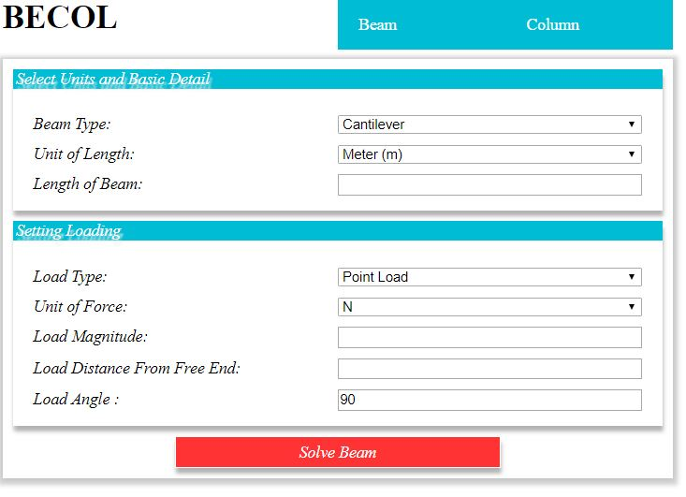
Figure 4: The web interface for beam analysis
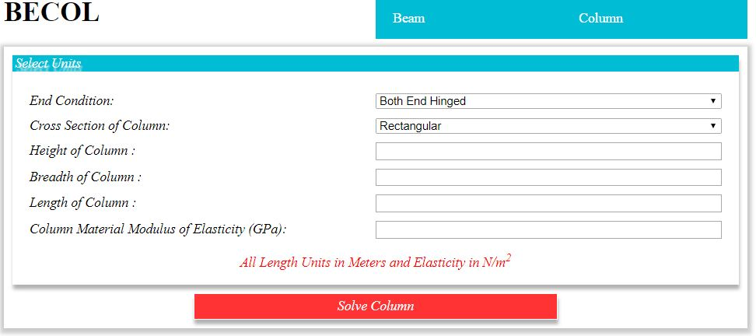
Figure 5: The web interface for column analysis
3.2 Interface Testing
The BECOL application was tested with the inputs in Figure 6 and 7. The application was tested with sample questions in both (Khurmi & Gupta, 2005) and (Rajput, 2008) Strength of Materials textbooks.

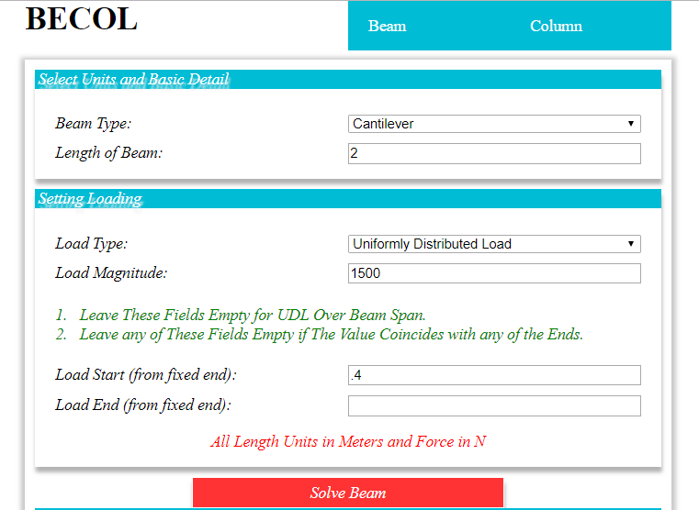
Figure 6: Uniformly Loaded Cantilever Beam Test Question Answer Parameter Input on BECOL
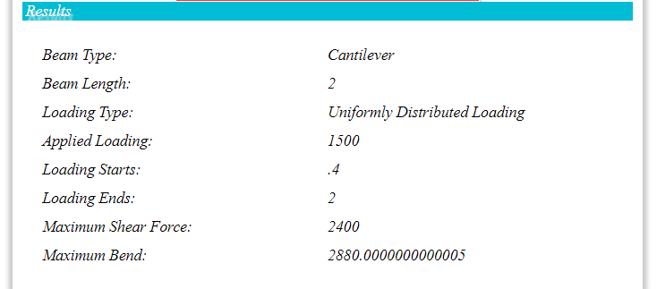
Figure 7: Uniformly Loaded Cantilever Beam Test Question Answer from BECOL
Discussion of Results
The output from the application agrees with the numerical calculation results over 98%. And this shows that the developed application (BECOL) is reliable. Comparing the results from the source and the result from the developed application, the percentage error or percentage different is 0.03%. The difference in the answer of the question source and that of the BECOL is as a result of approximation of the answer at some step in the calculation from the source.
5.1 Conclusion
The light weight approach to the interface development aid the accessibility as the loading time of application and the request to the server are minimized. The modern approach to the application logic through object oriented programming concept, improves the robustness of the application and extensibility through application programming interface. The results from the analysis through the application is reliable and provides higher precision as the errors relating human imperfection is eliminated by precisely implementing the engineering formulae.

References
Alkali, B., Bako, M. D., Lawal, S., Lawal, S. S., & Mohammed, M. M. (2016). Development of an Improved Deflection Testing Apparatus For Short Column. NIMechE. FUT Minna: Nigeria Institution of Mechanical Engineers.
Bansal, D. R. (1996). A Textbook of Strength of Materials. Daryaganj, New Delhi: Luxmi Publications (P) Ltd.
Duckett, J. (2008). THE ESSENTIAL GUIDE TO HTML5 USING GAMES TO LEARN HTML5 AND JAVASCRIPT. Indiana: Willey Publishing Inc.
Duckett, J. (2011). HTML & CSS: Design and build Websites. Indianapolis, IN: John Wiley & Sons, Inc.
Flanagan, D. (2011). JavaScript: The Definitive Guide. Sebastopol, CA: O’Reilly Media, Inc.
Goodman, D. (2001). JavaScript Bible. Indiana: Hungary Minds.
HEARN, E. J. (1997). MECHANICS OF MATERIALS I, An Introduction to the Mechanics of Elastic and Plastic Deformation of Solids and Structural Materials. Woburn, MA 01801-2041: Butterworth-Heinemann.
Hege Refsnes, S. R. (2010). Learn HTML and CSS with w3schools. Indianapolis, Indiana: Wiley Publishing, Inc.
Khurmi, R. K., & Gupta, J. K. (2005). A Textbook of Machine Design. RAM NAGAR, NEW DELHI: EURASIA PUBLISHING HOUSE (PVT.) LTD.
Michael Ashby, H. S. (2007). Materials Engineering Science Processing and Design. Burlington, MA 01803: Elsevier Ltd.
Nash, W. A. (1998). Schaum's outline of Theory and Problems of Strength of Materials. New York: McGRAW Hill.
Powell, T. A. (2010). HTML AND CSS: THE COMPLETE REFERENCE. New York: Mcgraw-Hill.
Rajput, E. R. (2008). Strength of Materials. Ram Nagar, New Delhi: S. Chand & Company Ltd.
Ryder, G. H. (1969). Strength of Materials. Macmilan.
Schifreen, R. (2009). The Web Book: How to create Web sites and applications with HTML, CSS, Javascript, PHP and MySQL. UK: Oakworth Business Publishing Ltd.

