Earth Science Research; Vol. 2, No. 2; 2013
ISSN 1927-0542 E-ISSN 1927-0550 Published by Canadian Center of Science and Education

An Assessment of the Hydrocarbon Potential of the Gombe Formation,
Upper Benue Trough, Northeastern Nigeria: Organic Geochemical Point of View
U. S. Onoduku¹, E. A. Okosun¹ & W. G. Akande¹
1
Department of Geology, Federal University of Technology, Minna, Nigeria
Correspondence: U. S. Onoduku, Department of Geology, Federal University of Technology, Minna, Nigeria. E-mail: onoduku.usman@futminna.edu.ng

Received: April 20, 2013 Accepted: July 11, 2013 Online Published: July 19, 2013 doi:10.5539/esr.v2n2p203 URL: http://dx.doi.org/10.5539/esr.v2n2p203

Abstract
Gombe Formation is a heterogeneous sequence within the Upper Benue Trough consisting principally of shales with sands, clays and intercalations of coal. It is over 600 m thick maximally in some parts of the sub-basin and has been dated Maastritchtian. Fifteen (15) core samples from 3 boreholes (BA-7, BA-16 and BA-17) dug around the Maiganga Coal Mine have been studied geochemically using the Rock-Eval 6 method with the principal aim of evaluating their potential as possible source rocks for petroleum. The results of the Rock-Eval analysis for analyzed core samples from these boreholes within Gombe Formation shows that the samples in boreholes BA-7 and BA-16 contain Type II kerogen while those from borehole BA-17 contain Type III kerogen, and that the samples from boreholes BA-7 and BA-16 have very good generative potential while those from borehole BA-17 have good to very good potential. This study also reveals that the analyzed samples especially those from boreholes BA-7 and BA-16 may constitute good source rocks if the burial depth is sufficient. The Rock-Eval Tmax data available for thermal maturity assessment of the samples suggest that the analyzed samples from the three boreholes are thermally immature. This assessment is consistent with the immaturity status of their coeval Formations (Pindiga and Gongila Formations) in other part of the Benue Trough, suggesting that these contemporaneous Formations may be related in depth and/or have experienced similar geothermal gradient. It is therefore recommended that the thermal maturity of the analyzed samples from the three boreholes be re-evaluated by other thermal maturity indices such as vitrinite reflectance measurement and biomarker evaluation in order to further authenticate the maturity status of the Formation.
Keywords: Benue trough, gombe formation, Rock-Eval 6, coal intercalations, petroleum
1. Introduction
Nigeria’s current petroleum and gas reserves are put at 35 billion barrels (bbls) and 170 trillion standard cubic feet (Tcf) respectively (Obaje et al., 2006) and her current production stands at 2.5 million barrels per day (bbl/d) (NTA International Network News, Monday 27th August, 2012). The above figures call for caution and the need for a continuous and more aggressive exploration strategy to find more oil if the nation will continue to rely on crude oil exportation as one of her major foreign earnings. It will be an understatement to say that Nigeria operates monoeconomy and solely depends on her crude export as the major economic life-wire at present.
Furthermore, since most of the Multinational Oil Companies operating in Nigeria are business-cum-profit oriented and mostly rely on the exploration works of their initial oil prospectors for their current production, this coupled with their unwillingness to invest huge amount of money in frontier basins probably due to the various failures they have encountered in such previous exploration activities in Nigerian sedimentary basins other than the oil-rich Niger Delta Basin, the challenges now therefore heavily lie on the academia and other researchers to strengthen their research efforts to locate hidden and yet-to-find oil deposits for the sustenance of Nigeria to continue to be in the oil business. And, this would be achieved through integrated studies of the available data on the Nigerian sedimentary basins especially the less to outright unexplored inland basins, no matter how little in scope. This will infinitesimally add to our records of research data and serves as impetus to our younger geoscientists for continuous geoscience research work.

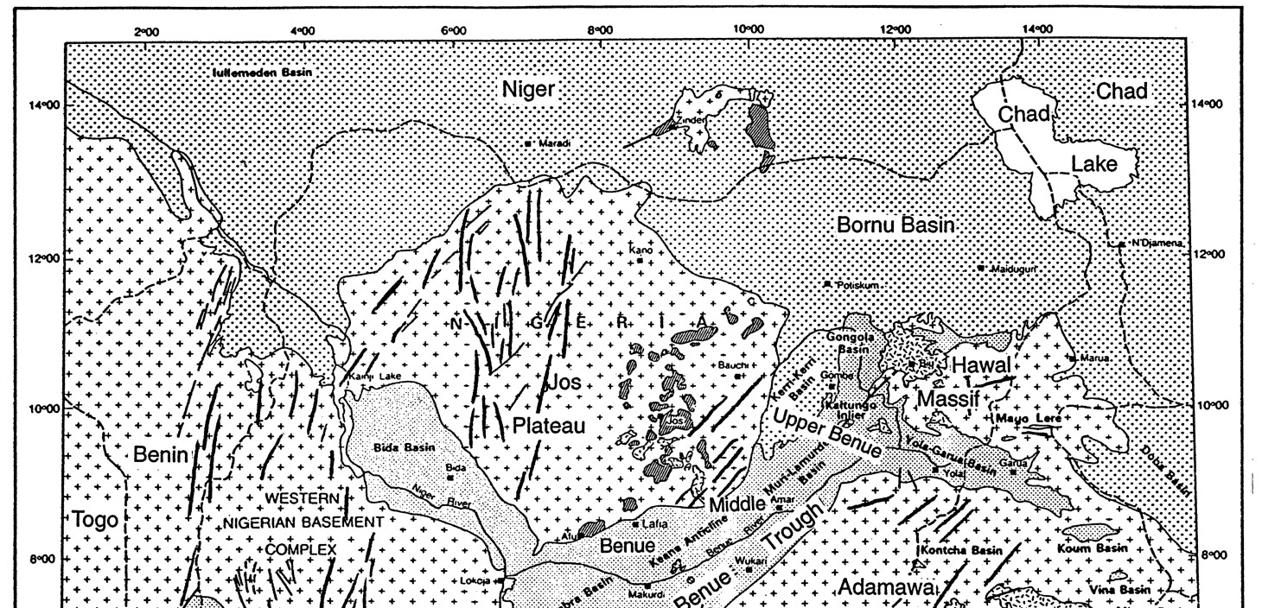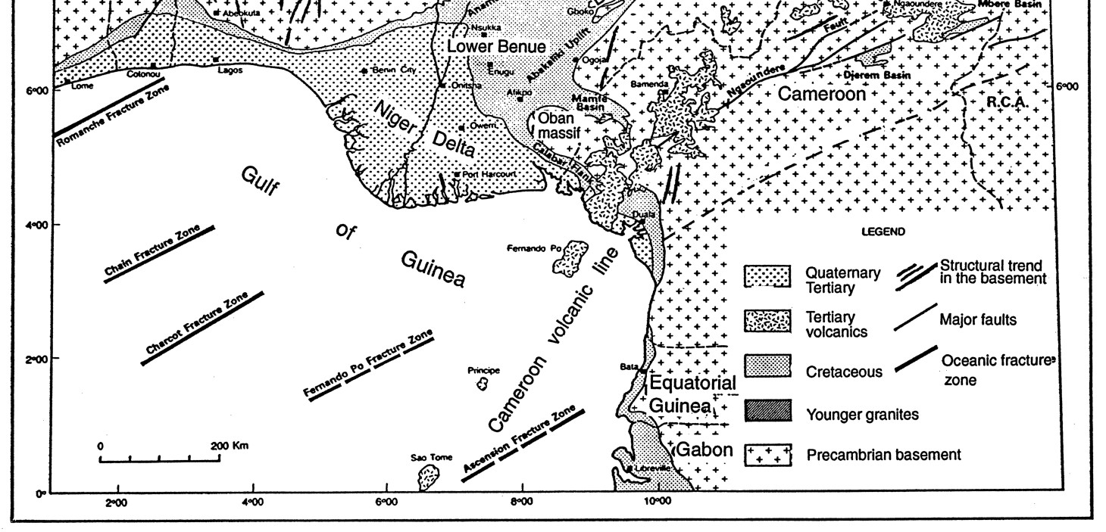
Figure 1. Geological sketch map of the Benue Trough and surroundings. Offshore, the traces of the Equatorial
Fracture Zones are indicated (After Odebode, 2010)

The Gombe Formation is located within the Upper Benue Trough of northeastern Nigeria and is precisely situated as the immediate downward formation below Kerri-Kerri Formation within the Gongola arm of the Trough (Figures 1 and 2). It is an equivalent of Ajali/Owerri/Mamu formation of the Anambra (Lower Benue) Basin, Lafia Formation of the Middle Benue Trough, non-depositional phase (hiatus) of the Yola sub-basin and Lokoja Formation of the Middle Niger Basin (Figure 2). It extends into the southeastern part of the Bornu Basin. It is a heterogeneous formation, principally made of shales, silts, sands and coal seams. The coal seams are presently being mined and used for kiln firing at the Ashaka Cement Factory, some 100 km away. The cores recovered from the maximum depth of 60 m piezometric boreholes drilled for the purpose of hydro-studies within the coal mine serve as the samples used for this study. Previous workers (e.g. Obaje et al., 2006) had used samples from the first set of and the only drilled boreholes within the Benue Trough to date the Formation and their results put the Formation as the Maastrichtian age. The boreholes are Kolmain-River-1 drilled by Shell Nigeria Exploration and Production Company (SNEPCO) in 1999, Kuzari-1 and Nasara-1 drilled by Elf Petroleum Nigeria Ltd (Totalfina Elf) in 1999 and Chevron Nigeria Ltd (Chevron Texaco) in 2000 respectively. The first borehole produced gas while the other two were reportedly dry (Obaje et al., 2006). Apart from the above boreholes, the Maiganga Coal Mine boreholes serve as the only link to access the subsurface geology and samples from the area even though the boreholes were drilled to limited depths that served the purpose they were meant for. Despite this short-coming, the information derived therein has provided the basis for comparison and correlation with the earlier study areas of the sub-basin. Apart from a list of composite prerequisites for petroleum source rock evaluation of a basin or region, source rocks evaluation stands leading and is therefore of higher priority while others complement the economic viability of petroleum accumulation.

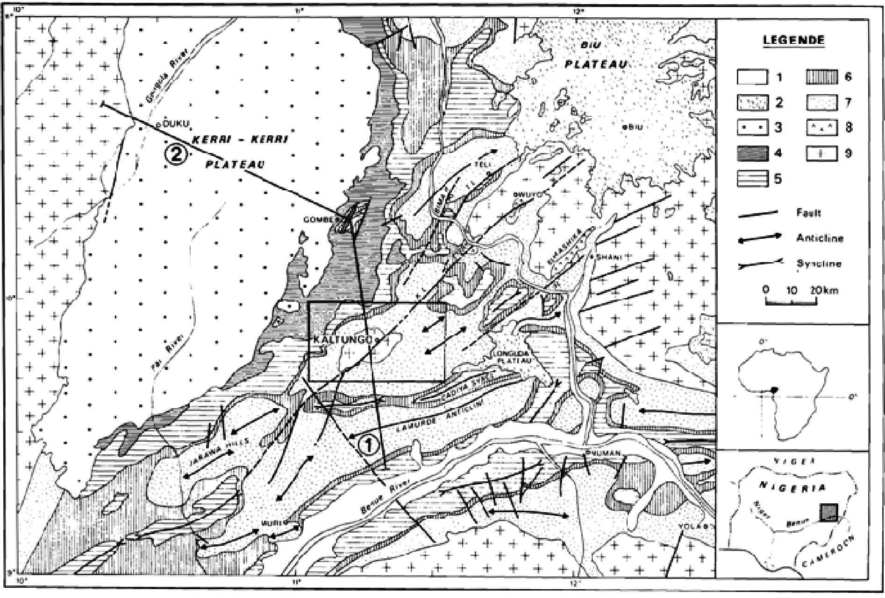
Figure 2. Simplified geological map of the Upper Benue Trough showing its stratigraphy and the structural elements. [1: Quaternary alluvium; 2: Tertiary volcanic; 3: Kerri-Kerri Formation; 4: Gombe Formation; 5:
Pindiga Formation; 6: Yolde Formation; 7: Bima Sandstone; 8: Burashika Complex (Mesozoic volcanism); 9:
Undifferentiated Basement Complex] (After Benkhlil, 1989)

Except for the Cenozoic Niger Delta which has been described as ‘oil-rich belt’ and popularly known for its petroleum generation and accumulation, little is known of the Mesozoic (especially the Cretaceous) petroleum deposits in Nigeria. These should equally be explored since their counterparts in other basins of the world have proved as viable geologic abode for petroleum generation (Klemme & Ulmishek, 1999), and this forms the basis for the present study

Geological Settings of the Benue Trough / Gombe Formation
The geology of the Benue Trough and that of the Gombe Formation had been described by several authors (e.g.
Obaje et al., 1994; Obaje & Abbas, 1996a; Obaje & Ligouis, 1996b; Obaje, 2000; Obaje & Hamza, 2000;
Rayment, 1965; Lawal, 1982). Thus, only the vital salient areas will be discussed in this study to avoid repetition. The Gombe Formation is an integral part of the larger Benue Trough of Nigeria. The Benue Trough is regarded as an aulacogen basin within the central West Africa that stretches NNE–SSW for about 800 km in length and 150 km in width. It is said to have contain a sedimentary pile of up to 6000 m of Cretaceous–Tertiary age.
The Gombe Formation which directly underlies the Kerri-Kerri Formation is made up of admixture of sands, shales, clays and coals. Its type locality is Gombe. The area covered by the Formation is generally low-lying with some dissected ridges scattered sporadically across the area. The Maiganga Coal Mine is underlain by the Gombe Formation in its entirety with two thin seams (maximum of 3 m thick recorded) of coal occurring between 30–36 m of the boreholes. These coal seams are presently being mined and used for the firing of the Ashaka Cement kilns.

Materials and Methods
A total of fifteen (15) core samples were selected from the 3 boreholes dug around the Maiganga Coal Mine for the Rock Eval-6 analysis, the sample density being five (5) samples per borehole.
The selection of the sampled horizon (horizon of interest to this study) was based on the results of the analyzed palynomorph data also from the study area. Richer palynomorphs horizons were therefore preferentially selected and sampled for geochemical analysis because of their anticipated good results.
The following procedures were systematically observed.

Sample Cleaning
The core samples were initially cleaned by seeping in 100% dichloromethane (CHCl) with shaking followed by decanting of the solvent until the samples were clean. After drying, the samples were washed under running tap water and then dried again in an oven at a pre-set temperature of 30 ºC.

Total Organic Carbon Analysis
Total organic Carbon (TOC) analysis was performed by means of the LECO CS 125 carbon analyzer according to the following procedure.
About 200 mg of the pre-cleaned samples were crushed and accurately weighed into clean LECO crucibles. The rocks were then de-mineralized by hot 10% HCl and afterwards repeatedly with distilled water. After drying at 60ºC, the crucibles were automatically introduced into the furnace for combustion and measurement of the organic carbon content.

Rock-Eval Pyrolysis
Rock Eval pyrolysis was performed by means of the Rock–Eval 6 pyrolyser as follows:
Each pre- cleaned portion of the samples were crushed in mortar using pestle and weighed accurately (100 mg approx.) into the sample holder. All the sample holders were transferred into pre-numbered slots in the sample carousel. A commercial standard rock sample was then similarly weighed into other sample holders and slotted into the carousel after every 10 rock samples. Thereafter, the carousel was placed into appropriate location in the instrument and the analysis START program button was activated, from then on, the instrument operated automatically until the last sample in the carousel was analyzed.
The analysis process involved the transfer of each sample into the furnace where it was heated initially at 300 ºC for three minutes in an atmosphere of helium to release the free hydrocarbons (S₁). Pyrolysis of the bound hydrocarbons to give S₂ peak following immediately as the oven temperature was ramped up rapidly to 550 ºC at the rate of 25 ºC/min. Both the S₁ and S₂ hydrocarbon peaks were measured using a Flame Ionization Detector (FID). A splitting arrangement permitted the measurement of S₃ peak (carbon dioxide) by means of a Thermal Conductivity Detector (TCD).
The instrument automatically recorded the temperature corresponding to the maximum of the S₂ peak i.e. Tmax. An in-built computer processed the raw data to afford the values corresponding to the respective Rock – Eval indices.
The parameters of rock-eval analysis include the direct measurements (S₁, S₂, S₃, TOC and Tmax) and the derived measurements (HI, OI and PI).

Results
The results of the TOC contents and Rock-Eval data for the studied samples are presented in Table 1. The table shows that the Total Organic Carbon (TOC) content for boreholes BA–7, BA–16 and BA–17 vary from 4.20 to 4.27 wt. %, 3.50 to 4.26 wt. % and 2.00 to 2.24 wt. % respectively with the exception of the coal samples whose TOC values vary from 47.00 to 47.10 wt. % in boreholes BA-7 and BA-16 where the coal seams occur. The Hydrogen Index (HI) value ranges from 230 to 261 mg HC/ g TOC in samples from boreholes BA–7, 230 to 262 mg HC/ g TOC in BA–16 and 92 to 102 mg HC/g TOC in BA–17 with overall average HI of 195.13 mg HC/g TOC for the three studied boreholes. The Oxygen Index (OI) measured in mg CO₂/gTOC vary from 40 to 90 in boreholes BA–7, 38 to 89 in borehole BA–16 and 64–75 in borehole BA–17. The Tmax values are also in the ranges of 426–431 ºC, 420–431 ºC and 425–43 ºC for boreholes BA–7, BA–16 and BA–17 respectively. The other parameters such as S1+S2, S2/S3, Productivity Index (PI) were also computed as shown in Table 1.

Table 1. Rock-Eval 6 pyrolysis results of the analysed samples from boreholes BA-6, BA-16 and BA-17 of Gombe Formation
Sample  No | Depth  (m) | TOC  (wt. %) | S₁ mg/g | S₂ S₃ Tmax mg/g mg/g ºC |  |  | HI | OI | S1+S2 | S₂/S₃ | PI
 |  |  |  | BOREHOLE BA-7
BA7a  BA7b  BA7c  BA7d  *BA7e | 31.32  32.70  34.60  19.36  36.34 | 4.27  4.23  4.20  4.25  47.10 | 0.77  0.75  0.72  0.76  1.70 | 9.82  9.88  9.80  9.77  123.02 | 3.78  3.80  3.78  3.81  18.66 | 430  431  430  433  426 | 230  234  233  230  261 | 88  90  90  90  40 | 10.59  10.63  10.52  10.53  124.72 | 2.60  2.60  2.59  2.56  6.59 | 0.07  0.07  0.06  0.07  0.01
 |  |  |  | BOREHOLE BA-16
*BA16a  *BA16b BA16c  BA16d  BA16e | 33.75  35.12  22.71  41.42  54.40 | 47.07  47.00  4.26  3.50  3.55 | 1.72  1.68  0.81  0.45  0.43 | 122.04  120.10  9.81  2.50  2.61 | 18.63  18.60  3.78  2.10  2.01 | 422  430  427  420  431 | 259  256  230  259  262 | 40  40  89  38  40 | 123.76  121.78  10.62  2.95  3.04 | 6.60  6.45  2.59  1.19  1.29 | 0.01  0.01  0.07  0.01  0.01
 |  |  |  | BOREHOLE BA-17
BA17a  BA17b  BA17c  BA17d  BA17e | 37.26  39.34  19.25  16.74  23.05 | 2.21  2.00  2.22  2.24  2.18 | 0.24  0.24  0.22  0.27  0.28 | 2.03  2.03  2.06  2.07  2.04 | 1.46  1.50  1.47  1.44  1.44 | 429  426  425  430  430 | 92  102  93  92  94 | 66  75  66  64  66 | 2.27  2.27  2.28  2.34  2.32 | 1.40  1.35  1.40  1.43  1.41 | 0.11  0.10  0.09  0.11  0.12
*Samples with this mark are not used in the computations of the Average. S₁ and S₂ are in mg hydrocarbon / g rock, S₃ is in mg CO₂; HI, Hydrogen Index (HI = S₂ / TOC *100); OI, Oxygen Index (OI = S₃ / TOC *100); TOC, Total organic carbon (wt %), SP, Genetic Potential (SP = S₁+ S₂), PI, Productivity Index (S₁/S₁+S₂).

0
5
10
15
20
25
30
35
40
45
50
55
60
2
0
1
3
4
5
Depth (m)
TOC (wt.%)
Well BA-6
Well BA-16
Well BA-17
Figure 3. TOC versus depth plot showing distributions (trends) of the TOC values of the analysed samples in Wells BA-7, BA-16 and BA-17 of Gombe Formation. [Note: The coal samples wells BA-7 and BA-16 are excluded in the plot as their values seem to obscure the trends]
In a bid to display the distributions (trends) of the TOC values of the samples, TOC versus depth plots are generated for the three (3) boreholes and presented in Figure 3. In order to characterize the organic matter type (kerogen type) of the samples, the modified Van Krevelen diagrams (HI versus OI) are displayed in Figure 4. For the evaluation of the generation potential and quality of the analysed samples, graphs of (S₁ + S₂) against TOC were plotted in similar way to that of Ghoria (1998) and this is presented for the three boreholes in Figure 5. The HI versus Tmax plots were also generated so as to show the level of thermal maturity of the samples in the three boreholes as shown in Figure 6.

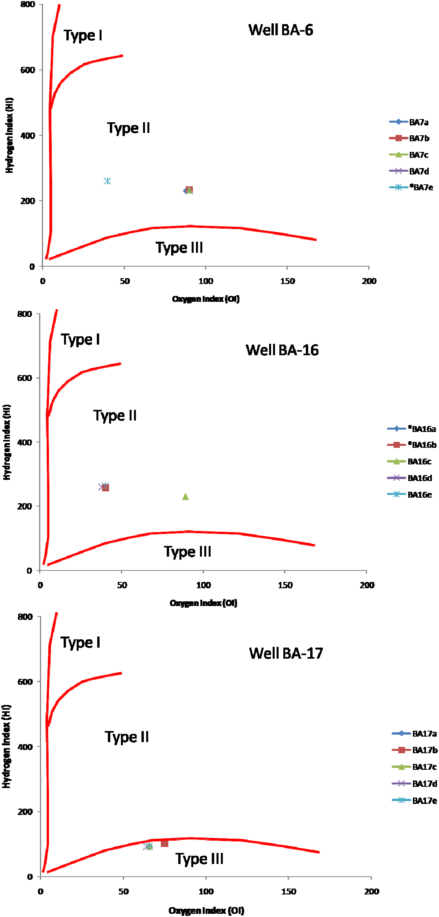
Borehole BA-7
Borehole BA-
1
6

Borehole BA-
1
7

Figure 4. Modified van Krevelen diagrams showing the organic matter types of the studied samples of Borehole
BA-7 (top), BA-16 (middle) and BA-17 (bottom)
Borehole BA-17
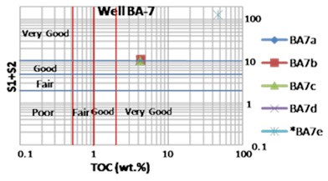

Borehole BA-16
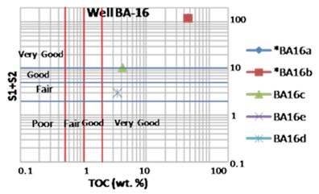

Borehole BA-17
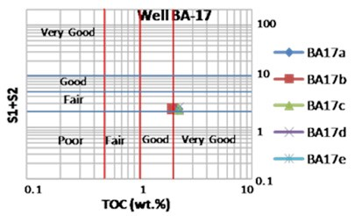
Figure 5. Generation potential for the studied samples studied samples of Borehole BA-7 (top), BA-16 (middle) and BA-17 (bottom) (After Ghoria, 1998)
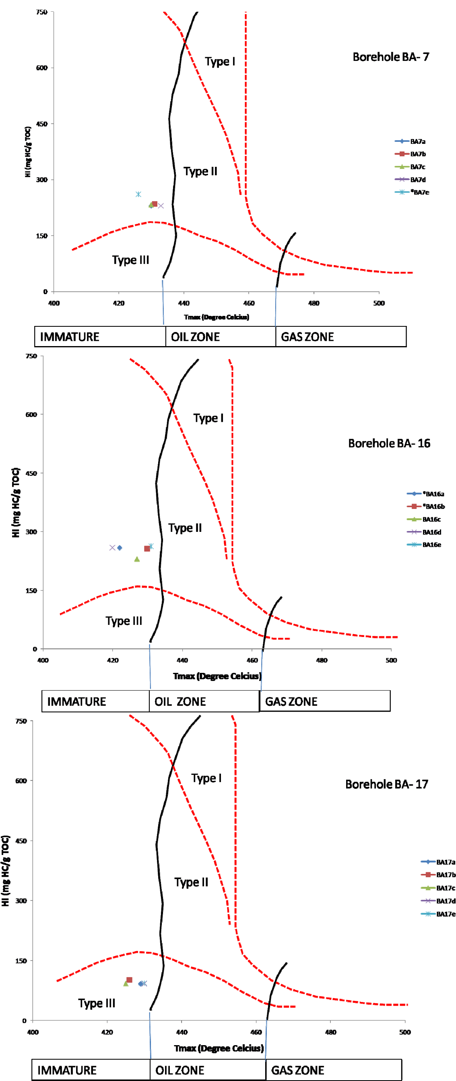
Figure 6. Rock-Eval Tmax versus HI plots for for studied samples of borehole BA-7 (top), BA-16 (middle) and
BA-17 (bottom)

Discussion of Results

Organic Matter (Kerogen) Type
The organic matter type contained in a sediment or sedimentary rock is a function of the materials from which it was sourced, marine or terrestrial or both, and this has a direct bearing or influence on the nature of the hydrocarbon products (oil or gas or both) to be produced after thermal maturation (Hunt, 1979; Tissot & Welte, 1984; Barker, 1996). Peters (1986) proposed that, for mature source rock, HI for gas-prone organic matter is less than 150, gas-oil-prone organic matter is ranged between 150 and 300, whereas the oil-prone organic matter is more than 300 HI. It is therefore very imperative to determine the kerogen types of the source rocks exploring for in a basin for exploration decision purposes.
The results from this study showed that the HI values exceed 200 mg/gTOC for the boreholes BA-7 and BA-16, and thus the analysed samples are gas-oil-prone. However, the HI values for well BA-17 are far below 150, meaning that the analysed samples for this particular borehole are ideal potential gas generator. The modified van Krevelen diagrams (Figure 4) confirms this by classifying boreholes BA-7 and BA-16, and borehole BA-17 as containing kerogen Type II and Type III respectively. This indicates that the source of the organic matter for the Gombe Formation is from admixture of terrestrial and marine sources for Wells BA-7 and BA-16, and major terrestrial contributors or sources for Well BA-17.

Organic Matter Richness and Generation Potential
The amount of organic carbon (TOC) is a measure of the quantity of organic matter in the source rocks (Tissot & Welte, 1984). By and large, the higher the TOC, the better the chance and potential for hydrocarbon generation (Akande, 2012). In fact, Tukur et al. (2006) posited that TOC is the first primary factor to be considered in assessing the hydrocarbon generative potential of a sedimentary basin and/or Formation. Thus, a rock that is organic matter lean is automatically excluded from further screening for hydrocarbon source potential.
A quick look at TOC versus depth plot in Figure 3 shows that the TOC content steadily increases with depth in Well BA-16 whereas Wells BA-7 and BA-17 has a similar trend as TOC decreases with depth but suddenly reverse the trend at approximately 35 m and 40 m respectively, although the coal samples in Wells BA-7 and BA- BA-16 are excluded in the plot as their values tend to obscure these trends. As shown in Table 1, the Total Organic Carbon (TOC) contents for wells BA–7, BA–16 and BA–17, averaging 4.24, 3.77 and 2.17 wt. %, vary from 4.20 to 4.27 wt. %, 3.50 to 4.26 wt. % and 2.00 to 2.24 wt. % respectively; with the exception of the coal samples whose TOC values are in order of few tens of wt. % varying from 47.00 to 47.10% in wells BA-7 and BA-16 where the coal seams occur.
The high TOC values generally suggest that the condition during sediment deposition was favourable for organic matter production and preservation. The analysed samples may have been deposited under anoxic conditions in the Maastrichtian time compared to the oxic event model suggested for Cenomanian to Turonian times in the adjacent Yolde, Dukul and Jessu Formations (Ojo & Akande, 2002) which were considered to be organically lean.
According to the guidelines of Peters (1986), the TOC values between 0.5 and 1.0% indicate a fair source-rock generative potential, TOC values varying from 1.0 to 2.0% reflect a good generative potential, TOC values between 2.0 and 4.0% refer to a very good generative potential, and rocks with TOC greater than 4.0% are considered to have excellent generative potential. In line with the above criteria, the TOC results of rock samples in this study show that the analysed samples from boreholes BA-7 and BA-16 have very good generative while those from borehole BA-17 have good to very good generative potential respectively. This is demonstrated in the plot of the S₁ + S₂ versus TOC (Figure 5). It is suffice to say that in term generation potential boreholes BA-7 and BA- 16 are more promising than BA- 17 and this is underpinned by the presence of type II kerogens in the former and type III kerogen in the latter (Figure 4).
Tissot and Welte (1984) also proposed a genetic potential (SP = S₁ + S₂) for the classification of source rocks. According to their classification scheme, rocks having SP of less than 2 mg HC/ g rock correspond to gas-prone rocks or non-generative ones, rocks with SP between 2 and 6 mg HC/ g rock are moderate source rocks, and those with SP greater than 6 mg HC/ g rock are good source rocks. Based on the above criteria, the analysed samples borehole BA-7 are good source rocks, those from borehole BA-16 are moderate to good source rocks while samples from borehole BA-17 are considered to be moderate source rocks. They added further that those rocks with exceptionally high SP values in order of 100 or 200 mg HC/ g rock may provide either an excellent source rock, if the burial depth is sufficient, or an oil shale, if the burial depth is shallow. Thus, the analysed samples especially those from boreholes BA-7 and BA-16 with fairly high SP may constitute a good source if the burial depth is sufficient.

Thermal Maturity Assessment
Thermal maturity of potential source rocks or oils can be evaluated by a number of parameters (vitrinite reflectance, R_{o}; spore colouration; Thermal Alteration Index,TAI; Rock-Eval Tmax). However, only Rock-Eval Tmax data are available to evaluate thermal maturity of the selected samples of the three boreholes considered in this study. The Tmax values for the three boreholes generally less than 435 ºC (426–431 ºC for borehole BA–7, 420–431 ºC for borehole BA–16 and 425–43 ºC for borehole BA–17), averaging 431, 426 and 428 ºC for boreholes BA-7, BA-16 and BA-17 respectively (Table 1). These values suggest that the analysed samples from the three boreholes are thermally immature (Figure 6). The thermal maturity levels attained by the source rock facies in the studied wells compared favourably with the immaturity status of their coeval Formations in the Benue Trough (Pindiga and Gongila Formations), suggesting that these contemporaneous Formations may be related in depth and/or have experienced similar geothermal gradient.

Conclusion
The results of the Rock-Eval analysis for analysed core samples from Wells BA-7, BA-16 and BA-17 within Gombe Formation have shown that the samples in boreholes BA-7 and BA-16 contain Type II kerogen while those from borehole BA-17 contain Type III kerogen. In terms of generation potential, the analysed samples from boreholes BA-7 and BA- 16 have very good generative potential while those from borehole BA-17 have good to very good generative potential respectively.
This study also revealed that the analysed samples especially those from boreholes BA-7 and BA-16 may constitute a good source if the burial depth is sufficient. However, what may pose challenges, from exploration point of view, is thermal maturity of these samples as the Rock-Eval Tmax data suggest that the analysed samples from the three boreholes are thermally immature. This thermal maturity assessment is consistent with the immaturity status of their coeval Formations (Pindiga and Gongila Formations) in other part of the Benue Trough, suggesting that these contemporaneous Formations may be related in depth and/or have experienced similar geothermal gradient.
It is recommended that the thermal maturity of the analysed samples from the three boreholes should also be re-evaluated by other thermal maturity indices such as vitrinite reflectance measurements in order to be double sure that the analysed samples are actually immature.

References
Akande, W. G. (2012). Evaluation of Hydrocarbon Generation Potential of the Mesozoic Organic-Rich Rocks Using TOC Content and Rock-Eval Pyrolysis Techniques. Geosciences, 2(6), 164-169.
Barker, C. (1996). Thermal Modelling of Petroleum Generation: Theory and Applications. New York: Elsevier.
Benkhelil, J. (1989). The Origin and Evolution of the Cretaceous Benue Trough (Nigeria). J. Afr. Earth Sci., 8, 251-282. http://dx.doi.org/10.1016/S0899-5362(89)80028-4
Ghoria, K. A. R. (1998). Petroleum source-rock potential and thermal maturity of the Officer Basin, Western Australia. Geological survey of Western Australia, p. 52 (Unpublished).
Klemme, H. D., & Ulmishek, G. F. (1999). Effective Petroleum Source Rocks of the World: Stratigraphic Distribution and Controlling Depositional Factors. AAPG Bulletin, 75, 1809-1851.
Hunt, J. M. (1979). Petroleum Geochemistry and Geology. In: W. H. Freeman & S. Francisco (Eds.), In the Middle Benue Trough of Nigeria. J. of Petroleum Geology, 19(1), 77-94.
Lawal, O. (1982). Biostratigraphie, Palynologie et Paleoenvironments des Formation Cretaces de la itaute Benoue; Nigeria – North-Oriental. Doctorat de Specialite. Universite de Nice. pp. 198.
Obaje, N. G., Attah, D. O., Opeloye, S. A., & Moumouni, A. (2006). Geochemical evaluation of the hydrocarbon prospects of sedimentary basins in Northern Nigeria. Geochemical Journal, 40, 227-243. http://dx.doi.org/10.2343/geochemj.40.227
Obaje, N. G. (2000). Biomarker Evaluation of the Oil-Generative Potential of Organic matter in Cretaceous strata from the Benue Trough (Nigeria). J. of Nigerian Association of Petroleum Explorationists, 15(1), 29-46.
Obaje, N. G., & Hamza, H. (2000). Liquid Hydrocarbon source-rock Potential of Mid-Cretaceous Coals and Coal Measures in the Middle Benue Trough of Nigeria. Int. J. Earth Sciences, 89(1), 130-139.
http://dx.doi.org/10.1007/s005310050321
Obaje, N. G., Abaa, S. I., Najime, T., & Suh, C. E. (1999). Economic Geology of Nigerian Coal Resources – a brief review. Geosciences Review, 6, 1-12.
Obaje, N. G., & Abaa, S. I. (1996a). Potential for Coal-Derived Gaseous Hydrocarbons in the Middle Benue
Trough of Nigeria. Journal of Petroleum Geology, 19(1), 77-94. http://dx.doi.org/10.1111/j.1747-5457.1996.tb00514.x
Obaje, N. G., & Ligouis, B. (1996b). Petrographic Evaluation of the Depositional Environment of the Cretaceous Oba/Lafia coal deposits in the Benue Trough of Nigeria. J. of Africa Earth Sciences, 22(2), 159-171. http://dx.doi.org/10.1016/0899-5362(96)00003-6
Obaje, N. G., Ligouis, B., & Abaa, S. I. (1994). Petrographic Composition and Depositional Environments of Cretaceous Coals and Coal Measures in the middle Benue Trough of Nigeria. Int. J. of Coal Geology, 26, 233-260. http://dx.doi.org/10.1016/0166-5162(94)90012-4
Odebode, M. O. (2010). A Handout on the Geology of the Benue and Anambra Basins, Nigeria. Unpublished.
Ojo, O. J., & Akande, S. O. (2002). Petroleum Geochemical Evaluation of the Mid-Cretaceous Sequence in the Dadiya Syncline, Yola Basin, Northeastern Nigeria. J. of Mining and Geology, 38(1), 35-42.
Peters, K. E. (1986). Guidelines for Evaluating Petroleum Source Rock Using Programmed Analysis. AAPG Bull., 70, 318-329.
Reyment, R. A. (1965). Aspects of the geology of Nigeria. The Stratigraphy of the Cretaceous and Cenozoic deposits (pp. 23-73). Ibadan University Press.
Tissot, B. P., & Welte, D. H. (1984). Petroleum Formation and Occurrence (p. 699). New York: Springer-Verlag.
Tukur, A., Samaila, N. K., Shettima, B., & Jauro, A. (2006). An Assessment of the Hydrocarbon potential of some Cretaceous Coals from the Benue Trough, Nigeria. Jolorn, 7(2), 57-64.

Copyrights
Copyright for this article is retained by the author(s), with first publication rights granted to the journal.
This is an open-access article distributed under the terms and conditions of the Creative Commons Attribution license (http://creativecommons.org/licenses/by/3.0/).

