DIGITAL WALLET: A REVENUE COLLECTION SYSTEM FOR LOW-INCOME EARNERS
ZUBAIRU, H. A.¹, MOHAMMED, I. K.², BABAKANO, F. J.³ & ETUK, S. O.⁴
^{1.3.4}Department of Information and Media Technology, Federal University of Technology, Minna, Nigeria.
²Department of Computer Science, Federal University of Technology, Minna, Nigeria.
E-mail: abu.zubairu@futminna.edu.ng; idris.kolos@futminna.edu.ng; faiza.bkano@futminna.edu.ng; abiolastella@futminna.edu.ng
Phone: +234-803-658-4777
Abstract
Revenue collection at state and local governments’ levels has been a big challenge and remains a major hindrance to the state in discharging its statutory responsibilities and economic goals in Nigeria. Automation as a means of revenue collection has been globally recognized as the most efficient, effective, economical and transparent means of revenues collection. States and local governments therefore need to improve revenue collection mechanisms and systems to reach collection targets aimed at expanding the revenue base and increasing revenue compliance through integration of proper technology for revenue collection. In this research, we design and implement a digital wallet system with central aggregation and payment solutions that cater for cashless and seamless transaction processing for informal sector with online and offline form of payment. The system has both desktop and mobile App and is designed using Java programming language. Evaluation of the proposed system shows that the system is capable of creating a centralize payment system and curb corruption and leakage that are inherent in the current manual revenue collection system.
Keywords: Revenue, Digital Wallet, e-payment, Tax, Tax evasion, Information System, Information Technology

Introduction
Revenue collection is a major source of fund to governments. Governments in both developed and developing world depend on internal revenue to some extent (Olaoye, Ashaolu & Adewoye, 2009). In the same vein, it is one of the main sources of income for governments at all levels in Nigeria (Ojong, Anthony & Arikpo, 2016). Ngotho and Kerongo (2014) maintained that collection of revenue is important for any government anywhere in the world to acquire assets which are not liable to debt and which the government uses to provide basic human needs and social amenities. High value revenue collection by government is necessary to promote efficiency in the service delivery and economic development by various arms of government. Nevertheless, available literatures have shown that government at various level in Nigeria face serious challenges in their revenue collection (Akintoye & Dada, 2013), where governments are not able to collect sufficient funds to cover their budget expectations. There are cases where revenue collection agencies are not remitting all the amount of money they collected to the government treasury (Ngotho & Kerongo, 2014).
Furthermore, there are recorded cases of collusion between revenue collection agency staff and revenue payers to avoid paying the correct charges and instead bribe the collector to shield from paying the stipulated amount to the government coffer (Olatunji, 2009). The consequence of these unholy practices is an economic loss, which could have negative impact on the country economic development (Kangu, Kambuni, Oyugi et al., 2011), growth (Olatunji, 2009), and service delivery (Namoit, 2012). Like many developing nations, Nigeria lacks an efficient revenue collection system leaving a high proportion of revenue uncollected as a result of leakages and corruption, especially at state and local government levels (Benard & Nzuki, 2018). The efficiency and effectiveness of revenue collection depend on the medium of collection and could be enhanced through the use of Information and Communications Technology (ICT) as a driver, as it is currently being practiced in developed nations.
Information Technology (IT) as an emerging technology in the 21st century, is making daily running of business transactions and organizational activities lot easier, its perceived benefits and usefulness has led to its adoption by many organizations both private and public sector (Al-mamary, Shamsuddin, & Aziati, 2014). ICT on revenue collection through electronic medium started in USA, and then spread to the developing countries (Muthama, 2013). Though, in recent time, revenue collection at Federal level in Nigeria has been boosted through the use of Information and Communication Technology (ICT) as a tool for collecting revenue. Adoption of ICT at Federal Government level (Treasury Single Account-TSA) as medium for revenue collection has block loopholes and seal the leakages of corruption in revenue collection and thus it is efficient and effective to use. ICT adoption replaces inefficient production on revenue collection process.
However, ICT has not been fully used at state and local government levels for revenue collection, especially from the informal sectors. Most states and local government in Nigeria still depend on the use of local tax collectors with their inherent problems of non-remittance, lack of courtesy, record falsification, bribery and corruption (Benard & Nzuki, 2018). As Nigeria faces economic crisis from the fluctuation of oil prices, states are advised to look into their internal generating revenue in order to meet up with their statutory responsibilities.
Most states and local government in Nigeria still depend on the use of local tax collectors with their inherent problems of non-remittance, lack of courtesy, record falsification, bribery and corruption (Benard & Nzuki, 2018). These manual revenue collection has led to consistent low revenue yields by both state and local government.
In 2018, only 19 million Nigerians paid into federal or state coffers, according to government data. Meanwhile, World Bank reports that Nigeria's economically active population is 65 million in that same year. Going by this figure, only about 30% of the population pay tax or revenue. In addition, UN report in 2018 reveals that, Nigeria's estimated revenue gap was one of the largest in Africa, as shown in Figure 1.

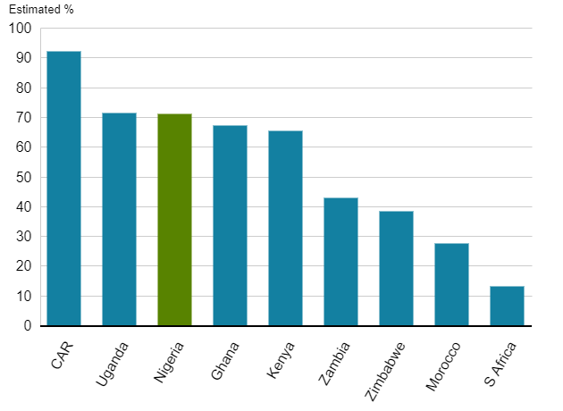
Figure 1: Revenue gap in African countries (UN Economic Commission for Africa)

Therefore, Federal government of Nigeria introduces the use of Information Technology to boost her revenue generation at federal level. However, despite this measure, revenue evasion and avoidance are still noticeable in most states and local government in Nigeria. Therefore, this paper proposes the use of digital wallet for seamless collection and remittance of revenue from the informal sector of the economy. It is envisaging that, the system will address the issue of revenue leakages and creates fiscal accountability between the people and the government.
Literature Review
Related Work
Rocheleau and Wu (2005) study titled E-Government and Financial Transactions, asserts that governments can provide incentives to encourage the use of online payment and transaction. However, the study did not show the effectiveness of the electronic payments in term of government revenue collection from her citizens. A research thesis by Kaburia (2004) found out that inadequate electronic payment alternatives was a critical issue militating against the growth of electronic business in some African countries. Kinyanjui and Kahonge (2013) in their research found that the use of e-payment via mobile phone based technology in a mobile based parking increased parking fees generation.
The research of Wahab (2012), titled adoption and use of electronic payment systems in Ghana opined that the use of the electronic payment system was discovered to be low as a result of inadequate availability of infrastructures. Olushola (2015), in his research thesis using Technology Acceptance Model and the Theory of Planned Behavior in the context of ICT integration in the public sector, identifies the impact of ICT on the collection of company income tax in Nigeria.
Kinuthia and Akinnusi (2014) in their research revealed that inadequate technology infrastructure was a barrier to the smooth running of online business (e-commerce). However, the study did not show the impact of e-commerce on revenue collection. A research project by Nyongesa (2014) indicate that the use of information technology as a medium of collecting revenue would largely increase the revenue collection process, though, the study was not clear on how the revenue collection would be influenced by digital platform as a means payment. Otieno, Oginda, Obura, Aila, Ojera and Siringi (2013) research findings indicate that information system improve efficiency and effectiveness of revenue collection system.
Benard and Nzuki (2018), adopt the use of Technology Acceptance Model and Theory of Acceptance to study Information Communication Technology policies, Employee’s perception and financial allocation on revenue collection. Findings of the study was that, Information Communication Technology policies on revenue collection, Employee’s perception on revenue collection and financial allocation on revenue collection all had influence on Revenue collection.
Githinji, Mwaniki, Kirwa and Mutongwa (2014) in their study on the use of Information and communication Technology on revenue collection, maintain that through the use of ICT for the revenue collection; the medium has improved the effectiveness of the revenue collection and seal the leakages and increase revenue collection. They stress that ICT adoption addresses the loopholes and seal the leakages of corruption in revenue collection and thus it was efficient and effective to use. Karimi (2017) research on the effect of technology and information systems on revenue collection by government and its agencies, established that Information and communication Technology (ICT) plays a vital role in revenue collection, nevertheless, the author opined that, there are certain militating factors against the effective use of ICT on revenue collection, and thus recommends it as future work in the study.
The related works had studied the effect of Information Technology or Information system on revenue collection process, but none of the study actually deploy the use of ICT as a means of revue collections. This is knowledge gap that this study intended to fill.
Methodology
We adopt an object-oriented analysis approach to organize requirements around objects, where behaviors and states are integrated to modeled real world objects that the revenue collection system interacts with. An e-wallet scenario was developed to model a digital storage where user’s information are stored. A potential user will have to create a digital wallet account where virtual money and other details are store in order to pay revenue or top-up e-wallet. The use case diagram, Entity-Relational Diagram (ERD), activity diagram and the system architecture are shown and discuss in this section.

Use Case Diagram of the System
A Use Case diagram pictorially represent functionality provided by the system. The goal of the Use-Case is to aid the development teams visualize the function of the system and the relationship between and among the actors. The system Use-Case is shown in Figure 2.

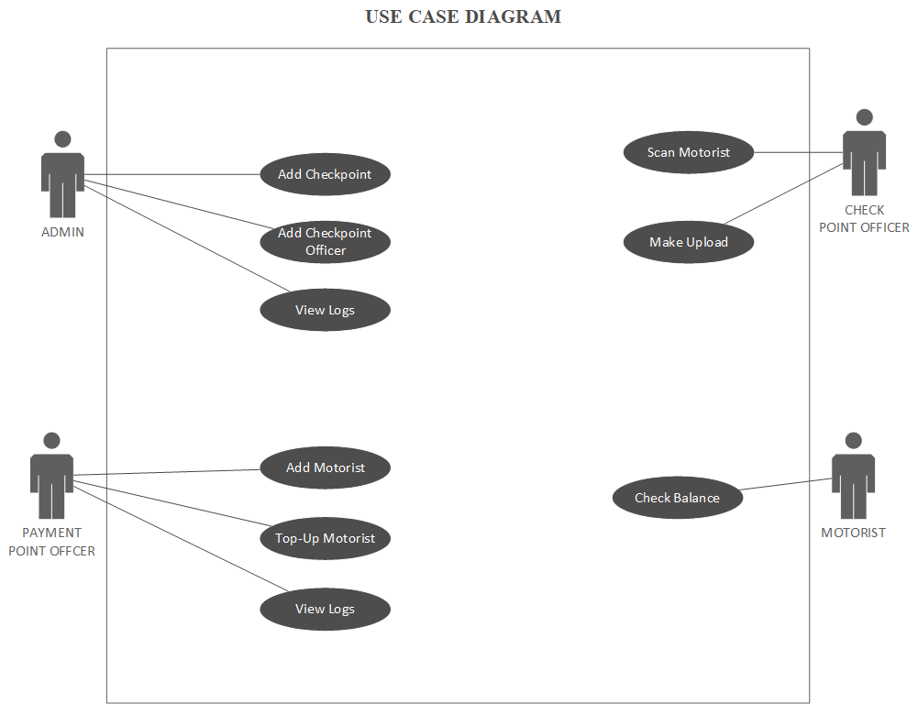

Figure 2: The System Use Case

The revenue collection system involves four main actors. These include an admin, payment point officer, checkpoint officer and a motorist. There is also a Network Operator that provides the infrastructure necessary for online communication.

Entity-Relational Diagram (ERD)
Entity-Relational Diagram shows the proposed system with the entities, their attributes and the relationship that exists between the entities. The ERD describes how data is being modelled. The ERD of the revenue collection system is shown in Figure 3.

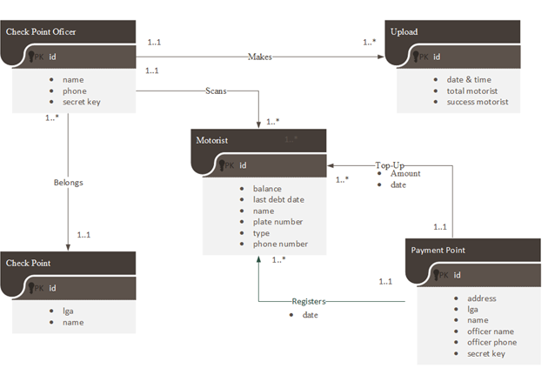
Figure 3: The ER Diagram of the system

Activity Diagram
The activity diagram defines the states of a system and these state changes are dynamic in nature, its specific aim is to define state changes triggered by events. It denotes sequences of state change from a system point of view. Activity Diagram are used to model states and also events operation on the system. The activity diagram of the system is shown in Figure 4.

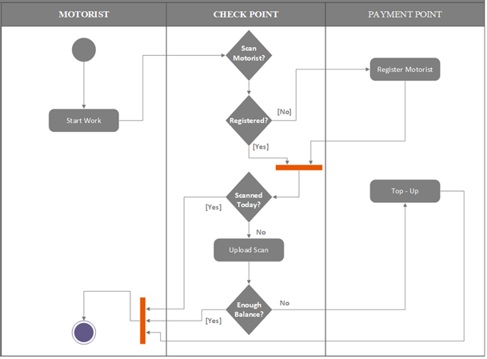

Figure 4: The Activity Diagram of the system

System Architecture
The revenue collection system architecture is shown in Figure 5. The architecture is designed to run on two platforms, namely; desktop and mobile version and these are driven by the following actors – Network operator, Task-Force, Agents and Motorists.

The motorist uses his mobile device to make revenue payment over a network. The request includes the details of the motorist and specify amount to be pay as revenue to the government. All these information are store in the motorist’s digital wallet, which at point of payment process digitally.

In addition, there are regulators who are involved in monitoring compliance with the rules and laws related to revenue collection and payments. These are generally government bodies who uses the desktop version of the system for monitoring using the digital dashboard of the system

GPRS/
Network
GPRS/
Network
Enrolment Centre
Motorists
Taskforce with payment point
Taskforce with payment point
Server
Database
Motorists

Figure 5: The Architecture of the System
A Network operator in this paper is the network provider, which provides the infrastructure necessary for wireless communication service. A taskforce is a revenue collection company contracted by either the State or Local Government to manage Agents to effectively use payment terminal to collect, validate and top-up motorist’s digital wallet as the case may be. The taskforce verifies the credentials of the agents and the motorist to checks whether the agents and motorists are duly enrolled into the revenue collection system
User, Taskforce and Agent are equipped with a desktop and mobile version of the system respectively to manage the digital wallet for enrolling user, reporting and visualization, user privilege and wallet deposit.

Experimental Evaluation
The evaluation of the concept was carried out by implementing the digital wallet as QRcode and the payment point as mobile phone. The QRcode is shown in Figure 6.
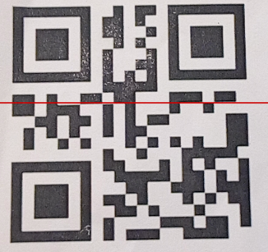
Figure 6: QRcode simulated as digital wallet
The QRcode is created using the motorist plate number for security reason. To top up the wallet, the number plate is required.
To pay for revenue, the taskforce uses his or her phone to scan the digital wallet in the motorist’s phone to accept payment through an App in the phone that is connected to a payment gateway. The system work like normal conventional payment terminals, as shown in Figure 7.
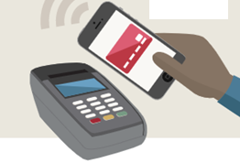
Figure 7: Digital wallet and payment Point
The authority that uses the platform to execute enrolment and revenue collection register taskforce at a different designated points within a locality as shown in Figure 8.
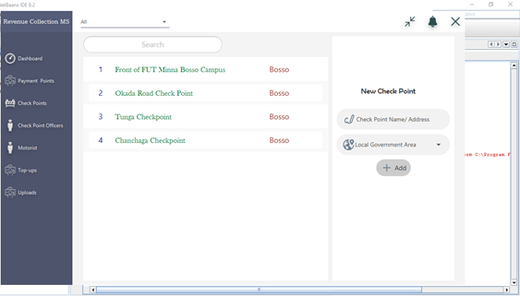
Figure 8: Enrolment of Taskforces into the platform
The admin of the system can view the number of motorist scanned and uploaded on daily basis as shown in Figure 9.
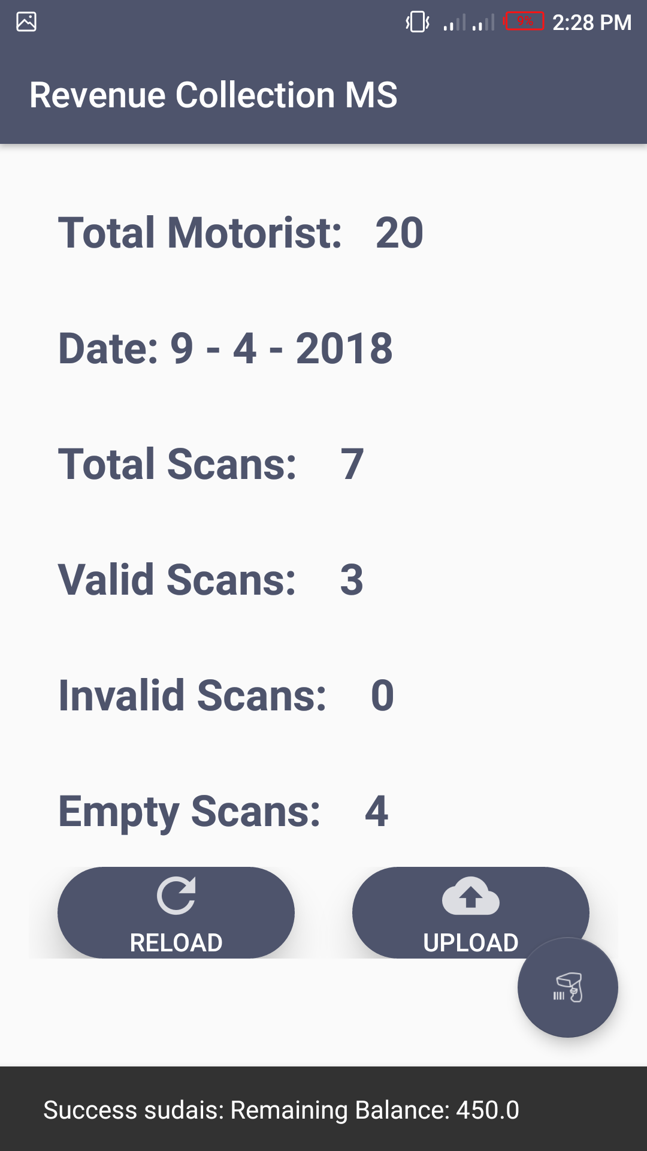
Figure 9: Screen shot of number of motorist scan
As shown in Figure 9, the system is designed to work both online and offline, if the scan was made when there is no network, it can be stored and later uploaded into central server. With this, revenue collection is made cashless, easier and more transparent with a centralized payment system. The Government or the revenue body can have a seamless access to the revenue collection process for proper auditing. The authority can use the statistically analysis feature of the system to visualize the revenue collection activities, as shown in Figure 10. Collection is as easy as scanning a sticker container a QR or Barcode on the vehicle which will deduct the daily revenue charge from the vehicle owner wallet. Motorist can top-up their wallet in any designated payment center close to them.
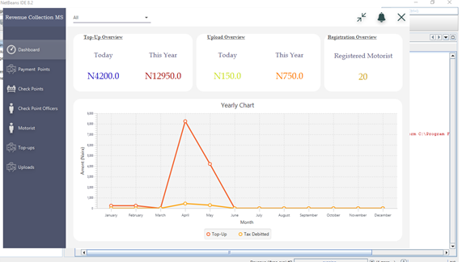
Figure 10: Dashboard display of revenue summary
As shown in Figure 10, the system has a digital dashboard that displays to the Admin, the summary of the revenue collection activities. The admin can also view the number of motorist that top up their digital wallets and the correspond amount as shown in Figure 11.
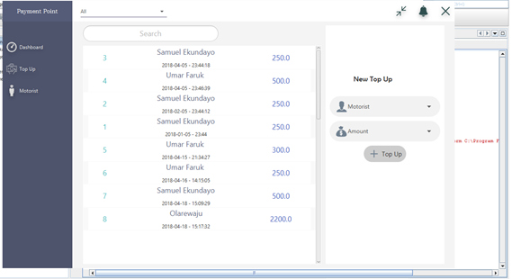
Figure 11: Display of top-up made by motorist
Conclusion and Recommendation
In this paper, we designed and implemented an electronic revenue collection system for the low income earners of the economy for state and local governments in Nigeria. The system serves as a means to achieve a cashless environment through the use of digital wallet for government revenue collection processes, allowing government to exploit the capabilities of Information technology to transform its revenue collection process.
The desktop version of the system has executive dashboard where the authority can be able to access anywhere, anytime for the monitoring and management of revenue collected by task forces. With this system, revenue collection and payment is being centralized which reduces corruption in the payment process.
Nevertheless, the result obtained from this experiment is from the prototype and not real implementation, which limits its applicability. Therefore, real implementation in collaboration with the stakeholders is a recommendation for future work. In the future work, the collection system will W2WWsupport an Enterprise Resource Planning (ERP) system that will be used for reporting as the payments goes through real-time settlement into the government treasury.

References
Akintoye, I. R. & Dada, S. O. (2013). Tax justice, economic growth and development in sub-Saharan Africa: Evidence from Nigeria. Journal of Management Policy, 3(5), 104-120.
Al-Mamary, Y. H., Shamsuddin, A., & Aziati, N. (2014). Factors affecting successful adoption of management information systems in organizations towards enhancing organizational performance. American Journal of Systems and Software, 2(5), 121–126. Retrieved from; Http://Doi.Org/10.12691/Ajss-2-5-2
Benard, R. K. & Nzuki, D. (2018). Information Communication Technology Considerations and Revenue collection in Nairobi city county, Kenya, International Journal of Social Sciences and Information Technology, 4(10), 21-32
Githinji, R. K., Mwaniki, M., Kirwa, K. J., & Mutongwa, S. M. (2014). Information and Communication Technology (ICT) On Revenue Collection by Kenyan Counties. International Journal of Academic Research in Business and Social Sciences, 4(11), 238–260. Retrieved from http://Doi.Org/10.6007/Ijarbss/V4-I11/1303
Kaburia, P. T. (2004). E-payment systems and alternatives for developing Countries. Unpublished MSc Thesis submitted to the University of Nairobi, Kenya.
Karimi, H, Maina, K. E., & Kinyua, J. M. (2017). Effect of Technology and Information Systems On Revenue Collection By The County Government of Embu, Kenya. International Academic Journal of Information Systems and Technology, 2(1), 19–35.
Kinuthia, J. N. K. & Akinnusi, D. M. (2014). The magnitude of barriers facing ecommerce businesses in Kenya. Journal of Internet and Information Systems, 4(1), 12-27.
Kinyanjui, K. E. & Kahonge, A. M. (2013). Mobile phone –based parking system. International Journal of Information Technology, Control and Automation (IJITCA), 3(1), 21-27.
Lyndon M.E & Paymaster F. B (2016), The Impact of Company Income Tax and Value added Tax on Economic Growth: Evidence from Nigeria. European Journal of Accounting, Auditing and Finance Research, 4(7), 106-112.
Kangu, M. Kambuni, L. M., Oyugi, E. A. et al., (2011). A Report on the Implementation of Devolved Government in Kenya. Retrieved from https://www.ke.undp.org/content/kenya/en/home/library/government-reports/interim-report-of-the-task-force-on-devolved-government.html

Muthama, J. (2013). The effects of revenue system modernization on revenue collection at Kenya revenue. A Master’s Degree Project submitted in partial fulfilment of the requirements for the award of the degree of Master of Science in finance, University of Nairobi, Kenya.
Ngotho, J. & Kerongo, F. (2014). Determinants of revenue collection in developing countries: Kenya’s tax collection perspective. Journal of Management and Business Administration. Retrieved from http://writersbureau.net/journals/jmba/determinants-of-revenue-collectionin-developing-countrieskenyas-tax-collection-perspective.pdf.
Nyongesa, N. M. (2014). Strategies adopted by the county government of Mombasa in raising revenue. Unpublished MBA Research Project, Nairobi: University of Nairobi.
Olatunji, O. C. (2009). A Review of Value Added Tax (VAT) Administration in Nigeria. International Business Management, 3(4), 61-68.
Olaoye, C. O., Asaolu, T. O. & Adewoye, J. O. (2009). A Review of Revenue Generation in Nigerian Local Government: A Case Study of Ekiti State. International Business Management, 3(3), 54-60.
Ojong, C. M., Anthony, C. & Arikpo, C. F. (2016). The Impact of Tax Revenue on Economic Growth: Evidence from Nigeria. IOSR Journal of Economics and Finance, 7(1), 32-38.
Otieno, O. C., Oginda, M., Obura, J. M., Aila, F. O., Ojera, F. B. & Siringi, E. M. (2013). Effect of Information Systems on by Local Authorities in Homa Bay County, Kenya. Universal Journal of Accounting and Finance, 1(1), 29-33.
Olushola, T. (2015). The Impact of Information and Communication Technology on Company Income Tax Collection in Nigeria. Thesis submitted to the Faculty of Business & Law at De Montfort University, Leicester in partial fulfilment of the requirements for the Degree of Doctor of Philosophy.
Rocheleau, B. & Wu, L. (2005). E-Government and Financial Transactions: Potential Versus Reality. The Electronic Journal of e-Government, 3(4), 219-230, available online at www.ejeg.com.
Wahab, Y. A. (2012). The Adoption and Use of Electronic Payment Systems in Ghana. A Case of E-Zwich in the Sunyani Municipality. Unpublished Commonwealth Executive Masters in Business Administration Thesis. Kwame Nkrumah University of Science and Technology.

