Spectral Determination of Depth to the Basement Rocks under Birnin-Kebbi and Tambuwel/Fokku Area of Sokoto Basin, Nigeria.
A. S. Yusuf¹, C. O. Edet^{1,2*}
¹Department of Physics, Federal University of Technology, Minna, Nigeria.
²Department of Physics, Cross River University of Technology, Calabar, Nigeria.
Corresponding Author’s mail; meetseediq@gmail.com
ABSTRACT
In this study, depth analysis method was used in determining the depth of the basement rocks of Birnin-Kebbi and Tambuwel/Fokku area. Magnetic data used in this study were collected through Aeromagnetic survey of a substantial part of Nigeria which was carried out by geological survey between (1974-1980). Depth of the magnetic layers was determined using statistical spectral depth analysis of the residual magnetic field and surface maps of the layers was produced and analyzed. The residual magnetic data were divided into twelve sections and the spectral depth was calculated for each section. The result showed that the lowest depth to basement is 1.200 km and the highest is 1.65km. However, this thickness is considered too low for any petroleum potentiality.
Key Words: Spectral, Depth, Basement Rocks, Aeromagnetic
- Introduction
Nigeria is one of the Countries involved in oil exploration and oil is found in sedimentary basins. The first step in determining petroleum potentials of an area is finding the thickness of sediments in the basin. This study is intended to throw more light on the application of spectral analysis as one of the tools used in determining the thickness of sediments in sedimentary basin using Birnin-Kebbi and Tambuwel/Fokku of the Sokoto basin as a case study.
Magnetics exploration is carried out on land, at sea and in air. For areas of appreciable extent, reconnaissance survey over both land and sea is conveniently borne done with airborne magnetometer. In oil exploration, magnetic is exclusively a reconnaissance tool, generally in the form of airborne survey. It is done as a preliminary to seismic reflection method to establish the approximate depth, topography and character of the basement rock. Since the susceptibility of sedimentary rocks is relatively small, the main response is due to igneous rocks below the sediments. Consequently, we would expect rather low magnetic relief in such areas and this is the case (Telford et al, 1976).
1.2 Location of the Study Area
The study area which comprise and tambuwel/Fokku lies between latitude 12.0⁰ to 12.5⁰ and longitude 4.0⁰ to 5.0⁰. The Birnin-Kebbi and tambuwel/Fokku are made of two aeromagnetic maps. Birnin-Kebbi is at the north-eastern end of the country with a co-ordinate 13⁰04North and 5⁰14East of Nigeria. Two aeromagnetic maps were used, each of 0.5⁰ by 0.5⁰.
1.3 The Geology of the Study Area
The Sokoto basin is located on the north-eastern end of the country. It is part of an extensive sedimentary basin underlying most of Sokoto state. The Sokoto basin lies uncomfortably to the basement complex. Then basin is composed of basically eight stratigraphic units each having distinct hydro geological characteristics. The Sokoto Basin centered in the neighboring Republic of Niger has a maximum thickness of about 1,000 meters in the Nigerian sectors, which is less than 1,500 meters for it to generate hydrocarbons. However, the Sokoto Basin contains limestone and gypsum that can sustain the cement factory operating in Sokoto state.
The Sokoto Basin is Nigeria sector of extensive lullemmeden Basin warped trough (Adeleye, 1976). It predominantly consists of a gently undulating plain with elevation varying from 250 to 400 meters above sea level. The area is marked by high drainage density stream.
The phosphates show features of an epicontinental setting. A unique set of conditions favoured the accumulation of phosphates availability of phosphorus in excess of normal in the shallow marine waters, tectonic setting, structural setting and post-depositional history. Deposition of phosphates was in the periods of changing tectonics in the Palaeocene which modified the regional chemistry if bottom waters. The regional tectonic framework determined the basin sediment environment, depositional processes and the resulting geometries. The intra-continental basin bordered by gravity faults provided the essential shallow water system.
The main types of rock in the Sokoto basin consist of clay stone, sandstone and carbonate from the cretaceous to tertiary. Alluvium of quaternary age underlines the lowland of the Sokoto River. The sediment of the basin lie uncomfortably on the basement complex and have been affected by series of marine transgressions.
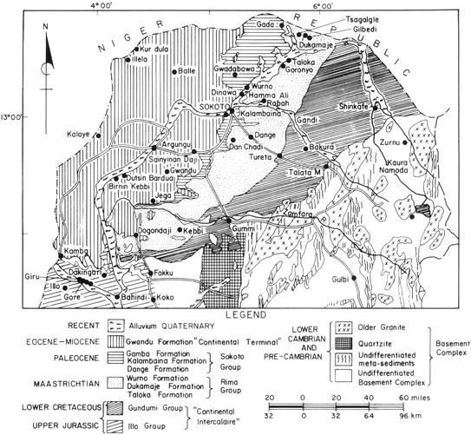
Fig 1.0; General Geological Sketch Map of Sokoto Basin, (springer.com/chapter/10.1007/978-3-540-92685-6_7).

2.0 Methods
The following procedures were used for the study
- The Birnin-kebbi and Tabuwel/Fokku map were digitized manually by Prof. Udensi on a 37 by 19 grid system.
- The data were arranged in a contoured form and contoured for further analysis and interpretation of the study area.
- Trends on the magnetic field map will be analyzed qualitatively.
- The regional and the residual magnetic field map if the area will be determined by fitting a first degree polynomial field using the polynomial fitting (least square) method.
- Depth to the magnetic layers will be determined using statistical spectral depth analysis of the residual magnetic field and surface maps of the layers shall be produced and analyzed.
Aeromagnetic survey of a substantial part of Nigeria was carried out by the geological survey of Nigeria Between 1974-1980. The magnetic information consists of profile or flight lines plotted on continuous strip chart on tape records. To achieve this, the Nigeria landmass was divided into blocks. The magnetic data were collected at a normal flight altitude of 500ft 152.4m) along N-S flight lines spaced approximately 2km apart. The data were later published in the form of 1/2⁰ by 1/2⁰ aeromagnetic map on a scale of 1:100,000. The magnetic values were plotted at 10Nt (gamma) interval. The maps were also written on them for easy reference 340 maps cover the entire country. Not all parts of Nigeria have been flown. The study area, Birnin-Kebbi and Tambuwel/Fokku is in the Sokoto basin and the area is entirely covered with sedimentary rocks. The actual magnetic values within this area were by removing 25,000 gamma before plotting the contour map (Hunting’s, 1976). This means that a value of 25,000 gamma should be added to the contour value so as to obtain the actual magnetic field at a given point.
3.0 Analysis and Interpretation of Residual Field

Aeromagnetic data is in the determination of depth of buried magnetic rocks. These depths are commonly computed from measurements made on the adequate grid control is available, depths can also be established by the use catalogues of three dimensional prismatic models. A frequent short coming of these techniques is the fact that the calculations are performed on isolated anomalies, which are distorted by noise and recognized recently that a statistical approach some may sometimes be preferable because more than one anomaly can then be used to determined depths of magnetics structures. While this approach cannot be expected to have the resolution theoretically achievable by analysis carried out on individual anomalies, it can lead to the determination of mean depth values to major units of buried magnetic rocks. In particular, the statistical approach has been found to yield estimated of mean depth to basement underlying a sedimentary basin (Hahn et al., 2001).
The trend agrees completely with the deductions of (Ajakaiye et al., 1980) who identified a system of NE-SW trending narrow magnetic lineament along which are concentrated the Alkaline Ring complexes and suggested that the lineament represented pre-existing zones of weakness in the pan African crust. (Anamba and Ajakaiye, 1987) also identified predominant tectonic.

Statistical spectral analysis only become a handy tool for geophysical phenomenal analysis after the advent of large capacity electronic computer, and its was within the last fifty years. (Spector, 1968) and (Grant,1970) developed a depth determination method which matches two dimensional power spectral calculated from gridded total intensity magnetic field data with corresponding spectral obtained from theoretical model. Their model assumed that an uncorrelated distribution of magnetic sources exist at a number of discrete depth intervals in the geologic column. The evolution of spectral analysis has same important precursor, by which one tried to prevent data only in a simple time domain style. The most important of these precursors is the harmonic analysis of Fourier series expansion of given time series of data.
In the general case, f(t) can stand for any time function, such as displacement, particle velocity, acceleration, temperature, rainfall, wind velocity, geomagnetic field intensity e.t.c. The phenomenon e.g. geomagnetic field can also be spaced function f(x). In this chapter, the characteristics of the residual magnetic field are studied using statistical spectral method. This is done by first transforming the data from space to the frequency domain and then analyzing their frequency characteristics.
For depth estimation for magnetic field data this can be approximated to exp (-2hr) (Spector and Grant, 1970). The exp (-2hr) term is the dominant factor in the power spectrum. Map spectral are usually declining functions of r whose rate decay is largely dominated by the mean depth of bodies. If these are two set of sources, then they can be recognized by marker change in the spectral decays rate. The energy spectrum of the double ensemble will then consist of two parts. The first, which relate to the deeper sources, is relatively strong and at low frequencies and decay away rapidly. The second which arises from the shallower ensemble of sources, dominates the high frequency end of the spectrum. In the general case, the radial spectrum may be conveniently approximated by straight line segments, the slopes of which rate to depth of the depth of the possible layers, (Spectra and Grant 1970, Naidu, 1970 and Hahn et al., 1976).
Each linear segment groups points due to anomalies caused by bodies occurring within a particular depth. If Z is the mean depth of layer, the depth factor for this ensemble of anomalies id exp (-2ZK). Thus the logarithmic plot of the radial spectrum would give a straight line whose slope is thus given as.
Z= -m/2 1.1
where m is the slope of the fitting straight line. Equation 4.15 can be applied directly id the frequency unit is in radians per kilometer. If, however, the frequency unit is in cycles per kilometer the corresponding relation can be expressed as:
Z= -m/4 1.2
The use of Discrete Fourier Transformation introduces the problem of aliasing and the truncation effect (or Gibbs phenomenon). Aliasing was reduced by the digitizing interval used in the study (section). The truncation effect arises in that when a limited portion of an aeromagnetic anomaly map is subjected to Fourier synthesis; it is difficult to reconstruct the shape edges of the anomaly with a limited number of frequencies. This truncation effect also leads to the introduction of spurious oscillation around the region of discontinuity. This means that false frequencies will be introduced into the spectrum. Applying a cosine-taper to observe data before Fourier transformation will reduce the truncation effect.
The evaluation is done using an algorithm that is a two dimensional extension of the fast Fourier Transform (Oppenheim and Schafer, 1975). Next, the frequency intervals are subdivided into sub-intervals which lie with one unit of Frequency range. The average spectrum of the partial wave falling within this frequency range is calculated and the resulting values together constitute the radial spectrum of the anomalous field (Hahn et al., 1976, Negi et al., 1983, Kangkolo, 1996 and Udensi, 2001).
Finally, it has been found (Pal et al., 1978) that in the use of the approach to magnetic sources depth determinations, the error in the depth prediction increase with the depth of source and is also related to the map size. The map size required for adequate result should be much larger (about 10 times) than the map target depth (Udensi, 2001). The low frequency components in the energy spectrum are generated from the deepest layers whose locations are most likely in error. Thus it is advisable in the general method here to ignore the first few points in the energy spectrum. The Spectra and (Grant, 1970) method described above, as noted earlier assumes a uniform distribution of parameters for an assemble of magnetized blocks to depth-dependent.
Fedi et al., 1997 has improved on this assumption by indicating that apart from the depth dependent exponential, there is also a power-law rate of decay that is independent of depth. However, this improve affect the low frequency range, which has already been noted as being likely in error. The low frequency range which has already been noted likely in error. The low frequency range will be avoided in the deductions that follow.
3.1 Results and Discussion
The research total covering between longitude 4⁰ to 5.0⁰ and latitude 12.0⁰ to 12.5⁰ was sub-divided into twelve sections for the purpose of spectral depth determination to basement are then evaluated using equation 4.15 i.e Z = -m/2 where m represents the gradient and Z gives the mean depth of buried assemblages. These depths are shown as H₁ and H₂ on table 1, the depth to basement required is contour on map fig (2) and fig (3) which shows that the highest deposited exists around Birnin-kebbi within longitude 4.0º to 4.5º and latitude 12.0º to 12.3º.where a depth of 1.651km was observed. The lowest point in the study area is between longitude 4.6º to 4.8º and latitude 12.1º to 12.4º with a minimum depth of 1.200 km.
Table 1: location and magnitude of first and second spectral depth
Section | Longitude | Latitude | Depth H₁ (KM) | Depth H₂ (KM)
1 | 4.184 | 12.189 | 0.025 | 1.498
2 | 4.184 | 12.297 | 0.372 | 1.450
3 | 4.184 | 12.586 | 0.396 | 1.651
4 | 4.395 | 12.189 | 0.376 | 1.581
5 | 4.395 | 12.297 | 0.402 | 1.575
6 | 4.395 | 12.486 | 0.523 | 1.445
7 | 4.684 | 12.189 | 0.437 | 1.287
8 | 4.684 | 12.189 | 0.490 | 1.532
9 | 4.684 | 12.486 | 0.490 | 1.532
10 | 4.947 | 12.189 | 0.487 | 1.378
11 | 4.947 | 12.297 | 0.361 | 1.595
12 | 4.947 | 12.486 | 0.547 | 1.200

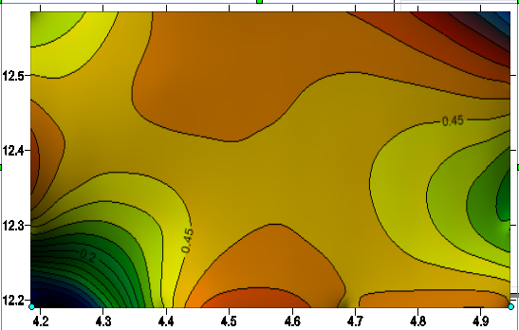
Fig 2; Contour Map of the first layer depth Contoured at 0.1 KM interval

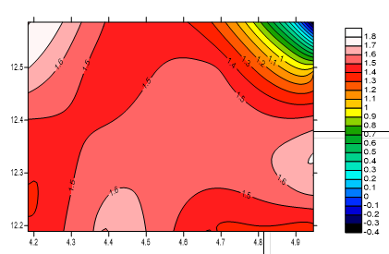

Fig 3; Contour Map of the second layer depth Contoured at 0.5 KM interval

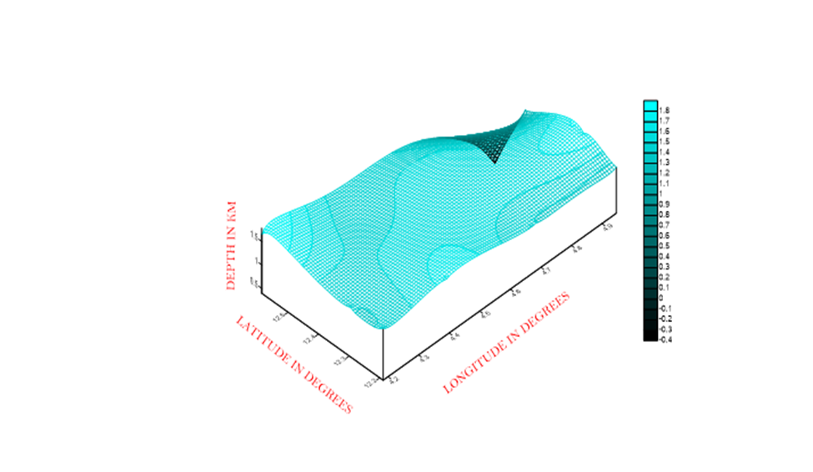

Fig 4; Surface plot map of first magnetic layer of the study area.
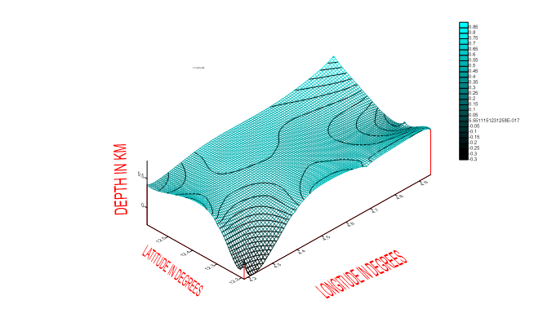

Fig. 5; Surface plot map of second magnetic layer of the study area.
4.0 Conclusion
The spectral analysis carried out on the data obtained over Birnin-Kebbi and Tawabuwel/Fokku shows two major magnetic horizon under the area; the deeper source are represented by low frequency segments of the spectrum, while the shallower magnetic source are represented by the high frequency segment of the spectrum.
The values of H₁ and H₂ obtained above were used to produce the contour maps of the first and second layers spectral depth, fig (2) and fig (3).
The first layers, which are of the shallower magnitude sources brought out by the above analysis, can be attributed mostly to lateritic ironstone capping and the effect of surrounding basement magnetic rocks (Kogbe, 1981).
The second layers which are the deepest sources may be attributed to magnetic rocks intrude unto the basement surface. Another probable origin of the magnetic anomalies contributing to this layer is lateral variations in basement susceptibilities features like fault and fractures.
In either case, we can reasonably deduce that the H₂ values obtained from the above spectral analysis represents the average depth of the basement complex in the section considered.
These values of H₂ were used to obtain approximate contour map of the basement surface in the basin fig. (3). Since the spectral depth evaluated represents the average depth at the center of the section considered, we can determine the longitude and latitude values from the center of each of the twelve sections from which, surface plot of the approximate basement complex in the area were generated.
Therefore from our result our highest value of H₂ is 1.651km along longitude 4.947º and latitude 12.486º and our lowest value of H₂ is 1.200km along longitude 4.947º and latitude 12.486º
A generalized depth to magnetic basement map produced from the depth results of the spectral analysis over the study area, reveals a shallow basement surface.
5.0 Recommendations
Base on the findings of this study, we recommend that; further investigations should be carried out in other locations within the Sokoto basin and the country at large.

6.0 References
Adeniyi. J. O. (1985). Ground Total Magnetic Intensity in part of Nupe Basin and the Adjacent Basement Complex, Niger State Nigeria, Nigerian Journal of Applied Sciences, 3:67-78
Affleck, J. (1963). Magnetic Anommaly Trend and Spacing Patterns. Geophysics, 28 (3):
Ajakaiye, D.E, Hall, D. H and Millar T.W. (1980). Interpolation of aeromagnetic data across the central crystalline shield area of Nigeria Geophysicist J.r. Astrsoc 83, P. 503-517
379-395
Ajakaiye, D.E. Hall, Ashiekaa, J.A. and Udensi, E.E (1991). Magnetic Anomalies in The Nigeria Continental Mass based on Aeromagnetic Surveys. Tectno physics, 192:211-230
Ananaba, S.E Ajakaiye, D.E (1987). Evidence of Tectonic control of Mineralization Nigeria from Lineament density analysis. A Land sat Study Int. J. Remote Sensing 8, 10: 1445-1453
Ball, M. (1974). Spectral Analysis in Geophysics, Elsevier Publishing Co, Amsterdam, 563pp.
Buser, Hugo. (1966). Paleostructures of Nigeria and adjacent countries. Scheizerbart sche Verlagsbuchandlung, Stuttgart (1966).
Dobrin, M.B. (1976). Introduction to Geophysical prospecting McGraw-Hill. New York, 630pp.
Grant, N.K. (1978). Structural Distinction between a Metasediemntary Cover and the Underlying Basement in 600 Myrs old Pan-African Domain of Northern Nigeria. Geo.Soc. Amer. Bull., 89:50-58
Hahn, A,. Kind. E.G., and Mishra, D.C. (1076). Depth estimation of Magentic Sources by eans of Flourier amplitude spectra. Geophysicall Prsp. 24:278-308
Hatman, R. R. Jesky, D. J. and Freidberg, J.L. (1971). A system of rapid digital aeromagnetic interpretation Geophysics 36(5):891-918.
https://link.springer.com/chapter/10.1007/978-3-540-92685-6_7
Jain, S. (1976). An atomatc method of direct interpretation of magnetic profiles. Geophysics 41(3):531-541.
Japanease International Cooperation Agency (JICA): the study of groundwater development in Sokoto state of Nigeria: Progress Report Vol. 3,4 and 5.
Kogbe, A.C. (1979). Geology of the Southe Eastern (Sokoto) sector of the Iullemmenden Basin, Bulletin, Department of Geology. A.B.U Zaria, Nigeria 420pp.
Kogbe, A.C. (1981). Cretaceous and Tertiary of the lullemmenden Basin in Nigeria (West Africa). Cretaceous Research, 2: 129-189
McCurry, P. (1976). The Geology of the Precambrian to Lower Paleozic Rocks of Northern Nigeria – A Review. In Kogbe, C. A. (editor). Geology of Nigeria. Elizabethan, Public. Co, Lagos. Pp15-40
Misha, D. C., and Naidu, P. S. (1974). Two-dimensional power Spectral analysis of aeromagnetic fields. Geophysics. Prosp, 22:345-353
Naidu, P. S. (1970). Statistical Structure of aeromagnetic fields. Geophysics 35 (2): 279-292
Neev, D., Hall and Saul, J. M. (1982). The Pelusium Magashear System across Africa and Associated Lineament Swarms. Journal of Geophysical Research, 87(B2): 1015-1030
Negi, J. G., Agrawai, P. K. and Rao, K.N.N. (1983). Three Dimensional Model of the Koyna Area of Maharashtra State (Indian) based on the Spectral Analysis of Aeromagnetic Data. Geophysics, 48:964-974.
Ojo, S. B., and R. Kangkolo. (1991). Shortcomings in the determination of regional fields by polynomial fittings: A simple solution. Journal of Applied Geophysics, 36:205-212
Oppenheim, A. V., and Schafer, R. W. (1975). Digital Signal Processing. Prentice Hall International, Inc., N. J.
Oluyide, P. O. (1988). Structural trends in Nigeria Basement Complex. In Oluyide P. O. (Ed.) Precambrian Geology of Nigeria – Geological Survey of Nigeria Kaduna.
Pal. P. C., Khuran, K.K. and Unikdrishman, P. (1978). Two examples of spectral approach to source depth estimation is gravity and magnetic page 177:772-783
Spector, A., and Grant, F. S, (1990). Statistical models for interpreting aeromagnetic data. Geophysics 35:293-302
Telford, W.M.N., Geldart, L. P., Sheriff, R. E. and Keys, O. A. (1976): Applied Geophysics Cambridge University Press. Cambridge 860pp.
Udensi, E.E., (2001). Interpretation of the total magnetic field over the Nupe Basin in West central Nigeria using aeromagnetic data. Ph.D Thesis ABU, Zaria, Nigeria.

