Journal of Inclusive cities and Built environment. Vol. 3 Issue 5,

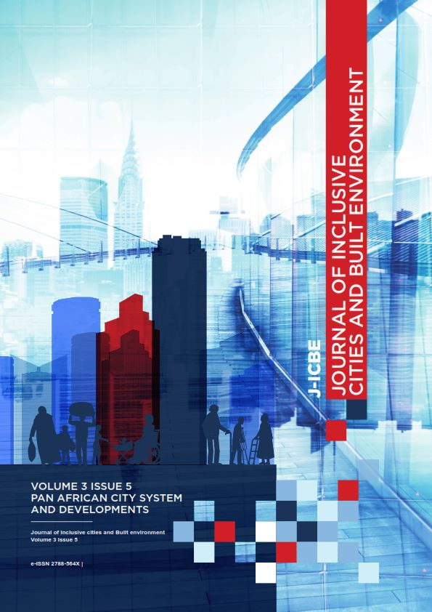

Published by the University of KwaZulu-Natal https://journals.ukzn.ac.za/index.php/JICBE
© Creative Commons With Attribution (CC-BY)
Journal of Inclusive cities and Built environment. Vol. 3 Issue 5

J-ICBE
JOURNAL OF INCLUSIVE CITIES AND BUILT ENVIRONMENT

5TH ISSUE VOLUME 3 ON PAN AFRICAN CITY SYSTEM AND DEVELOPMENTS

Volume 3 Issue 5
Published 6 July 2023

TABLE OF CONTENTS

1. | EDITORIAL: PAN AFRICAN CITY SYSTEM AND DEVELOPMENTS | III
2. | ACCESS TO ELECTRICITY IN SULEJA LOCAL GOVERNMENT AREA OF NIGER STATE, NIGERIA | 1
3. | A SOCIAL INNOVATION APPROACH TO URBAN DEVELOPMENT IN THE UNITED STATES | 17
4. | UNLOCKING THE VALUE OF WASTE: A CASE STUDY OF MINNA METROPOLIST | 27
5. | ASSESSMENT OF THE ALMAJIRI’S TSANGAYA HOUSES IN THE URBAN CENTRES OF NORTHERN NIGERIA. | 39
6. | APPRAISAL AND DESIGN OF LANDSCAPE ELEMENTS IN THE FEDERAL COLLEGE OF EDUCATION KONTAGORA, NIGERIA | 49
7. | GIS-BASED APPROACH TO SMALL HYDROPOWER POTENTIAL ASSESSMENT ALONG RIVER OGUN, NIGERIA | 65
8. | LIVELIHOOD DIVERSIFICATION AND HOUSEHOLDS’ VULNERABILITY TO CLIMATE CHANGE IN INLAND TOWNS IN MOPANI DISTRICT, SOUTH AFRICA | 75
9. | URBAN INFORMALITY AND PLANNING: COUNTING THE COST OF NON-PARTICIPATORY PLANNING IN MASVINGO CITY, ZIMBABWE | 89

Published by the University of KwaZulu-Natal https://journals.ukzn.ac.za/index.php/JICBE
© Creative Commons With Attribution (CC-BY)
Journal of Inclusive cities and Built environment. Vol. 3 Issue 5

How to cite: H.H Magidimisha-Chipungu. 2023. Editorial. Journal of Inclusive cities and Built environment. Vol. 3 Issue 5, Pg iii-vi.

EDITORIAL: PAN AFRICAN CITY SYSTEM AND DEVELOPMENTS

By H.H. Magidimisha-Chipungu

Published 6 July 2023

INTRODUCTION

The Pan African city on the continent and its diaspora can be envisioned as the engine of cultural, social, economic vibrancy and growth. Quite a lot has been written, idealized, researched, and memorialized about the Pan African city on the continent and the diaspora; yet there is still more to learn and understand about the dynamics that drive it. Transforming from being a mere “colonial seat” to an “economic hub” whose activities have attracted other diverse activities, the Pan African city posits itself as a platform for spatial, social, and economic change. Its growth over the years has transformed physical space and attracted people from different walks of life who seek to live a fulfilled life. Hence the Pan African city emerges as a dynamic centre whose depth of opportunities is fully comprehended amid perpetuating misery. The colonial divide which symbolized the city yesterday still manifests itself today in yet other dimensions amid the continual search for a better tomorrow. It is indeed no secret that amid its growth, the Pan African City has had its fair share of challenges – hence a better tomorrow can only be achieved by analysing and understanding the past and the present. From this perspective, this Symposium seeks to unravel the dynamic forces of the Pan African City at work to contribute towards lasting solutions.

This special issue focuses on housing and the city system in Africa with respect to the various challenges therein. The issue is a fallout of the Pan African housing conference held by the Africa-America Collaborative a network of academics and industry players in the built environment held between June 27 to 30 2022 at the University of KwaZulu Natal. Articles which made the special issues where peer-reviewed with the consent of the presenters and the accepted articles are herein published as a special journal issue in the Volume 3 issue number 5 of Journal of Inclusive Cities and Built Environment (JICBE).

The special issue has in it 8 accepted articles from authors both within and outside Africa, dwelling on subjects ranging from housing, energy, waste management, poverty and deprivation, social innovation approaches amongst others. This editorial briefly touches on the contents of each of the papers. Adeleye et al. looked at the duration, legality, and reliability of electricity supply which constitute one of the biggest challenges that residents of Suleja LGA confronts. These electricity access indicators manifest themselves in limited hours of electricity supply, estimated billing, and abrupt interruption of electricity daily. The electricity challenges encountered threaten the actualisation of the Sustainable Development Goal 7 across the LGA. This study assesses access to grid electricity in Suleja LGA. In carrying out this assessment, the indicators of grid electricity access by employing the multi-tier energy framework

to measure access to grid electricity and the performance of SDG 7 in Suleja LGA was examined. Using data collected from 149 households in Suleja LGA, household socio-economic characteristics were used to evaluate the household determinant of electricity access. The study reveals that acute duration and reliability of electricity access were recorded in Suleja LGA with indexes of 0.26 and 0.17, respectively. Aggregate grid electricity access of 0.61, which implies fair electricity access, was also recorded in Suleja LGA. The study further shows that the income of the household head is the only significant predictor (<.001) of the level of grid electricity access, while other factors do not significantly influence the level of grid electricity access 9 > 0.05. This study thus recommends improving the duration and reliability of grid electricity supplied by the Abuja Electricity Distribution Company (AEDC). The study further recommends that the good indexes recorded for affordability, health/safety, and quality of electricity supply should be sustained by the AEDC.

The second paper on the issue by Gourrier was an assessment the City of Baltimore, Maryland, which is a major metropolitan city that has had its well-publicized challenges both economically and with its highly segregated housing stock. However, after decades of disinvestment, discrimination, and neglect, one community in West Baltimore is beginning to take control of its neighbourhood and forging ahead with sustainable and community-centric development. The purpose of the study is to analyse the socially innovative approach of urban development in West Baltimore in contrast to traditional development mechanisms used in the United States. The research is an empirical case study focusing on the Upton Community of West Baltimore and its multi-sector approach to development. The research results illustrate how the multi-sector community-led collaboration has created a sustainable economic activity that centres the community and approaches urban development without displacing its legacy residents.

Ummulkhair and Emigilati evaluated the effective management of waste which is now a national priority. Recycling of waste encompasses a method of classification, sorting, levelling, lessening and reuse of waste products. In Minna, toxic and non-toxic wastes are not collected separately by waste management agencies but are deposited in the same dumpsite or in sanitary landfills, usually close to communities and available to scavengers, creating challenges to human health. Recycling is still at an elementary level in Minna due to lack of requisite data on accumulated waste, unavailability of facilities to transform waste to useful products, lack of proper environmental awareness and inability of the government to promote waste recycling by drafting policies and offering support to private waste management companies. Therefore, the goal of this study is to identify various types of recyclable solid waste generated in Minna, their sources and destinations, and potentials for wealth creation and a sustainable environment. Field survey, Questionnaires administered to scavengers, and interviews with waste dealers and fabricators revealed various types, sources, destinations, and potentials of recyclable solid waste. Data acquired was analysed using Descriptive statistics. Scavengers acquire various types of recyclable solid wastes from different sources. These wastes are collected and sold to waste dealers within Minna, who sell to recycling companies outside the metropolis, due to lack of government policies or interventions and necessary facilities for recycling. Solid waste recycling has the potential to provide financial stability, income, and job opportunities for the residents, while still reducing the volume of waste in circulation and conserving the environment of Minna metropolis. Proper environmental awareness and Government intervention to promote waste recycling by drafting policies and offering support to private waste management companies will improve the level of recycling practices within Minna.

Another paper by Muhammad et al., considers the fact that several empirical studies have assessed housing in different perspective, but few have examined the Alma Jiri’s tsangayas houses in urban northern Nigeria. Note that many Alma jiris have lost their lives through street violence, ritual killing, kidnapping, disease, and hunger. The study asses the tsangaya houses in northern Nigeria vis-a-viz: scarcity of sleeping rooms, sleeping materials, number of pupils per room, numbers of pupils sleeping on veranda, numbers in an incomplete building or any other vacant places, water and sanitary facilities, condition of building components; windows, roof, doors, and floors with the view of its negative influence on the pupils. Eighty-nine (89) Almajiri tsangaya across Northern Nigeria visited to elicit information on the Almajiri tsangaya houses using structured questionnaires. Standard deviation and percentage distribution used to analyse the data. The Findings reveals among others that; there are serious scarcity of sleeping rooms, poor sleeping materials, high number of pupils per room, many sleep on veranda, incomplete buildings, or any other vacant places, they have poor water and sanitary facilities, poor condition of building components such as windows, roof, doors, and floors having negative influence on the pupils. The study recommended regular and

effective supervision and monitoring of Almajiri tsangaya system of education by every state authority and provision of social amenities like accommodation, water and electricity by wealthy individual and government. To ensure good and habitable living environment that will be conducive for living and leaning as recommended.

Idowu et al in their paper examined campus landscape design, planning, and management have to do with the arrangement of both the natural and artificial features on land for resource conservation for practicable, healthy, and pleasurable functions. The culture of efficient campus landscaping, exhibited in developing countries like Nigeria is not the same with that of the higher institutions of learning in the developed countries. This study aimed at examining the condition of the landscape elements of the Federal College of Education Kontagora, Niger State, with the view to developing a culturally integrated design proposal that would be aesthetically and functionally pleasing to users. Both primary and secondary data were employed in the study. The data required for this study included satellite imageries of the campus, the topographical map of the institution, and information on the existing hard and soft landscape elements and data on users’ perception. The data were analysed using descriptive approach, while JASP
0.9.2.0 descriptive software, ArcGIS 10.2, AutoCAD 2018, terra incognita, Global mapper, Sketch Up 2018, Lumion
8.0 were used to prepare the landscape design proposals for the institution. The study shows that there was evidence of present of both hard and soft landscape elements restricted to the clinic area alone, while departmental areas, staff quarters, hostel, the school library are left with little or no functional and aesthetically pleasing landscape. With respect to the condition of the hard landscape elements of the FCE, Kontagora, investigation revealed that the paved path (82.8%), road (66.7%), drainage (85.9%), waste bin (98%), parking area (90.8%) and water fountain (100%) were in poor condition, while the seat out (75.8%), signage (84.2%), and lighting (69.1%) were in good condition. The results of the condition of the soft landscape elements revealed that both the lawn (95.8%) and hedges (77%) are poor, while the trees (63.3%) in good condition. The prevalent challenges affecting landscape development in an FCE Kontagora range from funding (50%) and the management attitude (20%) to landscaping. In such regard, 83% of users are not satisfied with the condition of existing landscape elements of FCE Kontagora. With the aid of Google Earth map of the area, the topography map and the existing based map were extracted and then used in preparing the design proposal plan for FCE Kontagora campus landscaping.

Another paper by Akande et al. examined electricity access which is one of the challenges faced in Nigeria today; and this problem is more pronounced in the rural communities. Connecting rural communities to the national grid is always a problem due the financial and logistical constraints of extending power through difficult terrain. To meet the energy demands of this deprived vast rural population small hydropower plants are recommended to be built and installed. Small hydropower is a clean renewable and reliable energy alternative that meets the economic and environmental energy policy objectives. Improved technological development in GIS and remote sensing provides alternative methodologies for the assessment of theoretical hydropower potentials. This study provides a methodological pathway towards identifying small hydropower potentials for rural communities along the River Course. Input data for the study include Digital Elevation Model (DEM), precipitation and evaporation collected in raster, and population data. The study identified a total of 57 potential hydropower sites with a maximum energy potential of 5.80 mw site. Ogun River has 75380kW of potential energy distributed along the river course in Ogun State. The estimated energy potential is expected to support about 22,040, 16530, and 11020 households at 100%
75% and 50% performance respectively. The study concludes that small hydropower plants are viable option for reducing the energy deficit of the country and can also help in the attainment of sustainable development goals 7 (universal energy access for all). The study recommends that government must take advantage of emerging GIS and remote sensing technologies to identify, estimate, and develop small hydropower plants for rural electrification while pursing and encouraging energy democratisation and decentralization.

Yussuf et al. considered climate change as an undoubted reality with complex interactions and increasing human socioeconomic (Livelihood) consequences. This study investigates the nexus between Households Vulnerability Index (HVI) and Livelihood Diversifications Index (LDI) in non-coastal Mopani towns, South Africa. A scientifically guided sample (size) of 500 from estimated population of 34,790 was drawn, using random sampling procedure, while monthly climatic data were extracted from gridded high-resolution satellite datasets for the period 1957-2017. The trends in temperature and rainfall are determined using Trend Analysis. United Nations Habitat’s HVI and Herfindahl– Hirschman LDI are employed for the analysis of household’s HVI and LDI accordingly. The study reveals increasing

temperature and declining rainfall overtime in the study area. While about a quarter of the sampled households are job seekers, 51% have multiple income sources. High HVI was recorded across the district. Meanwhile a point increase in LDI, reduces HVI by 3.092, 9.238, and 1.290 points in Tzaneen, Modjadjiskloof and Giyani towns respectively. The paper recommends livelihood diversification strategy, particularly into non-climate-fed activities, while emphasising private sector-driven youth entrepreneurship programme.

Finally, Chigwenya in his paper noted that urban informality has been marginalised in development of cities of global South and this has been responsible for the widespread environmental problems in areas occupied by the urban informality. People in the informal sector in Masvingo city are suffering a lot of exclusion which is environmental injustice and disenfranchisement of their right to the city. The research examined the environmental problems associated with exclusion of urban informality in the city of Masvingo. The research employed a mixed methods approach to the inquiry where both quantitative and qualitative methods were employed. The research found out that the informal sector in the city of Masvingo is excluded in the development of the city hence spaces occupied by them are not included in the city’s environmental planning and management systems. They are not provided with waste collection infrastructure and services. This exclusion is a denial of urban informality’s right to the city. The research recommends activities of the informal sector are included in development of the city for sustainability and inclusivity of the city.

In the final analysis, the Pan African city requires a multi-dimension approach to solving both the housing and the myriad of infrastructure challenges using a multi-throng approach while also considering several global best practices that shapes the global city system towards sustainability and modern realities.

Editor in Chief
Prof. Hangwelani Hope Magidimisha-Chipungu
Email: Magidimishah@ukzn.ac.za
University of KwaZulu-Natal

Published by the University of KwaZulu-Natal https://journals.ukzn.ac.za/index.php/JICBE
© Creative Commons With Attribution (CC-BY)
Journal of Inclusive cities and Built environment. Vol. 3 Issue 5

How to cite: J.M. Yusuf et al., 2023. Livelihood diversification and households’ vulnerability to climate change in inland towns in Mopani District, South Africa . Journal of Inclusive cities and Built environment. Vol. 3 Issue 5, Pg 75-88.

LIVELIHOOD DIVERSIFICATION AND HOUSEHOLDS’ VULNERABILITY TO CLIMATE
CHANGE IN INLAND TOWNS IN MOPANI DISTRICT, SOUTH AFRICA

By J.M Yusuf, P. Bikam, H. Chikoore, W.M Raheem, C.B Ohadugha and A.R. Suleiman

Published 6 July 2023

ABSTRACT

Climate change is already an undoubted reality with complex interactions and increasing human socioeconomic (Livelihood) consequences. This study investigates the nexus between Households Vulnerability Index (HVI) and Livelihood Diversifications Index (LDI) in non-coastal Mopani towns, South Africa. A scientifically-guided sample (size) of 500 from estimated population of 34,790 was drawn, using random sampling procedure, while monthly climatic data were extracted from gridded high-resolution satellite datasets for the period 1957-2017. The trends in temperature and rainfall are determined using Trend Analysis. United Nations Habitat’s HVI and Herfindahl–Hirschman LDI are employed for the analysis of household’s HVI and LDI accordingly. The study reveals increasing temperature and declining rainfall overtime in the study area. While about a quarter of the sampled households are job seekers,
51% have multiple income sources. High HVI was recorded across the District. Meanwhile a point increase in LDI, reduces HVI by 3.092, 9.238, and 1.290 points in Tzaneen, Modjadjiskloof and Giyani towns respectively. The paper recommends livelihood diversification strategy, particularly into non-climate-fed activities, while emphasising private sector-driven youth entrepreneurship programme.

KEY WORDS Livelihood Diversification, Climate Change, Non-climate-fed activities, Vulnerability, Urban Adaptation

Jimoh Musa Yusuf1,2*, Peter Bikam1, Hector Chikoore3, Raheem W.M.3 , Ohadugha C.B.4, Suleiman A.R2.
1 Department of Urban and Regional Planning, University of Venda, Thohoyandou, 0950 Limpopo, South Africa; peter.bikam@univen.ac.za
2 Department of Urban and Regional Planning, University of Ilorin, Ilorin, Nigeria.
3 Unit for Environmental Sciences, North-West University, Vanderbijlpark, South Africa; 32945280@nwu.ac.za
4 Department of Urban and Regional Planning, Federal University of Technology, Minna, Nigeria
*Correspondence Author: jimoh.my@unilorin.edu.ng

1. INTRODUCTION

Livelihood diversification strategies to cope with climate-related challenges are different globally, depending on the type and magnitude of environmental challenges suffered by regions (Sallawu, Tanko, Coker and Sadiq, 2016). For instance, droughts and intermittent floods are recurrent in inner cities of South Africa, while coastal regions are ‘hotspots’ for sea rise mayhems (Nicholls, Polman, Levy, Taylor and Cobley, 2007). Meanwhile, livelihood diversification as a strategy to climatic and non-climatic challenges is becoming prevalent (Brown, Stephens, Ouma, Murithi, and Barrett, 2006; United Nation Development Programme, 2009; Bhatta and Aggarwal, 2016; Teweldemedhin and Kapimbi, 2012). Scholars like Hailu and Hassen, (2012); Gebru and Beyene, (2012) emphasising that the larger the diversification portfolio, the more flexible to shift between coping options to climate-related adversities, essentially diversifying to non-climate fed activities (Piya, Maharjan and Joshi, 2011; Apata, Apata, Igbalajobi and Awoniyi, 2010).

No doubt, the nature of household vulnerability to climate change is dynamic and critical, so also is the capability to adapt, but both may largely be influenced by livelihood diversification (Hailu and Hassen, 2012). This justifies the need to examine (if it exist) the influence of households’ livelihood diversification on the variations in household vulnerability to climate change in the Mopani District and across the six towns. This is intended to strengthen the understanding of the potentials or otherwise of livelihood diversification as a strategy to tackling the susceptibility occasioned by the incidences of climate change in urban centres.
2. STUDY CONTEXT

Environment being a major prerequisite for human existence and survival, (Intergovernmental Panel on Climate Change, 2012) has been altered by human actions. It has been destabilised by human-induced activities and compromising the safety as well as security of the environment. Consequently, it’s affecting the health and well-being, economic prosperity and threatening human survival. This is worsened by the resultant effects of the alteration and the changing climate (McElroy, 2012).

The impacts of climate change are now obvious on human activities and livelihood with the potentials of exceeding mere variations in temperature and precipitation (IPCC 2014), particularly in developing economies, including Africa, resulting from their peculiarities. Reported evidences of rivers drying up, increasing desertification, reduction in the intensities and occurrences of rainfall, heightened temperatures, sanitation challenges, coupled with shortage of basic services, increasing climate-related hazards and limited resilience and adaptive capacities of towns and their inhabitants have been the true situations in Southern Africa (Wilbanks and Kates, 1999; Adelekan and Gbadegesin, 2004; Basher and Brice, 2005; Archer and Tadross, 2009; World Bank, 2010). South Africa may likely, under the business-as-usual scenario continue to be faced with the challenges of the phenomenon even becoming increasingly severe. This may explain why Mopani district alongside twenty other Municipalities were declared disaster zones in South Africa with respect to climate change in 2016. The zones were characterised by extreme weather events (floods, drought, heat waves), the spread of climate-sensitive diseases (malaria, diarrhoea etc) (Congedo and Macchi,
2015; Manderson, Kubayi. and Drimie,
2016; Mopani District Municipality Integrated Development Plan, 2016; Mopani District Disaster Management Report, 2017). These are leading the
population of the District to becoming sensitive to the extreme climate events, with increasing risks to health and livelihood, compounded by high rates of poverty and unemployment, high rates of dependency and inadequate access to resources and basic services (Christensen and Christensen, 2007 and UNDP 1999; Nkondze, Masuku, and Manyatsi, 2013).

In the South African context, climate change adaptation strategic policy is lacking, institutional arrangements are weak, overlapping and conflicting, couple with the shortfall in skills and equipment to monitor and mitigate disaster and promote adaptation in the Mopani District Municipality. These have influenced the plummeting of households’ adaptive capacity in the district and have equally frustrated attempts at appropriate interventions to enhance adaptation to climate change disasters in Mopani towns (McKinney and Schoch, 1998; Okunmadewa, 2000; Mopani District Municipality Integrated Development Plan (MDMIDP), 2016).

Meanwhile, a knowledge gap exists in the spatial planning system regarding climate change vulnerability and adaptation while they have ironically received attention and appreciation in research, programs, and projects, as a rural phenomenon. However, the current planning practices, particularly in Mopani District (like most other African municipalities) do not have the prerequisite understanding of some underlying factors of climate change vulnerability and adaptation with respect to socioeconomic components (particularly livelihood diversification) and other relevant influencing indicators of household vulnerability and adaptation strategies (Clark 2009; Jörn Birkmann, Matthias, Frauke Kraas and Nguyen Quang (2010); BNRCC, 2012; MDMIDP,
2016).

Consequently, this study is challenged with these incidental phenomena to:

▪ Unpack the level of households’
vulnerable due to their exposure

BY J.M YUSUF, P. BIKAM, H. CHIKOORE, W.M RAHEEM, C.B OHADUGHA AND A.R. SULEIMAN LIVELIHOOD DIVERSIFICATION AND HOUSEHOLDS’ VULNERABILITY TO CLIMATE CHANGE IN INLAND TOWNS IN MOPANI DISTRICT, SOUTH AFRICA

and sensitivity levels as-well-as their capacity to adapt in Mopani District; and

▪ Evaluate how, in turn, the engagement in stream of economic activities (Livelihood Diversification) has influenced the vulnerability level among households in the District.

To this end, the following questions are germane, (a) can it be said that households are vulnerable to climate change in Mopani District and to what extent, (b) can it be said that LDI has any influence on HVI levels across the selected towns and the District? These questions brought about the following hypotheses to be tested:

▪ No significant difference in the variation of household vulnerability across towns.

▪ No significant relationship between LDI and HVI across the towns and the District.

Literature show that most studies so far conducted on livelihood diversification, vulnerability and adaptation to climate change, have focused significantly on rural farmers (Sallawu et al., 2016; Yamba et al., 2017), while those on urban area, focussed largely on big and were coastal cities (Bigio, 2009; Hallegatte, 2012; Nhuan, Tue, Hue, Quy, and Lieu, 2016). However, there is no empirical analysis on the association between livelihood attributes of households and their vulnerability levels to climate change in urban sector of Mopani District, as at the time of this report. The study thus seeks the examination of the HVI and its nexus with LDI in some selected noncoastal, six small and medium-sized towns of Mopani District. The findings will serve as a basis for appropriating urban adaptation policies, particularly for highly vulnerable groups in Giyani, Hoedspruit, Modjadjiskloof, Nkowankowa, Tzaneen, and Phalaborwa in the district. It is on this context that the aim and objectives of the study are expressed as follow:
2.1. Aim of the Study:

The study seeks to examine the level of household vulnerability to climate-related impacts and its nexus with livelihood diversification as an adaptive strategy among households in six towns (Giyani, Hoedspruit, ModjadjisKloof, Nkowankowa, Phalaborwa, and Tzaneen) in the Mopani District, with the view to suggesting practicable and sustainable strategies of strengthening the adaptive capability of households and resilience in the towns.

2.2. Objectives are to:

▪ Examine the trends of climatic parameters (rainfall and temperature) in the
Mopani District during 1958-2017;

▪ Assess the level of households’ vulnerability in the selected towns; and

▪ Analyse the influence of livelihood diversification on household vulnerability
level in the selected towns of the District.

2.3. Study Area

Mopani District Municipality is a Category C Municipality, located on global view, between the Longitudes: 29° 52´E to 31ْ° 52´E and Latitudes: 23° 0´S to 24ْ° 38´S, with 31ْ° E as the central meridian. The district is bordered in the east by Mozambique and Vhembe District Municipality in the north (figures 1). To the south are Thulamela and Makhado Municipalities, and, to the west, by Capricorn District Municipality. The district spans a total area of 2 001 100 ha (20 011 km²) (Mopani District Municipality,
2016).

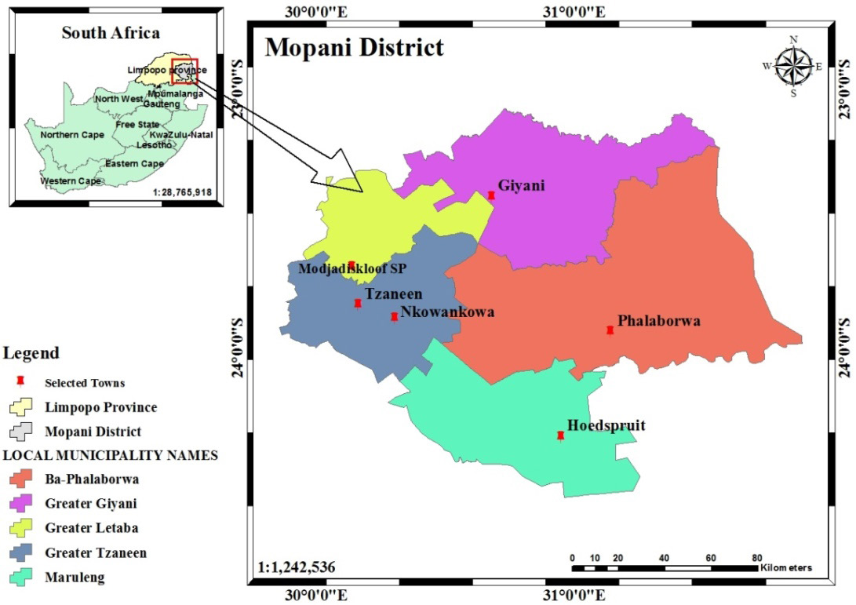
Figure 1: Mopani District showing the Local Municipalities and the selected towns with in the context of Limpopo Province and South Africa (Source: Adopted from Jimoh et al, 2020)

It has five local municipalities: Ba-Phalaborwa, Greater Giyani, Greater Letaba, Greater Tzaneen and Maruleng with the District seat at Giyani town. Mopani is situated at the Summer rainfall zone, having mean maximum and minimum temperatures respectively in the range of 28-38°C (mean of ~33°C), and 16-22°C (mean of ~19°C). The increasing climate related challenges in the district, prompted its declaration among twenty others as climate change disaster zones in 2016. Having to embattle with extreme events of floods, drought, heat waves, and the spread of

Journal of Inclusive cities and Built environment. Vol. 3 Issue 5, Pg 75-88.

climate-sensitive diseases (Mopani District Municipality Integrated Development Plan, 2016; Limpopo Provincial Government, Environmental Implementation Plan, 2016; Congedo and Macchi, 2015), with increasing risk to lives and livelihood (Olsson et al., 2014). This study emphasized on Tzaneen, Nkowankowa, Hoedspruit, Modjadjiskloof, Phalaborwa and Giyani towns as purposively selected.

3. METHODOLOGY

3.1. Types and sources of data

The study used population data from Statistics South Africa (StatSA) and Community Survey. Both monthly and annual meteorological parameters (rainfall and temperature) data were gathered from high-resolution monthly CRU data of the University of East Anglia data, 0.5° x 0.5° latitude/longitude grid cells from a global climatic data set. The data was based on a grid from latitudes
24.4°S to 23.3°S and 30.0°E and 31.1°E between 1958 and 2017 (temperature) and 1958-2016 (rainfall). Several studies like Mitchel and Jones (2005); Harris et al., (2014) justify the use of this data set.
3.2. The Study Population and Sample Size

The population figures and the household numbers of the selected towns as they were gathered from StatSA (2011) and community Survey (2016) were projected to the year 2017 at both Local Municipal annual growth rates, where township rates were not available. The six towns had about 114,632 (One Hundred and Fourteen Thousand, Six Hundred and Thirty-two) inhabitants totalling about 34,790 (Thirty four Thousand Seven Hundred and Ninety) households, with Nkowankowa having the greatest share (12,650 households) and ModjadjisKloof having the lowest share of about 661 households. Table 1 shows the population size of each of the selected towns upon which the number of sampled households was estimated.

Table 1: Population Figures and households’ number in the selected towns

2011 Average Annual 2017
Selected population Household Growth Population Household
Towns Figure Size Rate % (projected) Number
Phalaborwa | 13 108 | 3.1 | 2.61 | 15 298 | 5 861
Modjadjis  Kloof | 1 815 | 2.7 | *-0.29 | 1 785 | 661
Hoedspruit | 3 157 | 2.8 | * 1.08 | 3 368 | 1 202
Giyani | 25 954 | 3.1 | 1.08 | 27 660 | 8 922
Tzaneen | 14 571 | 2.9 | 1.5 | 15, 933 | 5 494
Nkowankowa | 48 255 | 4.0 | 2.4 | 50 599 | 12 650
Total |  |  |  | 114 643 | 34 790

Source: StatsSA (2011) and Community Survey 2016;

*Local Municipal population growth rate (2001 - 2011)

The procedure for the estimation of sampled population was statistically guided to determine the sample size adopted. That is shown as follows:

z2pq

Meanwhile, processed and published
n = d2
(1)

information were sourced from relevant media and responsible agencies and institutions of government and libraries. For instance, background information on the study area with respect to the topic (incidences of climate-related characteristics) was sourced from Local and District Municipalities and provincial and national governments. These were specifically gathered from Integrated Development Plans, Spatial Planning and Land Use Management Act, (SPLUMA), etc. Other information were harvested from published journals, conference proceedings, texts, and periodicals such as the International Journal of Agricultural Science, Research and Technology, Journal of Agricultural and Resource Economics, International Journal of Climatology, Journal of Agricultural Extension, Economics & Sociology, etc.
Z= the standard normal deviation at 2.0; P= 50% i.e. 0.50; q= 1.0 P; d= the degree of accuracy is set at 0.05

With an anticipated response rate of 80%, the actual sample size n=500 were arrived at using:

n
n = 0.8 (2)
s
Table 2: Sampled households from the selected towns in Mopani District

Towns | Average hhold size | Number of households | % | Required sample size | Sampled households
Phalaborwa | 3,1 | 5 861 | 16,85 | 67,4 | 84
Modjadjis  Kloof | 2,7 | 661 | 1,90 | 7,6 | 9,5
Hoedspruit | 2,8 | 1 202 | 3,46 | 13,8 | 17
Giyani | 3,1 | 8 922 | 25,65 | 102,6 | 128
Tzaneen | 2,9 | 5 494 | 15,79 | 63,1 | 79
Nkowankowa | 4.0 | 12,650 | 36.36 | 145,4 | 181.8
Total |  | 34 790 | 100 | 400 | 500

Source: Census StatsSA (2011) as projected to 2017

78

BY J.M YUSUF, P. BIKAM, H. CHIKOORE, W.M RAHEEM, C.B OHADUGHA AND A.R. SULEIMAN LIVELIHOOD DIVERSIFICATION AND HOUSEHOLDS’ VULNERABILITY TO CLIMATE CHANGE IN INLAND TOWNS IN MOPANI DISTRICT, SOUTH AFRICA

Table 2 indicates the various sample sizes for respective towns estimated from the average household size and, the number of households. The percentage covered by each town over the total (six) selected communities gives the estimates for the proportion share and the number of sampled households in each town over the entire sampled households.

3.3. The respondents to the sample questionnaire and procedure

This choice of the sampled respondents was guided by the peculiarity of this study. Head of household constituted the main focus, regardless of their peculiarities (sex, age, social status and disability). Nevertheless, in absence of head of household, any designated or eldest adult (available) member of the household that resides with the family on a permanent basis was interviewed.

Primary data were collected using structured questionnaire and interview and was analyzed using descriptive statistics such as means and frequency. The study adopted the (UN-Habitat,
2011) expression to measure Household
Vulnerability Index, as symbolised as:

Vulnerability = Exposure + Sensitivity – Adaptive Capacity

V = E + S – AC (3)

HVI For the population N made up of n
full impact. The calculated value of the weights describes the contribution of each indicator to the value of the index.

The sum of the weighted vulnerabilities across all dimensions gives the particular household’s total vulnerability Vhhi:

= ∑ m m
j=1 Xwj/ ∑ j=1 Xwj= Vhhi (4)

The study estimated the contributions of each of the identified indicators by summing down the dimensions and calculates the dimension’s contribution to vulnerability. For the HVI, the sum of the weights is set to

j=1 wj = 100 (5)
∑ m

Ordered Logit Regression Model an extension of the Binary Logic Model was applied, being a Model that is appropriate for scenarios of study like this with more than two values for the dependent variable (Dragos and Veres, 2007). In this study, the dependent variable has three categories: low, moderate and high vulnerability. The low vulnerability category was used as the reference category.

Thus, to capture the Livelihood Diversification Index, the simplicity of calculation and its requirement of small amount of data justify the flexibility of Herfindahl index of diversification (Kimenju, and Tschirley, 2009), it is symbolised as:
The trend was examined using time series analysis, adopting the parametric t-test to determine whether the slope Coefficient on the fitted simple linear:

Y = a + bx (7)

The slope coefficient sign indicates whether positive or negative trend. The year of record forms the independent variable in the formula (x) while the climate parameters form the dependent variables. Correlation was adopted to determine the strength of relationship that exists between the variations in the parameters and time.

households, i.e. (N = {hh1, hh2, hh3… hhn}, V is a subset of v households that have some degree of vulnerability, having an internal vulnerability. Thus v ≤ n and v=0 implies that there are no vulnerable households, and v=n implies that all households are vulnerable. Principal Component Analysis (PCA) following (Filmer and Pritchett, 2001; Nelson et al, 2010b; Gbetibouo and Ringler,
2009; Cutter, 2003) was employed to analyse selected indicators of exposure, sensitivity, and adaptive capacity separately using Statistical Package for Social Sciences (SPSS). The weighting then varies and ranged from 0 and 1. This was used to construct the respective
index with values 0 = no impact, and 1,
Dk = 1 - ∑ N (S )2 (5)
i=1 i,k

Where Dk is the diversification index; i is the specific livelihood activity; N is the total number of activities being considered; k is the particular household; and Si, k is the share of ith activity to the total household income for kth household

The data for the two climatic cycles were extracted from gridded High- resolution climate dataset from monthly meteorological stations (Harris, Jones, Osborn and Lister, 2014; Mitchell and Jones 2005).

79

Journal of Inclusive cities and Built environment. Vol. 3 Issue 5, Pg 75-88.

4. RESULTS AND DISCUSSION

4.1. Climate change in Mopani District (1958 – 2017)

The result as presented in Figures 2 and 3 illustrate the monthly average of both minimum and maximum temperature between
1958 and 2017. From these figures, the maximum as well as minimum temperature both exhibit an upward trend with correlation
co-

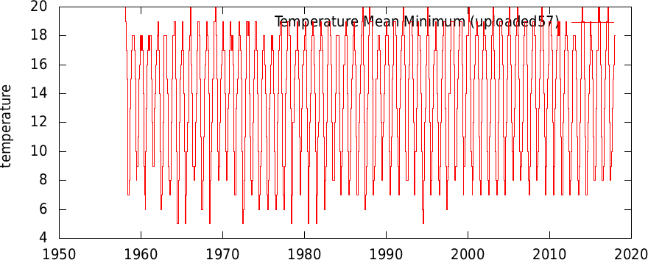
Figure 2: Mean inter-annual variability of temperature (Minimum) over Mopani District (1958-2017)8 (Adopted from
Jimoh et al, 2020)

efficient r = 0.174905504 and R² = 0.0323 (Maximum) and r = 0.60465539 and R² = 0.0028 (Manimum). These imply that
Mopani exhibited warm trend in temperature over the period (1958-2017). This was reflected in both the minimum and maximum
temperature on one hand.

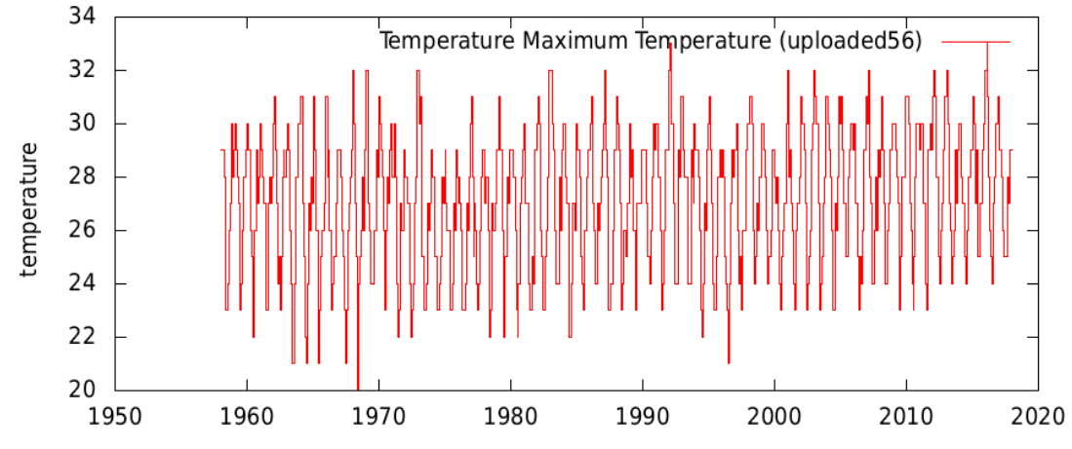
Figure 3: Mean inter-annual variability of temperature (Maximum) over Mopani Distric (1958-2017) (Adopted from Jimoh et al, 2020)

Rainfall on the other hand consistently showed reducing trend during the same period (1958-2017) Figure 4, with r= -0.142894. Analysis of Inter-annual variability across seasons in the district according to Figure 4 indicating high rainfall variability, thus, making it unreliable over the district. The implication of this reducing trend has made rainfall shifted to a later onset (extending the dry fire season) whilst extreme in terms of floods (often due to Cyclones) and droughts (linked to Pacific El Nino) have become more frequent. Notwithstanding the trend, the fluctuation in rainfall has occasioned some extreme events such as floods in the late
1950s, 2000 and 2013 as well as droughts in 2016. The incidence did destroy properties and consequently displayed households
and their livelihood activities

80
BY J.M YUSUF, P. BIKAM, H. CHIKOORE, W.M RAHEEM, C.B OHADUGHA AND A.R. SULEIMAN LIVELIHOOD DIVERSIFICATION AND HOUSEHOLDS’ VULNERABILITY TO CLIMATE CHANGE IN INLAND TOWNS IN MOPANI DISTRICT, SOUTH AFRICA

Figure 4: Mean inter-annual variability of precipitation over Mopani District (1958-2017) (Adopted from Jimoh et al,
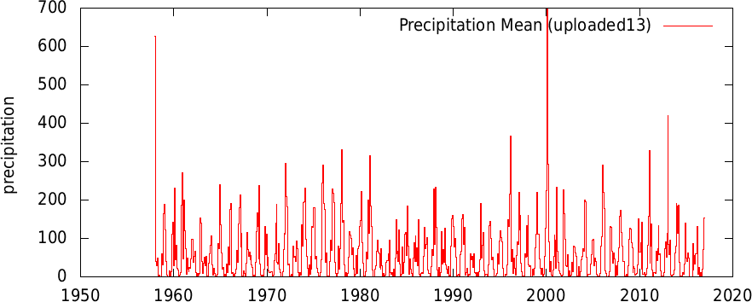
2020)

These incidences have thereby placed the towns in a continuous and more dangerous situation, particularly for children, older adults and women who are the most vulnerable groups (Jimoh 2020). The scenario may not be unconnected with the invasion of vegetation cover by impervious surfaces (building, surface concretization, road asphalt etc) and land bareness. Most times, this is complemented and aggravated by deforestation, induced by wood energy sourcing and lumbering that characterised some of these towns.

Because of the complex nature of the steps involved and the sophistication in the models for estimating the projection, the study adopted the temperature projections from existing studies on Africa from simulations through the global CCAM under the A2 scenario relative to 1961-1990 for 2071-2100 (Francois et al, 2015). The study like others, projected between 4-6°C for Africa, as against the 3°C global projection. The increasing temperature signal is very strong for southern African region with the observed trend indicating an increase of more than 150% the global rate. The projection of rainfall over Africa according to (Francois et al, 2015) depicted a pattern that is characterised with greater uncertainties than that of temperature. The trend in rainfall in Africa is projected to be decreasing, particularly for the region of southern Africa (Christensen and Christensen,
2007). With high poverty level and
weak administrative capacity of the local municipalities to respond with appropriate strategies to climate change (Mopani District Municipality Integrated Development Plan, 2016), Mopani residents may be at high risk.

The study analysed the Households’ participation in various livelihood (economic) activities and their share of income from different sources in the district, to examine the possibility of households distributing climate-prone hazards among the alternative income sources. The result is as summarised in table 3.

4.2. Households’ livelihood and income share

In order to understand the influence of livelihood on household vulnerability, the economic characteristics of the respondents was examined with respect to the households’ income share and participation in stream of economic activities.

On this note the study analysed the Households’ participation in various livelihood (economic) activities and their share of income from different sources in the district, to examine the possibility of households distributing climate change hazards among the alternative income sources. The results as summarised in Table 3 reveals that more than

Table 3. Household income share by occupation and participation in different activities

Participation Income
Activities % % Share % Ranking
No Job Farming Mining Artisans  Self employed Trading/Business Professionals Civil Servants Lumbering  Others  No response | 23.0  6.3  8.1  6.0  18.1  10.1  13.3  11.5  1.4  0.8  1.4 | -  8.27  10.67  8.0  24.0  13.33  17.6  15.2  1.87  1.07  - | -  6.8  8.1  5.6  26.2  14.1  19.5  17.8  1.4  0.5  - | -  6th  5th  7th  1st  4th  2nd  3rd  8th  9th
Total | 100

*No job, and No response can’t be categorized, hence, they were exempted from the
estimation With Chi2=37.221 and p=000

81

Journal of Inclusive cities and Built environment. Vol. 3 Issue 5, Pg 75-88.

One in every five household heads are job seekers, 6.3% and 1.4% of the entire households were engaged in climate-fed economic activity (farming and Lumbering) with 6.8% and 1.4% income share and ranked 6th and 8th respectively. By implication, climate-fed economy, though forms part of, but did not dominate the economic engagement of the households. This further implies potentially reduced impacts of climate adversities on the households’ livelihood and their livelihood engagements. This finding is contrary to that of (Sallawu et al,
2016) in their analysis of “Livelihood and Income Diversification Strategies among Rural Farm Households in Niger State, Nigeria”, where climate-fed economic engagement (farming) constituted the highest income share and ranked first among several, with high potential of susceptibility to climate adversities.

In order to facilitate the determination of LDI, the household participation was estimated by simple division of the frequency (n) of respondents in a particular income generating activity by the total number of respondent that are engaged in other form of activity, then multiply by 100.

The share of income was similarly estimated by the division of the total income that accrued from all the respondents that engaged a particular livelihood activity by the total income from all the working sampled households, and then multiply by 100. Ranking on the other hand, followed the order of participation of the respondents from the highest to the least, following (Sallawu et al, 2016). The results as presented depicts that the majority (93.7%) of household across the district derived their means of livelihood from non-farming activities. Farming has only participation of about 8.27%.

The result further shows that households are also engaged in mining, artisanship, trading and other forms of businesses, as well-as professional engagements, civil service, lumbering and others activities.
However, self-employed and professional categories led in the ranking as well as income share respectively, (51%) are observed to have multiple (streams) of livelihood activities across towns, 37% of Tzaneen was in this category, while Giyani and Modjadjiskloof respectively accounted for 47% and 60%. The case of Hoedspruit indicated no respondent engaged in any other form of economic activities except their primary economic engagements. With Chi2=37.221 and p=000 multiple livelihood activity is statistically significant across the towns in the District. This implies the possibility of distributing hazard that may result from climate change among the alternative income sources. This finding reinforces the discoveries by (Yamba et al,
2017) in their analysis of Smallholder Farmers’ Livelihood Security Options amidst
Climate Variability and Change in Rural Ghana.

4.3. Households’ vulnerability index in Mopani

Having analysed the involvement of households in in various forms of livelihood and their income share by occupation, it is considered very essential, to identify the households vulnerability levels and subsequently address the nexus between them across the district.

The components of vulnerability (exposure, sensitivity and adaptive capacity) were examined. The estimation of HVI to climate change in Mopani District as shown in able 3 was accomplished following (Gbetibouo, and Ringler, 2009) expression of vulnerability, as:

V= E+S – AC, (8)

Where V is Vulnerability; E is Exposure; S is Sensitivity: and AS is Adaptive Capacity

4.3.1. EXPOSURE

Table 3 shows the varying degrees of exposure of household in the towns. The exposure level among households to climate change was generally high. About nine in every ten (91.9%) of household heads in Mopani District were exposed. The cumulative proportion of households that were not exposed across the District was as low as 8.1%. However, the result of exposure level varied across the selected towns in the District. Though, Analysis of Variance (ANOVA) reveals a non-significant variation in exposure, with the F-statistic value

82

BY J.M YUSUF, P. BIKAM, H. CHIKOORE, W.M RAHEEM, C.B OHADUGHA AND A.R. SULEIMAN LIVELIHOOD DIVERSIFICATION AND HOUSEHOLDS’ VULNERABILITY TO CLIMATE CHANGE IN INLAND TOWNS IN MOPANI DISTRICT, SOUTH AFRICA

Table 3: Distribution of vulnerability and its components among household across towns

Variables Tzaneen Nkowa- Hoedspruit Modjadjis- Phalaborwa Giyani Mopani nkowa Kloof
Exposure Not Exposed Just Exposed Exposed Sensitivity  Not Sensitive Just  Sensitive  Very Sensitive Adaptive Capacity Very Much Capable Very Capable Capable  Not Capable  Not Capable at All Vulnerability Lowly Vulnerable  Moderately Vulnerable  Highly Vulnerable | %  5.06  53.17  41.77  82.3  17.7  0  12.7  51  22.8  12.7  1.3  10.13  11.39  78.48 | %  3.42  54.29  42.29  82.9  17.1  0  4.6  38.9  28  28.6  0  12  19.43  68.57 | %  33.33  16.67  50  22.2  38.9  38.9  5.55  33.3  11.1  27.8  11.1  55.56  33.3  11.1 | %  40  0  60  100  0  0  30  30  0  40  0  30  10  60 | %  10.71  32.14  57.14  92.9  6  12  6  37  36  21.4  0  57  22.62  73.81 | %  8.5  55.4  36.1  73.85  21.54  4.62  14.62  22.31  37.69  20.77  4.62  14.62  20.77  62.31 | %  8.1  48.2  43.7  80.2  16.9  2.8  9.1  37.30  30.24  22.4  1.41  13.51  19.36  67.14

*Exposure (X2 = 37.221, p=.000); Sensitivity (X2 = 351.332, p = 0.000); Adaptive Capacity (X² = 663.676 and p = 0.000); HVI with X2 = 2341 and p = 0.002 (Source: Adopted from Jimoh et al, 2021) being 1.48 and the respective p values equal 0.1951 >0.05 across board.

These imply that there was no significant difference in households’ level of exposure across these towns, whereas, in Mopani as a district there was a statistically significant level of exposure, with X2 = 37.22 and p =.000, as summarised in Table 3.

4.3.2. SENSITIVITY

Sensitivity as the second leg of hazards and one of the components of vulnerability was found to be generally low in the district. This is evidenced in the results summarised in Table 3 that four in every five households across the district are not sensitive. Only Hoedspruit has a very considerably proportion of the population that are sensitive with only 22.2% not sensitive, while Phalaborwa has the highest non-sensitive population (92.9%). The findings were substantiated in Table 3 by the results obtained from Chi- square test with X2 = 351.332, df = 190, p = 0.000, <0.05, implying a statistically significant scenario. It means therefore that household sensitivity index is statistically significant across the towns in the district.

4.3.3. ADAPTIVE CAPACITY

Adaptive capacity as estimated using the identified hypothesised variables as indicators including both Personal Possession variables (i.e car and home ownership, air conditioner etc.) and Communities Possession variables (i.e availability of potable water, electricity, waste management outfit etc.). The results as indicated in Table 3, across Mopani was reportedly high with about
76.6% household categorised as capable, while those not capable takes only 23.8%. The results as summarised in Table 3 imply
a statistically significant variation in the adaptive capacity level of households across the six towns with X²=663.676 and p=0.000
<0.05.

83
Journal of Inclusive cities and Built environment. Vol. 3 Issue 5, Pg 75-88.

Plate 1: Unprotected Sewer leakage in Nkowankowa Plate 2: Typical home in Mogkgopa-Modjadjiskloof

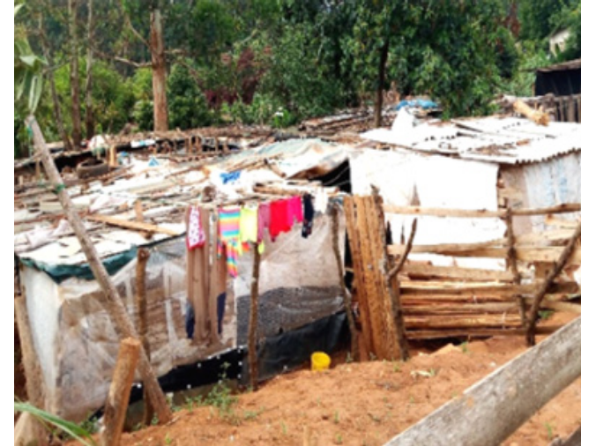
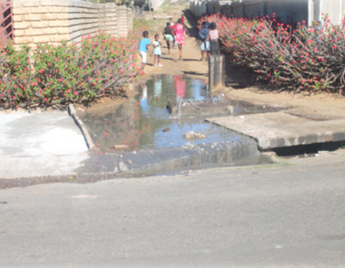

Plate 3: Water way blockage in Tzaneen Plate 4: Waste overflow for lack of drainage in Phalaborwa
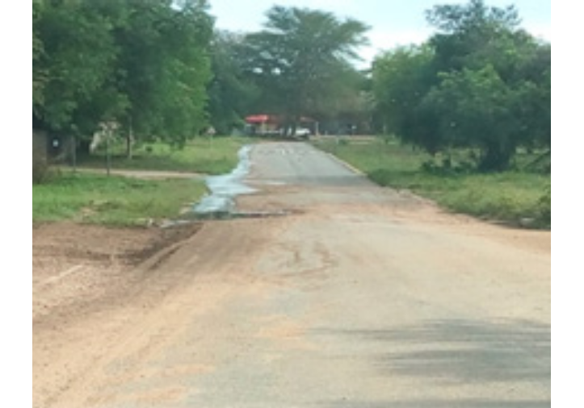
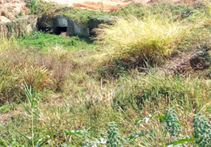

Plate 5: Uncoordinated solid waste disposal in Giyani Plate 6: Threats by erosion-prone topography in
Modjadjiskloof

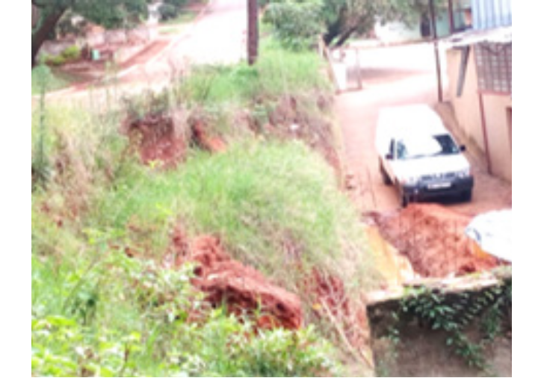
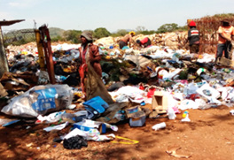

84
BY J.M YUSUF, P. BIKAM, H. CHIKOORE, W.M RAHEEM, C.B OHADUGHA AND A.R. SULEIMAN LIVELIHOOD DIVERSIFICATION AND HOUSEHOLDS’ VULNERABILITY TO CLIMATE CHANGE IN INLAND TOWNS IN MOPANI DISTRICT, SOUTH AFRICA

The level of adaptability may be occasioned by the socioeconomic conditions of the households, which are in most cases complemented by other factors (administrative, physical etc) capable of aggravating the vulnerability through its components. These include but not limited to system failure (Plates
1), poverty rate (with 86% of the District’s households that lived in shacks (plate 2) in 2019 and about 628 941 of 1 150 722 people that lived in poverty the same year, by upper limit line of poverty) (https// www. cogta. gov. za/ddm/wp-cont ent/ uploads/2020/11/Mopani-October-2020. pdf). Attitudinal issues and locational factors were as well captured by the authors during field survey (plates 5 and
6 respectively).

4.4. Aggregate Households’ Vulnerability Index

Table 3 presents the aggregates of vulnerability index across the selected towns, depicting highly vulnerable households in Mopani District with
67.14% on the average. On the spread across towns, Tzaneen (78.48%) was obviously the town that housed the highest proportion of households that are vulnerable, followed by Phalaborwa (73.81%), while Hoedspruit town had the highest proportion of household with low vulnerability in the district. The Chi-Square test results as shown in Table 3 further indicates a statistically significant scenario in HVI with X2 = 2341 and p=0.002, <0.05 across selected town in the district. With this result, the hypothesis that stated no significant variation in the household vulnerability level across towns is rejected.

4.5. The nexus between livelihood diversification and household vulnerability indext

The fundamental question that arises at this juncture occasioned the need to test the earlier stated hypothesis on the nexus between LDI and HVI in the district and selected towns. This hypothesis was tested using Ordered Logit Regression Model. The result of
the analysis is presented in Table 4. The result revealed that in Mopani, a negative relationship exists between LDI and HVI. This implies that as livelihood becomes more diversified, the HVI to climate change declined. The regression results depict that a point increase in LDI reduces HVI by 0.729 point in Mopani as a district. Similar results were obtained for Modjadjiskloof, Tzaneen and Giyani towns. For these three towns, a point increase in LDI reduces HVI by 9.238, 3.092, and 1.29 points respectively. The four models are statistically

Table 4: Regression Results of Livelihood Diversification Index and
Mopani
Giyani
Phalaborwa
Modjadjis
Kloof
vulnerability Index
Tzaneen
Nkowan-
kowa
Hoedspruit

Variables
LDI Observations Pseudo R2  Wald Chi2 | -3.092* (1.679)  79  0.043  3.39* | 0.103 (0.800)  175  -  0.02 | -  -  18  -  - | -9.238*** (2.796)  10  0.242  10.91*** | -0.391 (0.911)  84  -  0.18 | -1.29* (0.768)  130  0.011  2.80* | -0.729* (0.414)  496  0.003  3.10*

Note: Robust standard errors in parentheses; *** p<0.01, significant at 1%; ** p<0.05, significant at 5%; * p<0.1, significant at 10% significant and in good fit, with X2 =
3.10, 3.39, 10.91, and 2.80, with statistically significant relationships between LDI and HVI. The result is contrary to those obtained for Nkowankowa and Phalaborwa, where LDI does not significantly influence HVI. The R2 for all the models are quite low, indicating that livelihood diversification explained only a small variation in household vulnerability.

However, in Modjadjiskloof, the R² of 0.242 indicates that livelihood diversification explains about 24.2% of variations in HVI. Hence, the hypothesis that states no significant relationship between livelihood diversification and Household’s vulnerability Index across the district is hereby rejected.

5. CONCLUSION

Climate is changing. While temperature was on the rise, precipitation was on the decline across the district during 1958–2017 and 1958-2016 respectively. These have brought about dryer, hotter and harsh climatic conditions to the residents of urban Mopani, occasioning droughts and flash floods at various times and intensities with occasional devastating consequences. This is a condition under which the households will have to endure for years to come in a business as usual (do nothing) situation, except conscious and aggressive adaptation strategy (tree planting for instance) is adopted

The HVI to climate change and disasters in Mopani towns is stratified into low, moderate, and high levels. The magnitude varied as a result of a combination of exposure to relatively strong climate change signals and other factors. Several factors were identified to have contributed to this scenario, ranging from physical (terrain and soil nature etc.), to human (socioeconomic and attitudinal), system failure (infrastructure collapse and weak administrative capacity by local municipalities), residents’ duration of stay in the locality and weak livelihood diversification out of others.

85

Journal of Inclusive cities and Built environment. Vol. 3 Issue 5, Pg 75-88.

The paper thus recommends livelihood diversification as sustainable non- coastal, small and medium sized urban adaptation strategy particularly, diversification into activities that are independent of climate (non-climate- fed activities). It further recommends a private sector-driven, but government- facilitated urban entrepreneurship and skills acquisition programs in green-related (sustainable) economic sector, to mitigate climate change as well as create wealth to adapt to it. It also underscores the need for huge investment in this sector through capital market participation in sustainable jobs creation to enhance active economic diversification among the poor population. Urban agriculture (home- grown fruit and vegetable farming) program must be promoted as pastime economic engagement to achieve food security, generates economic returns and reduce urban heat island, while enhancing carbon sinking. Promotion of horticultural business among households can enhance greening of the towns to reduce the effects of exposure occasioned by temperature.

86
BY J.M YUSUF, P. BIKAM, H. CHIKOORE, W.M RAHEEM, C.B OHADUGHA AND A.R. SULEIMAN LIVELIHOOD DIVERSIFICATION AND HOUSEHOLDS’ VULNERABILITY TO CLIMATE CHANGE IN INLAND TOWNS IN MOPANI DISTRICT, SOUTH AFRICA

6. REFERENCES | Cutter, B. 2003. Shirley Social vulnerability to environmental hazards. | Hailu, R. and A. Hassen 2012.  Livelihood diversification among the
Adelekan, I.O. and Gbadegesin, | Social Science Quarterly, South western | agricultural land scarce peasants in
A.S., 2005. Analysis of the public | Social Science Association, 10, pp. | the Central highlands of Ethiopia.
perception of climate change issues in | 1540-6237. | International Journal of Agricultural
an indigenous African city. International  Journal of Environmental Studies, 62(1), | Douglas R.B., Emma S.C., James O.O. | Science, Research and Technology,  2(1): pp. 1-8.
pp.115-124. | and Christopher B.B. (2014). Livelihood  strategies in rural Kenyan highlands. | Hallegatte, S. 2012. A cost effective
Apata, T.G., Apata, O.M., Igbalajobi, | African Journal of Agricultural and | solution to reduce disaster losses
O.A. and Awoniyi, S.M.O., 2010. | Resource Economics (AFJARE), 1(1), | in developing countries: hydro-
Determinants of rural poverty in Nigeria: | 1-35 | meteorological services, early warning,
Evidence from small holder farmers in South-western, Nigeria. Journal of | Dragos, C., and Veres, V. 2007. | and evacuation. The World Bank.
science and technology education research, 1(4), pp.85-91. | Romanian Farmers’ Market-A  Multinomial Logit Model Approach. Zbornik radova Ekonomskog fakulteta | Harris I., P.D. Jones, T.J. Osborn  and D.H. Lister 2014. Updated high- resolution grids of monthly climatic
Archer, E.R. and Tadross, M.A., 2009. | u Rijeci, časopis za ekonomsku teoriju i | observations – the CRU TS3.10
Climate change and desertification in | praksu-Proceedings of Rijeka Faculty of | Datasets. International Journal of
South Africa—science and response. | Economics, Journal of Economics and | Climatology, (34): pp. 623–642.
African Journal of Range & Forage | Business, 25(2), pp. 291-308. | Accessed online 21 March 2019 at
Science, 26(3), pp.127-131. | Filmer, D. and Pritchett, L.H. 2001. | wileyonlinelibrary.com DOI: 10.1002/  joc.3711
Basher, R. and Briceño, S., 2005. | Estimating wealth effects without
Climate and disaster risk reduction | expenditure data—or tears: an | https//www.cogta.gov.za/ddm/wp-
in Africa. Climate change and Africa, | application to educational enrolments in | content/uploads/2020/11/Mopani-
pp.271-284. | states of India. Demography, 38(1), pp. | October-2020.pdf
 | 115-132.
Bigio, A., 2009, June. Adapting to |  | IPCC, 2014: Climate Change 2014:
climate change and preparing for | Francois E., Jimmy A., Mary-Jane B., | Synthesis Report. Contribution of
natural disasters in the coastal cities | Mogesh N., Rebecca G., Marcus T., | Working Groups I, II and III to the
of North Africa. In Urban Research | John M., Jack K., Micha W., Charles | Fifth Assessment Report of the
Symposium, Cities and Climate | I. and Charles G. 2015. Projections | Intergovernmental Panel on Climate
Change: Responding to an Urgent | of rapidly rising surface temperatures | Change [Core Writing Team, R.K.
Agenda, June (pp. 28-30). | over Africa under low mitigation. | Pachauri and L.A. Meyer (eds.)]. IPCC,
 | Environmental Research Letters, 10(8), | Geneva, Switzerland, 151 pp.
Brown, R., C. Stephens, J. Ouma, M. | 085004.
Murithi, C. Barrett 2006. Livelihood |  | Jimoh, M.Y.; Bikam, P.; Chikoore, H.
strategies in the rural Kenyan highlands. | Gbetibouo, G. A., & Ringler, C. 2009. | The influence of Socioeconeomic
African Journal of Agriculture Resource | Mapping South African farming sector | Factors on Households’ Vulnerability
Economics, 1(1), pp. 21-36. | vulnerability to climate change and | to Climate Change Semiarid Towns of
 | variability: A subnational assessment | Mopani, South Africa. Climate 2021
Christensen, J.H. and Christensen, | pp. 2-4. Washington, DC: International | 2021, 9, 13 https://doi.org/doi:10.3390/
O.B., 2007. A summary of the | Food Policy Research Institute | cli9010013
PRUDENCE model projections of | (IFPRI) and Center for Environmental
changes in European climate by the end | Economics and Policy in Africa | Jörn Birkmann, Matthias Garschagen,
of this century. Climatic change, 81(1), | (CEEPA). | Frauke Kraas and Nguyen Quang
pp. 7-30. |  | (2010): Adaptive urban governance:
 | Gebru, G.W. and F. Beyene, 2012. | new challenges for the second
Clark, P., 2009. European cities and | Rural household livelihood strategies | generation of urban adaptation
towns: 400-2000. Oxford University | in drought-prone areas: A case of | strategies to climate change, Integrated
Press on Demand. Jörn et al., 2010; | Gulomekeda District, eastern zone | Research System for Sustainability
 | of Tigray National Regional State, | Science, United Nations University,
Congedo, L. and Macchi, S., 2015. | Ethiopia. Journal of Development and | Springer, available online at https://
The demographic dimension of climate | Agricultural Economics, 4(6), pp. 158- | www.rd.springer.com/content/
change vulnerability: exploring the | 168. | pdf/10.1007%2Fs11625-010-0111-3.pdf
relation between population growth and |  | visited on the 30/6/2017
urban sprawl in Dar es Salaam. Current
Opinion in Environmental Sustainability,
13, pp. 1-10.

87
Journal of Inclusive cities and Built environment. Vol. 3 Issue 5, Pg 75-88.

Kimenju, S.C. and Tschirley, D, 2009. Agriculture and livelihood diversification in Kenyan rural households. Nairobi: Tegemeo Institute of Agricultural Policy and Development. | Nelson, R., Kokic, P., Crimp, S., Martin, P., Meinke, H., Howden, S. M 2010b. The Vulnerability of Australian Rural Communities to Climate Variability and Change: Part II - Integrating Impacts with Adaptive Capacity. Environmental | Samandari, A. M. 2017. Gender- responsive land degradation neutrality. Global Land Outlook working paper. United Nations Convention to  Combat Desertification (UNCCD)  https://knowledge. unccd. int/sites/
Limpopo Provincial Government, | Science and Policy, 13, pp. 18 - 27. | default/files/2018-06/3.% 20Gender-
Environmental Implementation Plan |  | Responsive% 2BLDN A_M
2016-2020, 2nd Eds. second provincial | Nhuan, M.T., Tue, N.T., Hue, N.T.H., | Samandari. pdf.
gazette., Limpopo Department of | Quy, T.D. and Lieu, T.M. 2016. An
Economic Development, environment | indicator-based approach to quantifying | Statistics South Africa, 2016.
and Tourism. | the adaptive capacity of urban | Community Survey, 2016. Statistics
 | households: the case of Da Nang city, | South Africa.
Manderson, A., Kubayi, N. and Drimie, | Central Vietnam. Urban Climate, 15, pp.
S., 2016. The impact of the South | 60-69. | Stats, S.A., 2011. Mid-year population
African drought as experienced by |  | estimates. Statistical release P, 302.
small-holder farmers over the June | Nicholls, A.R., Polman, R., Levy,
2015-February 2016 period in the | A.R., Taylor, J. and Cobley, S. | Teweldemedhin, M.Y. and Y. Kapimbi
Mopani District of Limpopo, South | 2007. Stressors, coping, and coping | 2012. Factors influencing enterprise
Africa. Stellenbosch: Agro-ecology | effectiveness: Gender, type of sport, | diversification as a risk strategy
Awareness Project, South African Food | and skill differences. Journal of sports | management in Namibia: A case
Lab. | sciences, 25(13). | study of communal farmers from the
 |  | Kunene region. International Journal of
McElroy, M.B. and Baker, D.J., 2013. | Nkondze, M.S., Masuku, M.B. and | Agriculture Science, 2(9), pp. 845-853.
Climate extremes: recent trends with | Manyatsi, A., 2013. Factors affecting
implications for national security. Vt. J. | households vulnerability to climate | UNDP Namibia, 1999. Namibia Human
Envtl. L., 15, p.727. | change in Swaziland: a case of | Development Report. UNDP.
McKinsey, G.I., 2011. Big data: The next | Mpolonjeni area development programme (ADP). Journal of | UNDP, 2009. United Nation
frontier for innovation, competition, and productivity. McKinsey Global Institute. | Agricultural Science, 5(10), p.108. | Development Program https://hdr.  undp.org/en/reports/global/hdr2009/ :
 | Okunmadewa, F., 2001. Poverty | accessed on the 9/7/2019
Mitchell T.D, Jones P.D. 2005. An improved method of constructing | reduction in Nigeria: A four-point demand. ‘The House’, University of | UN-Habitat 2011 Cities and climate
a database of monthly climate observations and associated high- | Ibadan. | change: Global report on human  settlements, Earthscan Earthscan Ltd,
resolution grids. International Journal of | Olsson, L., Opondo, M., Tschakert, P., | London, UK
Climatology, 2005, 25: pp. 693–712 | Agrawal, A. and Eriksen, S.E., 2014. Livelihoods and poverty. | Wilbanks, T.J. and Kates, R.W., 1999.
Mopani District Disaster Management |  | Global change in local places: how
Centre Report (2017) Vulnerability | Piya, L., Maharjan, K.L. and Joshi, | scale matters. Climatic change, 43(3),
Assessment of Household to Climate | N.P. 2011. Livelihood strategies of | pp.601-628.
Change (unpublished). | indigenous nationalities in Nepal: a case of Chepangs. 国際協力研究誌, 17(2), | World Bank, 2010. The World Bank
Mopani District Municipality Integrated  Development Plan 2016. South Africa. | pp. 99-113. | Annual Report 2010: Year in Review.  World Bank.
Available at http://www.mopani.gov.za/  documents/idp.php | Sallawu H., L. Tanko, A. A. A. Coker and M. S. Sadiq 2016. Livelihood | Yamba S., Divine O. A., Lawrencia
Mopani District Municipality, avalable | and Income Diversification Strategies  among Rural Farm Households in | P., and Felix A. 2017. Smallholder  Farmers’ Livelihood Security Options
at https://municipalities.co.za/ districts/view/28 /Mopani-District- Municipality#demographic | Niger State, Nigeria, Asian Journal of Agricultural Extension, Economics & Sociology, 11(4): pp. 1-11. | amidst Climate Variability and Change  in Rural Ghana. Hindawi Scientifica,  2017, Article ID 1868290, https://doi. org/10.1155/2017/1868290

88

48

