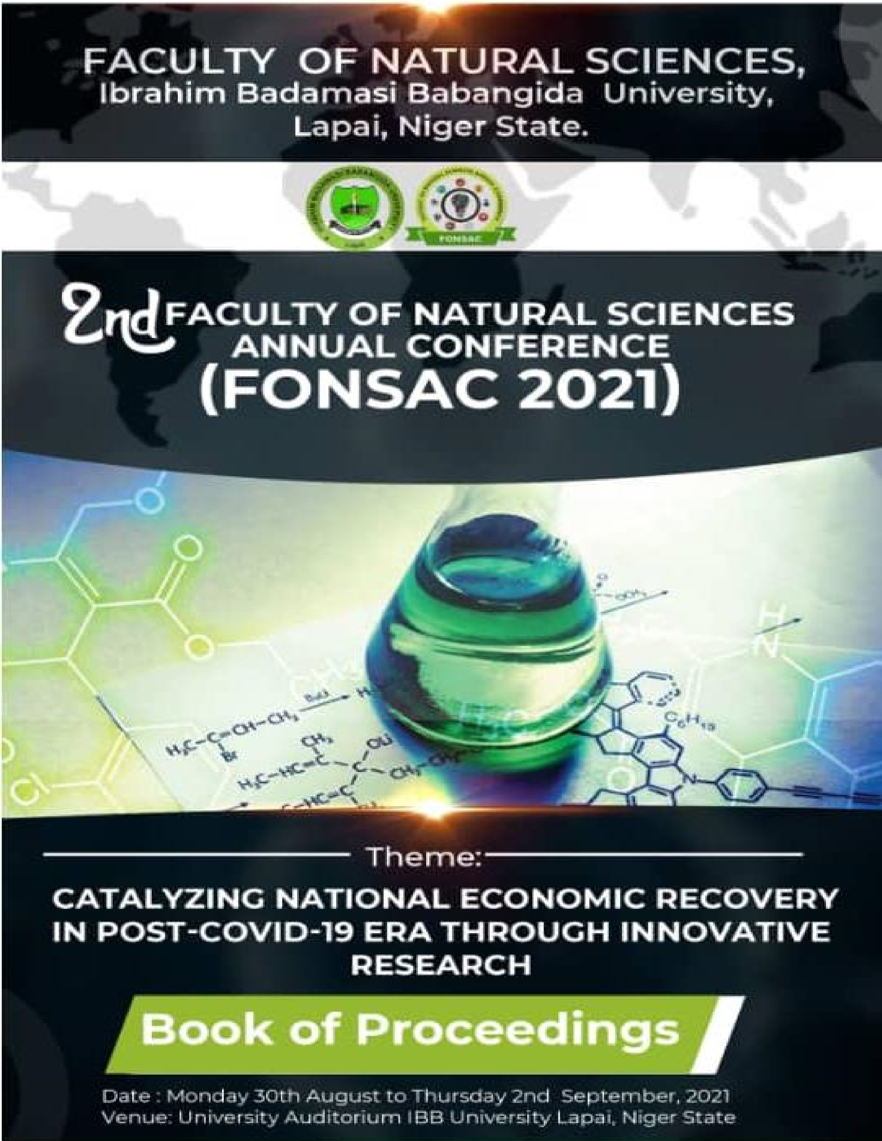

PROCEEDINGS OF
FONSAC 2021 LAPAI

Volume 1

Faculty of Natural Sciences
Ibrahim Badamasi Babangida University, Lapai, Niger State, Nigeria

University Auditorium, Lapai
Monday 30th August – Thursday 2nd September, 2021

Editors
Prof. Sheikh D. Abubakar
Dr. Musa Achimugu Dickson
Dr. Yahaya Aliyu Badeggi
Dr. Matthew Tsepav
Dr. Kabir Mohammed Adamu Dr. Baba John
Dr. Vincent Tochukwu Balogu
Dr. Hussaini Majiya
Dr. Ibrahim Abdullahi
Dr. Yakubu Azeh
Dr. Yusuf Tanko Usman
Dr. Amuzat Aliyu Olalekan
Dr. Jibrin Ndejiko
Dr. Andrew Iloh
Dr. Cyril Ogbiko
Dr. Haroun Aremu Kolawole
Dr. Daniel Apeh
Dr. Ossamulu I. Famous
Dr. Fatima Idris
Dr. Sulaiman Muhammed
Dr. B. A. Hayatuddeen
Engr. Elijah Joseph
A. S. Gene
C. O. Edet

All rights reserved.
© Faculty of Natural Sciences, IBB University, Lapai, 2021
ISBN: 978 978 994 2046

CONFERENCE ORGANIZING COMMITTEES
Budget & Implementation  Dr. Musa Achimugu Dickson  Opening Ceremony Dr. Yakuku Azeh  Exhibition/Technical Session  Dr. Kabir Mohammed Adamu  Dr. Jibrin Alhaji Yabagi  Dr. Ibrahim Maikudi Salihu  Mr. Yahaya Ibrahim  Hafsat Mohammed  Yakubu Manbe Mohammed  Secretariat  Mr. Mahmoud Gomina  Mrs. Rachel Osesienemo Sallau  Mr. Sadiq Umar | Media & Publicity  Dr. Ibrahim Abdullahi  Medical  Dr. Aishat Rabiu Sani  Logistics  Dr. Vincent Tochukwu Balogu  Dr. Abubakar Abdulkadir  Dr. Jibrin Ndejiko  Mrs. Fatimah Ladidi Jibril  Mrs. Hadiza Mohammed  Mr. Ibrahim Hamza Usman  Entertainment  Dr. Naomi John Dadi-Mamud  Dr. Amuzat Olalekan Aliyu  Mrs. Olubadewo O. Joshua  Mr. Mohmmed U. Tyabo  Mrs. Hauwa Hussaini Ndayako  Mr. Danjuma Aliyu Danjuma | Web/Virtual Conference  Mr. Kawu Abubakar  Security  Mr. Abdulganiyu Abdulrahman  Investiture  Dr. Hussaini Majiya  Dr. Munirat Bashir

Table of Contents
Editors Iii
Conference Organizing Committees Iv
Welcome Address by the Chief Host V
Prof. Abu Kasim Adamu
Welcome Address by the Conference Organizing Committee V ii
Dr. Musa Achimugu Dickson

INVITED TALKS
Key Note Address
Catalyzing National Economic Recovery in Post COVID-19 Era Through Innovative Research Xi ii
Dr. Ogbonnaya Onu

ORAL PRESENTATIONS
Anti-arthrithic potentials of ethanol extract of Ocimum gratissimum leaf 1
Gara T. Y., Afolabi T. O., Innalegwu D. A. & Ndayako H. H.
Spatio-Temporal Variations and Apparent Density of Tsetse Flies (Glossina Species) in 9
Selected Old Focal Areas of Niger State, Nigeria
Musa U. B., Salihu I. M., Ukubuiwe A. C., Adeniyi K. A., Yusuf A. B. & Olayemi I. K.
Investigating the Effects of Microbial Infested Feedstuffs on Performance of Clarias 18
gariepinus Fingerlings
Musa G. & Abdullahi M. O.
Evaluation of Nigerian Bitumen Yield and Composition by Hydrous and Anhydrous Pyrolysis: 38
A Case Study of Ondo State Bitumen
Raji A. & Garba M. U.
Determination of Trace Elements in Africa Locust Bean (Parkia biglobosa) 48
Idris M. A., Shuaibu M. D. & Ismail A. M.
Development of A Portable Solar Powered Arduino Microcontroller-Based Weather Station 53
Ughanze I. J., Ibrahim A. G., Eichie J. O. & Ugwu C. A.
Antimicrobial and Phytochemical Activities of Henna Plant 61
Olusola L. F., Agholor K., Mustapha A. & Ahmed A.
Weed Persistence Index, Weed Control Efficiency and Harvest Index in Onion (Allium cepa l.) 68
Field as Affected by Plant Population and Weed Control Treatments in Sudan Savanna,
Nigeria
Garba Y., Waziri A., Isah, A. S., Majin N. S. & Uthman A.
Utilization of Shea Caterpillar, Cirina butyrospermi in the Practical Diet of Hybrid African 76
Catfish, Clarobranchus Fingerlings
Alabi, A. T., Sadiku S. O. E. & Oyero J. O.

Phytochemical Constituents of Lannae bateri Leaves Extract and Evaluation of its Effect on 90
the Biochemical Parameters of Guinea Pig
Ejoba R.
In vitro antioxidant properties of free and bound phenolic extract of Celosia argentea, 96
Corchorus olitorius, Amaranthus hydridus and Jatropha tajorensis
Innalegwu D. A., Evans E. C., Gara T. Y. & Muhammad F. M.
Characterization of Zinc Oxide (ZnO) Nanoparticles Synthesized by Thermal Treatment 107
Method
Gene A. S., Gomina M., Salihu A. S., Musa H. I. & Muhammed H.
Oreochromis niloticus Status and Fundamental Potential roles in Ajalomi, River Ethiope, Delta 114
State
Iloba K. I., Oyedokun S. I. & Oderhohwo L.
Phytochemical Composition and Antifungal Activity of Aqueous and N-Hexane Extracts of 129
Calotropis procera Leaf
Madaki F. M., Bilbis L. S., Aliyu R. U. & Kabiru A. Y.
Mycological Evaluation of Smoked Dried Clarias gariepinus and Tilapia zilli sold in Minna 138
Metropolis
Oyero J. O., Adejola E. O. & Olatunji P. O.
Nutritional Compositions of Three Commonly Consumed Powder Vegetables Sold in Lapai, 142
Niger State, Nigeria
Uthman A., Anigo K. M., Musa A., Abdulazeez A., Garba Y. & Joseph P. S.
Investigation of the Diversity of Keratinophilic Fungi of the Animal House of Ibrahim 154
Badamasi Babangida University Lapai, Niger State, Nigeria
Hamza U. I., Tafida A. M., Yahaya I., Ndayako H. H., Gabi A. U., Salihu I. M., & Aliyu A. D.
Bacteriological Assessment of Tiger Nut Milk 164
Olusola L. F., Agholor K., Ahmed A., Mustapha A. & Mohammed A. S
Prevalence of Toxigenic Mycoflora in Groundnut Cake (Kulikuli) Sold in Niger State 172
Musa M. L., Adebola M. O., Aremu M. B., Zainab M. B. & Habib M. B.
Gastroprotective Activity of N-hexane and Chloroform Fractions of Sesamum radiatum Leaf 178
Extract on Aspirin Induced Ulceration in Rat
Hamzah R. U., Busari M. B., Agboola A. R., Mohammed H. A., Sayyadi A. Momoh O. L. & Ejiro O.
Preparation, Characterization and Applications of Activated Carbon from Agricultural Wastes 187
in Adsorption of Heavy metals
Gene A. S., Gomina M., Akanbi J. F., & Ibrahim H. A.
Isolation of Multidrug - Resistant Escherichia coli from Urogenital Samples of Patients with 196
Pelvic Inflammatory Disease in Niger State
Oyedum U. M., Kuta F. A., Saidu A. N. & Babayi H.
Assessment of Turmeric Curing on Heterotis niloticus Smoked with Peanut Shell Briquettes 206
as an Alternative to Firewood
Adejola E. O., Ibrahim S. U. & Oyero J. O.

Influence of Day-Length Conditions on Immature Fitness Attributes of Aedes aegypti 213
(Diptera: Culicidae)
Sule B. U., Ukubuiwe A. C., Olayemi I. K., Salihu I. M., Sodangi C. J. & Ukubuiwe C. C.
Production, Nutritional and Sensory Properties of Cashew Apple Jam. 220
Kolo S. I., Shehu A. A., Jubril B., Ayuba A. & Hassana M. S.
Dietary Exposure to Pesticide Residues from Fish and Livestock Products in Kogi East, Nigeria 225
Apeh D. O., Suleiman M. S., Atanu F. O., Olajide J. E., Mohammed L. S., Momoh F. O. &
Umar H. O.
Comparative Study of the Use of Natural Coagulants (Moringa oleifera and Watermelon) and 233
Artificial Coagulant (Alum) for Water Treatment
Muhammed J. J. & Jimoh A.
Construction and Evaluation of Two Bladed Savonius Vertical Axis Wind Turbine 242
Musa M., Ibrahim A. G., Argungu G. M., Chika C. & Ibrahim H. I.
Assessment of Partially Purified Urease from Spouted Citrullus vulgaris Seeds 252
Joseph P. S., Musa A. D., Evans C. E., Uthman A. & Ezikanyi G. K.
Nutritive and Pharmacological Properties of Annona senegalensis Leaf Extract 259
Ayeni G., Ejoba R., Yahaya A., & Larayetan R. A.
Mycological Evaluation of Barbing Saloon Tools in Lapai Town 276
Mohammed J. N., Babangida M. K. & Muhammad I. L.
Production and Partial Characterization of Proteases Produced by Bacillus lichenformis 282
Grown on Pineapple (Ananas comosus) and Watermelon (Citrillus lanatus) Peels as Carbon
Sources
Tsado A. N., Egwim E. C., Oyeleke S. B. & Shittu O. K.
Enzymatic Degradation of Human Hair by Purified Papain, Extracted from the Leaves of 290
Matured Female Pawpaw (Carica papaya)
Ejoba R. & Ayeni G.
Expand RSA Algorithm Cryptography Built on “Multiple N^{th}” Prime Figure 295
Mohammed B. H., Olumide O. & Abdulrahman A.
Effects of Graded Levels of Craseonyeteric thonglongyai Dung on the Concentrations of 305
Selected Anti Oxidant in the Leaf of Cnidoscolus aconitifolius (Euphorbiaceae)
Lawal B. A., Amanabo M., Abu M. L. & Uthman A.
Chemical Modification of Variety of Underutilized Nigerian Faro 15 Rice for the Production of 316
Pharmaceutical Grade Starch
Yisa B. N., Musa A. D., Abubakar M. & Egwim C. E.
In vitro Activity of Methanol Extracts of Stembark of Anogeissus leiocarpus on Plasmodium 337
falciparum
Ndayako H. H., Abdulsalam M. S, Bulus T., Yunusa Y. & Gara T. Y.
Characterization of Chemical and Enzyme Modified Cassava (Manihot esculenta Crantz) 346
Starch
Chindaya M. F., Musa A. D., Abubakar M. & Egwim. C. E.

Detection of Genetically Modified Maize and Soybean in Some Food Products from selected 358
Super and Local markets in Minna Metropolis, Niger state, Nigeria
Musa A. D. Ganiyu S. A., Osuji C., Egwim C. E. & Iloh A. C.
Application of Geographic Information System to Property Management 371
Dauda Y., Saidu U. A. & Mohammed J. K.
Fungi Species Associated with Invasion of Long-Term Packaged Bread Retailed Within 381
Selected Areas in Chikun LGA of Kaduna State
Mohammed S. S. D. & Kadani Z. D.
Water Tank Level Indicator Leakage Detection and Automatic Pump Controlling System 389
Adamu A., Badeggi Y. A., Ibrahim A., Gana U. M., Maipan-uku J. Y., Abubakar A. & Yusuf M.
Design and Implementation of Invigilator(s)/Supervisor(s) Roster for Semester Examination 399
Using USSD Code
Adamu A., Ibrahim A., Adamu A. I., Maipan-uku J. Y., Gana U. M., Awal A., Badeggi Y. A, Kawu A. A. & Lawal O. F.
Effects of Craseonysteris thonglongyai (Bumblebee Bat) Droppings and Chemical Fertilizer on 409
the Concentration of Some Antioxidants in the Leaf of Cnidoscolus chayamansa (Tree
Spinach)
Danazumi N. & Musa A.
Geoelectrical Exploration for Groundwater at Day Secondary School Maikunkele Town, Niger 416
State, Nigeria
Muhammad A., Suleiman I. K., Tsepav M. T., Umar S., Adetona A. Abbass & Aminu A.
Assessment of Tamarind, Tamarindus indica Pulp as Immune Booster in the Blood of Broiler 433
Chickens
Sode M. A. & Mohammed A.
Analytical Solution to Heat Conduction of Polystyrene Silver Nanoparticle (PS/AgNPs) 439
Composite in Spherical Coordinate
Imrana M. H., Yabagi J. A., Chukwude A. E., Ndanusa B., Bello M. L. & Yusuf T. U.
Digestive Enzyme Inhibitory Effect and Antioxidant Activities of a Ferulic Ester and Other 454
Phenolic Constituents from Entada Spiralis Ridl.
Roheem F. O., So’ad, S. Z. M. & Ahmed Q. U.
Investigating the Effects of Tarmarind, Tamarindus indica Pulp and Tetracycline on Serum 462
Biochemical Parameters in Broiler Chickens
Azaki T. S. & Mohammed A.
Phytochemical Composition and In vitro Antioxidant Potential of Different Solvent Extracts 470
of Terminalia schimperiana Leaves Extract
Yakubu N., Oloyede A. A., Abubakar H., Gogo M. F.., Hamzah B. U., Suleiman R., Abu M. L &
Amuzat A. O.
Verification of a Scalable Convolutional Neural Network (CNN) in Android Malware Detection 479
Adamu A. I., Aliyu U. S., Haruna A., Bashir Y. S. & Amina M. T.

Gastroprotective Activity of N-hexane and Chloroform Fractions of Sesamum radiatum Leaf Extract on Aspirin Induced Ulceration in Rat
^{*1}Hamzah R. U., ¹Busari M. B., ²Agboola A. R., ³Mohammed H. A., ¹Sayyadi A. ¹Momoh O. L. & ¹Ejiro O.
¹Department of Biochemistry, Federal University of Technology Minna, Niger State, Nigeria.
²Department of Biochemistry, College of Medicine, University of Calabar, Calabar, Crossriver State., Nigeria
³Department of Biological Oceanography, Nigerian Institute for Oceanography and Marine Research (NIOMR)Victoria Island Lagos, Nigeria.
*Correspondence Email: rabiola@futminna.edu.ng (+23408035911608)
ABSTRACT
Gastric ulcer is one of the most common gastrointestinal disorders, which causes a high rate of morbidity all over the world. Available drugs for ulcer treatment are associated with several side effects, thus the need to search for alternative treatment using plants and vegetable which are readily available and safer. The effect of n-hexane and chloroform fractions of Sesamum radiatum leaf extract on aspirin inducedulceration in albino rats were investigated. Ulcerative index, alkaline phosphatase (ALP), aspartate amino transferase (AST), alanine amino transferase (ALT), superoxide dismutase (SOD), catalase (CAT), Malondialdehyde (MDA) and the extent of inhibition of lipid peroxidation were determined using standard methods. Acute toxicity study revealed that the fractions were nontoxic up to a dose of 5000mg/kg bodyweight. Animals administered with 100 and 500mg/kg bodyweight of n-hexane fraction exhibit inhibition of ulceration of 33.33% and 50.00% while those of chloroform fractions showed 50.00% and 66.0% inhibition respectively compared to the 0% of the untreated group. AST, ALT, ALP and MDA Level of the ulcer induced rats treated with both fractions were significantly (p<0.05) reduced in a dose dependent manner. The SOD and CAT activities of Sesamum radiatum fractions treated groups showed significant increase as compared with untreated and toxic group. It can therefore be suggested that the n-hexane and chloroform fractions of S. radiatum may possess considerable therapeutic potential in the management of gastric ulcer.

Keywords: Sesasum radiatum, aspirin-induced ulcer, n-hexane, chloroform

INTRODUCTION
Ulcer is an open sore or lesion that occurs on the Ulceration of the gastric mucosa due to contact skin or membranous areas of the body. It could with gastric juice is called gastric ulcer. Where it be external or internal (Mcquaid, 2007). occurs in the lining of the stomach or duodenum,
Hamzah R. U., Busari M. B., Agboola A. R., Mohammed H. A., Sayyadi A. Momoh O. L. & Ejiro O. (2021). Gastroprotective Activity of N-hexane and Chloroform Fractions of Sesamum radiatum Leaf Extract on Aspirin Induced Ulceration in Rat. 2nd Faculty of
Natural Sciences Annual Conference. IBB University Lapai held between 30th August to 2nd September 2021. Pp 178-186

it is referred to as peptic ulcer. Peptic ulcer is a heterogeneous group of disorder involving the upper gastrointestinal tract that shows incidences of relapse, drug interactions and side effects such as arrhythmias, impotence, gynaecomastia, haematopoietic changes, etc. (Mcquaid, 2007).
Peptic ulcer is a gastro intestinal disorder due to an imbalance between the aggressive factors like acid, pepsin, Helicobacter pylori and defensive factors like bicarbonate secretion, prostaglandins, gastric mucus and innate resistance of the mucosal cell factors (Ramakrishnan, 2007). Normally peptic ulcer develops when aggressive factors overcome the defensive factors (Mcquaid, 2007). The major factors that disrupt the equilibrium between aggressive factors and defensive factors are Helicobacter pylori, acid–pepsin hyper secretion, non-steroidal anti-inflammatory drugs, sometimes idiopathic due to usage of tobacco, psychological stress and rapid gastric emptying (Atawodi, 2003).
Herbal medicines are considered as better alternatives for the treatment of peptic ulcer (Chukwurah, 2000). For instance, proton pump inhibitors (Omeprazole, lansoprazole) may cause nausea, abdominal pain, constipation, diarrhoea and H2 receptor antagonists (cimetidine) may cause gynaecomastia, loss of libido. Due to the occurrence of these side effects from the use of synthesized drugs for many diseases, Herbal medicines are considered safe for the treatment of ulcers with lesser adverse effects, economical, effectiveness and less toxic (Oyetayo, 2007).
Sesamum radiatum belongs to the family of Pedaliaceae. It is a leafy vegetable locally called ekukugogoro oe Ewe atura in Yoruba language, beni or gingelly in English, ridi in Hausa, and in Igala, Oro dudu (Gills, 1992). It is an indigenous vegetable that grows in small quantity in the rural areas. The plant occurs throughout the tropical Africa mainly as weed, where it is gathered in the wild and used as a potherb (Auwalu et al., 2007). It is one of the many neglected leafy vegetables of the tropics due to lack of knowledge of its medicinal importance.
In South - Western Nigeria the leaves are used to bring relaxation and health to the body, possibly because they relieve constipation and cure other ailments on ingestion (Odugbemi, 2008). The leaves, seeds and oil serve as food especially in farming communities in Nigeria (Akpan-Iwo et al., 2006). The leaves are also used for treating various stomach ailments. While the use of nonsteroidal anti-inflammatory drugs (NSAID) may be effective, they are sometimes associated with relapse and adverse effects (Dharmani & Palit, 2006). This has led to renewed interest in the search for new anti-ulcer drugs from natural sources. This study was therefore carried out to determine the effects of the chloroform and nhexane fractions of Sesamum radiatum on aspirin-induced ulceration in rats.
MATERIALS AND METHODS
Sample Collection, Chemicals and Control drug
Sesamum radiatum leaves were obtained from a private garden in Fiidi, Makurdi local Government of Benue in January of 2014.The plant was identified at the Department of Biological Science, University of Agriculture, Makurdi, Benue State.
Chemicals of analytic grade such as: methanol, chloroform, linoleic acid and Tween 20 produced by Amazon Chemical Limited, n-hexane, hydrogen peroxide, hydrochloric acid (Sigma Chemical Co. USA), ascorbic acid (Sigma Aldrich, USA) and others were used.
Aspirin (Greenfield Pharmaceutical Limited (JIANG S.U,China) and Omeprazole (Ranivan 20mg) produced by CIPLA Limited, India ) were used.
Extraction and Fractionation of Plant Sample
The leaves were thoroughly washed under running tap water and were air dried at room temperature for seven (7) days, grounded into powder using mortal and pestle. Fifty grams of the dried powdered leaves was weighed into a distillation flask and 400 ml of methanol solution was added to the flask. The mixture was refluxed for two hours, filtered hot using muslin cloth and subsequently evaporated using a rotary evaporator. The fractionation of the crude extract of the sample was carried out using chloroform and n-hexane to obtain the fractions. The fractions were subsequently concentrated using a rotary evaporator (Bibby Sterling Ltd, Stone Staffordshire ST 15OSA, UK) and water bath (45⁰C). The semi-dry extracts were weighed placed in a sterile sample bottles and stored in a refrigerator until require for further analysis (Ogbadoyi et al., 2007).
Experimental Animals
A total of forty (40) Wister albino Rats (weighing about 120 - 200 g) of both sexes were used in this experimental study. Animals were procured from the animal house of Department of Pharmacology and Clinical Pharmacy ABU, Zaria. They were transported in well ventilated plastic cages to Department of Biochemistry, Federal University of Technology Minna, Niger State. The Animals were allowed to acclimatize for a period of 3 weeks and fed with grower feed throughout this period having free access to tap water. Animal handling and experimentations complied with the principles governing the use of laboratory animals as laid out by the international standard set by the UK Animals (Scientific Procedures) Act, 1986 and associated guidelines, the European Communities’ council directive of 24 November 1986 (86/609/EEC), and the National Institutes of Health Guide for the Care and Use of Laboratory Animals (NIH Publication No. 8023, revised 1978).
Determination of Acute Toxicity LD₅₀
Acute toxicity studies were performed according to organization for economic co-operation and development (OECD) guidelines. Animals were observed for 14days to check for behavioral changes in animals and mortality rate (Wannang & Bichi,2004).
Induction of Ulcer and Experimental Design
Aspirin (25mg/kg body weight) was administered orally to all animals in the toxic and treatment groups. The animals were made to fast for 24 hours and administered with aspirin of 200 mg/ kg bw. Orally (Das & Banerjee, 1993). Animal were randomly grouped into seven groups of four animals each as follow; Group 1: Normal control group; Group 2: Positive Control (Aspirin + Omeprazole 20 mg/kg bw.); Group 3: Negative control (Induced with Aspirin and not treated); Group 4: Induced with Aspirin + 100 mg/kg bw. of chloroform fraction (CF); Group 5: Induced with Aspirin + 500 mg/kg bw. of chloroform fraction. (CF), Group 6: Induced + treated with 100mg/kg bw. of n-hexane fraction (NHF); Group 7: Induced + treated with 100mg/kg bw. of nhexane fraction (NHF). The experiment lasted for 14 days.
Collection of blood and Determination of Biochemical parameters
Collection of blood samples was done according to the method described previously by Yakubu et al. (2006). Rats were euthanized and plasma were collected for biochemical assays.
Assessment of Gastric Mucosal Lesion
The stomachs of the rats were removed and open along a greater curvature and were washed with ice-cold saline and examined for microscopic mucosal lesions. The gastric mucosal lesions were expressed in terms of ulcer index (UI) according to method described by Peskar et al., (2002).
Preparation of Stomach Tissue Homogenate
The stomach of animals was washed in ice cold normal saline (0.9% NaCl) solution, blotted and weighed. The grounded tissues (each 0.5g) were then treated with 4.5mL of appropriate buffers, at different pH for each biochemical assay. The resulting mixture was then homogenized and centrifuged at 1000 rpm for 15 minutes then it was removed from the centrifuge and the supernatant was decanted and stored at 10⁰C for further analysis.
Determination of liver Enzymes and Antioxidant Activities
Liver enzyme activities of the rat’s plasma were determined using the methods as specified by the Randox Kit used. Superoxide dismutase and catalase activities of tissue homogenate of experimental animals were determined following the method described by (Mishra and Fridovich, 1972) and (Sinha et al., 1972) while lipid peroxidation was determined by measuring Malondialdehyde using the method of (Armstrong & Browne, 1994).
Statistical Analysis
The results are given as mean ± Standard error using the SPSS 16.0 software. Group comparisons were statistically analyzed using one- way analysis of variance (ANOVA) with multiple comparisons versus control group. Values of P<0.05 were taken as significant.
RESULTS
The ulcerative index, liver enzyme assay (AST, ALT, and ALP) and antioxidant assay results of the chloroform fraction and n-hexane fraction of Sesamum radiatum leaf extract are presented in figure 1-7.

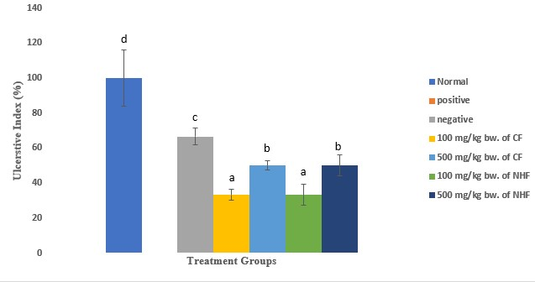
Figure 1: Effect of Chloroform and n-Hexane Sesamum radiatum Fractions of Leaf Extract on Ulcerative Index in Aspirin-Induced Ulcered Rats.
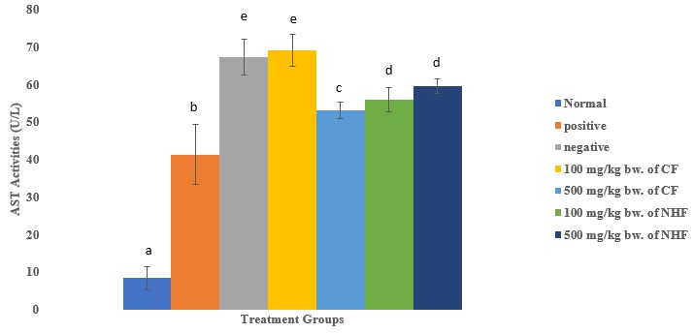
Figure 2: Effect of Chloroform and n-Hexane Sesamum radiatum Fractions of Leaf Extract on AST Activity in Aspirin-Induced Ulcered Rats.
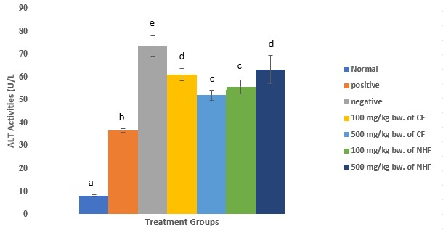
Figure 3: Effect of Chloroform and n-Hexane Sesamum radiatum Fractions of Leaf Extract on ALT Activity in Aspirin-Induced Ulcered Rats
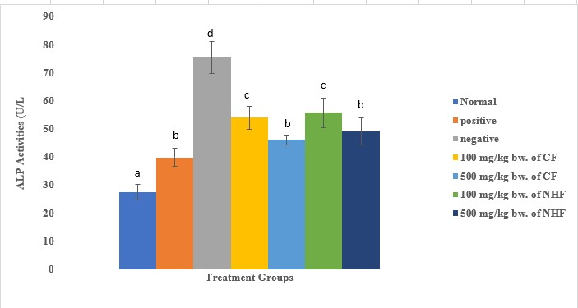
Figure 4: Effect of Chloroform and n-Hexane Sesamum radiatum Fractions of Leaf Extract on ALP
Activity in Aspirin-Induced Ulcered Rats
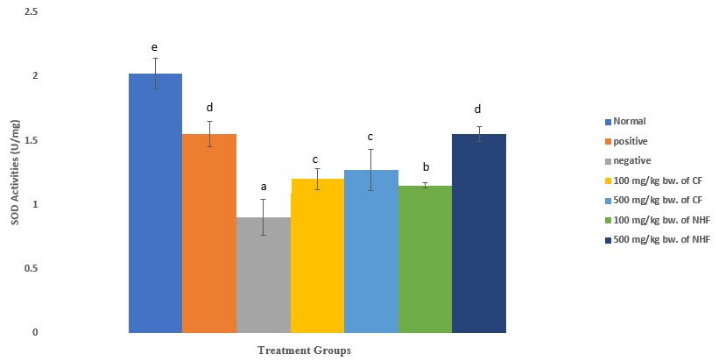
Figure 5: Effect of Chloroform and n-Hexane Sesamum radiatum Fractions of Leaf Extract on Superoxide Dismutase (SOD)Activity in Aspirin-Induced Ulcered Rats
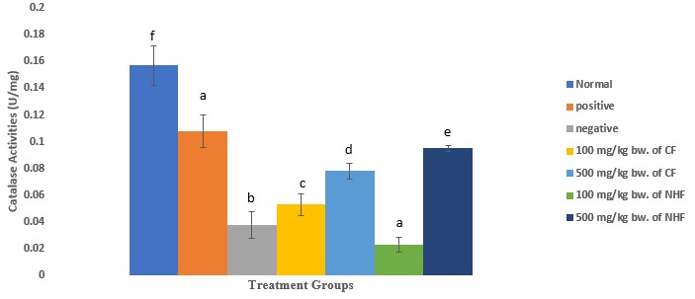
Figure 6: Effect of Chloroform and n-Hexane Sesamum radiatum Fractions of Leaf Extract on Catalase (CAT)Activity in Aspirin-Induced Ulcered Rats
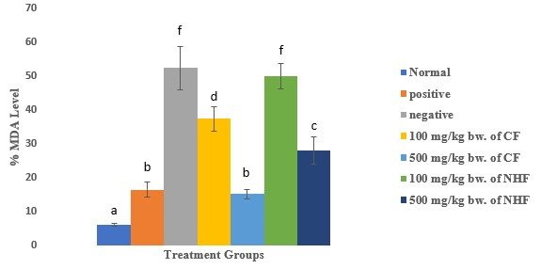
Figure 7: Effect of Chloroform and n-Hexane Sesamum radiatum Fractions of Leaf Extract on
Malondialdehyde (MDA) Level in Aspirin-Induced Ulcered Rats

DISCUSSIONS
The result of this study revealed that the chloroform and n-hexane fractions at 100 and 500mg/kg body weight led to the rapid healing in aspirin-induced gastric ulcer therefore significantly reducing the ulcerative index when compared to the untreated group. This result is compatible with a previous research result in which Bauhinia racemosa, Moringa pterygosperma and Trianthema pentandra were reported to cause a significant reduction in the ulcerative index of experimental rats (Akhtar & Ahmad, 1995), but is not in agreement with the report of Akhtar and Ahmad 1995, that showed that Cordia latifolia did not cause a reduction in ulcerative index. (Mozafar & Hossein, 2006) also reported a similar result in their experiment where they concluded that extract of Falcaria vulgaris reduced the ulcerative index in ethanol induced gastric ulcer in rats. Other works that agree with this result include that of Omojola et al. (2019), which reported that coconut milk reduced the ulcerative index in ethanol induced rats, Manowar et al. (2015) also showed the reduction of ulcerative index by Sesamum indicum in rats induced with ulcer
An increase in the liver enzymes were observed in the negative group and this indicate hepatic injury occurred due to aspirin-induction causing leakage of the enzymes into the blood (Myagmar et al., 2004). S. radiatum administration significantly decreased the levels of AST, ALT and ALP that shows its tissue damage preventing action and this may be attributed to the presence of phytochemicals capable of healing hepatic injury.
Catalase activity (CAT) and Superoxide dismutase activity (SOD) level were significantly decreased whereas there was significant increase in Malondialdehyde (MDA) activity in the in the negative group when compared with treated and control group. This decrease could be due to generation of free radical leading to lipid peroxidation. Administration of chloroform and extracts of S. radiatum at 100 and 500mg/kg bw were able to improve the antioxidant parameters. This result is in agreement with previously published work by Vinodhini et al., (2007) which show bale leaf extracts showed positive effect on the status of antioxidant parameters.
CONCLUSION
In conclusion, the results shows that chloroform and n-hexane fractions of Sesamum radiatum leaf extract possess gastro protective activity .and provides support for the traditional use of this plant in the treatment of gastric ulcer. Further studies are ongoing to isolate the active components and to elucidate their mechanism of action.
REFERENCES
Akhtar, A.H. & Ahmad, K.U. (1995). Antiulcerogenic evaluation of the methanol extract of some indigenous medicinal Plants of Pakistan in aspirin ulcerated rats. Journal of Ethnopharmacology, 46(1): 1-6
Akpan-Iwo, G., Idowu, A. A. & Misari, S. M. (2006) Collection and evaluation of Sesamum spp Germplasm in Nigeria. African Journal of Agricultural Research, 142:59-
62.
Armstrong, D. & Browne, R. (1994) The Analysis of Free Radicals, Lipid Peroxides, Antioxidant Enzymes and Compounds Related to Oxidative Stress as Applied to the Clinical Chemistry Laboratory.
Advances in Experimental Medicine and Biology, 366, 43-58.
Atawodi, S. E., Bulus, T., Ibrahim, S., Ameh, D. A., Nok, A. T., Mamman, M. & Galadima, M. (2003) In vitro trypanocidal effect of methanolic extract of some Nigerian savannah plants. African Journal of Biotechnology, 2 (9):317.
Auwalu, B. M., Babatunde., F. E., Oseni, T. O. & Muhammad, Y. M. 2(007) Productivity of vegetable sesamum (Sesamum radiatum) as influenced by nitrogen, phosphorus and season.
Advances in Horticultural Science, 21(1): 9-13.
Chukwurah, B. K. C. & Ajali, U. (2000) Antimicrobial investigation of the constituents of the methanolic extract of the rhizome of Anchomanes difformis. Indian Journal of Pharmaceutical Science. 62:296.
Das, D. & Banerjee, R.K. (1993). Effect of Stress on the Antioxidant Enzymes and Gastric Ulceration. Molecular and Cell Biochemistry 125: 115–125
Dharmani, P. & Paalit, G. (2006). Exploring Indian medicinal plants for anti-ulcer activity.
Indian Journal of Pharmacy.
83:95-99.
Gills, L. S. (1992) Ethnomedical uses of plants in Nigeria, University of Benin Press, Edo State Nigeria. 212.
Hano, J., Bugajski, J. & Danek, L. (2006). Effect of
Adrenergic Blockage on Gastric Secretion Altered by Catecholamine in Rats. Journal of Archives Immunology and Therapeutic Experimental (Warsz), 24(4):507-524.
Manowar, H., Iswar, H. & Anju, D. (2015). Pylorus
Ligation Induced Gastric Ulcer Protection by Sesamum Indicum Ethanolic Seed Extract, Research & Reviews: A Journal of Pharmaceutical Science, (6)3;42-49.
Mcquaid, K. R. (2007). Basic and clinical pharmacology. Singapore: McGraw- Hill. Drugs used in the treatment of gastrointestinal disease. In Katzung BG. 1009-1040.
Misra,H.P, & Fridovich, I (1972) The role of superoxide anion in the autoxidation of epinephrine and a simple assay for superoxide dismutase. Journal of Biology chemistry 25(10):3170-5.
Mozafar, K. & Hossein, S. (2006). Protective effect of Falcaria vulgaris Extract on ethanol induced gastric ulcer in Rat, Iranian Journal of Pharmacology and Therapeutics 5(1):43-46
Myagmar B.E., Shinno, E., Ichiba, T & Aniya, Y (2004). Antioxidant activity of medicinal herb Rhodocum vitis-idaea on galactosamine-induced liver in rats, phytomedicine, 11(5):416-423
Odugbemi, T. (2008). A Textbook of Medicinal Plants in Nigeria.University of Lagos Press. Lagos. 558.

Ogbadoyi, E. O., Akinsunbo, O., Abdulganiy, T. Z. & Okogun, A. J. (2007). In vivo Trypanocidal Activity of Annona senegalensis Leaf Extract against Trypanosoma brucei brucei. Journal of Ethnopharmacol. 112:85-89.

Omojola, A. T., Ofusori A.D., Edward S.S. & Extract of Fadogia agrestis. Recent Umeaku U. (2019) The histochemical Progress in Medicinal Plants.;12:393-402 and biochemical effects of coconut milk
in Wistar rats with ethanol-induced gastric ulcer, African Journals online
8(2); 2305-9478

Oyetayo, V. O. (2007). Comparative studies of the phytochemical and antimicrobial
properties of the leaf, stem and tuber of

Anchomanes difformis. Pharmacol.
Toxicology. 2(4):407-410.
Peskar, B. M., Ehrlich, K. & Peskar, B. A. (2002). Role of ATP-Sensitive Potassium
Channels in Postaglandin Mediated
Gastro-Protection in the Rat. Journal of

Pharmacology and Experimental
Therapeutics. 301(3): 969-974
Ramakrishnan, K. & Salinas, R. C. (2007). Peptic ulcer disease. American Family
Physician. 76(7): 1005-1012.
Sinha, K. A. (1972). Colorimetric Assay of
Catalase. Journal of Analytical

Biochemistry. 47:389-394.

Vinodhini S.R. & Hazeena, B.V.M. (2007) The
Hepatoprotective Effect of Bael Leaves (Aegle Marmelos) in Alcohol Induced
Liver Injury in Albino Rats, International
Journal of Science and Technology, 2(2),

83-92

Wannang, N.N. & Bichi, L.A. (2004). Determination of LD50 of The Aqueous
Extract of Solanum nigrum Linn. in Rats.
Best Journal, 1(2): 177-119.
Yakubu, M.T., Akanji, M.A. & Oladiji A.T. (2006)
Evaluation of Selected Biochemical Parameters of Male Albino Rat Liver following Administration of Aqueous Preparation, Characterization and Applications of Activated Carbon from Agricultural Wastes in Adsorption of Heavy Metals

