Liquidity Management and Business Performance of Listed Non-Financial Firms in Nigerian
Akinola O. Olakunle^{1*}, Osuolale I. Ololade¹, Ruth Kolo¹ &Mercy M. Adeyeye¹
¹ Department of Entrepreneurship and Business Studies, Federal University of Technology, Minna, Niger State, Nigeria
* akolaks@futminna.edu.ng

Abstract
The aim of this research is to investigate the relationship between liquidity management and performance, with profitability as the metric for performance, of firms listed on the Nigerian Stock Exchange (NSE) for the period 2013 to 2020. The study utilizes a fixed effect panel data approach and includes a sample of firms listed on the main board of the consumer goods sector of the NSE.The results reveal an insignificant negative correlation between the profitability of the listed firms and their Gearing Ratio, Average Collection Period, and Inventory Turnover Period. However, a non-significant positive correlation was observed between profitability and the Current Ratio, Average Payment Period, Cash Conversion Cycle, and Firm Size. This study is unique in that it is the first to focus primarily on firms listed on the main board of the consumer goods sector of the Nigeria Stock Exchange and it employs a robust test for potential endogeneity issues. Furthermore, to ensure the reliability and validity of the model, several diagnostic tests including normality test, multicollinearity test, heteroscedasticity test, autocorrelation test, and appropriate model selection test have been conducted.
Introduction
The consumer goods industry is a vital sector in the Nigerian economy, playing a crucial role in driving growth by contributing approximately 16% to the Gross Domestic Product (GDP). The industry is quickly becoming the third largest contributor to GDP after the oil, telecommunications, and banking sectors, with a projected $40 billion growth opportunity for the economy (Fiorini et al., 2013). With a large population of 200 million (World Bank IBRD-IDA, 2021) and a high rate of rural-urban migration, Nigerian cities are driving per capita consumption. To tap into this growth potential, firms need to implement effective working capital management strategies to manage their liquidity, reduce risk exposure, and improve productivity (Akindele &Odusina, 2015).
Previous research on firms' liquidity management and its impact on performance in Nigeria has yielded mixed results (see Ignatius, 2010; Bagchi & Chakrabarti, 2014). This study takes a distinct point of view by concentrating on the management of cash flow and the cash conversion cycle (CCC) of publicly traded firms in the consumer goods sector of the Nigerian Stock Exchange (NSE). It is a novel approach to explore this area of research.Additionally, this study addresses any potential endogeneity problems through the use of an econometrics diagnostic test model.
Review of Literature
Working capital management serves as a crucial source of liquidity and value enhancement for firms, thus it is important to maintain a balance between current assets and liabilities to ensure that they are neither lacking nor in excess. One of the strategies firms can adopt to optimize their working capital management is by utilizing the cash conversion cycle (CCC) concept to determine the firm's level of liquidity (Richard & Laughlin, 1980).
Research suggests that the way a company manages its working capital can greatly influence its financial success. Studies have found varying correlations between working capital management and profitability. Sharma and Kumar (2011) discovered a positive relationship, while Mathuva (2010) observed a negative correlation between account receivables and profitability, but a positive correlation between account payables, inventory turnover, and profitability in listed firms on the Nairobi Stock Exchange. Raheman and Nasr (2007) performed a study on 94 publicly traded companies in Pakistan and discovered a strong negative relationship between how a company manages its working capital and its profitability. They found that as the cash conversion cycle of the firms increases, profitability decreases and they recommended that firms should maintain a minimum level of cash conversion cycle to improve shareholders' wealth. In contrast, Banos-Caballero et al. (2012) examined the relationship between a firm's profitability and its working capital management, and found that there is a non-linear correlation between the two.. They observed that working capital of a firm and profitability have an inverse correlation. They noted that this inverse correlation may lead to low levels of investment by the firms and stall production processes, which, if not addressed, would ultimately lower the firm's level of productivity and profitability in the long run.
Previous research on the relationship between a firm's working capital management and profitability has yielded mixed results. Deloof (2003) found a negative effect on profitability when studying Belgian firms, while Lazaridis and Tryfonidis (2006) found a positive correlation between the cash conversion cycle of Greek companiesto be positively correlated with profitability. Ganeson (2007) also discovered a negative correlation between working capital utilization and profitability among 349 telecommunications firms in the United States. Other studies also have reported a negative relationship between a firm's cash conversion cycle and profitability. For example, Falope and Ajilore (2009) found a negative correlation between cash conversion cycle and profitability, Dong and Su (2010) reported a similar negative relationship between cash conversion cycle and profitability, Hayajneh and Yassine (2011) also found a negative correlation between cash conversion cycle and profitability in their study, and Akindele and Odusina (2015) reported negative relationship between cash conversion cycle and profitability among firms in Nigeria.The findings of these studies indicate that companies should strive to maintain an ideal cash conversion cycle to enhance the wealth of their shareholders.
The purpose of this study is to investigate the association between how firms handle their liquidity and their profitability for firms listed on the Nigerian Stock Exchange (NSE) from 2013 to 2020. The research will aim to establish the importance of liquidity management on the profitability of listed firms on the NSE and to explore the impact of different liquidity indicators such as the cash conversion cycle (CCC) and the size of the company on the profitability of firms listed on the NSE.The study will employ robust econometric techniques to control for potential endogeneity problems and ensure the efficiency and consistency of the model. The results of this study will add to the existing body of knowledge by offering an understanding of the liquidity management strategies employed by firms listed on the NSE and the effect on their profitability. It will provide an in-depth analysis of the relationship between liquidity management and profitability of firms listed on the NSE and will fill the gap in literature by providing a comprehensive analysis of the liquidity indicators such as CCC and company size on the profitability of firms listed on NSE.

Method of Investigation
To examine the relationship between liquidity management and profitability of listed firms on the Nigerian Stock Exchange (NSE), a purposive sampling technique was utilized to identify and analyze a sample of consumer goods companies listed on the NSE. This method was chosen as it allows the researcher to select companies that are most appropriate for the study and align with the research objectives. This technique enables a more targeted and in-depth examination of the liquidity management and profitability of firms listed on the NSE, rather than a more general or random sampling approach..However, MultiTrex PLC, Golden Guinea Breweries PLC, Dunlop Tyres& Rubbers PLC, and NASCON PLC were not included in the study because of the inadequate data present in their financial statements, making it impossible to conduct a proper analysis on their liquidity management and profitability.Secondary data were collected from the NSE website, and in cases of missing data, organizations' annual reports were downloaded from their websites to fill in the gaps.
Firms' performance was measured using Return on Asset (ROA) as a metric, while their liquidity position was measured by Cash Conversion Cycle (CCC), which includes accounts receivables, account payables, and inventory turnover. The sample of firms examined in this study were non-financial firms listed on the main board of the NSE from 2013 to 2020. An econometrics diagnostic test model was adopted to ensure the efficiency and consistency of the model adopted. To ensure the validity and reliability of the data analysis, the following statistical tests were performed: Normality test: to check if the data is normally distributed Multicollinearity test: to examine the correlation between independent variables Heteroscedasticity test: to check if the variance of the error terms is constant across the sample Serial correlation test: to check if there is any correlation between the residuals over time. These tests were carried out to ensure that the data meets the assumptions of multiple linear regression and the results of the analysis are reliable and accurate.

Model Specification
${ROA}_{i,t}= β_{0}+ β_{1}{GR}_{i,t}+ β_{2}{GWC}_{i,t}+ β_{3}{LS}_{i,t}+ β_{4}{CR}_{i,t}+ β_{5}{CCC}_{i,t}+ ε_{i,t}$ (1)

Where:
$GR$ = Gearing Ratio
$GWC$= Gross working capital turnover ratio
$LS$= Logarithm of sales used to measure firm size
$CR$= Current ratio
$$CCC={AR}_{i,t}+{IT}_{i,t}-{AP}_{i,t}$$
Note:
${AR}_{i,t}$= Accounts receivable
${IT}_{i,t}$= Inventory turnover
${AP}_{i,t}$= Account payable
$CCC$= Cash conversion cycle

Empirical Analysis
Descriptive statistics
Tables Iprovide descriptive statistical analysis of the dependent and independent variables collected over eight (8) years for all the 15firms listed on the NGSE. Accounting ratios were used for the calculation of all variables. In running a regression analysis, the variables must fulfil the criteria of the BLUE (best, linear, unbias, estimator). For this reason, tables II, III, and IV present the result of the multicollinearity test, heteroscedasticity test, and autocorrelation test to make the analysis and interpretation accurate.
Table II – Multicollinearity Test
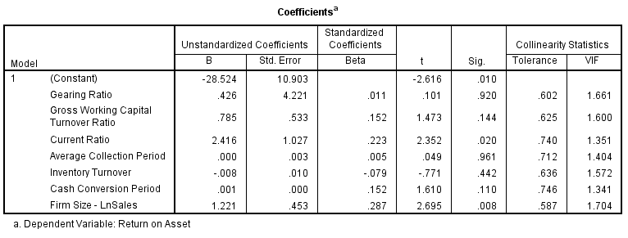
In order to guarantee the robustness of the regression estimates, a multicollinearity test on the dependent variables was performed. The results of the test, in terms of the Variation Inflation Factor (VIF) values, were less than three (3), indicating that there is no multicollinearity among the dependent variables in the model, making the estimates stable and reliable.As a general rule, when VIF values are above 3, it is considered a warning sign of multicollinearity, values between 3-5 indicate the presence of multicollinearity, and values above 10 reflect severe multicollinearity issues in the model. However, in this case, the VIF values obtained are well below the threshold of 3, indicating no presence of multicollinearity and the model is considered stable and reliable.
Table III – Auto Correlation Test
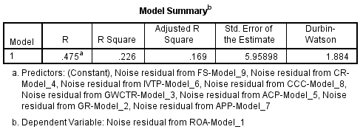
To detect the presence of autocorrelation, a Durbin-Watson test was first conducted. Since the data collected is a combination of time series and cross-sectional data, to address the problem of autocorrelation, the Autoregressive Integrated Moving Average (ARIMA) model was applied to ensure stationarity, that is, consistency in the values of the means and variance over time..The ARIMA (0,1,1) model was applied by identifying the auto-regression, first-order difference, and moving average 1. A Durbin-Watson test was then conducted, resulting in a value of 1.884, indicating that the model is now free of autocorrelation.

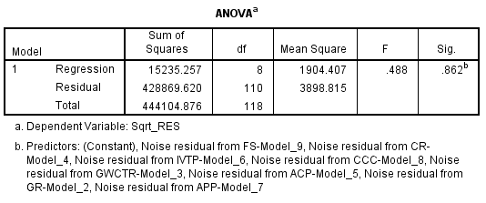
Table IV – HeteroscedasticityTest

To check for heteroscedasticity, the Breusch-Pagan test was applied on the transformed values obtained from the ARIMA model. This test is used to detect any variance in the error term, which can indicate heteroscedasticity.The test was conducted at a significance level of P>0.05. The P value obtained was .862, which indicates that the regression model is homoscedastic. This means that the error variance is constant across all levels of the independent variables, and the model's assumptions of homoscedasticity are met.
FINDINGS
Table IV – Regression Result Output
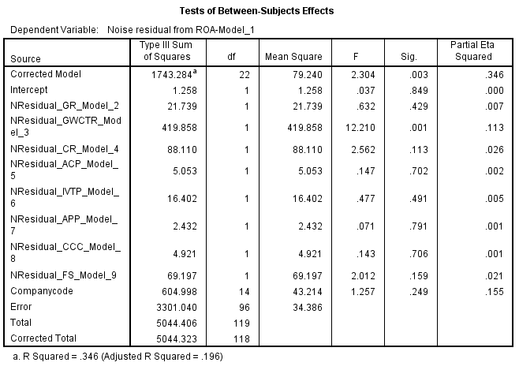
Table V
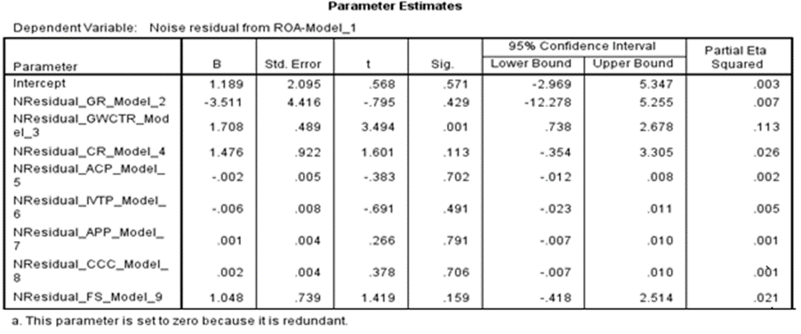
Kindly rewrite this paragraph "The results show an R-squared value of .346, indicating that 34.6% of the variation in profitability level for the companies studied is explained by the specified explanatory variables, such as Gearing Ratio (GR), Gross Working Capital Turnover Ratio (GWCTR), Firm Size (FS), Current Ratio (CR), Average Collection Period (ACP), Inventory Turnover Period (IVTP), Average Payment Period (APP), and Cash Conversion Circle (CCC). This implies that these variables play a significant role in determining the profitability of the firms under examination.However, as the R-squared value is not 1, it implies that there are other factors that have not been considered in the model which also affect the profitability of the firms.

H01: Gearing Ratio as a measure of profitability
The outcome of the hypothesis test (H01) revealed a non-significant correlation coefficient (p-value > .05) between the independent variable Gearing Ratio and the dependent variable Return on Asset (ROA) for firms listed on the main board of the Nigerian Stock Exchange (NSE) within the consumer goods sector.This suggests that the firms in the consumer goods sector listed on the main board of the Nigerian Stock Exchange (NSE) are not effectively utilizing debt financing to leverage their working capital and improve their profitability.it therefore infers that listing on the main board of the Nigerian Stock Exchange (NSE) may not be a sufficient condition for these firms to access the necessary financial leverage to enhance their operational performance.
Decision: Based on the results, we accept H01 and conclude that at a 5% significance level, there is no statistical evidence to indicate that listing on the main board of the Nigerian Stock Exchange (NSE) has a significant positive impact on the financial leverage of firms in the consumer goods sector, and thus on their profitability.

H02: Gross Working Capital Turnover Ratio (GWCTR) as a measure of profitability
The H02 test yielded a statistically significant, positive correlation of weak magnitude between GWCTR and ROA for firms in the consumer goods sector listed on the main board of the NSE.This implies that these firms are utilizing their working capital efficiently to support sales and growth, but there is room for improvement. The weak positive correlation implies that firms have a high percentage of their inventories as account receivables.
Decision: Based on the results of the H02 test, we reject the null hypothesis at a 0.5% significance level. The analysis of the data indicates a weak positive correlation between GWCTR and ROA for firms listed on the main board of the NSE, which implies that these companies may not be effectively utilizing their working capital to drive sales growth and profitability within the consumer goods industry.

H03: Current Ratio (CR) as a measure of profitability
The H03 test results suggest the presence of a positive correlation between Current Ratio (CR) and profitability for firms listed on the main board of the NSE in the consumer goods sector, however this correlation is not statistically significant. This implies that the high current ratio observed in the sector does not have a significant overall effect on the ability of these firms to meet their short-term obligations and enhance their level of profitability. This contradicts the findings of previous studies such as Sisay&Nongmaithem (2019) who found a positive significant correlation between CR and profitability in their analysis of 11 Share Manufacturing companies in Ethiopia.
Decision: We Accept the H0₃ at 0.5% significant level and state that no evidence was found from the result obtained to support that listing on the main board of NSE has necessarily enhanced the liquidity of the listed firms to meet their short-term obligations. The implication of this result is that the ability of these firms to remain solvent in the short run is questionable. An in-depth examination of multiple dynamic liquidity indicators, including Average Collection Period (ACP), Inventory Turnover Period (IVTP), Average Payment Period (APP), and Cash Conversion Cycle (CCC) is crucial for obtaining a comprehensive understanding of the liquidity and financial stability of firms listed on the main board of the NSE within the consumer goods sector.

H04: Average Collection Period (ACP) as a measure of profitability
The test of H04 aims to determine the liquidity of firms listed on the main board of the NSE by examining the cumulative effect of the account receivable management practice in the sector. The results of the analysis indicate that the coefficient for the Average Collection Period (ACP) variable is -0.002, with a corresponding p-value of 0.702. This suggests that there is a negative correlation between Average Collection Period (ACP) and profitability of firms, however this correlation is not statistically significant. It implies that ACP contributed a 0.2% reduction to Return on Asset (ROA). This is in line with the results obtained in previous studies by Wafula, Tibbs, &Ondiek (2019), Ponsian, Chrispina, Tago, &Mkiibi (2014), Mathuva (2010), Dong (2010), &Falope&Ajilore (2009) who found a negative correlation between ACP and profitability. However, the findings of Sharma and Kumar (2011) support a positive significant relationship between ACP and ROA for Indian firms.

Comparing the results of ACP to that of Current Ratio (CR), one can deduce that part of the liquidity challenge for firms listed on the main board of the consumer goods sector of NSE could be traced to their negative ACP.
Decision:We accept H04 and conclude that at a 0.5% significant level, evidence found did not support that ACP of firms listed on the main board of the consumer goods sector contributed to the increase in profitability of firms in the sector.

H05: Inventory Turnover Period (IVTP) as a measure of profitability
The test of H05 aims to examine the ability of firms listed on the main board of the NSE concerning how fast they can sell their inventories as a measure of profitability. This reflects how much of their capital is tied down due to high inventory holdings. The result of the test shows that the coefficient of the Inventory Turnover Period (IVTP) variable is -.006 and the p-value is .491. This indicates that there is a negative but insignificant correlation between Inventory Turnover Period (IVTP) and profitability of firms. It implies that IVTP contributed a 0.6% reduction to the profitability of the firms. However, the negative interaction was not found to be significant enough to cause any serious distortion to the sector inventory turnover. The low IVTP is a pointer to low sales or holdings of excess inventory in the sector.
Decision:We accept H05 and conclude that at a 0.5% significant level, evidence found did not support that IVTP of firms listed on the main board of the consumer goods sector had any significant contribution to the increase in profitability of firms in the sector.

H06: Average Payment Period (APP) as a measure of profitability
The test of H06 aims to measure the average period in which firms in this sector could hold on to creditors' funds before payment. The advantage of this to firms is that it helps them to free up cash which could be converted into other use in the short run. The result of the test shows that the coefficient of the Average Payment Period (APP) variable is .001 and the p-value is .791. This indicates a positive but insignificant relationship between Average Payment Period (APP) and profitability of firms.. It implies that a 0.1% change in profitability level is accounted for by APP in the sector. This result is in contrast to the findings reported by Aguenaou, Farooq, Abrache& Brahimi (2015), &Afeef (2011), who have stated that there is an insignificant negative correlation between APP and profitability of firms.
Decision: Accept H06 based on the resultsand conclude that at a 0.5% significant level, there is no evidence to support that APP observed for firms listed on the main board of the consumer goods sector had any significant contribution to the increase in profitability of firms in the sector.

H07: Cash Conversion Circle (CCC) as a measure of profitability
H07 posits that the Cash Conversion Cycle (CCC) as a metric for evaluating the profitability for firms listed on the main board of the consumer goods sector on the NSE. The results of the analysis showed a positive but insignificant relationship between liquidity (measured by CCC) and profitability, with a β of -.002 at P = -.706. This indicates that the listed firms are not generating enough cash to cover their daily operations and meet their credit obligations. The CCC could be improved by reducing cash tied up in working capital and speeding up collections to increase profitability. However, the results contradict previous studies by Singh & Kaur (2017) and Deloof (2003), Shin &Soenen (1998) &Nobanee, Abdullatif, Alhajjar (2011) that found a significant negative impact between CCC and profitability.
Decision: We Accept H0₇ at 0.5% significant level, based on the analysis, there is no indication that the observed CCC for firms listed on the main board of the consumer goods sector on the NSE had a statistically significant impact on the profitability of firms in the sector.The H07 accepted at a 0.5% significant level.

H08: Firm Size (FS) as a measure of profitability
An examination of the relationship between firm size and profitability was conducted for firms listed in the consumer goods sector of the NSE.. The β coefficient of 1.048 and P-value of 0.159 obtained from the analysis suggest that firm size has a positive, but not statistically significant, effect on the profitability of listed firms in the consumer goods sector of the NSE. The results obtained imply that the positive relationship observed is not significant enough for the listed firms observed to take advantage of economy of scale to improve on their level of profitability. This is contrary to the findings of Isik, Unal, Unal (2017), Isik and Tasgin, 2017, Liu,Wei, &Xie(2014), Dogan, 2013, Akinyomi&Olagunju (2013), &Serrasqueiro and Nunes, 2008 who reported a positive significant relationship between firm size and profitability.
Decision: Accept H0₈We accept H08 at a 0.5% significance level, and conclude that there is no statistically significant evidence to support the claim that firm size positively impacts the profitability of firms listed on the main board of the consumer goods sector on the NSE.

Conclusion

The study examined the relationship between the variables of liquidity management and firm profitability for listed firms on the main board of consumer goods on the NSE. The study used fixed effect panel data regression model, using indices like gearing ratio, current ratio, gross working capital turnover ratio, average collection period, inventory turnover period, average payment period, and cash conversion cycle, along with other control variables for a sample of 15 Nigerian firms. Profitability was measured in terms of return on asset (ROA). Unlike previous studies, a robust test has been carried out for possible endogeneity problems. To achieve this an econometrics diagnostic test model was adopted to ensure the efficiency and consistency of the model adopted. In this wise, a normality test, multicollinearity test, heteroscedasticity test, autocorrelation test, and appropriate model selection test was carried out. This research have revealed vital management practices requiring improvement to aid financial performance of firms listed in this sector.
The study revealed a negative insignificant correlation between profitability of the listed firms and their Gearing Ratio (GR), Average Collection Period (ACP), and Inventory Turnover Period (IVTP). While a non-significant positive correlation was observed between profitability and the Current Ratio (CR), Average Payment Period (APP), Cash Conversion Cycle (CCC), and Firm Size (FS). The Gross Working Capital Turnover Ratio (GWCTR) revealed a weak positive correlation to the profitability of the listed firms.
Findings supports that better management of receivables, average collection period and current ratio will improve CCC and enhance profitability of the listed firms in this sector. Drawing further inference from the research findings, one can conclude that listed firms could further improve on their inventory management system through the implementation of proper inventory control mechanism such as economic ordering quantity (EOQ), Demand forecasting, perpetual inventory management (PIM), and Six sigma to enhance profitability. On firm’s size, the listed firms could shore up their capital base in other to take advantage of economy of scale to improve their profitability level.

References
Afeef, M (2011). Analyzing the Impact of Working Capital Management on the Profitability of SME’s in Pakistan. International Journal of Business and Sciences, 2(22), 173-183.

Aguenaou, S., Farooq, O, Abrache, J., & Brahimi, M. (2015). The Relationship between Working Capital Management and Profitability: Empirical Evidence from Morocco. Global Review of Accounting and Finance, 118 – 139.

Akindele, J.A. &Odusina, A.O. (2015). Working Capital Management and Firm Profitability: Evidence from Nigerian Quoted Companies. Research Journal of Finance and Accounting, 6(7), 148 – 153.

Akinyomi, O.J. &Olagunju, A. (2013). Effect of Firm Size on Profitability – Evidence from Nigeria Manufacturing Sector. Prime Journal of Business Administration and Management, 1171 -1175.

Bagchi, B. and Chakrabarti, J. (2014). Modeling liquidity management for Indian FMCG firms.International Journal of Commerce and Management, 24(4), 334-354.

Baños-Caballero, S., García-Teruel, P. and Martínez-Solano, P. (2012), How does working capital management affect the profitability of Spanish SMEs? Small Business Economics, Vol. 39 (2), 517-529.

Bhunia, A. and Khan, I. (2011). Liquidity management efficiency of Indian steel companies. Far East Journal of Psychology and Business, 3(3), 3-13.

Deloof M. (2003). Does Working Capital Management Affects Profitability of Belgian Firms? Journal of Business Finance & Accounting, 30(3/4), 573-587.

Doğan, M. (2013). Does firm size affect the firm profitability? Evidence from Turkey. Research Journal of Finance and Accounting, 4(4), 53-59.

Dong, H.P &Su, J (2010). The relationship between working capital management and profitability: a Vietnam case, International Research Journal of Finance and Economics, 49, pp. 59- 67.

Falope, O. I, Ajilore O. T (2009). Working capital management and corporate profitability: evidence from panel data analysis of selected quoted companies in Nigeria.Research Journal of Business Management, 3, 73-84.

Fiorini, R., Hattingh, D., Maclaren, A., Russo, B.., and Sun-Basorun, A. (2013). Africa’s growing giant: Nigeria’s new retail economy. Publish by McKinsey & Company

Ganesan, V (2007): An analysis of working capital management efficiency in telecommunication equipment industry, Rivier Academic Journal, 3(2), 1 – 10.

Garcia-Teruel, P.J. & Martínez-Solano, P. (2007). Effects of Working Capital Management on SME Profitability. International Journal of Managerial Finance, 3(2), 164-177.

Hayajneh, O.S & Yassine, F.L.A (2011): The impact of working capital efficiency on profitability-an empirical analysis on Jordanian manufacturing firms, International Research Journal of Finance andEconomics, 66, pp. 61- 76.

Ignatius, E. (2010). Liquidity management in small firms: a learning perspective. Journal of Small Business and Enterprise Development, 17(1), 123-138.

Isik, O, Unal, E.A., &Unal, Y. (2017). The Effect of Firm Size on Profitability: Evidence from Turkish Manufacturing Sector. Journal of Business, Economics and Finance, 6(4), 301 – 308.

Isik, O., and Tasgin, U.F. (2017). Profitability and Its Determinants in Turkish Manufacturing Industry: Evidence from a Dynamic Panel Model. International Journal of Economics and Finance, 9(8), 66-75.

Lazaridis, I. &Tryfonidis, D. (2006). Relationship between working capital management and profitability of listed companies in Athens Stock Exchange. Journal of financial management and analysis, 19, 26-35.

Liu, Y., Wei, Z. and Xie, F. (2014). Do women directors improve firm performance in China? Journal of Corporate Finance, 28, 169-184.

Long, M.S., Malitz, L.B. and Ravid, S.A. (1993). Trade credit, quality guarantees, and product Marketability. Financial Management, 22(4), 117-127.

Lyroudi, K. and Mc Carty, D. (1992). An empirical investigation of the cash conversion cycle of small business firm. The Journal of Small Business Finance, 2(1), 139-161.
Lyroudi, K., Mc Carty, D., Lazaridis, J. and Chatzigagios, T. (1999). An empirical investigation of liquidity: the case of UK firms. Paper presented at the Annual Financial Management Association Meeting, Orlando.

Mathuva, D. (2010). The Influence of Working Capital Management Components on Corporate Profitability: A Survey on Kenyan Listed Firms. Research Journal of Business Management, 4(1), 1-11.

Melyk, L.Z. and Birita (1974). Comprehensive liquidity index as a measure of corporate liquidity. Scientific and Behavioral Foundation of Decision Sciences, Southeastern Region of the American Institute for Decision Sciences, Atlanta, 162-165.

Morris, L. (1995). Changes in working capital of small firms in relation to changes in economic Activity. American Journal of Business, 10(2), 45-50.

Moss, J.D. and Stine, B. (1993). Cash conversion cycle and firm size: a study of retail firms. Managerial Finance, 19(8), 25-34.

Nobanne, H., Abdullatif, M., &Alhajjar, M. (2011). Cash Conversion Cycle and Firm’s Performance of Japanese Firms. Asian Review of Accounting, 9(2), 147 – 156.

Nwaobia, A, Kajola, S.O & Adedeji, S.B (2012): Working capital management and firm performance: evidence from Nigerian listed firms, Journal of Applied finance and Banking (Forthcoming).

Ponsian, N., Chrispina, K., Tago, G., &Mkiibi, H. (2014). The effect of working capital management on profitability. International Journal of Economics, Finance and Management Sciences, 2(6), 347 – 355.

Raheman, A. and M. Nasr, (2007).Working Capital Management and Profitability – Case of Pakistani Firms. International Review of Business Research Papers. 3 (2), 275 - 296.

Richard, V.D. and Laughlin, E.J. (1980). A cash conversion cycle approach to liquidity analysis. Financial Management, 36(1), 32-38.

Richards, V.D. &Laughhin, E.J. (1980). A cash conversion cycle approach to liquidity analysis. Financial management, 9 (1), 32-38.

Rifki, I. (2010). Strengthening and improving the liquidity management in Islamic banking. Humanomics, 26(1), 18-35.

Schilling, G. (1996). Working capital’s role in maintaining corporate liquidity. TMA Journal, 16(5), 4-7.

Sen, M.&Oruc, E. (2009): Relationship between efficiency levels of working capital management and return on total assets in ISE, International Journal of Business and Management, 4(10), pp. 109- 114.

Serrasqueiro, Z. S. and Nunes, P. M. (2008). Performance and size: Empirical evidence from Portuguese SMEs. Small Business Economics, 31(2), 195-217.

Sharma &kumar (2011). Effect of Working Capital Management on Firm Profitability: Empirical Evidence from India.Global Business Review12(1) 159–173.

Shin, H.H. and Soenen, L. (1998). Efficiency of working capital management and corporate profitability. Financial Practice and Education, 8(2), 37-45.

Singh, S. and Kaur, H. (2017). Working Capital Management and Profitability: Evidence from selected steel manufacturing companies in India. Indian Journal of Commerce & Management Studies, 8(2), 73 – 79.

Uyar, A. (2009). The relationship of cash conversion cycle with firm size and profitability: an empirical investigation in Turkey. International Research Journal of Finance and Economics, 24(2), 186 – 193.

Wafula, W.M, Tibbs, C.Y., and Ondiek, A.B. (2019). Average Collection Period and Financial Performance of Nzoia Water Services Company. International Journal of Multidisciplinary and Current Research 7, 273 – 279.

Wang, Y.J. (2002). Liquidity management operating performance and corporate value: evidence from Japan and Taiwan. Journal of Multinational Financial Management, 12(2), 159-169.

World Bank IBRD-IDA (2021). Population estimates and projections. Retrieved from https://data.worldbank.org/country/nigeria?view=chart

Zangina, I. and Godfred, A.B. (2009). Corporate liquidity management of listed firms in Ghana. Asia-Pacific Journal of Business Administration, 1(2), 189-198.

