Design and Implementation of an Automated Trolley with self-billing System for Super Market Applications

Justice Anunuso¹, Rayhan Awojobi¹, Mustapha Hafiz Bola², Mohammed Shaba Abubakar³, Ayuba Elkanah Jatau³, Adamu Abdullahi Ginyan¹
¹ Department of Mechatronics Engineering, Federal University of Technology
j.anunuso@futminna.edu.ng, -, adamsuk.g@gamil.com
² Department of Telecommunication Engineering, Federal University of Technology
Bola4micro@gmail.com
³ Department of Mechanical Engineering Technology, Niger State Polytechnic Zungeru
Msabubakar66@gmail.com, elkanahayubaj@gmail.com
Abstract. This project involved designing and implementing an automated billing system in a shopping trolley to improve the shopping experience and reduce the average time spent by customers. The shopping cart was designed with metal iron pipes and equipped with a barcode scanner interfaced with a Raspberry Pi 4 microcontroller, an RFID scanner, and a buzzer for cart security check. The system was built to automate the billing process and reduce the need for manual labor, thereby reducing the chances of human error. The RFID technology added an extra layer of security, preventing shoplifting or theft. The automated billing system reduces the time spent while shopping, improving the overall shopping experience for customers. The system is cost-effective and can be easily integrated into supermarkets' existing infrastructure. The primary objective of the system was to improve the shopping experience for customers while reducing the average time spent while shopping. The system's scalability and cost-effectiveness make it an ideal solution for supermarkets looking to improve their customers' shopping experience.
Keywords: Raspberry Pi Controller, Python
1 Introduction
The increasing reliability and cost-effectiveness of the Internet of Things (IoT) related smart devices in the shopping field makes it imperative to ensure that such advancements are used to address the concerns of the general public [1]. In this context, [2] conducted a study that demonstrates how a reliable, smart, and intelligent Smart Shopping Cart can be implemented, which is practical to use in any physical retail store, including supermarkets, where it can reduce effort and help in creating a common shopping experience for customers. The system automates the billing process, reducing the need for customers to wait in long lines to view their purchased items and enabling customers to monitor their financial status and available deals [3]. The system also helps in detecting instances of fraud by dishonest customers, which enhances its appeal to both buyers and sellers.
[4] proposed a system that uses standardized labels and weight sensors to detect the presence of items in the shopping cart and update the information available to the customer. The system also employs customized charging structures, relieving staff of tedious checkout filtering, lowering overall staff requirements, and increasing operational efficiency.
Therefore, the use of an automated shopping cart with a self-billing system in a supermarket can increase customer satisfaction, provide more control to customers, and simplify stock control for the store management, thus making it financially viable [5],[6].

In point of fact, a significant number of individuals nowadays make use of marketplaces in order to purchase the vast majority of their goods. Customers regularly run into issues and challenges when they are attempting to make transactions. These difficulties include being afraid that the money they brought would not be adequate to cover all of the things they had bought and spending a substantial amount of time at the cash register when they tried to pay for their items [7].

Supermarket shoppers purchase more groceries. Finding a customer's fundamental requirements at a supermarket is tough and time-consuming. After finding their requirements, customers must wait in the billing queue to pay for their purchases. Thus, the supermarket must eliminate the lengthy queue system, automate invoicing, and construct a smart trolley module that allows customers to shop securely and easily.
The goal of this project is to develop an automated trolley with a self-billing system that is particularly designed for use in supermarkets. The main objectives include developing a shopping cart with an integrated automated invoicing system, using RFID technology to improve cart security checks, and figuring out how long consumers typically spend shopping.
2 Literature Review
2.1 Automated billing cart system
Grocery stores today are often crowded, resulting in long queues at the billing counter. Several studies propose using RFID technology in conjunction with other technologies to create automated self-billing systems that save customers time and increase efficiency. [8] proposed an RFID-based self-checkout counter system, while [9] developed an RFID reader-equipped trolley for supermarket automation. [10] proposed an autonomous trolley with an electronic billing system and smart trolley-based bill detection. [11] developed a smart cart using infrared sensors, RFID tags, and ZigBee for wireless communication with the server. [12] proposed an advanced retail system that uses RFID-enabled smart carts and an automated invoicing system, including a smart stick for blind people. These proposed systems aim to provide a hassle-free shopping experience, reduce waiting times, and increase efficiency at the billing counter.
2.2 Time spent shopping
Urban cities have turned shopping into a daily pastime, with more hurried shoppers especially during promotions and sales. IoT technology can minimize labor work and costs while also improving the shopping experience for consumers by allowing them to complete self-checkout. However, there are still issues with providing information about products, detecting theft, and saving superstores from loss [13]. Automatic payment systems with stock monitoring and product recognition using RFID tags and ZigBee have also been proposed [14],[15]. To minimize human effort, automated billing devices using Li-Fi have been suggested [16]. Proposed solutions aim to help customers save time and improve their shopping experience [17],[18].
2.2 Barcode detection for shopping cart
In a world where people are increasingly opting to buy groceries from supermarkets and hypermarkets, finding essential products can be time-consuming, and waiting in long billing queues can be frustrating, particularly during the COVID-19 pandemic. To address these challenges, [19] proposed a smart trolley based on Internet of Things (IoT) with an advanced billing system to make shopping easier, more secure, and avoid long queues. The system includes a smart trolley equipped with an LCD display, a barcode scanner, and a Raspberry-Pi. This exploratory model aims to eliminate tedious shopping interactions and administration-related issues. The proposed framework can be implemented at a business scale under genuine circumstances.
2.3 RFID for security applications
"RFID based security and access control system" by [20] discusses an access control system that combines RFID technology with biometric authentication to provide safe access. [21] provides an extensive overview of the research on RFID security and privacy issues and emphasizes the importance of strong security and privacy safeguards to address these concerns. [22] discusses the benefits and limitations of RFID applications in various industries and examines the various security threats posed by RFID systems, along with the security
3 Methodology
The project report explains the process of developing an automated trolley equipped with a self-billing system that can be used in supermarkets. The project is divided into two parts, the trolley and the billing system. The trolley consists of a barcode scanner, an LCD screen, and a keypad for user convenience, with a DC battery powering the system. The billing system is comprised of a server with a database and a Wi-Fi module for communicating with the trolley.
3.1 Components used
Table 1. Components used
S/M | Components Used
1 | Raspberry Pi4 B
2 | Barcode Scanner
3 | 2004 LCD
4 | RFID Tag and Reader
5 | Battery
6 | Buzzer
7 | Shopping Trolley

3.2 Block diagram
The block diagram below shows the connection between the components and hardware of the project:
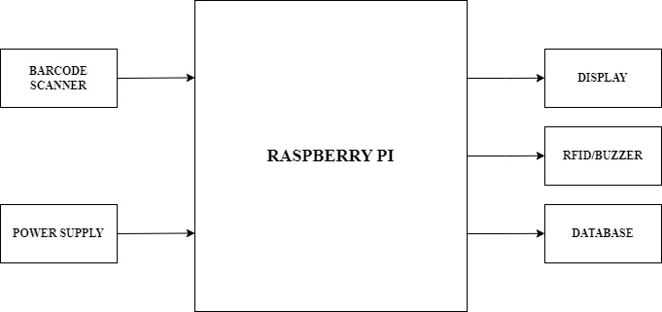
Fig. 1 Block diagram showing the connection between the component of the trolley
3.3 Flowchart
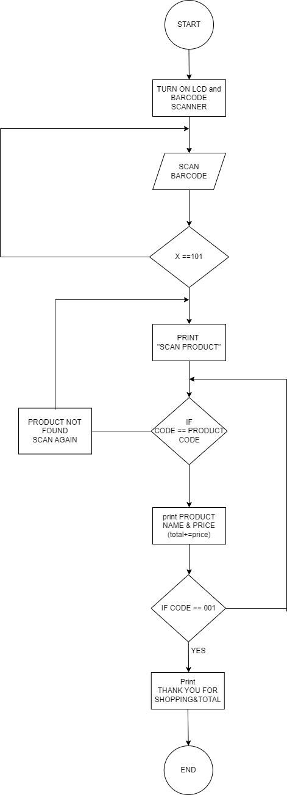
Fig. 2 Flowchart
3.4 Load capacity design calculation
Shopping cart weight capacity depends on load capacity. A cart's load capacity is its maximum weight without structural damage.
Cart materials and structure determine load capacity. The estimate considers the materials' yield strength, ultimate strength, and design safety features.

$Load Capacity= {(σy ×FoS)}/A$ (1)
Where;
$σy$is the yield strength of the material used;
FoS is the safety factor;
A is the cross-sectional area.
4 Result and discussion
This section details how the supermarket billing cart was developed and deployed. The system's hardware was extensively tested before being carefully combined and attached to the microcontroller board. This detailed approach has generated an efficient and smooth automated billing trolley system that can offer supermarket customers with reliable and accurate billing services.
4.1 Shopping Cart
The main function of the shopping cart is to give customers a practical way to transport the goods they want to buy as they shop. This was achieved by meticulously designing the trolley to accommodate a variety of items and make it easy to operate. The cart's durability and longevity are ensured by its construction with premium 1-inch steel conduit and iron wire gauze net. In Fig. 3, which depicts the completed grocery cart after its construction, demonstrates the efficacy of this design.

Fig. 3 Rear View and Side View of Shopping Trolley
4.2 Automated Billing System
The cutting-edge Automatic Billing System speeds up grocery checkout lines. The shopping cart-mounted gadget allows customers to scan and pay without going to the checkout stand. This system uses a barcode scanner, Raspberry Pi microprocessor, and LCD to quickly and easily charge customers. Instead of the time-consuming checkout procedure, customers may charge their purchases while shopping. This inventive solution's easy checkout makes shopping stress-free. Fig. 4 shows the barcode scanner being tested and the LCD showing the value that was scanned.
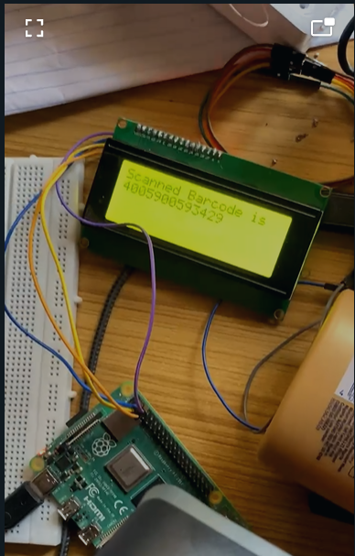
Fig. 4 Billing system Test
4.3 Automated Billing System on Trolley
Promising test results were observed, validating the functionality of the project components. The system effectively displays product information, including name and price, on an LCD screen upon customer scanning. It continuously updates the running total as items are scanned, providing customers with spending transparency. The end shopping barcode triggers payment processing, where all scanned items are displayed for verification. This successful implementation improves the shopping experience by offering real-time information and streamlining payments. Future iterations could explore additional features like mobile app integration or loyalty programs. Ultimately, the project shows potential to enhance efficiency, reduce wait times, and increase customer satisfaction. Fig. 5 shows how the billing system and the barcode scanner is mounted on the shopping trolley for customer convenience. Fig. 6 shows the result on the display when a product registered in the shopping mall is scanned.

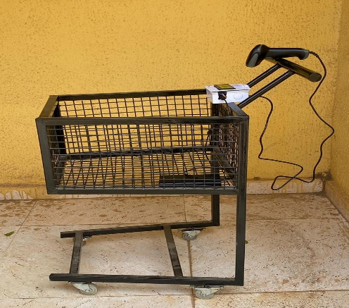
Fig. 5 Final Shopping Trolley system
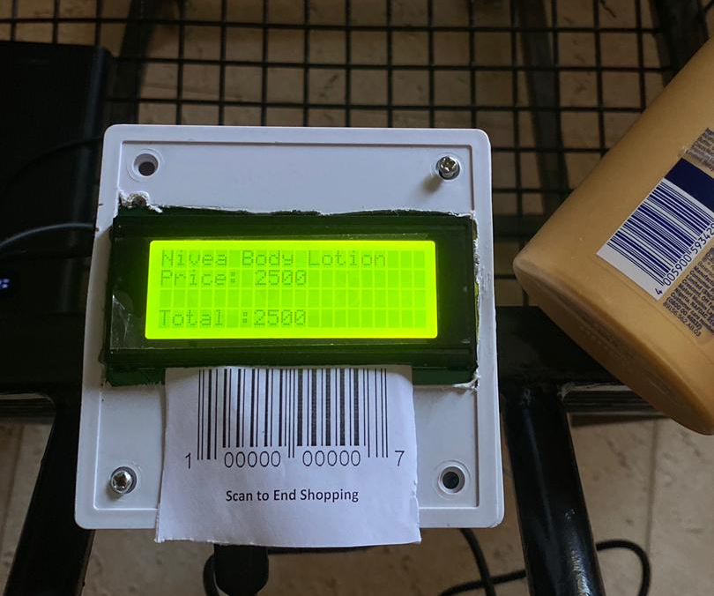
Fig. 6 Display when product is scanned
5 Conclusion
The development of an automated billing system for supermarkets was a significant achievement. The Python-programmed system, operated by Raspberry Pi, streamlined the checkout process, enhancing speed and efficiency. Its creation followed a well-defined methodology, resulting in a functional, reliable, and user-friendly final product. The system's goal was to improve the shopping experience by speeding up checkout, allowing customers more time for browsing. This, in turn, encourages repeat business and attracts new customers. By reducing manual labor and calculation errors, the system offers a dependable and efficient billing procedure, benefiting supermarket operators. Overall, the automated billing system is a valuable addition for stores seeking to enhance checkout procedures, benefiting customers and store owners alike.
References
[1] Shahroz, M., Mushtaq, M. F., Ahmad, M., Ullah, S., Mehmood, A., & Choi, G. S. (2020). IoT-based smart shopping cart using radio frequency identification. IEEE Access, 8, 68426-68438.
[2] Karjol, S., Holla, A. K., Abhilash, C. B., Amrutha, P. V., & Manohar, Y. V. (2018, April). An IOT based smart shopping cart for smart shopping. In Cognitive Computing and Information Processing: Third International Conference, CCIP 2017, Bengaluru, India, December 15-16, 2017, Revised Selected Papers (pp. 373-385). Singapore: Springer Singapore.
[3] Sutagundar, A., Ettinamani, M., & Attar, A. (2018). IoT based smart shopping mall. In 2018 Second International Conference on Green Computing and Internet of Things (ICGCIoT) (pp. 355-360). IEEE
[4] Guo, H., & Li, J. (2014). Research on the application of intelligent campus supermarket system--based on the Internet of Things (IOT) technology. In 2014 seventh international symposium on computational intelligence and design (Vol. 1, pp. 390-394). IEEE.
[5] Sutagundar, A., Ettinamani, M., & Attar, A. (2018). IoT based smart shopping mall. In 2018 Second International Conference on Green Computing and Internet of Things (ICGCIoT) (pp. 355-360). IEEE
[6] Chen, R., Peng, L., & Qin, Y. (2010). Supermarket shopping guide system based on Internet of things. IET Conference Publications, 1(1), 17–20. https://doi.org/10.1049/cp.2010.1020
[7] Suraj, S., Guruprasad, V., Pranava, U. R., & Nag, P. S. (2016). RFID Based Wireless Intelligent Cart Using ARM7. International Journal of Innovative Research in Science, Engineering and Technology, 5(8), 1-10.
[8] Bhatwal, P., & Chamoli, O. (2015). Automated Self-Billing System Using RFID Technology. International Journal of Emerging Trends & Technology in Computer Science (I JETTCS), 4(2), 1–5.
[9] Peradath, A. N. J. A. L. I., Purushothaman, A. N. J. A. L. I., Gopinath, A. N. J. A. N. A., Km, A. N. U. S. R. E. E., & Joe, N. (2017). RFID based smart trolley for supermarket automation. International Research Journal of Engineering and Technology, 4(7), 1975-1980.
[10] Imran, I. R. (2022). Design and Implementation of Autonomous Trolley with E Billing. International Journal of Innovations in Science & Technology, 4(3), 670–682. https://doi.org/10.33411/IJIST/2022020309
[11] Kowshika, S., Varshini, G. M., Megha, V., & Lakshmi, K. (2021). IoT based Smart Shopping Trolley with Mobile Cart Application. In 2021 7th International Conference on Advanced Computing and Communication Systems (ICACCS) (Vol. 1, pp. 1186-1189). IEEE.
[12] Rao, M. (2018). RFID Based Smart Trolley Using IOT. International Journal of Science and Research (IJSR).
[13] Dev, M. K., Kannan, R., Agarshan, M., Karthik, S., & Lakshmi, K. (2021). Automated billing smart trolley and stock monitoring. In 2021 5th International Conference on Computing Methodologies and Communication (ICCMC) (pp. 500-505). IEEE.
[14] Murugesan, S. (2021). SMART MOTORIZED TROLLEY. INFORMATION TECHNOLOGY IN INDUSTRY, 9(3), 186-190.
[15] Shankar, S. K., S, B., Basha, S. A., Ahamed, S. A., & Reddy, N. S. K. (2021). Smart Trolley for Smart Shopping with an Advance Billing System using IoT. Proceedings of the Fifth International Conference on Computing Methodologies and Communication (ICCMC 2021), 390–394.
[16] Chattoraj, S., Bhowmik, S., Vishwakarma, K., & Roy, P. (2017). Design and implementation of low cost electronic toll collection system in India. In 2017 Second International Conference on Electrical, Computer and Communication Technologies (ICECCT) (pp. 1-4). IEEE.
[17] Arora, J., Gagandeep, S. J., & Kumar, R. (2018). Smart Goods Billing Management and Payment System for Shopping Malls. International Journal of Engineering & Technology, 7(2.7), 456-461.
[18] Kaur, A., Singh, G., Kukreja, V., Sharma, S., Singh, S., & Yoon, B. (2022). Adaptation of IoT with Blockchain in Food Supply Chain Management: An Analysis-Based Review in Development, Benefits and Potential Applications. Sensors, 22(8174), 1–13.
[19] Shankar, S. K., S, B., Basha, S. A., Ahamed, S. A., & Reddy, N. S. K. (2021). Smart Trolley for Smart Shopping with an Advance Billing System using IoT. Proceedings of the Fifth International Conference on Computing Methodologies and Communication (ICCMC 2021), 390–394.
[20] Farooq, U., Hasan, M., Amar, M., Hanif, A., & Asad, M. U. (2014). RFID based security and access control system. International Journal of Engineering and Technology, 6(4), 309.
[21] Juels, A. (2006). RFID security and privacy: A research survey. IEEE journal on selected areas in communications, 24(2), 381-394
[22] Munoz-Ausecha, C., Ruiz-Rosero, J., & Ramirez-Gonzalez, G. (2021). RFID applications and security review. Computation, 9(6), 69.

