Impact of Climate Variability on the Prevalence of Malaria and Cholera in Minna and Environs.
Usman, Abdullahi Alfa¹, Suleiman, Yahaya Muhammed² , Abdulahkeem Salau Bello³
Department of Geography Federal University of Technology Minna
aausman78@gmail.com 08065929444

Sub-Theme: Educational Research for Development Communities

Abstract
The study set out to examine the trend in the prevalence of Malaria and Cholera for 20 years in Minna from 1996 – 2015.The Data for the study was extracted from Medical archive of malaria and cholera of in-patient and out-patient cases on monthly and yearly basis in public hospitals and private clinics in Minna which was analysed using trend line analysis .The study found out that10,000 people were infected with malaria in 1996, 1997 - 2008 showed a fluctuating trend of malaria cases, while 2009 showed an increase and highest recorded cases of 40525 people infected with Malaria. It was also established that the monthly trend of people infected with Malaria indicates that people infected with Malaria tends to increase gradually by April at beginning of raining season and attained a peak at September before declining in November. However the annual trend of cholera cases showed that 1250 people were infected in 1996 which also fluctuated to a drop in 2004 and a rise in 2005 to 5062 people being the highest cases of cholera occurrence before it fluctuated to a drop in 2015.while the monthly trend pattern showed cholera with highest occurrence during the peak of rainfall in August and lowest in December. This study concluded that rainfall is the major determinant factor for the prevalence of malaria and cholera cases in the study area. It is recommended that government continues the awareness program on the use of treated mosquito net and sanitation to prevent and reduce incidence cases of malaria and cholera.
Keywords: Cholera, climate change, Malaria, Rainfall, Trend

1.0 INTRODUCTION
1.1 Background to the study
Climate change encompasses both increases and decreases in temperature as well as shifts in precipitation, changing risks of certain types of severe weather events, and changes to other features of the climate system.
It has been unequivocally established that the emission of greenhouse gases (GHGs) by man is altering the Earth's climate system (IPCC, 2013). Observational data have shown that since the 1950s, the atmosphere and ocean have warmed, sea levels have risen, and GHGs’ concentration is increasing (IPCC, 2013). According to the latest Intergovernmental Panel on Climate Change (IPCC) Assessment Report Five (AR5), the average global trend of land and ocean warming between 1880 and 2012 is 0.85°C, with the last three decades being the warmest in the period, while the average sea level rise is about 0.19m. These increases have been associated with anthropogenic emissions of GHGs by several studies (Hegerl et al., 2006; Ingram, 2017). The causes of this change are increasingly well understood. The Third Assessment Report of the Intergovernmental Panel on Climate Change, published in 2018, Global warming will likely rise to 1.5 °C above pre-industrial levels between 2030 and 2052 if warming continues to increase at the current rate. Anthropogenic greenhouse gas emissions have so far contributed 0.8–1.2 °C (1.4–2.2 °F) of warming. The gases which have already been emitted are unlikely to cause global temperatures to rise to 1.5 °C alone, and a global temperature rise to 1.5 °C above pre-industrial levels is avoidable depending on the rate of further emissions. Climate-related risks associated with increasing global warming depend on geographic location, "levels of development and vulnerability", and the speed and reach of climate mitigation and climate adaptation practices.
Climate variability and change are caused essentially by natural and anthropogenic activities. The natural activities include interaction of the oceans and the atmosphere, changes in the earth’s orbit, changes in the energy received from the sun and volcanic eruptions. Very recently, there was a consensus that anthropogenic activities constituted the major cause of climate change. Human-induced alterations of the natural world have contributed to the high increase in the rate of gaseous emissions into the atmosphere, thereby causing global warming.
Over the decades, it is revealed that anthropogenic activities like urbanization, population explosion, deforestation, industrialization and the release of greenhouse gases contribute highly to the depletion of the ozone layer and its associated global warming, climate variability and change. The World Health Organization (WHO) estimates that about 150,000 deaths annually (especially in African countries) are attributable to climate change. ( Odjugo, 2009)
Despite Africa’s small carbon emissions, the negative impact of climate change will be more pronounced in this continent (Muller, 2009). Africa has been described as a “hot spot” and vulnerable to climate change, with respect to challenges such as extreme weather events, drought, disease, water scarcity, and low coping capacity (e.g., Collier and Venables, 2008;Connor and Mantilla, 2008; Diffenbaugh and Giorgi, 2012; WHO,2013a).
According to the IPCC AR4 on Africa, since 1960s, the air temperature in Africa has a significant trend of warming (IPCC, 2007a; Muller, 2009). Despite the consistency in the warming trend across the continent, spatial differences are to be noted: these are characterized by inter annual variability (Kruger and Shongwe, 2009).
Climate change is projected to impact on sub-Saharan Africa disproportionately, via an increase or decrease in rainfall, an increase in temperature, and extended droughts . Despite the uncertainties involved in climate model projections, there is seemingly a consensus that these changes might have a severe impact on Africa, although details of these are still not clear at the local level (Muller, 2009).
Malaria is a life-threatening parasitic disease transmitted by female mosquitoes of the genus Anopheles it is endemic in over 100 countries, causing an estimated 900 million clinical cases and almost 3 million deaths annually (Sutherst,.2014) Malaria is a major public health burdening the tropics, and has the potential to significantly increase in response to climate change . Over the past century the world has warmed by 0.6˚C, with a range of ecological consequences.
According to WHO (2004). Malaria kills over one million people each year, while 300 to 500 million people are suffering from chronic malaria around the world. This is one of the most common and serious diseases of our time. The death toll is predicted to double in the next 20 years if no new control measures are developed (Chapman., et al 2010).
Succinctly, the problems of climatic variation which include flooding, storms, etc., have a marked effect on the prevalence of mosquitoes which cause malaria. The disease, malaria, is a major health problem in Nigeria, with stable transmission throughout the country. It accounts for about 50% of out-patient consultation, 15% of hospital admission, and also prime among the top three causes of death in the country National Malaria Control Plan of Action 1996 to 2001 (WHO 2011)
In Africa, cholera cases and deaths are reported to be increasing both in severity and number, most especially in countries like Nigeria (Marin, 2013). The endemic nature of cholera (Harris et al., 2012) makes it one of the major public health threats in these countries (where the environmental and food hygiene tradition remains grossly insufficient.
In Minna and environs, weather and climate tend to affect the spread of malaria and cholera. The rate of increased precipitation stimulates breeding sites of mosquito which results in an increased mosquito bite. The residence of Minna is vulnerable to mosquito bite resulting in malaria because most of the houses are within the fringes of water bodies, farm gardens and tall grasses as well as within the flight distance from its respective breeding habitats. Mosquitoes also breed on the edges of ponds and streams, open septic tanks, open cesspools, over flowing sewages, water barrels, clogged troughs, street catch basins, also these people tend to suffer from cholera diseases due to contaminated wells, streams and rivers caused by floods,

  - Statement of the Research Problem
Adverse effects of climate change are threatening to undo decades of development efforts and frustrate poverty eradication programs in developing countries, (Pearce et al., 2015).and the burden of malaria varies across different areas of the globe and even within a nation (mark et al., 2014). Succinctly, the problems of climatic variation which include flooding and storms, etc., have a marked effect on the prevalence of mosquitoes which cause malaria.
The disease, malaria, is a major health problem in Nigeria, with stable transmission throughout the country. It accounts for about 50% of out-patient consultation, 15% of hospital admission, and also prime among the top three causes of death in the country National Malaria Control Plan of Action 1996 to 2001 (Efe et al., 2013). Lately, the United Nations agencies for health (World Health Organization (WHO)) and meteorology (World Meteorological Organization (WMO)) revealed new evidence linking the prevalence of infectious diseases such as meningitis, diarrhoea, and malaria to climate change (Miller, 2013).
In developing countries, increase in diarrhoeal disease, cholera, malaria, and typhoid is of specific concern (Morris et al., 2005).The observed changes in climate and the likely increases in the risk of infectious diseases led to growing concern of the organization, which sparked a plethora of research around the possible dimensions of these alterations and their extent, and also exploring the potential to predict climate change’s future impact on important diseases (Kovats et al., 2013).
The projected risks to health that are attributable to climate change will vary in magnitude and by region, but they are anticipated to be mainly negative, most especially in developing nations. Also Increases in malnutrition and diarrhoea-related disease is expected, mainly in low-income populations (Nicola et al., 2016).
As pointed out by Lubchenco and Karl (2012), we necessitate to cognize how much and how frequent any changes in climate variables should be awaited with an extreme weather event in order to forecast its impacts. Although studies exist on the relationship between climate and diseases such as cholera and meningitis (Marin 2013).Yet there is a rarely a study on the impact of climate variability on the prevalence of malaria in this study area so this current research intends to fill in the gap by exploring the nexus between selected climatic variables, rainfall and temperature and selected climate- sensitive infectious diseases, malaria and cholera diseases in Minna.Through the utilization of both primary data and secondary information.
  - Material and Method
The Data for this study was extracted from Medical archive of malaria and cholera of in-patient and out-patient cases on monthly and yearly basis for 20 years from public hospitals and private clinics in Minna which was analysed and plotted using trend line analysis.

  - Result and Discussion

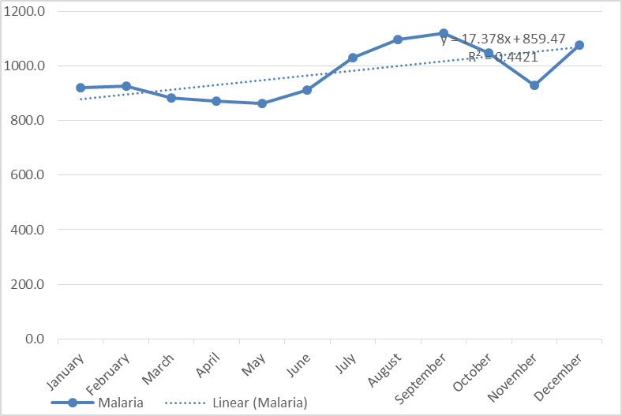
Figure 1. Mean Monthly Trend Pattern of Malaria from January to December
Figure 1 showed the monthly trend pattern of people infected with malaria, which indicates that people infected with malaria is lower in January, February and march this is due to the reason that the development of the malaria parasite (Plasmodium falciparum and Plasmodium vivax) ceases when temperature exceeds 33°–39 °C (Guerra et al., 2010). The trend tends to increase gradually by April during the raining season and showed a peak in September with people infected with malaria this is also due to the reason that the Larval development of some mosquito vectors accelerates with increased rain and rising temperature (Wu et al., 2016) before declining in November during the dry spell.

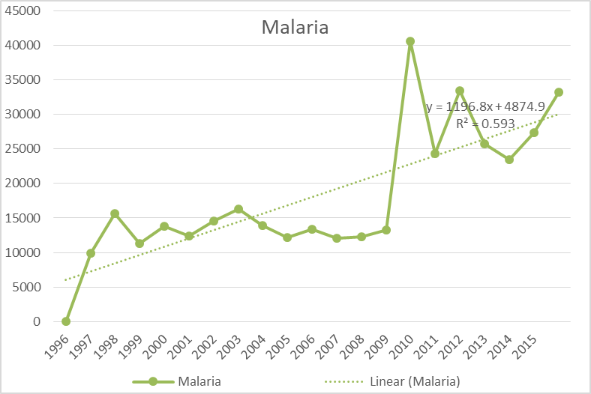
Figure 2 Annual Trend Pattern of Malaria 1996 to 2015
Figure 2 depicts the annual trend of malaria cases which shows that 10000 people were infected with malaria in 1996 at the beginning of the study and from 1997 - 2008 showed a slight fluctuation of malaria cases. While 2009 showed a tremendous increase and highest number of people infected with malaria to 40525 people. 2010 to 2015 however fluctuated with and upward trend.

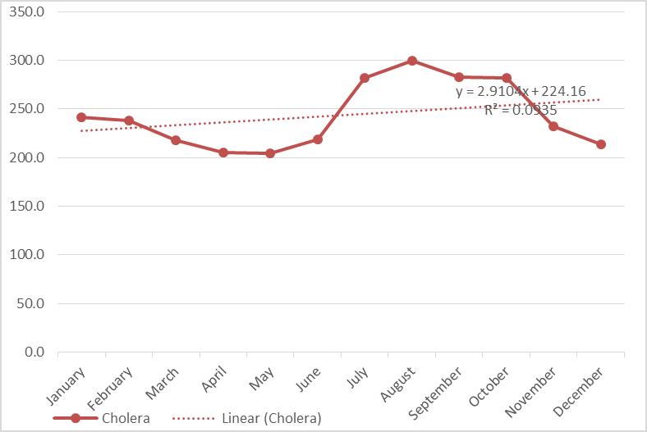
Figure 3 Mean Monthly Trend Pattern of Cholera.
Figure 3 shows that people infected with cholera were lower below the mean during the month of March, May and April and fluctuated to a peak in august with the highest number of people infected with cholera. August being the month of highest recorded rainfall also shows that cholera cases are most prevalent in the month of August.( Cann et al.,2013) heavy rainfall events are associated with outbreaks of waterborne disease.Also this is because disease agents (viruses, bacteria, and other parasites) and their vectors (such as insects or rodents) are clearly sensitive to temperature, moisture, and other ambient environmental conditions (Ayanlade et al., 2010; Shuman, 2011).

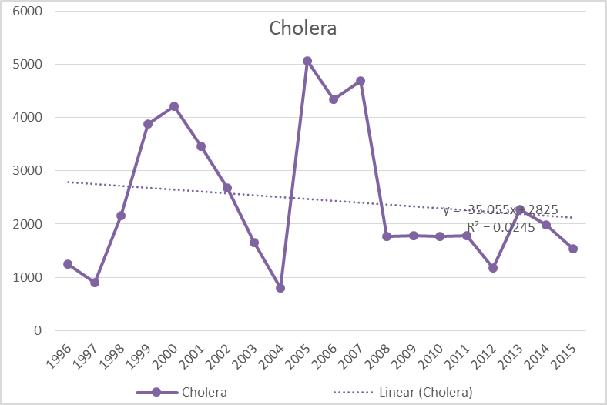
Figure 4. Annual Trend Pattern of Malaria 1996 to 2015.
Figure 4 showed the annual trend of cholera cases with 1250 people infected in 1996 as the lowest year with people infected with malaria while 1997 to 2000 showed an increased number of infected to 4200 people. 2001 to 2004 shows a fluctuation of cholera cases before an immediate rise in 2005 which recorded highest cases of cholera with 5062 people before it fluctuated to a drop from 2005 to 2015.

  - Conclusion and Recommendation
Climate change plays a significant role in the prevalence of both cholera and malaria cases in the study area. If climate change continues unabated, it is likely that the range of these deadly diseases (malaria and cholera) will continue to be on the increase. This research also found out that rainfall is the major determinant factor for the prevalence of cholera and malaria cases in the study area. As the rainfall amount increases from the beginning of the study period (1996) to the recent years, so also the number of cholera and malaria cases gradually increases with slight fluctuations. The study recommends the reduction in greenhouse gas emissions which is the major cause of climate change; that laws should be enacted on indiscriminate waste disposal along water channels in the area, and the monthly environmental sanitation should be encouraged and strengthened. People should ensure that there is no any stagnant water around their surrounding and grasses should be cleared. Also, the use of mosquito nets should be encouraged by the government. Government should also assist in the sinking of bore holes in rural communities, and people should also be ensured that water obtained from ponds is treated before consumption.

References
Ayanlade, N. O. Adeoye and O. Babatimehin, “Cli- mate Change/Variability and
MalariaTransmission in Sub-Saharan Africa: A Case of Nigeria,” An
International Conference on the Occasion of the 250th Anniversary of the
Royal Norwegian Society of Sciences and Letters, Trondheim 21-24 June 2010.
Cann, K., Thomas, D., Salmon, R., Wyn-jones, A., & Kay, D. (2013). Extreme
water-related weather events and waterborne disease. Epidemiology and
Infection, 141(4), 671-686.
Connor, S. J., & Mantilla, G. C. (2008). Integration of seasonal forecasts into early warning
systems for climate-sensitive diseases such as malaria and dengue (Vol. 30).
Guerra CA, Howes RE, Patil AP, Gething PW, Van Boeckel TP, et al. (2010)
The international limits and population at risk of Plasmodium vivax transmission in
2009. PloS Neglected Tropical Diseases 4:
Efe SI, Ojoh C (2013) Climate variability and malaria prevalence in Warri metropolis.
Atmosphere Climate Science 3:132–140, Scientific Research USA.
IPCC. (2007). Climate Change 2007: Synthesis Report. In Pachauri, R.K and A. Reisinger,A.
(Eds.). Contribution of Working Groups I, II and III to the Fourth Assessment Report
of climate change.
Kovats, R.S., Menne, B., McMichael, A.J., Corvalan, C., Bertollini, R., 2013. Climate
Change and Human Health: Impact and Adaptation. World Health Organization
Hegerl, G. C., Karl, T. R., Allen, M., Bindoff, N. L., Gillett, N., Karoly, D., Zwiers, F.
(2006).Climate change detection and attribution: Beyond mean temperature signals.
Journalof Climate, 19(20), 5058-5077. Islands: Minimizing Impacts Through Rainfall
Forecasts and Hazard Mitigation. Pacific ENSO Applications Center, Honolulu.
Ingram, W. J. (2017). Detection and attribution of climate change, and understanding solar
influence on climate. Space Science Reviews, 125(1-4), 199-211.
Lubchenco, J., Karl, T.R., 2012. Predicting and managing extreme weather events
Today 65, 31–37
Mark Musumba, Aklesso Egbendewe‐Mondzozo and Bruce A. McCarl, Analysis of the Cost
of Malaria in Children and Use of Insecticide‐treated Bednets in Africa, African
Development Review, 26, 1, (74-87), (2014)
Marin, M.A., Thompson, C.C., Freitas, F.S., Fonseca, E.L., Aboderin, A.O., Zailani,
S.B., et al. ( 2013) Cholera outbreaks in Nigeria are associated with multidrug
resistant atypical El Tor and Non‐O1/Non‐O139 Vibrio cholerae.
Miller, A. (2013). UN atlas links climate change to disease spread. Canadian Medical
Association Journal, 185(1),
Morris, J. G. (2005). Cholera and other types of vibriosis: A story of human pandemics and
oysters on the half shell. Clinical Infectious Diseases, 37(2), 272-280.
Müller, C. (2009). Climate change impact on Sub-Saharan Africa: an overview and analysis
Of scenarios and models: German Development Institute/Deutsches Institut für
Entwicklungspolitik (DIE).
Nicola Bulled, Merrill Singer. 2016. Health and the Anthropocene. A Companion to the
Anthropology of Environmental Health, pages 483-516.
Odjugo, P. A. O. (2009). The Impact of Climate Change on Water Resources; Global and
Regional Analysis. Indonesian Journal of Geography, 39(1), 23-41.
Pearce, T., Ford, J., Willox, A., & Smit, B. (2015). Inuit Traditional Ecological Knowledge
(TEK), Subsistence Hunting and Adaptation to Climate Change in the Canadian
Arctic. Arctic,68(2), 233-245.

Sutherst, R.W. (2014) Global Change and Human Vulnerability to Vector-Borne Diseases.
Clinical Microbiology Reviews,17, 136-173.
Wu, X.X., Y.M. Lu, S. Zhou, L.F. Chen, and B. Xu. 2016. Impact of climate change on
human infectious diseases: Empirical evidence and human adabtation
Environment International 86: 14–23.

