Fabrication of dye sensitized solar cell using produced platinum doped multiwall carbon nanotube as counter electrode.

Ibrahim S. O.
Department of Physics, Federal university of Technology, Minna, Nigeria

sharifat.ibr@futmina.edu.ng,

Carbon nanotubes (CNTs) were synthesised by catalytic chemical vapour deposition (CCVD) method. The synthesised CNTs was purified with acid to remove the catalyst impurities and to enhanced deposition platinum (Pt) onto the CNTs surface. Platinum multiwall (Pt-MWCNTs) nanocomposites were produced by a wet impregnation technique and a known amount (0.5 g) nanocomposites was dispersed in Texanol and Acrylic resins to form a paste. The paste was screen printed on an FTO glass substrate. Surface morphology, chemical composition, crystallographic structure electrical performance of the obtained Pt-MWCNTs nanocomposites were confirmed by HRSEM, HRTEM, EDS, XRD. The produced MWCNTs and Pt-MWCNTs were used as counter electrode to fabricate the dye sensitized solar cell. The efficiency of MWCNTs, Pt-MWCNTs solar cell were found to be 0.28 and 1.71 respectively and the cell with Ecolcarb was found to: $η=0.16\%.$

INTRODUCTION
Dye sensitized solar cells (DSSCs) have attracted much attention recently and becomes potential alternatives to conventional silicon solar cells. This is due to their ease fabrication process, environment friendly materials, relatively low cost and moderately power efficiency values (O’Regan and Gratzel, 1991; Nakade, et al, 2002; Siwach et al., 2017; Siwach et al., 2019). A typical DSSC device is made up of four main components: a photoanode (TiO₂ or ZnO), a sensitizer which is the dye, a redox coupled electrolyte, and a counter electrode (CE). The photoanode is usually fabricated from titanium oxide (TiO₂) or zinc oxide (ZnO) nanoparticles and the surface is covered with the sensitizer dye molecules. A redox couple made up of iodide/triiodide ions dissolved in acetonitrile serves as a liquid electrolyte in DSSCs. As a result of high catalytic activity towards reduction of electrolyte, platinum (Pt) is the most common material been employed as a CE in this device (Sedghi and Miankushki, 2014; Siwach, 2019). Pt based DSSCs have achieved high efficiency values of about 13.0 % (NREL 2024) but high cost and limited stores of this metal are the major factors that increase the overall cost of DSSCs and hence hinders the commercialization of this cell on large scale (Chiba et al., 2006). Recently, many carbonaceous materials such as carbon black, graphene, carbon nanotubes etc. are being studied and introduced into DSSCs system as a low-cost replacement of Pt CEs owing to their special properties such as high surface area, good corrosion resistance towards iodine, high catalysis for triiodide reduction and low cost when compare with the cost of platinum metal (Siriroj, et al., 2012; Siwach et al., 2019). Among them carbon nanotubes (CNTs) have attracted huge attention due to their outstanding properties like excellent electronic properties, high mechanical strength, and good thermal stability (Zheng, et al., 2015). Lee and his group employed single wall carbon nanotubes (SWCNTs) and multi wall carbon nanotubes (MWCNTs) as CEs in DSSCs and obtained efficiency of 4.03 % and 4.36 % for SWCNTs and MWCNTs CE respectively (Lee et al., 2010; Siwach et al., 2019). This value which is higher than the DSSC based on Pt based counter electrode. Hence there is a crucial need for a low-cost CE which possess high catalytic activity that can significantly increases the practical applications as well as commercialization of DSSCs.
In this paper, CE based on Pt, MWCNTs, and Pt/MWCNTs were Synthesized and their effect on photoconversion efficiency of DSSCs were investigated.

MATERIALS AND METHODS
Materials for Dye sensitized Solar Cells (DSSCs).
All chemicals that were employed for this study were analytical grade, ranging from 98.0 to 99.9 % purity.
Synthesis and characterization of MWCNTs and Pt/MWCNTs counter electrodes for dye sensitized solar cells was previously done in our earlier study (Ibrahim et al., 2017; Aliyu et al., 2017; Afolabi, 2009). N749 dye (Black dye), FTO (15 Ω sq-1) were purchase from Solaronix in Switzerland, and MWCNTs which was previously synthesized was used to produced Pt-MWCNTs and finaly the prepared Pt-MWCNTs was used as counter electrode (CE) material. The
Polyethylene glycol (PEG₂₀₀₀₀) was purchased from Himedia (India). De-ionized water was used throughout the experimental procedure to avoid contamination. The DSSC photoanodes were fabricated by doctor blading the TiO₂ nano powder on pre-cleaned FTO substrate as it was discussed by (Siwach, et al., 2017).
The MWCNTs was treated with acid before their use as CE of DSSCs. The procedure for acid treatment of MWCNTs was described in our previous studies (Ibrahim, et al., 2017; Afolabi et al., 2011) The Pt CE film was prepared by dropping H₂PtCl₆ solution on the FTO glass and then annealed at 400 °C for 30 min. The MWCNTs CE and Pt/MWCNTs CE films were prepared by coating their pastes on the conducting side of the FTO glass with doctor blade method and annealed at 400 °C for 30 min.
The paste of MWCNTs was prepared by grinding the acid treated MWCNTs powder and the binder carboxymethyl cellulose (CMC) with de-ionized water in a mortar & pestle for about 1 h. Similarly, Pt/MWCNTs paste was also prepared by treating MWCNTs (0.2 wt%), CMC and H₂PtCl₆ (0.2 wt%) with acid using pestle and mortar for about an hour. (Ibrahim et al., 2020: Abdulkareem et al.,2016)
The DSSCs having different CEs were assembled by using a sandwich-type configuration. Now, the DSSCs with different CEs such as Pt CE, MWCNTs CE, and Pt/MWCNTs CE were assembled in a sandwiched configuration i.e. by putting dye loaded TiO₂ photoanodes on the top of each CE, respectively and finally filled with an iodide/triiodide based liquid electrolyte to complete the cell structure. Solar simulator was used to to determine the current-voltage(I-V) characteristics of the cell.
For UV- Spectroscopy measurement, UV-VIS Spectrometer, 1800 series was used to measure the absorbance of the particular layer:

RESULTS AND DISCUSSION

Figure 1: The peak absorbance of MWCNTs and Pt-MWCNTs.
The optical band gap of CNTs and Pt-MWCNT were evaluated from the absorption spectra using Tauc plot and using the equation (1) below.
$$αhv=A{\left(hv-E_{g}\right)}^{n} \left(1\right)$$
Where:
A is a constant, Eg is band gap, n is different allowed transition

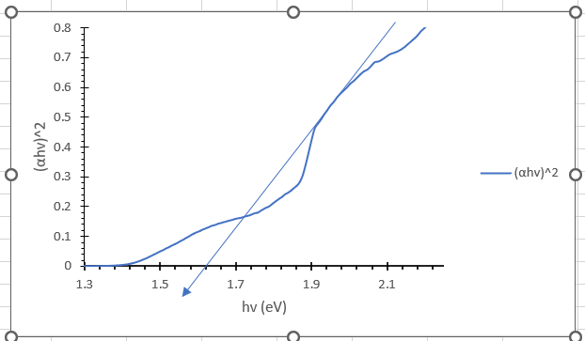
Figure 2: Optical band gap of MWCNTs was found to be 1.62 eV

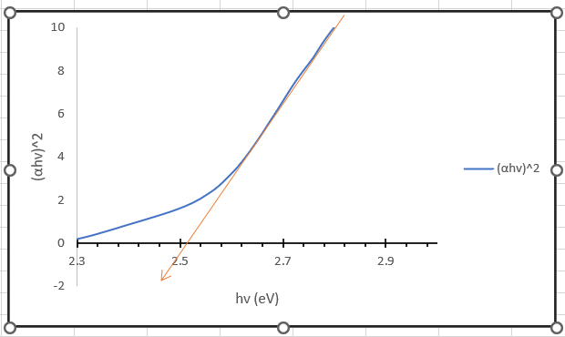
Figure 3: Optical band gap of Pt-MWCNTs was found to be 2.52 eV
Current-voltage analysis
The efficiency of the cells was calculated by the product of Voc, Jsc and FF divided by a Voc of 100mW/cm². It was under an illumination of AM 1.5 (P_{in}).
The formula that was used for the fill factor (FF) and efficiency are:
FF (fill factor) = $\frac{P_{max}}{\left(V_{oc} ×I_{sc}\right)}$
$η$ = $\left(\frac{P_{max}}{P_{in}}\right)$ x 100

ECOLCARB: - Current voltage analysis
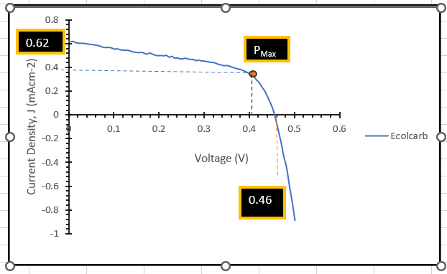
Figure 4: Current-voltage Curve for Ecolcarb
DSSC Efficiency FOR ECOLCARB WAS CALCULATED AS:
J_{max} = 0.39 mAcm⁻²
V_{max} = 0.41V
J_{sc} = 0.62 mAcm⁻²
V_{oc} = 0.46V
$\text{ Fill} \text{factor} (FF)= \frac{P_{max}}{V_{OC}J_{SC}}= \frac{V_{max}J_{max}}{V_{OC}J_{SC}}$
$FF= \frac{0.41×0.39}{0.46×0.62} =\frac{0.16}{0.35}=0. 56$
$\text{η}= \frac{{FF.V}_{oc}.J_{sc}}{P_{in}}$ =$\frac{0.56×0.46×0.62}{100}×100 =0.$16 %
MWCNTs: Current voltage analysis of MWCNTs

Figure 5: Current-voltage Curve for MWCNT
DSSC Efficiency FOR MWCNTS WAS CALCULATED AS:
J_{max} = 0.61 mAcm⁻²
V_{max} = 0.38V
J_{sc} = 0.75 mAcm⁻²
V_{oc} = 0.46V
$\text{ Fill} \text{factor} (FF)= \frac{P_{max}}{V_{OC}J_{SC}}= \frac{V_{max}J_{max}}{V_{OC}J_{SC}}$
$FF= \frac{0.38×0.61}{0.46×0.75} =\frac{0.23}{0.35}=0. 66$
$\text{η}= \frac{{FF.V}_{oc}.J_{sc}}{P_{in}}$ =$\frac{0.66×0.46×0.75}{100}×100 =0.28\%$
Current voltage analysis of Pt-MWCNT
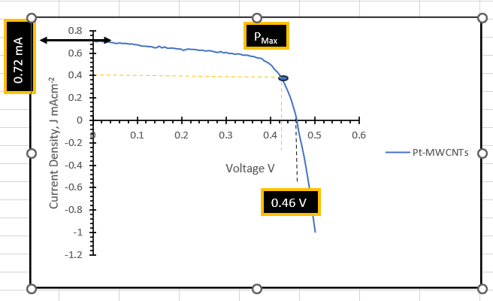
Figure 6: Current-voltage Curve for Pt-MWCNT
DSSC Efficiency FOR Pt-MWCNTS WAS CALCULATED AS:
J_{max} = 0.40 mAcm⁻²
V_{max} = 0.41V
J_{sc} = 0.72 mAcm⁻²
V_{oc} = 0.46V
$\text{ Fill} \text{factor} (FF)= \frac{P_{max}}{V_{OC}J_{SC}}= \frac{V_{max}J_{max}}{V_{OC}J_{SC}}$
$FF= \frac{0.42×0.40}{0.46×0.72} =\frac{1.7}{0.33}.=5.15$
$\text{η}= \frac{{FF.V}_{oc}.J_{sc}}{P_{in}}$ =$\frac{5.15×0.46×0.72}{100}×100 =1.71 \%$
Table : I-V Characterisation Parameters of DSSC with MWCNTs, Pt- MWCNT and Ecocarb

Counter Electrode | V_{0C} | J_{SC} | FF | $η$ %
ECOCALB | 0.46 | 0.62 | 0.16 | 0.16
MWCNTs | 0.46 | 0.62 | 0.66 | 0.28
Pt-MWCNTs | 0.46 | 0.72 | 5.15 | 1-71
SUMMARY: Current-Voltage Analysis
Table : I-V Characterisation Parameters of DSSC with ECOLCARB; MWCNTs, Pt- MWCNT

REFERENCE
Abdulkareem, A. S., Suleiman, B., Abdulazeez, A. T., Kariim, I., Abubakre, O. K. and Afolabi, A. S., (2016). Synthesis and Characterisation of Carbon nanotubes on Fe/Al₂O₃ Composite Catalyst by Chemical Vapour deposition Method. Proceedings of the World Congress on Engineering and Computer Science, San Francisco, USA, 11. Retrieved February 2017. ISBN: 978-988-14048-2-4
Afolabi, A. S. (2009). Development of carbon nanotubes platinum electro catalytic electrodes for proton exchange membrane fuel cell. Unpublished PhD thesis, University of the Witwatersrand, Faculty of Engineering and the Built Environment. Johannesburg, South Africa, 65-80.
Afolabi, A. S., Abdulkareem, A. S., Mhlanga, S. D., & Iyuke, S. E. (2011). “Synthesis and purification of bimetallic catalysed carbon nanotubes in a horizontal CVD reactor”. Journal of Experimental Nanoscience, 6(3), 248-262
Aliyu, A., Abdulkareem, A. S., Kovo, A. S., Abubakre, O. K., Tijani, J. O., Kariim, I. (2017). Synthesize multi-walled carbon nanotubes via catalytic chemical vapour deposition method on Fe-Ni bimetallic catalyst supported on kaolin. Carbon Letters, 21, 33-50.
Chiba, Y., Islam, A., Watanabe, Y., Komiya, R., Koide, N., & Han, L. (2006). Dye-sensitized solar cells with conversion efficiency of 11.1%. Japanese journal of applied physics, 45(7L), L638.
Ibrahim S. O., Isah, K. U., Abdulkareem A. S. and Ahmadu U., (2017). Synthesis and Characterisation of platinum doped multiwall carbon nanotube. Nigerian Institute of Physics (NIP) Book of Abstract 40th Annual conference, Federal University of Technology Minna. November 20-24, 2017, Pp 147.
Ibrahim S. O., Isah, K. U, Abdulkareem A. S, Ahmadu U, Tijani, J.O, Roos, W. D. (2020). Synthesis and Characterization of Platinum Multi-Walled Carbon Nanotubes Nanocomposite Film Electrode. Journal of Materials Science: Materials in Electronics. https://doi.org/10.1007/s10854-020-03550-0.
Lee, S. U., Choi, W. S., & Hong, B. (2010). A comparative study of dye-sensitized solar cells added carbon nanotubes to electrolyte and counter electrodes. Solar Energy Materials and Solar Cells, 94(4), 680-685.
Nakade, S., Matsuda, M., Kambe, S., Saito, Y., Kitamura, T., Sakata, T., ... & Yanagida, S. (2002). Dependence of TiO2 nanoparticle preparation methods and annealing temperature on the efficiency of dye-sensitized solar cells. The Journal of Physical Chemistry B, 106(39), 10004-10010.
National Renewable Energy Laboratory (NREL), (2024). Best Research-Cell Efficiency Chart. http://www.nrel.gov/ncpv/images/efficiency_chart.jpg.
O’Regan B, & Gratzel M., (1991). A low-cost, high-efficiency solar cell based on dye sensitized Colloidal TiO₂ films. Nature, 353(6346), 737-740.
Sedghi, A. (2014). Effect of multi walled carbon nanotubes as counter electrode on dye sensitized solar cells. International Journal of Electrochemical Science, 9(4), 2029-2037.
Siriroj, S., Pimanpang, S., Towannang, M., Maiaugree, W., Phumying, S., Jarernboon, W., & Amornkitbamrung, V. (2012). High performance dye-sensitized solar cell based on hydrothermally deposited multiwall carbon nanotube counter electrode. Applied Physics Letters, 100(24).
Siwach, B., Mohan, D., & Barala, M. (2019, August). Fabrication and characterization of MWCNTs and Pt/MWCNTs counter electrodes for dye sensitized solar cells. In AIP Conference Proceedings (Vol. 2142, No. 1). AIP Publishing.
Siwach, B., Mohan, D., & Jyoti, D. (2017). To investigate opulence of graphene in ZnO/graphene nanocomposites-based dye sensitized solar cells. Journal of Materials Science: Materials in Electronics, 28, 11500-11508.
Siwach, B., Mohan, D., Sharma, S., & Jyoti, D. (2017). Process optimization of dye-sensitized solar cells using TiO₂ TiO₂–graphene nanocomposites. Bulletin of Materials Science, 40, 1371-1377.
Siwach, B., Sharma, S., & Mohan, D. (2017). Structural, optical and morphological properties of ZnO/MWCNTs nanocomposite photoanodes for Dye Sensitized Solar Cells (DSSCs) application. Journal of Integrated Science and Technology, 5(1), 1-4.
Zheng, W., Qi, T., Zhang, Y. C., Shi, H. Y., & Tian, J. Q. (2015). Fabrication and characterization of a multi-walled carbon nanotube-based counter electrode for dye-sensitized solar cells. New Carbon Materials, 30(5), 391-396.

