STRUCTURAL AND OPTICAL CHARACTERISATION OF CZTS (Cu₂ZnSnS₄)/Ag NANOSTRUCTURE USING HYDROTHERMAL SYNTHESIS
Titus Yahaya, Mohammed Isah Kimpa*, Abubakar Alhaji Ahmad, Sherifat O. Ibrahim & Kasim Uthman Isah.
Department of Physics, School of Physical Sciences, Federal University of Technology, Minna, Nigeria.
*Corresponding Author: kimpa@futminna.edu.ng (+234-0-803-865-4849)

Abstract: Cu₂ZnSnS₄ (CZTS) powders were synthesized via hydrothermal process to grow silver (Ag) nanoparticles onto CZTS at different weight percentage of Ag (0.05 wt %, 0.025 wt% and 0.075 wt %). The obtained samples were characterized using X-ray diffractometry (XRD), Scanning Electron Microscopy (SEM), UV-visible spectroscopy (UV-Vis) and Raman Spectroscopy. It was observed that the presence of Ag enhanced the optical properties of CZTS with increasing concentration of the Ag while the XRD showed the presence of mixed amorphous and crystalline nature having short range periodicity of mixed ternary and quaternary phases of CuZnS or CZTS materials. The SEM images shows that the thin film were composed of several intersectional spherical shaped particles, It was observed that there is an increase in Ag content and decrease in Cu content when the ratio increases from 0 to 0.075 wt% and could be used in its application as a photocatalyst.
Keywords: Cu₂ZnSnS_{4,} photocatalyst, ternary, quaternary

- Introduction
The expansion of human society largely depends on safe energy supply and fossil fuel has been serving as the most reliable energy source but not stable. Human activities are closely resting on the use of several forms and sources of energy to perform work. The energy content of an energy source is the available energy per unit of weight or volume, and the challenge is to effectively extract and use this energy without significant losses in conversion, transportation or utilization [1]. Thus, the more the energy consumed, greater is the amount of work accomplished. By implication the economic expansion is thus directly correlated with greater levels of energy consumption. However, as a non-renewable energy source, the exhaustion of fossil fuel is inevitable and imminent in this century. To address this problem, renewable energy especially solar energy has attracted much attention, because it directly converts solar energy into electrical power leaving no environmental effect [2].
The quaternary Cu₂ZnSnS₄ (CZTS) compound, derived from CuInS₂ by replacing In(III) with Zn(II) and Sn(IV), has the advantages of optimum direct band gap (around 1.5 eV) for use in single-junction solar cells, abundance of the constituent elements, and high absorption coefficient (>10⁴ cm⁻¹) [4]. Thus, increasing attention has been paid on CZTS materials in recent years [5]
Low-cost solar cells based on CZTS films as absorber layers have achieved an increasing conversion efficiency [6]. CZTS nanocrystalline materials have been found to show potentials for use in negative electrodes for lithium ion batteries. Theoretical calculations have shown that conversion efficiency as high as 32 % was possible for CZTS layer of several micrometers [7].
In this work, we structurally and optically characterisation of CZTS (Cu₂ZnSnS₄)/Ag nanostructure using hydrothermal synthesis.
- Experimental Procedure
2.1 CZTS Hydrothermal Process
To synthesized CZTS, 0.2 mmol of CuCl₂.2H₂O, 0.1 mmol of ZnCl_{2,} 0.1 mmol of SnCl₄.5H₂O, 0.5 mmol of C₂H₅NS and 1.0 g of PAA were dissolve in 36 ml of deionised water under rigorous magnetic stirrer. The resulting solution was transfer to a Teflon-lined stainless steel autoclave of 45 ml capacity, which was then sealed and maintain at 150 ºC for 24hr and the autoclave was allowed to cool to room temperature naturally. The sample was labeled 150 ºC for 24hr. The precipitates were observed from the autoclaving of the sample and was centrifuged and washed with deionized water, absolute ethanol and acetone 2 after the other. Finally, the product was vacuum-dry at 80 ºC for 5h.
2.2 Hydrothermal Process of CZTS/Ag

The obtained CZTS powder was weigh at 0.76g and keep in a conical flask, and then various amount of AgNO₃ powder were added to it at vaarious percentage weight of 0.05wt%, 0.025wt% and 0.075wt% in 20 mL deionized water. The solution was then transferred into a Teflon-lined autoclave at 200 ºC for 1 hr in a microwave-assisted system for the hydrothermal process. Finally, the products were washed for about three times with ethanol and DI water, centrifuge and dry in a vacuum oven at 60 ºC for 1hr to obtain the desire composite of CZTS/Ag powders.

- Results and discussion
Fig. 1a shows the XRD patterns of CZTS thin films deposited. In the as-deposited sample, the broad hump ranging from 20º and 28º corresponds to the mixed amorphous and crystalline nature having short range periodicity of mixed ternary and quaternary phases of CuZnS or CZTS materials. Upon heat treatment (annealing at 150 ºC), the broad hump disappeared and a sharp peaks appears at 2θ around 28º, 32º, 48º and 57º which corresponds to (112), (020), (220) and (224) planes of tetragonal kesterite structure respectively (JCPDS Card no. 26-0575). The transfer of one phase to another phase depends on the formation of enthalpy for the particular phase [6]. The as-prepared CZTS thin film has the strongest reflection at (112) plane which is the most prominent plane of the sample.
On the other hand, it was observed that the pattern on Fig. 1 (b – d) films also have their strongest reflection at (101), (110) and (112) respectively which were the most prominent plane of the films. Reflections for planes (110), (020), (102), (101), (200), (220), (102), (211) and (323) were also observed for both samples. The planes were observed at a low intensity for CZTS/Ag (0.05 wt %) film and improved as the concentration of Ag increased to 0.025 wt%. It became obviously pronounce in the Ag content of 0.075 wt%. These results are similar to the ones obtained previously [8].
Fig. 2. shows the SEM image of the CZTS composites thin film sample obtained at different weight percentage of CZTS/Ag (0.05 wt %, 0.025 wt%, 0.075 wt%). The SEM images of the synthesized samples illustrates that the thin film was composed of several intersectional spherical shaped particles. The SEM sample were labelled A, B, C and D as CZTS, CZTS/Ag 0.05 wt%, CZTS/Ag 0.025 wt% and CZTS/Ag 0.075 wt% respectively. The particles were observed to be dispersed generally, but the addition of Ag on the CZTS were not observed due to the amount of Ag nanoparticle content in it.
Fig. 3. shows the UV-Vis absorption spectrum for the composite powders, CZTS, CZTS/0.05wt%, CZTS/0.025wt% and CZTS/0.075wt%. For highly efficient solar absorber material, a wide absorption range in the UVis is very vital for the harvesting of solar light and the energy band gap can demonstrate the ability of the photo response under solar irradiation. The absorption spectrum in Fig. 3. Was observed to exhibit similar analogy for light trapping phenomena. The improvement in the absorbance may be ascribed to the introduction of Ag dopant into the host’s CZTS which led to creating additional optical states within forbidden gap and resulted in an increase of the optical transitions which in turn led to improve the absorbance [9]. It was observed that doping Ag enhanced the light absorption, and this fact can also be ascribed to the charge transfer process from the valence band to the conduction band by board surface plasmon resonance (SPR) absorption in the visible region [10]. For a direct band gap material the absorption coefficient satisfy the relation (αhv) ²₌ A(hv – Eg), where α, v, Eg and A are the absorption coefficient, light frequency, band gap energy and a constant respectively. The direct band gap Eg calculated by extrapolating the linear portion of the curves of (αhv) ² vs (hv) gives values of Eg as follows; 2.48 eV for CZTS sample. Consequently, introduction of Ag in the CZTS varied the values of the band gap. The values of Eg are 2.27 eV for CZTS/Ag (0.025) sample, 2.34 eV for CZTS/Ag (0.05) sample, 2.43 eV for CZTS/Ag (0.075) sample, as shown in Fig. 4. which is in agreement with the reported value in literature [11].

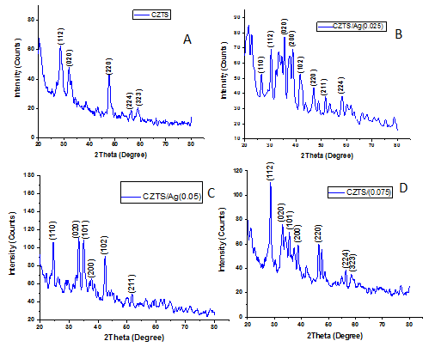
Fig. 1: Typical XRD patterns of the products of CZTS and CZTS /Ag composite thin films
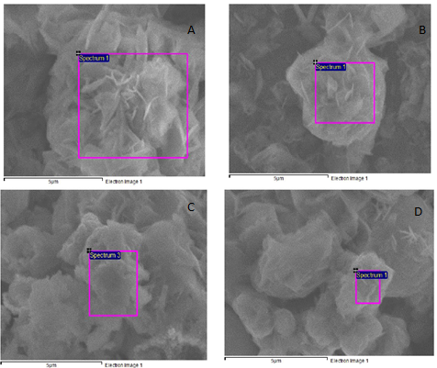
Fig. 2: SEM images for the CZTS/Ag composite thin film samples at different weight percentage of Ag (0.05 wt %, 0.025 wt%, 0.075 wt %).

Fig. 3: The optical absorption versus wavelength for CZTS, CZTS/Ag (0.05wt %), CZTS/Ag (0.025wt %) and CZTS/Ag (0.075wt %) films.

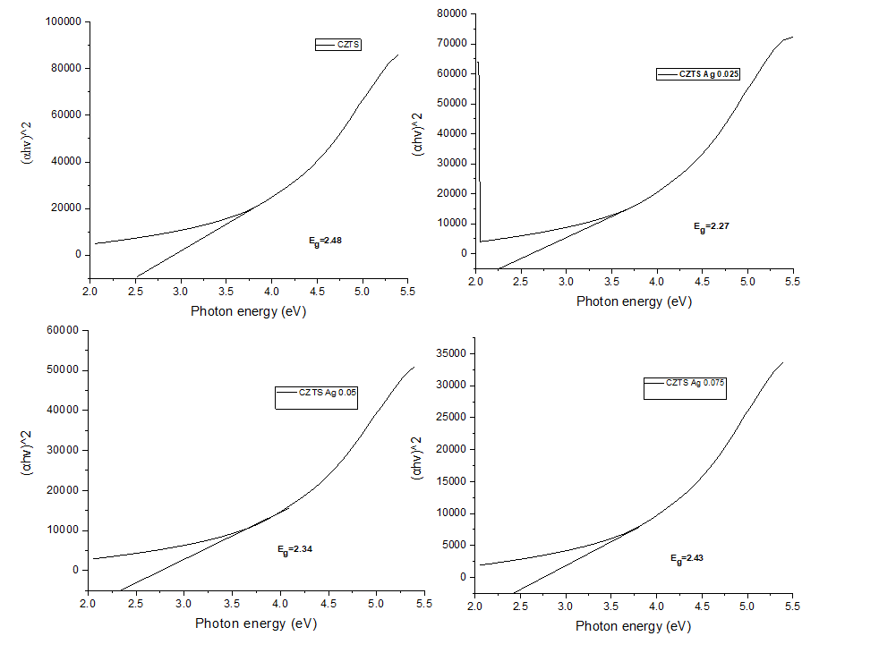
Fig. 4: The plot of (αhv) ² versus (hv) for the as-prepared CZTS and CZTS/Ag composite at different wt%

- Conclusions
This paper examined CZTS and CZTS/Ag composites, using hydrothermal method. The effect of Ag content on the structural, morphological and optical properties was systematically studied. Structural and morphological analyses were carried out using XRD while optical properties were explored using UV-Visible Spectroscopy.
The improvement in the absorbance was ascribed to the introduction of Ag content into the host’s CZTS which led to creating additional optical states within forbidden gap and resulted into an increase in the optical transitions which in turn led to improve the absorbance. The CZTS band gab was 2.48 eV as extrapolated from the band gab plot, band gab energy of 2.27 eV, 2.34 eV and 2.43 eV were extrapolated for CZTS/Ag (0.025, 0.05, and 0.075 wt %) respectively. The CZTS/Ag composite was found to be mixed amorphous and crystalline nature having short range periodicity of mixed ternary and quaternary phases of CuZnS or CZTS materials which was revealed by the XRD partern.
These results are evident such that the structural and optical properties of the as-synthesized CZTS were enhanced with the introduction of Ag content.

References
[1] Sánchez, A. S., Torres, E. A., & Kalid, R. D. A. (2015). Renewable energy generation for the rural electrification of isolated communities in the Amazon Region. Renewable and Sustainable Energy Reviews, 49, 278-290.
[2] Zhou YL, Zhou WH, Li M, Du YF, Wu SX, Hierarchical Cu2ZnSnS4 particles for a low cost solar cell: morphology control and growth mechanism. Journal Physics Chemical C, 115(40); 19632–19639, 2011.
[3] Walsh A, Chen SY, Wei SH, Gong XG, Kesterite thin-film solar cells: advances in materials modeling of Cu2ZnSnS4. Advance Energy Material, 2(4):400–409, 2012.
[4] Arun K., Kwang-Soo L., Seong-Man Y., Shashikant P. and Ji-Beom Y., Effect of Growth Parameters and Annealing Atmosphere on the properties of Cu2ZnSnS4 Thin films Deposited by Co-sputtering.International journal of Photoenergy pp 7, 2013.
[5] Qiu, Lei, “Fabrication of Cu2ZnSnS4 thin films by microwave assisted sol-gel method." Superlattices and Microstructures 126 (2019): 83-88.
[6] Hussein H., Ahmad Y., Doping the bismuth into the host’s cu₂znsns₄ semiconductor as a novel material for thin film solar cell. Results in Physics, 1586–1595, 2019.
[7] Fernandes, M., Cao, L, Zhang, B.L & Jiang, J. C., CZTS stoichiomery on band gap energy. Journal of Alloys and Compounds, (582): 528-534, 2017.
[8] Hossain, S., Quaderi, G. D. A., Hussain, K. M. A. and Faruqe, T., Synthesis and Characterization of Undoped and Aluminum Doped Zinc OxideThin Films using Thermal Evaporation Method. Nuclear Science and Applications: 27 (12),25-31, 2018.
[9] Fernandes, M., Cao, L, Zhang, B.L & Jiang, J. C , CZTS stoichiomery on band gap energy. Journal of Alloys and Compounds, (582): 528-534, 2017.
[10] Hossain, S., Quaderi, G. D. A., Hussain, K. M. A. and Faruqe, T. Synthesis and Characterization of Undoped and Aluminum Doped Zinc OxideThin Films using Thermal Evaporation Method. Nuclear Science and Applications: 27 (12), 25-31, 2018.
[11] Pradhan, Narayan, et al. "Luminescence, plasmonic, and magnetic properties of doped semiconductor nanocrystals." Angewandte Chemie International Edition 56.25 (2017): 7038-7054.

