**Synthesis and Characterisation of ZnO and ZnO/Ag Nanocomposite for Application in Optoelectronics**

**M. I. Kimpa1, M. M. Kpanje, H Isah1,2 F. M. Abdullahi1, A. A. Abubakar1 and K. U. Isah1**

**1 Department of Physics, School of Physical Sciences, Federal University of Technology Minna.**

**2Department of Physical Sciences, School of Natural and Applied Sciences, Niger State Polytechnic Zungeru.**

**Corresponding Author:** [**kimpa@futminna.edu.ng**](mailto:kimpa@futminna.edu.ng) **(+234-803-8654-849)**

**ABSTRACT**

ZnO nanoparticles are of significant interest as they provide many practical applications worldwide. Its wide energy bandgap makes it a good photocatalyst material for optoelectronic devices. However, one drawback of using ZnO is that it has some structural defects, such as Zn/oxygen vacancies and therefore have many mid-gap trap states, which through recombination reduces its photocatalyst performance. In this study, ZnO nanoparticles (NPs) was synthesised using hydrothermal method. The synthesised ZnO was doped with Ag plasmonic nanoparticles by the reduction of AgNO3 via a simple chemical reduction method in order to enhance its light absorbance. XRD and UV visible spectroscopic analysis were used to investigate the structural and optical properties of the synthesised ZnO and Ag doped ZnO. Structural analysis revealed that ZnO NPs had a wurtzite hexagonal structure evidenced by the three major wurtzite peaks. Two other additional peaks reveals the presence of Ag in the ZnO oxide lattice. The spectra exhibit the absorption band which is a characteristics of wurtzite crystal ZnO. The pure ZnO had its absorption peak at at 263 nm while for ZnO/Ag1 (0.1 mmol of AgNO3), ZnO/Ag2 (0.2mmol of AgNO3) and ZnO/Ag3 (0.1mmol of AgNO3) the peaks are at 264, 270 and 286 nm respectively. These shows that there was a shift in absorption peak to higher wavelength. ZnO/Ag composite had the highest absorption in both UV and visible spectrum. Bandgap reduction as obtained from Tauc’s plot revealed energy below the conduction band making the Ag doped ZnO a good material for application in optoelectronics.

**1.0 Introduction**

Zinc oxide (ZnO) is a wide bandgap semiconductor material that exhibits unique electronic and optical properties when at least one dimension is constrained at the nanoscale (Wang, 2004). These properties have found various applications in optics and energy conversion devices. As a result, the study and fabrication of ZnO nanomaterials have been at the frontline of recent research (Xu *et al*., 2012). Some of the important roles played by zinc oxide in current industry are due to its special characteristics such as anti-corrosion, anti-bacteria and excellent heat resistance. The ZnO nanoparticles are of significant interest as they provide many practical applications worldwide (Heer *et al.,* 2017). Its wide energy band (3.37 eV) and high bond energy (60 meV) makes it a good material for application in photoelectronic and electronic devices, devices emitting surface acoustic wave, sensors, field emitters, UV lasers and and dye sensitized solar cells (Agnieska & Teofil, 2014).

ZnO nanoparticles are synthesised by different methods such as wet chemical method, vapor phase method, hydrothermal method, precipitation method, atomic layer deposition and sonochemical method (Naresh Kumar *et al.,* 2017).Hydrothermal method unlike other methods is attributed with the following favorable circumstances which makes it more appropriate and suitable than different other methods for ZnO synthesis. The method does not necessitate the use of organic solvents or supplementary processing of the product (grinding and calcination), which makes it a simple and environmentally friendly technique. This synthesis process takes place in an autoclave, where the mixture of substrates is heated slowly to a temperature of 100 –300 °C and left for more than a few days. As a result of heating followed by cooling, crystal nuclei are formed, which then grow. This process has various advantages, counting the prospect of carrying out the synthesis at low temperatures, the different shapes and dimensions of the resulting crystals depending on the composition of the starting mixture and the process temperature and pressure (Parihar *et al.,* 2018).

There is a growing need for nanostructured materials with tailored optical and electrical properties. However, a single material does not always provide the required properties: for this reason, a combination of different materials with accurately controlled organisation is sometimes necessary in order to enhance the performance of a host material and/or to acquire new properties. In this study, ZnO was synthesised and the effect of combining it with noble metal (silver (Ag) plasmon) was investigated by examining the structural and optical properties of the resulting nanocomposite

**2.0 Experimental method**

**2.1 Synthesis of ZnO**

In the synthesis of ZnO, 68.145 g of ZnCl2 and 80 g of NaOH which correspond to molar ratio (1:4) was measured respectively using an electronic weighing balance and turned into a beaker containing 100 ml of deionized water. The mixture was stirred continuously until completely dissolved forming a white precipitate of Zn(OH)2. The white precipitate was filtered and washed using deionized water. The filtrate was then dispersed in deionized water and its pH level adjusted to between 11- 12 using hydrochloric acid (HCl) in drops. The pH adjusted mixture was stirred using a magnetic stirrer for 3 hrs and then turned into the Teflon-lining of a hydrothermal autoclave. The solution was heated in a hot air oven at 160 oC for 6 hrs. The oven was then allowed to cool to room temperature naturally and the autoclave brought out. The heated mixture was filtered and washed using deionized water. The filtrate was then dried in a hot air oven at 60 oC for another 6 hrs. The obtained dry product is the synthesised nanoparticle of ZnO.

**2.2 Synthesis of ZnO/Ag nanocomposite**

Deposition of Ag on ZnO surface was done as follows: firstly, 500 mg of the as-synthesized white ZnO powder was dispersed well in 20 mL of deionized water using a high speed dispersator for 30 min. 16.987 mg (0.0001 mol), of the AgNO3 was then added to the above dispersed ZnO solution with continuous stirring so that the AgNO3 is well adsorbed on ZnO surface. The AgNO3 adsorbed ZnO precipitate was collected and washed several times with deionized water to drain out the excess AgNO3 from the solution. The precipitate was re-dispersed again in 20 mL of deionized water followed by addition of 6.41 mg (0.0002 mol) hydrazine hydrate (reducing agent) within the solution with continuous stirring. Ag nanoparticles was deposited on to the surface of ZnO particles which results in a yellow colour precipitate

**3.0 Result and discussion**

## 3.1 X-Ray Diffraction (XRD)

The X-ray diffraction patterns of the synthesised samples were studied using X-ray diffractometer (XRD, Rigaku D, Max 2500, Japan) to confirm the crystallinity ofthe samples and investigate its crystal structure.

Figure 1 shows the XRD patterns of the synthesised ZnO and ZnO/Ag samples deposited on FTO glass substrate by spin coating. As seen in the figure, ZnO sample revealed eight peaks at various 2theta values. The synthesised ZnO thin film has the densest plane with strongest reflection at (101) plane. It was also observed that the XRD pattern of the ZnO/Ag films have the strongest reflection at (101), the densest plane of the films. Reflections for planes (100), (002), (101), (102), (110), (103), (112) and (201) are also observed for both samples. However, the (111) and (200) planes at 2θ = 38.30and 43.08 respectively, accounts for the presence of Ag plasmons in the ZnO/Ag samples as Ag grows on ZnO lattice. Structural changes due to silver doping were not observed.

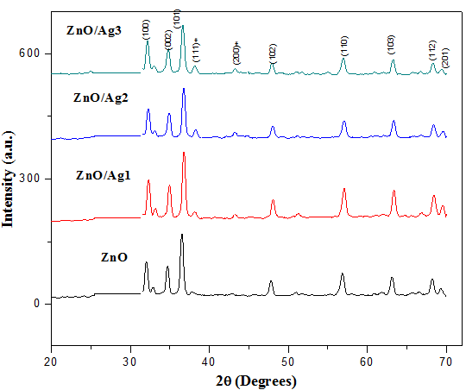

Figure 1:XRD patterns for the as-synthesised ZnO and ZnO/Ag samples.

Useful information that characterises the growth were obtained from the XRD measurement. These includes average crystallite size (D), defect density (δ), lattice strain (η), lattice stress (σ), lattice parameters (a, b and c) and d-spacing. The average crystallite size of the nanoparticles was calculated from Scherrer formula (Jacobsson, 2010).

$D=\frac{0.94λ}{βCosθ}$ (1)

Where λ is X-ray wavelength (0.15406 nm), β is full width at half maximum (FWHM) and θ is Bragg’s diffraction angle.

The dislocation density ($δ$), which represents the amount of defects in the sample is defined as the length of dislocation lines per unit volume of the crystal. The dislocation density have small values for deposited films which indicates that microstrains are released due to the thermal annealing. It can be calculated using the equation (Bindu & Thomas, 2014).

$δ=\frac{1}{D^{2}}$ (2)

Table 1: Crystallite size and defects densities of ZnO and ZnO/Ag samples

|  |  |  |
| --- | --- | --- |
| **Sample** | **Crystallite size (nm)** | **Defect densities (nm-1)** |
| ZnO | 41 | 5.95x10-4 |
| ZnO/Ag1 | 45 | 4.94x10-4 |
| ZnO/Ag2 | 39 | 6.57x10-4 |
| ZnO/Ag3 | 31 | 10.4x10-4 |

The calculated crystallite sizes of the as-synthesised ZnO and ZnO/Ag samples are shown in Table 1. It was observed that the crystal crystallite size decreased with increasing concentration of Ag. This occurred as a result of ionic ratio difference between Zn2+ and Ag+ ions which consequently leads to segregation of Ag at the vicinity of the grain boundary of ZnO. Also, low Ag solubility in ZnO leads to Ag atoms being incorporated in the grain boundaries and/or on the film surface leading to reduction in crystallite size. This result is in compliance with what was obtained by (Dehimi *et. al.,* 2015)

The lattice constants a=b≠c and cell volume of the hexagonal structure are obtained using

$a=b=\frac{λ}{√3sinθ}$ (3)

$c=\frac{λ}{sinθ}$ (4)

$V=\frac{\sqrt{3}}{2}×a^{2}c$ (5)

Table 2: Lattice constants and cell volume of the major wurtzite peaks obtained from diffraction patterns of ZnO and ZnO/Ag nanocomposites.

|  |  |  |  |  |
| --- | --- | --- | --- | --- |
| samples | peaks | a=b (Å) | c (Å) | V (Å3) |
| ZnO | 100  002  101 | 3.22  2.98  2.84 | 5.58  5.15  4.91 | 50.03  39.54  34.23 |
| ZnO/Ag1 | 100  002  101 | 3.19  2.96  2.82 | 5.53  5.12  4.89 | 48.91  38.92  33.66 |
| ZnO/Ag2 | 100  002  101 | 3.20  2.96  2.82 | 5.54  5.13  4.88 | 49.11  39.03  33.57 |
| ZnO/Ag3 | 100  002  101 | 3.21  2.97  2.83 | 5.57  5.15  4.89 | 49.78  39.42  33.84 |

The lattice parameter of a semiconductor depends on the concentration of foreign atoms and defects, external strains and temperature (Ozgur *et al.,* 2005). Table 2 shows the calculated values of lattice constants and cell volume of the three major peaks of ZnO. The lattice constants of (100) peaks range from 3.19 to 3.22 Å and 5.53 to 5.58 for ‘a’ and ‘c’ lattice constants respectively. These values mostly range from 3.2475 to 3.2501 Å for the ‘a’ parameter and 5.2042 to 5.2075 Å for the ‘c’ parameter. The films with ‘c’ values greater than that of the bulk ZnO value (3.205 Å) have a positive or extensive stress whereas those with lower values have a negative or compressive stress (Thool *et al.,* 2014).

The lattice strain caused by the substrate and film mismatch η is evaluated using equation 6

$η=\frac{β}{4tanɵ}$ (6)

The lattice stress in the thin film is calculated using the relation

$σ=-233\frac{c-c_{o}}{c_{o}}$ (7)

where c is lattice constant of the films and co = 5.2066 Ao is the unstrained lattice constant of bulk ZnO. The minus sign indicates the compressive nature of the stress

Table 3: Calculated structural parameters of the three major peaks for ZnO and Ag doped ZnO

|  |  |  |  |  |
| --- | --- | --- | --- | --- |
| Samples | Peak position(o) | β (Radians) | η×10-3 | σ (Gpa) |
| ZnO | 32.081 | 0.1968 | 2.987 | -2598.89 |
|  | 34.780 | 0.1574 | 2.193 | -2830.05 |
|  | 36.509 | 0.2362 | 2.989 | -3108.16 |
| ZnO/Ag1 | 32.3313 | 0.1968 | 2.962 | -2243.27 |
|  | 34.9698 | 0.1574 | 2.18 | -2061.63 |
|  | 36.7637 | 0.1181 | 1.551 | -1953.26 |
| ZnO/Ag2 | 32.2863 | 0.1968 | 2.967 | -2246.63 |
|  | 34.935 | 0.1968 | 2.729 | -2063.85 |
|  | 36.7987 | 0.2362 | 3.098 | -1951.25 |
| ZnO/Ag3 | 32.1363 | 0.2755 | 4.173 | -2257.9 |
|  | 34.8154 | 0.2362 | 3.287 | -2071.49 |
|  | 36.696 | 0.2755 | 3.625 | -1957.15 |

The interplanar spacing (d) is calculated using Bragg’s law which is given as

$d=nλsinθ$ (8)

Where; n is order of diffraction, λ is wavelength and θ is diffraction angle

The interplanar spacing (dhkl) corresponding to thethree main peaks calculated using the Bragg’s law are presented in table 4. The values are in descending order of magnitude and showed a little deviation from the JCPDS standard standard values (Gurav *et al.,* 2011). The percentage contraction is also presented in the same table and lies in the range 0.83-4.5% with Zno having the highest contraction value of 4.5%. This suggests that the incorporation of Ag plasmons into ZnO crystals reduced the interplanar spacing contraction of the Ag doped ZnO nanocomposite.

Table 4 Interplanar spacing (dhkl) from XRD, JCPDS data card for corresponding (hkl) values and percentage variation of d

|  |  |  |  |  |
| --- | --- | --- | --- | --- |
| Sample | Hkl | dXRD (Å) | dJCPDS (Å) | % Contraction |
| ZnO | 100 | 2.79004 | 2.8135 | 0.833837 |
|  | 002 | 2.57945 | 2.6027 | 0.893303 |
|  | 101 | 2.36471 | 2.4751 | 4.460022 |
| ZnO/Ag1 | 100 | 2.76902 | 2.8135 | 1.580949 |
|  | 002 | 2.5659 | 2.6027 | 1.413916 |
|  | 101 | 2.44472 | 2.4751 | 1.227425 |
| ZnO/Ag2 | 100 | 2.77277 | 2.8135 | 1.447663 |
|  | 002 | 2.56838 | 2.6027 | 1.318631 |
|  | 101 | 2.44247 | 2.4751 | 1.318331 |
| ZnO/Ag3 | 100 | 2.78537 | 2.8135 | 0.999822 |
|  | 002 | 2.57693 | 2.6027 | 0.990126 |
|  | 101 | 2.44907 | 2.4751 | 1.051675 |

**3.2 Absorption spectra**

The optical characterization was carried out using ultraviolet–visible light (UV–vis) spectrophotometer (Shimadzu UV-Visible Spectrophotometer, UV-1800 Series, Japan).

The optical absorption data were used to evaluate the transmittance, optical bandgap, refractive index, extinction coefficient and other linear and nonlinear optical parameters for the synthesised ZnO and Ag doped ZnO samples. Figure 2 shows the absorption spectra of both as-synthesised ZnO and Ag-doped ZnO samples. Absorption peaks were observed at 263 nm, 264 nm, 270 nm and 286 nm for ZnO, ZnO/Ag 1, 2 and 3 respectively, which shows slight shift in absorption peaks. The absorption of the Ag doped ZnO is observed to have high values with Ag concentration increase in the visible region

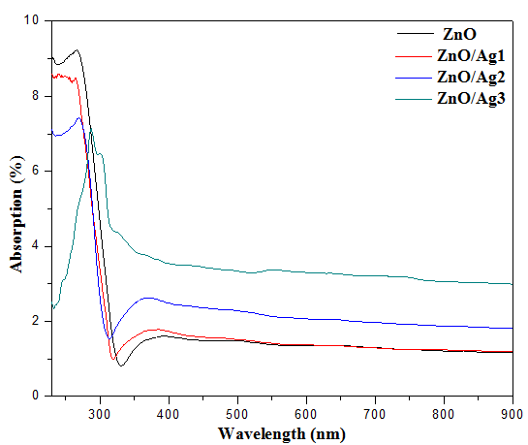

Figure 2: (a) Absortion spectra of as-synthesised ZnO and ZnO/Ag

Transmittance can be calculated from absorbance result using Beer-Lambert law. The Beer-Lambert law is the linear relationship between absorbance and concentration of an absorbing species. The law states that the absorbance is proportional to the transmitted intensity (Cosimo, 2015).

A= -log (%T) (9)

where A is the measured absorbance and T is the transmittance. If equation 4 is expressed in term of T, it gives (Buba and Adelabu, 2010)

$T={10}^{-A}$ (10)

Figure 3.3 shows the transmittance plot against wavelength for the as-synthesised ZnO and ZnO/Ag samples.

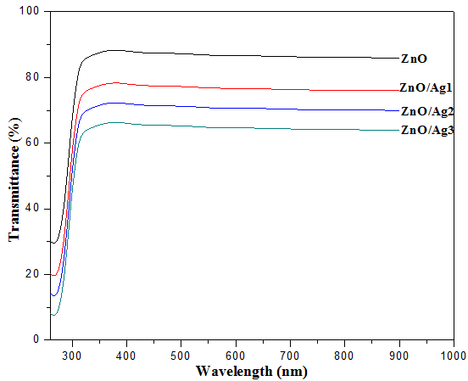

Figure 3: Transmittance spectra of the as-synthesised ZnO and ZnO/Ag samples.

The transmittance of the as-synthesised ZnO and ZnO/Ag samples was observed in the spectral range of 280-900 nm as seen in Figure 3. The pure as-synthesised ZnO oxide exhibited a transmittance of 83% making it a good window material for optoelectronic application. A transmittance value of 74%, 70% and64% was observed for ZnO/Ag1, ZnO/Ag2 and ZnO/Ag3 samples respectively. Increase of scattering due roughness of the surface of nanoparticles and oxygen vacancies produces decrement in optical transmission (Kayani *et al.,* 2020). This trend was observed in a research work by (Suman *et al*., 2013).

The extinction coefficient describesthe attenuation of light in a medium and higher *k* valueindicates the probability of raising the electron transferacross the mobility gap with photon energy. Therefore, thehigher values are the representation of greater attenuation of light in a thin film (Hossain *et al.,* 2018). It is mathematically expressed as (Abdelraheem et al., 2020)

$$k=\frac{αλ }{4π} (11)$$

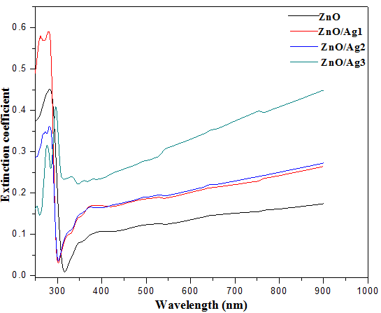

Figure 4: A plot of extinction coefficient against photon energy for the as-synthesised ZnO and ZnO/Ag samples**.**

α is absorption coefficient, λ is wavelength. Figure 4 shows the extinction coefficient (*k*) spectra of the ZnO and Ag doped ZnO thin films. It is observed that, extinction coefficient falls abruptly with the increase of wavelength in the UV region. Higher values were observed in the visible spectra region.

In modern day optoelectronics and its design, the knowledge of refractive index variation with wavelength is useful in predicting the photoelectric characteristics of a device (Ostroverkhovaa & singer, 2002). The refractive index was evaluated using the relation

$n=\frac{(1+R)}{(1-R)}+{\left[\frac{4R}{{(1-R)}^{2}}-K^{2}\right]}^{1/2}$ (12)

Where R is reflectance obtained from the unity equation ans k is extinction coefficient. Figure 4 shows a plot of refractive index versus wavelength for the as-synthesised ZnO and Ag samples. The refractive index highest peak was observed in the UV region later accompanied by an exponential decrease. The reduction in refractive index with wavelength depicts the dependence correlation between absorption coefficient and refractive index which indicates the normal behavior of the as-synthesised ZnO and ZnO/Ag samples. This is in accordance with the studies by (Ahmad *et al*., 2019 & Kumar *et. al*., 2016).

The numerical values of the refractive index between 300-900 nm wavelength is observed to be higher with the addition of Ag content. This may be attributed to the increase in polarisabilty. The atomic radius of Ag is larger than that of Zn. The longer the atomic radius, the larger the polarisability as explained by Lorentz-Lorenz equation (Shaaban *et al.,* 2016)

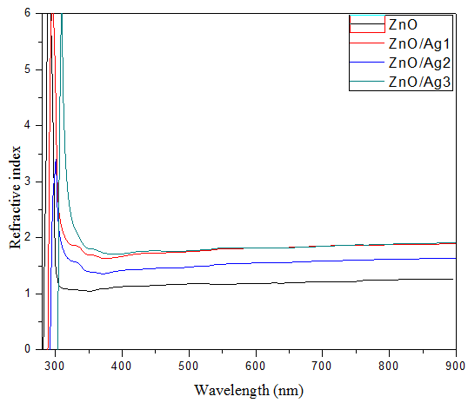

Figure 5: A plot of refractive index versus wavelength for the synthesised ZnO and ZnO/Ag samples

The optical conductivity of the material was also estimated using equation (13).

$σ=\frac{αnc}{4πk}$ (13)

Where α, n, c and k are absorption coefficient, refractive index, speed of light and extinction coefficient respectively. Figure 4 shows a plot of optical conductivity for the as-synthesised ZnO and ZnO/Ag samples. The optical conductivity measures the number of free charges present in the material. The free carriers increases in ZnO/Ag nanocomposite with Ag contents. The enhancement in optical conductivity is high in the high energy region (UV), because free carriers absorb photon energy. While, the decrement in the optical conductivity in the visible region is due to trapping of free carriers (Kayani *et al.,* 2020).

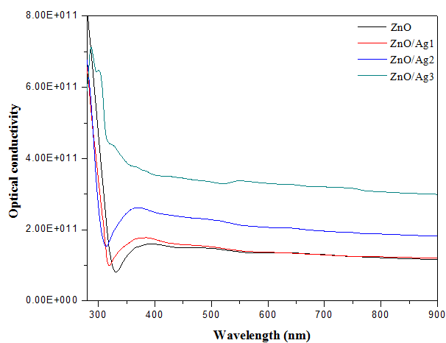

**Figure 6:** A plot of optical conductivity against photon energy for the as-synthesised ZnO and ZnO/Ag samples.

**3.3 Optical bandgap**

The optical energy band gap was calculated using Tauc’s formula given as:

${(αhv)}^{n}=k\left(hv-E_{g}\right)$ (3.14)

Where α is absorption coefficient, h is planck’s constant, ν is photon energy, k is band tailing parameter (constant). Figure 4.7 shows the plot of (αhν)2 versus photon energy for the as-synthesised ZnO and ZnO/Ag samples. The band gap extrapolated for the syhtnesised ZnO and Ag doped ZnO are presented in Table 3.3. It was observed that the band gap energy decreased with increasing concentration of Ag. This is due to creationof intermediate states between the conduction and valence band of ZnO host matrix with the addition of Ag, which areresponsible for reduction in the calculated band gap of ZnO/Ag samples. Ag plays the role of accepter material tochange the band gap of the as-synthesised ZnO and hence, decrease theband gap (Kumar *et. al*., 2016).

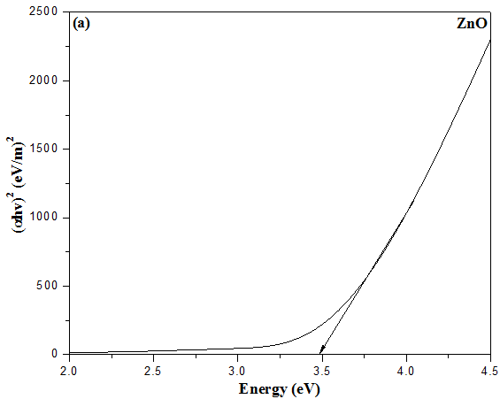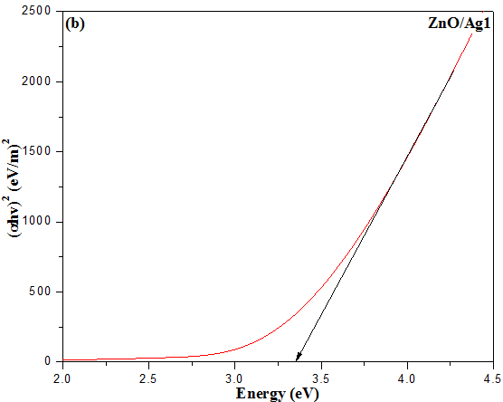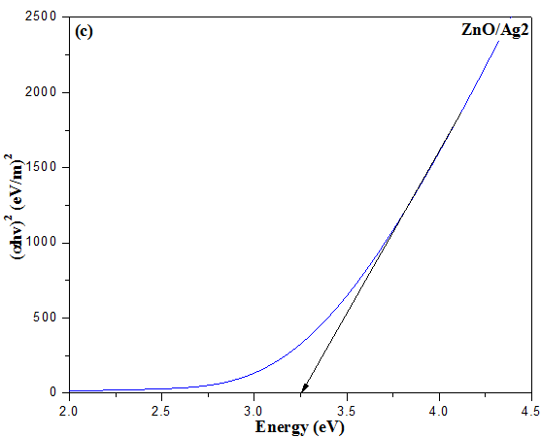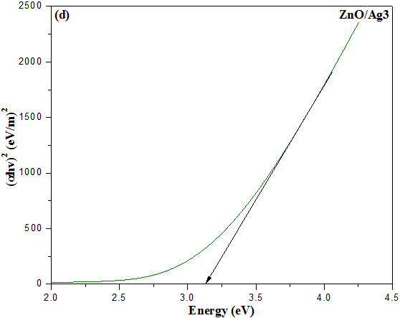

**Figure 7**: plot of optical bandgap versus photon energy for the as-synthesised ZnO and ZnO/Ag samples.

**4.0 Conclusion**

In conclusion, ZnO has been synthesized via hydrothermal method. The as-sythesized ZnO was doped with Ag plasmons by the reduction of AgNO3 to Ag ions using hydrazine hydrate as reducing agent in order to enhance the photon absorption of ZnO in the visible spectrum region of light spectra. XRD pattern corresponding to (100), (002) and (101) planes which identify the wurtzite ZnO.Additional peak observed at 2ɵ value of 38.3o and 43.08o corresponds with silver (111) and (200) planes respectively. A right hand shift to a higher wavelength attributed to the presence of Ag plasmons in ZnO lattice was observed for Ag doped samples. ZnO/Ag3 has the highest absorption range of 365 nm and 430 nm in the UV visible spectra. The refractive index plots are in accordance to the standard for both doped and undoped ZnO. The increase in refractive index with Ag addition has been explained in term of polarisability. The band gap values obtained from Tauc’s plots reveal energy level in between the conduction and valence band of the synthesized wide bandgap of the synthesized photocatalyst.

WDD model was used to calculate and interpret the optoelectronic and dispersion  
properties of ZnO and Ag doped ZnO thin films. Composite of oxide thin films with controllable  
refractive index and tunable optical and optoelectronic properties provides a pathway to design smartmulti-functional materials. Such materials may act as potential candidates for the fabrication of modernoptoelectronic devices and thin film transistors.

**REFERENCES**

Abdelraheem, A. M., Abd-Elrahman, M. I., Mohamed, M., Hadia, N. M. A., & Shaaban, E. R. (2020). Linear and non-linear optical parameters of diluted magnetic semiconductor CdS0. 9Mn0. 1 thin film: influence of the film thickness. *Journal of Electronic Materials*, *49*(3), 1944-1956.

Agnieszka, K. & Teofil, J. (2014). Zinc oxide -from synthesis to application: a review. Materials 2833-2881. doi: 10.3390/ma7042833.

Ahmad, I., Ahmed, E., & Ahmad, M. (2019). The excellent photocatalytic performances of silver doped ZnO nanoparticles for hydrogen evolution. *SN Applied Sciences*, *1*(4), 1-12.

Bindu, P., & Thomas, S. (2014). Estimation of lattice strain in ZnO nanoparticles: X-ray peak profile analysis. *Journal of Theoretical and Applied Physics*, *8*(4), 123-134.

Buba, A. D. A., & Adelabu, J. S. A. (2010). Optical and electrical properties of chemically deposited ZnO thin films. *The Pacific Journal of Science and Technology*, *11*(2), 429-434.

Cosimo, D. C. and Claudia, H. (2015). UV/VIS Spectrophotometry - Fundamentals and Applications. Mettler-Toledo Publication No. ME-30256131.

Dehimi, M., Touam, T., Chelouche, A., Boudjouan, F., Djouadi, D., Solard, J., ... & Doghmane, A. (2015). Effects of low Ag doping on physical and optical waveguide properties of highly oriented sol-gel ZnO thin films. *Advances in Condensed Matter Physics*, *2015*.

Gurav, K. V., Patil, U. M., Pawar, S. M., Kim, J. H., & Lokhande, C. D. (2011). Controlled crystallite orientation in ZnO nanorods prepared by chemical bath deposition: Effect of H2O2. *Journal of alloys and compounds*, *509*(29), 7723-7728.

Heer, A. S. K., Mansoori, S. M. and Chamria, N. (2017). Biosynthesis and Characterization of Zinc Oxide Nanoparticle Using Ficus Religiosa Leaves Extract, World Journal of Pharmaceutical Research Volume 6, Issue 10, 818-826.

Hossain, S., Quaderi, G. D. A., Hussain, K. M. A., & Faruqe, T. (2018). Synthesis and Characterization of Undoped and Aluminum Doped Zinc Oxide Thin Films using Thermal Evaporation Method. *NUCLEAR SCIENCE AND APPLICATIONS*, *27*(1&2).

Jacobsson, T. J. (2010). Synthesis and characterisation of ZnO nanoparticles. An experimental investigation of some of their size dependent quantum effects.

Karyaoui, M., Mhamdi, A., Kaouach, H., Labidi, A., Boukhachem, A., Boubaker, K., ... & Chtourou, R. (2015). Some physical investigations on silver-doped ZnO sprayed thin films. *Materials Science in Semiconductor Processing*, *30*, 255-262.

Kasim I. U. (2013). Optical and morphological studies of chemical bath deposited nanocrystalline Cd 1-x Zn x S thin films.

Kayani, Z. N., Manzoor, F., Zafar, A., Mahmood, M., Rasheed, M., & Anwar, M. (2020). Impact of Ag doping on structural, optical, morphological, optical and photoluminescent properties of ZnO nanoparticles. *Optical and Quantum Electronics*, *52*(7), 1-18.

Kumar, S., Singh, V., & Tanwar, A. (2016). Structural, morphological, optical and photocatalytic properties of Ag-doped ZnO nanoparticles. *Journal of Materials Science: Materials in Electronics*, *27*(2), 2166-2173

Naresh Kumar, P., Sakthivel, K., & Balasubramanian, V. (2017). Microwave assisted biosynthesis of rice shaped ZnO nanoparticles using Amorphophallus konjac tuber extract and its application in dye sensitized solar cells, Materials Science-Poland, 35(1), 111-119. doi: <https://doi.org/10.1515/msp-2017-0029>

Ostroverkhova, O., & Singer, K. D. (2002). Space-charge dynamics in photorefractive polymers. *Journal of applied physics*, *92*(4), 1727-1743.

Özgür, Ü., Alivov, Y. I., Liu, C., Teke, A., Reshchikov, M., Doğan, S., ... & Morkoç, A. H. (2005). A comprehensive review of ZnO materials and devices. *Journal of applied physics*, *98*(4), 11.

Parihar, V., Raja, M., & Paulose, R. (2018). A brief review of structural, electrical and electrochemical properties of zinc oxide nanoparticles. Reviews on Advanced Materials Science, 53(2), 119-130.

Shaaban, E. R., El-Hagary, M., Moustafa, E. S., Hassan, H. S., Ismail, Y. A., Emam-Ismail, M., & Ali, A. S. (2016). Structural, linear and nonlinear optical properties of co-doped ZnO thin films. *Applied Physics A*, *122*(1), 1-10.

Thool, G. S., Singh, A. K., Singh, R. S., Gupta, A., & Susan, M. A. B. H. (2014). Facile synthesis of flat crystal ZnO thin films by solution growth method: a micro-structural investigation. *Journal of Saudi Chemical Society*, *18*(5), 712-721.

Wang, Z. L. (2004). Zinc oxide nanostructures: growth, properties and applications. J. Phys.: Condens. Matter 16 R829–R858 doi:10.1088/0953-8984/16/25/R01

Xu, X., Wu, M., Asoro, M., Ferreira, P. J., & Fan, D. L. (2012). One-Step Hydrothermal Synthesis of Comb-Like ZnO Nanostructures. Crystal growth & design, 12(10), 4829–4833. <https://doi.org/10.1021/cg3005773>