**Estimation of Geochemical Thresholds for a Suite of Elements in Soil from Tsofon Birnin-Gwari area, Nigeria: Implication for Exploration and Environmental Studies**

*Nuhu Musa Waziri1, 2, Isah Aliyu Goro1, Idris-Nda Abdullahi1 & Salome Hephzibah Waziri1

1Department of Geology, School of Physical Sciences, Federal University of Technology, Minna, Nigeria

2Department of Geology, Faculty of Earth and Environmental Sciences, Bayero University, Kano, Nigeria

**\*Corresponding Author**: [nuhuwaziri@futminna.edu.ng](mailto:nuhuwaziri@futminna.edu.ng)

The geochemical threshold values for a suite of elements in residual soil of the Tsofon Birnin-Gwari area, NW Nigeria were computed using two statistical methods. This area is within the Nigerian Schist Belts and is famous for artisanal and small-scale gold mining. The concentration of 17 trace elements in 32 samples was determined using wavelength dispersive X-ray fluorescence spectrometry (WD-XRF). The data was subsequently used to compute threshold concentrations for each of the elements using (i) **mean+2SD** and (ii) **median+2MAD** methods. Before the treatments, the data was smoothened by using ½DL for samples with element concentration below the detection limit. The results show that for all the elements, the mean+SD method provided higher threshold values compared to the median+2MAD approach. This may be attributed to the fact that the mean is likely to be influenced by a few positively skewed data points compared with the median. The standard deviation was generally high for all the elements, indicating wide dispersion around the mean. Accordingly, the threshold values from the first method show that nearly all element concentrations are at the background level, without anomalous values. However, based on the second method, some of the elements were found to have concentrations significantly above the upper limit of background fluctuation. For practical applications in exploration and environmental studies, it is concluded that the median+2MAD approach is more robust at estimating threshold values. However, other methods such as graphical and fractal analysis may be considered as potential alternatives for this purpose.

**Keywords**: Geochemistry, Geostatistics, Environmental Geochemistry, Prospecting, Background

1. **INTRODUCTION**

The knowledge and subsequent use of local background concentration of chemical elements, especially trace elements in geological materials is an indispensable tool for both resource exploration and environmental pollution monitoring. This is because it provides the basis for evaluating conditions at a site, leading to decisions to be made about a mineral prospect or pollution levels due to both geogenic and anthropogenic inputs (McIlwaine *et al*., 2016). Comparing the results of chemical analysis with already established baseline values in rocks, soils, sediments, or even surface and groundwater in an area can lead to the identification of geochemical processes at play and their implications regarding potential causes of anomalous levels of elements in an environment. While geochemical background is not a single value but rather a range, a threshold concentration marks the upper limit of background fluctuation and may therefore be used to effectively separate geochemical data into background and anomalous areas. Many methods have been advanced in the literature for the establishment of local geochemical thresholds or background (e.g. Reimann *et al*., 2005 and references therein; Adepoju *et al*., 2021). Due perhaps to the absence of readily available data on local and regional background or thresholds, many researchers in both mineral exploration and environmental assessment have continuously resorted to the use of values extraneous to their areas of study. Such often adopted concentrations include the upper crustal abundances (e.g. Taylor and McLennan, 1995; Wedephol, 1995) and elemental concentrations in specific geologic materials (e.g. Post Archean Average Shale, PAAS) or maximum allowable concentrations (MACs) defined by environmental agencies in different jurisdictions. Despite the widespread adoption of such published values in normalizing geochemical data (e.g. Amadi et al., 2012; Waziri, 2014; Alekseenko *et al*., 2022; Wang *et al*., 2023), they are unable to account for local variations in the natural distribution of elements resulting from different lithologies or bedrock. The aim of this paper therefore is to establish local threshold concentrations of a suite of trace elements for soils developed over the rocks of the Kushaka Schist Belt in the Birnin-Gwari area of north-western Nigeria.

**2.0 METHODOLOGY**

**2.1 The Study Area**

The Tsofon Birnin-Gwari area lies between latitude 10°55ʹN and 11°05ʹN and longitude 6°45ʹE and 6°52ʹE, with altitudes of between 518.16 m and 712.28 m. The area is drained by two main rivers, the Kureta and Gora Rivers with many other tributary channels including Baigado and Abuya Rivers (Waziri, 2012). Geologically, it is characterized by granitic inselbergs and roughly north-south trending ridges that cut into the Kushaka Schist and are generally in conformity with the general trend in the Nigerian Basement Complex. Lithologies in the Kushaka schist belt are mainly semi-pelitic biotite muscovite schist, along with phyllites, metasiltstones, and graphitic schists (Turner, 1983). Interbedded with these units is a banded iron formation and the thick amphibolites in part of the area have been interpreted by Turner as an indication of large volcanic accumulation. The granites were observed to form very prominent geomorphological features, especially in the southern part of the study area, while to the northwest, the older migmatite-gneiss basement outcrops. According to Garba (2000), the entire sequence in this area has been cut and displaced by the NE-SW trending Kalangai transcurrent fault. It was identified as one of the areas associated with gold mineralization and mining in Nigeria (Woakes and Bafor, 1983). It has had a long history of gold mining, spanning several decades, beginning from the colonial era and this is still the case till the present.

**2.2 Sampling and Analysis**

Surface soil (top 20 cm) was sampled and used in this study. In total, thirty-two composite samples were collected using a plastic scoop. The composite samples were made from three sub-samples collected at the apices of triangles with all sides 10 m long to account for local natural variability (Swyngedouw and Crepin, 2008). The sub-samples were thoroughly mixed and about 1 kg of composite soil was collected into self-sealing polyethylene bags following removal of rock fragments and vegetation materials such as roots and twigs (Salminen, 2008). The soils were then dried using a fan-assisted method at a temperature not exceeding 100 °C for 24 hours and the < 2 mm fraction was used for subsequent analysis. Chemical analysis was carried out using a wavelength dispersive X-ray fluorescence spectrometer (WD-XRF, from Brucker AXS, Germany) according to standard methods, details of which have been described by Waziri (2014) and references thein. The method's lower limit of detection (DL) is 10 ppm for Sc, V, Cr, Ni, Cu, As, Rb, Y, Nb, La, Ce, and Th; 9 ppm for Zn; 6 ppm for Zr; 24 ppm for Ba and 20 ppm for Pb.

**2.3 Data Analysis**

**2.3.1 Dealing with Disjointed Datasets**

It is a common problem with geoenvironmental or compositional data to have disjointed data or data with missing points. In geochemistry, this problem is often due to low concentrations of analytes, below the method detection limits. This results in incomplete numeric data, where for some elements in particular samples, no values are recorded and instead, the acronym BDL is recorded. This presents a problem when carrying out data analysis, especially using statistical methods. To get around this, several approaches have been advanced within the scientific literature, including (i) substituting with zero (0) for such samples and (ii) using half the detection limit (½DL) for the element of interest. That an element was not detected in any matrix does not necessarily mean that it does not exist, it is just present in concentrations below the method detection limit. The second approach is therefore considered to be more robust and introduces lower levels of error than the first one (Nehls and Ackland, 1973; Kushner, 1976; USEPA, 2000; Flikkema, 2016).

**2.3.2 Checking the nature of the distribution**

Geochemical data can have several statistical distribution styles, although they hardly ever obey the normal distribution requirement. Data of geochemical or environmental nature is almost always non-normally distributed, tending more towards log-normal behaviour. This presents enormous challenges with data interpretation, especially when applying treatments like descriptive statistics and parametric tests. In this study, one of the methods adopted for the estimation of threshold values is dependent on the arithmetic average or mean, which is a parametric statistic. This therefore necessitates checking the nature of the distribution of the chemical data to make valid conclusions. For this study, the test of data normality was carried out using the histogram method with the aid of the Legacy Charts builder in SPSS 16.0 for Windows. Figure 1 shows that the data does follow normal distribution, which confirms earlier assumptions made about the nature environmental data.

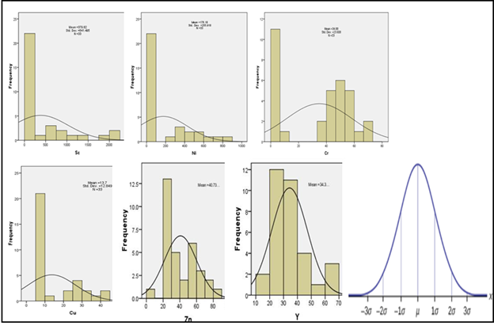

**Figure 1: Nature of distribution for a selection of the elements, showing the data does obey normal distribution.**

**2.2.3 The Mean+2standard deviation method (T1)**

This method involved the computation of the mean ($\overline{X}$) concentration for each element, together with the standard deviation (δ). This was carried out using the Descriptive Statistics function in SPSS 16.0. The threshold concentrations (T) were then calculated thus:

**T = $\overline{X}$ +2δ**, (1)

where T is the threshold value, $\overline{X}$ is the mean of the distribution and δ is the standard deviation around the mean.

**2.3.4 The median+2MAD method (T2)**

To calculate the threshold concentration using this method, the median (m) of the distribution was first computed. This value was subsequently subtracted from each of the values and the absolute value of the differences was obtained. The median of this second set of values was then calculated and this represents the median absolute deviation. From these two values, the threshold concentration was computed according to the equation:

**T = m +2MAD**, (2)

where m represents the median of the distribution of each element and MAD is the median absolute deviation, which is the median of the deviation from each concentration value. This operation was out carried in the MS Excel environment.

**2.3.5 Calculation of Enrichment Ratios**

Enrichment ratios are often used as a means of identifying anomalous distribution of chemical elements in nature. They help to discriminate areas with anomalous values due to either natural or anthropogenic factors. The method involves normalising the concentration of an element in a sample to some reference value or background such as the upper crustal concentration (UCC) of Taylor and McLennan (1995) and Wedephol (1995). Others use maximum allowable concentrations (MAC) from regulatory bodies for environmental studies or locally established background values that account for local geologic control. In this work, the computed threshold values for both methods were used alongside the UCC **(Table 1)** values to compare the effects. Enrichment ratios (ER) were computed using equation 3 thus:

**ER** = $\frac{Ci}{Bi}$, (3)

where Ci is the elemental concentration in the sample and Bi is its background concentration as defined above. An enrichment ratio, ER of 1 indicates that the material is neither enriched nor depleted in a particular element relative to the average crustal concentration. In other words, this indicates the natural abundance of the element in a geologic material. On the other hand an ER of > 1 or < 1 is an indication of enrichment or depletion (Waziri, 2014).

**3.0 RESULTS AND DISCUSSION**

**3.1 Computed Threshold values**

The computed threshold concentrations based on the two methods described in this work are presented in Table 1, along with the upper crustal concentrations (UCC) of the elements from Taylor and McLennan (1995). The T1 estimates are always higher than those for both the T2 **(Figure 2)** method and the UCC, except in the case of Sr, where the UCC is a lot higher than the T1. The T2 estimates for eleven of the elements were found to be above their UCC, although, for some of them (V, Ni, Nb, and Ba), there seems to be some level of agreement between their UCC and T2 values.

**3.2 Comparison of the Computed Values**

The mean threshold concentrations were found to be 441 ppm and 185 ppm respectively. Although visual observation indicates the two computed values are markedly different **(Figure 2)**, t-test results (at 95 % confidence limit) show that they are statistically similar, with no significant difference (P (T<=t) two-tail =0.31>0.05, **Table 2**). This may mean that from a statistical standpoint, using either value may not lead to any significant difference in the outcomes. This observation may be due to the fact the mean value for the mean+2sd is influenced more by a few very high values for some elements (such as Sc, Ni, and Zr).

**Table 1. The Threshold concentrations of the elements along with their UCC**

|  |  |  |  |
| --- | --- | --- | --- |
|  | **Mean+2SD (T1)** | **Median+2MAD (T2)** | **UCC** |
| **Sc** | 1667 | 5 | 11 |
| **V** | 84 | 65 | 60 |
| **Cr** | 82 | 57 | 35 |
| **Ni** | 690 | 23 | 20 |
| **Cu** | 39 | 5 | 25 |
| **Zn** | 79 | 51 | 71 |
| **As** | 55 | 27 | 1.5 |
| **Rb** | 120 | 77 | 112 |
| **Sr** | 81 | 55 | 350 |
| **Y** | 59 | 40 | 22 |
| **Zr** | 3565 | 2041 | 190 |
| **Nb** | 32 | 26 | 25 |
| **Ba** | 707 | 500 | 550 |
| **La** | 59 | 44 | 30 |
| **Ce** | 104 | 85 | 64 |
| **Pb** | 35 | 31 | 20 |
| **Th** | 33 | 21 | 10.7 |

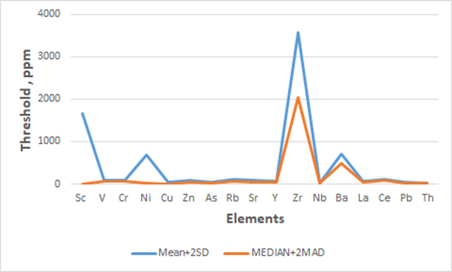

**Figure 2: Computed threshold concentrations for the suite of elements**

**Table 2. Statistical comparison of the computed threshold concentrations using a t-test**



Enrichment ratios computed for all the elements using three normalizing values indicate that for 11 of the elements (V, Cr, Ni, As, Y, Zr, Nb, La, Ce, Pb and Th), the median values increase in the order T1<T2<UCC. Similarly, the median enrichment ratios of >1 were only obtained for Cr, As, Y, Zr, La, Ce, Pb and Th using the UCC normalization and not for both the T1 and T2 threshold values **(Table 3)**. It shows therefore that both methods for establishing the threshold values used in this work result in higher estimates of the background compared to the UCC of the elements, resulting in a seeming depletion of most of the elements.

**3.3 Implication of the Computed Values**

The stated aim of this work is to establish local threshold concentrations for selected trace elements in soil from Birnin-Gwari area. The computed values have the potential to improve the way things are done in both exploration and pollution projects. The area is known to be rich in resources, especially gold, which has been continuously won from quartz-sulfide-gold veins since the colonial period. The use of locally established thresholds can play a major role in identifying new mineral occurrences and finding the extension of already known deposits.

**Table 3: Summary of enrichment ratios**

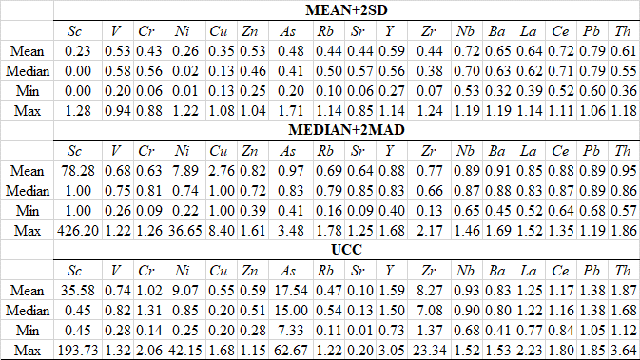

While finding new resources to support economic growth and prosperity of the population is a key role of geochemical exploration, ensuring sustainable consumption by preserving the quality of environmental media is an equally important target. Understanding element distribution, and in particular distinguishing between the local natural abundance and human-induced alterations is necessary to assess the impact of the extractive industry on the environment. Comparing elemental concentrations in the area with locally established upper limits of background fluctuation provides a tool for measuring the level of contamination of environmental matrices by activities such as mining and application of agrochemicals in the area. As noted in the introduction, the practice of adopting published values outside of a geographic area may not account for geologic control on the distribution of elements and therefore deficient in both exploration and environmental assessment.

**4.0 Conclusion**

This work has deployed statistical methods to establish local threshold values for trace elements in soil using geochemical data. The mean+2δ and median+2MAD approaches were used to compare the outcome with each other and to the often used upper continental crust concentrations. The mean+2sd method generally gave higher estimates of the thresholds due perhaps to the effect of a few high data outliers, leading to a situation where all the geochemical data used for this appear as background. The median+2mad approach is less sensitive to the nature of distribution and therefore provides better estimates of the upper limit of background fluctuation and is therefore recommended as the method of choice. Future research in the Birnin-Gwari can attempt to relate the computed threshold concentrations to the underlying lithology, which will further improve our knowledge of how elements are distributed in soils and therefore their parent rocks in the area.

**References**

Adepoju, M. O., Okonkwo, C. T. and Bolarinwa, A. T. (2021). Pedogeochemical Survey for Uranium Mineralization in Parts of Igarra Schist Belt, Southwestern Nigeria. *Ife Journal of Science,* 23(2), 191-204.

Alekseenko, A.V., Drebenstedt, C. and Bec, J. (2022). Assessment and abatement of the eco-risk caused by mine spoils in the dry subtropical climate. *Environmental Geochemistry Health* 44, 1581–1603.

Amadi, A.N., Yisa, J., Ogbonnaya, I.C., Dan-Hassan, M.A., Jacob, J.O. and Alkali, Y.B. (2012). Quality Evaluation of River Chanchaga Using Metal Pollution Index and Principal Component Analysis. *Journal of Geography and Geology*, 4(2), 13-21

Flikkema, R.M. (2016). Statistical Methodology for Data with Multiple Limits of Detection. PhD Dissertation, Western Michigan University. <https://scholarworks.wmich.edu/dissertations/1619>

Kushner, E.J. (1976). On determining the statistical parameters for pollution concentration from a truncated data set. Atmospheric Environment, 10(11), 975-979

McIlwaine, R., Cox, S.F. and Doherty, R. (2016). Determining geochemical threshold values from the Tellus data sets: the examples of zinc and iodine. In M.E. Young (Ed.), *Unearthed:* *impacts of the Tellus surveys of* *the north of Ireland*. Dublin. Royal Irish Academy. DOI:10.3318/ 978-1-908996-88-6.ch21

Nehls, G.J., Akland, G.G. 1973. Procedures for handling aerometric data. *Journal Air Pollution Control Association*, 23, 180-184.

Reimann, C., Filzmoser, P. and Garrets, R.G. (2005). Background and threshold: critical comparison of methods of determination. *Science of the Total Environment*, 346, 1– 16.

Salminen, R. (2008). Field Methods in Regional Geochemical Surveys. In B. De Vivo, H.E. Balkin and A. Lima (Eds.)  *Environmental Geochemistry: Site Characterisation, Data Analysis, and Case Histories*, (pp.1-13). Amsterdam, Elsevier.

Swyngedouw, C and Crepin, J.M. (2008). Sampling methods for Site Characterisation. In B. De Vivo, H.E. Balkin and A. Lima (Eds.) *Environmental Geochemistry: Site Characterisation, Data Analysis, and Case Histories*, (pp.14-30). Amsterdam, Elsevier.

USEPA. 2000. Assigning values to non-detected/ non-quantified pesticide residue in human food exposure assessments. Office of Pesticide Programs. [Online] https://archive.epa.gov/pesticides/trac/web/pdf/trac3b012.pdf [21/03/2024].

Wang, M., Yang, L., Li, J., & Liang, Q. (2023**).** The Evaluation of Sources of Heavy Metal Anomalies in the Surface Soil of Eastern Tibet. *Minerals*, 13, 1-12.

Waziri, N.M. (2014). Environmental Geochemistry of Soils and Stream Sediments from the Birnin-Gwari Artisanal Mining Area, North-western Nigeria. *Universal Journal of Geoscience, 2(1), 18-27*.