**MODELING THE DYNAMICS OF MHD FLOW OF NANOFLUID OVER A PERMEABLE EXPONENTIALY SHRINKING SHEET WITH ARRHENIUS CHEMICAL REACTION**

**UMAR, A. A. 1, OLAYIWOLA, R. O. 2, AKINWANDE, N. I. 2, & MUHAMMAD, R. 2**

1National Examinations Council Headquarters, Minna, Nigeria.

2Department of Mathematics, Federal University of Technology, Minna, Nigeria

**E-mail:** [elumar6@gmail.com](mailto:elumar6@gmail.com) **Phone No:** +234-803-044-2917

**Abstract**

*This paper deals with three-dimensional flow of nanofluid over permeable exponentially shrinking sheet. Large magnetic field of varying strength is applied perpendicular in the flow direction along the z-axis. The nanofluid model incorporates Brownian motion, thermophoresis, thermal radiation and Arrhenius reaction effects. The governing boundary-layer partial differential equations describing the system are formulated and transform into a set of ordinary differential equations with the help of similarity variables. The solutions of the resulting non -dimensional equations were obtained by iteration perturbation technique and some graphical illustrations displaying the influence of some emerging parameter on velocity, temperature and concentration were provided. It is observed that the temperature and concentration profiles are increasing functions of Brownian motion and thermophoretic parameters. However, the influence of velocity ratio parameter on primary velocity, temperature and concentration is the same while that of secondary velocity profiles is different.* *The primary velocity, temperature and concentration profiles displays an increasing behavior whereas that of secondary velocity is quite opposite for increasing values of the activation energy parameter.*

**Keywords:** Arrhenius Chemical Reaction, Magnetic Field, Nanofluid, Shrinking Sheet,

Thermal Radiation

**Introduction**

The thermal conductivity of heat transfer fluids plays a critical role in the working of energy-efficient heat transfer equipment [8]. Conventional heat transfer fluids like ethylene glycol, engine oil, water have a restriction in energy-efficient heat transfer strength that is needful in many industrial applications. In comparison, metal are very good conductors. For instance, the conductivity of Silver or Copper thermally is about 700 times greater than water and 3000 times greater than that of engine oil. Industries have strong need to develop advanced heat transfer fluids with significantly higher thermal conductivities than are presently available and that has led to utilization of nanoparticles in the base fluid which are called nanofluid. The term nanoparticle comes from the Latin prefix’nano’. Its prefix is used to denote the particles of a unit. In this context, nano-particles have a size between 100nm-2500nm [9]. The boundary layer flow over a shrinking surface is an ideal concept in respective industrial processes; such situation includes manufacturing of glass sheet, polymer dispensation, paper manufacture, in textile industries and many others. The most common applications of shrinking sheet problem in industries and engineering are shrinking films, wrapping bulk products, shrinking film is very useful as it can be unwrapped easily with adequate heat. This is new field of research at present and few literatures is available on this area now [5]

Buongiorno [1] worked on convective transport in nanofluids. He considered thermophoresis and Brownian motion effects, and highlighted that even though there are different elements which affects nanofluid flow but only thermophoresis and Brownian diffusion have significant effect on nanofluid. Recently, a lot of works with reference to Buongiorno idea have examined different problem concerning the behavior of nanofluid and their various applications under different situations.

Rajesh *et al.* [2] examined Transient MHD Nanofluid Flow and Heat Transfer due to a Moving Vertical plate with Thermal Radiation and Temperature Oscillation Effects. The different physical parameters on the nanofluid flow and heat transfer characteristics were numerically examined, and also that the heat transfer rate reduce with increase in Eckert number and magnetic parameter and also heat transfer rate increase with increase in nanoparticle volume fraction.

Three-Dimensional Flow of a Nanofluid Induced by an Exponentially Stretching Sheet was analysed by Khan *et al*. [3]. They applied the implicit finite difference scheme known as keller-box method for local similarity solution. They concluded that increase in thermophoresis and Brownian motion parameter increase the temperature. This means that heat transfer rate from the sheet reduces when the effects of Brownian motion and thermophoresis strengths are increase. They added that increase in nanoparticle fraction and mass transfer rate of the sheet decreases when thermophoresis parameter is increased.

Anuradha and Priyadharshini [4] studied MHD Convection Boundary Layer Flow of a Nano Fluid over a Permeable Shrinking Sheet in the Presence of Thermal Radiation and Chemical Reaction. They observed that addition of magnetic parameter values increases the velocity and diminish concentration and temperature profiles. The temperature of the fluid is decrease with increase of unsteadiness parameter and thus increase heat transfer rate.

To the best of our knowledge, three-dimensional flow of nanofluid induce by permeable exponentially shrinking sheet has few literatures. Hence the present research is carried out to extend the flow concept of Khan *et al* [3] and Anuradha and Priyadharshini [4] by simultaneously incorporating permeability and porosity, radiative heat flux, Magnetic, Arrhenius chemical reaction, Accumulation term and Heat source terms. Also, the methods of solution undertaken by almost all the above mention authors are numerical techniques. It is intended to present iteration perturbation approach for this work and in addition provide some graphical responses of the system.

**Mathematical Formulation**

We consider boundary layer flow of nanofluid over a permeable sheet shrank exponentially along xy direction in the presence of large magnetic field of strength which is applied perpendicular to the flow direction in the z-axis. Arrhenius chemical reaction with thermal radiation is considered in the flow region, we suppose that the sheet was shrank with velocities  and  along the direction of the xy-plane where and  are constants.

Based on the above assumptions and following Khan *et al*. [3] and Anuradha and Priyadarshini [4], the boundary layer equations governing the three-dimensional nano fluid flow are:

Continuity equation:

 (1)

Momentum equation:

 (2)

 (3)

Energy equation:

 (4)

Species equation:

 (5)

The initial and boundary conditions are:

 (6)

Where  and  are velocity components along x, y and z direction respectively,is the kinematic viscosity, t is the time, is the thermal diffusivity,is heat generation coefficient, is electrical conductivity,density of base fluid, is the nanoparticle density,is the specific heat of the nanoparticle at constant pressure , is the specific heat of the base fluid at constant pressure.

is the ratio of the nanoparticle heat capacity and the base fluid heat capacity, is the Brownian diffusion coefficient,is the thermophoresis diffusion coefficient, is the fluid temperature, C is the concentration of the fluid,  is the volumetric expansion coefficient of concentration, is the volumetric coefficient of thermal expansion, 

is the acceleration due to gravity, anduniform temperature and concentration far from the sheet,is the Arrhenius function term,  exothermic/endothermic parameter , is the fitted rate constant that lies in range -1 to 1. is the chemical reaction constant (rate constant),  is the energy constant andis the activation energy for the reaction. Implementing Rosseland’s approximation, the radiative heat flux

 (7)

Where and are the Stefan-Boltzmann constant and mean absorption coefficient respectively.

If we assume that the temperature difference within the flow are small such that can be expressed as a function of temperature linearly, then the expansion of about in taylor form is written as

. (8)

And neglecting higher terms after the first-degree yields

 (9)

Putting (9) into (7) gives

 (10)

And (10) is substituted back into (4)

**Similarity Transformation and Method of Solution**

Using the following similarity variables

 (11)

Introducing equation (11) into (1) - (6) provides the following transformed equations with the boundary conditions:

 (12)

 (13)

 (14)

 (15)

 (16)

Where



where the dimensionless parameters are:



Equations (12) – (15) subject to boundary condition (16) is solved using Iteration Perturbation technique as in Mohammed *et al*. [6] and Olayiwola [7].

We set out with the initial approximate solutions:

 (17)

 (18)

Where isis an unknown constant

Introducing (18) and (19) into (12) – (15) provides the following approximated equations:

(19)

(20)

 (21)

 (22)

Rewriting equations (19) – (22) in the forms:

(23)

 (24)

 (25)

 (26)

Embedding an artificial parameter  in equations (23) – (26) yields

 (27)

 (28)

 (29)

 (30)

Assuming the solution of equations (27) – (30) can be expressed as:

 (31)

Substituting (31) into (27) – (30) and simplifying in terms of like powers of  provides

:

 (32)

 (33)

 (34)

 (35)

**:**

 (36)

 (37)

(38)

 (39)

Seeking integration of (32) – (39) we obtain

 (40)

Where

**Results and Discussion**

Figures 1 to 3 displays the effects of magnetic parameter  on the velocities and temperature profiles. Incremental behavior was observed on both the velocities and temperature profiles for increasing values of magnetic parameter. Figures 4 to 7 depict the velocities, temperature and concentration profiles for various values of velocity ratio. An augmentation in indicates decrease in both the velocity profiles  and. The temperature and concentration also increase with increasing values. Figure 8 reveals the impact of increasing Brownian diffusion parameter on temperature. For increasing value of the temperature increased. In figures 9 and 10, Both temperature and concentration profiles are increased with increasing values of . An increasing impact was found on the concentration profile with increase in the chemical reaction parameter in Figure 11. Figures 12 to 15 show the influence of activation energy parameter on the velocity, temperature and concentration profiles. For increasing values of activation, the primary velocity is increased and the secondary velocity is reduced. Similarly for increasing value of  the temperature is gradually reduced and the concentration is increased. Figure 16 illustrates the effect of Radiation parameter on temperature. The temperature decays when the value of  is increased

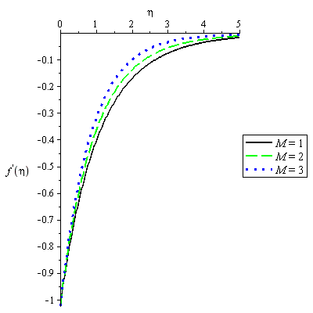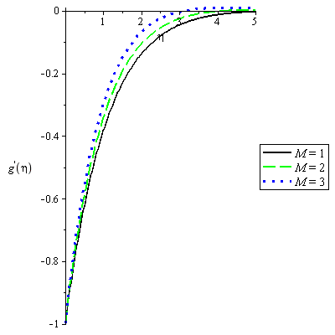

**Figure 1: Velocity Profile for various values of**  **on  Figure 2: Velocity Profile for various values of**  **on **

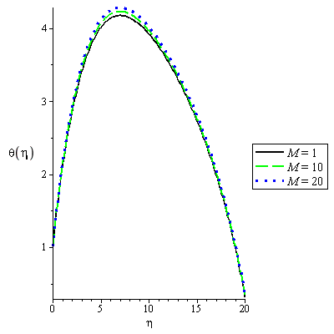 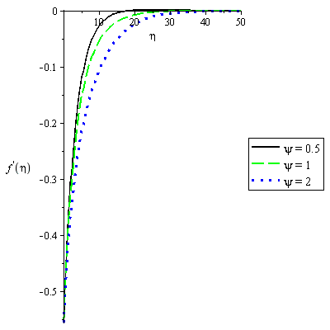

**Figure 3: Temperature Profile for various values of**  **on  Figure 4: Temperature Profile for various values of** **on**



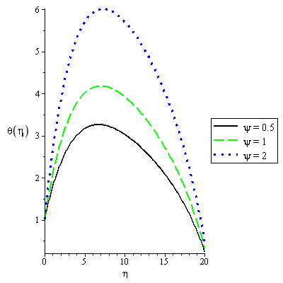

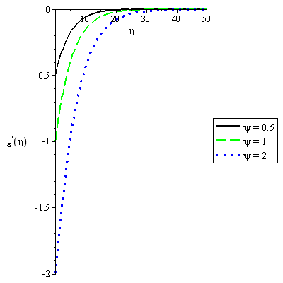

**Figure 5: Velocity Profile for various values of**  **on  Figure 6: Velocity Profile for various values of**  **on**



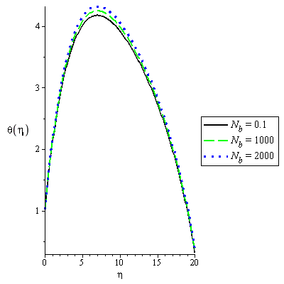**Figure 7: Concentration Profile for various values of** **on Figure 8: Temperature Profile for various values of** **on**

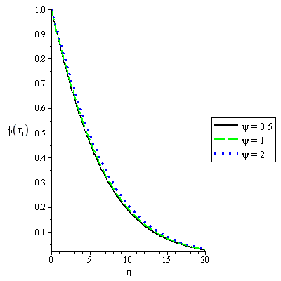



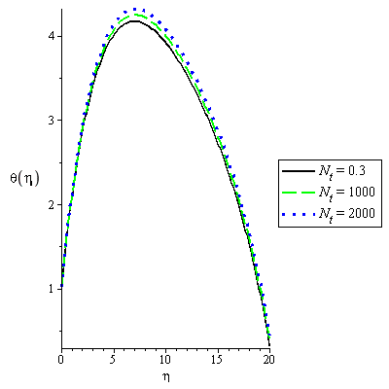

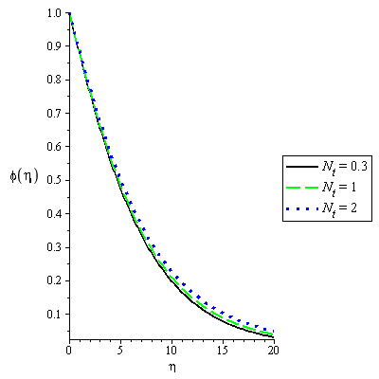

**Figure 9: Concentration Profile for various values of****on Figure 10: Temperature Profile for various values of****on**



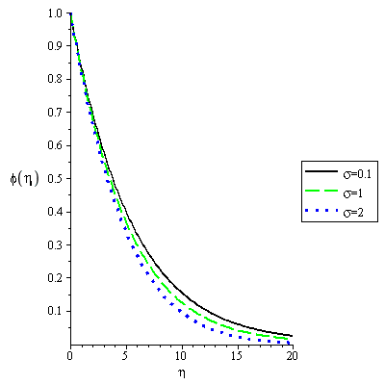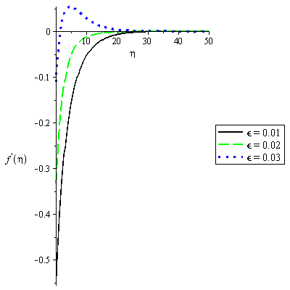

**Figure 11: Concentration Profile for various values of**  **on ** **Figure 12: Velocity Profile for various values of**  **on**



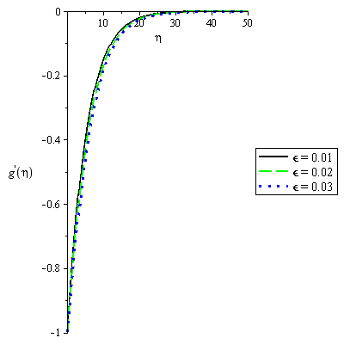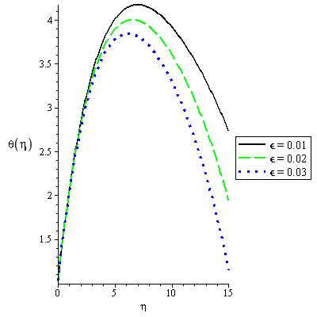

**Figure 13: Velocity Profile for various values of**  **on  Figure 14: Temperature Profile for various values of**  **on**



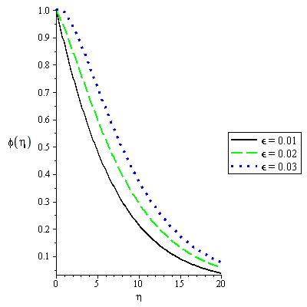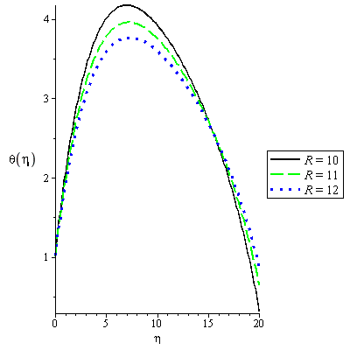

**Figure 15: Concentration Profile for various values of**  **on  Figure 16: Concentration Profile for various values of** 

**on**

**Conclusion**

The solution of three dimensional MHD flow of nanofluid induced by permeable exponentially shrinking sheet in the presence of thermal radiation and Arrhenius chemical reaction has been found by applying iteration perturbation techniques. The model incorporates permeability, porosity, Arrhenius chemical reaction, unsteadiness, heat source, Brownian motion, thermophoresis and thermal radiation term in three-dimensional flow. A similarity solution was obtained and the following observations are discovered:

(i). The magnetic effect and activation energy have the tendency to increase the primary velocity but the effect of velocity ratio is quite opposite.

(ii). The magnetic effect increases the secondary velocity but the impact of velocity ratio parameter and activation energy shrink the velocity.

(iii). The temperature strength is increased with increasing values of magnetic effect, velocity ratio parameter, thermophoretic, Brownian diffusion and activation energy parameters, but decreases with increase in radiation parameter.

(iv). Concentration is decreased with increase in chemical reaction parameter but quite opposite when thermophoretic, velocity and activation energy parameters are increase.

**References**

Buongiorno, J. (2006). Convective transport in nanofluids, *ASME J. Heat Transfer* 128 240-250.

Rajesh V., Mallesh, M. P., & Sridevi, C. (2015). Transient MHD Nanofluid flow and heat transfer due to moving vertical plate with thermal radiation and temperature oscillation effects. *International Conference on Computational Heat and Mass Transfer, Procedia Engineering* 127(2015) 901-908.

Khan, J. A., Mustafa, M., Hayat, T., Sheikhlesiami, M., & Alsaedi, A. (2015). Three-dimensional flow of nanofluid induced by an exponentially stretching sheet: An application to solar energy, *PLOS ONE* 10(3).

Anuradha, S., & Priyadharshini, P. (2016). MHD free convection boundary layer flow of Nanofluid over a permeable shrinking sheet in the presence of thermal radiation and chemical reaction. *Chemical and Process Engineering Research*, 46, 2225-0913.

Anuradha, S., & Yegammai, M. (2017). MHD free convection boundary layer flow of Nanofluid over a permeable shrinking sheet with nth order chemical reaction. *International Journal of Engineering Technologies and Management Research*, 4, 2454-1907.

Mohammed, A. A., Olayiwola, R. O., & Yisa, E. M. (2015). Simulation of heat and mass transfer in the flow of incompressible viscous fluid past an infinite vertical plate. Gen. Math. Notes, ICSRS Publication, Vol. 31, pp.54-65, ISSN 2219-7184.

Olayiwola, R. O. (2016). Modeling and analytical simulation of a laminar premixed flame impinging on a normal solid surface. *Nigeria Journal of Mathematics and Applications (NJMA)*, 25, 226-240.

Cengel, Y. A. (2003, 1998). *Heat transfer: A practical approach.* Mc Graw-Hill: Inc. Second Edition.

Choi, S. U. S., & Eastman J. A. (1995). Enhancing thermal conductivity of fluids with Nanoparticles, *Energy Technology Division and Materials Science Division Argonne National Laboratory, Argonne, Illinois*