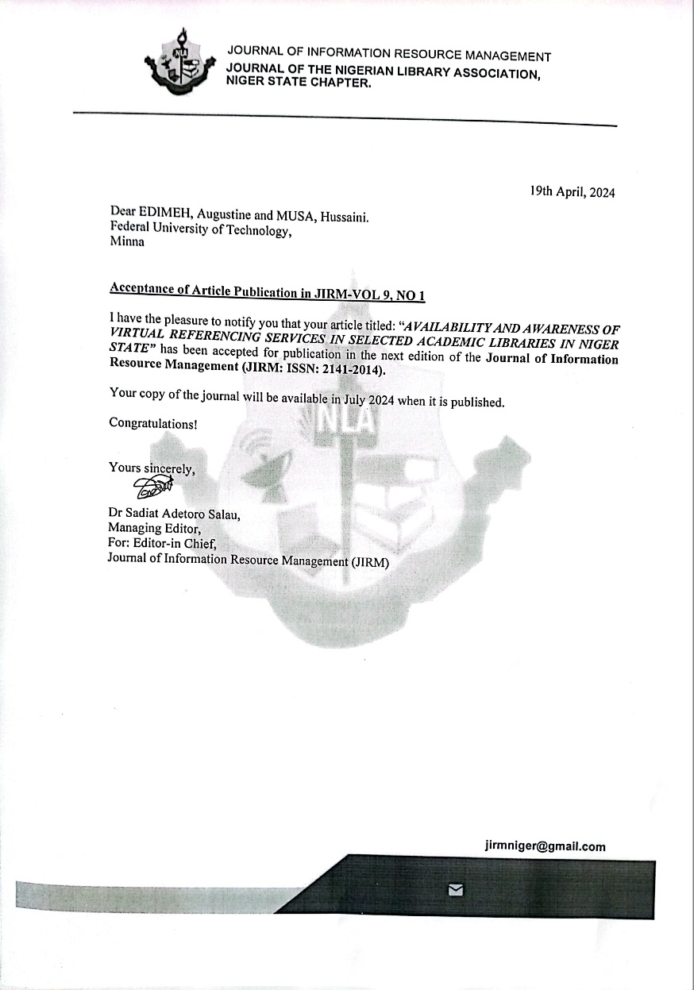

AVAILABILITY AND AWARENESS OF VIRTUAL REFERENCING SERVICES IN SELECTED ACADEMIC LIBRARIES IN NIGER STATE
BY
EDIMEH, Augustine,

MUSA, Hussaini
&
ABDULKADIR, Mustapha Gana

University Library Services
Federal University of Technology, PMB 65 Minna Niger-State
Correspondence contact: Telephone (Mobile): + 234-803-441-5996
E – Mail: austine.edimeh@futminna.edu.ng

ABSTRACT
The study's primary goals were to find out how widely available VRS infrastructure and technologies are, as well as how knowledgeable librarians and library patrons are about VRS. Three hundred (300) VRS users and thirteen (13) library professionals from the Ibrahim Badamasi Babangida University Lapai (Abubakar Gimba Library), the Federal University of Technology Minna (Ibrahim Badamasi Babangida Library), and the Niger State College of Education (Yahaya Madaki Library) provided data for the quantitative descriptive design. The results revealed that there exists sufficient infrastructure, technologies, and training facilities and programs accessible to both VRS librarians and users. The conclusions of the investigation indicated that a portion of the librarians were cognizant of VRS, however, they exhibited reluctance in becoming involved in the provision of this service. It is advisable that the awareness of both users and librarians be heightened in order to augment the quantity of VRS users, and to enlist more librarians to ensure timely responses to users. Once again, the study proposed.
KEY TERMS: Academic Libraries, Niger State, Patrons, Reference Services and Virtual Referencing Services

Reference
Abubakar, M. K. (2021). Implementation and Use of Virtual Reference Services in Academic Libraries during and post COVID-19 Pandemic: A Necessity for Developing Countries. Library Philosophy and Practice.
Adetayo, A. J. (2021). Leveraging bring your own device for mobility of library reference services: The Nigerian perspective. The Reference Librarian, 62(2), 106-125.
Akor, P.U. and Alhassan, J.A (2015). Evaluation of Reference Services in Academic Libraries: a Comparative Analysis of Three Universities in Nigeria. Journal of Balkan Libraries Union, 3, (1), 24-29
Aswath, L., and KS, M. S. (2017). Knowledge Management: an Academic Library Perceptive. Editorial Board, 6(11), 128.
Bennett, L. (2016) Advantages and disadvantages of google form. Available at https://prezi.com (Accessed on 20/1/2024)
Creswell, J. W. (2020). Educational research: Planning, conducting, and evaluating quantitative and qualitative research. Pearson Higher Ed.
Emerson, R. W. (2021). Convenience sampling revisited: Embracing its limitations through thoughtful study design. Journal of Visual Impairment and Blindness, 115(1), 76-77.
Gbaje, E. S. (2007). Implementing a national virtual library for higher institutions in Nigeria. LIBRES: Library and Information Science Research Electronic Journal, 17(2), 1-15.
Glace, J., Kern, K., Morse, L., and Rice, J. (2004). Guidelines for Implementing and Maintaining Virtual Reference Services. Reference and User Services Quarterly, 44(1), 9.
Hurley, D. A., and Warner, A. (2022). Does proactivity drive use? Understanding growth in chat reference services. Public Services Quarterly, 18(2), 79-90.
IFLA. (2008). IFLA digital reference guidelines. Available at: https://www.ifla.org/wp-content/uploads/2019/05/assets/reference-and-information-services/publications/ifla-digital-reference-guidelines-en.pdf. (Accessed on 5/1/2024)
Kern, K.M (2009) Implementing Virtual Reference Is It the Right Thing, Right Now? In Virtual Reference Best Practices: Tailoring Services to Your Library. ALA: Chicago. P.S.
Khan, A., Masrek, M. N., Mahmood, K., and Qutab, S. (2017). Factors influencing the adoption of digital reference services among the university librarians in Pakistan. The Electronic Library.
Kiana, L., and Mabeifam, M. (2020). Perception and use of the virtual library by Undergraduates at the International University of Management, Namibia. African Journal of Library, Archives and Information Science, 30 (1), 15-22.
Lateef, S., & Mairaj, M. I. (2023). Librarians’ Perceptions toward Virtual Reference Services in Pakistani University Libraries. Internet Reference Services Quarterly, 1-22.
Lee R. (2006), Lifc Online: Teens, Technology, and the World to come. Retrieved online (10/09/2022) at www.pewinternet.org/ppt/Teens%20 and%20tech-nology.pdf.
Malik, A. and Mahmood, K. (2014) Readiness for digital reference service (VRS) in university libraries: a survey in the Punjab, Pakistan. Journal of Information Development. 30, (2), 181-188.
Mawhinney, T. (2020). User preferences related to virtual reference services in an academic library. The Journal of Academic Librarianship, 46 (1), 102094.
Mehta, D., and Wang, X. (2020). COVID-19 and digital library services–a case study of a university library. Digital library perspectives.
Mwiinga, T. M., M’kulama, A., Chisunka-Mwila, C. P., and Daka, K. L. (2020). Use of digital reference services in selected academic libraries in Zambia.
Nicholas, P., and Sterling, J. (2014). Collaborative Virtual Reference Service: Should Jamaican Libraries be in a National Consortium. Library and Information Association of Jamaica Bulletin, 1, 1-23.
Oluwabiyi, M. O. (2017). Digital reference services: an overview. Information Impact: Journal of Information and Knowledge Management, 8(1), 66-75.
Qobose, E. and Mologanyi, B. (2015). Evaluating Virtual Reference Service at University of Botswana Library: a case study of Question Point. A paper submitted at IFLA WLIC 2015, Cape Town
Sahin, M. D., and Öztürk, G. (2019). Mixed Method Research: Theoretical Foundations, Designs and Its Use in Educational Research. International Journal of Contemporary Educational Research, 6(2), 301-310.
Sinhababu, A., and Kumar, S. (2019). Understanding Virtual Reference Service Guidelines: A Roadmap for Successful Implementation. International Journal of Information Library and Society, 8(2), 68.
Sinhababu, A., & Kumar, S. (2023). Awareness and users’ opinion regarding need of virtual reference service in Chandigarh Region innovation and knowledge cluster institutions (CRIKC) in India: A study. Internet Reference Services Quarterly, 27(1), 37-48.
Sinhababu, A., & Kumar, S. (2023a). Visualizing Synchronous Virtual Reference Service in Chandigarh Region Innovation and Knowledge Cluster (CRIKC) Institutions in India: Librarians’ Perception. Journal of Library & Information Services in Distance Learning, 17(3-4), 116-133.
Uutoni, W. (2018). Providing digital reference services: a Namibian case study. Information and Learning Science.
Ward, D., Liriano, M. I., Gard, B. A., and Johnson, R. L. (2004). Guidelines for behavioral performance of reference and information service providers. Reference and User Services Quarterly, 44(1), 14.
Yang, S. Q., and Dalal, H. A. (2015). Delivering virtual reference services on the web: an investigation into the current practice by academic libraries. The Journal of Academic Librarianship, 41(1), 68-86.
Yonus, M. (2014) Digital Reference service in Pakistan University libraries. Available at:https://dspace.lboro.ac.uk/2134/16 (Accessed on 14/1/2024)

