**A MATHEMATICAL MODEL OF SCABBY MOUTH DISEASE INCORPORATING THE QUARANTINE CLASS.**

1Abdurrahman Olamide Nurat, 2Aboyeji Folawe Ibironke, 3Akinwande Ninuola Ifeoluwa and

4Somma Samuel Abu

Department of Mathematics, Federal University of Technology, Minna, Nigeria

[1nurat.a@futminna.edu.ng,2](mailto:1nurat.a@futminna.edu.ng,2)aboyejifolawe@gmail.com, [3ninuola.wande@futminna.edu.ng](mailto:3ninuola.wande@futminna.edu.ng) and [4sam.abu@futminna.edu.ng](mailto:4sam.abu@futminna.edu.ng)

**ABSTRACT**

We propose a mathematical model to study the transmission and control of scabby mouth disease in sheep, incorporating the vaccinated and quarantine classes.  The Disease-free equilibrium was obtained and the reproduction number was also computed. The local stability of DFE was analyzed for stability.  Sensitivity analysis of basic reproduction number with respect to some parameters of the model was carried out and the sensitive parameters with $R_{0}$ are presented graphically. The local stability of DFE is stable if $R_{0}<1$. The sensitivity analysis shows that the contact rate $α$ is the most sensitive parameter to increase the spread of the disease and vaccination rate $ω$ is the highest sensitive parameter to control the transmission of scabby.

**Keywords:** scabby mouth disease, Quarantine, Diseases Free Equilibrium, Reproduction number.

INTRODUCTION

Scabby mouth is a highly contagious viral disease of the skin of sheep and goats which usually affects lambs and kids. The disease is caused by a pox virus which is normally present in scabs on affected animals. The virus can survive off the sheep for many years under the right conditions (Sunday et al, 2012). Once the disease is introduced to a property, the virus will remain in the environment for many years. Sheep become infected through injuries or abrasions on the skin of the muzzle, the lips or coronet or other areas of bare skin. Two to four days after infection the skin becomes reddened and may show some swelling. The first signs of infection are usually seen near the corners of the lips. The next stage is the development of blisters which quickly develop into pustules. These pustules then rupture, excreting virus and forming scabs, giving the disease its typical appearance. The scabs lift in one to two weeks, leaving raw skin which quickly heals and returns to normal. In some lambs, the lesions spread along the lips and merge to form scabs which may involve the whole of the lips. In severe cases, the lesions may extend into the mouth, onto the tongue and into the nostrils. The lesions usually disappear within four to six weeks of the initial infection. Severely affected lambs may be unable to feed for several days, resulting in a loss of condition and an increased susceptibility to other diseases or death by starvation in young lambs. Scabby mouth alone does not cause deaths, but it will severely depress growth rates. Lesions on the teats and udders of ewes may predispose to mastitis.

No treatment will kill the virus and the disease normally runs its course in three to four weeks (seaman et al, 2016). Spread may be reduced by moving affected mobs to paddocks where injury to the skin is less likely, such as paddocks with less thistle or burr. Severely affected animals may need treatment to overcome secondary infections. Sheep are best vaccinated as lambs at lamb marking. This involves scratching the live vaccine onto the skin on the inner thigh (CDC, 2007). The lamb will develop a skin infection at the site of vaccination within five to ten days and develop immunity in 14 days. Sheep should be checked five to ten days after vaccination to ensure that the vaccine has taken. Successful vaccination produces pustules along the line of the scratches. These pustules progress to small scabs which normally disappear three to four weeks after vaccination. People should avoid contact with the scabs and cover all cuts and abrasions before handling animals and wash hands and clothes thoroughly after handling. Once immunity has developed, vaccinated sheep are protected for 12 months (WHO, 2018).

**SCHEMATIC DIAGRAM**

















$α$

$μ+∂$

$μ$ $ϕ$ $ρ$ $τ$

$ω$

$μ+∂$

$$μ$$

$\frac{dS}{dt}=β+φV-\frac{αSI}{N}-\left(ω+μ\right)S$ (1)

$\frac{dI}{dt}=\frac{αSI}{N}-\left(γ+ρ+μ+∂\right)I$ (2)

$\frac{dQ}{dt}=ρI-(τ+μ+∂)Q{}$ (3)

$\frac{dV}{dt}=ωS-(ϕ+μ)V$ (4)

$\frac{dR}{dt}=γI+τQ-μR$ (5)

**Table 1.1: Definition of Variables and Parameters.**

|  |  |
| --- | --- |
| **Variables and Parameters** | **Description** |
| $S$ | Susceptible class |
| $I$ | Infected Class |
| $V$ | Vaccinated Class |
| $$Q$$ | Quarantine Class |
| $$R$$ | Recovered Class |
| $$β$$ | Recruitment/Birth Rate |
| $$α$$ | infection rate |
| $$ρ$$ | Rate at which the infected class is quarantined |
| $$∂$$ | death due to complication from infection |
| $$ω$$ | Vaccination rate |
| $$ϕ$$ | loss of immunity |
| $$μ$$ | natural death rate |
| $$γ$$ | recovery rate |
| $$τ$$ | treatment rate |

Let

$k_{1}=(ω+μ),k_{2}{=}(γ+ρ+μ+∂),k_{3}{=}(τ+μ+∂),k_{4}{=}(ϕ+μ);{}$ (6)

**Equilibrium state of the model**

At equilibrium state,

$\frac{dS}{dt}=\frac{dI}{dt}=\frac{dQ}{dt}=\frac{dV}{dt}=\frac{dR}{dt}=0$ (7)

Let $\left(\begin{matrix}S \\ I \\ Q \\ V \\ R\end{matrix}\right)=\left(\begin{matrix}S_{0}^{*} \\ I_{0}^{*} \\ Q_{0}^{*} \\ V_{0}^{*} \\ R_{0}^{*}\end{matrix}\right)$ (8)

We have the following equations

$β+φV_{0}^{*}-\frac{αS_{0}^{*}I_{0}^{*}}{N_{0}^{*}}-k_{1}S_{0}^{*}=0$ (9)

$\frac{αS_{0}^{*}I_{0}^{*}}{N_{0}^{*}}-k_{2}I_{0}^{*}=0$ (10)

$ρI_{0}^{*}-k_{3}Q_{0}^{*}{=}0$ (11)

$ωS_{0}^{*}-k_{4}V_{0}^{*}=0$ (12)

$γI_{0}^{*}+τQ_{0}^{*}-μR_{0}^{*}=0$ (13)

From equation (10)

$(αS_{0}^{*}-k_{2})I_{0}^{*}{=}0$ (14)

$⇒I_{0}^{*}=0$ (15)

From 9

$β+ϕV_{0}^{*}-k_{1}S_{0}^{*}=0$ (16)

$⇒V_{0}^{*}=\frac{k_{1}S_{0}^{*}-β}{ϕ}$ (17)

From equation 12,

$V_{0}^{*}=\frac{ωS_{0}^{*}}{k_{4}}$ (18)

comparing equation 17 and 18, we have

$\frac{ωS_{0}^{*}}{k_{4}}=\frac{(k_{1}S_{0}^{*}-β)}{ϕ}$ (19)

$S_{0}^{*}=\frac{βk_{4}}{k_{1}k_{4}-ωϕ}$ (20)

Substituting equation (20) into (18), we have

$V_{0}^{*}=\frac{ωβ}{k_{1}k_{4}-ωϕ}$ (21)

Substituting equation 15 into 11, we have

$k_{3}Q_{0}^{*}{=}0$ (22)

$⇒Q_{0}^{*}{=}0$ (23)

substituting equations 15 and 21 into equation 13,

$μR_{0}^{*}=0$ ( 24)

$⇒R_{0}^{*}=0$ (25)

$\left(\begin{matrix}S_{0}^{*} \\ I_{0}^{*} \\ Q_{0}^{*} \\ V_{0}^{*} \\ R_{0}^{*}\end{matrix}\right)=\left(\begin{matrix}\frac{βk_{4}}{k_{1}k_{4}-ωϕ} \\ 0 \\ 0 \\ \frac{ωβ}{k_{1}k_{4}-ωϕ} \\ 0\end{matrix}\right)$ (26)

$N_{0}^{*}=\frac{βk_{5}}{k_{1}k_{4}-ωϕ}$ (27)

Where $k_{5}=k_{4}+ω$ (28)

**THE REPRODUCTION NUMBER $R_{0}$**

The basic reproduction number is the average number of secondary infections produced when one infective is introduced into the host population where everyone is susceptible (Benyah, 2009).

When $R_{0}<1$ The infection will die out in the long run but if $R_{0}>1$ the infection will be able to spread in the population. In this model the reproduction number is given as the largest eigen-value or spectral radius of $FV^{-1_{}}$. Where $F_{i}$ is the rate of appearance of new infection in compartment $i$, $V_{i}$ is the transfer of infection from one compartment $i$ to another.

$FV^{-1}=\left(\frac{dF_{i}}{dx_{i}}\right){\left(\frac{dV_{i}}{dx_{i}}\right)}^{-1}$ (29)

$F_{i}=\left(\begin{matrix}\frac{αSI}{N} \\ ρI\end{matrix}\right)$ (30)

At DFE

$F=\left(\begin{matrix}\frac{αS_{0}^{*}}{N_{0}^{*}} & 0 \\ ρ & 0\end{matrix}\right)=\left(\begin{matrix}\frac{αk_{4}}{k_{5}} & 0 \\ ρ & 0\end{matrix}\right)$ (29)

$\frac{S_{0}}{N_{0}}=\frac{k_{4}}{k_{5}}$ (30)

$V_{i}=\left(\begin{matrix}k_{2}I \\ k_{3}Q\end{matrix}\right)$ (31)

$V_{i}=\left(\begin{matrix}\frac{dV_{i}}{dI} \\ \frac{dV_{i}}{dQ}\end{matrix}\right)=\left(\begin{matrix}k_{2} & 0 \\ 0 & k_{3}\end{matrix}\right)$ (32)

$\left|V\right|=\left|\left(\begin{matrix}k_{2} & 0 \\ 0 & k_{3}\end{matrix}\right)\right|=\left(k_{2}k_{3}\right)$ (33)

$AdjV=\left(\begin{matrix}{k_{3}}_{} & 0 \\ 0 & k_{2}\end{matrix}\right)$ (34)

$V^{-1}=\left(\begin{matrix}\frac{1}{k_{2}} & 0 \\ 0 & \frac{1}{k_{3}}\end{matrix}\right)$ (35)

$FV^{-1}=\left(\begin{matrix}\frac{αk_{4}}{k_{2}k_{5}} & 0 \\ 0 & 0\end{matrix}\right)$ (36)

$\left|FV^{-1}-Iλ\right|=0$ (37)

$\left|\begin{matrix}\frac{αk_{4}}{k_{2}k_{5}}-λ & 0 \\ 0 & -λ\end{matrix}\right|=0$ (38)

$-λ\left(\frac{αk_{4}}{k_{2}k_{5}}-λ\right)=0$ (39)

$λ_{1}=0,λ_{2}=\frac{αk_{4}}{k_{2}k_{5}}$ (40)

Therefore, the reproduction number

$R_{0}=\frac{αk_{4}}{k_{2}k_{5}}$ (41)

**LOCAL STABILITY OF THE DISEASE FREE EQUIIBRIUM (DFE)**

$J(E^{0}{)}=(S_{0}^{*}{I_{0}^{*}{Q_{0}^{*}{V_{0}^{*}{R_{0}^{*}{)}}}}}$ (42)

$J(E^{0}{)}=\left(\begin{matrix}-αI-k_{1} & -αS & 0 & ϕ & 0 \\ αI & αS-k_{2} & 0 & 0 & 0 \\ 0 & ρ & -k_{3} & 0 & 0 \\ ω & 0 & 0 & -k_{4} & 0 \\ 0 & γ & τ & 0 & -μ\end{matrix}\right)$ (43)

Substituting (24) into (39) we have that

$\left(\begin{matrix}-k_{1} & -\frac{αβk_{4}}{k_{1}k_{4}-ωϕ} & 0 & ϕ & 0 \\ 0 & \frac{αβk_{4}}{k_{1}k_{4}-ωϕ}-k_{2} & 0 & 0 & 0 \\ 0 & ρ & -k_{3} & 0 & 0 \\ ω & 0 & 0 & -k_{4} & 0 \\ 0 & γ & τ & 0 & -μ\end{matrix}\right)$ (44)

$\left(\begin{matrix}-k_{1} & - & 0 & ϕ & 0 \\ 0 & -k_{2} & 0 & 0 & 0 \\ 0 & ρ & -k_{3} & 0 & 0 \\ ω & 0 & 0 & -k_{4} & 0 \\ 0 & γ & τ & 0 & -μ\end{matrix}\right)$ (45)

$\left|\begin{matrix}-k_{1} & -\frac{αk_{4}(k_{1}-β)}{ωϕ} & 0 & ϕ & 0 \\ 0 & \frac{k_{2}ϕω+αk_{4}(k_{1}-β)}{ωϕ} & 0 & 0 & 0 \\ 0 & 0 & -k_{3} & 0 & 0 \\ 0 & 0 & 0 & \frac{ϕω-k_{1}k_{4}}{k_{1}} & 0 \\ 0 & 0 & 0 & 0 & -μ\end{matrix}\right|$ (46) $\left(\begin{matrix}-k_{1}-λ_{1} & -\frac{αk_{4}(k_{1}-β)}{ωϕ} & 0 & ϕ & 0 \\ 0 & \frac{k_{2}ϕω+αk_{4}(k_{1}-β)}{ωϕ}-λ_{2} & 0 & 0 & 0 \\ 0 & 0 & -k_{3}-λ_{3} & 0 & 0 \\ 0 & 0 & 0 & \frac{ϕω-k_{1}k_{4}}{k_{1}}-λ_{4} & 0 \\ 0 & 0 & 0 & 0 & -μ-λ_{5}\end{matrix}\right)$ (47)

$\left(\begin{matrix}λ_{1}=-k_{1} \\ λ_{2}=\frac{-k_{2}ϕω+αk_{4}(k_{1}-β)}{ωϕ} \\ λ_{3}=-k_{3} \\ λ_{4}=\frac{ϕω-k_{1}k_{4}}{k_{1}} \\ λ_{5}=-μ\end{matrix}\right)$ (48)

For the Disease-Free state to be achieved $λ_{2}$ and $λ_{4}$ have to be negative. For $λ_{2}$ to be negative we have that

$-k_{2}ϕω+αk_{4}(k_{1}-β)<0$ (49)

$⇒αk_{4}(k_{1}-β)<k_{2}ϕω$ (50)

$\frac{αk_{4}(k_{1}-β)}{k_{2}ϕω}<1$ (51)

Comparing (41) to (51)

$⇒R_{0}<1$ which implies that the disease will die out

On the other hand, $λ_{4}<0$ implies that

$⇒ϕω<k_{1}k_{4}$ (52)

$⇒ϕω<(ω+μ)(ϕ+μ)$ (53)

$⇒ϕω<ϕω+ωμ+μϕ+μ^{2}$ (54)

$⇒-ωμ<μϕ+μ^{2}$ (55)

$ω>-(ϕ+μ)$ (56)

**Discussion of result**

**Sensitivity Analysis**

The approach of Somma and Akinwande (2020) was followed to carried out the sensitivity analysis. Table 2 is the sensitivity indices of low and transmission rate

**Table 2:** Sensitivity Indices

|  |  |  |
| --- | --- | --- |
| parameters | Low transmission | High transmission |
| $$α$$ | 1.0000 | 1.0000 |
| $$γ$$ | -0.4892 | -0.5276 |
| $$ω$$ | -0.6098 | -0.5319 |
| $$ρ$$ | -0.4092 | -0.4655 |
| $$φ$$ | 0.4713 | 0.4245 |

Table 2 shows that contact rate $α$ is the most sensitive parameter follow by vaccination rate $ω$, recovery rate $γ$, quarantine rate $ρ$ and loss of immunity rate $φ$. The positive values indicate the parameters that will increase the reproduction of the scabby disease and the negative values indicate the parameters that will reduce the reproduction of the scabby disease and eventually put it under control.

**Graphical Representation of Sensitive Parameters and Basic Reproduction Number**

Figures 2 to 6 are the Graphical Representation of Sensitive Parameters and Basic Reproduction Number.

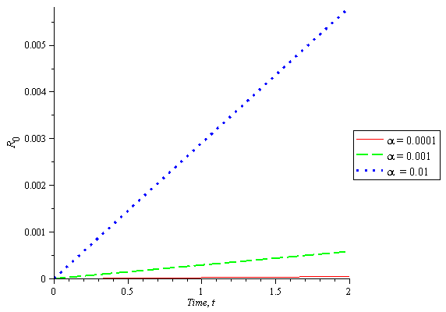

Figure 2**:** Graph of Basic Reproduction Number against different proportions of Contact rate

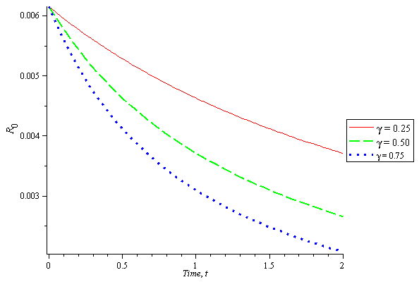

Figure 3:Graph of Basic Reproduction Number against different proportions of Recovery rate

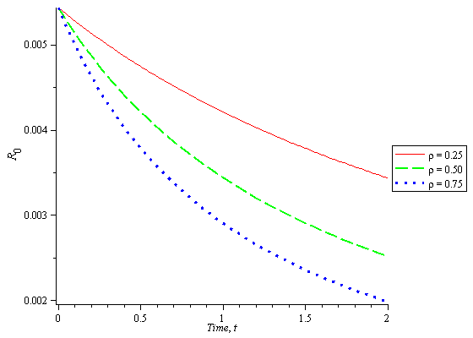

Figure 4:Graph of Basic Reproduction Number against different proportions of Quarantine rate

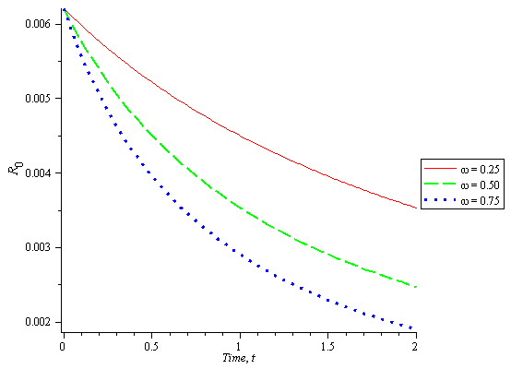

Figure 5:Graph of Basic Reproduction Number against different proportions of Vaccination rate

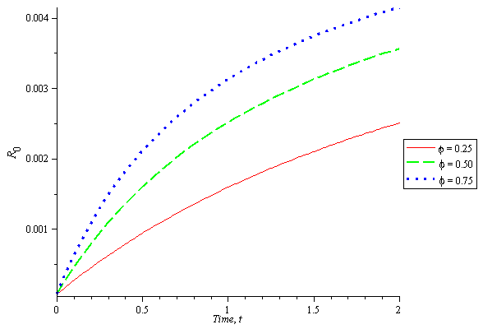

Figure 6: Graph of Basic Reproduction Number against different proportions of Loss of Immunity rate

Figure 2 shows that as contact rate increases with time the basic reproduction number increases. This implies that the contact rate is a key parameter that will spread the scabby disease. In figure 3, 4 and 5, it is observed that as recovery, quarantine and vaccination rates increases with time the basic reproduction number decreases. These parameters are the sensitive parameters that will bring scabby under control. Figure 6 revealed that as loss of immunity rate increase the basic reproduction number increases.

**CONCLUSION**

The local stability and sensitivity analyses of the Mathematical modeling of Scabby diseases incorporating quarantine were carried out. Sensitive parameters were plotted graphically against basic reproduction number. The sensitivity analysis shows that recovery, quarantine and vaccination rates are the sensitive parameters that will bring scabby under control. Therefore, vaccination of susceptible individuals, quarantine and treatment of the infected individuals should be given priority.

**REFERENCES**

**Benyah, F. (2009). Introduction to Mathematical Modeling; 7th Regional College on Modeling, Simulation and Optimization, University of Cape Coast, Ghana.**

**Beltrami E. Mathematics for Dynamics Modelling; Academic Press Inc London**

**(1989).**

**Diekmann O. & Heesterbeck J.A.P (2000) Mathematical Epidemiology of Infectious**

**Diseases Model Building, Analysis and Interpretation; New York, Wiley.**

Hand, Foot, and Mouth Disease. Retrieved July 24, 2007*, from Centres for Disease Control and Prevention:* [*http://www.cdc.gov*](http://www.cdc.gov)

[http://dx.doi.org/10.1037/pag0000131](https://psycnet.apa.org/doi/10.1037/pag0000131)

Johnsie Ortiz & Daniel Rubin. (2006*). “Critical Response Models for Foot-and-Mouth Disease Epidemics’’*

Roy N. (2012), Mathematical Modelling of Hand-Foot-Mouth Disease: Quarantine as a Control Measure. *IJASETR 1(2): p. 34 - 44.*

Steady Mushayabasa, Claver P. Bhunu & Mlamuli Dhlamini (2011). “Impact of Vaccination and Culling on Controlling Foot and Mouth Disease: A Mathematical Modelling Approach”. *World Journal of Vaccines, 2011, 1, 156-161*

**Somma S. A.** & Akinwande N. I. (2020) Sensitivity Analysis for the Mathematical Modelling of Monkey Pox Virus Incorporating Quarantine and Public Enlightenment Campaign. *FULafia Journal of Science & Technology*, 6(1), 54-61.

Sunday & Inyama (2012). “Mathematical Model for the Epidemiology of Fowl Pox Infection Transmission That Incorporates Discrete Delay*”. IOSR Journal of Mathematics (IOSR-JM) e-ISSN: 2278-5728, p-ISSN: 2319-765X. Volume 10, Issue 4 Ver. V (Jul-Aug. 2014), PP 08-16* [www.iosrjournals.org](http://www.iosrjournals.org).

# World Health Organization (2018). Scabby Mouth Disease, WHO, Geneva, 2018.