Malaysian Journal Of Civil Engineering

MODELS TO PREDICT THE FRESH AND HARDENED PROPERTIES OF PALM KERNEL SHELL CONCRETE

D. N. Kolo*, T. Y. Tsado, B. A. Abbas, Adamu, H. N.

Department of Civil Engineering, Federal University of Technology
Minna, Nigeria

Article history
Received
23 September 2021
Received in revised form
23 December 2021
Accepted
25 December 2021
Published online
31 March 2022

*Corresponding author daniel.kolo@futminna.edu.ng

Graphical abstract Abstract

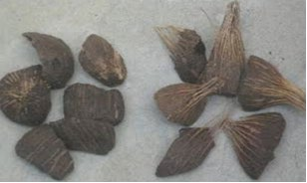Concrete is an assemblage of Cement, aggregates and water, the most frequently used fine aggregate for concrete production is sand sourced from river banks. The continuous exploitation of available granite conventionally used as coarse aggregate in concrete production coupled with rapid infrastructural development has resulted in its scarcity and often high cost. The suitability of utilising Palm Kernel Shell (PKS) as partial replacement for coarse aggregate in concrete production was examined in this paper. Preliminary tests were conducted on all aggregates to determine their suitability for concrete production. Concrete with 5, 10, 15, 20 and 25% PKS-coarse aggregate content was cast with a mix ratio of 1:2:4. The freshly prepared Palm Kernel Shell Concrete (PKSC) was cast in moulds measuring 150 x 150 x 150mm and cured using ponding method. The Compressive strength result shows that an increase in the PKS content results in a decrease in compressive strength of concrete. Linear regression models for the slump and compressive strength of the PKSC were developed and found to be sufficient in predicting the compressive strengths with R2 values of 96% and 92 % respectively.

Keywords: Concrete, Compressive Strength, Model, Palm Kernel Shell, Slump

© 2022 Penerbit UTM Press. All rights reserved

1.0 INTRODUCTION

The desire to explore the viability of agricultural and industrial wastes as substitutes for conventional aggregates in concrete production is gaining grounds. This is as a result of economic and environmental considerations (Ezeifula et al., 2017). The use of these wastes is timely especially for a developing country like Nigeria where the cost of available building materials over the years has led to a clamour for alternative sources of materials for construction. The challenge for the use of locally sourced materials for construction works is as a result of such clamour and is believed to be a strategy to reduce the overall cost of buildings and construction (Nduka et al., 2018). Agricultural wastes like palm kernel shell (PKS) and periwinkle shell over the years have been identified by researchers to have some potentials in partially replacing conventional aggregates in concrete production. However, they have not been fully utilised as a sole coarse aggregate.
According to Ezeifula et al. (2017) agricultural and industrial wastes incorporated in the production of concrete are lightweight aggregates which result in lightweight concrete. The advantages of utilising lightweight concrete over the conventional concrete in construction includes: reduced dead load, reduced rate of exploitation of natural resources and reduced cost of construction.
Palm kernel is the main source of palm oil, which is a major cooking ingredient used in Nigeria. The shells are the fractions remaining after oil, fibre and nuts have been extracted (Mo et al., 2016). Several researches conducted over the years provide proof of the viability of palm kernel shell as an effective replacement material for coarse aggregate in concrete production Okafor (1998): Osei and Jackson (2012): Williams et al. (2014): and Asuzu et al. (2017). Hence this research developed statistical models to predict the slump and compressive strength of palm kernel shell concrete (PKSC). Figure 1 depicts the palm kernel shells used in the research.

1 D. N. Kolo, T. Y. Tsado & Abbas B. A./ Malaysian Journal of Civil Engineering 34:1 (2022) 29–35
34:1 (2022) 29-35 | www.mjce.utm.my | ISSN 1823-7843 | DOI: https://doi.org/10.11113/mjce.v34.17710

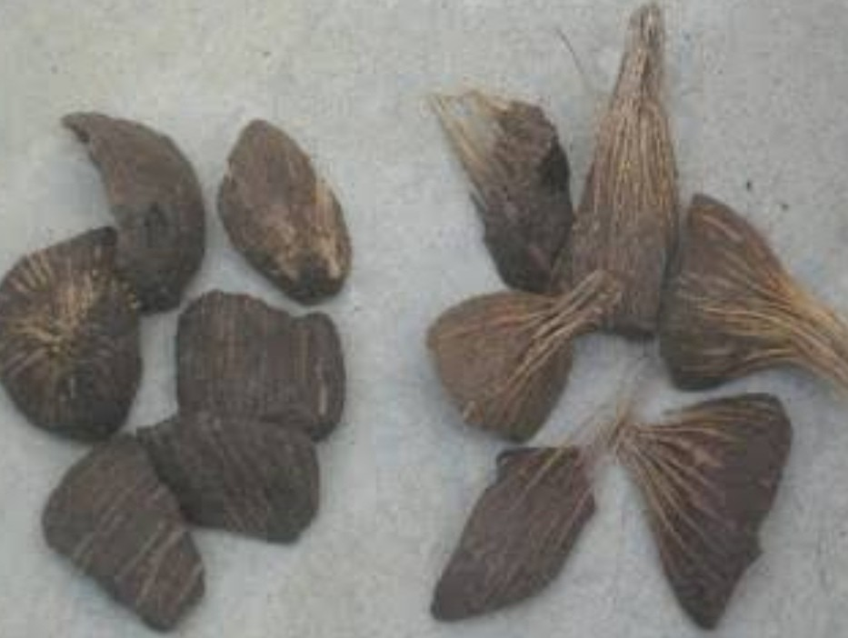Figure 1 Palm Kernel Shell

2.0 METHODOLOGY

2.1 Materials

Dangote brand of cement which was obtained from the Building Materials Market Minna, Niger State, Nigeria was used. The cement conforms to BS 12 (1996). The sand (fine aggregate) utilised was sourced from Chanchaga, Minna, Niger State. The sand was clean, sharp, free from dirt’s. Fine Aggregates generally according to BS 882 (1992) refer to aggregates which pass through sieve size 4.75 mm. Water adjudged to be fit for drinking was utilised, the water was sourced from the Civil Engineering Laboratory, Federal University of Technology Minna, Niger State, Nigeria and used in casting the cubes. BS EN 1008 (2002) states that water to be used for casting of concrete must be clean, fit for drinking and free from impurities. The Coarse Aggregate used was sourced from Minna, Niger State, Nigeria. The coarse aggregates conform to specifications for natural aggregates as stipulated in BS 882 (1992). The Palm Kernel Shell used for this research was sourced from Ilofa, Kwara State, Nigeria.

2.2 Concrete Slump Test

Slump test was conducted on the fresh PKSC in accordance to BS EN 12350-2, the test is used in assessing the consistency of fresh concrete. A steel cylindrical cone was used. It was placed on a solid flat surface then filled up with fresh concrete in three layers. Each layer is then tampered 25 times to ensure compaction. The top of the cone is then levelled, thereafter the cone is carefully lifted up leaving a heap of concrete which settles (slumps slightly). The upturned slump cone is then placed on the flat base which serves as a reference point; the difference in the level between the top of the slump cone and that of the concrete is measured to the nearest 10mm. This is the slump of the concrete (Neville and Brookes, 2008). The slump obtained may take one of three possible forms namely: true slump, shear slump and collapse slump. A true slump is generally desired: the concrete subsides a little when the cone is removed, keeping more to the initial shape. In the case of a shear slump, the top of the concrete shears off and slips

sideways while for a collapse slump, the concrete mass collapses completely. Figure 2 presents the three types of slump available.

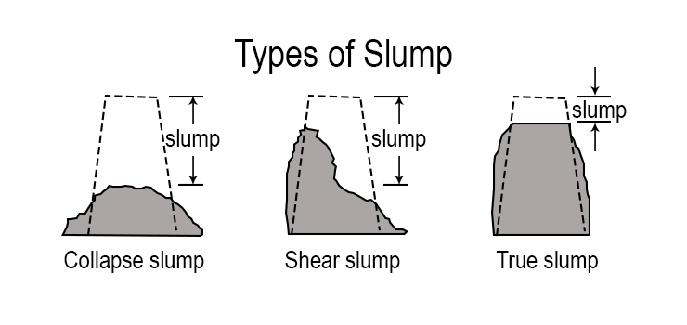

Figure 2 Types of Concrete Slump

2.3 Casting of Concrete Cubes

The Concrete cubes tested were cast in iron moulds measuring
150 x 150 x 150 mm. A concrete mixing machine was used in mixing the aggregates in order to achieve the desired homogeneity of the mixture. The moulds used were well lubricated with oil in order to reduce friction and enhance de- moulding of the cast concrete cubes. The cubes were cured for
28 days using Ponding method. The cube casting was
performed in accordance to stipulations spelt out in BS 1881 (1983).

2.4 Compressive Strength Test on Concrete Cubes

The test was conducted using the Compressive testing machine. Each cube was weighed before crushing; thereafter respective compressive strengths were calculated using equation (1). The test was conducted in accordance to stipulations in BS 1881:116.
Fcu = (N/mm2) (1) Table 1 presents the mix proportions of the various constituent
materials utilised in the PKS concrete.

2.5 Model Development

Linear regression analysis was employed in developing the models. Microsoft excel 2010 was the tool employed in developing the models. The percentage replacement level of PKS was selected as the independent variable and labelled P, while both the slump and compressive strength of the PKSC were selected as the dependent variables and labelled Y, Y1 for slump and Y2 for 28days compressive strength. Linear regression analysis is the multivariate technique used in analysing relationships and predicting future values between several independent variables and a single dependent variable (Kolo,
2019).

Table 1 Mix proportions of concrete materials

Percentage  Replacement (%) | Water (Kg) | Cement (Kg) | Fine Aggregate (Kg) | Granite (Kg) | Palm Kernel Shell  (Kg)
0  5  10 | 7.51  7.51  7.51 | 10.88  10.88  10.88 | 21.67  21.67  21.76 | 43.52  41.34  39.17 | 0.00  2.18  4.35
15 | 7.51 | 10.88 | 21.76 | 37.00 | 6.53
20 | 7.51 | 10.88 | 21.76 | 34.82 | 8.70
25 | 7.51 | 10.88 | 21.76 | 32.64 | 10.88
Total | 45.06 | 65.28 | 130.56 | 228.49 | 32.64

3.0 RESULTS AND DISCUSSION

3.1 Physical Properties of Aggregates

Tables 2, Table 3 and Table 4 present the results of sieve analysis conducted on the fine aggregate, Granite and Palm kernel Shell
respectively used in production of the PKSC. The particle size distribution is of critical importance because it has effect on the eventual strength of concrete.

Table 2 Sieve analysis result of Fine Aggregate

BS Sieve size  (mm) | Weight  Retained  (g) | Percentage  Retained  (%) | Cumulative  percentage  Retained (%) | Percentage Passing (%)
5.00 | 3.80 | 0.76 | 0.76 | 99.24
3.35 | 6.10 | 1.22 | 1.98 | 98.02
2.36 | 8.20 | 1.64 | 3.62 | 96.38
2.00 | 7.60 | 1.52 | 5.14 | 94.86
1.18 | 49.00 | 9.80 | 14.94 | 85.06
850 | 56.00 | 11.20 | 21.16 | 73.86
650 | 99.70 | 19.94 | 46.08 | 53.92
450 | 105.80 | 21.16 | 67.24 | 32.76
300 | 93.10 | 18.62 | 85.86 | 14.14
150 | 64.50 | 12.90 | 98.76 | 1.24
75 | 5.20 | 1.04 | 99.80 | 0.20
Pan | 1.00 | 0.20 | 100.00 | 0.00
500

Table 3 Sieve analysis result for Granite

BS Sieve size  (mm) | Weight retained  (g) | Percentage retained  (%) | Cumulative percentage  retained (%) | Percentage passing (%)
28.00 | 55.00 | 5.50 | 5.50 | 94.50
20.00 | 445.00 | 44.50 | 50.00 | 50.00
14.00 | 455.00 | 45.50 | 95.50 | 4.50
10.00 | 35.00 | 3.50 | 99.00 | 1.00
6.30 | 10.00 | 1.00 | 100.00 | 0.00
5.00 | 0.00 | 0.00 | 0.00 | 0.00
Pan | 0.00 | 0.00 | 0.00 | 0.00
Total | 1000 | 1000

Table 4 Sieve analysis result for Palm Kernel Shell

BS Sieve size (mm) | Weight retained  (g) | Percentage retained  (%) | Cumulative percentage  retained (%) | Percentage passing (%)
28.00 | 8.50 | 0.85 | 0.85 | 99.15
20.00 | 92.00 | 9.20 | 10.05 | 89.95
14.00 | 379.50 | 37.95 | 48.00 | 52.00
10.00 | 270.00 | 27.00 | 75.00 | 25.00

6.30 | 250.00 | 25.00 | 100.00 | 0.00
5.00 | 0.00 | 0.00 | 0.00 | 0.00
Pan | 0.00 | 0.00 | 0.00 | 0.00
Total | 1000 | 1000

Results obtained for specific gravity test conducted on the concrete constituent materials are presented on Table 5. Neville and Brooks (2008) recommends specific gravity values of 2.6 – 2.7 for natural aggregates. As can be seen, only palm kernel shell fell short of this standard with specific gravity value of 1.21. The low PKS specific gravity value is in line with research conducted by Azuna (2019) and Gibigaye et al. (2017). Azuna (2019) further opined that specific gravity value of PKS always does not exceed 2.0. Ndoke (2006) recorded the highest PKS specific gravity value of 1.62. These values are in line with the specific gravities obtained for other natural light weight aggregates like pumice and expanded shale which normally return specific gravity values ranging between 0.8 –
0.9 and 1.3 – 1.7 respectively Azuna (2019). The low specific
gravity value for the palm kernel shell is an indication that palm kernel is weaker than the conventional granite used.
3.2 Slump and Compressive Strength

Slump: Result for the slump test and compressive strength tests conducted on the PKS concrete is presented on Table 6. From the result, it is seen that the slump values reduced with increase in percentage replacement level of PKS. This is in line with results obtained by Itam et al. (2016).

Compressive Strength: As can be seen from Table 6, a decrease in compressive strength values was recorded with the increase in PKS content in the concrete with the optimum strength of
24.00 N/mm2 obtained at 5% replacement level. The trend in compressive strength values is in line with result of research conducted by Purwanti and Artiningsih (2018).

Table 5 Specific gravities of constituent materials

Material | Specific Gravity
Cement | 3.14
Fine Aggregate | 2.61
Granite | 2.65
Palm Kernel Shell | 1.21

Table 6 Slump and Compressive Strength test results

Percentage Replacement (%) | Slump (mm) | 28 Days Compressive Strength (N/mm2)
0 | 45.00 | 27.91
5 | 38.00 | 24.00
10 | 35.00 | 20.53
15 | 30.00 | 18.84
20 | 28.00 | 17.66
25 | 25.00 | 16.18

3.3 Regression Models

Table 7 presents results for the regression statistics and slump model developed. As seen from Table 7, the slump model returned adjusted R square value of 0.96. This implies that the model can predict the slump of PKS concrete with an accuracy of 96%. The developed model is represented on equation (1).

Y1 = - 0.77x + 43.14 (1)

Where Y1 = Slump of PKS concrete
x= Percentage replacement level

Table 7 Regression Statistics for Slump Model

Regression Statistics
Multiple R 0.98
R Square 0.97
Adjusted R Square 0.96
Standard Error 1.51
The residual plot, normal probability plot and line plots are presented on Figures 1, 2 and 3 respectively. From the residual plot it is seen that the residuals do not follow a definite path as they are scattered on both the negative and positive sides of the plot. The result of normal probability plot for data used in developing the slump model presents points lying generally close to the straight line indicating that the residuals are relatively normally distributed. Furthermore, the result of the experimental vs. predicted data as depicted by the line plot on Figure 3 shows the experimental and predicted data very close to each other. This further explains the 96% adjusted R square (R2) value indicating that the model is adequate in predicting the slump of concrete containing PKS.

The residual plot, normal probability plot and line plots are presented on Figures 1, 2 and 3 respectively. From the residual plot it is seen that the residuals do not follow a definite path as they are scattered on both the negative and positive sides of the plot. The result of normal probability plot for data used in developing the slump model shows points mainly close to the straight line, this indicates that the residuals are normally
distributed. Furthermore, the result of the experimental vs. predicted data as depicted by the line plot on Figure 3 shows the experimental and predicted data very close to each other. This further explains the 96% adjusted R square (R2) value indicating that the model is adequate in predicting the slump of concrete containing PKS.

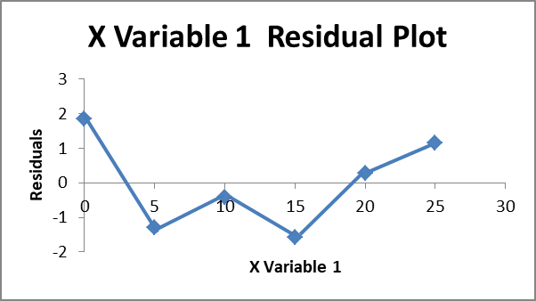
Figure 1 Residual plot for Slump Model

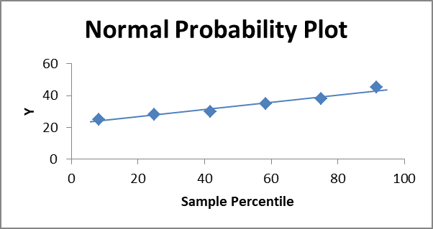
Figure 2 Normal probability plot for slump model

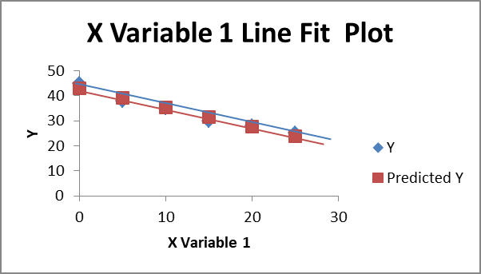
Figure 3 Experimental vs. Predicted Slump result

Table 8 presents results for the regression statistics and for the slump model developed. The slump model returned an adjusted R square of 0.92; this implies that the model can
predict the slump of PKS concrete with an accuracy of 92%. The developed model is represented on equation (2).

Y2 = - 0.45x + 26.52 (2)

Where Y2 = Compressive Strength of PKS concrete
X = Percentage replacement level

Table 8 Regression Statistics for Compressive strength model
The residual plot, normal probability plot and line plots are presented on Figures 4, 5 and 6 respectively. As seen from the residual plot, the residuals do not follow a definite path as they are scattered on both the negative and positive sides of the
plot. The normal probability plot as seen on Figure 5 shows
Regression Statis tics Multiple R 0.97
R Square 0.94
Adjusted R Square 0.92
Standard Error 1.22
points close to the straight line. This indicates that the residuals in the data under consideration are approximately normally distributed. Furthermore, the result of the experimental vs. predicted data as depicted by the line plot on Figure 6 shows the experimental and predicted data very close to each other. This further explains the 92% adjusted R square (R2) value indicating that the model is adequate in predicting the Compressive strength of concrete containing PKS.

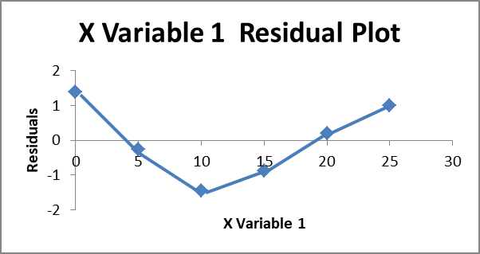
Figure 4 Residual plot for Compressive Strength model

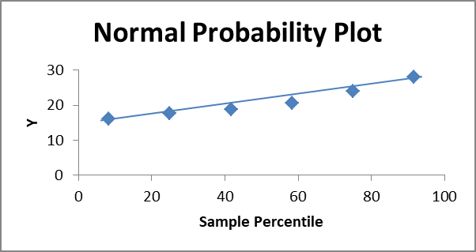Figure 5 Normal Probability plot for Compressive Strength model

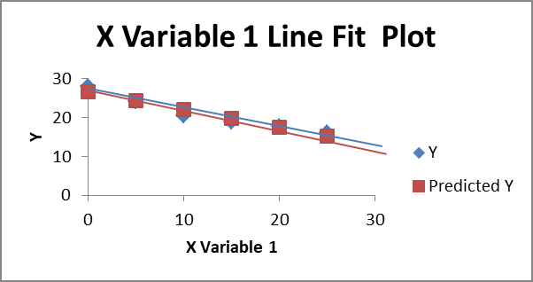
Figure 6 Experimental vs. Predicted Compressive Strength values

4.0 CONCLUSION

Based on the findings of this research, the following conclusion is drawn:
i. The higher the quantity of PKS in concrete, the lower
the slump of the concrete produced.
ii. The Compressive strength of concrete reduces with
an increase in the percentage replacement level of PKS. The optimum replacement level of 5% with compressive strength of 24 N/mm2 is hence suggested.
iii. The linear regression models developed can
sufficiently predict the slump and compressive strength of PKSC with adjusted R2 values of 96% and
92% respectively.

References

[1] Asuzu, C. C., Okereke, C. D., Asoegwu, S. N., and Nwachukwu, P. I.
2017. Suitability of Agricultural Waste Product (Palm Kernel Shell) as Coarse Aggregate in Concret: A Review. International Journal of Agriculture, Environment and Bioresearch. 2(2): 313-319.
[2] Azunna, S. U. 2019. Compressive strength of concrete with palm
kernel shell as a partial replacement for coarse aggregate. SN Applied
Sciences. 1: 342. DOI: https://doi.org/10.1007/s42452-019-0334-6.
[3] BS 12 1996. Specification for Portland Cement. British standard
Portland. British standard Institute. 2 Park Street, London WIA 2BS. [4] BS 882 1992. Specification for aggregates from natural sources for
concrete. British Standard Institution. 2 Park Street, London WIA 2BS. [5] BS 1881 Part 116, 1983. Method for Determining Compressive
Strength of Concrete Cubes, British Standard Institution, Her Majesty
Stationary office London.
[6] BS EN 1008 2002. Mixing water for concrete: Specification for
sampling, testing and assessing the suitability of water, including water recovered from concrete industry as mixing water for concrete. London, British Standards Institution.
[7] BE EN 12350-2 2019. Testing Fresh Concrete Part 2: Slump test.
British Standards Institution.
[8] Ezeifula, U. G., Opara, H. E., and Anya, C. U. 2017. Mechanical Properties of Palm Kernel Shell Concrete in Comparison with Periwinkle Shell Concrete. Malaysian Journal of Civil Engineering.
29(1): 1-14.
[9] Gibigaye, M., Godonou, G. F., Katte, R., and Degan, G. 2017.
Structured mixture proportioning for oil palm shell concrete. Elsevier:
Case Studies in Construction Materials. 6: 219 – 224.
[10] Itam, Z., Beddu, S., Kamal, N. L. M., and Alam, M. A. 2016. The Feasibility of Palm Kernel Shell as a Replacement for Coarse Aggregate in Lightweight Concrete. International Conference on
Advances in Renewable Energy and Technologies (ICARET).
[11] Kolo, D. N. 2019. Safety and Reliability Studies of Reinforced
Concrete Structural Elements in Buildings. Unpublished PhD Thesis,
Department of Civil Engineering, Federal University of Technology, Minna, Nigeria.
[12] Mo, K. H., Alengaram, U. J., and Jumaat, M. Z. 2015. Experimental investigation on the Properties of Lightweight Concrete containing
Waste oil palm shell aggregate. Procedia Engineering. 125, 587-593. [13] Ndoke, P. N. 2006. Performance of palm kernel shells as partial
replacement for coarse aggregate in asphalt concrete. Leonardo
Electronic Journal of Practices and Technologies, 5(9): 145-152.
[14] Nduka, D. O., Fagbenle, O. I., Joshua, O., Ogunde, A. O., and Omuh, I.
O. 2018. Comparative Analysis of Concrete Strength Utilizing Quarry-
crushed and Locally sourced Coarse Aggregates. International Journal of Mechanical Engineering and Technology (IJMET), 9(1): 609-617.
[15] Nevile, A. M. and Brookes J. J. 2008. Concrete Technology, Revised edition. Pearson Education Limited, Edinburgh gate, Harlow, Essex
CM20 2JE, England.
[16] Osei, D. Y., and Jackson, E. N. 2012. Experimental study on Palm
Kernel Shells as Coarse Aggregates in Concrete. International Journal
of Scientific and Engineering Research, 3(8): 1-6.
[17] Purwanti, H., and Artiningsih, T. P. 2018. Palm kernel Shell as an alternative Aggregate on High Performance Concrete. Journal of Science Innovare. 1(2) p-ISSN:2615-3769; e-ISSN: 2615-3750.
[18] Williams, F. N., Ijigah, E. A., Anum, I., Isa, R. B., and Obanibi, A. O.
2014. Suitabilty of Palm Kernel Shell as Coarse Aggregate in
Lightweight Concrete Production. Civil and Engineering Research,
6(7): 55-59.

