Magazine of Civil Engineering. 2021. 106(6). Article No. 10601

Magazine of Civil Engineering

ISSN
2712-8172

journal homepage: http://engstroy.spbstu.ru/

DOI: 10.34910/MCE.106.1

Effect of vertical circular openings
on flexural strength of reinforced concrete beam

S.M. Auta* , O. Jamiu, B. Alhaji

Federal University of Technology Minna, Minna, Nigeria

*E-mail: samuel.auta@futminna.edu.ng

Keywords: vertical, circular, openings, flexural, strength, ANSYS, building.

Abstract. Modern building construction techniques sometimes involve the passing of pipes or ducts for water supply, electrification, and telecommunication through reinforced concrete beams to protect them against mechanical damages and add aesthetic value to buildings. This study looks into the effect of vertical circular openings on the flexural strength of the reinforced concrete beam. Two (2) sets of beam samples were investigated during this study: computer simulated reinforced concrete (RC) beam using ANSYS 19.1 and laboratory cast. The results of the flexural strength test conducted show the following: Reinforced concrete beam with vertical circular openings of diameter greater than 33.3 % of beam width (B) reduced its flexural strength by at least 20 %; maximum compressive stress of concrete occurs at the openings region of the beam; the difference in ultimate load capacity of finite element (FE) beam models and experimental beam specimen is 3.5 %. It can be deduced that ANSYS software is an appropriate finite element (FE) tool to predict the behaviour of RC beams. Hence, it is hereby recommended that the diameter of the vertical circular opening in RC beam should not exceed 33.3 % of the beam width and its location from beam support should not exceed L/6.

1. Introduction

Modern building construction technique sometimes requires many pipes and ducts in order to accommodate essential services such as water supply, air conditioning, electricity, telephone, and computer network [1]. Normally, these ducts and pipes are surface mounted, clipped to the wall thereby exposing them to harsh weather condition and are prone to mechanical damages. In recent time, these pipes are being concealed in the wall as conduits and are made to pass through web of beams as means to secure them against damages, harsh weather condition and equally add more aesthetics to buildings.

The creation of such openings in existing reinforced concrete beams produces discontinuity in the normal flow of stresses which would reduce the beam shear capacity and stiffness [2]. The reduced stiffness of the beam may also give rise to excessive deflection under service load and result in a considerable redistribution of internal forces and moments in a continuous beam [3]. More significant reduction in the shear capacity was recorded when the openings interrupted the natural load path, that is, the line connecting the load and support points [4].

Flexural strengths of reinforced concrete beams with horizontal web openings have been researched; however, limited information is available when web openings are vertical. Hafiz et al. [4] verified the FE beam model with horizontal circular openings against experimental test data of RC solid beam without openings and discovered that the rectangular RC beams with circular openings diameter more than
44 % of beam depth (D) reduced the ultimate load capacity by at least 34.29 % [4]. Saksena1 and Patel [5] stated that the performance of the beams with horizontal circular openings at centre of span has lesser effect on the ultimate load capacity of the RC rectangular section beams and more so, introducing the

Auta, S.M., Jamiu, O., Alhaji, B. Effect of vertical circular openings on flexural strength of reinforced concrete beam. Magazine of Civil Engineering. 2021. 106(6). Article No. 10601. DOI: 10.34910/MCE.106.1

© Auta, S.M., Jamiu, O., Alhaji, B., 2021. Published by Peter the Great St.Petersburg Polytechnic University. This work is licensed under a CC BY-NC 4.0

circular openings of diameter of 45 % of depth near the support reduces the ultimate load capacity of rectangular section RC beams by at least 32 % compared to solid beam [5].

On the other hand, Maaddawy and Ariss [6] concluded that the inclusion of web horizontal openings drastically reduced the beam shear capacity and stiffness [6]. Abdalla et al. [7] carried out studies on reinforced concrete beams with horizontal openings un-strengthened and strengthened with FRP sheets. The effect of this strengthening technique on deflection, strain, cracking, and ultimate load was investigated. It was discovered that the presence of an un-strengthened openings in the shear zone of a reinforced concrete beam significantly decreases its ultimate load carrying capacity. An un-strengthened opening with height of 0.6 of the beam depth may reduce its load capacity by 75 % [7]. Guidelines have been provided for creating openings in new and existing slabs in British standard [8] and America building code [9].

A number of studies have been conducted on effect of openings in slabs, beams considering the web and columns but limited information is available as regards vertical openings in reinforced concrete beam which has become a common practice on construction field around this part of the world without caution. In order to provides guide lines to professionals in construction field on how and where to introduce vertical circular openings on reinforced concrete beam when need arises thus research into the effect of vertical circular openings is recommended [4]. If the beam is pre-designed to have vertical circular openings of known sizes and location, this will be sufficient to ensure the safety and serviceability of the structure.

The need of openings in structural element for passage of pipes or ducts in modern buildings is inevitable; however, the consequence of this is a reduction in shear and ultimate load capacity of the structural element (beam) which is of great concern to smart construction industry [2]. This study aims to evaluate the bending behaviour of reinforced concrete beams with vertical circular openings across its web by determining the physical and mechanical properties of aggregates; determining the flexural strength of laboratory cast reinforced concrete beams with vertical circular openings using flexural testing machine and; determine the flexural strength of computer simulated reinforced concrete beam with vertical circular openings using ANSYS 19.1 software.

2. Materials and Method

2.1. Description of specimen

For the purpose of this research, total numbers of ten (10) beam specimens were produced during the laboratory cast experiment. Dimension of beam specimen considered was 150 mm × 250 mm ×
× 1200 mm as shown in Fig. 1. Two number of twelve (12) millimeter diameter bars each were used for both tension and compression reinforcement respectively. Eight (8) millimeter diameter bar was used for stirrup. The concrete cover to reinforcement was limited to 20 mm in accordance to the importance of concrete cover [10]. Table 1 gives the identification details of the beam specimens investigated in this study. Each beam was identified using seven alphanumeric characters, the first two letters BM indicates beam model, while the first two numbers indicates the diameter of the circular openings in millimeter and the last three numbers indicates the distance of the openings from the supports. For instance, BM 25-150 means beam model with 25 diameter openings located 150 mm from the supports.

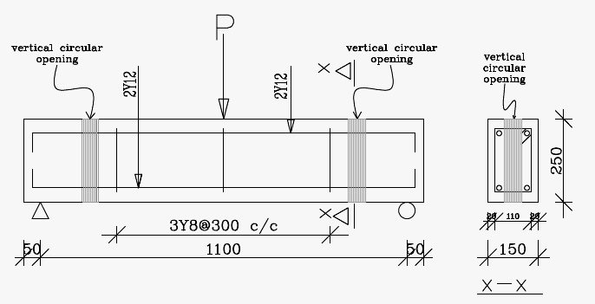

Figure 1. Reinforced concrete beam with openings (Dimensions in mm).

2.2. Laboratory investigation

The preliminary tests such as Aggregate Crushing Value (ACV), Aggregate Impact Value (AIV) and particle size distribution tests for aggregates were carried out prior to concrete making. In order that the materials should not differ from materials used in general practice, the coarse aggregate (granite), fine aggregate (sharp sand), cement, and reinforcing bars were purchased in the open market.

Table 1. Beam specimens studied in this research.

Beam Identification

BM BM BM

BM BM
25-150 50-150 25-350 50-350 0-0

Diameter of openings (mm) | 25 |  | 50 |  | 25 |  | 50 |  | –
Distance of openings from supports | 150 |  | 150 |  | 350 |  | 350 |  | –

On the coarse aggregate used in this study, both ACV and AIV were carried out in accordance with the British standard requirements [11, 12]. ACV was conducted to check the resistance of the coarse aggregate against gradually applied compressive load while AIV check the suitability of the coarse aggregate under applied impact loading condition. Results obtained for ACV and AIV were 25.9 and 18.3 % respectively which falls within limits of 23–30 % for ACV and 17–21 % for AIV. Thus, coarse aggregate used in this research is good granite.

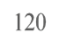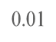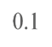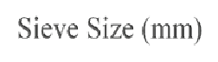Particle size distribution test was conducted on the fine aggregate in accordance to British standard requirements [13] and the result obtained is shown in Fig. 2. Percentage passing by mass for fines on sieve number 200 (75 μm) was 0.8 % which satisfied the requirements of 4 % maximum limit for uncrushed, partially crushed and crushed gravel sand. Dangote (42.5 N Grade) Ordinary Portland Cement was selected for this study due to its availability within the vicinity of the laboratory where the experiment was carried out [14].

Figure 2. Particle size distribution curve for the fine aggregate.

Tensile test was conducted to determine the characteristics strength for the reinforcing bars used in this research. Results obtained showed that the reinforcing bars used for this study have characteristics strength of 389 N/mm2 which is lower than 460 N/mm2 minimum requirements specified in British standard [15].

Compressive strength test was conducted on concrete for the beam specimens in accordance to British standard [16]. Results obtained showed that the concrete satisfied the minimum requirement for C20/25 grade concrete.

Flexural strength test was conducted on beam specimens as shown on plate I in accordance to
British standard [17]. The breaking load (F) value was recorded from the testing machine and the flexural
PX 1
strength was calculated using the formula: Fcr = bd 2 , where P is the breaking load (in N); l is the distance
between the supports (in mm); b is the width of the beam (in mm); d is the depth of the beam
(in mm).

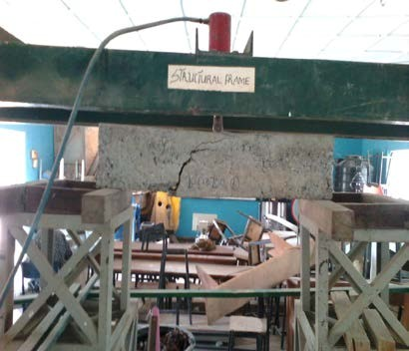

Plate I: Experimental set-up for the centre-point load bending test.

2.3. Computer modeled beam specimen

ANSYS is a finite element analysis (FEA) code widely used in the computer-aided engineering field [18]. ANSYS software allows engineers to construct computer models of structures, machine components or systems; apply operating loads and other design criteria; and study physical responses, such as stress levels, temperature distributions, pressure, etc. It permits an evaluation of a design without having to build and destroy multiple prototypes in testing. ANSYS 19.1 is the FEM software employed for simulation of beam models in this research.

2.3.1. Modeling of beam specimen

Analysis of the beam model in ANSYS begins with the geometry definition which is defined based on the type of simulation to be carried out [19]. Static structural option on ANSYS 19.1 workbench was adopted in this analysis. Solid 65 was used to model concrete and Link 180 was used to model the steel reinforcement.

2.3.2. Meshing

Meshing is the breaking down of the model into smaller elements that can be separately analysed. The accuracy of the analysis result is proportional to the meshing size. Smaller mesh size gives accurate result but with longer computational time [20]. In this research, accurate results were obtained using mesh size of 25 mm.

2.3.3. Loading and boundary condition

To ensure that the modeled specimen behave the same way as the experimental beam, boundary conditions were set similar to the laboratory cast. Setting the boundary conditions and constrains is an essential step in Finite Element Analysis. The key step to starting analysis is the setting of boundary conditions [19].

3. Results and Discussion

3.1. Flexural strength

The results obtained from the flexural strength test carried out in this study are presented in Table 2 while the pictorial representation of relationship between beam specimens investigated is shown in Fig. 2. Rectangular solid beam without vertical circular openings (BM 0-0) recorded the highest flexural strength of 13.50 N/mm2 and this serves as reference beam to compare other specimen with openings. BM 25-150 recorded flexural strength of 13.50 N/mm2 which is similar to that of solid beam without openings while BM
50-150 recorded 10.50 N/mm2 as flexural strength. Both specimens whose openings were located at
150 mm from supports have their flexural strength reduced by 0 and 8.74 % respectively when compared with solid beam without openings. BM 25-350 and BM 50-350 recorded significant loss in flexural strength by having 17.4 and 19.63 percentage reduction respectively when compared to solid beam without openings. The results show that presence of vertical circular openings leads to reduction in flexural strength of rectangular reinforced concrete beam specimen.

In addition, increase in sizes of the vertical circular openings leads to corresponding decrease in load bearing capacity of the beam specimens. Vertical circular openings that are located far from supports recorded lower flexural strengths when compared to openings located close to the supports as shown in

Fig. 3. BM 50-350 with 50 mm diameter openings located at 350 mm from supports record the lowest flexural strength of 10.85 N/mm2, which represents 20 % loss in bending strength of the beams.

It can be deduced that reinforced concrete beams with circular openings of diameter less than or equal to 33.3 % of the beam width (without special reinforcement in openings zone) located within distance of L/6 from the supports behave in similar way compared to solid beams without openings, where L is the overall length of the beam. In another word, RC beams with circular openings of diameter greater than
33.3 % of the beam width located at distance L/3 from supports shows reduction of 19.63 % in the flexural strength. Most critical position of vertical circular openings in RC beams made of normal concrete is near the mid-span. Also, the best position for location of openings in beams is near the supports.

Table 2. Flexural strength of experimental beam specimens at 28 days.

duction
S/No. Beam Specimen |  | Average Ultimate Load  (kN) | Flexural Strength  (N/mm2) | Percentage re  (%)
A | BM 0-0 | 115 | 13.50 | –
B | BM 25-150 | 115 | 13.50 | –
C | BM 50-150 | 105 | 12.32 | 8.74
D | BM 25-350 | 95 | 11.15 | 17.40
E | BM 50-350 | 92.5 | 10.85 | 19.63

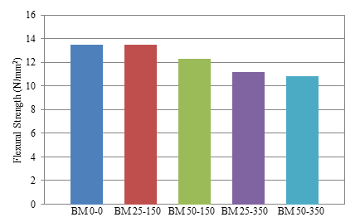

Figure 3. Flexural strength of Beam specimen at age of 28 days.

3.2. Stresses at Ultimate Load for ANSYS Beam Specimens

Both BM 25-150 and BM 50-150 recorded maximum compressive stress of concrete at mid-span of the beam around the area where load was applied as shown in Fig. 3. It is an indication that introducing vertical circular openings with diameter of about 33.3 % of beam width at L/6 from supports has little or no effect on the flexural behaviour of the RC beam, where L is the overall length of the beam. Therefore, location of circular openings close to the beam supports induces little or no stress in reinforced concrete beam and does not make it behave differently from solid beam without vertical circular openings.

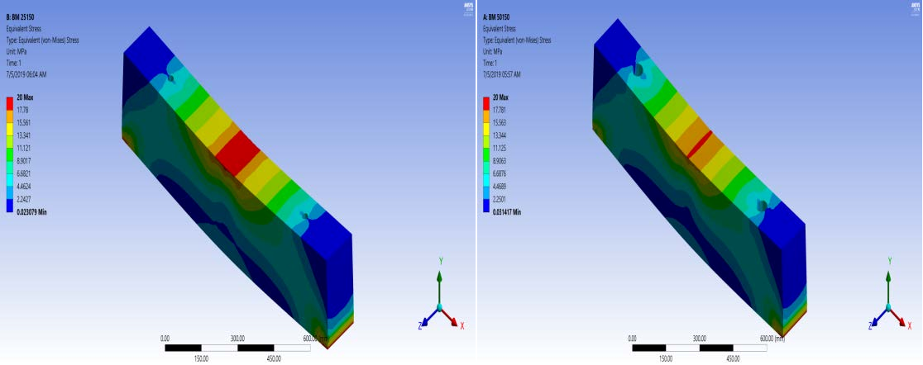Maximum Compressive Stress of Concrete

Figure 4. Equivalent (von-mises) stress for BM 25-150 and BM 50-150.

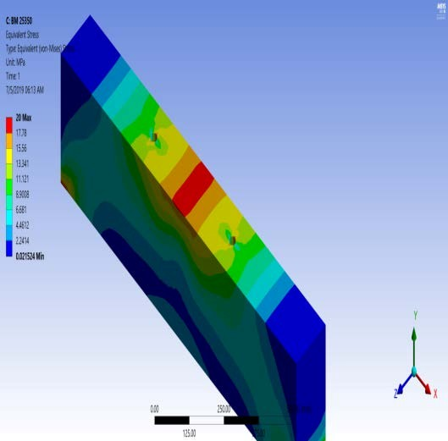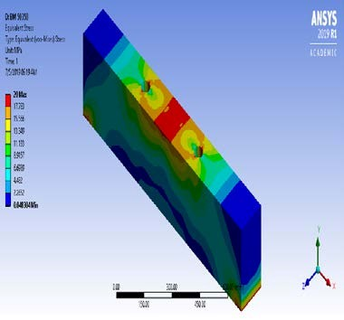Beam specimens with circular openings located at L/3 from supports, that is, BM 25-350 and BM 50-350, maximum compressive stress were recorded at the edge of openings as shown in Fig. 3. Failure in these beam samples started from the edges of the openings, thus location of openings close to mid-span of the beam is detrimental to the flexural strength of reinforced concrete beam.

Figure 5. Equivalent (von- mises) stress for BM 25-350 and BM 50-350.

3.3. Comparison of Results with Reviewed Literatures

When compared with previous study [4] though with horizontal web openings, it was observed that
44 % of beam depth maximum opening diameter recommendation for web openings may not be valid for vertical circular openings in RC beam.

Contrast to what was observed in previous research on horizontal web openings [5], present study showed that the most critical area to locate vertical circular openings in RC beams is towards the mid span (L/3 from the support) which falls within the bending zone of the beam or in other words, it is safer to locate vertical openings close to beam supports.

4. Conclusion and Recommendations

4.1. Conclusion

Effect of vertical circular openings on behaviour of reinforced concrete beam has been explored and the following conclusions were drawn from the study: Diameter of vertical circular openings in RC beam should not exceed 33.3 % of beam width and their location on the beam should not exceed L/6 from beam supports where L is the overall length of the beam; most critical position to locate vertical circular openings in RC beam is within the flexure zone (L/3) towards the midspan and the best size for vertical circular openings is the narrower one whose diameter is less than 33.3 % of the beam width; and the computer aided simulation for beams with vertical circular openings using ANSYS 19.1 software as implemented in the present study shows good agreement with experimental data.

4.2. Recommendations

Based on the conclusion made from this research, following recommendations are hereby suggested:

1. Vertical circular openings in RC beams for multi-storey buildings should be discouraged as this could leads to compromise on the safety of the structural elements (beams) involved.

2. Further study should be conducted on strengthening the region of vertical circular openings in reinforced concrete beam.

References

1. Nishitha, N., Kavitha, P. Effect of openings in deep beams with varying span to depth ratios using strut and tie model method.
IOSR Journal of Mechanical and Civil Engineering (IOSR-JMCE). 2016. Vol. 20. No. 201. Pp. 78–81.
2. Vivek, R., Madhavi, T.C. Behaviour of Reinforced Concrete Beam with Web Openings. ARPN Journal of Engineering and Applied
Sciences. 2016. Vol. 11. No. 9. Pp. 5993–5995.
3. Jithinbose, K.J., Thomas, J., Parappattu, N.B. Effect of Openings in Beams – A Review. International Journal of Innovative
Research in Advanced Engineering (IJIRAE). 2016. Vol. 3. No. 09. Pp. 15–19.

4. Hafiz, R.B., Ahmed, S., Barua, S., Chowdhury, S.R. Effects of Openings on the Behaviour of Reinforced Concrete Beam. IOSR Journal of Mechanical and Civil Engineering (IOSR-JMCE). 2014. Vol. 11. No. 2. Pp. 52–61.
5. British Standards Institution BS 812-110: 1990. Testing Aggregates-part 110: Methods for Determination of Aggregate Crushing
Value. British Standards Institution, London.
6. British Standards Institution BS 812-112:1990. Testing Aggregates-part 112: Methods for Determination of Aggregate Impact
Value. British Standards Institution, London.
7. British Standards Institution BS 812-103.1:1985. Methods for determination of particle size distribution – Sieve tests. British
Standards Institute, London.
8. British Standards Institution. BS 882:1992. Specification of aggregates from natural sources for concrete. British Standards
Institute, London.
9. British Standards Institutions BS 4449:1997. Carbon steel bars for the reinforcement of concrete. British Standards Institute, London.
10. British Standards Institution BS 1881-118:1983 Testing Concrete-part 118: Methods for Determination of Flexural Strength. British
Standards Institution, London, 1983.
11. Wilson, P.P., Nair, E.M.S. Investigation on Reinforced Concrete Columns with Holes. International Research Journal of
Engineering and Technology (IRJET). 2017. Vol. 04. No. 05. Pp. 1393–1395.
12. Talikoti, B., Kurbet, S.N., Kuppast, V.V., Arvind, M. Harmonic analysis of a two cylinder crankshaft using ANSYS. Inventive
Computation Technologies (ICICT). DOI: 10.1109/INVENTIVE, 2016.7823219
13. QiongyingLv, Y.M. Modal analysis of a magnetic climbing wall car frame based on the ANSYS. IEEE Workshop on Electronics, Computer and Applications. 2014. Pp. 938–940.
14. El-Maaddawy, T., El-Ariss, B. Behavior of Concrete Beams with Short Shear Span and Web Opening Strengthened in Shear with
CFRP Composites. Journal of Composites for Construction, 2012.
15. Hafiz, R.B., Ahmed, S., Barua, S., Chowdhury, S.R. Effects of Opening on the Behavior of Reinforced Concrete Beam. IOSR Journal of Mechanical and Civil Engineering (IOSR-JMCE). e-ISSN: 2278-1684, p-ISSN: 2320-334X. 2014. Vol. 11. No. 2. Ver. VII (Mar – Apr.). Pp. 52–61.
16. Mansur, M.A. Design of reinforced concrete beams with Web openings. Proceedings of the 6th Asia-Pacific Structural Engineering and Construction Conference. 2006. Vol. A. Pp. 104–120.
17. Mansur, M.A., Tan, K.H. Concrete beams with openings: analysis and design. CRC Press LLC, Boca Raton, Florida, USA, 1999.
220 p.
18. Mansur, M.A. Effect of openings on the behavior and strength of RC beams in shear. Cement Concrete Composite. 1998. 20(6).
Pp. 477–486.
19. Mansur, M.A., Tan, K.H. Design procedure forreinforced concrete beams with large web openings. ACI Structure J. 1992. 93(4).
Pp. 404–410.
20. Mansur, M.A., Tan, K.H., Lee, Y.F., Lee, S.L. Piecewise Linear Behavior of RC Beams with Openings. J. Struct. Eng. 1991.
Pp. 1607–1621.
21. Mansur, M.A., Ting, S.K., Lee, S. Torsion Tests of R/C Beams with Large Openings. J. Struct. Eng. 1983. Pp. 1780–1791.
22. Mota, M., Kamara, M. Floor Openings in Two-Way Slabs. Concrete international, 2019. Pp. 33–36.
23. Naik, N., Kumar, R., Rajaiah, K. Optimum Hole Shapes in Beams under Pure Bending. J. Eng. Mech. 1986. Vol. 112.
Pp. 407–411.
24. Ogunbiyi, M., Olawale, S., Alabi, O., Thanni, M. Assessment of the Qualities of Dangote and Elephant (Portland) Cement Brands commonly used in the Nigerian Construction Industry. International Journal of Innovative Research in Science, Engineering and Technology (IJIRSET). March 2017. Vol. 6. No. 3.
25. Prentzas, E.G. Behaviour and reinforcement of concrete beams with large rectangular apertures. Ph.D. Thesis, University of
Sheffield, U.K., 1968. 230 p.
26. Saksena, N.H., Patel, P.G. Effects of the Circular Openings on the Behaviour of Concrete Beams without Additional Reinforcement in Opening Region Using FEM Method. International Journal of Advanced Engineering Technology e-ISSN 0976-3945IJAET/Vol. IV/ Issue II/April-June, 2013/40-42.

Contacts:

Samuel Mahuta Auta, samuel.auta@futminna.edu.ng
Oladipo Jamiu, oladipojamiuconsult@gmail.com
Bala Alhaji, bala.alhaji@futminna.edu.ng

