EFFECTS OF SOME ENVIRONMENTAL FACTORS ON TEMPORAL DISTRIBUTION OF ZOOPLANKTON IN LAPAI-GWARI STREAM, NIGER STATE, NIGERIA

MOHAMMED, A. Z¹ *., Musa, M ²., ARIMORO, F. O¹ ., AUTA, Y. I¹ ., SAMUEL, P. O¹ ., ADAMA, B. S¹ .

1 - Department of Animal Biology, Federal University of Technology, Minna.
2 - Graduate student of the Department of Animal Biology, Federal University of Technology, Minna.

Correspondence Author: Mohammed, Adamu Zubairu, Department of Animal Biology, Federal University of Technology Minna.
E-mail: adamumzkolo@futminna.edu.ng
Running title: effect of some environmental factors

Abstract:
The impact of some environmental factors on the distribution of zooplankton in the Lapai-Gwari stream was investigated for a period of six months using standard techniques to understand the ecosystem dynamics, species interactions, and overall ecosystem health. Results revealed that all the physical and chemical parameters studied were significantly different monthly with a high total dissolved solids value observed in the month of April which was above the National Environmental Standards and regulation enforcement agency for surface waters. A total of 902 individuals of zooplankton were observed which was made up of 51% rotifers, 20% copepods, and 29% Cladocerans. The rotifers were also found to be more in the rainy months with Filinia terminalis dominating in the month of March. Among the copepods, Macrocyclops fuscus was found to dominate in May. Whereas among the cladocera, Alonella exigua, dominates in August. The eigenvalues from the canonical correspondence analysis accounted for 29.37% of all the environmental parameters that were observed from Axis 1 and the permutation test revealed no significant difference. Brachionus baylyi, Brachionus palas, Asplanchna multiceps, Brachionus sesssilis, Euchlanis mentameyers, and Asplanchna intermedia, appeared to be strongly associated with alkalinity and the months of June and July. From the physico-chemical parameters and zooplankton the stream appeared slightly perturbed with the presences of polluting indicator organisms like Asplanchna Species and the Brachionus, probably due to the various anthropogenic activities around the stream and resulting in low faunal diversity of zooplankton.
Keywords: Physico-chemical parameters, zooplankton diversity and abundance, Lapai-Gwari Stream, perturbed, anthropogenic activities.

Introduction
Headwaters, streams, and wetlands are important watersheds that are critical for maintaining biodiversity, ecosystem functions, natural resource-based economies, human society, and culture, (Susan et al., 2019). Though most expected output in water bodies is fish, power supply, and recreation, the actual converters of the energy, phytoplankton to zooplankton to higher trophic levels are neglected. Fresh water is an important component in the aquatic ecosystem whose main function is to facilitate the links in the food chain (Agnes et al., 2021; Bonjoru et al., 2020).
Zooplankton graze on primary producers and organic debris in the water column and thereby play an important role in the integration of the energy budget of the ecosystem (Anene et al., 2003), transferring primary productivity to fish and other consumers (Dejen et al., 2004) and purifying the water column (Okogwu, 2010). Zooplankton is of great importance in the bio-monitoring of pollution (Davies et al 2009). The nature of species occurring, diversity, biomass, and season of maximum abundance of zooplanktonic organisms differs in water bodies (FAO, 2006; Ravera, 1996). The community structure and diversity are sensitive to changes in environmental conditions (Thias and Elvio, 2013), nutrient changes, and also to different levels of pollution (Arimoro and Oganna 2010). Their standing crop and species composition are most likely to indicate the quality of the water body in question (Pinto-Coeluo, et al. 2005; Pramila et al. 2008; Arimoro and Oganna 2010; Hashemzadeh and Ventkataramana, 2012). The zooplankton community includes copepods, cladocerans, rotifers, chaetognaths, amphipods, holoplankton, and larva stages of meroplankton. Associated with plankton studies is the analysis of physico-chemical parameters which reflects the abiotic status of the ecosystem (Mulani et al., 2009). Therefore, the zooplankton population in a community is related to the physico-chemical property of the water body.
Lapai-gwari stream is a water body that receives effluent from Mosgola-fishing community. The stream originates from around Bosso in Minna the capital of Niger State and flows down to be recharged from effluents of about one hundred fish ponds. The stream did not receive attention from previous workers; hence this study evaluates the effects of physico-chemical properties on the distribution and abundance of zooplankton in the Lapai-Gwari Stream in Minna, Niger State.

Materials and methods
Study area
Lapai-Gwari is a feeder stream located at coordinates 5.56ºN and 7.55ºE (Figure 1), about 7.0 km away from Bosso Local Government Area of Niger State, Nigeria. Farming activities take place on the fringes of the stream. Other anthropogenic activities that go on within the stream are fishing, washing, and swimming.
Sampling stations
Sampling Station 1 was located within the 90º31’’N and 6º30 1.9’’E. It was a shallow area of the stream with irrigation activities taking place during the dry season involving the application of chemicals input from fertilizers.
Station 2 had coordinates as 9º31’25” N; 6º29’57” E with less anthropogenic activities and located about 500m away from Station 1.
Station 3 had coordinates of 9º31’17” N; 6º29’59” E and was located about 500m away from Station 2, with human activities such as washing and bathing taking place.

Sample collection
Water samples were collected monthly for a period of six months from March to August 2019 from each sampling station into a 1.0liter plastic bottle and labelled. They are packaged into plastic buckets covered with ice blocks and were transported to the laboratory for analysis within 5.0 hours of sample collection. Water samples for dissolved oxygen were collected in 250.0ml bottles with glass stoppers and fixed immediately at the point of collection with sodium-iodide-azide and manganous sulphate. From the one-liter plastic bottle above, 230.0ml of the sample is incubated for the determination of BOD. The remaining sample is used for the determination of other chemical parameters.
Three sampling points were selected, taking into account the human activities such as washing, bathing, fishing, boating etc., the outlets, inlets, morphometric features and growth of aquatic vegetation, etc.

For the quantitative analysis of zooplankton, water was filtered through a No. 25 bolting silk cloth, net of mesh size 63μm. The plankton collected was concentrated to 60.0ml and preserved in 4% formalin.

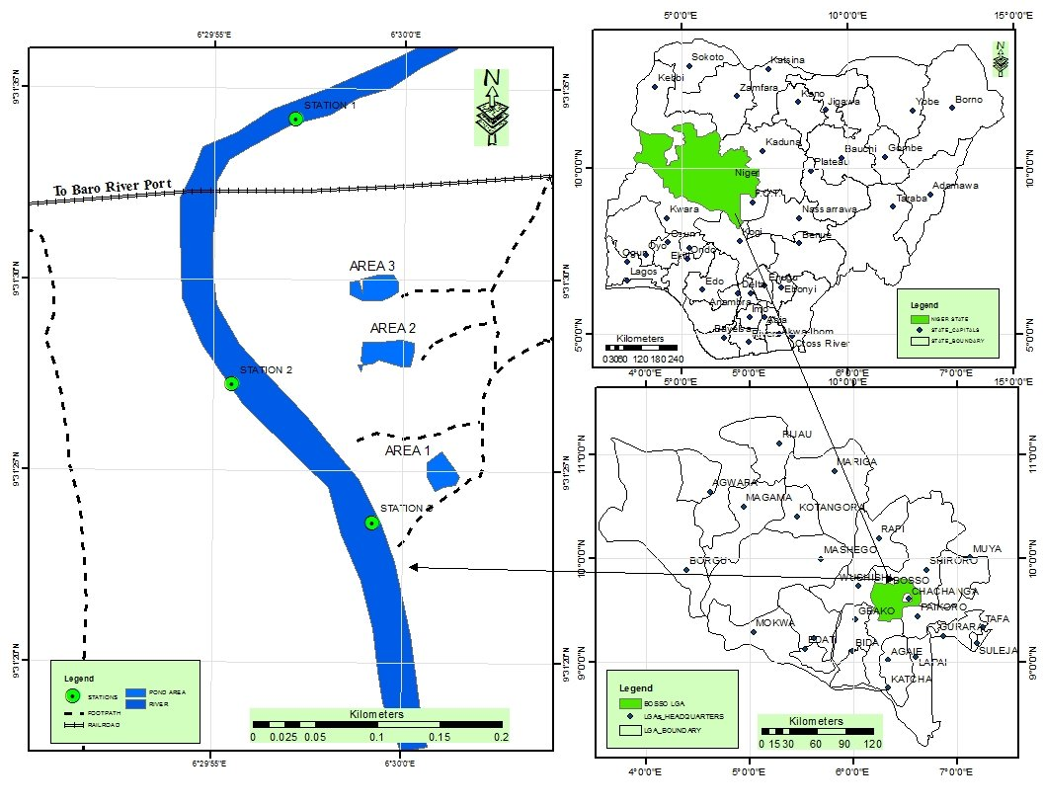
Figure 1: Map of Lapai-Gwari Stream showing sampling stations (1-3)
(Map of Nigeria and Niger State inserted)

Determination of physico-chemical parameters and zooplankton abundance
Temperature, pH, and transparency were measured in situ. The temperature was measured using mercury-in-glass thermometer accurate to 0.1ºC, pH was measured with a pH meter (Hanna model H1-98107) while transparency was measured using a standard Secchi disc having a diameter of 20.0cm with black and white quarters.

In the laboratory, each water sample was analyzed for ten parameters including temperature, pH, electrical conductivity, total dissolved solids, DO, BOD, nitrate, phosphate, alkalinity, and hardness were analyzed. The DO and BOD were determined by Winkler's titrimetric method described by APHA. (2009)., while conductivity was measured using an intelligent meter (model AD. 33915). Nitrate and phosphate were determined using spectrophotometer (Model 400) (APHA, 2009). The total alkalinity was determined using Bromo - cresol green and methyl red as indicators titrating with hydrochloric acid; total hardness was determined by titration using Ethylene diamine tetra-acetic acid (EDTA) with Eriochrome Black T as an indicator (APHA, 2009).

One milliliter of concentrated sample was examined dropwise on a slide under the microscope (Olympus BH2 with a Toupview a microscope camera version x 64 3.7.8481) and the zooplankton were identified and counted. The identification was done following the standard guides of Edmondson (1959), Needham and Needham (1969), Battish (1992) and Haney et al. (2004).

Data Analysis
The range, mean, and standard deviation, of the physico-chemical parameters, were calculated using excel package version 14.0.4734.1000(32-bit) of Microsoft office professional plus 2010. Duncan range multiple test was used to separate the means using and SPSS 23 package. Canonical Correspondence Analysis (CCA) was used to express the relationship between the and physico-chemical parameters and zooplankton abundance; rare species (< 2% abundance at a sampling site) were not included in the CCA, Monte Carlo permutation test with 199 permutations was used to assess the significance of the canonical axes extracted, (Arimoro and Ogana 2010)

Results
The physico-chemical parameters
The physico-chemical parameters of the Lapai-Gwari stream are shown in Table 1. The highest value of 34.67±0.88ºC (Table 1) air temperature was recorded in April and the lowest (31.67±0.88ºC) was recorded in August. A significant monthly difference (p < 0.05) in air temperature was observed. Highest water temperature of 30.83±0.17ºC was recorded in April while, 24.73±0.19ºC was recorded in July as the lowest with a significant variation (p > 0.05) among the months. The pH was highest (8.16±0.16) in May and the lowest (6.36±0.15) was recorded in March. A significant difference (p ≤ 0.05) was observed the months and the values were within the NISREA, (2007) and the WHO (2011) standards of drinking water. The highest electrical conductivity was 972±94.48 µS/cm recorded in June and the lowest was recorded in July. The values recorded showed significant differences (p<05) and also were within the NISREA, (2007) standard. The concentration of total dissolved solid was highest (1053±22.67 mg/l) in April and lowest (236±56.36mg/l) in July, a significant difference (p < 0.05) in the concentration of total dissolved solids was observed during the sampling period. Dissolved oxygen was highest (4.48±0.32mg/l) during March and the lowest value (3.23±0.67) in May, with significant difference (p < 0.05) observed. Biological oxygen demand in the stream was highest (2.71±0.15mg/l, in March while the lowest value (0.30±0.23mg/l) was in August with a significant difference (p < 0.05). The result showed that nitrate was highest (7.68±0.66mg/l) in the stream in March while the lowest (1.65±0.62 mg/l) was observed in May, a significant monthly difference was observed at (p < 0.05). The highest phosphate concentration recorded in the stream was 1.14±0.05 mg/l in March and the lowest (0.57±0.47 mg/l) was in May, significant monthly difference was observed between the periods of the study. The highest alkalinity value recorded was 136.33±12.35mg/l in July, while the lowest value was 64.5mg/l in March, the values were significantly different (p <0.05). The highest value of hardness was recorded in May, 168.33±12.35 mg/l, while the lowest value 97.30±3.33mg/l was recorded in April, a significant difference (p < 0.05) was during the study period. Of all the values recorded, total dissolved solids, phosphate phosphorus values were higher than the standard values of NESREA, 2007 and WHO (2011).

Table 1: Summary of physico-chemical parameters (Mean ± SD) recorded in Lapai-Gwari Stream
Parameter (Mg/L) | Mar | Apr | May | Jun | Jul | Aug | Mean/stdev | NIS 2007 | WHO 2011
Tempt-air (⁰C) | 34±0.58^{ab} | 34.67±0.88^{b} | 33±0.58^{ab} | 32±0.58^{ab} | 32±1.15^{ab} | 31.67±0.88ª | 32.89±2.11 | -
Temp water (⁰C) | 30.13±0.03^{d} | 30.83±0.17^{d} | 29±0.56^{c} | 26±0.58^{b} | 24.73±0.19ª | 28.03±0.03^{c} | 28.12±2.95 | Ambient
pH | 6.36±0.15ª* | 7.07±0.39ª | 8.16±0.16^{b} | 7.32±0.18ª | 6.76±0.11ª | 7.07±0.068ª | 7.03±1.68 | 6.5-8.5 | 6.5 – 9.2
E. Cond.(µScm⁻¹) | 714±78.68^{ab} | 714±78.68^{ab} | 689.7±26.6^{ab} | 972±94.48ª | 499±21.07ª | 660±36.63^{ab} | 685.62±93.92 | 1000 | -
TDS (mgL⁻¹) | 617.7±147.28^{b} | 1053±22.67^{c} | 554.33±0.67^{b} | 547±2.96^{b} | 236±56.36ª | 272±0.00ª | 542.84±27.05 | 500 | 500
DO (mgL⁻¹) | 4.48±0.32^{b} | 3.27±0.07ª | 3.23±0.67ª | 3.87±0.27^{ab} | 4.10±0.23^{b} | 4.00±0.35^{ab} | 3.76±1.68 | 5 | 4 – 6
BOD (mgL⁻¹) | 2.30±0.15^{b} | 2.15±0.14^{b} | 1.00±0.12ª | 2.71±0.29^{b} | 2.71±0.29^{b} | 0.33±0.23ª | 1.67±0.14 | - | 6
NO₃-N(mgL⁻¹) | 7.68±0.66^{c} | 3.41±0.55^{ab} | 1.65±0.62ª | 4.56±0.57^{bc} | 5.61±0.27^{c} | 3.75±0.57^{ab} | 4.37±1.95 | 50 | 50
PO₄-P(mgL⁻¹) | 1.14±0.05^{b} | 0.77±0.66ª | 0.57±0.47ª | 1.08±0.12^{b} | 0.65±0.08ª | 0.72±0.11ª | 0.82±0.04 | - | 0.1
Alkalinity(mgL⁻¹) | 64.5±8.74ª | 99.33±8.11^{ab} | 109±3.61^{b} | 107±1.53^{b} | 168.33±12.35^{b} | 99.33±3.53^{ab} | 101.78±12.90 | - | -
Hardness(mgL⁻¹) | 118.67±4.67^{b} | 97.30±3.33ª | 168.33±12.35^{c} | 135±1.77^{c} | 134.67±2.40^{c} | 133±1.76^{c} | 129.95±37.02 | -
Note:Values with the same superscript alphabet in the same row are not significantly different at p = 0.05

Key: mgL⁻¹ milligram per liter; WHO: (2011) World health organization water standard 2011; NIS; Nigerian Environmental Standards, (2007), Nigeria Standards and Regulations Enforcement Agency; NISREA, (2007).

Zooplankton abundance
A total number of 902 zooplankton organisms were recorded in the study. They were made of 54 species from three phyla, comprising 29 species of rotifers with 462 individuals making up 51% of the population. Cladocerans has 15 species of 257 individuals making 29% of the population, while there were 10 species of copepods with 183 individuals making 20% of the population. This makes the rotifers most abundant.

Temporal distribution of zooplankton
The community structure showed that rotifers peak values were recorded in May and July and its lowest value was in April, while the peak of cladoceran was in August and the lowest was in March and the copepod peaked in March while the lowest value was in June. Generally, the zooplankton were more abundant in the rainy months (June, July, and August), with the rotifer more abundant (102; 22%) followed by May (96; 21%) and the least was April (42; 16%) (Figure 2). The maximum abundance among the copepods was in March with 42; 23% followed by 41; 22% in April and the least was recorded in June (6; 3%). In the Cladocera, the lowest of them was recorded in March (25; 8%) while the highest was recorded in August (72; 29%) and was followed by May (51; 14%; Figure 2).

Figure 2: Temporal zooplankton distribution of Lapai-Gwari Stream, Minna, Niger State.

It was observed that more of the rotifers were recorded in July (Figure 2, Table 2 and 3) with Asplanchna sieboldi was the most abundant (42 individuals) of all the rotifers and was most abundant in the month of August, this was followed by Brachionus fulcatus which (39 individuals) was most abundant in the months March (Table 3) 12 individuals. In the copepod, the highest number recorded was Calanoida nauplis (Table2 and 4) with 36 individuals with the highest in the month of May, July and August, this was followed by Eucyclops elegance with 27 individuals with highest in the months of April having 14 individuals. In the cladoceran, highest value was recorded in the month of August with 72 individuals, (Table and 5) with Daphnia pulcaria dominating having 30 individuals.

Table 2: Temporal Abundance of Zooplankton recorded in Lapai-Gwari Stream.

 | March | April | May | June | July | August | Total
Copepods | 42 | 41 | 24 | 6 | 34 | 36 | 183
Cladoceran | 25 | 47 | 51 | 29 | 33 | 72 | 257
Rotifers | 69 | 42 | 96 | 78 | 102 | 75 | 462

Table 3: Temporal abundance (%) of species of rotifers in Lapai-Gwari Stream.

Rotifers | Codes in  Figure 3 | March | April | May | June | July | August
Asplanchna sieboldi | Asp. S | 0 | 3 | 9 | 9 | 9 | 12
Asplanchna girodi | Asp. G | 6 | 0 | 0 | 3 | 0 | 0
Asplanchna intermedia | Asp. I | 0 | 0 | 0 | 6 | 0 | 0
Asplanchna multiceps | Asp. M | 0 | 0 | 0 | 0 | 6 | 0
Anuraeopsis fissa | Aur. F | 0 | 0 | 0 | 9 | 9 | 0
Stenocionops furcatuscoelatus | Ste. Fc | 0 | 0 | 0 | 9 | 9 | 0
Brachionus fulcatus | Brac. F | 12 | 0 | 0 | 9 | 9 | 9
Brachionus quandridentitus | Brac. Q | 0 | 0 | 12 | 0 | 9 | 0
Brachionus palas | Brac. Pl | 0 | 0 | 12 | 0 | 9 | 0
Brachionus baylyi | Brac. B | 0 | 0 | 0 | 3 | 9 | 0
Brachionus sessilis | Brac. Ses | 0 | 0 | 0 | 12 | 12 | 0
Brachionus pinenaus | Brac.pi | 0 | 0 | 0 | 0 | 9 | 0
Bradyscela clauda | Brad. C | 0 | 0 | 0 | 0 | 0 | 9
Cephalodella eva | Ceph. E | 6 | 0 | 12 | 0 | 0 | 0
Cephalodella gracilis | Ceph. G | 0 | 6 | 0 | 0 | 0 | 0
Filinia terminalis | Fila. T | 15 | 0 | 12 | 0 | 0 | 9
Limnocalanus macrurus | Limn. M | 0 | 0 | 9 | 0 | 0 | 6
Lecane ludwigii | Lec. R | 0 | 6 | 0 | 0 | 0 | 0
Encentrum felis | Enc. P | 0 | 5 | 0 | 0 | 0 | 0
Euchlanis mentamyers | Euch. M | 0 | 0 | 0 | 3 | 0 | 0
Orthocyclops modestus | Oct. m | 0 | 0 | 12 | 12 | 0 | 0
Ptygura brachiate | Pty. F | 0 | 0 | 12 | 0 | 0 | 12
Ptygura mucicola | Pty. M | 0 | 0 | 0 | 0 | 0 | 9
Ptygura barbasta | Pty. B | 6 | 12 | 0 | 0 | 0 | 9
Pleuroxus denticulate | Proa. Den | 0 | 3 | 0 | 3 | 3 | 0
Pleuroxus procuvus | Pleu. Pro | 3 | 0 | 0 | 0 | 0 | 0
Pampholyx complanata | Pam. C | 12 | 1 | 0 | 0 | 0 | 0
Notholca caudate | Notol. G | 9 | 6 | 0 | 0 | 9 | 0
Testudinella parva | Test. P | 0 | 0 | 6 | 0 | 0

Table 4: Temporal abundance of species of copepods in Lapai-Gwari Stream

Copepods | Codes in  Figure 3 | March | April | May | June | July | August
Anthocyclops robustus | Ant. Rb | 1 | 4 | 0 | 0 | 9 | 1
Macrocyclops fuscus | Macy. F | 9 | 0 | 15 | 0 | 0 | 0
Calanoida nauplis | Calan. N | 0 | 3 | 9 | 6 | 9 | 9
Cyclops scutifer | Cycl. S | 3 | 0 | 0 | 0 | 0 | 0
Cyclops strenuous | Cycl. S | 3 | 9 | 0 | 0 | 0 | 0
Daphnia pulex | Dap.pl | 13 | 11 | 0 | 0 | 0 | 0
DiacyclopsThomasi | Dia.th | 0 | 0 | 0 | 0 | 7 | 11
Eucyclops elegance | Eub. Tb | 7 | 14 | 0 | 0 | 0 | 6
Eucyclops elegans | Euc.el | 6 | 0 | 0 | 0 | 0 | 0
Homocyclops ater | Hemib | 0 | 0 | 0 | 0 | 9 | 9

Table 5: Temporal abundance of species of cladocerans in Lapai-Gwari Stream

Cladocerans species | Codes in  Figure 3 | March | April | May | June | July | August
Acroperus harpae | Acrop. Sp | 0 | 6 | 0 | 0 | 3 | 6
Alonella exigua | Alo.e | 0 | 0 | 0 | 0 | 3 | 12
Bosmania longirostris | Bos. L | 0 | 6 | 9 | 6 | 6 | 0
Eubosmina tubicen | Eub. Tb | 7 | 14 | 0 | 0 | 0 | 6
Ceriodaphnia laticaudata | Ceriod. L | 0 | 9 | 0 | 6 | 0 | 0
Ceriodaphnia quadrangular | Ceriod. Q | 0 | 0 | 6 | 6 | 0 | 3
Ceriodaphnia reticulate | Ceriod. R | 3 | 0 | 0 | 5 | 0 | 3
Ceriodapniat atic | Ceriod. T | 0 | 0 | 0 | 0 | 0 | 12
Chydorus sphaericus | Chydorus.sp | 3 | 0 | 0 | 0 | 6 | 9
Daphnia cronuta | Daph. Cro | 0 | 0 | 6 | 6 | 9 | 12
Daphnia curinata | Daph. C | 0 | 0 | 9 | 0 | 0 | 0
Daphnia pulcaria | Daph. P | 12 | 0 | 9 | 0 | 0 | 9
Ilyocryptu ssp | IIlyo | 0 | 6 | 6 | 0 | 0 | 0
Lesberisaenig matosa | Lesb. A | 0 | 0 | 6 | 0 | 6 | 0
Plinispiralisalti carinatus | Planis. A | 0 | 6 | 0 | 0 | 0 | 0

Relationship between environmental variables and zooplankton abundance
The CCA ordination plot for sites, environmental variables, and species is shown in Figure 3. The CCA ordination showed that some environmental factors did not seem to have much influence on ceriodaphnia laticuadata, filinia terminalis,Daphnia pulcarai, cephallodella eva, and Macrocyclops fuscus.
The eigenvalues showed that the environmental parameters accounted for 29.37% of the distribution of the organisms recorded in the study. The montecarlo permutation test showed that all the axis created from the CCA chart were significant. Brachionus palas, Asplanchna multiceps, Brachionus sessilis, Euchlanis mentameyers and Asplanchna intermedia were strongly associated with the alkalinity and also months of June and July, which are rainy periods are negatively correlated with DO. Ceriodaphnia tatic, Ptygura brachiate, Limnocalanus macrurus, Testudinella parva where positively correlated with DO and are associated with August and May.

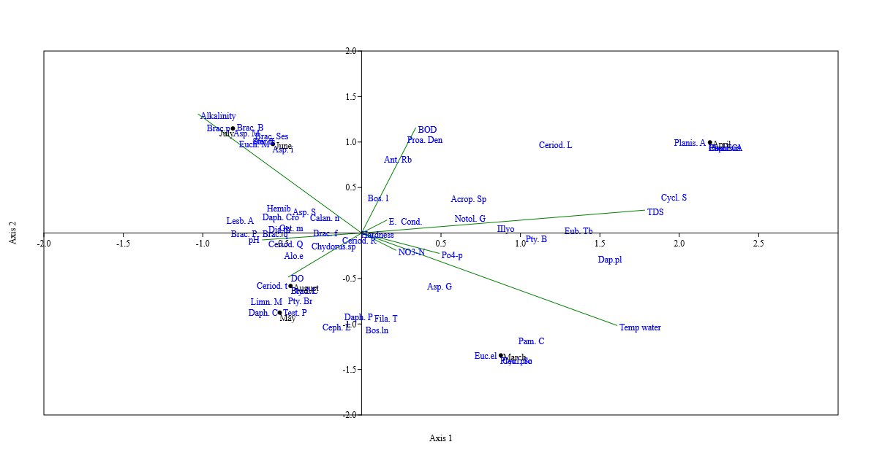
Figure 3: Canonical Correspondence Analysis (CCA) plots for environmental variables, months the zooplankton in Lapai-Gwari Stream.

Discussion
The water and the air temperatures fluctuated between the months of sampling. Water temperature was highest in April a dry season month compared with that of July a month that receives a lot of rainfall. This result varied from the report of Tanko et al., (2016), who obtained a higher temperature in June in Kufena Inselberg pool Zaria. The air temperature was highest in April and lowest in July, most likely because of increased insolation, thus more heat from the sun can penetrate down leading to increased temperature in April. Karney and Koycheva (2009), reported that some of the factors that cause an increase in the water temperature are environmental e.g. channel engineering, riparian management, and thermal pollution such that an increase in air temperature by one degree will cause the water temperature to increase by 0.3–0.9 ºC. Keke et al., (2015) reported similar air and water temperature fluctuations in River Kaduna. The pH value recorded in this study ranged from slightly acidic to alkaline. This is in line with the report of Nigerian Industrial Standards (NIS 2007); WHO (2011); Rabiu et al., (2018) and Adakole et al., (2003).

The range of the value of electrical conductivity and total dissolved solids recorded in the present study were within the recommended range of NESREA (2007) and are in agreement with the report of Anna (2018). According to the classification of Todd and May (2005) and WHO (2011), the TDS of the stream falls in freshwater type NESREA (2007) and WHO (2011), while the electrical conductivity of the stream falls in the none saline type (NESREA (2007 and WHO 2011, Rhodes ,1992).
The DO and BOD recorded is in line with the report of Susilowati et al., (2018), who reviewed factors that affects the DO and BOD in Madiun River. The DO value recorded was within the NESREA (2007) and WHO (2011) while the BOD value was lower the two standards. This water body could best be used for fisheries and wildlife. The nitrate value reported in this research is in line with the report of Isiuku and Enyoh (2020) and also within the range of the NESREA (2007) and WHO (2011). Though the phosphate was higher than the WHO (2011), a similar higher value was reported by Ken’ichi et al., (2017) and Isiuku and Enyoh, (2020) in some water bodies in south eastern, Nigeria. The alkalinity recorded from this study was high and in line with the report of and Gwana et al., (2017) in Allau Lake North-Easteren Nigeria, and Nathan et al., (2013) from fish farms in USA.
Rotifers were found to dominate the other zooplankton encountered, this does not agree with the findings of Mohammed et al., (2016) who reported that the rotifers were fewer in Tungan Kawo (Wushishi) Dam, North Central, Nigeria. This might be attributed to the stress in the lake due to anthropogenic activities. The dominance of rotifers in this report might be associated with the parthenogenetic form of reproduction and short developmental period under favourable environmental conditions (Pouriot et al.,1977). Rotifers were found to dominate the zooplankton followed by the cladocerans and finally the copepods in Bhopal the capital city of Madhya state of India, (Bhat et al., 2014).

The increase in the number of zooplankton observed in the rainy periods compared to the dry season might be due to the rains bringing in allochthonous materials that support the multiplication of the zooplankton. This is in agreement with the report of Arimoro and Oganah (2010), whereas Tanko et al., (2016) attributed the increase in zooplankton in the wet season to the dilution effect of the rains such that the diluted flood released nutrients to become less toxic to the increased zooplankton and allowed them to populate in the wet season compared to the dry season. Low abundance of some zooplankton like Asplanchna girodes, Cephalodella gracilis, and Eucyclops elegance might be associated with inability to cope with variation in environmental quality. This is consistent with reports by Arimoro and Oganah (2010) and Mohammed et al., (2016).

Conclusions and recommendation

The Orders of zooplankton observed were Rotifera, Copepoda, and Cladocera consisting of 902 individuals. This was made up of 51% rotifers, 20% copepods, and 29% Cladocerans. A total of 31species of rotifers, 15 species of cladocerans, and 10 species of copepods were encountered in with the rotifers found to dominate Brachionus pinenaus, Brachionus baylyi, Brachionus sessilis, Euchlanus mentamyersseem to have much affinity for alkalinity while Ceriodaphniatatic, Limnocalanus macrurus, Daphnia cronuta, Ptygura barbasta and Testudinella parvaseem to have affinity for DO. Some physico-chemical parameters and zooplankton diversity and abundance, indicate that the stream appear slightly perturbed, probably due to the various anthropogenic activities around the stream resulting in low diversity of some zooplankton. It appears that the stream may also be fed from the fishing community which releases its waste product it. Further study on the effect of alkalinity on this zooplankton may useful information on its impact in the stream.

References
Adakole, J. A., Mbah, C. E. and Dalla, M. A. 2003. Physico-chemical limnology of lake Kubanni, Zaria-Nigeria. 29thWEDC international conference, Abuja-Nigeria.
Agnes, v., Simone, A.P., Tibor, E., Thomas, H., Beata, P., Loan-Cristian, L., Cristian, M.A., Almut, G., Tamas, G., Anita, D., Milos, C., Bojan, G. and Andras, B. 2021. Freshwater systems and ecosystem services: Challenges and chances for cross-fertilization of disciplines, Ambio, 51:135–151 https://doi.org/10.1007/s13280-021-01556-4
Akbulut, N. E. and Tavsanoglu, U. N. 2017. Impacts of environmental factors on zooplankton taxonomic diversity in coastal lagoons in Turkey. Turkish Journal of Zoology, 41: 1-11 doi:10.3906/zoo-1704-37
Anene, A. 2003. Techniques in Hydrobiology. In: Research Techniques in Biological and Chemical Sciences. E.N. Onyeike and J.O. Osuji (eds), Oweri: Springfield Publishers Ltd, 174-189.
Anna, F. R. 2018. Correlation between conductivity and total dissolved solids in various types of water: A review. IOP Conference Series: Earth and Environmental Science 118 012019
APHA. (2009). Standard Methods for the Examination of Water and Wastewater 17th Edition.American Public Health Association. Inc. Washington D.C., 68 - 70.
Arimoro, F. O. and Oganah, O. A. 2010. Zooplankton Community Responses in a Perturbed Tropical Stream in the Niger Delta, Nigeria. The Open Environmental and Biological Monitoring Journal, 3, 1-11.
Battish, S. K. 1992. Freshwater Zooplankton of India. Oxford and IBH Publishing Co., New Delhi, pp233.
Bhat, N. A., Ashwani, W. and Rajni, R. 2014. Spatio-temporal variation of the zooplankton community in a tropical wetland (Bhoj Wetland), Bhopal, India. Journal of Ecology and the Natural Environment, 6(8), 252-270, DOI: 10.5897/JENE2014.0458
Bonjoru, R., Jerry, T. J. and Bakari, G. H. 2020. A preliminary checklist of zooplankton and macroinvertebrates of river Kashimbila, Taraba state, Nigeria. International Journal of Fisheries and Aquatic Studies, 8(2): 24-27
Davies, O. A., Tawari, C. C. and Abowei, J. F. N. 2009. Zooplankton of Elechi Creek, Niger Delta, Nigeria. Environmental Ecology., 26(4c): 2441-2346.
Dejen, E., Ngweheng, I., Nogelkerke, I. and Sibbing, E. 2004. Temporal and Spatial distribution of microcrustacean Zooplankton in relation to turbidity and other environmental factors in a large tropical lake (L. Tana, Ethiopia). Hydrobiologia, 513: 39-49.
Edmondson, W.T. 1959. Freshwater biology. 2nd Ed. John Wiley and Sons, New York: 124pp.
Eugene, N. O., and Julian, O. O. (Eds.), (2003). Research Techniques in Biological and Chemical Sciences. Springfield Publishers, 174-189.
Food and Agriculture Organisation (FAO), 2006. Interrelationship between Fish and Plankton in Inland Water. Retrieved from: http.//w.w.w.fao.org/Doc REP/006/X7580E03.htm106k-coached, (Accessed on: June, 9 2022).
Haney, J. F., Maria, A. A., Elisha, A., Stephanie, A., Darren, J. B., Wendy, B., Shane, R. B., Breanna, T. 2004. "An-Image-based Key to the Zooplankton of North America" version 5.0 released 2013. University of New Hampshire Center for Freshwater Biology <cfb.unh.edu> 8 Mar 2004
Hashemzadeh, F. and Venkataramana, G.V. 2012. Impact of Physico-Chemical Parameters of Water on Zooplankton Diversity in Nanjangud Industrial Area, India. International Research Journal of Environment Sciences, 1(4), 37-42.
Isiuku, B.O. and Enyoh, C.E. 2020. Pollution and health risks assessment of nitrate and phosphate concentrations in water bodies in South Eastern, Nigeria. Environmental Advances 2 100018
Jonnalagada, S.B. and Mhere, G. 2001. Water quality of the Odzi River in the Eastern Highlands of Zimbabwe. Water Resources 35(10) 2371-2376 DOI: 10.1016/s0043-1354(00)00533-9
Karney, B. and Koycheva, J. 2009. Stream Water Temperature and Climate Change-An Ecological Perspective. International Symposium on Water Management and Hydraulic Engineering Ohrid/Macedonia,771-777;1-5 September 2009
Keke, U.N., Arimoro, F.O., Ayanwale, A.V. and Aliyu, S.M. 2015. Physicochemical parameters and heavy metals content of surface water in downstream kaduna river, Zungeru, Niger State, Nigeria. Applied science research journal. 3(2): 46 -57
Ken’ichi, S., Masaaki, C., Ichiro, T., Chikage, Y., Kyoichi, O. and Atsushi, K. 2017. Differences in StreamWater Nitrate Concentrations. Hydrology, 2017: 1-12.
Kumar, S.K., Logeshkumaran, A., Magesh, N.S., Godson, P.S. and Chandrasekar, N. 2015. Hydro-geochemistry and application of water quality index (WQI) for groundwater quality assessment, Anna Nagar, part of Chennai City, Tamil Nadu, India. Applied Water Science. 5 335–343
Mohammed, A. Z., Agbaja, J. E. and Arimoro, F. O. 2016. Zooplankton Community Response to Deteriorating Water Quality In Tungan Kawo (Wushishi Dam), North Central, Nigeria. International journal of innovative research and advanced studies, 3-1, 51-56.
Mulani, S.K., Mule, M.B. and Patil, S.U. 2009. Studies on water quality and zooplankton community of the Panchganga River in Kolhapur city. Journal of Environmental Biology 30,455-459
Nathan, S.L., Jay, B., Shelton, E.H., Brian, and Hugh., K.T. 2013. "Interpretation of Water Analysis." Southern Regional Aquaculture Center, SRAC Publication No. 4606, 2013: 1-12.
Needham, J.G. and Needham, P.R. 1969. A guide to the study of Freshwater Biology. Holden-day inc.San Francisco, California, pp108.
NIS. 2007. Nigerian standard for drinking water quality. Nigerian industrial standard nis 554. Wuse Zone 7, Abuja, Nigeria: Standard Organization of Nigeria.
Okogwu, O.I., 2010. Seasonal Variation of Species Composition and Abundance of Zooplankton in Ehoma Lake, a flood plain lake in Nigeria. Applied Biology Department, Ebonyi State University, Abakeliki, Ebonyi State Nigeria.
Pinto-Coeluo, R., Pinel-Alloul, R., Mathurt, G. and Havens, K.E. 2005. Crustacean zooplankton in lakes and reservoirs of temperate and tropical regions: Variation with trophic status. Canadian Journal of Fish and Aquatic Science, 62, 348-361.
Pouriot, R., Rougier, C. and Miquelis, A. 1997. Origin and development of river zooplankton: example of the Marne. RhoadesHydrobiologia, 345, 143 – 148.
Pramila, K., Sharda, D., Chaudhari, P.R. and Wate, S.R. 2008. A Biomonitoring of Plankton to Assess Quality Water in the Lakes of Nagpur City. Proceedings of Taai2007: The 12thWorlrd Lake Conference, 160-164.
Rabiu, H.D., Umar, L.M., Sulaiman, I., Madina, M. and Abubakar, A.I. 2018. Assessment of the water quality of watari dam, kano state using selected physicochemical parameters. International Journal of Advanced Academic Research | Sciences, Technology & Engineering ISSN: 2488-9849 4(5) 62-77
Ravera, O. 1996. Zooplankton and trophic state relationships in temperate lakes. Pallenzamemoriedell’Istitutoitaliano di idrobiologia dot, 54,195-212.
Rhoades, J.D., Kandiah, A. and Mashali, A.M. 1992. The use of saline waters for crop production. FAO Irrigation and Drainage, FAO, Rome, 48.
Susan A.R., Mažeika, P.S., Patrick, D.S., Randall, W.C., Robert, M.H., Kurt, D.F., Dana, M.I., Julian, D.O., Kevin, R.B., Robert, J.D., and Lisa, E. 2029. (11) (PDF) Headwater Streams and Wetlands are Critical for Sustaining Fish, Fisheries, and Ecosystem Services. Available from: https://www.researchgate.net/publication/330479297_Headwater_Streams_and_Wetlands_are_Critical_for_Sustaining_Fish_Fisheries_and_Ecosystem_Services#fullTextFileContent [accessed Jun 05, 2022].
Susilowati, S., Joko, S., Muhammad, M. and Maridi, M. 2018. Dynamics and Factors that Affect DO-BOD Concentrations of Madiun River. AIP Conference Proceedings 2049, 020052 (2018); https://doi.org/10.1063/1.5082457
Tanko, D., Chia, M.A. and Nuhu, G. 2016. Zooplankton community structure and dynamics during the transition from dry to rainy season: A case study of Inselberg (rock) pool Zaria Nigeria. The Zoologist, 14: 7-13
Thais, X.M. and Elvio, S.F.M. 2013. Spatial Distribution of Zooplankton Diversity across Temporary Pools in a Semiarid Intermittent River. International Journal of Biodiversity. 1, 1-13.
Todd, D.K. and May, L.W. 2005. Groundwater Hydrology third edition. John Wiley & Sons, Inc. pp 652
USEPA 1986. Quality Criteria for Water, office of water regulations and Standards, Washington DC 20460 EPA 440/5-86-001
W.H.O. 2011. Guidelines for drinking water quality. V-1 recommendations World Health Organizations, Geneva Switzerland, 145-220.

