**Investigating the Geothermal Resource Potential in Parts of North Central Nigeria Using Aeromagnetic Data**

Alkali A., Alhassan D. U. Salako, K. A., Jane, O.La., Rafiu A.A and Udensi E. E.

Federal University of Technology Minna

[aisha.alkali@futminna.edu.ng](mailto:aisha.alkali@futminna.edu.ng); 08035703809

**ABSTRACT**

The assessment of geothermal potential in parts of North Central Nigeria using spectral depth analysis of aeromagnetic data was carried out. The study area is bounded by latitude 9. 00o to 10. 00o N and longitude 7.00o to 9.00 o E with an estimated total area of 24, 200 km2. The Total magnetic intensity map was divided into twenty - eight overlapping blocks, each block was subjected to spectral analyses to obtained centroid depth (Zo) and depth to top of basement (Zt) obtained were used to estimate the curie point depth which was then used to compute geothermal heat flow of the study area. The result of centroid depth varies between 10 km to 2 km, the depth to top of basement ranges from 1.42 km to 0.86 km. The Curie Point Depth (CPD), range from 3.449 km to 19.31 km with an average value of 9.196 km. The maximum CPD is found around the southern part at a depth of 18.5 km and minimum CPD is found around northern part with 14.5 km depth corresponding to areas around Gitata and Naraguta. The corresponding geothermal gradient and heat flow values varying from 30.03 oCkm-1 to 168.16 oCkm-1 with average of 70.98 oCkm-1 and heat flow ranges from 176.24 mWm-2 to 262.77 mWm-2 with an average value of 178.17mWm-2 respectively. The results show that the study area is not viable for geothermal energy due to its high anomalous nature of heat flow.

Keywords: Aeromagnetic data, Curie Point, Geothermal gradient, Heat flow

1. **Introduction**

Nigeria is known to be one of the biggest producers of oil and gas in the world and hydrocarbons has being the major source of generating energy but due to in –adequacy of hydrocarbon energy in addressing the power need of the nation, it is necessary to search for a sustainable renewable energy sources like geothermal in Nigeria energy sector. Geothermal energy sources pose to be a reliable, efficient energy source for the generation of electricity and environmental friendly (Adedapo *et al.,* 2013). Due to the many benefits of geothermal energy such as; unlimited power supply, environmental friendliness, low emission of greenhouse gases, and global availability more attention has been given to it in other countries as an alternative source of energy. All these benefits make geothermal energy a very vital contributor to the global energy productions in an environmentally friendly way (Sui *et al.,* 2019). Adequate power generation is one of the vital roles for economic, financial and social growth of a country. Limitation in exploring other sources of energy in the study area has led to increase joblessness among youths as many multi-national companies as well as small and medium scale enterprises (SMEs) have fold up, crime rate and other social vices also have increased tremendously.

This work estimates the Curie- point depths (CPD), geothermal gradients and subsurface heat flow anomalies for the assessment of geothermal potentials from high resolution Aeromagnetic Data in parts of North Central Nigeria. The high resolution Aeromagnetic Data was obtained from the Nigerian Geological Survey Agency (NGSA) as part of the airborne magnetic survey data acquired between 2005 and 2009. Several studies have shown that regional magnetic data can be used extensively to determine the thermal structure of the Earth’s crust in various geologic environments (Nwankwo and Shehu, 2015). The Curie point (bottom of magnetic source) depth is the point where rocks lose their ferromagnetic properties due to an increase in temperature in the crust (Tanaka *et al.,* 1999: Bansal *et al.,* 2011). The depth to bottom magnetic source (DBMS) or Curie point depth (CPD) is known as the depth at which the dominant magnetic mineral in the crust passes from a ferromagnetic state to a paramagnetic state under the effect of increasing temperature (Nagata, 1961; Ofor and Udensi, 2014). It is expected that geothermally active areas would be associated with shallow Curie point depth (Nuri *et al.,* 2005). Curie point temperature varies from region to region depending on the geology and the mineralogical content of the rocks. Therefore, one can normally expect shallow Curie point depth (CPD) at the regions which have geothermal potential, young volcanisms and thin crust (Aydin and Oksum, 2010). At temperature above CPT, the thermal agitation of the ferromagnetic rock materials lead to the spontaneous alignment of the point that ferromagnetic minerals become totally paramagnetic (Nwankwo and Sunday, 2017). The assessment of the variations in the Curie-point depth of an area can provide valuable information about the regional temperature distribution at depth and the potential of subsurface geothermal energy (Tselentis, 1991). The geothermal gradient is the rate at which the earth’s temperature increases with depth. Geothermal energy resource differs from any other renewable energy resource, so it has an edge over other renewable energy. Geothermal energy is the energy contained in the intense heat of the earth that continually flows outward from deep inside the earth. It can be accessed and exploited by drilling of oil and natural gas. Geothermal energy when compared with other renewable is an enormous, underuse heat and power resource that emits little or no greenhouse gasses (Dipippo & Renner, 2014). The search for geothermal resources focuses on those areas of the earth’s crust where geologic processes have raised temperatures near the surface such that the heat contained can be utilized. Such areas include; Fracture and thinned crust which allow the magma to rise to the surface as lava that comes because of the volcanic events within the earth (Whitmarsh, 2001). Among the renewable, geothermal energy can produce year- round constant power, a significant differentiation from both solar and wind power, which must wait for the sun to shine or the wind to blow respectively.

In some part of Nigeria, there are geological and geophysical evidences and presence of warm spring in the southwest (Ikogosi) and hot spring in the North central (Wikki) which have a good indicator for geothermal potential energy. This research aims to provide an insight into the geothermal energy potential of the study area as an alternative source of sustainable energy production of power by identifying and delineating the areas with favourable geothermal conditions and utilizations, through the estimation of the Curie-point depth, geothermal gradient and heat flow.

**1.1 Location and the Geological setting of the Study Area**

The Study area is situated within the North central part of Nigeria (Fig. 1). It is bounded with latitude 9. 00o to 10. 00o N and longitude 7.00o to 9.00 o E with an estimated total area of 24, 200 km2. The study area covers eight (8) aeromagnetic data sheets which include Bishini, Kachia, Kafanchaa, Naraguta, Abuja, Gitata, Jamaa and Kurra. These data were obtained from Nigeria Geological Survey Agency. The study area is situated within the Precambrian Basement which covers about 50% of the total surface of Nigeria. The Nigerian Basement Complex (Fig. 1) forms part of the Pan African mobile belt and lies between the Congo Craton and south of the Taurage Shield (Obaje, 2009).

It is composed of the following litho structural units: The Migmatite- Gneiss complex (MGC), The Metasedimentary and Metavolcanic rocks (The Schist Belt). The Pan - African granitoids (The Older Granites), undeformed acid and basic dykes. The Nigerian basement was affected by the 600 Ma Pan African Orogeny and occupies the reactivated region which resulted from plate collision between the passive continental margins (Burke and Dewey, 1972 and Dada, 2006). The basement rocks are believed to be the result of at least four major orogenic cycles of deformations, metamorphism and remobilization corresponding to the Liberian (1100 Ma), and the Pan African cycles (600 Ma) (Obaje, 2009).

The Pan African deformation was accompanied by a regional metamorphism, migmatisation and extensive granitization and gneissitisation which produced syn-tectonic granites and homogeneous gneisses (Abaa, 1983). Late tectonic emplacement of granites and granodiorites and associated contact metamorphism accompanied the end stage of this last formation. The Basement Complex is intruded by the Mesozoic calc-alkaline ring complex known as the Younger Granites. The Basement Complex is divided into four; namely, the Migmatite-Gneiss-Quartzite Complex, the Schist Belt, the Older Granites and the Undeformed Acid and Basic Dykes (Obaje, 2009). The Kwoi area is underlain by migmatite gneisses, schist, quartzites and minor amphibolies. These metasedimentary rocks have been intruded by granitic rocks ranging from the Pan-African suites to the Jurassic suites which form undulating rolling whalebacks. Figure 2 shows the geological map of the study area.

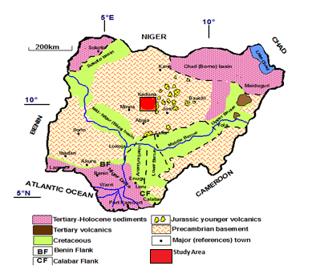

Fig. 1: Geology map of Nigeria showing Study area (NGSA 2006**)**

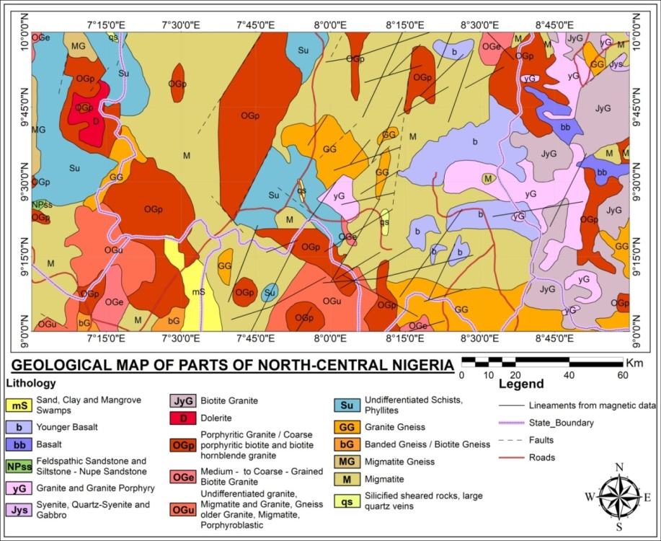

Figure 2: Geological Map of the Study Area adopted from Nigeria Geological Survey

1. **MATERIALS AND METHODS**

The aeromagnetic data used in this study were obtained from Nigeria Geological Survey Agency. Eight aeromagnetic maps with sheets number 165, 166, 167, 168, 186, 187, 188 and 189 covering the study area within parts of North Central Nigeria were acquired from the Nigeria Geological Survey agency (NGSA). These maps were obtained as part of the nationwide aeromagnetic survey of 2009 sponsored by the NGSA. The data were acquired along a series of NE-SW flight lines with a spacing of 500 m and average flight elevation of spacing of 200 m and an average flight elevation of about 80 m while tie lines occur at about 2000 m interval. The geomagnetic gradient was removed from the data using the international Geomagnetic Reference Field (IGRF), 2005. The data were made available in the form of grids on a scale of 1:100, 000. These data were processed and merged together into a common dataset. In this study, the total area to be covered is about 24, 200 km2 extending from latitude 9. 00o to 10. 00o N and longitude 7.00o to 9.00 o E.

The total magnetic intensity data was processed and divided into twenty-eight overlapping blocks to carry out spectral analysis to obtain the curie point depth (CPD) of the study area. Steps for determine depth to top of magnetic four-sided prism (Zt) from the gradient of the log of power spectrum has been discussed extensively by several authors Bhattacharyya and leu (1977); from the idea of specter and Grant (1970) calculated the Depth to the centroid of the magnetized source rock (Zo). The analysis was done using computer software (Oasis Montaj) and mat lab designed for analysis of potential field data. In this study, the spectral analysis was made using interactive Oasis Montaj, version 8.4 which enables two dimensional frequency domains processing of potential field data. The results of the analysis are plotted on a logarithmic scale against the radial wave number using a programme in Mat lab. Bhattacharyya and Leu (1975 and 1977) to develop the method to determine the bottom depth of magnetized bodies (Zb). Production of Total Magnetic Intensity (TMI) map using Oasis Montaj software, Separation of the regional and residual anomalies, division of TMI map into twenty-eight overlapping blocks, performing spectral analysis on each blocks, evaluating the depth to the magnetic source using spectral analysis estimating the geothermal gradient and heat flow. The data were plotted using a program written in Matlab to deduce the centroid depth from the slope of the long wavelength (Zo) and the depth to top of the magnetized body (Zt).

Total magnetic intensity map (Fig. 3) was divided into twenty-eight spectral blocks (Spectral block 1-4) of overlapping sections. The divisions of the TMI map into spectral sections were done manually and the spectral energies were plotted within it. The spectral data obtained were later exported to Microsoft excel worksheets one after the other where the data for wave number and log of energy spectrum were extracted for plotting .The spectral blocks energy files were used as input files into spectral program plot (SPP) developed with MATLAB. The data were plotted using a program written in Matlab to deduce the centroid depth from the Slope of the long wavelength (Zo) and the Depth to top of the magnetized body (Zt).

These approaches assumed a random uniform uncorrelated distribution of sources. The power spectrum, P, for a 2D assemblage of bodies can be written as follow (Spector and Grant, 1970; Blakely, 1995).

 (1)

where P, is the power density spectrum of the Magnetization, Kx and Ky are the wave numbers in the x- and y- direction; Cm is proportionality constant, θm and θf are the directional factors related to the magnetization and geomagnetic field respectively; and Zt and Zb are the top and bottom depths of the magnetic sources respectively. The equation can be simplified by noting that all terms except |θm|2 and |θf|2 are radially symmetric. The radial averages of θm and θf are constants. If P(x,y) is completely random and uncorrelated, P(Kx, Ky) is a constant. Hence, the radial average of P is:

 (2)

where A1 is a constant,k is the wave number andP|k| power spectral density Zt and Zb denote the depths to the top and bottom of the magnetic body respectively. According to Okubo *et al.* (1985), CPD (Zb) can be achieved in two stages. First of all, the centroid depth (Z0) of the inmost magnetic source is appraised from the gradient of the lengthiest wavelength part of the spectrum divided by the wave number using the following equation (Nwankwo & Shehu, 2015):

  (3)

where P(k) is the radially average power spectrum, and A is a constant depending on the properties of magnetization and its orientation and Zo is the centroid depth of the magnetic sources (Tanaka and Matsubayashi, 1999). Secondly, the uppermost depth to the magnetic body is also derived from the gradient of high wave number portion of the power spectrum as follows:

 (4)

where B is a constant; Zt is the depth to the top of the magnetic sources. The depth to the bottom of the magnetization Zb is:

 (5)

where Zb is the depth to the bottom of magnetized body, Zo is the centroid depth and Zt is the depth to top of the magnetized body. As discussed in the methods above, CPD is calculated in three phases: (i) dividing the TMI map into overlapping blocks, (ii) Computing the logarithm of power spectrum for each blocks, the centroid depth and depth to top of the magnetized body is got and (iii) using Zb = 2Z0 − Zt the basal depth is calculated which is the CPD.

The heat flow is therefore calculated from the equation as follow;

 (6)

where q is the heat flow, k is the thermal conductivity.

According to Tanaka, Okubo, and Matsubayashi (1999); Stampolidis *et al.,* (2005), the Curie depth is related with the Curie temperature (580oC) and thermal conductivity of 2.5 W/moC-1 as average for igneous rocks are used as standard in this work (Nwankwo *et al*; 2009). The geothermal gradient (dT/dZ) between the Earth’s surface and the Curie point depth (Zb) is defined using the relation as follow;

 (7)

dT/dZ is the thermal gradient,(580o) is the Curie temperature and Zbis the Curie depth

1. **Result and Discussion**
   1. **Total Magnetic Intensity anomaly and the residual magnetic intensity anomaly**

**RESULT AND DISCUSSION**

The total magnetic intensity (TMI) map of the area (Fig. 3) indicate regions of (H) and (L) with a magnetic intensity values ranging from 33777.1 nT to 33460.3 nT respectively. The map shows variation of highs and lows in magnetic signature. The high magnetic susceptibilities obtained could be found around the North-eastern part of the study area which corresponds to Lere, Kajuru, Toro, Riyom and BarkinLadi areas. These anomalies could be due to presence of basalt in the area as mapped by Figure 2. The low magnetic signature are found around the south-western part of the study area, corresponding to Gwagwalada, Abaji, Suleja and Gurara areas which could be due to level of weathering of the basement rock and thick overburden. The area with low magnetic susceptibility values ranging between 33570.2 nT and 33632.4nT indicates alluvium deposit around Muya, Kokona and Akwanga areas.

**3.2. Spectral Analysis**

The Total Magnetic Intensity (Fig.3) of the study area was divided into twenty-eight overlapping blocks (Blocks 1-4) overlapping magnetic sections. The divisions of TMI map into spectral sections of blocks were done with Oasis Montaj. The analysis was carried out using a spectral program plot (SPP) developed with MATLAB. Fig.4 is the Graph of the logarithm of spectral energies against frequencies obtained for blocks 1-4. The estimated value for centroid depth and depth to top of the magnetized body, Zo and Zt respectively were detailed in Table 1.



Figure 3: Total Magnetic Intensity of the study area

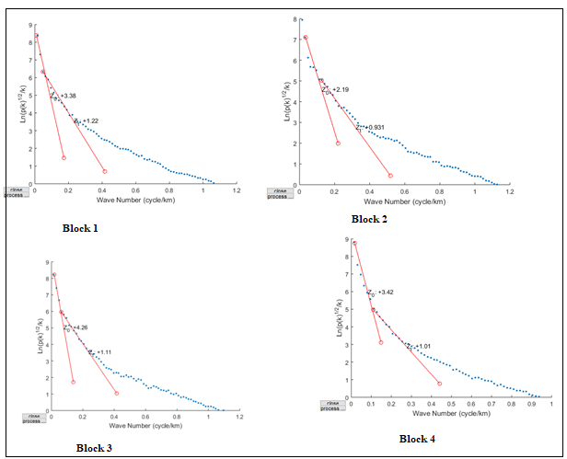

Fig. 4: A sample of spectral blocks 1-4 showing the logarithm of spectral energies against frequencies obtained for block 1-4

Table 1. Estimated Curie point depth (CPD), geothermal gradients and heat flow for the 28 blocks in the study area.

|  |  |  |  |  |  |  |  |
| --- | --- | --- | --- | --- | --- | --- | --- |
| BLOCKS | Long  (Deg) | Lat.  (Deg.) | Depth to Centroid (km) | Depth to Top  (km) | Curie Depth  (km) | Geothermal gradient. oC/Km | Heat flow  mWm-2 |
| 1 | 7.25 | 9.75 | 3.38 | 1.22 | 5.54 | 104.69 | 262.77 |
| 2 | 7.5 | 9.75 | 2.19 | 0.931 | 3.449 | 168.16 | 422.09 |
| 3 | 7.75 | 9.75 | 4.26 | 1.11 | 7.41 | 78.2 | 196.46 |
| 4 | 8 | 9.75 | 3.42 | 1.01 | 5.83 | 99.48 | 249.70 |
| 5 | 8.25 | 9.75 | 3.93 | 1.28 | 6.58 | 88.14 | 221.24 |
| 6 | 8.5 | 9.75 | 3.98 | 1.25 | 6.71 | 86.43 | 216.95 |
| 7 | 8.75 | 9.75 | 7.22 | 1.39 | 13.05 | 44.44 | 111.55 |
| 8 | 7.25 | 9.583 | 4.64 | 1.23 | 8.05 | 72.04 | 180.84 |
| 9 | 7.5 | 9.583 | 4.86 | 0.991 | 8.729 | 66.44 | 116.77 |
| 10 | 7.75 | 9.583 | 4.67 | 0.945 | 8.395 | 69.08 | 173.41 |
| 11 | 8 | 9.583 | 5.82 | 1.21 | 10.43 | 55.60 | 139.57 |
| 12 | 8.25 | 9.583 | 4.18 | 1.26 | 7.1 | 81.69 | 205.04 |
| 13 | 8.5 | 9.583 | 4.29 | 1.28 | 7.3 | 79.45 | 199.42 |
| 14 | 8.75 | 9.583 | 8.47 | 1.34 | 15.6 | 37.17 | 93.32 |
| 15 | 7.25 | 9.416 | 3.39 | 1.42 | 5.36 | 108.20 | 271.60 |
| 16 | 7.5 | 9.416 | 7.52 | 1.31 | 13.73 | 42.24 | 106.03 |
| 17 | 7.75 | 9.416 | 10.3 | 1.29 | 19.31 | 30.03 | 75.39 |
| 18 | 8 | 9.416 | 5.44 | 1.2 | 9.68 | 59.91 | 150.39 |
| 19 | 8.25 | 9.416 | 5.14 | 1.36 | 8.92 | 65.02 | 163.20 |
| 20 | 8.5 | 9.416 | 4.49 | 1.08 | 7.9 | 73.41 | 184.27 |
| 21 | 8.75 | 9.416 | 6.04 | 0.857 | 11.223 | 51.67 | 129.71 |
| 22 | 7.25 | 9.25 | 5.69 | 1.12 | 10.26 | 56.53 | 141.89 |
| 23 | 7.5 | 9.25 | 5.0 | 1.35 | 8.65 | 67.05 | 168.300 |
| 24 | 7.75 | 9.25 | 5.66 | 1.41 | 9.91 | 58.52 | 146.90 |
| 25 | 8 | 9.25 | 5.38 | 1.3 | 9.46 | 61.31 | 153.89 |
| 26 | 8.25 | 9.25 | 5.71 | 0.992 | 10.428 | 55.61 | 139.60 |
| 27 | 8.5 | 9.25 | 5.83 | 1.43 | 10.23 | 56.69 | 142.30 |
| 28 | 8.75 | 9.25 | 4.65 | 1.04 | 8.26 | 70.21 | 176.24 |

**3.3. Depth to Centroid of the magnetized body**

The result of centroid depth vary between 10 km to 2 km (Fig.5a) and shows to be minimum at the north-western part around Kachia area and was observed to be maximum at south-Eastern part around Kagarko and Barkin Ladin areas.

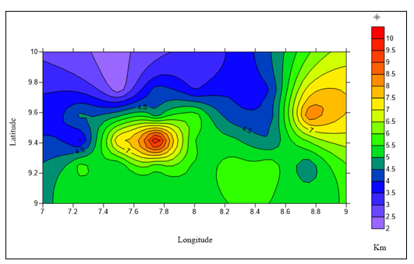

(a)

Fig. 5a: Contour map of the depth to centroid of the magnetized body

**3.4. Depth to top of magnetic boundary**

The depth to top of magnetic boundary has values ranging from 1.42 km to 0.86 km (Fig. 5b ) and was observed to be maximum around South northern part to western edge of the map and at minimum around Eastern part and upper north of the study area.

**3.5** **The Curie Point Depth (CPD) Map:** The results of the spectral analysis of Aeromagnetic anomalies over the area shows that the Curie point depth map of the study area (Fig.5c ) using (equation 5) shows that depth varies from 3.449 km to 19.31 km with an average of 9.196 km (Table 1). The most pronounced high curie depth (Maximum CPD) is situated at Riyom, Barkin ladi at the Eastern part and at the central part of the map corresponding to Kagarko area at a depth of 18.5 km to 14.5 km. The shallow curie-point depth were observed at Northwestern part around Zangon Kataf, Kaura, Paikoro and Gurara areas with a depth of 7.5 km to 3.5 km. Literatures such as (Tanaka *et al*., 1999., Elena and Udensi, 2012) states that CPD usually varies greatly with different geological settings and are shallower in volcanic and geothermal fields. The CPDs at volcanic, tectonic and associated geodynamic environments have CPD shallower than 10 km (Obande et al., 2014), while CPDs ranging between 15 and 25 km are as a result of island arcs and ridges and deeper than 25 km in plateaus and trenches (Tanaka *et al*., 1999). The magnetic signatures at these depths are attributed to variation in basement susceptibilities resulting from intra-basement features such as faults and fractures.

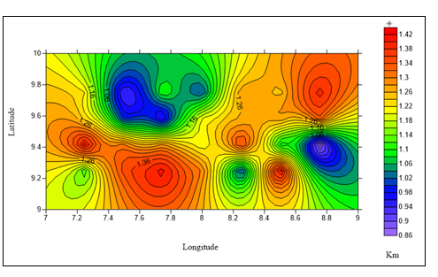

(b)

Fig.5b: contour map of depth to top of magnetic boundary

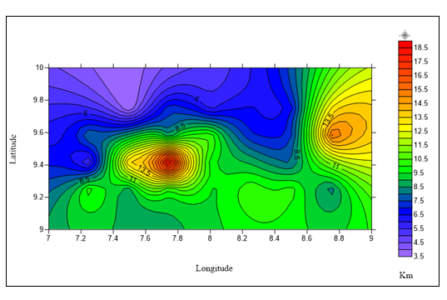

(c)

Fig 5c: depth to bottom of magnetized body (CPD) in km

**3.5. The Geothermal Gradient Map:** Figure.5d; indicate that the geothermal gradient in (oCkm-1) show the rate of depth dependent temperature growth. The results show that geothermal gradients (Fig. 5d) vary between 165 oCkm-1 to 30 oCkm-1 with an average value of 70.98 oCkm-1. High geothermal gradient are observed at the North western part of the study area with a gradient of 165 oCkm-1, and lowest geothermal gradient were observed around the Eastsouthern part of the area corresponding to Toro, Riyom and Akwanga, areas, at a depth of 40 oCkm-1 and Barkin ladi area at a depth of 30 oCkm-1 respectively.

**3.6. The Heat Flow:** The heat flow (Figure 5e) show that the heat flow values (estimated in accordance with equation 6 ) is observed to have value ranging from 420 mWm-2 to 80 mWm-2 with an average value of 178.17 mWm-2. The heat flow range from 180 mWm-2 to 80 mWm-2 from the lower edge of South Eastern part and maximun values of 420 mWm-2 to 280 mWm-2 was observed at the Northern part of the study area. An anomalous heat flow with depth of (420, 260 and 120 mWm-2 ) were observed especially at North western around Kauru and Muya areas. This point has the lowest Curie point depth within the study area and could be a geothermically active region. The lowest heat flow depths were observed at the Eastern part of Riyom up to the central South covering the lower edges of Kagarko and Kokona with a depth of 80 to 100 mWm-2 which falls within a good geothermal heat flow condition but with the greatest Curie point depth. The maps (Fig. 5d and e) is closely related it indicates that most areas of high heat flow correspond to high geothermal gradient. Generally, high heat flow values correspond to volcanic and metamorphic region since the two units have high heat conductivities (Nwankwo et al., 2011). Additionally, heat flow is significantly affected by tectonically active regions (Tanaka et al., 1999). Current works show that heat flow is greatly dependent upon geological conditions. Geothermal energy does also occur in areas where basement rocks that have relatively normal heat flow are covered by thick blanket of thermally insulated sediments (Ofor and Udensi, 2014). It can be inferred that the average high heat in the study area may be as a result of tectonic activities in the study area. In thermally normal continental regions the average heat flow is about 60 mWm-2, values between 80 and 100 mWm-2 are good geothermal source, while values greater than 100mWm-2 is an indication of anomalous geothermal conditions (Nwankwo and Sunday, 2017).

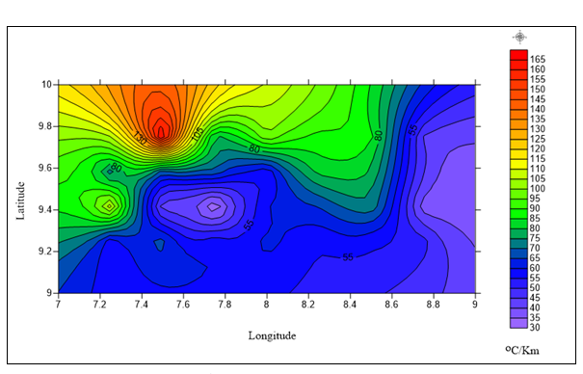

(d)  
 Fig 5d: Geothermal Gradient Map

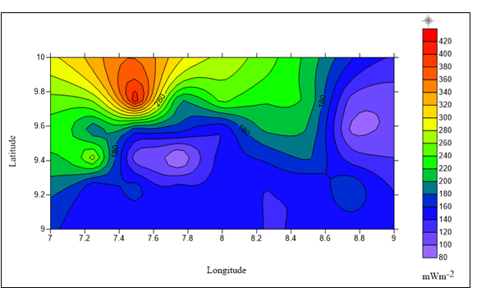

(e)

Fig 5e: Heat flow map

**CONCLUSION**

This study present the result of depth to Centriod, depth to the top, Curie Point Depth (CPD), geothermal gradient and heat flow from the spectral analysis of aeromagnetic data of parts of North Central Nigeria. The CPD depth obtained ranges from 3.449 km to 19.31 km with an average value of 9.196 km. The calculated geothermal gradient in the study area based on the CPD varies between 165 oCkm-1 to 30 oCkm-1 with an average of 70.98oCkm-1. The corresponding heat flow values estimated from the geothermal gradient the study area varies between 420 mWm-2 and 80 mWm-2 with an average value of 178.17 mWm-2. The lowest heat flow depths were observed at the Eastern part of Riyom up to the central South covering the lower edges of Kagarko and Kokona with 80 to 100 mWm-2 and falls within a good geothermal heat flow condition. In view of this, the average heat flow of 178.17 mWm-2 estimated in the study area corresponding to Gitata and Naraguta areas which are areas without indication of favourable geothermal potentials. It can therefore deduced from this study that the area is not a good indicator of geothermal energy potential due to anomalous heat flow and tectonic active region within the study area.

**REFERENCES**

Abaa, S. I. (1983). The Structure and Petrography of Alkaline Rocks of the Mada Younger Granite Complex, Nigeria. *Journal of African Earth Science 3, 107-113*

Aydın, I., & Oksum, E. (2010). Exponential approach to estimate the Curie-temperature depth. *Journal of Geophysics and Engineering* 7(2), 113-125.

Bhattacharyya, B., & Leu, L. K. (1975). Analysis of magnetic anomalies over Yellowstone National Park: mapping of Curie point isothermal surface for geothermal reconnaissance. *Journal of Geophysical Research,* 80(32), 4461-4465.

Bansal, A.R., Gabriel, G., Dimri, V.P., and Krawczk, C.M., (2011). Estimation of depth to the bottom of magnetic sources by a modified centroid method for fractal distribution of sources: An application to aeromagnetic data in Germany. *Geophysics* 76, 11-22.

Bhattacharyya, B., & Leu, L.K. (1977). Spectral analysis of gravity and magnetic anomalies due to rectangular prismatic bodies. *Geophysics*, 42(1), 41-50.

Blakely, R. J. (1996). Potential theory in gravity and magnetic applications: Cambridge university press.

Burke, K. C., & Dewey, J. F. (1972). Orogeny in Africa: In Dessauvagie T.F.J., Whiteman A.J. (Eds.), *African Geology* (pp.583-608). Ibadan: University of Ibadan Press

Dada, S. S. (2006). Proterozoic Evolution of Nigeria. In: Oshi O (Ed.), *The Basement Complex of Nigeria and its Mineral Resources (A Tribute to Prof. M. A. O. Rahaman),* (pp.29-44.). Ibadan: AkinJinad& Co.

Khojamli, A., Ardejani, F. D., Moradzadeh, A., Kalate, A. N., Kahoo, A. R., & Porkhial, S. (2016). Estimation of Curie point depths and heat flow from Ardebil province, Iran, using aeromagnetic data. *Arabian Journal of Geosciences*, 9(5), 383

Nagata, T. (1961). Rock Magnetism, Maruzen, Tokyo. Nnange, J.M, poudjom Djomani, p.350.

Nigerian Geological Survey Agency, (2006). *Geology and Structural Lineament Map of Nigeria.* Abuja: NGSA.

Nuri, D.M., Timur, U.Z., Mumtaz, H., Naci, O. (2005). Curie Point Depth variations to infer thermal structure of the crust at the African-Eurasian convergence zone, SW Turkey. Earth Planets and space, 57, 373-383. <https://doi.org/10.1186/F> 03351821

Nwankwo, L.I., Olasehinde, P.I., and Akoshile, C.O., (2011). Heat flow anomalies from the spectral analysis of airborne magnetic data of Nupe Basin, Nigeria. *Asian Journal of Earth Sci*ences, 4, 20-28.https://doi.org/10.1016/S0040-1951(99)00072-4

Nwankwo, L. I., & Shehu, A. T. (2015). Evaluation of Curie-point depths, geothermal gradients and nearsurface heat flow from high-resolution aeromagnetic (HRAM) data of the entire Sokoto Basin, Nigeria. Journal of Volcanology and Geothermal Research 305, 45-55. doi:https://doi.org/10.1016/j.jvolgeores.2015.09.017

Nwankwo, L.I., Sunday, A.J., (2017). Regional estimation of Curie-Point depths and succeeding geothermal parameters from recently acquired high-resolution aeromagnetic data of the entire Bida basin, north-central Nigeria. *Geothermal energy Science.* 1, 9.

Obaje, N. G. (2009). Geology and mineral resources of Nigeria Springer, Dordrecht Heidelberg London New York

Obande, G. E., Lawal, K. M., & Ahmed, L. A. (2014). Spectral analysis of aeromagnetic data for geothermal investigation of Wikki Warm Spring, north-east Nigeria. *Geothermic*, 50, 85-90.

Ofor, Ngozi, P. and Udensi, Emmanuel, E. (2014). Determination of the Heat Flow in the Sokoto Basin, Nigeria using Spectral Analysis of Aeromagnetic Data, *Journal of Natural Sciences Research*, Vol.4, No.6 pp.83-86

Okubo, Y., Graf, R., Hansen, R., Ogawa, K., & Tsu, H. (1985). Curie point depths of the island of Kyushu and surrounding areas, Japan. *Geophysics*, 50(3), 481-494.

Spector, A. and Grant, F.S. (1970). Statistical models for interpreting aeromagnetic data, *Geophysics*, Vol. 35, pp. 293-302

Stampolidis, A., Kane, I., Tsokas, G., & Tsourlos, P. (2005). Curie point depths of Albania inferred from ground total field magnetic data. Surveys in *Geophysics*, 26(4), 461-480.

Tanaka, A. Y. Okubo and O. Matsubayashi. (1999) Curie point depth based on spectrum analysis of the magnetic anomaly data in East and Southeast Asia, Tectonophysics, Vol.306, pp 461-470.

Tselentis, G. A., (1991) An attempt to define curie depth in Greece from aeromagnetic and heat flow data. PAGEOPH 136, 87-101.

Ross, H. E., Blakely, R. J., & Zoback, M. D. (2006). Testing the use of aeromagnetic data for the determination of Curie depth in California. *Geophysics*, 71(5), L51-L59.