Data logging Model for Metropolitan Vehicle Movement Monitoring and Control System

Samuel Adeniyi
Department of Mechatronics Engineering,
Federal University of Technology Minna, Niger State, Nigeria.
samdimsx@gmail.com
Paul Olamide Ojekunle
Department of Mechatronics Engineering,
Federal University of Technology Minna, Niger State, Nigeria.
paulolamide2@gmail.com
Kufre Esenowo Jack
Department of Mechatronics Engineering,
Federal University of Technology Minna, Niger State, Nigeria.
https://orcid.org/0000-0003-2422-5442

Lanre Joseph Olatomiwa Department of Electrical & Electronics Engineering
Federal University of Technology Minna, Niger State, Nigeria.
https://orcid.org/0000-0002-2044-4974
Taiye Hassan Salami
Department of Mechatronics Engineering,
Federal University of Technology Minna, Niger State, Nigeria.
taye.salami@futminna.edu.ng

Abdulhafeez Oluwatobi Oyelami
Department of Mechatronics Engineering,
Federal University of Technology Minna, Niger State, Nigeria.
exboyefeezy@gmail.com

Abstract— The automotive industry has experienced a spectacular expansion in the last decade, with an increase in number of cars in metropolitan cities. Maintaining track of automobiles based on their plates number in order to manage vehicular traffic properly in the city has posed difficulty. This research presents an artificial intelligence-based technology technique (YOLO) for tracking vehicle movement based on the vehicle's plate number with data logging model and a centralized database structure for vehicles identification and monitoring, using other techniques such as image processing and IoT mechanism for detection and recognition accuracy. In order to create an Intelligent Plate Number Recognition (IPNR) System, this study employs artificial intelligence, computer vision (image processing), laser scanning technologies, and convolutional neural networks (CNN). This model concepts and computations underpin potential solutions to this issue, guaranteeing a range of approaches to achieving the desired outcome. This work focuses on plate number identification using the contours tracing approach, as well as edge identification and sharpening using optical character recognition algorithm based on OpenCV libraries. The vehicle is monitored on real time using the GPS technology where the vehicle plate image was captured with the Pi camera to produce high-quality images. This research employs a wide range of techniques across the board (from license plate detection to character recognition) to boost the system's speed as much as feasible with negligible overhead. The studies demonstrated how useful image processing tools were used for data logging, and character recognition when combined with vehicles in urban environments. To carry out monitoring and management of the system, a responsive web application was designed for data logging.
Keywords: Artificial Intelligence, Computer Vision, Data Logging Model, Metropolitan Cities, Vehicle Movement Monitoring

Introduction
Research into image monitoring and processing systems has found significant use in the domain of vehicle licence number plate recognition (LNPR) [1]. Parking lots are only one place where today's widespread availability of high-quality cameras' number plate recognition systems are put to good use for traffic management [2][3]. The LNPR system are used for a variety of purposes, including border control [4], Auto-theft detection, automated parking attendants, gas station surveillance with red light cameras, speed enforcement, and safety measures [5]. There hasn't been much change in the fundamental processing algorithms behind these various uses of the technology.
Intelligent Plate Number Recognition (IPNR) System is one of the identification method for automobile machinery movement. The aforementioned method has an image processing capability for vehicle's license plate number identification. However, the IPNR system is limited by its inability to interface with the web platforms for remote security monitoring. Cordinating and processing vehicles information centrally in a metropolitan city is challenging. These challenges led to development of the centralized vehicles entry and exit documentary for the security concerns in urban areas [6]. Also, the inability to keep track of vehicle information from the license plate number makes it difficult for the assigned agency to trace a particular vehicle or group of vehicles on account of insecurity attributed to vehicular movement in metropolitan cities [7].
For an intelligent traffic or vehicle management system, the presented research is an image processing-based effort for automatic recognition of number plate from the vehicle's image [8]. People's interest in high-tech, precise, and reliable intelligent transportation systems has grown alongside the proliferation of roads and cars [9]. Due to viewpoint shifts, color-shading similarities between vehicle bodywork and license plates, a variety of plate styles, and inconsistent lighting during image capture, vehicle photographs pose a significant challenge for the Intelligent Plate Number Recognition (IPNR) System [10]. Vehicle traffic is growing by the day in various metropolitan cities, and as a mega city, Minna is not exempted, as such, many people are not responding well to traffic restrictions. Over speeding and careless driving are the most common causes of accidents [11]. People are hesitant to slow down to their maximum speed, especially in the school and college zones, which poses difficulty in vehicle identification. It could be tough to detect a car owner who sometimes breaks traffic laws and drives too quickly. Since traffic officials cannot detect a license plate number from a moving car because of its speed, hence, catching and punishing such drivers is impossible. The development of an IPNR system is therefore one solution to this problem. Although, there are a plethora of IPNR systems in the market today. These systems use many approaches, but it was still a difficult task because factors like vehicle speed, non-uniform vehicle number plates, vehicle number language, and lighting conditions could significantly impact the overall identification rate [12].
The IPNR System has many applications, including the detection of fast vehicles, the control of restricted areas, unattended parking spaces, the enforcement of traffic laws, and the collection of electronic tolls. The suggested work could be broken down into its main components, which are as follows: image capture; number plate recognition; edge detection; character segmentation; character recognition; and database comparison. In large urban areas, the location of a vehicle could be monitored and determined using vehicle tracking technology, which was a comprehensive security and fleet management solution that makes use of various methods, including global positioning system (GPS) and other navigation systems that use satellite and ground-based channels to pinpoint a vehicle's precise location. Installation of a vehicle detection device within a vehicle offers a practical real-time location, as well as the data gathered could be retrieved and archived for further evaluation [13][8]. [14] stated that this technology was an indispensable tool for monitoring a car whenever its owner so chooses; it is now common among owners of high-priced vehicles; it is used to prevent car theft and aid in the recovery of stolen vehicles; and the information it collects could be regarded on digital map via the internet and software. The state-of-the-art hardware and software components of the device make it possible to monitor and locate vehicles both available on the internet as well as off the internet. The vehicle module, the base station, and the data and control system make up the primary components of a tracking system [15].
The primary piece of detecting gear in an LNPR setup is a camera, which are stationed at intersections, traffic monitoring hubs, and other points of interest for the purpose of spotting illegally parked or stolen automobiles. Some articles employ a method based on pattern recognition [13][9], It was designed to recognize license plates using foreknowledge of the orientation of letters and numerals and was fast and precise sufficient for use in practical uses [14]. In order to adapt this system to identifying number plates from multiple regions, the technique was modified to account for the differences in orientation and font used for number plates in those locations while preserving its basic structure.
This research work aim to develop a data logging model for metropolitan vehicle system monitoring and control, with the following objectives: design remote security monitoring scheme for the metropolitan vehicle system; create a centralized database server for vehicle monitoring and control in Minna metropolitan city scenario; design data logging and storage scheme with graphical user interface for urban vehicle control system.

Reviewed Literature

Data Logging
Data logging entails the process of gathering and storing information over time in various systems or situations and this entails keeping track of a range of occurrences and finding its applications in metropolitan vehicle monitoring system like any other sector. While data logging is usually linked with gadgets, a simple approach to log data are through sensors and storage database or device, after which analysis are made on the saved data. The data logger stores inputs from the devices that are linked to it using a controller technology. Data loggers keep track of everything that goes on in the signaling system [13].
In today's organizations, a data logger—an electronic sensor device with a microprocessor and memory—is most frequently used to gather and store information. The information was then manually transmitted to a computer by removing the device and connecting it to the computer's Universal Serial Bus (USB) connection for data downloads, though it could also be uploaded to a cloud system. In the majority of use scenarios, cloud databanks are the most eeffective choice for storing the gathered data. Data are stored on a Storage Device (SD) card where the system converts the raw data to digital input for data collection. The data logger also includes a real-time clock chip, which stamps the data into the SD card at the end of the logging process[16]. The majority of data loggers are made to track a relatively narrow range of data, but the information most frequently gathered for supply chain objectives relates to the conditions for shipping and transportation. With this information, supply chain processes were audited to identify inefficiency in environmental activities. Although the pen-and-paper method can be used for some very simple use cases, it is not practical for any kind of extensive supervision, for this reason, data logging is needed to automate the whole process.
[12] offered a description of a low-priced advanced navigation system that employs a GPS module, a microcontroller, and a GSM module to monitor and transmit information without the need for additional infrastructure or subscription-based services. Furthermore, the system includes an inertia sensor for accident detection, a real-time clock for date and time, Ultrasonic sonar sensors for parking (measurement of distance between vehicle and barriers for autonomous parking), and a wand for data logging to an SD card, from which the path of the vehicle and visual movement on Google maps were determined.

Cloud-based Architecture
A cloud-based system comprises collections of network-connected distributed computing and storage servers which provides virtual environments for different system operations, application containers, and computing services [10]. Software system functions on cloud platform by deploying it on the cloud platform's virtual machines, albeit the benefit is limited to eliminating the requirement for actual hardware acquisition and maintenance. Users must still set up the appropriate computing environments within the cloud servers such as dependency libraries, networking, and storage system. Some of these responsibilities are alleviated by application containers, which give interfaces to computing environments that users do not have to set up separately for each system software deployment on a cloud platform.
Infrastructure as a Service (IaaS), Platform as a Service (PaaS), Function as a Service (FaaS), and Software as a Service (SaaS) are all ways in which cloud-based platforms are utilized. For data transformation, modification, and event monitoring, this system employs FaaS as an event-based architecture. Given its flexibility and scalability of resources, it was used for customizable IoT applications that is handled by the IoT Hub and Stream Analytics services.

Deep Learning
Deep learning, a subfield of machine learning, is necessary for a multi-neural network structure. Neural networks try to emulate the brain's function by allowing them to learn from enormous volumes of data, but they are still far less capable than the human brain. If a need for more precise predictions than a single-layer neural network could provide emerges, adding more hidden layers might be the way to go. Current and future products and services leverage deep understanding technology, including voice-activated TV remote controls, digital assistants like self-driving automobiles, and credit card fraud detection. Deep learning is a type of machine learning that is necessary for a multiple neural network. Despite being vastly outmatched by the capabilities of a human brain, artificial neural networks make an attempt to simulate brain activity by allowing extensive data to be used for learning. Although predictions from single-layer neural networks are likely to be approximations, optimizing and improving accuracy through the use of several convolutional nodes is possible. Deep understanding technology was used in both established and emerging markets, and may be found in products as varied as voice-activated TV remote controls, digital assistants, and credit card fraud detection. [16] reports opine that deep learning was able to learn from massive volumes of unlabelled data in a variety of fields, and that this made it a good fit for deeper explanation. Applications of deep learning include automatic speech recognition, image recognition, NLP, drug discovery and toxicology, CRM, a decision process, and bioinformatics. Accordingly, it could be used for a system to keep tabs on vehicles in a city. [17] examined the application of Deep Learning to key issues in big data analytics, such as the extraction of complicated patterns from large datasets, the simplification of discriminative tasks, the acceleration of information retrieval, and the indexing of data semantically.
You Only Look Once (YOLO), a subset of Deep Learning, was utilized to develop this apparatus. The majority of object identification algorithms segment pictures into regions of interest (ROIs). In order to label any object or portion of an object, a detection method are applied to these ROIs or segments. On the other hand, the YOLO model applies a single neural network to the image sequence [15]. The network was then responsible for separating the image into labeled regions and regions of interest. The framework follows a second phase to add up the ROIs with the same label before eventually outputting the object's label and position in the images. Using this new method, the network quickly identifies and categorize photos, paving the way for real-time image recognition [18].
The first and only drawback of this network was that it has trouble with the detection of little objects because it seeks to output detection findings all at once. In contrast, the latest iteration of YOLO could detect tiny objects, thanks to the addition of multiple classification steps into the network. The ability to make detections at three distinct scales was the most notable improvement in version 3.0. The only drawback are 15-fps slowdown in processing speed compared to YOLO (v2.0).
As Suggested by [19] the drawback of this network was that it struggles when trying to detect extremely small objects, as the network seeks to output detection data all at once. However, the current YOLO is able to recognize tiny objects because of the addition of many categorization steps to the network. The most notable improvement in version 3 (v3.0) is the addition of detections at three distinct levels of detail. This has the disadvantage of being roughly 15 frames per second slower than YOLO, but else was ideal in (v2.0). In addition, thanks to [19] research, there is now a possibility to have access to cutting-edge possibilities for vehicle tracking made possible by recent developments in Deep Learning based methods and computational capabilities. High-resolution satellite images were processed using an open-source convolutional neural network (CNN) called You Only Look Once-version 2 (YOLOv2), which was trained using a set of images with a resolution of $1024 × 1024$ from the VEDIA database to generate the spatio-temporal GIS tracks of moving vehicles. With an accuracy of 91%, this method analyses aerial images retrieved from captured images and feed the automobile output back into the GIS-based LinkTheDots algorithm, enabling vehicles detection and Spatio-temporal tracks production in GIS format.
[20], developed a vehicle tracking algorithm using GOTURN and the YOLOv2-tracker system. In order to train the algorithm, a training images and a test set were gathered. The findings demonstrate that the YOLOv2-tracker vehicle algorithm improves tracking of both speed and accuracy while simultaneously overcoming unauthorised access. Samuel [15] conducted studies using deep learning and vehicle tracking utilizing similarity measurement and association algorithms for visual vehicle detection. In this model, the traditional hog feature extraction method was used to first collect car appearance features, and then the motion similarity was determined. Vehicles could be identified in both video and experimental data thanks to the YOLOv3 detection method. Experiments were conducted in the context of Tensor Flow to detect vehicles in videos using a convolutional neural network based on the YOLOv3 architecture; the results are evaluated in terms of classification accuracies and error detection rate. This dataset was used to train the YOLOv3 neural network.
The next section considers implementing the design of a remote security monitoring scheme for the Minna metropolitan vehicle system with a centralized database server for vehicle monitoring and control in metropolitan cities scenarios, as well as providing a data logging and storage scheme with a graphical user interface for urban (Minna) vehicle control system.

Methodology
To obtain the appropriate result, it is essential to use the appropriate materials and methods, commands and algorithms for the system design. Artificial Intelligence in vehicle location detection find its application in the transportation field, where vehicles are located across many regions using CNN, computer vision, Optical Character Recognition (OCR), and internet of things (IoT) mechanism as its techniques for the development of an Intelligent Plate Number Recognition (IPNR) System with data logging model that serves as a centralized database structure for vehicles identification. The duration for the design, development, training of data and analysis was three months.

Materials
OpenCV, OCR Technology, Proteus, Python, Hypertext Markup Language (HTML), and Cascading Style Sheet (CSS) are just some of the programming languages and software libraries used in this research. This study makes use of the Raspberry Pi 3 Model B+ and a Pi Camera for its hardware components.

Methods
In this study, many images were used in the processing methods to extract the license plate's focal region and identify its individual characters. The segmented license plate is the unit of analysis in this paper. The circuit configuration for the model is represented in figure 1, and the controller circuit is represented in figure 2.
- Metropolitan Vehicle System Monitoring and Control Design
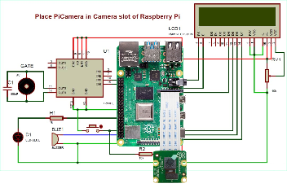
Figure 1: Circuit of remote security monitoring for the metropolitan vehicle system
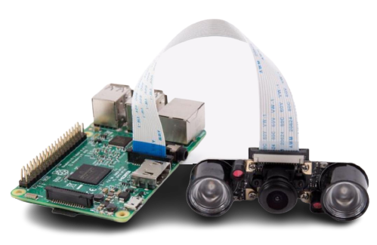
Figure 2: Controller Circuit for the metropolitan vehicle system with Pi camera module
Figure 3: System Flow chat
The flowchart in figure 3 explains the many stages involved in creating the proposed system, including image processing and license plate recognition.
- Image Identification
This section discusses the tools that use a computer-powered camera's capacity to recognize and track certain elements inside a scene, such as people, vehicles, buildings, and signs. It's a strategy for accumulating, processing, analyzing, and empathizing with visual data. Artificial intelligence (AI) software, a camera, and machine vision technologies are used by computers for picture recognition.
- Acquisition of the Vehicle Image
The Pi camera attached to the controller captures the vehicle’s image, and sends the image into the specified directory in the raspberry pi for image segmentation and characterization.
- A Centralized Database Server Design for Vehicle Monitoring and Control in Minna Metropolitan City Scenario.
- Character Segmentation (CS)
Identifying occurrences of items in images provides the philosophy for this approach. In this context vehicle are recognized and detected using deep learning through the license plate number. Character segmentation makes it possible to recognize and find multiple objects.
- Optical Character Recognition (OCR)
This section extracts data from the license plate number image file and converts it to a machine-readable format that utilizes it for data processing prior to data logging. The optical scanner was used to copy or read text, while the software was often responsible for additional processing. Artificial Intelligence (AI) was used in the software to implement increasingly complex methods of intelligent character recognition, such as distinguishing writing styles. Hence, OCR technology was used for extraction, processing, and automatic data entry. Also, archiving historical material into searchable formats, such as newspapers, periodicals, and phonebooks becomes possible with this technology. More so, OCR technique offers great ability to save time, reduce errors, and reduce effort. It also allows for compressing of files into ZIP files and highlighting keywords among others. While collecting photos of documents, OCR allows it to be digitally archived, with the added benefit of allowing for further editing and searching. The optical character recognition template matching test data is represented in figure 4.
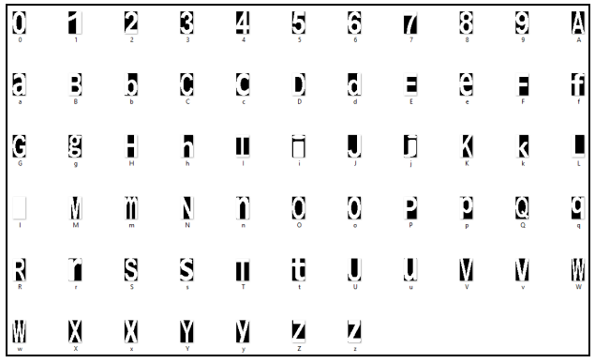
Figure 4: Optical Character Recognition Template Matching Test Data
- Data Logging and Storage Scheme Design with Graphical User Interface for Minna Metropolitan Vehicle Control System
- Data Logging
Gathering, storing, and displaying of data on a variety of issues, topics, and time periods in order to assess activities, detect patterns, and anticipate future events was the focus of this section. It entails keeping track of a range of vehicle occurrences from the captured image of the license plate number in Minna city. This section uses the SD Card for data logging, after which the data was processed and transferred to the web application for monitoring purposes of the vehicle agencies.
- Data Management System
The process of ingesting, storing, organizing, and preserving the data created and collected by the Pi camera is known as data management. The IT systems that run the vehicle monitoring system and give analytical information to help secure and track vehicle movement activities in urban regions require effective data management. The data management process entails activities that work together to ensure that data in corporate systems are correct, available, and accessible to the appropriate vehicle monitoring agencies.

Results And Discussion
The result for this research is sub-divided into three categories, and these are discussed as follow:

Result and discussion of a remote security monitoring scheme for the metropolitan vehicle.
Table 1: Data Logs for Metropolitan Vehicle Monitoring and Control System
ID | Bad Driving | Hit and Run | Car Theft | Vehicle
0 | 9 | 7 | 12 | MNA 350 MC
1 | 3 | 4 | 10 | MNA 389 ZR
2 | 4 | 2 | 8 | MNA 340 SR
3 | 6 | 5 | 6 | MNA 350 FX
4 | 5 | 6 | 8 | MNA 334 AC
5 | 3 | 3 | 5 | MNA 435 FC

Table 1 shows the data logs of crime that was done by 6 vehicles that were used for demonstration in Minna metropolitan city. The vehicles were tested for several offences for 15 times each.

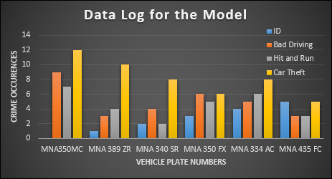
Figure 5: Data Log for the Model

The data log for the system model was represented in figure 5. The crime occurrences of the vehicles in Minna metropolitan city are plotted against the vehicle plate number. Six different plate numbers were used to test for bad driving, hit and run, and car theft. The ID for the vehicles starts from zero as it is used in an array form. The dataset used for this system training were configured in such a way that the system detects multiple crimes enacted by a license plate number. As such the results of the demonstration is shown in table 1 and figure 5. The plate number MNA 350 MC had 9 cases of bad driving, 7 cases of hit and run, and 12 cases of car theft. The demonstration was conducted at Kpakungu Minna, and Talba Housing Estate Minna, where the model was fixed at a vintage position for this demonstration.
For Bad driving test, this was demonstrated at Kpakungu Minna. The demonstration shows that the car left its lane for more than 10 minutes, and does not obey the nearest traffic light to the system model, hence, this car crime was categorized under bad driving. The car was tested 15 times of which it faulted for 9 times from the YOLO technique.

For hit and run scenario, the same car was tested at Talba Housing Estate with the system model hanged at a vintage position, and some materials to represents human, or other automobile, were put at 50 meters away from the start arena of the vehicle to demonstrate the hit and run scenario. The car was tested 15 times for this demonstration also.

For car theft instances, the same car plate number was inputted in the web application for monitoring, in order to show the location of the vehicle in real-time. This was done in order to confirm the vehicle location in case of theft scenarios, and this test was conducted 15 times. Vice versa the test was conducted for vehicle ID 1 to 5 corresponding to other car crimes in table 1 and figure 5.

Result and discussion of centralized database architecture for vehicle monitoring and control in Minna metropolitan city scenario.
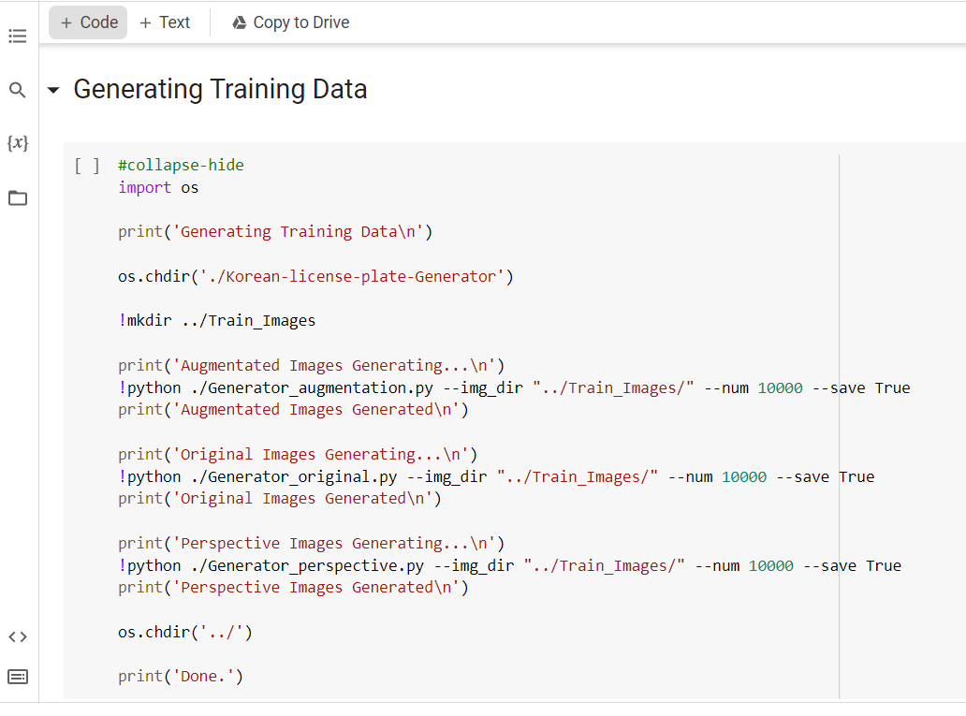

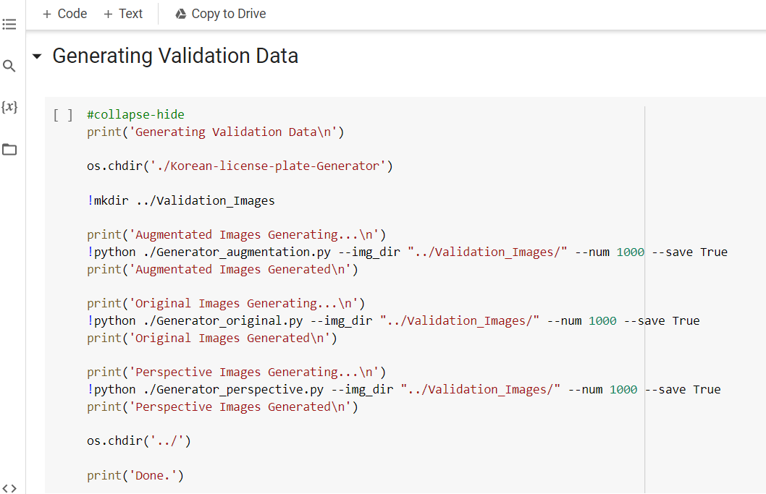

Figure 6: Centralized Database Server Control System
Figure 6 shows the centralized database interactions from Google Colab for the training of this data set for this model.

Result and discussion of data logging and storage scheme with graphical user interface for the metropolitan vehicle control system.
A metropolitan vehicle movement monitoring and control system's authentication and signup portion was depicted in figure 7 for the vehicle data logging system. The model was accessible to the administrator only through this area of the logging system. Furthermore, figure 8 shows the logs section for the data-logging vehicle monitoring system.

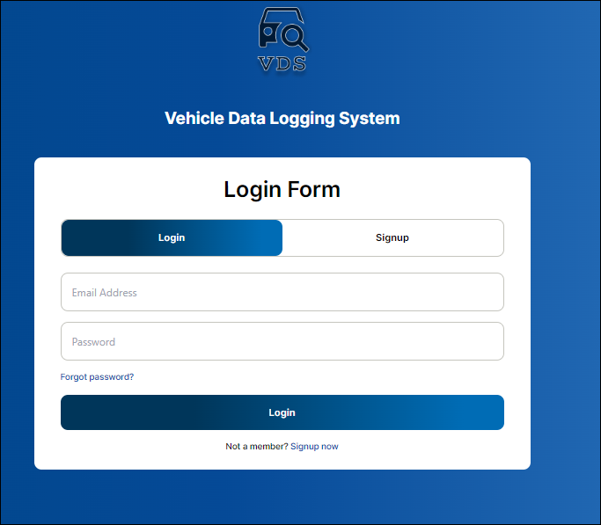
Figure 7: Authentication and signup section for the Data Logging Vehicle Monitoring System

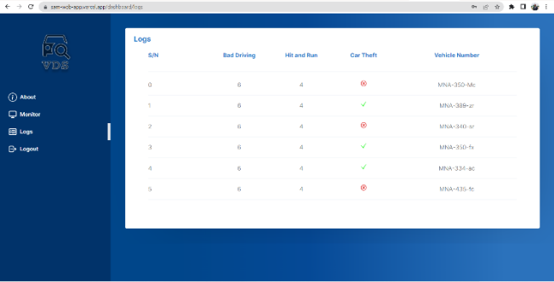

Figure 8: Logs Section for the Data Logging Vehicle Monitoring System

Conclusion
This study used intelligent recognition approach to identity vehicle license plate numbers for use in Minna metropolitan city. Images of license plates were captured using a Pi Camera connected to the Raspberry Pi, with further processing, analysis, and storage handled by Google Collab. To keep tabs on every vehicle under demonstration, a responsive web application was developed. Following the completion of this study, a remote security and control system was developed using the YOLOv3 algorithm, tesseract, and PyImageSearch. The efficiency of all transportation infrastructure components was evaluated. This in validation of the literature [11], which solves the problem of the growing vehicle traffic situations in urban city, but applied in Minna metropolitan city. With this technology, people could be made to respond well to traffic restrictions, over speeding and careless driving which were the most common causes of accidents.

Acknowledgment
Gratitude to the effort of my supervisors for their diligent contribution during the course of this research work. Their immense wisdom as harnessed has contributed to the success of this model.

References
[1] M. T. Qadri and M. Asif, “Automatic Number Plate Recognition System For Vehicle Identification Using Optical Character Recognition,” 2009 Int. Conf. Educ. Technol. Comput., vol. 1, no. 1, pp. 335–338, 2009, doi: 10.1109/ICETC.2009.54.
[2] V. C. M. Vishnu, N. M, and R. R, “Intelligent traffic video surveillance and accident detection system with dynamic traffic signal control,” Cluster Comput., vol. 1, no. 1, pp. 1–13, 2017, doi:10.1007/s10586-017-0974-5.
[3] S. Sharma, “A-PNR : Automatic Plate Number Recognition,” ICCCT, vol. 1, no. 1, pp. 1–5, 2017.
[4] K. Kumar, S. Sinha, and P. Manupriya, “D-PNR : Deep License Plate Number Recognition,” in Proceedings of2nd International Conference on Computer Vision & Image Processing, Advances in Intelligent Systems and Computing, 2018, pp. 1–10. doi: 10.1007/978-981-10-7898-9.
[5] D. E. Knuthf, J. James H. Morris, and V. R. Pratt, “Fast Pattern Matching in Strings,” SIAM J. Comput., vol. 6, no. 2, pp. 323–350, 1977.
[6] A. Broumandnia, S. T. Branch, and M. Fathy, “Application of pattern recognition for Farsi license plate recognition Application of pattern recognition for Farsi license plate recognition,” in ICGST, 2015, no. January 2005, pp. 1–7.
[7] V. Vidyapeetham and V. Vidyapeetham, “Indian Car Number Plate Recognition using Deep Learning,” in 2019 2nd International Conference on Intelligent Computing, Instrumentation and Control Technologies (ICICICT), 2019, pp. 1269–1272.
[8] H. Saghaei, “Proposal for Automatic License and Number Plate Recognition System for Vehicle Identification,” in 2016 1st International Conference on New Research Achievements in Electrical and Computer Engineering, 2016, pp. 1–5.
[9] K. Yogheedha, “Automatic Vehicle License Plate Recognition System based on Image Processing and Template Matching Approach,” in 2018 International Conference on Computational Approach in Smart Systems Design and Applications (ICASSDA), 2018, pp. 1–8.
[10] C. Gerber and M. Chung, “Number Plate Detection with a Multi-Convolutional Neural Network Approach with Optical Character Recognition for Mobile Devices,” J. Inf. Process. Syst., vol. 12, no. 1, pp. 100–108, 2016.
[11] C. A. Rahman, W. Badawy, and A. Radmanesh, “A Real-Time Vehicle ’ s License Plate Recognition System,” Proc. IEEE Conf. Adv. Video Signal Based Surveill., vol. 1, no. 1, pp. 4–7, 2003.
[12] T. Sirithinaphong, and K. Chamnongtha, “The Recognition Of Car License Plate for Automatic Parking System,” in Fifth International Symposium on Signal Procession and its Applications (ISSPA), 1999, pp. 455–457.
[13] S. Du, M. Ibrahim, and M. Shehata, “Automatic License Plate Recognition ( ALPR ): A State of the Art Review,” IEEE, vol. 1, no. 1, pp. 1–14, 2011.
[14] Y. Wen, Y. Lu, J. Yan, Z. Zhou, K. M. Von Deneen, and P. Shi, “An Algorithm for License Plate Recognition Applied to Intelligent Transportation System,” IEEE Trans. Ind. Informatics, vol. 12, no. 3, pp. 830–845, 2011.
[15] J. Bagade, M. Kamble, K. Pardeshi, B. Punjabi, and R. Singh, “Automatic Number Plate Recognition System: Machine Learning Approach,” IOSR J. Comput. Eng., vol. 1, no. 7, pp. 34–39, 2011.
[16] M. V. Srinu, B. S. Shankar, and P. R. R. R. K, “Real Time Car Parking System and Parking Fee Display Using Raspberry Pi,” Int. J. Res., vol. 3, no. 4, pp. 421–426, 2018.
[17] Balamurugan .G, S. Punniakodi, R. .K, and Arulalan.V, “Automatic Number Plate Recognition System Using Super-Resolution Technique,” IEEE, vol. 1, no. 1, pp. 273–277, 2015.
[18] J. Redmon and A. Farhadi, “YOLO9000: Better, Faster, Stronger,” Cvpr2017, vol. 1, no. 1, pp. 7263–7271, 2016.
[19] S. Usmankhujaev, S. Baydadaev, and K. J. Woo, “Real-time, Deep Learning Based Wrong Direction Detection,” Appl. Sci., vol. 10, no. 7, pp. 1–13, 2020, doi: 10.3390/app10072453.
[20] J. Liu, R. Cong, X. Wang, and Y. Zhou, “Link-Aware Frame Selection for Efficient License Plate Recognition in Dynamic Edge Networks,” Electron., vol. 11, no. 19, pp. 1–20, 2022, doi: 10.3390/electronics11193186.

