THE IMPACT OF LIME AND PHOSPHOROUS FERTILIZER APPLICATIONS ON THE GROWTH OF SOYABEAN (GLYCINE MAX)
*Uzoma A.O. Ameh, S.J and Osunde, A.O
Department of Soil Science, Federal University of Technology, P.M.B 65, Minna, Nigeria
*Correspondence: uzo_ozo@yahoo.com.
Abstract
A Pot experiment was carried out in year 2004 on "Acid-Sands of Awka, Kugbo from the Derived Savanna and Akufo soil from the Southern. Guinea Savanna Agro-ecological Zones of Nigeria to evaluate the impact of lime and P fertilizer application on the growth of soybean (Glycine max). It consisted of four lime treatments (0,2,4, and 6 ton ha⁻¹ on three soils combined with three levels (0,30, and 60kg P₂ O₅ ha⁻¹ applied as SSP. The experiment was laid out in split plot design. There was significant response in the performance of soybean in the limed and P fertilized treatment compared to the unlimed and unfertilized treatments. Akufo and Kugbo soils performed significantly higher at 4 ton ha⁻¹ of lime combined with 60kg P₂ O₅ ha ⁻¹ while Awka plants were best at 2 ton ha⁻¹ in combination with 60kg P₂ O₅ ha ⁻¹. Generally, results reflected appreciable depression in performance when plants were treated above the optimal lime requirement. which resulted in unfavorable soil condition and reduction in plant growth
_____________________________________________________________________________.
Keywords: Acid sands, Amendment, fertility regeneration, fertilizer trial, Tropical soils.

Introduction
"Acid Sands" are acid soils that are found in parts of the tropical climate and in areas having underlying geology made up of sedimentary rocks or unconsolidated sediments (Bredenkamp, 1996). These tropical and subtropical agricultural soils formed on coastal plain sands located in the high rainfall regions are strongly acidic, low in base saturation but high in aluminum saturation (Maduakor, 1994.) The world distribution of Acid-Sands is related to climate and parent material. In Africa, the occurrence of acid-sands is prevalent in the west, south and central regions particularly Ghana and Nigeria (Plessens et al., 2006). In Nigeria, the occurrence covers Lagos, Ogun, Ondo, Edo, Delta, Anambra, Enugu, Oyo, Cross-River, the Federal. Capital Territory ( FAO, 2004).

Liming have been recognized as the first requirement for effective use of Acid soils in tropical areas (Lelei et al., 2000). The maintenance of satisfactory soil fertility levels in humid regions depends considerably on the judicious use of Lime to balance the losses of calcium and magnesium from the soil. Liming not only maintains the level of exchangeable calcium and magnesium but also provides chemical and physical environment that encourages the growth common plants (FAO, 2004). The strategy for the soil fertility management of acid soils include decreasing the detrimental effect of acidity and building the fertility status especially that of phosphorus, whereby root conditions below the plough layer will enhance absorption from the soil solution and ensure optimum utilization of an applied nutrient by plant (Bowen et al., 1999) The supply and availability of phosphorus in acid soils ranges from low to medium in the plough layer of the soil, therefore, these soils will usually need P fertilizer application for optimum yield of most crops as its deficiency will prevent crops from completing their life cycle ( Buerkert et al., 2001).
For successful soybean production, large quantities of lime and phosphorus (P) fertilizers may be required. (Fageria et al., 1994). Liming improves microbiological activities of acid soils, which in turn increase N fixation by legumes (Gllier, 2001; Bala et al., 2001; Kolawole 2000) and also promotes mineralization of organic materials However, over liming may reduce crop yield by inducing p and micronutrient deficiencies ( Fageria, 1964).
A pot experiment was therefore carried out to investigate and evaluate the impact of lime and P fertilizer application on the optimum performance of Soybean grown on acid sands from the Derived Savanna and Southern Guinea Savanna Zones of Nigeria.

Material and Methods
The soil samples were collected from three different locations of different pedogenic characteristics namely Akufo (Oxic or Orthic Luvisol), Awka (Typic Paleustults and Haplustults) and Kugbo (colluvium and Nupe sand stone residuum) (Ohiri et al., 1989; Akamigbo, 2002). The soil samples were air-dried and passed through a 2mm sieve to determine particle size by Hydrometer method, soil pH in H₂,0 and 0.01 M CaCl₂ by pH meter, Organic carbon by Walkley-Black method, Total N (%) by Kjeldahl method and Available P using the' Vanadomolybdate wet digestion, Exchangeable cations by Ammonium acetate (1N NH₄OAC) extraction method at pH 7.0 Exchangeable Acidity and Percentage Aluminum Saturation by titration with IN HCL. Powders of Hydrated lime Ca(0H)₂ and lime stone (CaC0₃) were obtained from Kano and Anambra States _Agricultural Development Program, respectively, Seed of soybean (Glycine max) variety, TGX1440-1E was obtained from the Nation Cereals Research Institute (NCRI), Badeggi while the Single Supe Phosphate (SSP), 18, (% P₂0₅ ha " was obtained from the Soil Science Department Federal University of Technology, Minna. The trial involved three soils, Akufo, Awka and Kugbo, four rates of CaCO₃ (0, 2, 4 and 6 ton ha⁻¹ ) and three levels of P (0, 30 and 60 kg P₂0₅ ha⁻¹) applied to each polythene pot containing 2.5 kg soil placed behind the soil laboratory. Five seeds of soybean (TGX 1440 -1E) were sown per pot two weeks after liming and germination test. The plants were then thinned to three plants per pot at 2WAP. The parameters measured include plant height measured at 6 weeks after planting (WAP), shoot biomass .weight and the phosphorus content of tissue after 60 days of planting. The plants were carefully uprooted and the shoots were cut at soil level while the roots were carefully washed,; rinsed and nodules collected. The shoots and the nodules were oven-dried separately and weighed for dry matter analysis while the shoots (leaves) were ground in a stainless steel grinder and sub-sample analyzed for its P content by the Vanadomolybdate yellow method following wet acid digestion. All the relevant data collected were subjected to statistical analysis using statistical analysis software (SAS. 2000). LSD was used to separate the means.

Table 1. Selected Physicochemical Properties of Soils before liming.
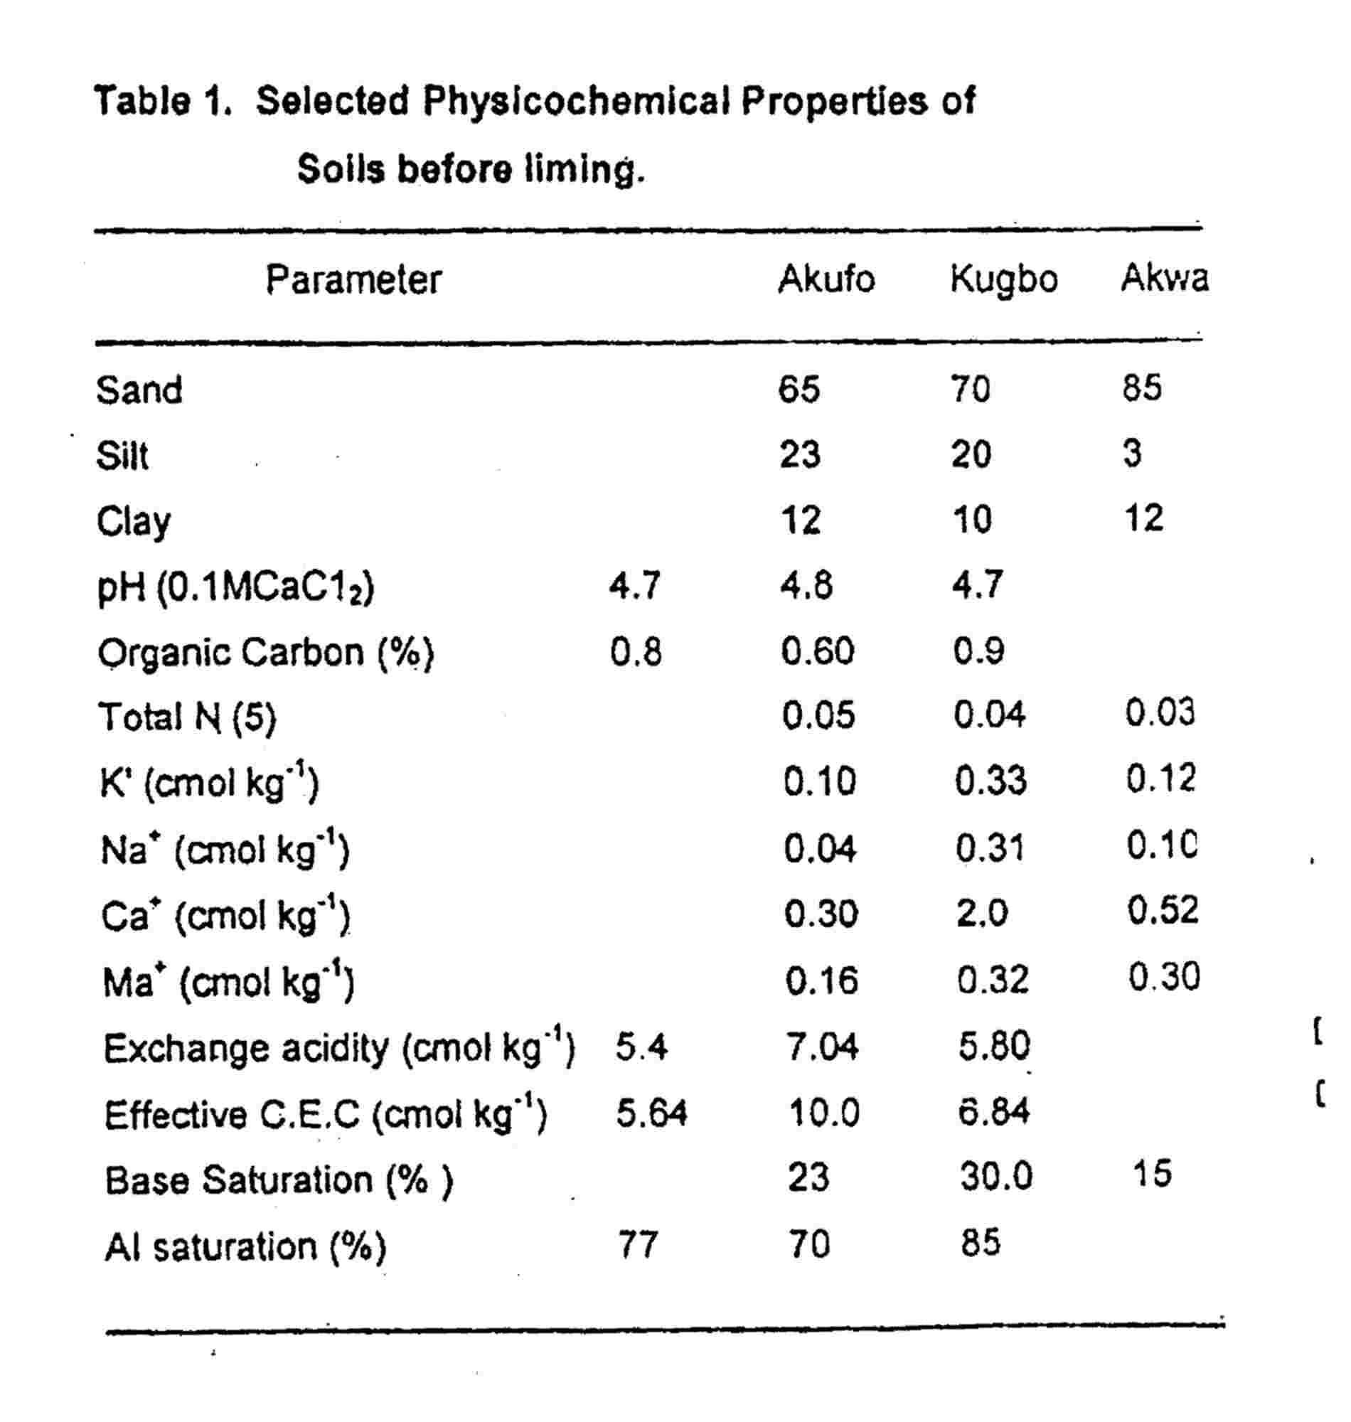

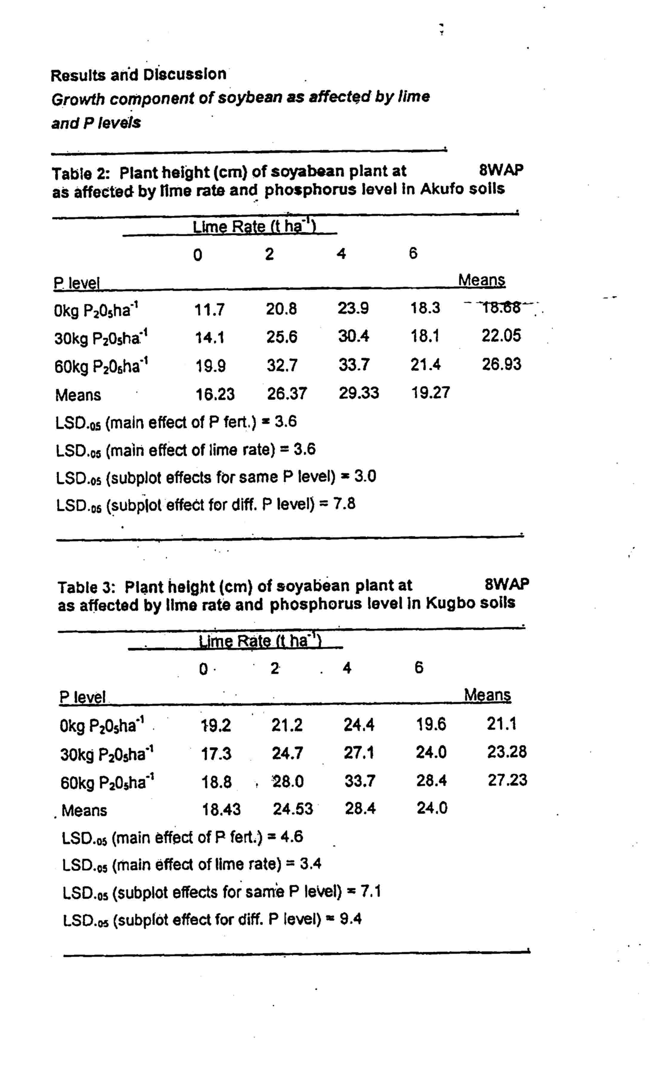

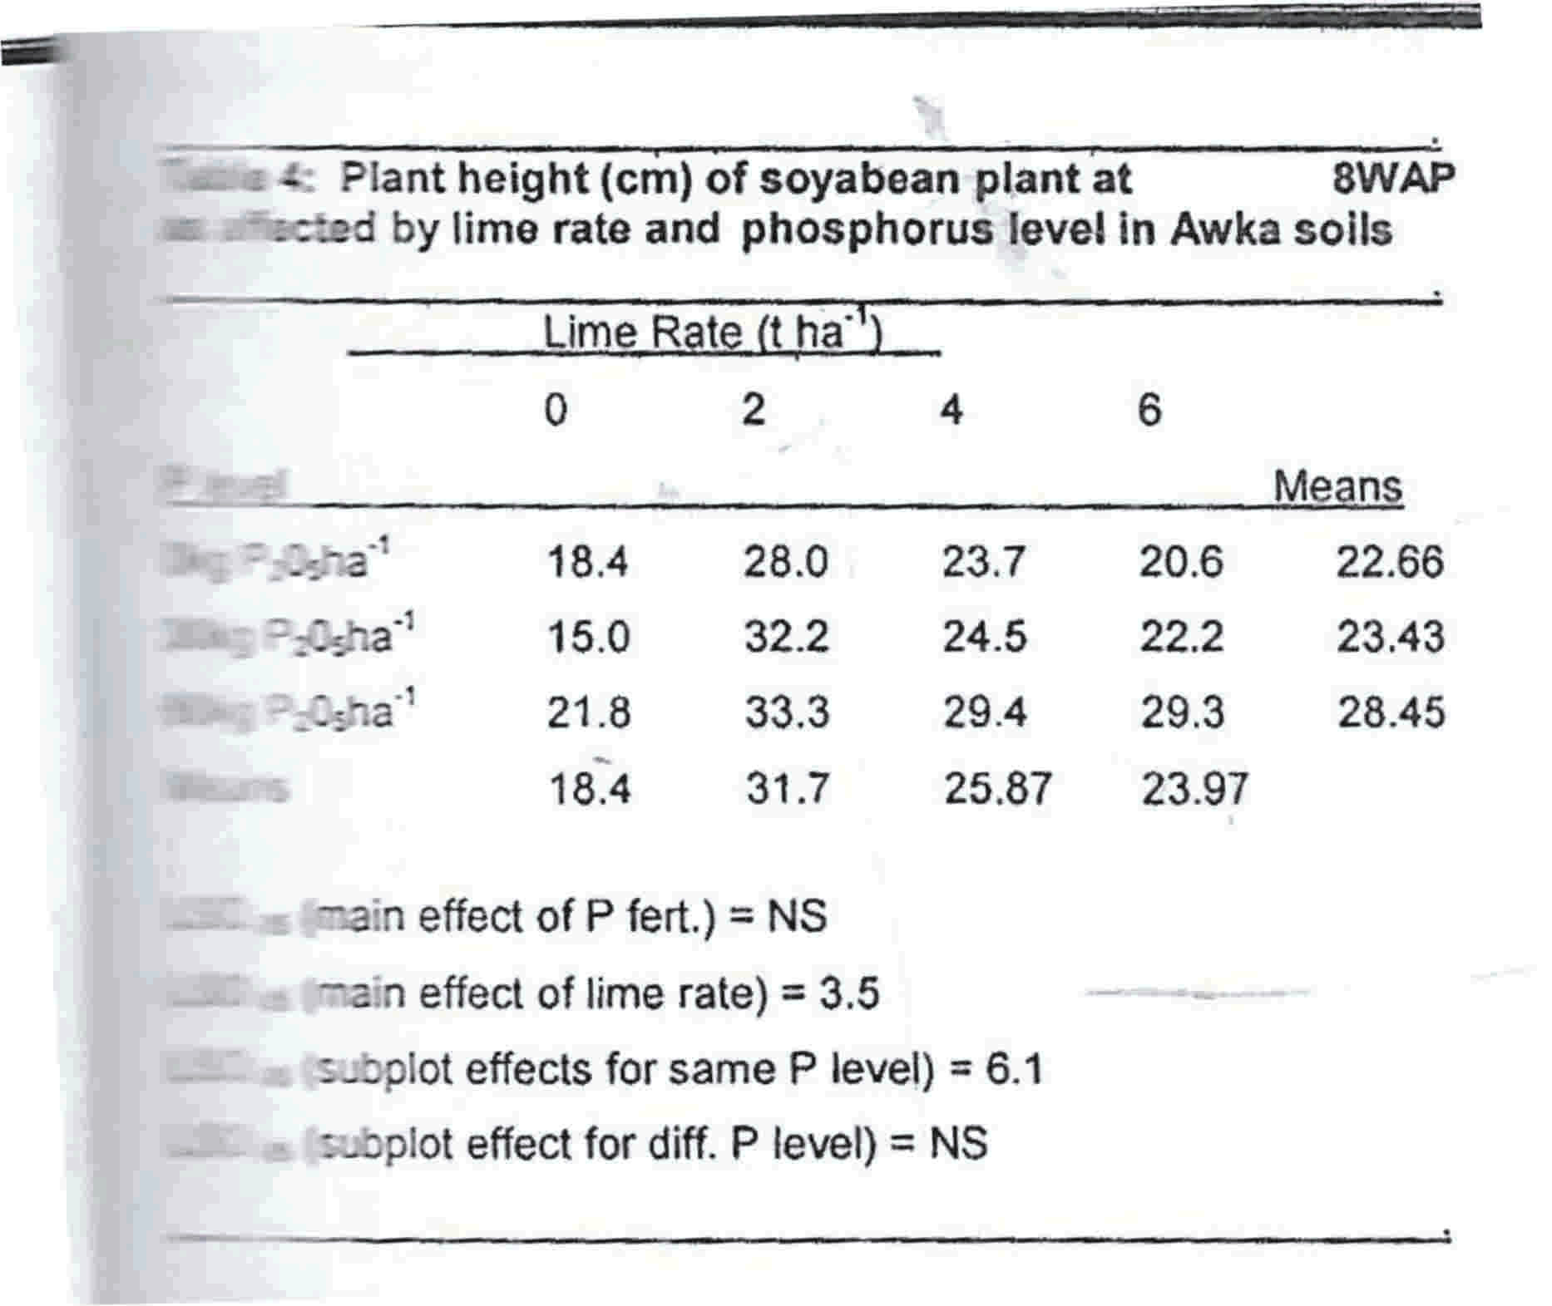
Plant height differed in response to treatments across the soils (table 2-4). The increase in height of plants when supplied with a combination of lime and phosphorus regardless of soil, may be attributed to the effect of liming on P nutrition of plants. Several workers (Johnson et al., 1982) have reported that liming reduced fixation of P and AL, Fe and Mn toxicity to soybean plants thereby making P available and also Ca and Mg. The amount of lime required to combine with a given. level of P in order to improve height varied with soils. Akufo and Kugbo soils gave their highest response when supplied with 4 ton ha⁻¹ lime and 60 kg P₂0₅ha⁻¹ while Awka plant were tallest when fertilized with 2 ton ha⁻¹ lime and 60 kg P₂0₅ha⁻¹ (Table 3 and 4). This is an indication that these soils averagely needed liming not more than 3 ton ha⁻¹ when external P fertilization up to 60 kg P₂0₅ ha⁻¹ was required. When P was not required, however, Awka soils would need liming up to 4 ton ha⁻¹ to increase height beyond that due to 30kg P₂0₅ha⁻¹application implying that more lime would be required to improve plant uptake of soil P better than the applied P. Mamaril et al. (1999) explained that lime treatments improve crop performance with time. Kamprath(1973) recorded satisfactory growth at pH 6.5 as a result of absorption of PO₄ and Molybdate.
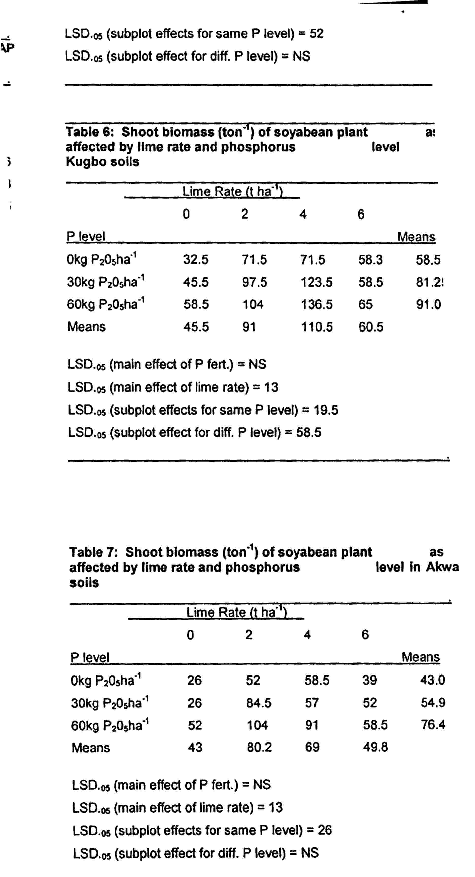

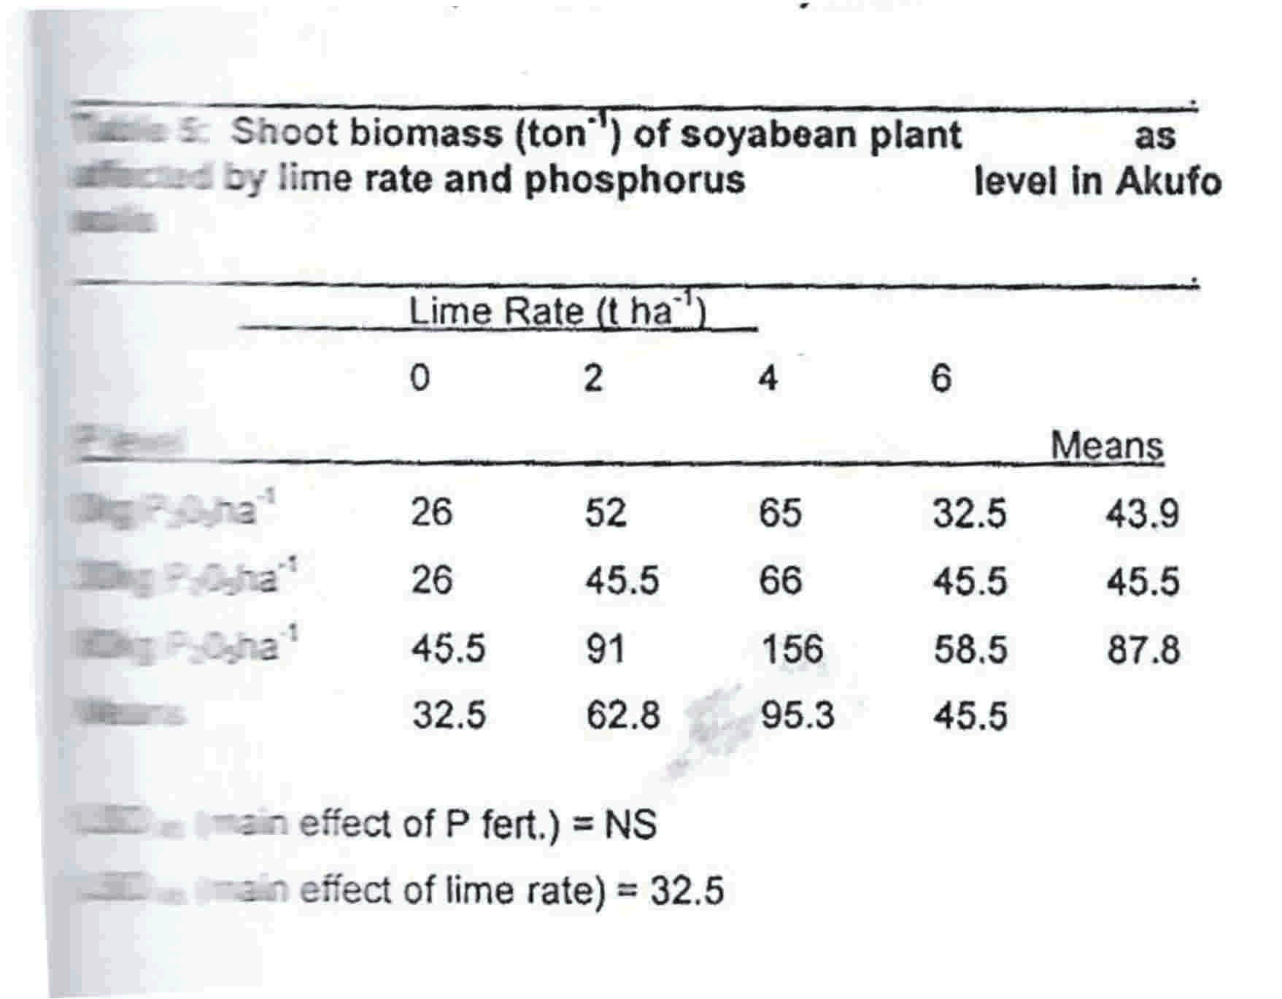

In this study, the weight of shoots varied because of treatment (Table 5-7). Liming up to 4 ton ha⁻¹ combined with 60kg P₂0₅ ha⁻¹ maximized weight of Akufo and Kugbo plants (Table 5 and 6) expressing improvement in growth as a result of availability of nutrients and their improved uptake. Sanginga et al. (2000) and Osunde et al. (2006) reported increased weight of cowpea tops at various rates of P applied. This response to lime of calcium source could probably be because the soil was enriched with calcium (Fageria1994). The availability of calcium to plants would however depend on uptake, of calcium which is a function of the growth of
new roots (Favarreto et al., 2006). More calcium in the lime was therefore taken by the new roots formed as a result of P application ( Favarreto et al., 2006). This probably explained why shoots were heavier when P increased at a particular lime rate. For example, shoot response at 6 tons ha⁻¹ lime as P increased from 0 to 60kg P₂O₂ ha⁻¹ regardless of soil type (Table 7). The shoot biomass of 26 ton ha⁻¹ recorded by Awka soil at 0 ton ha⁻¹ lime without P compared to value 0f 26 ton ha⁻¹ when 30 kg P₂O₅ ha⁻¹ was applied (Table 7) revealed that these plants were P-efficint under 0 ton ha⁻¹ lime (Baliger et al., 2001). The shoot biomass of Akufo plants limed up to 0 ton ha⁻¹ lime and 4 ton ha⁻¹(Table 6) did not change when P was applied up to 30 kg P₂O₅ ha⁻¹probably because the additional level of P was low and therefore more was needed.
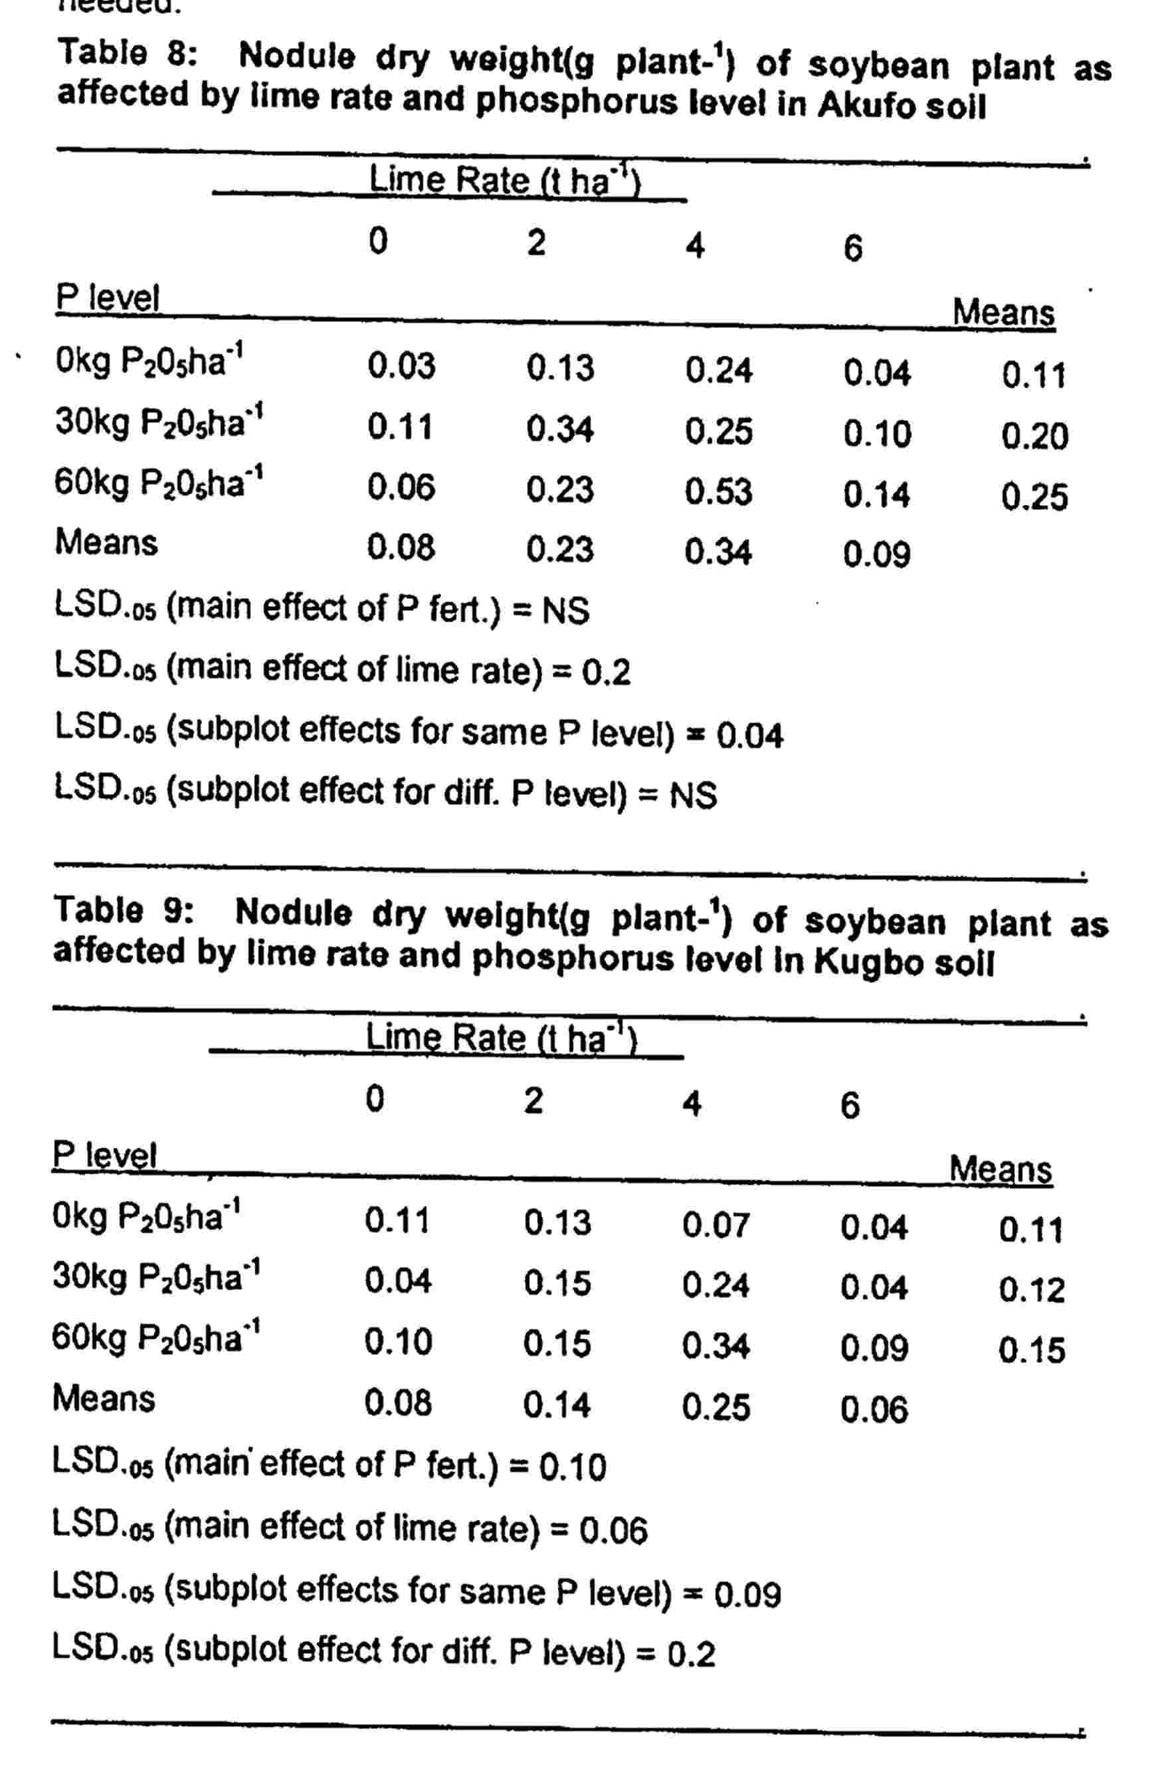

Nodulation of soybeans as affected by lime and P levels
Nodulation described as nodule dry weight increased with P application. 6 ton ha⁻¹ lime however depressed nodulation due to over liming. Fageria et al. (1994) reported that over liming resulted to unavailability or precipitation of P as insoluble CaPO₄⁻. Several other workers have reported the role P plays in nodulation. According to Osunde et al. (2006), nodules of legumes are strong sinks for P and short supply of P was found to reduce nodulation.

The response of soybean to P in acid soils would depend on adequate liming. Physiologically, nodule number and weight depends on the assimilate partitioning to nodules which has been reported to be a function of P and Ca availability and also the activity of microorganisms (Osunde et al., 2006). Growth was depressed due to a short supply of P, when lime of calcium source was inadequate.
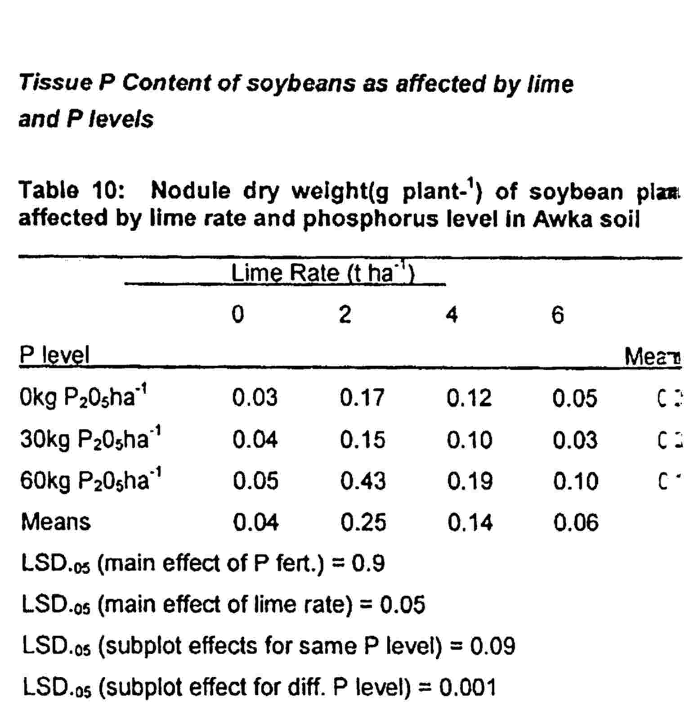

Liming and P fertilization increased P content of tissue (Table 10 and 11 ). This may either be due to higher absorption of P by roots or due to increased root proliferation. The increase in P content of Kugbo plants with P applied under 0 ton ha⁻¹ and 2 ton ha⁻¹ lime respectively (Table 12) might be as a result of increased root proliferation. This Is consistent with the report of Osunde (1993), that P fertilizer increased root growth, hence reduced the need for Arbuscular Mycorrhlza Infection (AMF).

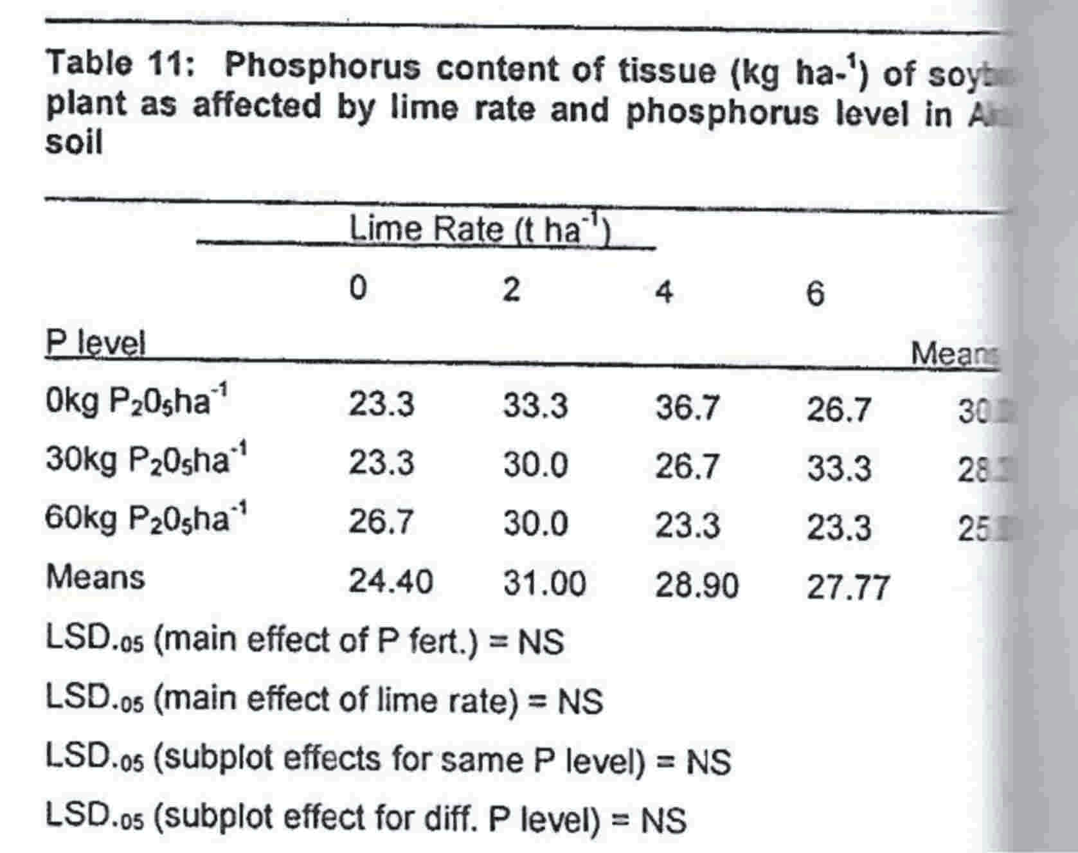

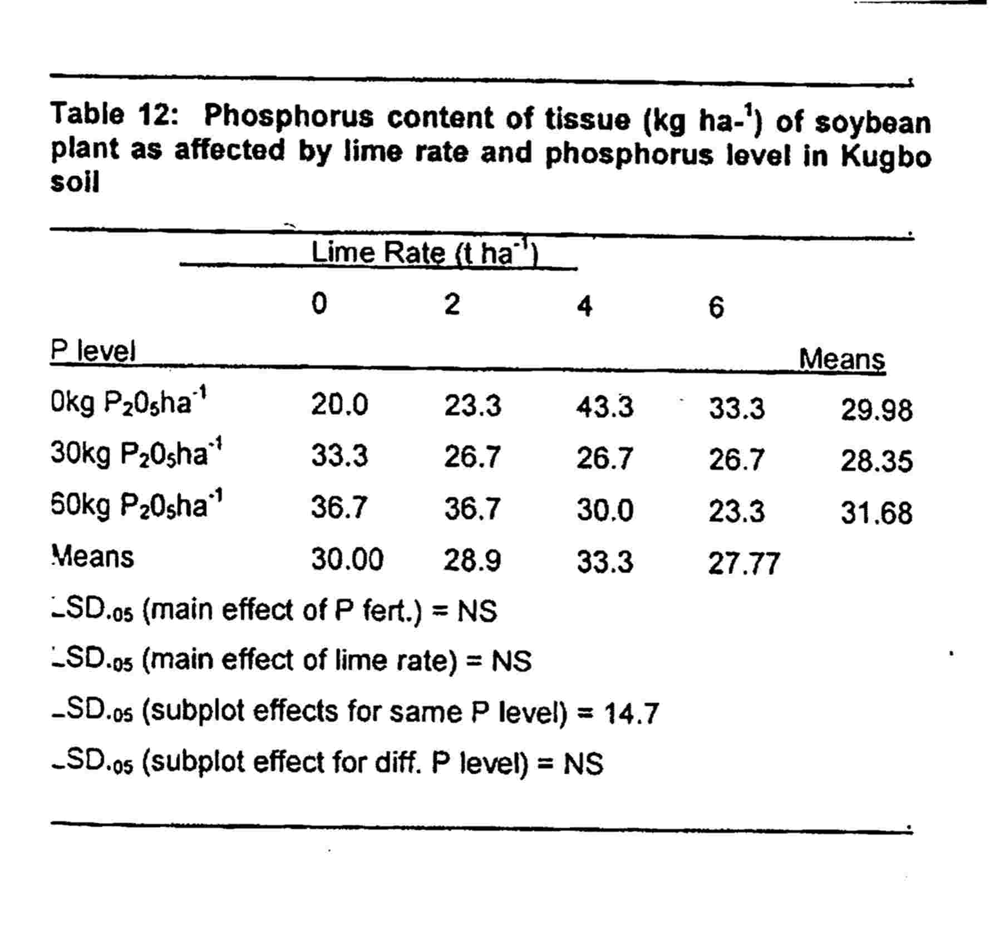

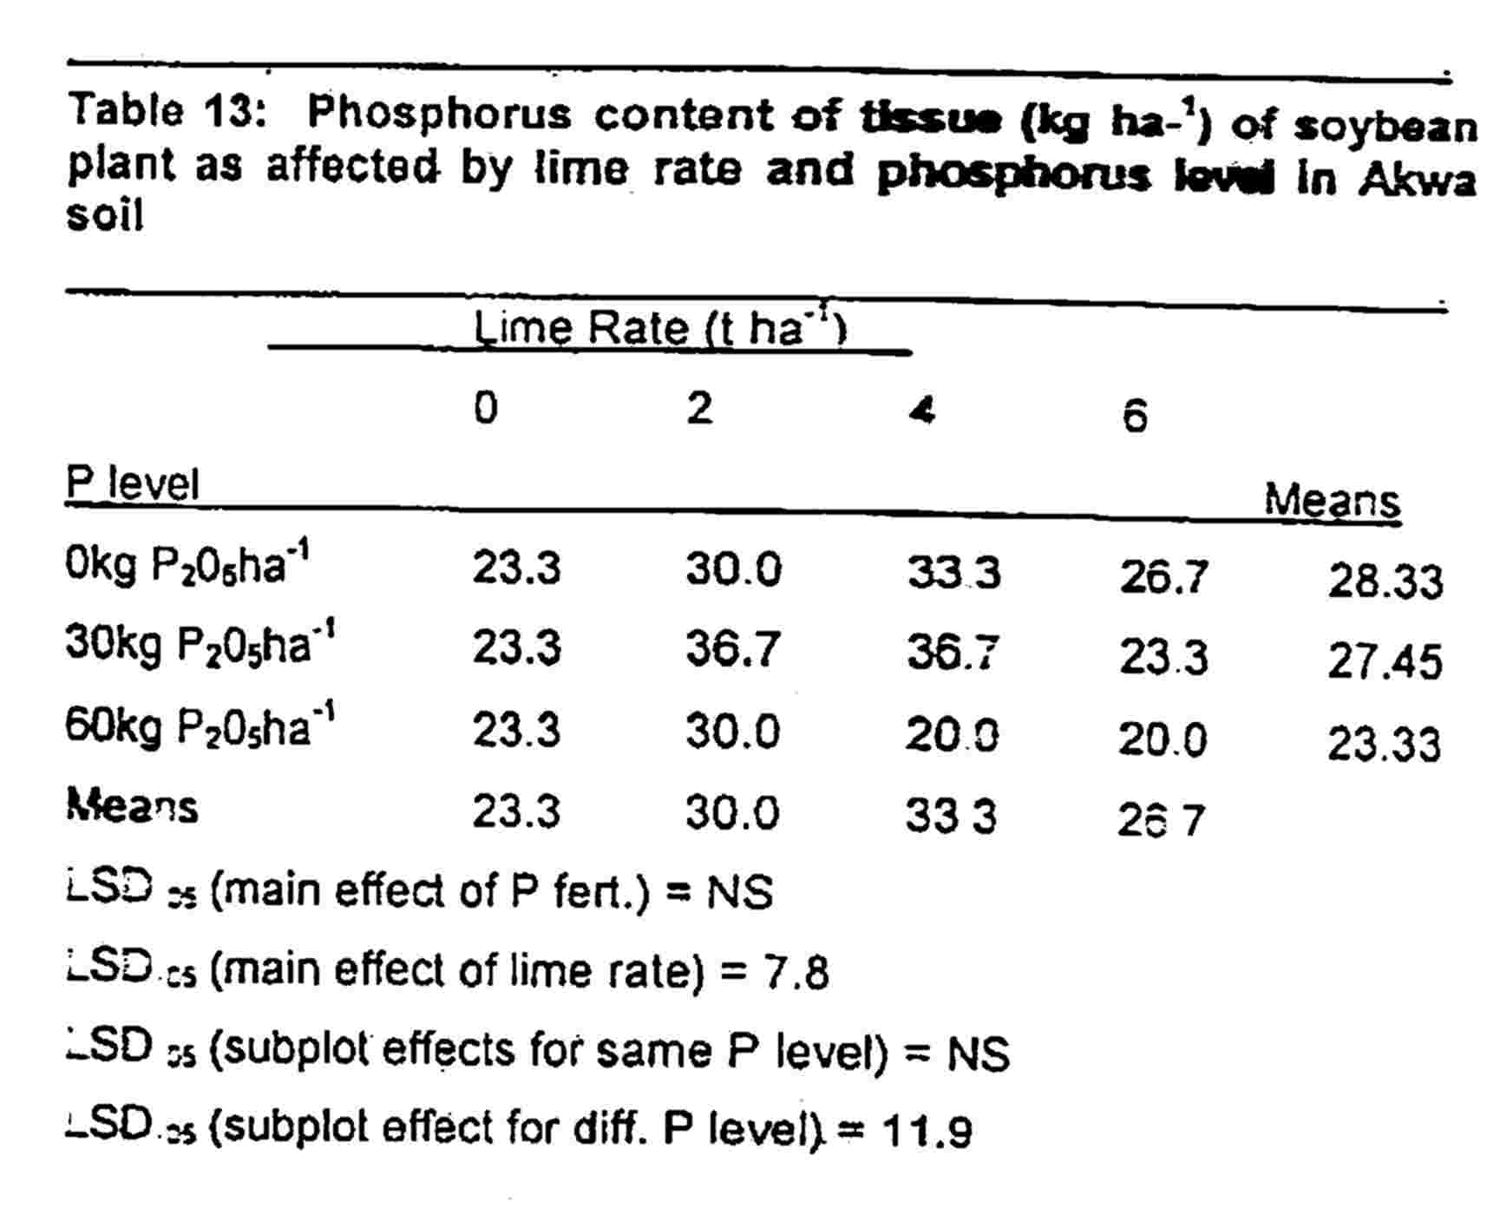

Conclusion
Soybean plants exhibited differences in growth, tissue P concentration and nodulation across. soils. The growth and development of plants on Kugbo and Akufo soils were better averagely at any combination of P under 4 ton ha⁻¹ lime. Similar trend was observed for Awka soils at any combination of P under 2 ton ha⁻¹ lime. The applicatlon of 60kg P₂0₅ ha⁻¹ however, gave the best response with little sacrifice in lime. Over liming resulted in depressions observed on growth and development. Awka soils would need liming up to 4 ton ha⁻¹ to Increase height beyond that due to 30 kg P₂0₅ ha⁻¹ application implying that more lime would be required to improve plant uptake of soil P better than the applied P. The tropical soil literature is full of reports citing lack of response or negative response when tropical. soils are limed. This has created the generalized idea that liming does not work in the tropics. Against this background, our reports have shown that soybeans responded to liming by improving growth and yield components. Liming should therefore be encouraged in the tropics for the cultivation of soybean on acid sands.

REFERENCES
Akamigbo, F.O.R (2002). Application of Soil Survey Information for Agricultural and Environment. Paper Presented at the 5-day US-Nigeria. Technical Assistance Programme.
Bala.A. and Gillet K. E. (2001). Symbiotic specificity
of tropical tree rhizobia for host legume.. New phytologist 149: 495-507.
Baliger,VC et al. (2001).Nutrient-use efficiency in plant. Commun. Soil Scl. Plant Anal. 32: 921-
950.
Bowen G.D. and Rovira. A.D (1999). The Rhizosphere and its management to improve plant growth, Adv. Agro. 66.1-102
Bredenkamp. G., Granger. J. E. and Van Rooyen, N. (1996). Moist Sandy HIghveld Grassland. In: Low. Vegetation. A.B and Robelo. A.G. (eds) South Africa, Lesotho and Swaziland. Department of Environmental Affairs and Tourism, Pretoria. Pp 5- 25.
Buerkert.A et al. (2001). Efficient phosphorus application strategies for increased crop production in Sub- saharan Africa. Field Crops Research 72: 1-15.
Fageria, N.K., V.C. Ballgar and R,J. Wright, (1991). Influence of phosphate rock resources and rates on rice and common bean production in an Oxisol In: R .J. Wright., R.J., Baligar, V.C., Muramann, R.P. (Eds.).Plant Interaction at low pH. Phosphorus Kluver Academic publisher, pp: 539-556.
Frageria, N.K, (1994). Soil acidity effects on availability .of Nitrogen, Phosphorus and Potassium, Better Crops International 10: 8-9
Favoretto, N., Norton, L.D., Jones, B.C and Brouder S.M.(2006). Gypsum Amendment and Exchangeable calcium and magnesium affecting phosphorus and nitrogen run off.. Soil Sci. Soc. Am. J. 70. 1788- 1796.
Food and Agriculture Organization (FAO), (2004). Use of phosphate rocks for sustainable Agriculture. in: Fertilizer and Plant Nutrition Bulletin, 13 (Zapata, .F .and Roy, R.N.) Eds., FAO Land and Water Development Division and International Atomic Energy Agency.
Giller, K.E. (2001). Nitrogen fixation in tropical cropping systems. 2nd Edition.CABI publishing. CAB international Wallingford, U.K. pp 423.
Johnson, M.I (1982). Notes on cowpea and grain legume research programme. Cropping Scheme meeting, IAR, ABU Zaria.
Kamprath E.J (1973). Soil Acidity and liming. Pp 126-128 In: PA. Sanchez (eds) "A Review of soil research in tropical Latin America', North Carolina. Agric, Exp. Stn. Tech. Bull. 219.
Kolawole, G.O., Tian, G. and Singh, B.B. (2000). Differential response of cowpea lines to application of P fertilizer. Proceedings of the World Cowpea Research Conference, IITA Ibadan, Nigeria, 4 -7th September 2000.
Lelei, J.J., B.O. Mochoge and R.N. Onwonga.(2000). Effect of Lime, urea, TSP on nitrogen and phosphorus mineralization In an acid soil during incubation. Afr. Crop Sci. J., 8: 327-336.

Maduakor, H.0 (1994) UnacIdulated and partially acidulated phosphate rock as P sources In an acid ultisol in the forest zone of Southern Eastern Nigeria. Zeitschrift Fur P Flanzenemahrung and Benkunde 1575.

Mamaril C.P., Dennis, E. and Lapitan, E.E (1991). Soil acidity and its interaction with P availability for a range of different crop types in: R.J. Wright, R. J. Baigar, V.C., Muramann, R.P (Eds.). Plant and soil Interaction at low pH. Kluwer Academic Publisher, pp: 475- 483.
Ohiri, A.C and Ano, A.O (1989). Characterization and evaluation of some soils of rainforest zone of Nigeria. Proceedings of the 17th Annual Conference of Soil Science Society of Nigeria. Nsukka, pp. 56-60.
Osunde, A.O., Bala, A and Uzoma. A (2006). Differential response of cowpea breeding limes to phosphorus and rhizobial inoculation in a low phosphorus soil in the Nigerian Southern Guinea Savanna. Pg 88-103. Piessens, K., Honnay, 0., Deviaeminck, R. and Hermy, M. (2006). Biotic and ablotic edge effects in highly fragmented heath lands adjacent to crop land and forest Agriculture.. Ecosystems and Environment 114. 335-342
Richardson, A.L. (1957). Soil Acidity and Liming with Tropical Crops. World Crops 38; 332-342.
Sanginga, N., Lyasse, 0..and Singh, B.B. (2000). Phosphorus use efficiency and nitrogen balance of cowpea breeding lines in a low P soil of the. derived savannah zone In West Africa. Plant and Soil 220: 119-128.
SAS Statistical Analysis Systems (2000). SAS Users Guide: statistical. Gary N.G: Statistical Analysis Systems Institute Inc.

