Estimation of the Lime Requirement of Selected soils in some Ecological Zones of Nigeria

Uzoma A.O. Ameh, S.J and Osunde A.O
Department of Soil Science, Federal University of Technology, P.M.B 65, Minna, Nigeria.
Correspondence :uzo_ozo@yahoo. com

Abstract

Liming is necessary for sustainable crop production on acid sands. A pot experiment was conducted in year 2004 on 'Acid-sands' of Akwa, Kugbo from the derived savannah and kufo from Southern Guinea Savannah agroecological Zones of Nigeria to estimate their lime requirements. The treatment consisted of three soils (Akwa, Kugbo and Akufo) and two lime sources (calcium carbonate and hydrated lime) applied at the rates of 0,2,4 and 6 ton ha⁻¹ to the soils. The experiment was laid out in split plot design replicated three times. Soil pH was determined potentiometrically on the soil sub-samples at 4,6,8 WAL (Weeks after liming ) in 0.01M CaCI₂ at solution ratio of 1:2. Regardless of lime sources, at least liming up to 2 tons ha⁻¹ was necessary to raise soil from 6.0 – 6.5 at 6-8 weeks after liming (WAL). Benefits to liming with CaC0₃ may never be obtained at 4 WAL unless liming rate is increased to 4 ton ha⁻¹ lime for Awka soil and 6 ton ha⁻¹ for Akufo and Kugbo soils respectively. In the case of liming with hydrated lime, even 6 ton ha⁻¹ lime will hardly give appreciable benefit with respect to soil fertility improvement, since the reference pH of 6-65 could not be attained. Lime of carbonate source seems to be a better choice than hydrated lime on this note. Further studies should however be carried out to investigate accrued benefits to crops due to liming these acid sands.
Key words: Acid sands, Tropical soils, Acid sands, Fertility improvement, Liming rate, Lime requirement
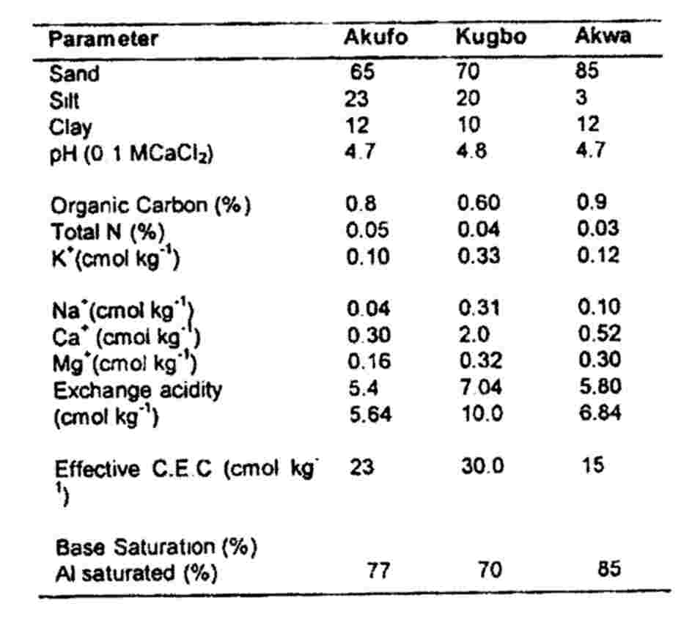

INTRODUCTION
“Acid – sands” are acid soils that occur in the parts of the tropical humid climates which have mean annual rainfall ranging between 1400 – 4000m in areas having underlying geology made up of ssssssesedimentary sedimentary rocks or Unconsolidated sediments (Bredenkampetal 1996). They are mostly ultisols and degraded alfisols. The degraded alfisols are less acidic but
sedimentary rocks or unconsolidated sediments (Bredenkamp et al., 1996). They are mostly ultisols and degraded alfisols. The degraded alfisols are less acidic but due to the continuous use of acid forming fertilizers such as ammonium sulphate on these soils, acidity problem is aggravated (Hoekenge et al.., 2003). In Nigeria, most of the soils in the rainforest, derived savannah and southern guinea savannah Agro–ecological zones are affected ( FAO, 2004). The management of acid soils has usually been tackled from the view point of lime application to neutralize soil acidity (Faveretto, 2006). This is because the maintenance of satisfactory soil fertility levels in humid regions depends considerably on the judicious use of lime to balance the losses of calcium and magnesium from the soil (Ojeniyi et al., 2001, FAO, 2004). The attainment of an appropriate soil reaction (pH) by liming acid soil is therefore imperative towards increasing food production in the affected part of the country (Ojeniyi et al., 1999). Presently more than 95% of farmers in these areas do not lime their soils as a routine, due to inadequate awareness of benefits of lime as a soil conditioner (FAO, 2004). Another problem facing the farmers in the area is the unawareness of the rate of application per unit area of land. This is probably because a limited study on liming has been carried out in Nigerian unlike the case of chemical fertilizer (Bababe et al., 1999; Lalijee, 2000). The need therefore arises for specific studies aimed at assessing the influence of increasing lime rates on soil pH and recommending levels at which specific lime materials could be judiciously used.
Table 1. Selected Physicochemical Properties of soil prior to Liming

studies aimed at assessing the influence of increasing lime rates on soil pH and recommending levels at which specific lime materials could be judiciously used.

Materials and Methods
The soil samples were collected from three different locations of different pedogenic characteristics and from the Derived Savannah and Southern Guinea Savannah Agro-Ecological Zones of Nigeria. These locations are Akwa (Typic Paleustults and Haplustults). Akufo (Oxic or Orthic Luvisol) and Kugbo (Colluvium and Nuoe sand

stone residuum) (Ohiri et al., 1989; Akamigbo, 2002). The soil samples were air-dried and passed through a 2mm sieve to determine particle size by hydromenter method, soil pH in H₂0 and 0.01M Cacl₂ by pH meter, organic carbon by Walkey black method, total N% by Kjeldahl method and available P using the vanado- Molydate wet digestion, exchangeable cation by Ammonium Acetate (NH₄0Ac extraction method at PH 7.0, Exchangeable acidity and percentage Aluminum saturation by titration with 1N HCl. Powders of hydrated lime Ca (OH)₂ and lime stone (CaC0₃) were obtained from Kano and Anambra states, Agricultural development project, respectively. These treatments consisted of two lime sources at four rates (0,2,4 and 6 ton ha⁻¹ ) and three soils in a split plot design with 3 replicates. The lime was applied to each pot containing 2.5kg soil kept moist for eight weeks after liming. Soil pH was then determine potentiometrically on the soil sub-samples at 4,6 and 8 weeks after liming in water and in 0.01M CaCl₂ at soil solution ratio of 1:2. All the relevant data collected were subjected to statistical analysis using statistical analysis software (SAS, 2002). LSD was used to separate the means.

Table 2. Soil pH values at 4WAL as affected by lime rate (CaC0₃)
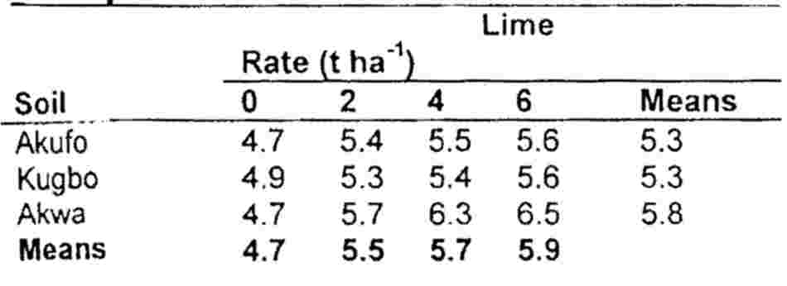
LSD.₀₅ (Main effect soils) = 0.07
LSD.₀₅ (Main effect of lime) = 0.08
LSD.₀₅ (Subplot effect for same soil) = 0.10
LSD.₀₅ (Subplot effect different soil) =0.20
WAL = weeks after liming
LSD = least significant difference

Results and Discussion
Soil pH as affected by liming
The choice of pH 6-6.5 as a reference was suggested by Kamprath (1973). Averagely, soil pH values were raised significantly as Calcium Carbonate application increased (Table 2-4). Irrespective of soil type, the reference pH of 6.0-6.5
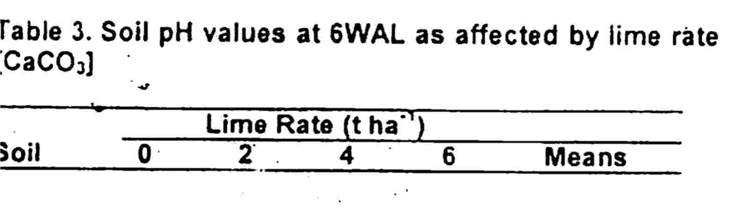
coulcould not be achieved at 4 weeks after liming (WAL) but at 6 or 8 WAL (Table 3-4), however only within the liming rate of 2 to 6 ton ha⁻¹. This is because at 4 WAL, substantial amount of CCa and Mg had not migrated to the subsoil where subsoil AluAluminium saturation prevents deeper root devdevelopment. The reverse was probably the case at 6 WAL and and 8 WAL. Several workers (Follet et al ,1981 Havlin et al a al., 1999) found out that under intensive management, an appliapplication of tons ha^{.-1} of lime caused Ca and Mg⁻to move from from top soil into subsoil within a given time. A similar trend vas was also observed when Hydrated lime was used. This mpliiimplied that a reference pH of 6.0-6.5 could either be achi achieved with little sacrifice in lime up to 2 ton ha⁻¹ or much sacrisacrifice in lime up to 6 ton ha⁻¹ depending on time.
Table 3. Soil pH values at 6WAL as affected by lime rate (CaC0₃)
 |  | Lime | Rate (t ha⁻¹)
Soil | 0 | 2 | 4 6 Means
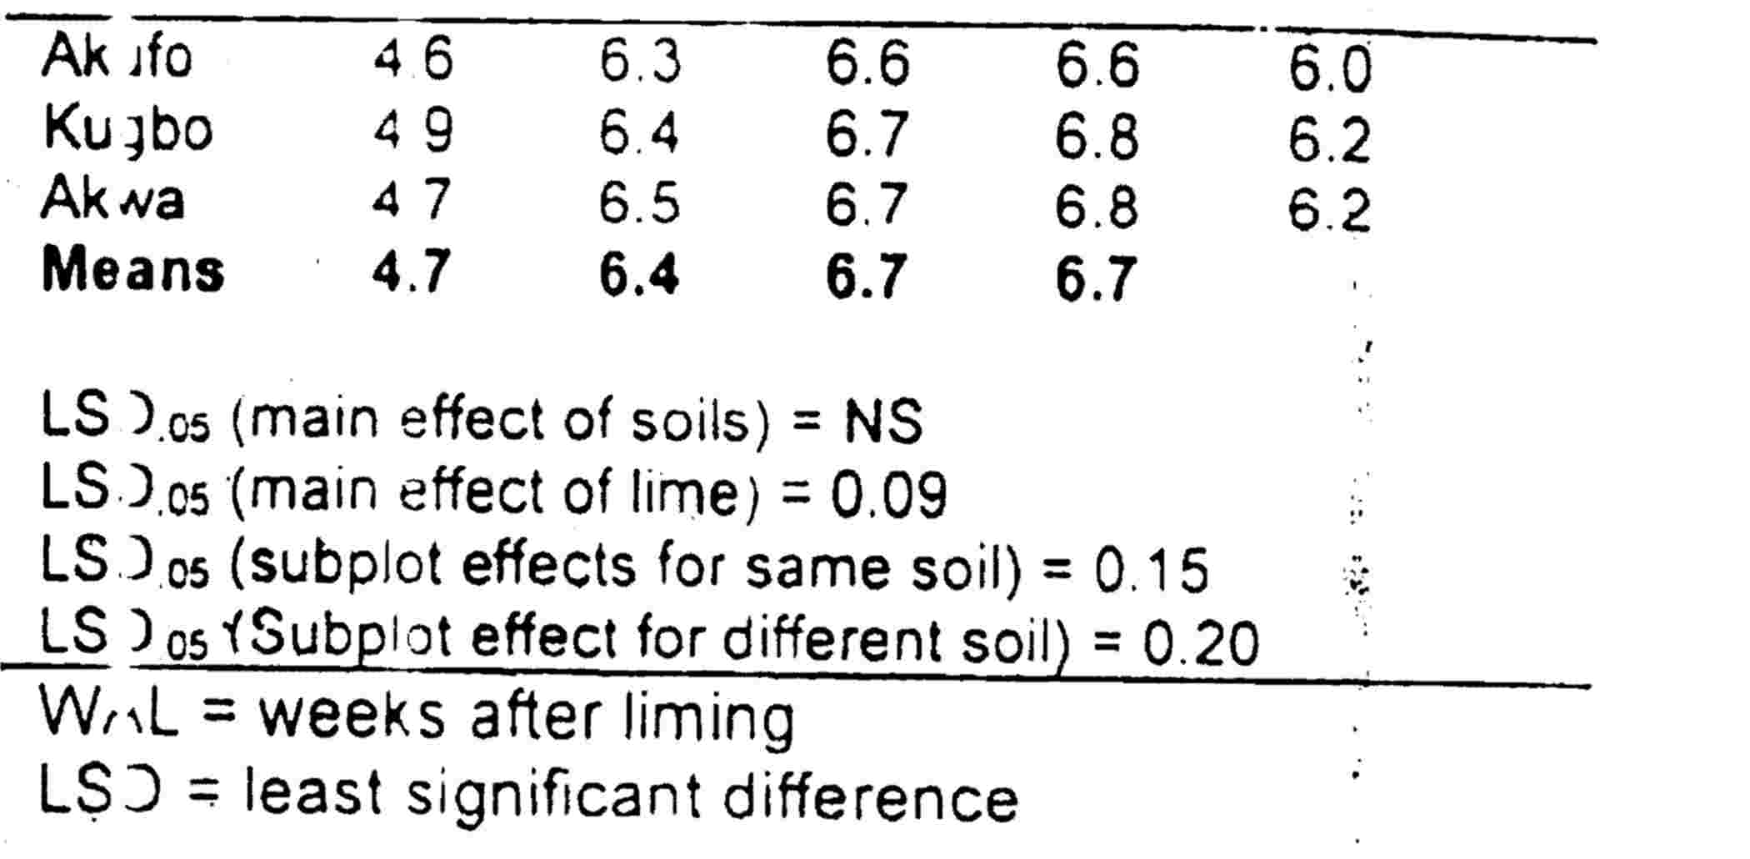

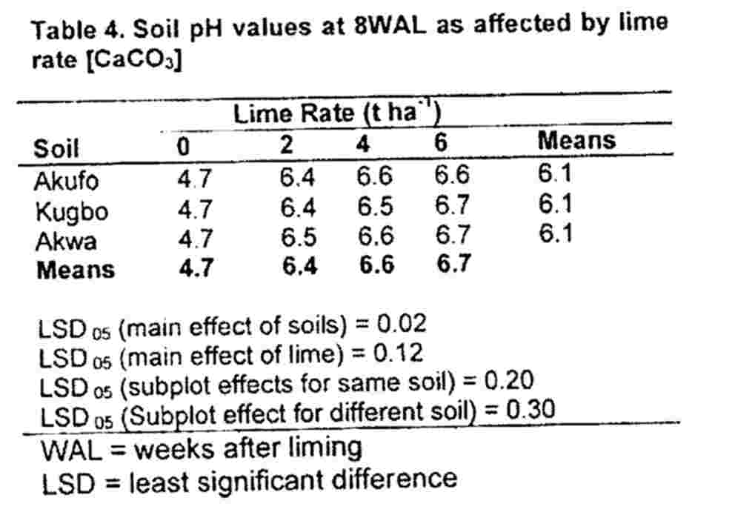

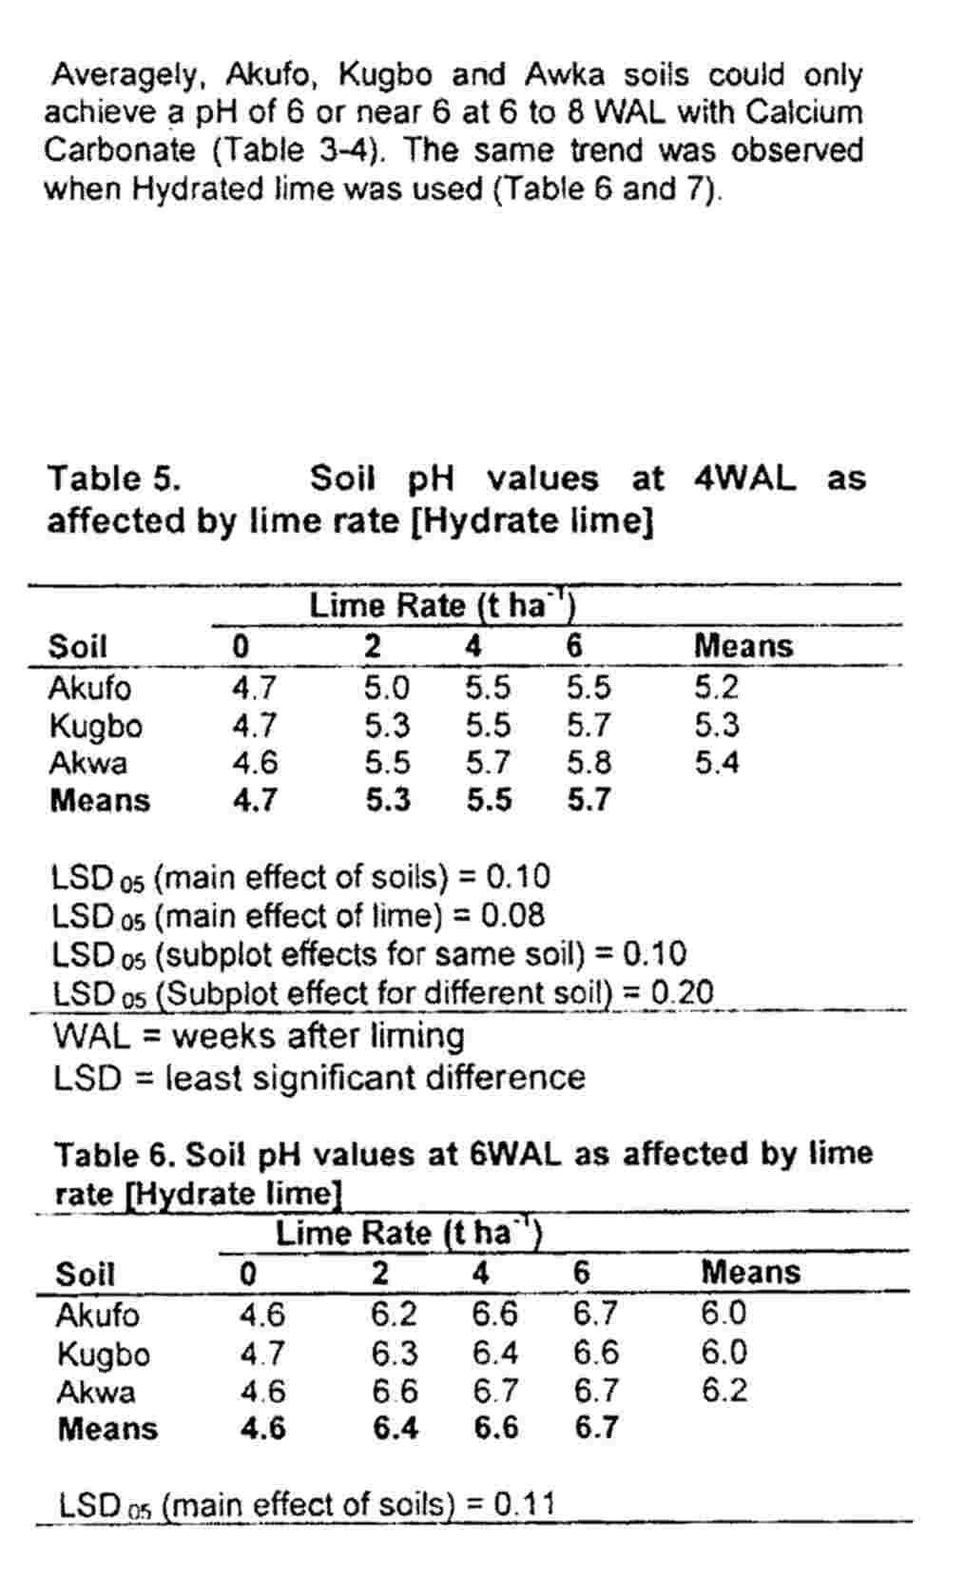

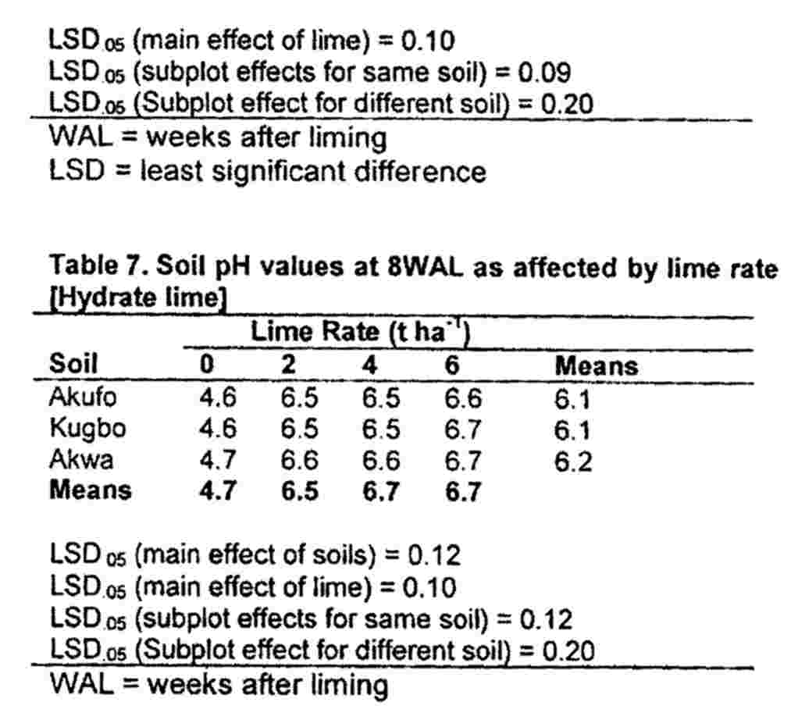
Regardless of lime sources, at least liming up to 2 ton ha⁻¹ was necessary to raise soil pH from 6.0-6.5 at 6-8 WAL. Benefits to liming with CaC0₃ may never be derived at 4 WAL unless liming rate is increased to 4 ton ha⁻¹ for Akwa soils and and 6 ton ha⁻¹ for Akufo and Kugbo soils respectively (Table 2). In the case of liming with hydrated lime, even 6 ton ha⁻¹ lime will barely give appreciate benefit with respect to soil fertility improvement (Table 5), since the
reference pH of 6.0-6.5 could not be attained. Lime of carbonate sources seems to be a better choice than hydrated lime in this regard. Although Akwa soil prior to liming had an AL Saturation of 85% (Table 1), averagely Akwa soil recorded higher pH, irrespective of liming rate and source probably due to structural stability; a better ratio of sand silt clay content (Table 1). Brady (1993) reported differences in pH of limed soils as a result of textural variability while schuffalen and Middleburg (1954) reported the formation of smaller aggregates due to liming to neutrality.

Conclusion
Results obtained shows that liming is an important step towards the management of acid sands.
Irrespective of lime sources, at least liming up to 2 ton ha⁻¹ was necessary to raise soil pH from 6.0-6.5 at 6-8 WAL. Benefit to liming with CaC0₃ may never be obtained at 4WAL unless liming rate is increased to 4 ton ha⁻¹ for Akwa, 6 ton ha⁻¹ for Akufo and Kugbo soils respectively. Further studies should however be carried out to investigate and evaluate the impact of lime on nutrient use efficiency of crops grown on acid sands from the Derived Savanna and Southern Guinea Savanna Zones of Nigeria.

Table 8.Physico- chemical properties of the soil after liming
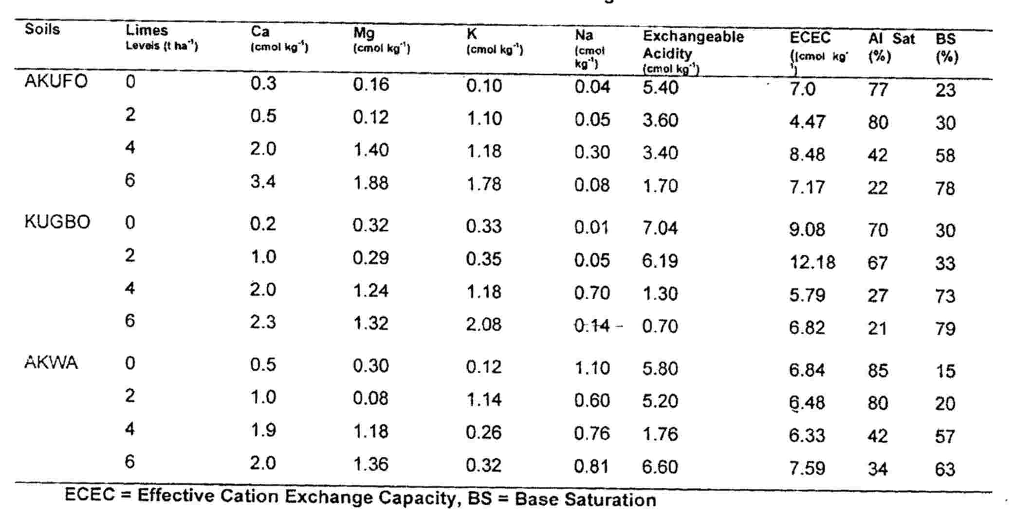

References
Akamigbo, F.O.R (2002). Application of soil survey information for agriculture and Environment. Paper presented at the 5th day US-Nigeria Technical Assistance Programme.

Bababe, B, and Kwari J. D (1999). Appraisal of farmers initiative in the use of soil organic amendment in the sudano-sahel region of N.E. Nigeria in: farmers and scientist in a changing environment-assessing Research in West Africa G. renardet (Editor) Margraf Verlag p 87-97.

Brady N.C (1993). Liming of acid soils. In nature and properties of soil. Macmillan New York, Pp 247-269.

Bredenkamp G. Granger, J, E, and Van Rooyen, N. (1996). Moist sandy Highveld grassland.In Low A.B and Robelo, A.G (eds). Vegetation of South Africa, Lesotho and Swaziland. Department of Environmental Affairs and Tourism, Pretoria.

Faveretto, N, (2006). Gypsum Amendment and Exchangeable calcium and magnesium affecting phosphorus and nitrogen in Run off. Soil Sci. Soc. Am J. 70: 1788-1796.

Food and Agriculture Organization (FAO) ( 2004). Use of phosphate rocks for sustainable Agriculture i n Fertilizer and Plant Nutrition. Bulletin, 13 (Zeppata, F. and Roy, R, N.) Eds, FAO. Land and Water Development Division and International Atomic Energy Agency.

Follet, R.H Murphy LS and Donahue R.L (1981).Fertilizers and soil amendments. Prentice Hall, incorporation, New York pp: 84-103, 393-415.
Havline J.L., Beaton J.D., Tisdale S.L and Nelson W.L (eds) (1999). Soil fertility and fertilizer: An introduction to Nutrient Management (6th Ed) Upper Saddle River, N. J Prentre Hall.

Hoekenge, O.A., Vision, O.A., Shaff, T .J., Moniforte, J.E., Lee, A.J., Howell, S.H and Kchian, C.V (2003). Identification and characterization of the tolerance loci in Arabidopsis by quantitative trait locus

mapping, A Physiological simple but genetic complex trait. Plant Physiological, June, 132.936-948.

Kamprath E.J (1973), Soil Acidity and liming Pp 126-128 In: P.A Sanchez (eds). "A Review of Soil Research in Tropical Latin American," North Carolina Agric. Exp. Stn. Tech. Bull. 219.

Lalijee B (2000). Fertilizer materials from sugar industry by- products..African soils 31: 215-232.

Ohiri, A.C. and Ano, A.O. (1989). Characterization and evaluation of some soils of rainforest zone of Nigerian, Proceedings of 11th Annual Conference of Soil Science of Nigerian Nsukka, pp 56-60.

Ojeniyi, S.O., Adetoro, A.O. and Odedina, S.A (1999).Effect of wood ash on soil fertility, nutrient contents and yield of okra. Paper presented at Horticultural Society of Nigeria Conference, Port Harcourt.

Ojeniyi, S.O., Oso O.P and Arotolu, A.A. (2001). Response of vegetables to wood ash fertilizer. Proceedings 35th Annual Conference of Agricultural Society of Nigeria. Pp 39-43.

SAS Statistical Analysis Systems (2000). SAS Users Guide; Statistical, Cary N.C. Statistical Analysis Systems Institute Inc

Schuffalen, A.C and Middleburg, H.A (1954). Structural determination of laterite soil through liming.Tran fifth Int. Congr. SS 2: 158-165.

