

**Nigerian Journal of Engineering Science Research (NI**

**JESR),**

**Vol. 1, Issue 1, pp.0x**

**-**

**xx**

***Copyright@ Department of Mechanical Engineering, Gen.***

***Abdusalami***

***Abubakar College of Engineering, Igbinedion University, Okada, Edo***

***State, Nigeria.***

**ISSN: 2636**

**-**

**7114**

***Journal homepage: www.nijesr.***

***iuokada.edu.ng***



**Simulink Modelling and Simulation of Mobile Agricultural Robots for Farm Monitoring**

# 1* Alkali, Babawuy, 2Sulaiman, I., 2Adedipe, O., 3 Salihu, B. A., 3Abubakar Sadiq Mohammed

***1*** *Department of Mechatronics Engineering, Federal University of Technology Minna, P.M.B 65, Minna, Niger State, Nigeria*

***2*** *Department of Mechanical Engineering, Federal University of Technology Minna, P.M.B 65, Minna, Niger State, Nigeria*

***3****Department of Telecommunication Engineering, Federal University of Technology Minna, P.M.B 65, Minna, Niger State, Nigeria*

***\*Babawuya Alkali,*** [*Babawuya@furminna.edu.ng*](mailto:Babawuya@furminna.edu.ng)*, 07038096888*



**Abstract:**

Mobile robots are immensely important robots used for various applications; agriculture, military, firefighting and space exploration. The differential drive configurations are widely used due to their simplicity, easiness of control and flexibility. This paper describes the modelling of a differential drive robot taking into account the kinematics, dynamics and control algorithm for robot. The efficacy of the designed controllers has been studied and seen to control the robot with an error of 0.15 m and deviation time of 10 s. A more robust controller is to be developed for future studies.

**Key words:** Controller, Differential Drive, Kinematics, Mobile Robots, Modelling

## INTRODUCTION

Autonomous mobile robots are immensely important robots used for various applications such as farming monitoring. They were traditional employed heavily for use in the manufacturing sector but have since gradually become available in other sectors (Yeo, 2012; Shamshiri and Wan, 2012). They are now used in agriculture, military, firefighting, space exploration and in service industry. Mobile robots as the name implies moves from one location to another in performing the desired task, they comprise of the following components: wheels, chassis, controller, drive mechanism, motor drive and sensor. The differential drive mobile robot (DDMR) especially has gained wide popularity due to its simplicity and ease of control (Leena and Saju, 2015; Yeo, 2012). The differential drive robot consists of two independent wheels at either side of the robot chassis. They are independent as each has an actuator assigned to propel it. The movements are achieved by applying and adjusting power to said motors as per required (Azzi and Mameche, 2010).

DDMR require an effective system of control for driving. The control algorithm depends on a mathematical model that describes the behaviour and properties of the system. The kinematic and dynamic modelling systems are used for this purpose, although the dynamic modelling is favoured due to being more real (Klancar *et al*., 2017; Yeo, 2012) and because it considers body weight and payload in determining its behaviour. The DDMR is however faced with the factor that affects its performance; the tracking problem, which is its ability to keep track of its current location. The issue is highly important in the study of autonomous robots (Kothandaraman, 2016). Without credible solution technique, the applications of DDMRs will remain limited. Various methodologies and technologies have been introduced and tested by different researchers over the years yielding favourable results. However, costs, complexity and required processing power increase with increased precision (Yeo, 2012). At present, tracking sensor systems used on different DDMRs platforms range from light and cheap encoders to ultrasonic sensors as well as bulkier and more expensive laser scanners and camera set-ups (Myin and Wi, 2016; Yeo, 2012). The challenge is to produce an accurate tracking system without the exorbitant costs normally associated with high-precision platforms.

This paper discusses a detailed kinematic and dynamic models and solution for the mobile robot application for farm monitoring which includes the chassis dynamics and actuator dynamics. This trajectory tracking is implemented using two controllers. A kinematic controller has been used for outer loop control to generate the reference velocities whereas a proportional controller has been used as inner loop controller to generate angular velocities for the wheels of the robot.

Finally, several test trajectories were created and the simulation results are presented are seen to show excellent trajectory tracking.

# MATERIAL AND METHODS

**Modelling of Differential Drive Mobile Robot**

A DDMR is a wheel robot with two motors as shown in Fig. 1. To manoeuvre the robot needs a linear velocity V and a heading of $θ$. By controlling the velocity and orientation, the path of the robot can be planned (Kothandaraman, 2016). This differential drive is characterised by two non-holonomic constraints which are obtained by two main assumptions (Leena and Saju, 2015; Petrović et al., 2016).

1. That the DDMR does not move sideward.
2. That each wheel maintains a one-point contact with the ground and no slipping of the wheel occurs in its longitudinal axis and no skidding in its orthogonal axis.

*2.1. Kinematic modelling*

Kinematic modelling deals with the geometric relationships that govern the system and studies the mathematics of motion without considering the affecting forces. From Fig. 1 $V_{r}$ is the velocity of the right wheel, $V_{l}$ is the velocity of left wheel, L is the distance between the centre of the wheels, $θ$ is the directional angle of the robot with respect to the reference coordinate system and r is the radius of the wheel.

(x,y)

$$θ$$

Y

r

L

V

X

Vr

Vl

Xb

Yb

$φ$ l

$φ$ r

Fig.1 DDMR parameters (Salem, 2013)

The DDMR kinematic equations are used to transform the robot from polar (r, $θ$) coordinates to rectangular (x,y) coordinate system. The linear velocity of each driving wheel is determined from the average of the linear velocities of both wheels (Dhaouad and Abu Hatab, 2013).

$V=\frac{V_{r}+V_{l}}{2}=r\frac{{\dot{φ}}_{r}+{\dot{φ}}_{l}}{2}$ (1)

Or

$\dot{x}=Vcos(θ)$ (2)

$\dot{y}=Vsin(θ)$ (3)

The angular velocity of the DDMR is given by Equation 4 (Anvari, 2013).

$\dot{θ}=ω=\frac{V_{r}-V_{l}}{L}=r\frac{{\dot{φ}}_{r}-{\dot{φ}}_{l}}{2}$ (4)

Substituting the linear velocity V into Equations 2 and 3 yields;

$\dot{x}=\frac{V_{r}+V_{l}}{2}cos(θ)$ (5)

$\dot{y}=\frac{V_{r}+V_{l}}{2}sin(θ)$ (6)

The individual velocities may be calculated using Equations 5 and 6.

$V_{r}=V+\frac{L}{2}ω$ (7)

$V_{l}=V-\frac{L}{2}ω$ (8)

The outputs, $V_{r}$ and $V_{l}$ can be used to generate the output $\dot{x}$, $\dot{y}$ and $ω$ using Equations 4, 5 and 6. Integrating these values results in the actual position x, y and the actual orientation $θ$. The values may be fed back for error calculation, making this system a closed loop system.

Considering the two coordinates in Figure 1, the inertial (X,Y) and the body ($X_{b},Y_{b}$) coordinates; the two coordinates are related by the rotation matrix $R_{θ}$ (Majid *et al*., 2016).

$R_{θ}=\left[\begin{matrix}cos(θ) & -sin(θ) \\ sin(θ) & cos(θ) \\ 0 & 1\end{matrix}\right]$ (9)

The matrix form of the kinematic equation is therefore (Tiep *et al*., 2018);

$\left[\begin{matrix}\dot{x} \\ \dot{y} \\ \dot{θ}\end{matrix}\right]=\left[\begin{matrix}cos(θ) & -sin(θ) \\ sin(θ) & cos(θ) \\ 0 & 1\end{matrix}\right]\left[\begin{matrix}V \\ ω\end{matrix}\right]$ (10)

Equation 10 describes the forward kinemtics of the DDMR.

*2.2. Dynamic modelling*

As for the dynamic modelling of the DDMR the motion along with the forces and energies are modelled and analysed. The Newton Euler and Lagrange methods are used for this purpose. Applying the Newton Euler method, the dynamics of the DDMR without the constraints are obtained as Equation 9, 10 and 11 (Dhaouad and Abu Hatab, 2013).

${Ma}_{u}=F_{uL}+F_{uR}$ (11)

${Ma}_{w}=F_{wL}-F_{wR}$ (12)

$J\ddot{θ}=\left(F_{uR}-F_{uL}\right)L+\left(F_{wR}-F_{wL}\right)d$ (13)

Where M be the total mass of the robot including the wheels and actuators [kg] and J the moment of inertia with respect to the centre of mass [kg $m^{2}$].

the dynamic equations of the robot considering the non-holonomic constraints however are given by Equation 14 and 15.

${\dot{v}}_{u}={d\dot{θ}}^{2}+\frac{F_{uL}+F_{uR}}{M}$ (14)

$\ddot{θ}=\left(F_{uR}-F_{uL}\right)\frac{L}{Md^{2}+J}+\frac{Mdv_{u}}{Md^{2}+J}\dot{θ}$ (15)

These equations can now easily be transformed to show the actuator torques applied to the wheels.

$M{\dot{v}}_{u}\dot{θ}-Md{\dot{θ}}^{2}=\frac{1}{R}\left(τ_{R}+τ_{L}\right)$ (16)

$(Md^{2}+J)\ddot{θ}-Mdv_{u}\dot{θ}=\frac{L}{R}(τ_{R}-τ_{L})$ (17)

*2.2.1 DC motor model*

The motors used to propel each wheel is the DC motors. They are generally used to drive DDMRs, a typical motor circuit is depicted in Fig. 2.



Fig. 2 Motor circuit

the armature voltage $v_{a}$ is used to control input while keeping the conditions in the field circuit constant. In particular, for a permanent-magnet dc motor, we have the following equations for the armature circuit (Dhaouadi and Abu Hatab, 2013).

$v_{a}=R_{a}i_{a}+L_{a}\frac{di_{a}}{dt}+e_{a}$ (18)

$e_{a}=K_{b}ω_{m}$ (19)

$τ_{m}=K_{t}i_{a}$ (20)

$τ=Nτ_{m}$ (21)

where, $i_{a}$ is the armature current, $R_{a}$ and $L_{a}$ are the resistance and inductance of the armature winding respectively. $e_{a}$ is the back emf, $ω_{m}$ is the rotor angular speed, $τ_{m}$ is the motor torque, $K_{b}$ and $K_{t}$ are the torque constant and back emf constant respectively. N is the gear ratio and is τ the output torque applied to the wheel.

**2.3 Controller design**

The controller for the simulation is in two phases; dynamic and kinematic control as seen in Fig. 3.

**Reference trajectories**

**Kinematic controller**

$$M^{-1}$$

**PID controller**

**Dynamic and actuator model**

**Kinematic model**

**Position, Orientation**

$$\left[\begin{matrix}x_{d} \\ y_{d}\end{matrix}\right]$$

$$\left[\begin{matrix}v_{aR} \\ v_{aL}\end{matrix}\right]$$

$$\left[\begin{matrix}V_{ref} \\ ω_{ref}\end{matrix}\right]$$

$$\left[\begin{matrix}V \\ ω\end{matrix}\right]$$

$$\left[\begin{matrix}x \\ y \\ θ\end{matrix}\right]$$

$$\left[\begin{matrix}ω_{Rref} \\ ω_{Lref}\end{matrix}\right]$$

$$\left[\begin{matrix}ω_{R} \\ ω_{L}\end{matrix}\right]$$

**M**

Fig. 3 System setup

*2.3.1 Dynamic controller*

As for the dynamics a PID (Proportional intergral derivative) controller is selected. Its control block in Simulink can be easily replaced with any other controller type. Moreover, PID controllers are ones of most used to achieve the desired time-domain behaviour of many different types of dynamic plants. The PID gains ($K_{P}, K_{I}, K_{D}$) are usually tuned experimentally to obtain the desired overall desired response. The PID controller transfer function is given by (Salem, 2013):

$G_{PID}=K_{P}+\frac{K_{I}}{s}+K_{D}=\frac{K_{D}s^{2}+K_{P}s{+K}_{I}}{s}=K_{D}\left[s^{2}+\frac{K_{P}}{K_{D}}s+\frac{K_{I}}{K_{D}}\right]/s$ (22)

The PID architecture is given in Fig. 4.

$$K_{P}$$

$$K_{I}∫$$

$$\frac{1}{K_{D}}\frac{d}{dt}$$

u(t)

e(t)

Fig. 4 PID controller architecture

*2.3.2 Kinematic controller*

For the kinematic equation, first the inverse kinematics using the forward kinematic Equation. But the coordinates of interest are position (x,y) (Leena and Saju, 2015). At a point p yielding a vector **h** = ${[x y]}^{T}$ neglecting the direction $θ$. Equation 10 becomes;

$\dot{h}=\left[\begin{matrix}\dot{x} \\ \dot{y}\end{matrix}\right]=\left[\begin{matrix}cos(θ) & -sin(θ) \\ sin(θ) & cos(θ)\end{matrix}\right]\left[\begin{matrix}V \\ ω\end{matrix}\right]$ (23)

And $R_{θ}$ becomes $R_{θvw}$

$R_{θvw}=\left[\begin{matrix}cos(θ) & -sin(θ) \\ sin(θ) & cos(θ)\end{matrix}\right]$ (24)

To obtain the inverse kinematics the inverse of $R_{θvw}$ must be taken like wise. The inverse kinematics becomes;

$\left[\begin{matrix}V \\ ω\end{matrix}\right]=\left[\begin{matrix}cos(θ) & sin(θ) \\ -sin(θ) & cos(θ)\end{matrix}\right]\left[\begin{matrix}\dot{x} \\ \dot{y}\end{matrix}\right]$ (25)

The proposed kinematic control law to be applied to the DDMR is given by;

$\left[\begin{matrix}V_{ref}^{c} \\ ω_{ref}^{c}\end{matrix}\right]=\left[\begin{matrix}cos(θ) & sin(θ) \\ -sin(θ) & cos(θ)\end{matrix}\right]\left[\begin{matrix}{\dot{x}}_{d}+l_{x} tanh\left(\frac{k_{x}}{I_{x}}\tilde{x}\right) \\ {\dot{y}}_{d}+l_{y} tanh\left(\frac{k_{y}}{I_{y}}\tilde{y}\right)\end{matrix}\right]$ (26)

The instantaneous distance error can be determined as

$e\left(t\right)=\sqrt{{\tilde{x}}^{2}+{\tilde{y}}^{2}}$ (27)

Where $\tilde{x}=x_{d}-x$, and $\tilde{y}=y_{d}-y$ are the current position errors in the X and Y axes, $k_{x}>0$ and $k_{y}>0$ are the gains of the controller, $l_{x}∈R$, and $l∈R$, are saturation constants, and (x,y) and ($x_{d},y_{d}$) are the current and desired coordinates of the point of interest respectively.

**2.4 Simulation Model**

The simulation model is built using MATLAB Simulink and is made up of seven subsystems. The DDMR kinematic model, dynamic model, actuator model, inner (PID) controller, inverse kinematic model, kinematic controller and the reference trajectories. These are shown in Fig. 5 of the built Simulink model.

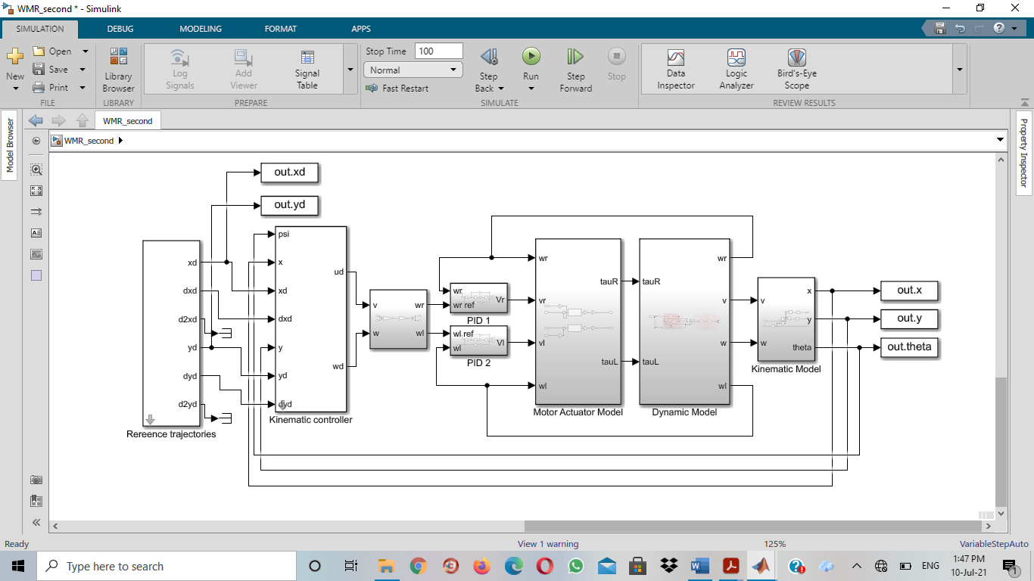

Fig. 5 Simulation model

Each of the subsystems mentioned are built using the equations mentioned in sections 2 and 3 respectively. The DDMR kinematic model subsystem for example is the based-on Equations 2, 3 and 4 for the DDMR position as depicted in Fig. 6, and Equations 1 and 4 for wheel kinematics.

1

2

3

2

1

$$\frac{1}{s}$$

sin

$$\frac{1}{s}$$

$$\frac{1}{s}$$

cos

$$×$$

$$×$$

Fig. 6 Robot position

The parameters used for the model are given in Table -1.

**Table -1 Simulation parameters**

|  |  |  |  |
| --- | --- | --- | --- |
| **Parameter** | **Symbol** | **Value** | **Unit** |
| Moment inertia of robot | J | 5 | Kg m2 |
| Robot mass | M | 12 | kg |
| Location of centre of gravity of robot | d | 0.05 | m |
| Radius of wheel | r | 0.075 | m |
| Distance between wheel | L | 0.2 | m |
| The torque constant | kt | 0.035 | Nm/Amp |
| The back emf constant | kb | 0.035 | V/rad/s |
| Inductance of the armature winding | La | 0.0 | H |
| Resistance of the armature winding | Ra | 8 | Ohm |
| The gear ratio | N | 2 |  |

For each wheel the values 220 and 10 were obtained from the iterations carried out for the proportional $K_{p}$ and integral $K_{i}$ components in the PID controller. 0 was used for the derivative $K_{d}$ component.

# RESULTS AND DISCUSSION

The result of the simulation is given in Fig. 7. A value of x, y and $θ$ along with $x_{d}$, $y_{d}$ is plotted together to analyse how well the controller tracks the reference trajectory. The robot is able to successfully track the reference trajectory as seen in Figure 8. There is a slight variation however when plots are examined. Deviation occurs at the corners as the robot is trying to make a turn (plot x against y). The desired trajectory for example at the farthest right corner is (0.9957, -0.3266) while the robot trajectory at the required position is (1.09, -0.3392).

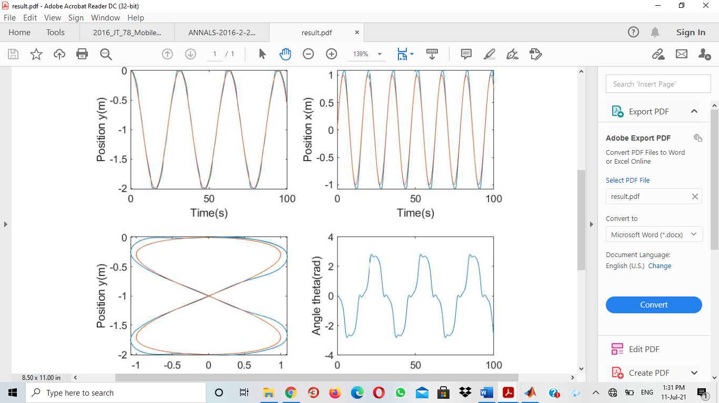

Fig. 7 Simulation results

The controller as is better tracks linear trajectories. The DDMR moves smoothly on the linear paths making up the trajectory and deviates slightly at the corners. Detailed examination of the x against time graph shows that it takes the DDMR about 10 s to re-connect with the desired trajectory after the detour.

The maximum distance error recorded is 0.15 m as shown in Figure 8. The instantaneous error was obtained using Equation 27. A separate subsystem containing said equation was used to obtain the error.

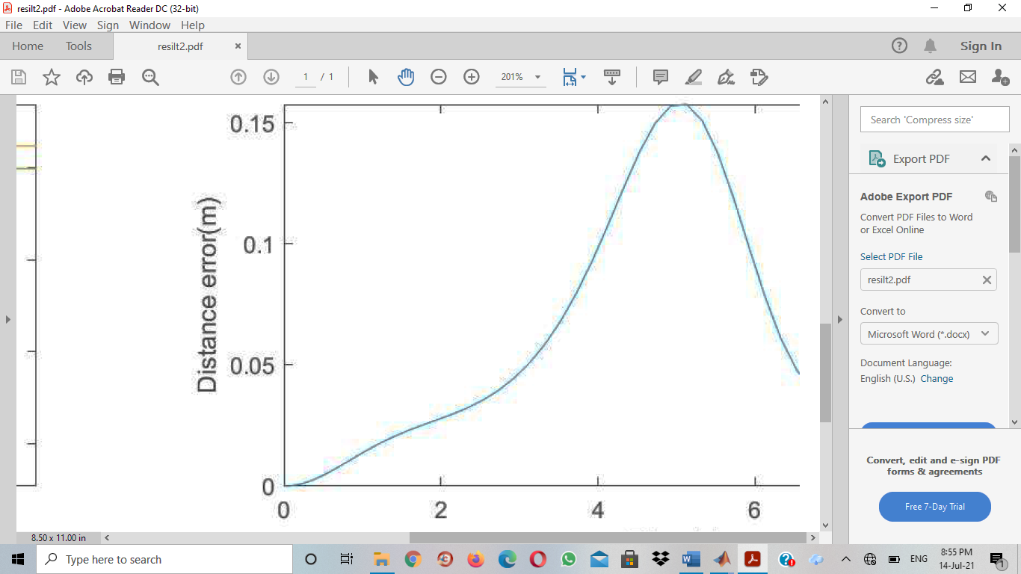

Fig. 8 Instantanous error

# CONCLUSION

The model of a DDMR was built and implemented in MATLB-simulink and controlled with an inner and outer controller. The model was capable of following the intended trajectory with slight deviations. For future considerations, there is need for a more robust controller and optimised tunning mechanisms to be employed for the PID. A hybrid controller is also a viable option to control the plant.

**CONFLICT OF INTEREST**

There is no conflict of interest for this research work.

# ACKNOWLEDGEMENT

Acknowledge should not be more than four lines. Information concerning research grant support and the assistance of colleagues or similar notes of appreciation may appear this section.

_____________________________________________________________________________

# REFERENCES

Azzi, O. & Mameche, H. (2010). *Dissertation template for Princeton university.* Faculty of Princeton University.

Dhaouadi, R. & Abu Hatab, A. (2013). Dynamic modelling of differential-drive mobile robots using Lagrange and Newton-Euler methodologies: A unified framework. *Advances in Robotics & Automation*, 1-7.

Klancar, G., Zdešar, A., Blažiˇc, S. & Škrjanc, I. (2017). *Wheeled mobile robots: From fundamentals towards autonomous systems.* Oxford: UK: Butterworth-Heinemann.

Kothandaraman, K. (2016). *Motion planning and control of differential drive mobile robot.* Maharashtra: Wright State University.

Leena, N. & Saju, K. K. (2015). Modelling and trajectory tracking of wheeled mobile robots. *Procedia Technology*, 538-545.

Majid, N. A., Mohamed, Z., Basri, M. A. M. (2016). Velocity control of a unicycle type of mobile robot using optimal pid controller. *Jurnal Teknologi*, 7-14.

Myin, C. & Wi, N. N. (2016). Position and velocity control for two-wheel differential drive mobile robot. *International Journal of Science, Engineering and Technology Research (IJSETR)*, 5(9), 2849-2855.

Petrović, E., Nikolić, V., Ćirić, I., Simonović, M., Pavlović, S., Mančić, M. & Rajković, B. (2016). Kinematic model and control of mobile robot for trajectory tracking. *International Journal of Engineering*, 161-164.

Salem, F. A. (2013). Dynamic and kinematic models and control for differential drive mobile robots. *International Journal of Current Engineering and Technology*, 253-263.

Shamshiri, R. & Wan I. (2012). *International Journal of Agriculture & Biotechnological Engineering*, 5(2): 9－19.

Tiep, D. K., Lee, K., Im, D., Kwak, B. & Ryoo, Y. (2018). Design of Fuzzy-PID Controller for Path Tracking of Mobile Robot with Differential drive. *International Journal of Fuzzy Logic and Intelligent Systems*, 18(3), 220-228.

Yeo, L. (2012). *Optical tracking control of a differentially-driven wheeled robot.* Victoria: RMIT University.