AN IMPROVEMENT OF BOND STRENGTH BETWEEN FERROCEMENT SKIN AND CORE MATERIAL OF FERROCEMENT FORM
By
Ameh, J.E.¹ Alao, T.O.² Apeh J.A.^{3 al}
1.Department of Building, Federal University of Technology, Minna, Nigeria
2.Department of Building, Federal University of Technology, Minna, Nigeria
3.Department of Building, Federal University of Technology, Minna, Nigeria
Abstract
Ferrocement Form supporting structural elements (Beams) is subjected to flexural forces due to the beam’s self weight. The bond between the Ferrocement form skin and the core material results in the mobilization of the tensile bond strength at the interface which is a plane bond. The study attempted to improve the bond strength by proposing an interlock bond at the interface. This was achieved by characterizing the bond strength according to the material strength used as the Ferocement skin and that of the core material. Experimentation was conducted in the Laboratory using normal Mortar, Granite mortar and self-compacting concrete- mortar interfaces as replicas to simulate Ferrocement Forms with in-filled/ core materials. Cubes were cast from the mixes of these materials and their compressive strength determined. Similarly, Cylinders were cast from the mixes of these materials and tensile the bond strengths determined by a direct tensile method for both the plane bond (control) and the proposed interlock bond. Results indicate that bond strength values for both the plane and interlock bond depends on the compressive strength of the interface materials. It also show that for the plane bond, bond strength values ranged from 1.57 N/mm² – 1.97 N/mm² at 28 days curing and for the interlock bond, its bond strength values ranged from 1.70 N/mm² – 2.17 N/mm² at 28 days curing age. The granite Mortar used at the interface of the Ferrocement skin and core material with an interlock bond has a bond strength value of 2.17 N/mm² compared with similar interface material but with a plane bond, value of 1.97 N/mm². The interlock bond strength improved by 9.22 % over that for the plane bond and granite mortar as interface material for Ferrocement Form is a promising material.

- Introduction
Ferrocement or Ferrocrete is a new material consisting of Cement Mortar and wire meshes. It is a building technique that produce a very flexible concrete structure or structural element. It has found application as over head tanks, grain silos to preserve Grains from Moisture and also, as a structural element or Form. It performs better in terms of flexural and stiffness, than in conventional reinforced concrete members which are too heavy and develop cracks easily.
The use of most construction materials is for optimal results and its effectiveness can be improved by combining its merits such as the ferrocement skin and the core material as a composite. In service, the bond between the Ferrocement skin and the core material is subjected to tensile stresses which weakens the interface (Plane bond) leading to failure of the Form. In practice, Mortar, normal concrete, high performance concrete have been used as ferrocement skin and core material in the construction of Ferrocement Form( Sadowska-Baraczewsska and Lapko (2007). Tayeh et al (2013) also showed that HPC is used to prepare construction elements for increased loading or for the repair of damaged sites in existing elements. The use of self- compacting concrete (SCC) to mitigate cracks and vibration problem in structural elements with high volume of rebars has been highlighted.
In composite members such as the Ferrocement Form, the bond at its interface between the skin and the core material depends largely on the degree of adhesion between them. This is readily important both in existing construction elements in the realization phases where the fresh concrete has not attained its material strength. The adhesive bond between the interface is an issue. It is formed in a vertical plane and vertically oriented in the direction of the applied Load or forces. The plane is common and exist through the entire stracta of the Ferrocement Form, from top to bottom. This presents a weak link in the Ferrocement Form and thus susceptible. A better bond is critical to the performance of the Ferrocement form. Also, being a thin reinforced concrete or laminate, cement based composite, has two main challenges; cracks and compaction which has be addressed. A lot of studies has been conducted on composites and Ferrocement but attention has not been given to the improvement of the bond strength between the interface of the ferrocement skin and the core material which is the focus of this study.
The work of Tawab et al (2012) showed that even though there was no application of any bonding agent or mechanical shear connection between the Form, skin and core materials, test results showed that considerable serviceability and ultimate Loads, crack resistance control and good energy absorption capacity on these areas but was silent on the improvement of the bond strength and its performance quality. The work of Falmy et al , (2013) on Ferrocement beams introduced bonding aagent and mechanical shear connectors in between the inner skin of the Ferrocement Form and the core material but the bond strength and its effect (s) on the Form has not been addressed. Moreover, volume fraction and specific area of the reinforcement meshes used in the study does not meet ACI (2006), and IFS (2001) specifications thus, the precast Forms are more of reinforced Mortars rather than Ferrocement Forms. In order to produce a more efficient precast Ferrocement Form, an improved Technology which entails the use of SCC, application of interlock bond at the interface of the Form was applied in the study. It is fervently hoped that the properties of SCC, incorporation of Ferrocement Form with an interlock bond at the interface of the Form improved its bond strength value and quality in performance.

- Materials and method
2.1 Materials
Portland cement (PC) CEM 1 42.5 N which conforms to BS EN 196 – 6 (1997) which was
Used to make concrete and Mortar Mixes. Fine aggregates of natural Siliceous Sand was
Used. Granite crushed aggregates of 10 mm, 5 mm and 2.5 mm nominal sixes was blended
and used for the study. Three (3nos) Core materials, Normal Mortar, (NM), Granite Mortar
(GM) and SCC were used as Ferrocement skin and core materials. Preliminary tests was
conducted on the materials to determine their suitability.
2.1.1Mix proportions
For Mix proportioning of SCC components, it was based on EFNARC (2005) provisions, and the mix design guidelines (Okamura and Ouchi, 2003) which was adopted for the study. The approach is rational with aggregate quantities being fixed, with W/B ratio of 0.40 and Super – Plasticizer (SP) dosage being adjusted so as to achieve optimum fresh properties that conform to EFNARC (2005) provisions. The Mix proportions of constituent materials in the work of Apeh and Ameh (2020) was adopted (table 1.0). For the mortar, a Mix ratio of ratio 1:3 was adopted.

Table 1: Mix Proportions
Mix ID | RECIPE | DENOTATION
Composition (Kg/m³) | NC | SCC | MORTAR | GPM
PC | 375 | 400 | 250 | 250
Water | 160 | 170 | 125 | 150
Sand (FA) | 848 | 848 | 750
Coarse Agg (10mm) | 741 | 501
Coarse Agg (5mm) |  | 741
Granite Powder |  |  |  | 750
Super Plasticizer (SP) |  | 2.2 % |  | 2.42%
W/B | 0.43 | 0.43 | 0.50 | 0.60
N.B. NC – Normal concrete, SCC – Self compacting concrete, GPM- Granite Mortar

2.2 Method
2.2.1 Experimental Programme and Test Procedure
All mixes were prepared as in table 1.0 in accordance with EFNARC (2005) and BS EN 122350-8, (2009). Ninety (90 nos) test specimen cubes and Ninety (90 nos) Cylinders were cast and demoulded after 24 hrs and cured for 3,7, 14, 21 and 28 days for compressive and tensile bond strength of the Ferrocement skin and Core materials.

2.2.2 Test Specimens
These consists of U-shaped Ferrocement laminates (Figure 1) incorporated as permanent Forms (150 x 300 x1200 mm) in practice but was simulated as cylinders (100 Ф mm x 200 mm). The SCC Form (Cylinder) were cast with mortar, SCC and granite Mortars. Three (3nos) Cylinders each, were cast as plane bond (control) while another three (3 nos) cast as interlock bond for the interface between the Ferrocement skin and the core Materials. An average of three tests results is recorded herein. The composite samples were produced at two stages: the mix for the Ferrocement skin was cast first which formed 50 % volume of the Cylinder Mould, allowed to set for about 15 to 20 minutes and then the core material cast too (Plates II,III, IV). This was repeated for all the Mixes and for both core and Ferrocement skin Materials.
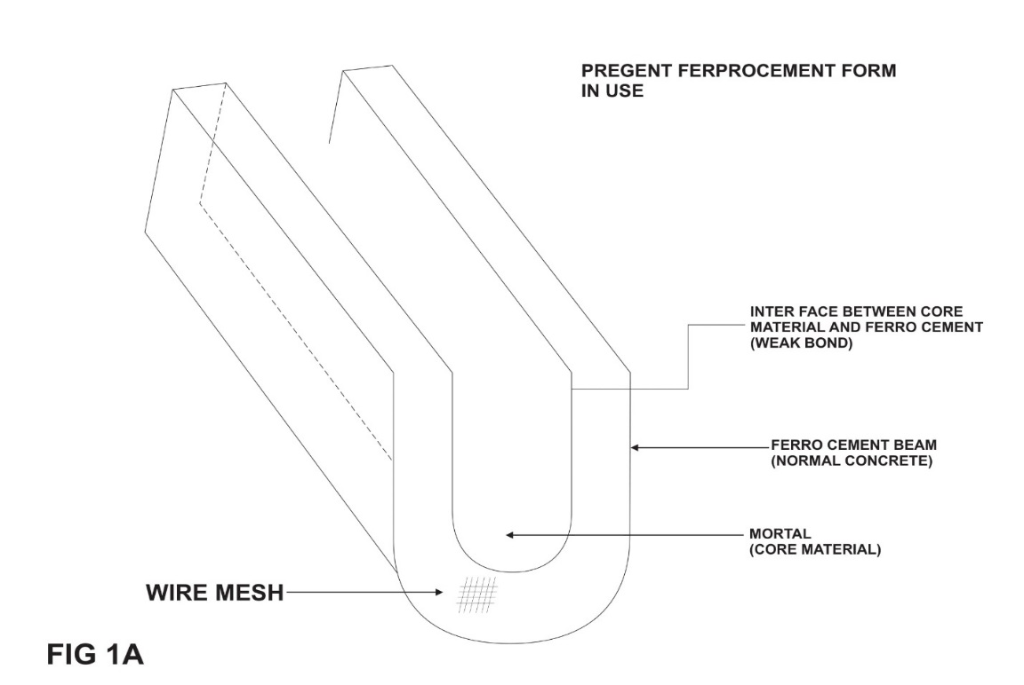

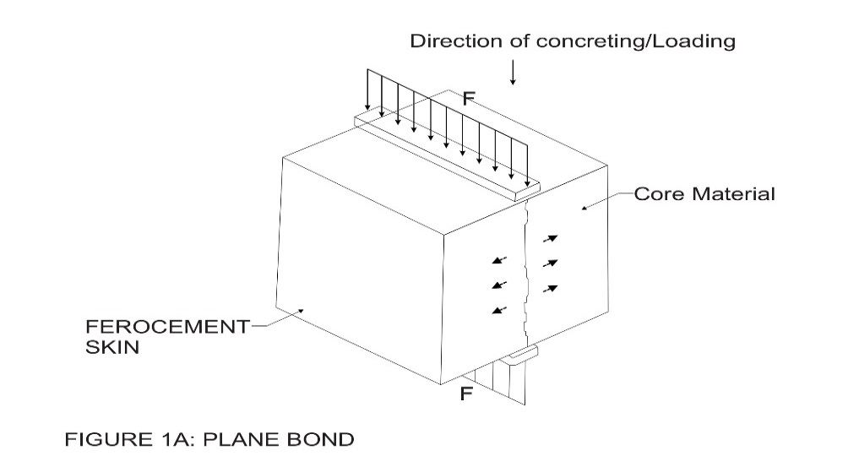
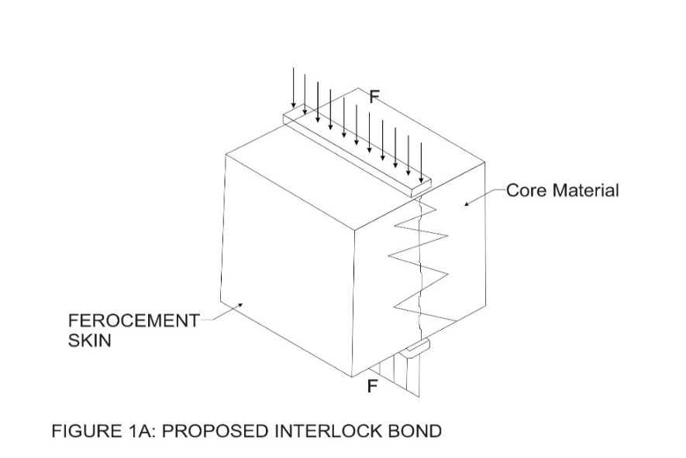

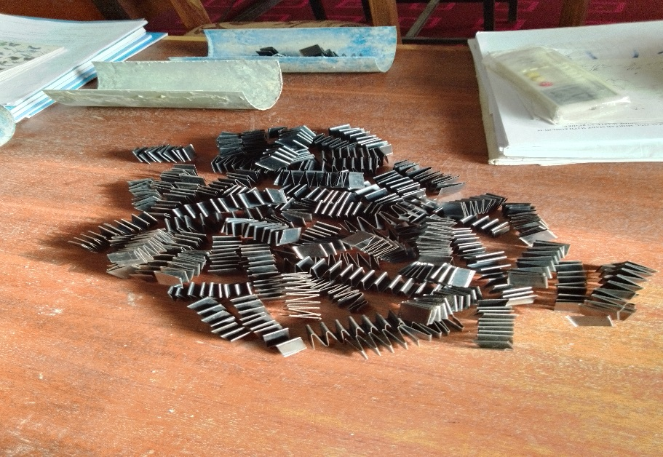
Plate I: Materials used to form interlock bond

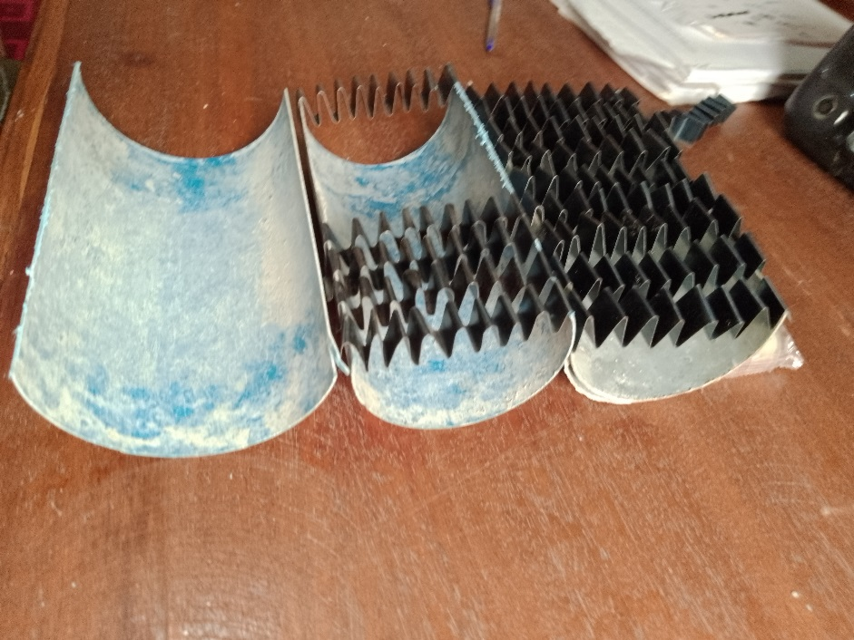
Plate II: Test specimen preparation for interlock bond

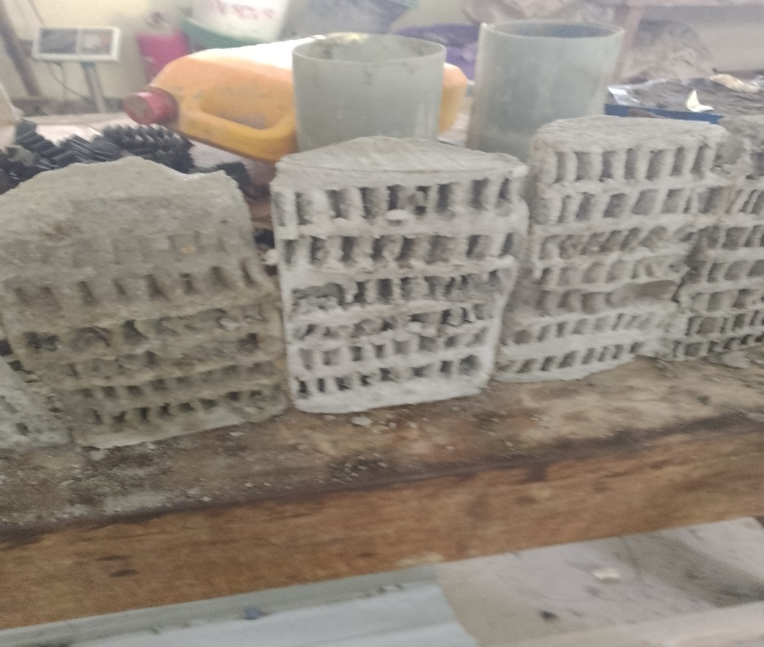
Plate III: Cast interlock bond specimen

2.3 Method
The study was conducted through experimentation in the Department of Building, Federal University of Technology, Minna, characterizing the bond strength of the Ferrocement Form simulated as test specimen Cylinders. The test cubes were crushed using a universal testing machine after each curing age. The simulated Cylinders as replicas of the Ferrocement Form were tested using an indirect tensile test method (Figure 1a and 1b) and the tensile bond strength determined using equation (1).The bond strength values of the tested samples were qualified in performance in accordance with the work of Springkel (2000).

Fct = ${2P}/{π.l.d}$ (in accordance with EN 12390-6) …………………………… (1)
Where,
f_{ct} is the tensile bond strength (N/mm²),
P = Maximum crushing load (kN),
L = length of contact line (mm),
d = cross section size (mm)
The effect of test parameters (types of core and Ferrocement skin materials) on the bond strength of the Form were not evaluated. Bond analysis was performed using simple statistics of mean, standard deviation and coefficient of variation (COV) on the sample specimens tested and the results related to compressive strength of the Mixes. The bond strength values were also characterized in accordance with the work of Springkel (2000), to the type of bond (plane and interlock) and optimum results obtained.

- Results and discussion
3.1 Test results
From the test results of the study, the bond strength show that the basic phenomenon for a bond at an interface of two different materials is adhesion which develops with curing age of the parent concrete which is the ferrocement skin in this case. The bond strength development could be linked to the development of the compressive strength of the Ferrocement skin which is the parent concrete. Test results include compressive strength, Tensile strength, Bond strength and relative bond strength development for control specimens and others with both plane and interlock bond types, which were compared. Similarly, the effects of test parameters (types of Form skin and core material0 were compared. These comparisms were analyzed and discussed extensively. It should be noted that effects of mesh types, and no of layers on the bond strength were not considered as these has no effects on bond strength because ferroceemnt skin and core material both have covers.
From the test results, analysis and discussions on the test specimens, concclusions were drawn and recommendations made. Test results for all the component specimens are shown in Table 3.0. Eighteen (18 nos) specimens were tested and each recorded result is a mean of three values. Three specimens each with plane and interlock bonds were tested. Plate V show the specimens used in the study. Compressive strength, bond strength and relative bond strength development increase with increase in curing age for all the specimens tested.

Table 2.0: Test results of the strength of Specimens
Compressive strength of composites at Curing Age
Composite Specimens
Specimen Ferrocement Skin Core Material Bond strength Type Relative bond
ID Age (Days) f_{cm} (N/mm²) f_{cm} (N/mm²) Ʈ_{b} (N/mm²) of bond strength
M - M 3 10.90 10.90 1.27 Plane 0.76
(cont) 7 11.85 11.85 1.34 0.80
14 13.85 13.85 1.41 0.84
21 14.28 14.28 1.47 0.88
28 16.63 16.63 1.67 1.00
SCC₁-M₁ 3 14.20 11.00 1.40 Interlock 0.76
7 16.80 12.20 1.50 0.81
14 19.20 13.40 1.57 0.85
21 25.30 15.30 1.61 0.87
28 30.50 16.15 1.85 1.00
GM₁-GM₁ 3 13.85 13.85 1.91 Interlock 0.88
7 14.89 14.89 1.97 0.91
14 15.75 15.75 2.04 0.94
21 16.82 16.82 2.08 0.96
28 18.25 18.25 2.17 1.00
M₁ - M₁ 3 10.90 10.90 1.37 Interlock 0.81
7 11.85 11.85 1.43 0.84
14 13.85 13.85 1.47 0.86
21 14.28 14.28 1.53 0.90
28 14.63 14.63 1.70 1.00
GM₂–GM₂ 3 13.85 13.85 1.75 Plane 0.89
7 14.89 14.89 1.79 0.91
14 15.75 15.75 1.85 0.94
21 16.82 16.82 1.91 0.97
28 18.25 18.25 1.97 1.00
SCC₂-M₂ 3 14.20 11.00 1.35 Plane 0.86
7 16.80 12.20 1.46 0.93
14 19.20 13.40 1.50 0.96
21 25.30 15.30 1.53 0.98
28 30.50 16.25 1.57 1.00

3.1.1 Bond Strength
From the test results, Specimen (GM₁ – GM₁) of granite Mortar as the Ferrocement Skin and Core material and with interlock bond has the highest tensile bond strength, Ʈ b, of 2.17 N/mm².This is an increase of 9.20 % over that of same specimen but subjected to plane bond. When SCC₁ –M₁ (with interlock bond) is compared with SCC₂ – M₂ (with plane bond), the bond strength for the former improved by 15.74 % over that of the latter. This implies that the interlock bond strength has an improvement over the plane bond method. The results also show that the materials used as Ferrocement skin and Core play a vital role in the improvement of the bond.at its interface. The materials for the specimen, SCC₁–M₁, are Self-compacting concrete and mortar. The bond strength for the interlock bond was 15 % better than that with the plane bond. This could be attributed to the compressive strength of SCC acting as the Ferrocement Skin compared with strength of Mortar (which is low) that was used both as the Ferrocement Skin and the Core material for the specimen but subjected to plane bond. This is a further confirmation of the improvement of interlock bond over that of the plane bond.
The bond strength for Specimen M₁ – M₁ (with interlock bond), improved in value over same specimen (with plane Bond by a value of 2 %. In summary, specimens with interlock bond compared with same specimens with plane bond improved in bond values of 9.20 %, 15.14 % and 2.0 % respectively over values for specimens with Plane bonds. This implies that the interlock bond strength has an improvement over that for Plane bonding. When the bond strength values for specimens with Plane bond are compared with control value, GM₂-GM₂ has an improved bond value of 15.23 %, SCC₂-M₂ has a decreased value of 6.37 %. Can it be inferred that the interlock bond type is responsible for this variation or are there other hidden factors? This needs further investigation. For the granite material, it shows that when used as both Ferrocement skin and core material has better bond strength values hence it is a promising material. Figures 3a and 3b show the bond strength development for both plane and interlock bond types. It increased with increase in curing age irrespective of bond type.

3.1.2 Relative increase of bond strength
The relative development of bond strength for a test specimen is the ratio of the bond strength for a particular age to that of the bond strength at 28 days curing age. Figures 4a and 4b show the relative development of tensile bond strength for all tested specimens with both plane and interlock bonds. The relative development of a bond strength for a test specimen is the ratio of the bond strength at a particular age to that of the bond strength at 28 days of curing age. For both plane and interlock bonds. The relative bond strength for each specimen increased with curing age. The relative increase of bond strength for specimen GM₂- GM₂ is similar to that for SCC₂- M₂ Specimen. This is because of the presence of Mortar as both the Ferrocement skin and the core material for the specimen while for SCC₁ – M₁ specimen, Mortar was used as core material while SCC was used as Ferrocement Skin. Because of over-presence of Mortar, it controlled the relative strength development and secluded the effect of SCC as the Ferrocement skin on the bond strength for the composite. The relative increase in bond strength for specimen GM₁ – GM₁ (Figure 4b), with interlock bond is higher than that for any of the specimens containing Mortar. This is because the granite dust is pozzolanic and enhance strength development through its pozzolanic reaction in addition to the PC hydration unlike in Mortar that has only PC hydration and the inert sand Particles not aiding additional hydration. The relative increase in bond strength development for specimens containing SCC has a slight edge over that containing solely Mortar(Figure 4a). Again, this is because SCC often contain additives which are pozzolanic and hence with its pozzolanic reaction, will improve relative bond strength development in addition to the PC hydration in the Mortar Mix.

Figure 3a: Bond strength versus curing Age for Plane bond specimens

Figure 3b: Bond strength versus curing Age for Interlock bond specimens

Figure 4a: Relative bond strength versus curing Age for Plane bond specimens

Figure 4b: Relative bond strength versus curing Age for Interlock bond Specimens

3.1.3 Failure Pattern of Specimens
The failure of specimen samples occurred through interface failure. Most of the common interface failure mode occurred within the core material transition zone (CTZ). This type of interface failure mode was characterized by a thin layer of the core material added to the Ferrocement skin. Therefore, failure occurred principally in the micro-concrete materials for the SCC₁ – M₁ and GM₁ – GM₁ specimens, the interface failure mode was observed both in the core material transition zone and in Ferrocement Skin. This indicates a strong adhesion of the matrix SCC in the Ferrocement skin and the Mortar matrix which served as the core material.
3.1.4 Quality of tensile bond strength
The Tensile bond strength of composite materials differs. Works from researches has shown that tensile bond strength of composite maaterials has values ranging from 2.54 N/mm² to 3.47 N/mm² depending on compressive strength of the composite materials, interface type and nature of surface of materials. The work of Springkel and Ozyilidirim (2000) shows that the interfacial bond strength test results of composite materials can be classified as shown In Table 3.0. Based on this classification, in the test specimen (QM₁ – GM₁), the bond strength value of 2.17 N/mm² at 28 days curing age is an excellent bond. The entire test results is shown in Table 3.0.

Table 3.0: Quality of Tensile bond strength of tested specimens.
s/no specimen ID Curing age (days) Bond strength (N/mm²) Remark
1. M – M (cont) 28 1.67 good
2. SCC₁ – M₁ 28 1.85 Very good
3. GM₁ – GM₁ 28 2.17 Excellent
4. M₁ – M₁ 28 1.70 very good
5. GM₂ – GM₂ 28 1.97 Very good
6. SCC₂ – M₂ 28 1.57 GOOD

- Conclusion
It was attempted to evaluate the bond strength between Ferrocement Skin and Core material of Ferroceement Form with a view towards its improvement. The feat was achieved by subjecting plane and interlock bonds of composite specimens simulated as Cylinders of varying materials such as Mortar, SCC, and Granite dust mortar. Cubes were cast and compressive strength determined from Mixes prepared from these Materials as Ferrocement Skin and core materials. From Cylinders cast, cured up to 28 Days using same Mixes, the tensile bond strengths were determined. Test results were analyzed and discussed fully and making reference to relevant literature. Summary of the findings include:
The bond strength of tested Specimens ranged from 1.57 N/mm² to 1.97 N/mm² for plane bond and 1.70 N/mm² to 2.17 N/mm² for interlock bond. The bond strength and relative bond strength development increase with curing age confirming the fact that bond strength is related to the compressive strength of the composite Specimens tested. The bond strength and relative bond strength development increase with increase in curing age. Bond strength of interlock bonding improved by 9 – 15 % over that of plane bonding. Therefore, it can be concluded that:
The bond strength of Ferrocement Form when interlocked improved by 9 to 15 % over that of plane bonding
The bond strength quality of Ferrocement Form ranged from good to excellent performance.
Granite Mortar can be used as a Ferrocement Skin and Core material for optimal strength.

REFERENCES
1 American Concrete Institute, ACI Committee 549 – IR- 88 (2006). Guide for the design,
Construction and repair of Ferrocement ; Manual of concrete Practice (P. 30).
Farmington Hill; American concrete Institute, ACI Committee 549 – IR- 88.
2. National Academy of Sciences (1973). Ferrocement applications in developing
Countries. A report of an adhoc Panel of the advisory committee on Technology for
International Development; Office of the foreign secretary, Washington, DC.
3. Naaman, A.E. (2000). Ferrocement and laminated cementitious composites; MI Techno
Press. Naaman, A.E. (1979). Performance criteria for ferrocement; Journal of
ferrocement, 9(2), 75 – 91.
5. Yogendran, V; Langan, B.W; Naque, M.N; and Wand, M.A. (1987). Silica Fume in
High Strength concrete. ACI MATERIALS JOURRNAL 87(51), 124 – 129.
6. Korany, Y.S. (1996). Repairing reinforced concrete columns using ferrocement
Laminates M.Sc. thesis submitted to the American university in cairo, Egypt, 151p.
7. AL- rifaei, W.N. and Hassan, A.H. (1994). Structural behavior of thin Ferrocement one-
Way bending elements. Journal of ferrocement, 24 (2), 115 – 126.
8. Frith, Y; Vidal, T; Turatsinze, A. and Pons, G. Flexural and shear behavior of steel fiber
Reinforced SCC Beams: KSCE J. Civ. Eng. 17(6), pp 1383 – 1393 (2013).
9. Geol, S; Singh, S.P; and Singh, P. Flexural fatique strength and failure Probability of
Self Compacting fibre reinforced concrete beams” Eng. Struct. 40, pp 131 – 140, (2012).
10. Rosenthal, I and Bijuger, F. (1985). Bending behavior of ferrocement-Reinforced
Concrete Composite, Journal of ferrocement, 15, no 1, 15 – 24.
11. Sandowicz, M. and graboski, j. 1985. Application of ferrocement channel elements to
Hou Sing. Proceeding of the second International symposium on ferrocement,
international Ferrocement center, Bangkok. 493 – 505.
12. Mays G.C. and Barnes, R.A. (1995). Ferrocement permanent Formwork as protection to
Reinforced concrete. Journal of Ferrocement, 25, no 4, 331 – 345.
13. Roa, P.K; and Rooa, V,J. 919870. Development and application of composite precast
Ferrocement and concrete roofing/flooring system. Proceedings of the first international
Conference on structural science and engineering, India.
.14. Abdel, T.A; (2012). Development of permanent Formwork for Beams using ferrocement
Laminates, Ph.D.Thesis submitted to Menoufia university, Egypt.
15. Fahmy, E.H; SHAHEEN, Y.B.I; abou, zeid, M.N; and Gaafar, H.M; (2013).
Ferrocemnet Sandwich and Hollow core Panels for Floor construction. Canadian journal
of civil Engineering, 39(12), 1297 - 1310.
16. EFNARC, (2005). The European project Group (2005). The European Guidelines for
Self -Compacting concrete. SCC European Project Group.
17. Apeh, J. A; and Ameh, J.E; (2020). Properties of steel fiber self- compacting concrete
In Corporating Quarry dust fine powder. Challenge Journal of Concrete research Letters,
11(1) (2020) 1 – 10.
18. Springkel, MM and Ozyilidirim, C (2000). Evaluation of High performance concrete
Overlays placed on Route 60 Overy hynnaven inlet, Virginia.
19. Sarkar, J. (2010). Characterization of the bond strength between ultra high performance
concrete Bridge deck Overlays and concrete substrate. Master of Science in Civil
Engineering, Michigan technological University.
20. Harris, DK, Sarkar J. and Aliborn, TM (2011). Interface bond characterization of Ultra-
high- Performance concrete Overlays. Paper presented at the transportation research
Board.

