**Hydration behaviour and properties of binary blended rice husk ash cement paste**

J A Apeh

Department of Building, School of Environmental Technology, Federal University of Technology, Minna, Nigeria. [apehjoe@futminna.edu.ng](mailto:apehjoe@futminna.edu.ng)

**Abstract**

For the hydration process of Rice Husk Ash (RHA) – cement blended mixtures to be fully explored and understood, the degrees of Cement, RHA-Cement reactions, non-evaporated water and free-lime contents as well as fresh properties and compressive strengths were determined at varying ages. Mixes of PC and RHA-PC blended cement pastes at replacement levels of 0, 5, 10, 15, 20, 25, 30, 35, 40 45 and 50 % respectively, by mass of PC labelled as PC, 5RHA-PC, 10RHA-PC, 15RHA-PC, 20RHA-PC, 25RHA-PC, 30HA-PC, 35RHA-PC, 40RHA-PC, 45RHA-PC and 50RHA-PC at a constant W/b ratio of 0.50 were used for this study. From the aforementioned mixes, fresh properties such as water of consistency and setting times were determined. Mortar cubes (50 x 50 x 50 mm) were cast and cured at 7, 14, 21, 28, 56 and 90 days and compressive strength determined at each aforementioned test age, then, there was stop hydration of the crushed specimens by immersion in a mixture of methanol to acetone (1:1) for one hour, filtered and dried for two hours. The sample was crushed and sieved through a 75μm sieve. Non- evaporable water content was determined by the loss on ignition method as well as free- lime content by the glycerol/ethanol method for each mix at same curing ages. PC and PC – RHA mixes were compared. Test results showed that water of consistency and setting times increased gradually with the addition of RHA as it replaced PC. Furthermore, compressive strength increased steadily up to 28 days and then gradually up to 90 days for the PC, but for the blended (RHA-PC) mixes, equating and surpassing control mix values at ages after 28 days for pastes with RHA less than 30 % replacement of PC. This is attributed to pozzolanic reactions with Ca (OH)2 liberated from cement hydration at later ages in addition to the cement hydration at early ages. For pastes containing RHA more than 30 % of PC, compressive strength was less than control values attributed to dilution effect. The trend in behavior for the non- evaporable water content is same with compressive strength but the free – lime content steadily increased up to 28 days and gradually with increase in RHA content up to 90 days for the PC paste, but for RHA-PC Pastes, they increased up to 56 days and then decreased up to 90 days. These results could enhance modelling of the behavior of RHA-PC blended cement paste. **Key words: Rice Husk Ash, compressive strength, Non-evaporable water content, Degree of hydration, Hydration behavior and Free-lime content.**

**Introduction**

In the course of cement production, the formation of its clinker content leads to generation of energy which cause global warming and emission of carbon dioxide (Co2) into the atmosphere. To overcome these negative impact it is imperative to reduce or replace the clinker content with supplementary cementitious materials (SCMs) and the use of rice husk ash (RHA) for such purpose cannot be over emphasized. RHA produced from incineration of rice husk and used as SCM has attracted the attention of researchers in recent times. Rich in Silica (SiO2), when added to concrete or mortar is known to improve both mechanical and durability properties (Nguyen *et al*, 2016). The work of (Yang *et al*, 2015)showed that the high Silica content of RHA in amorphous state at ambient temperatures of about 40oC in the presence of water reacts with Ca(OH)2 to form Calcium silicate hydrate gel, apart from the C-S-H produced on hydration of PC which accounts for additional increase in strength especially at later ages of curing.

RHA, an agricultural by – product is most available in all parts of the world with high silica content (Uzal and Turanli, 2012). The silica content of RHA is mostly amorphous when obtained by incineration of the rice husk at 600 – 800oC at controlled environment; has high specific surface area which give rise to the pozzolanic activity**.**This option of production is preferable as RHA produced from field burning (uncontrolled environment) has high carbon content and highly crystalline which negatively affects concrete performance due to its low reactivity. Furthermore,

incinerating conditions also influence the quality of RHA, especially in amorphous state which finds application in structural concrete. When incinerated under controlled conditions, about 50 % cellulose and 25 – 30 % Legnin are removed leaving behind amorphous silica. Its purity depends on percentage presence of unburnt Carbon. The work of Nehdi *et al* (2003), Ahmed and Adam (2007) showed that at controlled environments, RHA produced is predominantly amorphous and hence reactive under alkaline conditions just like in hydrating cement paste.

From the work of Foong (2015), the shape of RHA Particle is irregular with micro- pores which is attributed to the burning out of the cellulose and lignin resulting to the high loss on ignition (LoI). Nguyen (2011) also showed that quality of RHA is influenced by the porous structure of ash particles and the specific surface area. For RHA to be used in structural concrete depend on some of the physical properties like specific gravity, mean particle size and its Blaine fineness. Past works (Karim *et al*, 2013; Sua- iam and Makul, 2013) showed that the specific gravity of RHA is between 2.05 – 2.53, which is relatively lower than that of PC which is between 3.10 – 3.15 (Chindaprasit, 2009), that is meant to replace partially. This implies that concrete produced with PC replaced partially by RHA will be less dense with increase in replacement level. For effectiveness of RHA, it is imperative that it has high specific area. Studies have attested to this fact (Antiohos *et al*, 2014). Furthermore, for RHA to effectively take part in pozzolanic reaction, its particle size should be below 45μm. For RHA to be used in concrete or mortar works, its oxide composition should meet ASTM C 618 provisions and its LoI meets the BS 1996 provisions. These can be achieved through grinding and incineration at controlled conditions to increase homogeneity and Pozzolanic activity. The extent of chemical reaction occurring between active constituents of a pozzolana (RHA, Ca(OH)2 and H2O) measures its pozzolanic properties. This is a very important property as it is an indicator of its ability to participate in the reaction that leads to the formation of strength in concrete. Strength development abilities is a necessary condition for any material to be considered for structural applications. Because of the high content of amorphous silica in RHA, it has high pozzolanic activity due to its high specific surface area and fineness (Lee, 2015); while RHA with high carbon content (usually obtained from uncontrolled incinerated conditions) was found to exhibit low pozzolanic activity (Cordeiro et al, 2009).

Fresh properties of concrete such as consistence is the degree of wetness or otherwise which indicates whether a concrete is workable or not through the whole process of transportation, placement, finishing without segregation. It has been shown that paste containing RHA requires more water to achieve standard consistence when compared with control samples, and the water demand increase with increase in cement replacement with RHA. This is due to the porous structure of RHA which induces a large surface area (Lee, 2015). When used as a partial replacement of PC leads to the production of cheaper materials for low cost construction. From past studies, it has been established that the use of pozzolanic materials such as RHA in partial replacement of PC improves the fresh and hardened properties of mortar and concrete. The work of (Babako and Apeh, 2020) shows that RHA content in quaternary blended cement influenced the setting times of the blended cement as well as its consistency. This is attributed to the high pozzolanic activity of RHA and its porous structure which requires more water for its hydration. The reaction of RHA with Ca (OH)2 depends on its amorphous/crystalline content and its specific surface area. Early hydration of C3s in PC to form C-S-H is enhanced by incorporation of RHA which is attributed to its high specific surface area. Furthermore, RHA due to its high fineness serves as high nucleation sites for the precipitation of hydration products, through dispersion in cement pastes. This provides a necessary environment for more homogenous denser paste for the distribution of the finer pores due to the pozzolanic reactions between RHA and Ca (OH)2. The Pozzolana plays an important role in strength development due to its fineness. At early ages, the role the pozzolana fineness plays in strength development is through micro-filler effect or cement grains dispersion or both. However, at later ages, Ca(OH)2 combines with Silica to form more C-S-H. The works of Sivakumar and Ravibaskar (2009), showed that hydration mechanisms of cement blended with RHA which contains SiO2 will react with Ca(OH)2 to produce CSH gel and since this is pozzolanic reaction is a lime consuming reaction, the paste containing RHA has a lower Ca(OH)2 content. Compared with that of control paste. Further studies on effect of RHA on hydration, is not too clear. The undisputed fact is that use of RHA as partial replacement of PC changes its micro structure development due to pozzolanic acton which is time dependent. Feng *et al* (2004) showed that at early ages, RHA addition stimulates the hydration of cement. While Nguyen et al, (2011b) were of the opinion that RHA addition slows down hydration of cement at early age. But Lee, (2015) opined that the higher alkali content of RHA compared with that for PC tends to increase the PH value of the RHA blended cement paste thus accelerating the hydration of cement and pozzolanic reaction of RHA. Evidence also showed that pozzolanic activities of RHA paste is substantial at later ages than at early ages. The increase hydration of cement with the addition of RHA at later ages can be attributed to the porous structure of RHA particles. There is indication that the degree of hydration is also affected by RHA content (Nguyen 2011). There is need to harmonize these results. Optimal dosage of RHA in concrete or mortar is an issue.

The work of (Vashney 2011) on replacement of PC with RHA in RHA-PC blended cement showed that an optimum replacement level of 15 % yielded maximum compressive strength while higher replacement level led to decrease in strength. However, (Tanghui et al, 2016) replaced PC with RHA up to 30 % and obtained higher strength in concrete compared with (PC) control values, even as early as three days. Higher strength was attained when 50 % of PC was replaced with RHA compared with control values. These discrepancies in results with RHA content used in the replacement of PC in blended cement can be attributed to the use of different W/b ratios by researchers (Fapohunda *et al*, 2017).The hydration behaviour of blended cements containing RHA contents less than and greater than 30 % PC at a w/b ratio of 0.50 is worthy of further investigation.

Cement hydration occurs when water is added to the cement powder causing the different cement components to react with water. The part of water that reacts with the cement compound becomes chemically bound forming a new compound. The degree of hydration (α) is defined as the ratio of the amount of the hydrated cement and the original cement. The work of (Juenger and Siddique, 2015) showed that the maximum amount of chemically bounded water required for the chemical system is about a quarter of the weight of the cement. This process of cement hydration is continuous and leads to the growth of reaction products in the form of crystals which makes up the cement paste.

To estimate the degree of hydration of cement paste, various approaches used are based on different principles which leads to their results not tallying with each other. Despite these draw backs, each of these methods can still be used and yield acceptable results for the degree of hydration of 100 % PC paste. However, none of them is capable of estimating the degree of hydration of binary system such as RHA blended cement system. Also, the effect of RHA content on the behavouir of PC-RHA paste is yet to be fully understood. This forms the focus of this study.

The degree of hydration of any cement paste , α is a function of the non-evaporable water, wn, c, initial mass of cement present in the sample and k which represents the mass of chemically combined water needed to fully hydrate one grain of cement as shown in Equation (1):

α = ${wn}/{ck}$ (1)

From the work of **(**Clarridge, 2011**)** which developed an expression in relation to equation (1) for DOH for either a binary, ternary or quaternary blended mix, was adopted and used for the study. The aim of the study is to investigate the effect of RHA content on the hydration behavior of RHA blended cement in terms of compressive strength, chemically bound water and free-lime content. Paste sample and 50 mm mortar cubes of 100 % PC as control and others (5 – 50 %) containing varying contents of RHA as replacement of Pc was prepared and cured for 90 days.

1. **Materials and method**

2.1 Materials

The materials used in this investigation are Portland cement (PC), Rice husk Ash (RHA) and river sharp sand (fine aggregate). PC was obtained from a local dealer of Dangote cement company, Nigeria, of grade CEM1-42.5 N. RHA was obtained from incineration of rice husk at controlled temperature of 700oC for 2 hours at Cereals research institute (NCRI) Laboratory, Bida, Niger state Nigeria. Natural clean and air-dried river sand with a specific gravity of 2.38 was used. The RHA was ground using a local mill and sieved through a 75 μm sieve. Preliminary tests were carried out and the physical and chemical properties of constituents materials used for the study are shown in Table 1 and 2 respectively.

**Table 1: Physical and chemical properties of Materials**

|  |  |  |  |  |
| --- | --- | --- | --- | --- |
| **Properties** |  | **Material (wt%** | **PC** | **RHA** |
| **Physical** |  |  |  |  |
| Specific gravity | (g/cm3) |  | 3.15 | 2.25 |
| Blaine fineness | (cm2/g) |  | 3045 | 13730 |
| Loss on ignition | (LOI) |  | 5.98 | 2.93 |
|  |  |  |  |  |
| **Chemical** |  |  |  |  |
| CaO |  |  | 64.19 | 1.11 |
| SiO2 |  |  | 19.57 | 86.75 |
| Al2O3 |  |  | 5.47 | 0.68 |
| Fe2O3 |  |  | 3.24 | 0.94 |
| MgO |  |  | 2.01 | 0.92 |
| Mn2O5 |  |  | 1.25 | 0.33 |
| Na2O |  |  | 0.20 | 0.12 |
| K2O |  |  | 0.45 | 2.37 |
| SO2 |  |  | 2.74 | 0.03 |
| P2O5 |  |  |  | 3.53 |
| TiO2 |  |  |  | 0.31 |

Figure 1 show the X- ray diffraction pattern of the RHA used in the study. It show RHA which contains high content Silica at a diffraction angle of about 23o on the theta scale in amorphous state.. Intensity peaks depicting crystalline phase is absent when scanned from 10o through 90o on the theta scale.

**2.2** Preparation of sample mixes

Sample specimens used for the study were prepared using a mix ratio of 1:3; substituting PC with RHA at 0, 5 % stepwise increase up to 50 % in accordance with provisions in (BS EN 196-1). The blended mixes were classified into two groups (5RHA-PC to 25RHA-PC and 30RHA-PC to 50RHA-PC) respectively. With the aid of a mixer, the dried constituent materials (RHA+PC) was thoroughly mixed for about 15 minutes to attain homogeneity, then kept in air – tight plastic containers for further investigation. Composition of binders is shown in Table 2.

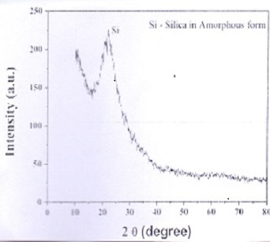

Figure 1: x –ray diffraction Pattern of Rice Husk Ash

**Table 2: Mix Proportion for binary binders**

|  |  |  |  |  |  |  |
| --- | --- | --- | --- | --- | --- | --- |
| **s/no** | **Mix ID** | **PC** | **RHA** | **Materials(kg/m3)**  **Sand** | **water** | **W/B** |
| 1 | PC (control) | 250.0 |  | 750 | 125 | 0.50 |
| 2 | 5RHA-PC | 237.5 | 12.5 | 750 | 125 | 0.50 |
| 3 | 10RHA-PC | 225.0 | 25.0 | 750 | 125 | 0.50 |
| 4 | 15RHA-PC | 212.5 | 37.50 | 750 | 125 | 0.50 |
| 5 | 20RHA-PC | 200.00 | 50.0 | 750 | 125 | 0.50 |
| 6 | 25RHA-PC | 187.50 | 62.50 | 750 | 125 | 0.50 |
| 7 | 30RHA-PC | 175.00 | 75.00 | 750 | 125 | 0.50 |
| 8 | 35RHA-PC | 162.50 | 87.50 | 750 | 125 | 0.50 |
| 9 | 40RHA-PC | 150.00 | 100.00 | 750 | 125 | 0.50 |
| 10 | 45RHA-PC | 137.50 | 112.50 | 750 | 125 | 0.50 |
| 11 | 50RHA-PC | 125.00 | 125.00 | 750 | 125 | 0.50 |

2.3 **Method**

**2.3.1** Consistency and setting times

**P**C and RHA-PC pastes were tested for consistency in accordance with provisions in (ASTM C 191). Freshly prepared pastes placed in 20 x 20 x 20 mm cube mortars in two equal layers were manually vibrated and then smoothed by a spatula. The values of consistency, setting times (initial and final) of the pastes were determined using the Vicat apparatus in accordance with provisions in (BS EN 196-3)**.** Water of consistency of the prepared pastes were determined using Equation (2):

Wc % = $L/W$ X 100 (2)

Where Wc is the water of consistency, L is the amount of water required to produce suitable Paste, and W is the mass of binder sample.

2.3.2 **Flow ability of Pastes**

The flow ability of PC and RHA-PC mortar pastes were determined using the Mortar flow table apparatus (MFTA) in accordance with provisions in (ASTM C 109). The average of two measurements for each test was recorded.

2.3.3 Compressive strength

Fresh Mortar pastes using mix proportions (Table 2) were obtained and then cast in 50 X 50 X 50 mm molds, vibrated and then kept at room temperature and relative humidity of 86 % for 24 hours. The specimens were then de-molded and cured for 7, 14, 28, 56 and 90 days respectively. Compressive strength was determined in accordance with provisions in (ASTM C 150/ASTM C150M). A set of three cubes were tested at each age using a universal compressive strength Machine with maximum capacity of 200 kN and average value recorded.

2.3.4 Degree of hydration of pastes (PC, RHA-PC)

For the PC, crushed specimens from the compressive strength test for each age were ground, dried for two hours and sieved through a 75 μm sieve. Hydration reaction was stopped by immersion in a mixture of (1:1) Methanol/Acetone for about one hour, filtered and dried for two hours. Using the ground dried sample, kinetics of hydration was evaluated accordingly. Chemically combined water content (Wn %) was determined by the ignition loss test method using equation (3):

Wn (%) = ${Wo − Wi}/{Wi − PCLOI }$ X 100 (3)

Where Wo is dried sample mass at 110oC, Wi is ignited sample at 1100oC, PCLOI is loss on ignition of PC. With known values of Wn % inserted in equation (1), DOH for PC paste was determined for all ages. However, for the RHA-PC pastes, equation (4) (Clarridge, 22011) was used as thus stated:

${Wn}/{ btot}$ = ${M110oC}/{M1100oC}$ { $\frac{Gu}{btot}$ (1 - LOIGu ) + [1 – RHALOI] } - - (4)

Where, btot is total mass of cementing binders, ${Gu}/{btot}$ is ratio of GU (same as PC) to total binder used, $\frac{RHA}{BTOT}$ is ratio of RHA to total binder used, LOIGu and LOIRHA is the loss-on-ignition values of Gu and RHA, Gu is initial mass of general purpose use cement (PC) binder, M110oC is mass of binder when oven dried, M1100oC is mass of binder when ignited at 1100oC. Similarly, using the Glycerol/Ethanol extraction approach, the total free lime content (%), was determined. The percentage free lime content was calculated. An average of two test values was recorded.

1. **Results and discussion**

3.1 **Physical and chemical properties of constituent materials**

3.1.1 Physical Properties

The chemical and physical properties of PC and RHA are shown in Table 1. The average specific gravity values shows that PC has a value of 3.15 and the value for RHA is 2.25.The specific surface area for PC is 3045 cm2/g and that of RHA is 13730 cm2/g, more than 4 times that for PC. This means that RHA particles are finer than that for PC. This implies that RHA particles occupy more space than PC and more volume of it is obtained when used to replace PC in mortar or concrete.

3.1.2 Chemical Properties

The LOI for RHA is 2.93 and 3.98 for PC (Table1).This is less than 6 % maximum stipulated in (ASTM C 618-05) for class C and F SCMs. PC value of 3.98 is slightly higher than the 3 % maximum stipulated in (BS 12). Due to fineness of RHA, it plays an important role in strength development at early age, serving as a micro filler and at later age, it combines with Ca(OH)2 to add more strength to the mortar or concrete. Furthermore, the sum of SiO2 + Al2O3 + Fe2O3 (SAF) for RHA exceeds 70 %, thus satisfied provisions in (ASTM C 618-05) for pozzolanic materials. The amount of SiO2 and Al2O3 (86.75 +0.68) = 87.43 % in RHA is an indicator of its reactive capability with the primary hydrate of cement.

**3.2 Standard consistency and setting times**

3.2.1 Standard consistency of PC and RHA-PC

The water of consistency, Wc for PC and RHA-PC cement containing varying contents of RHA is shown in figure 1a. Water of consistency, Wc, for PC is 33g and gradually increased with increase in RHA content to a value of 36g at 50 % RPC replacement. Addition of RHA increases the water for normal consistency attributed to the high content, specific surface area and fineness of RHA which requires more water for reaction. The standard consistency of PC is less compared with values for RHA-PC pastes. Consistence of mortar or concrete is the degree of wetness or otherwise which indicates whether it is workable or not throughout the whole process of transportation, placement, finishing without segregation. The work of Lapeyre and Kumar (2018) showed that paste containing RHA requires more water to achieve the standard consistence when compared with control values.



Figure 1a. Standard consistence versus RHA content



Figure 1b: setting time versus RHA content

(IST - Initial setting time, FST – Final setting time)

3.2.2 Setting time for PC and RHA-PC pastes

The initial and final setting times of the investigated pastes are shown in figure 1b. It increase progressively with RHA replacement levels. This agrees with the work of (Mar thong,2012) who attributed this behavior to the low rate of hydration in the paste containing RHA due to increase in water of consistency and setting times (initial and final) which is important in concrete or paste hydration as it determines the rate of strength development in the concrete or mortar. Figure 1b show that both setting times increase with increase in RHA content for RHA-PC concrete. The elongation of the final setting time for RHA-PC pastes is due to the formation of C-S-H from pozzolanic reaction between Ca(OH)2 and RHA which normally commences at least seven days after PC hydration and continued throughout the later ages of the curing period. Formation of C-S-H due to pozzolanic reaction forms part of the main cementing phase. Therefore, as the amount of RHA content increases, the final setting time is elongated. Figure 1c show the flow ability of PC, RHA-PC pastes against varying RHA contents. PC paste has a flow ability of 146 mm while for RHA-PC pastes, the flow ability decreases with increase in RHA content. The high specific surface area of RHA in the blended mortar required more water for lubrication of surface area and for reaction as the Pozzolan has high reactive index and thus was responsible for reduction in flow values. at 0 % RHA content, the flow ability is 146g, while at 50 % RHA content, flow ability reduces to 98g or 33%.



Figure 1c: flow ability of PC, PC-RHA

**3.3 Compressive strength**

Among concrete properties, compressive strength is one of the most important property because it is mostly used for the design of structural concrete and also as a means of compliance for field quality control. The results of compressive strength of hardened cement pastes (PC, RHA-PC), containing RHA as partial replacement of PC is shown in figures 2 and 3. Compressive strength increased with increase in curing age for all hydrated cement pastes. Compared with PC as control, strength values for 10RHA-PC and 15RHA-PC pastes are high (Figure 2). However, strength values for pastes (30RHA-PC to 50RHA-PC) are low compared with control values (Figure 3). The increase in strength values for all pastes at all hydration ages is due to the continuous formation of C-S-H Gels which continued to cement the hardened cement paste. The strength values for the blended pastes is due to PC hydration and as well as pozzolanic reactions between Ca(OH)2 and SiO2 of RHA which formed more C-S-H, while for the RHA-PC pastes with higher RHA contents (Figure 3), strength values are low compared with control values due to the reduction in cement content which led to the dilution effect. The reduction in cement content led to reduction in cement clinker (C3S) mainly responsible for high hydration. With increase in RHA content, there is more SiO2 and less Ca++ ions due to less cement content in the chemical system. This gave rise to a low $\frac{Ca++}{SiO2}$ ratio (dilution effect) which is responsible for low strength values.



Fig. 2: compressive strength versus Hydration Age

(For 5RHA-PC to 25RHA-PC)



Fig 3: Compressive strength versus Hydration Age

(For 30RHA-PC to 50RHA-PC)

**3.4 Kinetics of hydration**

Hydration mechanism of cement (PC) blended with RHA which contains a considerable amount of SiO2 reacts with Ca(OH)2 to produce the C-S-H Gel; and for the fact that the pozzolanic reaction is a lime-consuming reaction, the paste containing RHA has a lower Ca(OH)2 content than that of the pure PC paste (Sivakumar and Ravibaskar, 2009).

3.4.1 Degree of hydration (DOH)

Degree of hydration (DOH) was determined through chemically combined water values for each mix at each curing age and shown in Figures 4 and 5. For the control (PC) paste, the DOH increased with increase in hydration age due to the continuous PC hydration through the curing ages. At early ages, the DOH for PC paste was higher than that of the blended mixes containing RHA due to higher cement content and at this stage, pozzolanic reaction has not commenced in the blended mixes. However, at later ages, with pozzolanic reaction and PC hydration, more chemically combined water were consumed to form more C-S-H Gels due to the increase in hydration. For mixes with high pozzolanic (RHA) contents (30 % - 50 %) as shown in Figure 4 depicted a decline in degree of hydration which is due to the dilution effect and porous structure of RHA. Generally for these mixes (with high RHA contents), at 90 days of hydration, DOH decreased with increase in RHA content and only mixes with 10 % to 20 % RHA contents showed higher DOH



Fig. 4: Degree of hydration versus Age

(25RHA-PC to 50RHA-PC)



Fig. 5: Degree of hydration versus Age (for 5RHA to 25RHA)

3.4.2 Free- lime content (CH)

Figures 6 and 7 shows the variations in the free-lime contents for the mixes at varying hydration ages. At all ages, the control (PC) Paste showed higher free lime contents consumed compared with the blended pastes (RHA-PC). This shows that the incorporation of RHA reduced the free lime contents especially at late ages due to pozzolanic reactions for 5RHA-PC to 25RHA-PC pastes. However, for pastes (30RHA-PC to 50RHA-PC), the free lime contents consumed were much lower than control values (indication of lower hydration) attributed to the dilution effect. These results showed that for blended pastes with less than 30 % RHA content, more free lime content was consumed which increased hydration while for pastes with more than 30 % RHA content, less free lime content was consumed which accounts for lower hydration due to dilution effect. This is in conformity with the works of (Nguyen *et al*, 2016).



Fig 6: Free lime content versus hydration Age

(For 5RHA-PC to 25RHA-PC)



Fig.7: Free-lime content versus hydration Age

(For 30RHA-PC to 50RHA-PC)

3.5 **Hydration Products**

The XRD patterns of different mixtures after curing up to 90 days are presented in Figures 8, 9 and 10 respectively. The main hydration products are Calcium Silicate hydrate (CSH), Calcium hydroxide (CH) and calcium carbonate marked C. The Figures show the XRD patterns of PC and blended cement pastes made of 0, 10RHA, 20RHA and 30RHA hydrated up to 90 days. As the hydration proceeds, the peak intensity for the CH for PC (control) paste was high (due to PC hydration) while for CSH, it was low. As Curing age increases, the peak intensity for CH decreases while that for CSH increases, especially at later ages due to the pozzzolanic reactions of the active Silica and Alumina from the RHA and CH, a by- product from the continuous hydration to form CSH. This accounts for the decrease in the CH peak intensity and increase in the CSH peak intensity with increase in curing age. Peak intensity for unreacted SiO2 can also be observed and this increased with increase in PC replacement with RHA content. It is worthy to note that at later ages of curing duration, the CH produced by the continuous PC hydration was being consumed to form more CSH which accounts for more strength for the Mortar and its durability because of presence of CH which has an adverse effect on the Mortar. Traces of intensity peaks for carbonate (CO3) can be observed which is due to carbonation of hydration products. These results substantiate earlier results on compressive strength, Free- lime and combined water contents.

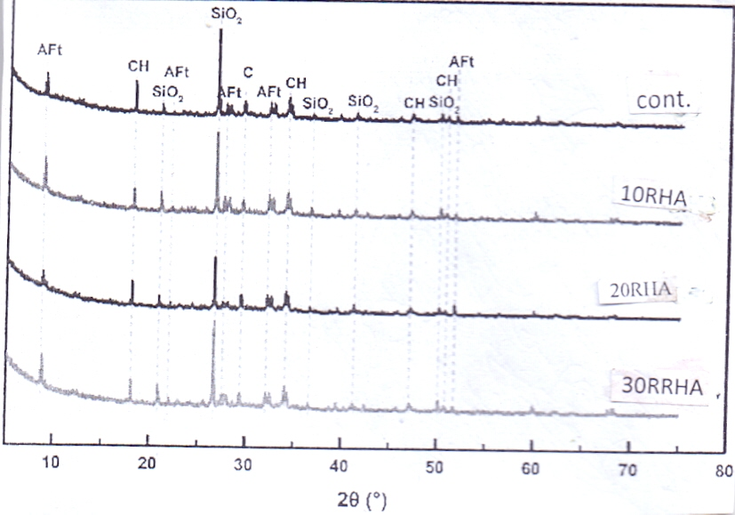

Figure 8: XRD Patterns for mixes for 56 days

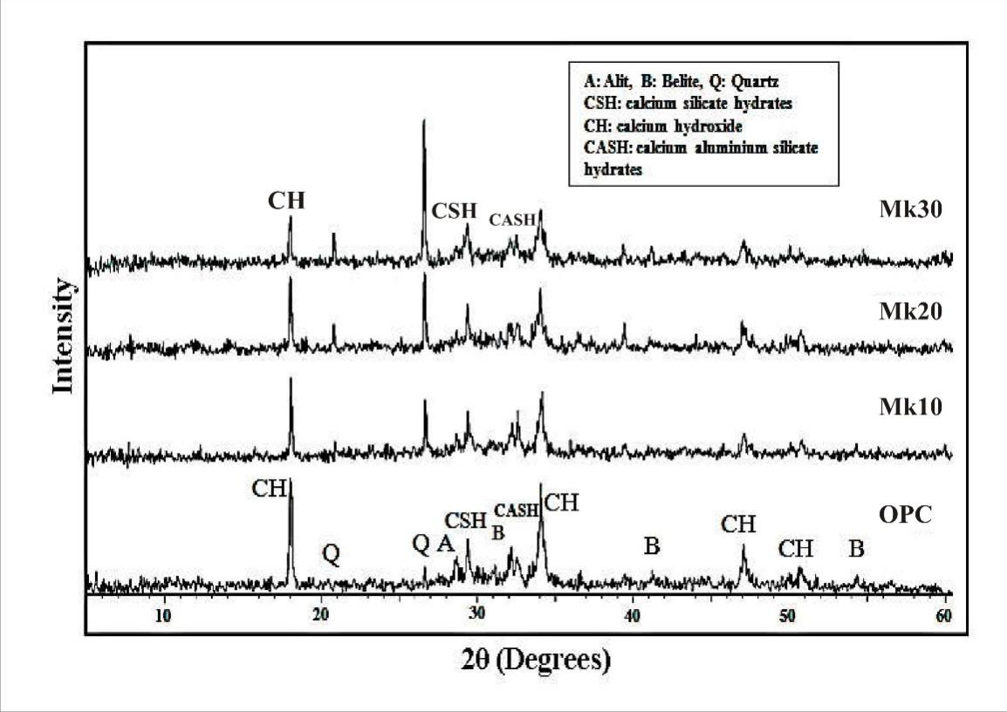

* 
* Figure 9: XRD Pattern for mixes for 90 days



1. **CONCLUSION AND RECOMMENDATIONS**

4.1 Conclusion

Hydration behavior and properties of binary blended Rice Husk Ash cement paste was studied. The results demonstrated that the inclusion of RHA content influenced the behavior and performance of the paste. From experimental test results, analysis and discussion, the following conclusions are drawn;

1 Rice husk burned at a temperature between 600 to 700oC using an appropriate incineration method will produce rice husk ash (RHA) with not less than 70 % in amorphous state and highly pozzolanic.

2. Compared with control (PC) values, blended cement pastes containing RHA requires more water to attain standard consistence and its water demand increased with increase in RHA content.

3. Hydration of blended cements containing RHA less than 30 % as replacement of PC has compressive strength which compares favorably with PC values, but decrease in strength with replacement level greater than 30 % of PC but slower in reaction.

4. Blended cements reacts with Ca(OH)2, a by- product of PC hydration to form C-S-H Gels. RHA contents greater than 30 % replacement of PC leads to low hydration of the blended cements (PC-RHA) due to dilution effect.

**4.2 Recommendation**

The slow nature of reactivity of blended cement pastes containing RHA should be investigated.

**References**

Nguyen, D. D. Devlin, L.P. Koshy, P. and Sorrell, C.C. ‘Effects of Acetic Acid on early

hydration of Portland cement .‘*Journal of Thermal Analysis and Calorimetry,* vol. 123, no 1,

pp489-499, 2016.

Yang, K.H. Jung, Y.B. Cho, M.S. and Tae, S.H. ‘Effect of Supplementary Cementitious Materials

on reduction of CO2 emissions from concrete. *Journal of Cleaner Production*, vol. 103; pp 774-

783, 2015.

Uzal, B. and Turanli, L. ‘Blended Cements containing high volume of natural Zeolites: properties,

hydration and paste microstructure ‘, Cement and concrete composites, vol. 34; no 1, pp 101-

109, 2012.

Babako and Apeh (2020): Setting time and standard consistency of Portland cement blended with

rice husk ash, Calcium carbide and Metakaolin. *IOP conference series: Materials sc. and*

*engineering*, 805; 02031 doi 10.1088/1737-899X/805/1/012031 (2020).

Varshney, H. (2016). Utilization of Rice husk ash in concrete as cement replacement. *IOSR*

*Journal of Mechanical and Civil Engineering,* 01(01), 28 – 33.

Tanghui, H. Qiang, W. Muian, L and Mutian, M. Early hydration properties of composite binder

containing Limestone powder with different fine nesses. J. Thermal Analysis Calorimetry, 123,

1141-1151, doi:10.1007/s 10973-015-5088-9. 2016.

Fapohunda, C; Akinbile, B, and Shittu, A. (2017); Structure and Properties of Mortar and Concrete

with Rice Husk ash as partial replacement of ordinary Portland Cement- a review. *International*

*journal of Sustainable Built Environment* (2017), 6, 675-692.

Juenger, M.C. and Siddique, R. (2015): Recent advances in understanding the role of

supplementary Cementitio us Materials in Concrete. *Cement Concrete Res*. 78; 71-80, doi:

10.1111/JACE. 15518

Clarridge, E. (2011): An investigation of hydration of steam-cured ternary and quaternary Cement

blends;A PhD. Thesis (Unpublished), Department of Civil Engineering, University of Toronto,

Canada, 2011.

BS EN-196-1-2016: Methods of testing cement. Determination of strength; British standards

Institution, 389 Chriswick high road, London, W4 4AL, UK.

ASTM C191 (2008): Standard method for normal consistency and setting of hydraulic cement

ASTM Annual Book of ASTM Standards, 04.01.2008.

BS EN 196-3: Methods of testing cement, determination of setting time and soundness, British

Standard Institution, London, 1999.

ASTM C 109. Standard test method for compressive strength of hydraulic cement Mortars. West

Conshoneken.

ASTM C150/C150M- 12; Standard specification for Portland cement. ASTM International.

Annual Book of ASTM standards, West Conshoneken, 2012.

ASTM C 618-05: 2008. Standard specification for coal Fly ash and raw or calcined natural

Pozzolan for use as a mineral Admixture in Concrete; American Society for Testing and

Materials International, West Conshoneken, Philadephia.

BS 12 (1996): British standard Institution; specification for Portland cement. British standard

Institution, London.

Lapeyre, I. and kumar, A. (2018): Influuence of Pozzolanic additives on Tricalcium Silicate, *J*

*. Am. Cemic. Soc*. 101, 3557-3574; doi: 10.1111/JACE. 15518.

Mar thong, C., (2012): Effect of rice husk ash concrete properties. *Int. J. Eng. Res. Technol* 10(6),

1-8.

Xiang, L. Peiyu, Y. and Aruhan, P. (2009): Assessment method of hydration degree of Cement in

complex Binder based on the Calcium hydroxide content. *J. Chinese Ceramic Soc.* 37, 1- 5.

Nguyen, V.T., Ye, G. Vau., Breugel, K., Copuoglu, O. (2016): Hydration and Microstructure of

ultra- high performance concrete incorporating Rice Husk ash. *Cem. Concr. Res.* 4(1), 1104-

1111.

.