EVALUATION OF RAINFALL EFFECT ON RICE PRODUCTION AT KATCHA

Aremu, J.K. (Ph.D.) and Usman, M.N. (B.Sc.)
Department of Geography, Nigerian Defence Academy, Kaduna

Abstract
This study analyses the relationship between rainfall and rice production in Katcha, Niger State, Nigeria. The study also described the trend of rainfall and rice production over a period between 1987 and 2011 to understand the effects of rainfall on rice production in the study area. Data on annual rainfall (mm) and rice production (t) were collected from 1987-2011 to determine the relationship between rainfall and rice production in Katcha, Niger State, Nigeria. The analytical tools used were Pearson’s Product Moment Correlation and line graph. The final result of the correlation (0.72) shows that there is significant relationship between rainfall and rice production in Katcha. It was found that rainfall has effect on rice production in the study area. The result of the findings also revealed that 1.64% (487.03mm) reduction in rainfall led to 2% (8,697.66tonnes) reduction in rice production. Therefore, strengthening farmers-extension workers relationship is paramount. It is suggested that rice varieties that can survive with good yield in adverse climatic conditions be developed by breeders to reduce rainfall effects on rice production.

Introduction
One of the most serious long-term challenges to achieve sustainable growth in rice production is climate change (Wassmann et al., 2007). Studies show that crops would respond very well to increase CO$2$ in the absence of climatic variability. The associated impacts of increased temperatures, altered pattern of rainfall and possibly high frequency of damaging events like drought and floods, would probably unite to decrease yields and increase risks in agricultural productivity in different parts of the world (Agarwal, 2008). Ahmed et al. (2009) suggested that a larger percentage of the African population will enter poverty as short-term changes in climate will increase the stress on food production. This is obvious that many farmers have been complaining of great input to less output of crop production especially rice that is very sensitive to any change in the climatic elements. Rainfall is one of the elements of weather that may determine the kind of crops to be produced in an agro-ecology. According to Boucher et al. (2011), it is a critical factor that limits potential crop yields especially in the areas of high dependent.
In Africa, where so many people rely directly on the rain for their foods and livelihoods, any changes in rainfall present a major risk (Boko et al., 2007). Indeed, the Inter-governmental Panel on Climate Change (IPCC) fourth assessment report suggest that some African countries may see yields from rain-fed agriculture fall by as much as 50% by 2020, if production practices remain unchanged (IPCC 2007). Sub-Saharan Africa (SSA) relies heavily on weather-sensitive agriculture (Stige et al., 2006). Rice production does not only need fertile soil but also favourable climate for good yield and large production. This is to say favourable climate is very essential in rice production because if not met definitely affect rice production negatively.
In Nigeria, the variation in weather and climate has led to a lot of devastating consequences and effects in various parts of the country (Odjugo, 2010). He further points out that the challenges of rainfall pattern and low yield of rice have been plaguing most of the farmers, especially rain-fed rice producing farmers in the present era of climate change in Nigeria. Rainfall is the primary source of agricultural water for cereal crop production in Nigeria (Ismaila et al., 2010). In line with this, Falkenmark opined that Rainfall plays a vital role in plant’s metabolism and nutrient intake through moisture which is being supplemented by rain water in a given area (Falkenmark et al., 2003). The inter-annual variability of rainfall particularly in the northern part of Nigeria is large, often results in climate hazards, especially floods and droughts with devastating effects on food production and associated with calamities and sufferings (Ismaila et al., 2010). Olaoye (1999) stresses further that despite the great potential of Nigeria in rice production, the frequent occurrence of drought occasioned by erratic rainfall distribution and/or cessation of rain during the growing season is the greatest hindrance to increased production and this is more serious in the northern part of the country where most of the rice and other cereals are produced.
Nigeria is a leading producer of rice in West Africa and it ranks highest as both the producer and consumer of rice in the Sub-region with figures slightly above 50% (West Africa Rice Development Association (WARDA), 1996). The demand for rice by the Nigerian populace is increasing with the increasing number of the population. This may be the reason why many farmers engage in cultivating rice provided the environment is conducive. The area for large-scale production has increased tremendously since 1989 (Singh et al., 1997). WARDA (1996) estimated a growth rate of 7.5% to 14.2% from 1983 to 1992 in Nigeria. Recent estimates by WARDA (1996); Singh et al. (1997) and Imolehin and Wada (2000) put potential areas for rice production and actual in Nigeria as 4.6 - 4.9 million ha and 1.7 million ha respectively. The increase in production may be due to an increase in land under rice cultivation and not increase in yield. However, due to the resilience of smallholder farmers and the demand for rice, production has been maintained despite the challenges of unfavourable pattern of rainfall.
Even though some researchers like Tunde et al. (2011), Aondoakaa (2012) and Ayinde et al. (2013) have carried out research on the Effects of Rainfall on Rice Production at Patigi-Kwara State, Abuja-Nigeria and Niger State respectively. No research specifically has been done in the study area on this topic. Since unfavourable pattern of rainfall has been a plaguing issue in the study area to local farmers, study like this is necessary to mitigate the adverse effects of rainfall on rice production in achieving food security in the local areas and the nation at large. The main objective of this study is to examine the relationship between rainfall and rain-fed rice production in Katcha, Niger State and the specific objectives are to determine the extent of rainfall variability in Katcha LGA from 1987-2011, determine the variation of rice production in Katcha between 1987 and 2011 and analyze the relationship between rainfall and rice production at Katcha LGA, Niger State over a period of 25 years (1987-2011) with a view of mitigating rainfall effect on rice production.

Methodology
Study Area
Katcha is a Local Government Area (LGA) in Niger State, Nigeria located on Lat. 7°08ꞌN to 9°00ꞌN of the Equator and Long. 8°02ꞌE to 9°00ꞌE of the Greenwich meridian with an area of 1681${km}^{2}$ (Niger State Bureau of Statistics, 2011). The study area is made up of ten (10) wards, namely: Bisanti, Badeggi, Essa, Kataeregi, Sidi-Saba, Dzwafu, Bakeko, Gbakogi, Edotsu, and Katcha (Fig. 1). The study area experiences two distinct dry and wet seasons with annual rainfall varying between 1100mm-1500mm (Aremu, 2004). The maximum temperature (30-38°C) is recorded between March and June, while the minimum (14-17°C) is usually between December and January of the following year in the study area (NCRI, 2012). The study area is dominated by sedimentary rocks which are characterized of sandstones and alluvial deposits, particularly along Badeggi area (Obaje, 2009). Using United States Department of Agriculture classification of soil types, five major soil types could be found in the study area. These include: Alfisols, Histosols, Mollisols, Spodosols and Ultisols (Niger state Bureau of statistics, 2011). The study area possesses relative lowland with abundant flood plains which encourages agricultural practices. The study area is one of the LGAs that provide the best area for rice growing in the state. Perhaps this may account for the location of the National Cereals Research Institute at Badeggi in the state (NCRI, 2012).

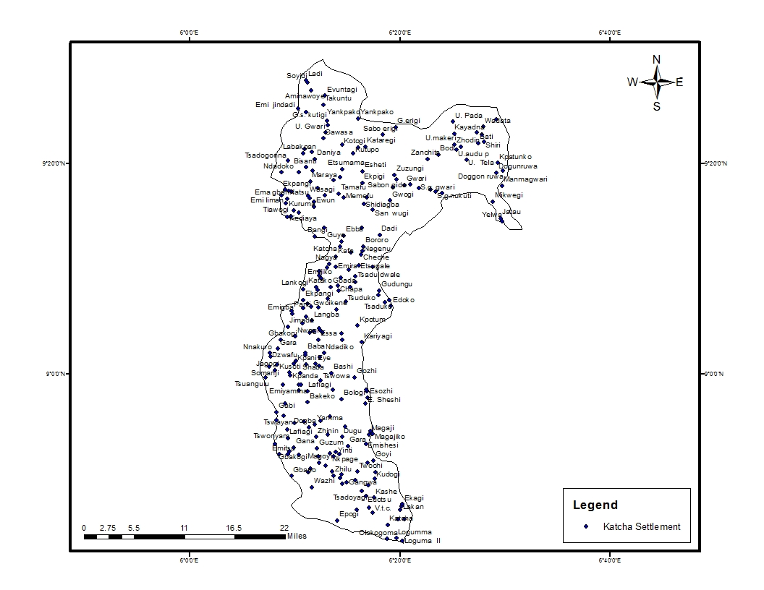
Fig. 1: Map of Katcha LGA Showing the Settlement
Source: Niger State Bureau of Statistics, 2011

Data Collection and Analysis
The data used were that of rainfall and rice production. The data on rainfall (mm) was collected from National Cereals Research Institute (NCRI), Badeggi Meteorological station. This is because the research is interested in data at micro (local) level and the meteorological station in National Cereals Research Institute (NCRI) is very close to the study area. The data on rainfall was collected on monthly basis for a period of 25years (1987-2011). The data on rice production was collected from Niger State Ministry of Agriculture and Rural Development for a period of 25years (1987-2011). The researcher used Pearson’s Product Moment Correlation.
r =
Where:
r = Correlation Coefficient
= The sum of values in x distribution
= The sum of values in y distribution
= The sum of the product of paired x and y values
= The sum of the squared values in x
= The sum of the squared values in y
n = the number of paired x and y values (Harry and Steven, 1994).
This method was adopted to show the relationship between rainfall and rice production in the study area. Line graph was used to show the trend in rainfall and rice production (fig. 3) for the period of twenty five years (1987- 2011) in the study area.

Results and Findings

The irregular pattern of rainfall in the study area during the period between 1987 and 2011 is shown in fig. 2 below. The pattern takes a zigzag shape by rising and falling (fig. 2). During the period, the annual amount recorded started with appreciable amount and rise up but fall immediately after five years. The least annual rainfall was recorded in 1992 with a decrease of 1.44% which is an equivalent of 427.64mm of rainfall. This decrease is more than the total rainfall received in every first three months of each year in the study area. The behaviour of rising and falling continues until 2009 when the peak of the rainfall amount was recorded during the period in the study area. The difference between the least and the highest rainfall was 1.98% which is an equivalent of 588.01mm of rainfall. The range was more than the half of 56% of total annual rainfall amount.

Fig. 2: Trend of Rainfall in Katcha LGA
Source: Field Work, 2016.
Relationship between Rainfall and Rice Production in Katcha

The trend of rainfall and rice production in the study area is shown in fig. 3 below. The relationship between rainfall and rice production is graphically illustrated in fig. 3. From fig. 3, there was drastic fall in the total annual rainfall of 1995 which also affected rice production. The decrease in the annual rainfall of 0.2% led to 0.23% decrease in the annual rice production compared to the immediate previous year. The decrease of 0.2% is equivalent to 59.39mm of rainfall while 0.23% is equivalent to 1000.23tonnes of rice. In the subsequent years, there was slight rise of 0.12-0.23% in rainfall amount which led to rise (0.04-0.31%) in the output of rice. After then, there was another fall of 0.33% in the annual rainfall of 1998 cropping season compared to 1996. The fall in rainfall led to a drastic decrease of 0.53% in rice production which is equivalent to 2,304.88tonnes. Another drastic decrease of 0.7% in the annual rainfall led to 1.24% decrease in rice production of 2002 cropping season. This is equivalent to 219.76mm and 5,392tonnes of rainfall and rice production respectively. The decrease of 5,392tonnes is more than half of the total annual rice production of the first seven years. This is a great shock which implies that rainfall has effect on rice production in the study area. However, the production output took a positive step forward until 2009 with an increment of 2% compared to 2002 rice production. The increase of 2% is equivalent to 8,697.66tonnes which outweigh the total annual rice production of the first seven years.

Fig. 3: Trend of Rainfall and Rice Production in Katcha
Source: Field Work, 2016.
Statistically, the data was analyzed using correlation method to show the relationship between rainfall and rice production in the study area during the period (1987-2011). The final result of the correlation gotten was 0.72 which shows that there is significant relationship between rainfall and rice production in the study area as illustrated in fig. 3. In addition, the average rainfall (mm) for the period (1987-2011) was calculated to be 1187.5mm while average rice production was 17,360t. About 64% of the total annual rainfall falls below average while 36% of the total annual rainfall rises above the average during the period as shown in fig. 2. This shows that the pattern of rainfall (fig.2) in the study area has adverse effect on rice production in Katcha.

Conclusion
From the findings of this research, it can be inferred that there is significant relationship between rainfall and rice production in Katcha. The final result of the correlation was 0.72. It was found that rainfall pattern has adverse effect on rice production in Katcha as shown by the shock which exist in the trend of rainfall and rice production (fig. 3).

Recommendations
From the result of this research, some recommendations are made to mitigate the effect of rainfall on rice production in Katcha and Nigeria at large. Strengthening farmers-extension workers relationship is paramount. It is suggested that rice varieties that can survive with good yield in adverse climatic conditions be developed by breeders to reduce rainfall effects on rice production. It is also suggested that government should be consistent in its agricultural policies such as provision of credit facilities, ban on importation of cereal crops especially rice and subsidizing agricultural inputs.

References
Agarwal, A., (2008). Forecasting Rice Yield under Climate Change Scenarios for Northeast Thailand (M.Sc. Thesis). Department of Water Engineering and Management, Asian Institute of Technology: Thailand.
Ahmed, S.A., Diffenbaugh, N.S., and Hertel, T.W., (2009). Climate Volatility Deepens Poverty Vulnerability in Developing Countries. Environ. Res. Lett. 4, 034004.
Aondoakaa, S.C., (2012). Effect of Climate Change on Agricultural Productivity in Federal Capital Territory (FCT), Abuja, Nigeria. Ethiopian Journal of Environmental Studies and Management (EJESM) Vol. 5, No.4:pp. 77-92.
Aremu, J.K., (2004). "Extreme Rain Analysis of Northern Nigeria: Implications for Agricultural Planning". Ph.D Thesis. Dept of Geog; FUT Minna.

Ayinde, O.E., Ojehomon, V.E.T., Daramola, F.S. and Falaki, A.A., (2013). Evaluation of the Effects of Climate Change on Rice Production in Niger State. Ethiopian Journal of Environmental Studies and Management Vol. 6:pp. 105- 117.
Boucher, O., G. Myhre, and Myhre, A., (2011). “Direct Human Influence of Irrigation on Atmospheric Water Vapour and Climate” Climate Dynamics, 22, pp.597–603.
Boko, M.I., A. Niang, C. Nyong, A. Vogel, M. Githeko, B. Medany, O. Elasha, R. Tabo and Yanda, P. (2007). ‘Africa’ in Climate Change 2007: Impacts, Adaptation and Vulnerability. Contribution Of Working Group II To The Fourth Assessment Report Of The Intergovernmental Panel On Climate Change, In: Parry, M.L., O.F. Canziani, J.P. Palutikof, P.J. Van der Linden and C.E. Hanson (Eds.), Cambridge University Press, Cambridge, UK.
Falkenmark, M., P. Fox, G. Persson and Rockstrom, J., (2003). Water Harvesting for Upgrading of Rain-fed Agriculture: Problems Analysis and Research Needs. SIWI Report: 11. Stockholm International Water Institute: Sweden.
Harry, F. and Steven, C.A., (1994). Statistics: Concepts and Applications. University Press: Cambridge.
Imolehin, E.D. and Wada, A.C., (2000). Meeting the Rice Production and Consumption Demands of Nigeria with Improved Technologies. International Rice Commission Newsletter, Vol. 49, FAO, Rome, pp. 23-41.
IPCC, (2007). Fourth Assessment Report of the Intergovernmental Panel on Climate Change: The Impacts, adaptation and vulnerability (Working Group III).Cambridge University Press: United Kingdom.
Ismaila, U., A.S. Gana, N.M. Tswanya and Dogara, D., (2010). Cereals Production in Nigeria: Problems, Constraints and Opportunities for Betterment. African Journal of Agricultural Research Vol. 5(12), pp. 1341-1350.
NCRI, (2012). Research Review and Planning workshop: NCRI (2012). Research Outreach Department, NCRI, Badeggi.
Niger State Bureau of Statistics, (2011 Edn). Facts and Figures on Niger State. Niger: Niger State Planning Commission.
Obaje, N.G., (2009). Geology and Mineral Resources of Nigeria (Vol. 120): Springer Verlag.
Odjugo, P.A.O., (2010). “General Overview of Climate Change Impacts in Nigeria” Journal of Hum. Ecol., 29(1): pp. 47-55.
Olaoye, O., (1999). Developing Drought Tolerant Varieties for the Savannah Agro-ecologies of Nigeria in 25th year commemorative publication of Genetic Society of Nigeria (1999), pp. 173-182.
Singh, B.N., S. Fagade, M.N. Ukwungwu, C. Williams, S.S. Jagtap, O. Oladimeji, A. Efisue, and Okhidievbie, O., (1997). Rice Growing Environments And Biophysical Constraints in Different Agroecological Zones Of Nigeria. Met. J. 2(1): pp. 35-44.
Stige, L.C., J. Stave, K.S. Chan, L. Ciannelli, N. Pettorelli, M. Glantz, H.R. Herren,
and Stenseth, N.C., (2006). The Effect of Climate Variation on Agro-Pastoral Production in Africa. Proc. Natl. Acad. Sci. U.S.A. 103, pp. 3049–3053.
Tunde, A.M., B. A. Usman and Olawepo, V.O., (2011). Effects of Climatic Variables on Crop Production in Patigi L.G.A., Kwara State, Nigeria. Journal of Geography and Regional Planning Vol. 4(14): pp. 695-700.
Wassmann, R., K. Butterbach-Bahl, and Dobermann, A., (2007). “Irrigated Rice Production Systems and Greenhouse Gas Emissions: Crop and Residue Management Trends, Climate Change Impacts and Mitigation strategies” CAB Reviews: Perspectives in Agriculture, Veterinary Science, Nutrition and Natural Resources, 2, 4-14.
West Africa Rice Development Association (WARDA), (1996). Rice Trends in Sub-Saharan Africa, Second Edition. Bouaké: WARDA.

