Isotropic and Anisotropic Variogram Models for Interpolating Monthly Mean Wind Speed Data of Six Selected Wind Stations in Nigeria

Abdullahi USMAN, James MAYAKI and Abubakar USMAN
Department of Statistics, School of Physical Sciences,
Federal University of Technology, Minna, Nigeria
Corresponding email address: - j.mayaki@futminna.edu.ng

Abstract
Mean Wind speeds often exhibit directionality in which they are increasing or decreasing across a surface; however, microclimatological effects sometimes produce high or low wind speed over a surface that can create confusion during kriging surface construction. The aim of this study was to investigate the appropriateness of anisotropic variogram models within ordinary kriging for interpolation of monthly mean wind speed data of six selected wind stations which include: Sokoto, Maiduguri, Ilorin, Ikeja, Port Harcourt and Enugu in Nigeria. Four types of isotropic and anisotropic variogram models were fitted: Linear, Spherical, Exponential, and Gaussian. Each model was described using the following parameters: the nugget variance, the sill, and the range. Three statistics to aid the interpretation of model output: the residual sum of square (RSS), R² and proportion C/(C₀+C) were provided to give the best fitted model for each wind station. The study found that the six wind stations could be best fitted by linear, Gaussian and exponential anisotropic models. Sokoto wind speed showed the strongest spatial distribution (>7.8 m/s), Maiduguri and Enugu, Ikeja and Port Harcourt showed similar wind speed patterns (3.1-4.0) m/s and (2.1-3.0) m/s respectively whereas Ilorin showed a pattern of low wind speeds (<2.0m/s). These results may assist in identifying wind stations that are suitable for exploitation of wind energy for electricity generation as well as in mitigating losses to structures due to excessive wind events.

Keywords: Anisotropic, Geostatistics; Semi variance, Wind speeds, Microclimatological

1. INTRODUCTION
Wind is the horizontal motion of air that pass-through a given point in a location and includes the direction from which the wind is coming from. Wind speed is the description of how fast the air is moving at certain point in a location. This is sometimes measured in meters per second. Wind speed, wind direction, air temperature, atmospheric pressure, humidity and solar radiation are important for monitoring and predicting weather patterns. Each of these parameters have numerous impacts on the weather and quality of life. Almost every impact of climate variation involves wind speed either directly or indirectly (Abhishek, et al. 2010; Tuller, 2004). For instance, one of the ways that air temperature variations affect objects and living organisms is through sensible heat flux density, which is a function of wind speed. According to Troccoli, et al (2012). accurate estimates of long-term linear trends of wind speed provide a useful indicator for circulation changes in the atmosphere and are invaluable for the planning and financing of wind energy.
Researches have showed that there have been comparisons of interpolation methods for temperature and precipitation, (Phillips et al., 1992; Collins and Bolstad, 1996; Goovaerts, 2000; Price et al., 2000; Jarvis and Stuart, 2001; Vicente-Serrano et al., 2003) few research efforts have been directed towards comparing the effectiveness of different spatial interpolators in predicting wind speed. Wind speed surface interpolation results suggest that deterministic methods should be avoided because they fail to account for spatial autocorrelation (Bentamy et al. 1996; Phillips et al. 1997; Sterk and Stein 1997; Venäläinen & Heikinheimo 2002; Oztopal 2006, Cellura et al. 2008; Luo et al. 2008; Zlatev et al. 2009; Akkala et al. 2010; Zlatev et al. 2010) and various forms of kriging have been shown to outperform other methods for interpolation of surface-level wind speeds (Lanza et al. 2001; Luo et al. 2008; Akkala et al. 2010; Zlatev et al. 2010). Although kriging has been shown to improve interpolation results, most previous studies that examined kriging focused on local- to regional-scale wind surfaces within a single country.
Kriging uses probability and spatial correlation to create a surface that is weighted by observed
values through a distance and direction-based semi variance function that can account for anisotropic spatial patterns and trends in wind behaviour (Luo et al. 2008). Isotropy (uniform values in all directions) is assumed during the kriging process unless anisotropy is specified. Consequently, comparisons between isotropic and anisotropic semi variogram-derived surfaces are not often made. Thus far, the use of anisotropy within kriging has been shown to be superfluous for local- and regional-scale modelling, although Luo et al. (2008) hypothesized that it may be more useful for meso- and macro-scale modelling.
In addition to issues of scale and anisotropy, the impact of heterogeneous terrain (or geographic
diversity) on wind speed interpolations is also poorly understood. Etienne and Beniston (2012)
examined extreme station data (i.e. top 10% of wind speeds) for wind storms in Europe using ‘basic’ kriging. The results found that topography greatly influences wind speeds and likely contributed to error effects not normally seen in interpolations of larger areas. Additionally, Zlatev et al. (2010) divided the United Kingdom into five areas of homogenous terrain to analyse wind speed interpolations and reduce the potential impact of over-smoothing and over fitting. Joyner et al. (2015) used cokriging to interpolate wind speeds for multiple European windstorms to account for errors associated with aspect, elevation, and land cover, further alluding to an impact of geographic diversity on wind speed interpolations.
The aim of this study was to investigate the appropriateness of anisotropic variogram models within ordinary kriging for interpolation of monthly mean wind speed data of six selected wind stations which include: Sokoto, Maiduguri, Ilorin, Ikeja, Port Harcourt and Enugu in Nigeria. Different theoretical models such as linear, spherical, exponential, and Gaussian were fitted to determine the best fitted model and finally, draw wind speed spatial distribution maps for each wind station.
2. MATERIALS AND METHODS

2.1 Study Area and Data Used
Nigeria co-ordinates on latitude 10.00ºN and longitude 8.00ºE. The climate is tropical; humid in the south and semi-arid in the north. It comprises various ecotypes and climatic zones. There
are two main seasons, namely, rainy and dry seasons. The rainy season lasts from March to November in the south and May to October in the north. During December to March, the Nigerian climate is entirely dominated by the north east trade winds, locally called "harmattan”, which originate from Sub-Tropical Anticyclones (STA). This “harmattan” is associated with the occurrence of thick dust haze and early morning fog and mist as a result of radiation cooling at night under clear skies. The climate is dominated by the influence of Tropical Maritime (TM) air mass, the Tropical Continental (TC) air mass and the Equatorial Easterlies (EE) (Ojo, 1977) in (Abiodun et al, 2011).
The monthly mean wind speed data were obtained from archives of the Nigerian Meteorological Agency (NIMET) Oshodi, Lagos, Nigeria. The data obtained covered a period of twenty-six years (1990-2015) for six stations which include: Sokoto, Maiduguri, Ilorin, Ikeja, Port Harcourt and Enugu wind stations. Figure 1 is the map of Nigeria showing the anemometer stations used in the study
Some missing entries were observed in the monthly wind speed data and were not replaced. Only one station got some missing observations. In geostatistics, data in the worksheet that are marked as missing are ignored during data builds and subsequent analyses. These values can be overridden by values specified. Permanent missing values appear as blank cells. The default missing value indicator (MVI) is the numeric value -99.0 but this can be changed in the user preferences window. Missing values appear in output files when a value cannot be interpolated
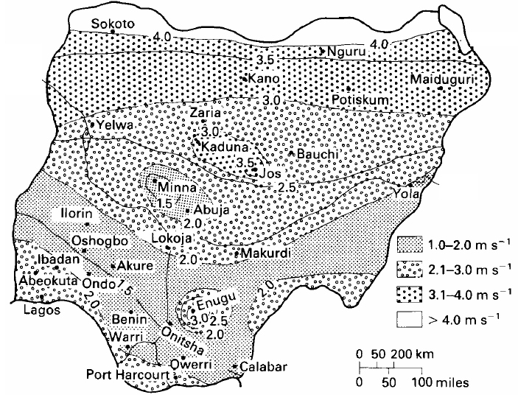
Figure 1: Nigeria annual average wind speeds distribution (isovents at 10 m height) showing four different wind speed regimes (Source: Ojosu and Salawu, 1990b)

because the location appears in an exclusive polygon or because numerical limitations disallow its computation (such as when a variogram model is inappropriately used during kriging). The examination of the monthly wind speed data indicated that they were not significantly different from a normal distribution (Figure 2).
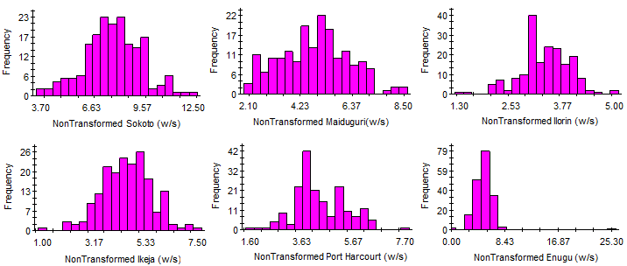
Figure 2: Non-transformed frequency distribution for the six selected wind stations
2.2. Geostatistical methods
2.2.1. Kriging
Kriging (Krige, 1966) is a stochastic technique similar to IDW, in that it uses a linear combination of weights at known points to estimate the value at an unknown point. Kriging weights are derived from a statistical model of spatial correlation expressed as semi variograms that characterize the spatial dependency and structure in the data. During surface construction, ordinary kriging was chosen to interpolate wind station data based on its superiority over other techniques (Luo et al. 2008; Akkala et al. 2010; Zlatev et al. 2010; Luo et al. 2011). Ordinary kriging is represented as
(2.1)
where, is the spatial location; is the location of measurement ; is the number of observations to consider and is a real weight.
2.2.2. Semi variance Analysis of Wind Speed Interpolation
In contrast with deterministic methods, kriging provides a solution to the problem of estimation of the surface by taking account of the spatial correlation. The spatial correlation between the measurement’s points can be quantified by means of the semi-variance function: The experimental variogram measures the average degree of dissimilarity between un-sampled values and a nearby data value and consequently can depict autocorrelation at various distances. The value of the experimental variogram for a separation distance of (referred to as the lag) is half of the average squared difference between the value at and the value at (Robinson and Metternicht, 2006):
(2.2)
where is the number of data pairs of measurement points with distance h apart. Using an analysis of experimental variogram model of ordinary kriging, a suitable four isotropic and anisotropic variogram models were fitted by different theoretical models such as spherical, exponential, linear, or Gaussian to determine three semi variogram parameters: the nugget (C₀), the sill (C₀ + C), and the range (A).
2.2.3 Accounting for Directional Influences— Anisotropic Variogram Models
There are two types of directional components that can affect the predictions in output surface: global trends and directional influences on the semi variogram or covariance (known as anisotropy). A global trend is an overriding process that affects all measurements in a deterministic manner. The global trend can be represented by a mathematical formula (e.g., a polynomial) and removed from the analysis of the measured points but added back in before predictions are made. This process is referred to as detrending
The shape of the semi variogram or covariance curve may also vary with direction (anisotropy) after the global trend is removed or if no trend exists. Anisotropy differs from the global trend because the global trend can be described by a physical process and modelled by a mathematical formula. The cause of the anisotropy (directional influence) in the semi variogram is not usually known, so it is modelled as random error. Even without knowing the cause, anisotropic influences can be quantified and accounted for.
Anisotropy is usually not a deterministic process that can be described by a single mathematical formula. It does not have a single source or influence that predictably affects all measured points. Anisotropy is a characteristic of a random process that shows higher autocorrelation in one direction than in another. For anisotropy, the shape of the semi variogram may vary with direction. Isotropy exists when the semi variogram does not vary according to direction. Isotropic variogram is a graph of semi variance against. separation distance. Where autocorrelation is present, semi variance is lower at smaller separation distances (autocorrelation is greater). This typically yields a curve such as that described in this analysis,
Anisotropic variogram models are similar to those for isotropic variograms but include directional information in the range parameter. Anisotropy refers to a direction-dependent trend in the data. The study used geometric anisotropy, i.e. anisotropy which is expressed as variograms with different ranges in different directions. The principal anisotropic axis (the major axis of the anisotropic model) is the direction with the longest range, i.e. the direction of major spatial continuity. The best way to evaluate anisotropy is to view the anisotropic semi variance surface (variogram map), and use the azimuth function to define and then set the principal anisotropic axis to the direction aligned with the lowest semi variance values (the direction of maximum spatial continuity, or major axis of the anisotropic variogram model). Anisotropic semi variograms were created during the interpolation procedure to account for directional dependence of wind speeds at varying distances, creating a spatial relationship for each direction that cannot be described by a single formula.
The principal axis is the direction of maximum spatial continuity, or base axis from which the offset angles for anisotropic analyses are calculated. Offset angles in this study are 0º, 45º, 90º, and 135º clockwise from the base axis; points aligned sufficiently close to one or another of these angles are included in the anisotropic analysis for that angle. The axis orientation should correspond to the axis of maximum spatial continuity, i.e. the major anisotropic axis. The default axis is 0º from the north-south (y) axis.
In anisotropic analyses, the offset tolerance determined how closely the alignment between any two points needs to be for those points to be included in the analysis for a given offset angle. Two points will be included in the analysis for a given offset angle if the angle between them is within the offset tolerance from the offset angle. For example, if the angle between two points is 59.3º and the offset tolerance is 15.0º, the points will be included only in the 45º angle class, which would include all angles between 30º and 60º. The default tolerance is 22.5º.

3. RESULTS AND DISCUSSION

3.1 Descriptive Spatial Statistics
The descriptive spatial statistics of monthly wind speeds for six selected stations are given in Table 1. The calculated spatial statistic included mean centre, standard distance (S_{D}), minimum and maximum, relative distance (R_{D}), skewness and kurtosis. The relative distances (R_{D}) of 66.00%, 50.73% and 50.30% were stronger, which indicated high spatial variability of wind speed for Sokoto, Maiduguri and Enugu stations respectively. While Port Harcourt, Ikeja and Ilorin stations indicated low spatial variability with R_{D} of 44.95%, 40.52% and 37.70% respectively. Sokoto in the northwest indicated the windiest station with spectacular mean centre wind speeds of 7.02 m/s. Maiduguri and Enugu are in the same mean centre region between 3.44 to 3.56 m/s and Ikeja and Port Harcourt are in the same region between 3.32 to 3.37 m/s. The monthly mean of the wind speed is relatively low in the south west cities of Ilorin (2.34m/s). Studies on the wind speed pattern across Nigeria by Adekoya and Adewale (1992) based on wind data from 30 meteorological stations and Fagbenle and Karayiannis (1994) based on wind data for 18 stations and from 1979-1988 were consistent with current study. Fagbenle and Karayiannis (1994) specifically mentioned that average wind speeds in Nigeria range from about 2 m/s to about 4 m/s with highest average speeds of about 3.5 m/s and 7.5 m/s in the south and north areas, respectively.
Table 1: Descriptive Spatial Statistics for the Six Selected Wind Stations
Station | Mean Center | S_{D} | Min | Max | R_{D} (%) | Skew | Kur
Sokoto  Maiduguri  Ilorin  Ikeja  Port Harcourt  Enugu | 7.021  3.566  2.341  3.329  3.373  3.447 | 4.634  1.809  0.906  1.349  1.516  1.734 | 3.70  2.10  1.30  1.00  1.60  0.00 | 12.50  8.50  5.00  7.50  7.70  5.30 | 66.002  50.729  37.701  40.522  44.945  50.304. | 0.000  0.120  -0.350  -0.130  0.290  -0.05 | 0.180  -0.490  0.670  0.430  0.190  0.791

The variations of wind speed across the six stations are due to some roughness of the environment surrounding the stations, variations in the height and position of anemometers, and atmospheric forcing (atmospheric circulation) changes also produce substantial effects. Bichet et al. reported that increasing the vegetation roughness length caused by increasing vegetation decreases the land wind speed. Wind speed tend to be higher at well exposed sites than at stations in the vicinity of forests, hills, mountains and other intervening structures such as high-rise buildings. The results observed here is expected since the north belongs to the arid and semi-arid ecotypes while the south is dominated by mangrove, swamp forests, tropical rainforests and guinea savanna tall grasslands Bichet et al, 2012.

Table 2: Best-fit Isotropic Variogram Models for the Six Selected Wind Stations
Station | Best-fit  Model | Nugget (C₀) | Sill  (C₀+C) | Range  A | RSS | R² | C/(C₀+C)
Sokoto  Maiduguri  Ilorin  Ikeja  Port Harcourt  Enugu | Spherical  Exponential  Exponential  Spherical  Linear  Spherical | 0.1850  1.475  0.0630  0.0640  1.0175  0.0010 | 2.6860  4.2880  0.3910  1.0940  1.0175  2.4550 | 0.1560  18.0270  0.1060  0.1420  2.7480  0.2400 | 0.618  0.547  0.029  0.085  0.059  0.840 | 0.173  0.718  0.000  0.101  0.000  0.098 | 0.931  0.656  0.839  0.941  0.000  1.000

In order to fit the best isotropic and anisotropic variogram models, three statistics to aid the interpretation of model output was provided in Table 2 & 3: residual sums of squares (RSS)–provides an exact measure of how well the model fits the variogram data; the lower the reduced sums of squares, the better the model fits. When isotropic and anisotropic variogram models were fitted, RSS chooses parameters for each of the variogram models by determining a combination of parameter values that minimizes RSS for any given model. R²–provides an indication of how well the model fits the variogram data; this value is not as sensitive or robust as the RSS value for best-fit calculations. And proportion C/(C₀+C) -- this statistic provides a measure of the proportion of sample variance (C₀+C) that is explained by spatially structured variance C. This value will be 1.0 for a variogram with no nugget variance (e.g. Enugu was one indicating the nugget variance is zero where the curve passes through the origin); conversely, it will be 0 where there is no spatially dependent variation at the range specified, (e.g. Port Harcourt was zero indicating no spatially dependent variation where there is a pure nugget effect (Table 2).
Table3: Best-fit Anisotropic Variogram Models for the Six Selected Wind Stations
Station | Best-fit  Model | Nugget (C₀) | Sill  (C₀+C) | Range A  Minor Major |  | RSS | R² | C/(C₀+C)
Sokoto  Maiduguri  Ilorin  Ikeja  Port Harcourt  Enugu | Linear  Gaussian  Exponential  Gaussian  Gaussian  Gaussian | 2.6430  1.6520  0.3600  1.0580  0.9950  2.4230 | 5.9878  8.3502  0.9560  3.5710  2.9240  11.209 | 11710.00  10.636  29.910  16.731  10.895  911.578 | 11711.00  11.135  92.640  24.872  21.806  911.578 | 10.50  11.50  0.217  2.710  1.980  1.450 | 0.171  0.406  0.134  0.150  0.243  0.059 | 0.559  0.802  0.623  0.704  0.660  0.784

The study used RSS to judge the effect of changes in model parameters. For isotropic models, spherical model was found to be the best fitted for Sokoto, Ikeja and Enugu with RSS values 0.618, 0.085 and 0.840 respectively; whereas spatial structures of Maiduguri and Ilorin were best fitted by the exponential model with RSS values 0.0.547 and 0.0.029 respectively and linear model was best fitted for Port Harcourt with RSS value 0.059 (Table 2). The corresponding isotropic variograms were given in figure 3 below.

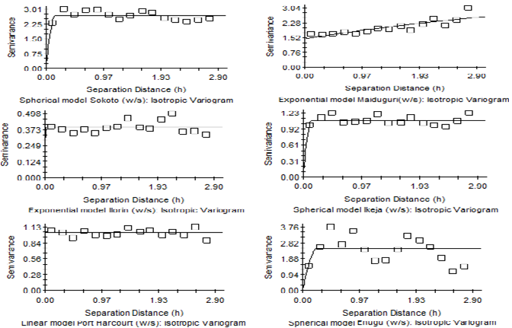
Figure 3: Best fitted Isotropic Variograms for the Six Selected Wind Stations

In other hand, for anisotropic models, linear model was found to be the best fitted for Sokoto, with RSS value 10.50; whereas spatial structures of Maiduguri, Ikeja, Port Harcourt and Enugu were best fitted by the Gaussian model with RSS values 11.50, 2.710, 1.980 and 1.450 respectively and exponential model was best fitted for Ilorin with RSS value 0.217 (Table 3).
The anisotropic variograms were fitted in four different directions. For consistency, the angles in the semi variances are between 0º and 180º, so that a value greater than 180º will appear as that value less 180º (e.g. 225º will be opposite of 90º in the semi variance). The nugget variance is the semi variance intercept of the model and can never be greater than the sill. The best-fitted isotropic and anisotropic models have low nugget variances (Figure 3 & 4). The range is the separation distance over which spatial dependence is apparent and cannot be less than 0. All values of range were greater than or equal to 0.1060m for isotropic variogram models (Table 2) and greater than or equal to range value from 10.636m to 11.135m for anisotropic variogram models (Table 3). Therefore, all the six selected wind stations had a range value greater than zero indicating existence of a spatial structure for them (Figure 3 & 4). In addition, the ordinary kriging with anisotropic produced an outline map of each wind speed within the larger interpolation grid area. Based on the Nigeria wind speeds classification, winds are classified into four different regimes: very low wind speeds (1.0-2.0 m/s), low wind speeds (2.1- 3.0 m/s), high wind speeds (3.1-4.0 m/s) and very high wind speeds (> 4.1 m/s). High wind speeds appeared in yellow and low wind speeds appeared in blue (Figure 4). The spatial distributions of Sokoto wind speed is stronger (>7.8m/s), Maiduguri and Enugu showed similar wind speed patterns (3.1-4.0m/s) and the spatial distribution of Ikeja and Port Harcourt is between (2.1-3.0m/s) whereas Ilorin showed a pattern of low wind speeds (<2.0m/s).

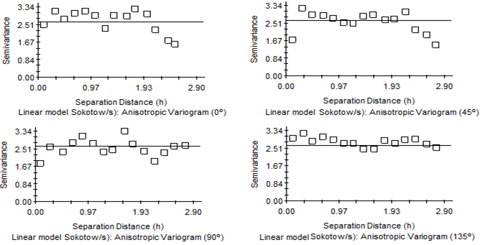

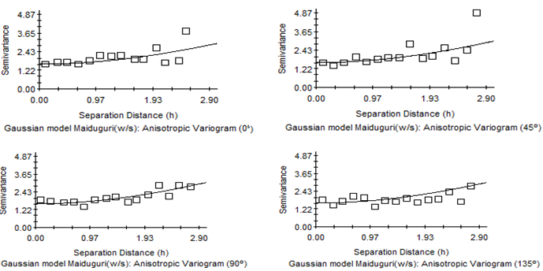

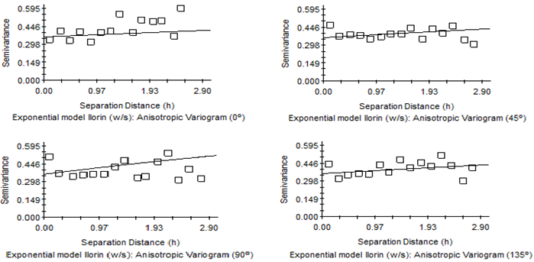

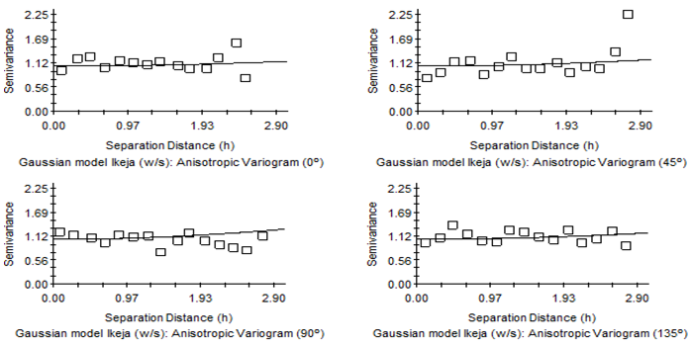

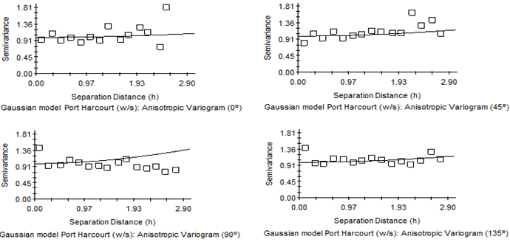
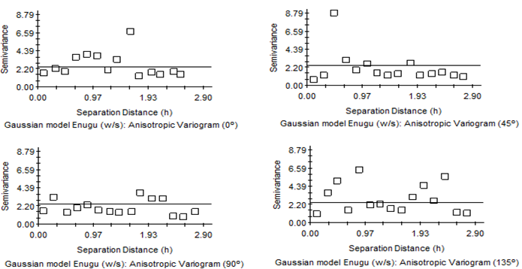
Figure 4: Best fitted anisotropic variograms in the directions N 0° E, N 45° E, N 90° E, and N 135° E with angular tolerance of 22.5 for the Six Selected Wind Stations

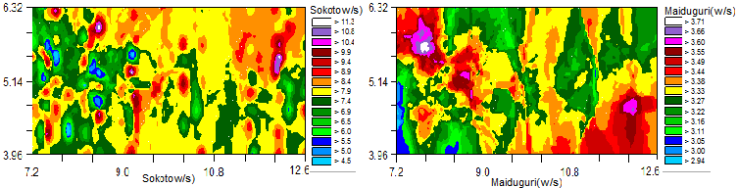

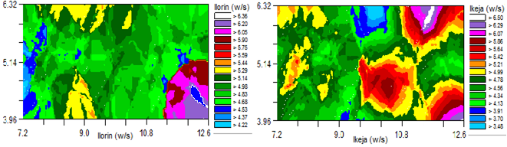
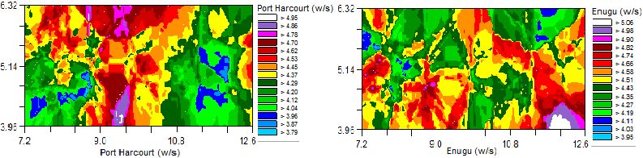Figure 5: Anisotropic kriging wind speed interpolation for six selected wind stations

The comparison between estimated and actual values of monthly wind speed for each sample station is given in figure 6. The regression coefficient described at the right corner of the graph represents a measure of the goodness of fit for the least-squares model describing the linear regression equation. A perfect 1:1 fit would have a regression coefficient (slope) of 1.00 and the best-fit line (the solid line in the graph above) would coincide with the dotted 45-degree line on the graph. The standard error refers to the standard error of the regression coefficient; the r² value is the proportion of variation explained by the best-fit line; and the y-intercept of the best-fit line is also provided. The SE Prediction term is defined as SDx(1 - r²)^{0.5} , where SD is standard deviation of the actual data (the data graphed on the y-axis).

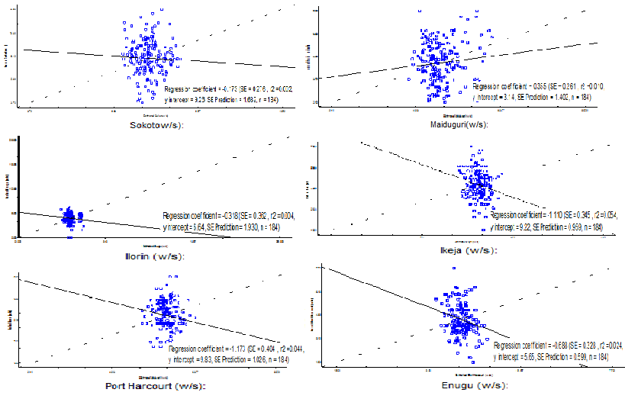
Figure 6: Comparison between actual and estimated wind speed via kriging

4. CONCLUSIONS
This study extended previous findings of Luo et al. 2008; Zlatev et al. 2009, and Carol et al. 2016 about the appropriateness of kriging for the interpolation of wind data by analysing isotropic and anisotropic semi variogram-derived kriging surfaces and evaluating a large surface across geographically diverse terrain. A geostatistical approach was applied to investigate the appropriateness of anisotropic variogram models within ordinary kriging on monthly mean wind speed data of six selected wind stations in the study areas. The calculated relative distances (R_{D}) of 66.00%, 50.73% and 50.30% were stronger, which indicated high spatial variability of wind speed for Sokoto, Maiduguri and Enugu stations respectively, whereas Port Harcourt, Ikeja and Ilorin stations indicated low spatial variability with R_{D} of 44.95%, 40.52% and 37.70% respectively. Sokoto in the northwest indicated the windiest station with spectacular mean centre wind speeds of 7.02 m/s. Maiduguri and Enugu are in the same mean centre region between 3.44 m/s to 3.56 m/s and Ikeja and Port Harcourt are in the same region between 3.32 m/s to 3.37 m/s. The monthly mean of the wind speed is relatively low in the south west cities of Ilorin (2.34m/s). The empirical semi variograms of the six wind stations could be best fitted by linear, Gaussian and exponential anisotropic models.

REFERENCES

Abiodun, B.J., Salami, A.T. and Tadross, M. (2011). Climate Change Scenarios for Nigeria:
Understanding the Bio-Physical Impacts. Climate Systems Analysis Group, Cape
Town, for Building Nigeria’s Response to Climate Change (BNRCC) Project,
Ibadan, Nigeria.

Abhishek, A., Lee, J.Y., Keener, T.C. and Yang, Y.J. (2010). Long-term wind speed variations
for Three Midwestern U.S cities. J. Air & Waste Manage. Assoc. 60, 1057 – 1064,
doi:10.3155/1047 – 3289.60.1057.

Adekoya L.O., Adewale A.A. (1992). Wind energy potential of Nigeria. Renewable Energy.
2: 35-39.

Akkala A, Devabhaktuni V, Kumar A. (2010). Interpolation techniques and associated software
for environmental data. Environ Prog Sustain Energy. 29:134_141.

Bentamy A, Quilfen Y, Gohin F, Grima N, Lenaour M, Servain J. (1996). Determination and
validation of average wind fields from ERS-1 scatterometer measurements. Newark,
NJ: International Publishers Distributor.

Bichet, A., Wild, M., Folini, D. and Schar, C. (2012). Causes for decadal variations of wind
speed over land: sensitivity studies with a global climate model. Geophysical
Research Letters, 39, L11701, doi:10.1029/ 2012GL051685.

Carol J. Friedland, T. Andrew Joyner, Carol Massarra, Robert V. Rohli, Anna M. Treviño,
Shubharoop Ghosh, Charles Huyck & Mark Weatherhead (2016): Isotropic and
anisotropic kriging approaches for interpolating surface-level wind speeds across
large, geographically diverse regions, Geomatics, Natural Hazards and Risk, DOI:
10.1080/19475705.2016.1185749

Cellura M, Cirrincione G, Marvuglia A, Miraoui A. (2008). Wind speed spatial estimation for
energy planning in Sicily: a neural kriging application. Renew Energy.
33:1251_1266.

Collins FC, Bolstad PV. (1996). A comparison of spatial interpolation techniques in
temperature estimation. In Proceedings of the Third International
Conference/Workshop on Integrating GIS and Environmental Modeling. National
Center for GeographicInformation Analysis (NCGIA): Santa Fe, NM, Santa Barbara,
CA: January 21–25.

Etienne C, Beniston M. 2012. Wind storm loss estimations in the Canton of Vaud (Western
Switzerland). Nat Hazards Earth Syst Sci. 12:3789_3798.

Fagbenle R.’L., Karayiannis T.G. 1994. On the wind energy resource of Nigeria. International
Journal of Energy Research. 18: 493-508.
Goovaerts P. (2000). Geostatistical approaches for incorporating elevation into the spatial
interpolation of rainfall. Journal of Hydrology 228: 113–129.

Lanza L, Ramirez J, Todini E. (2001). Stochastic rainfall interpolation and downscaling.
Hydrol. Earth Syst Sci. 5:139_143.

Jarvis CH, Stuart N. (2001). A comparison among strategies for interpolating maximum and
minimum daily air temperatures. Part II: the interaction between number of guiding
variables and the type of interpolation method. Journal of Applied Meteorology 40:
1075–1084.

Joyner TA, Friedland CJ, Rohli RV, Trevi~no AM, Massarra C, Paulus G. (2015). Cross-
correlation modeling of European windstorms: a cokriging approach for optimizing
surface wind estimates. Spat Stat. 13:62_75.

Krige DG. (1966). Two-dimensional weighted average trend surfaces for ore-evaluation.
Journal of the South African Institute of Mining and Metallurgy 66: 13–38.

Luo W, Taylor MC, Parker SR. (2008). A comparison of spatial interpolation methods to
estimate continuous wind speed surfaces using irregularly distributed data from
England and Wales. Int J Climatol. 28:947_959.

Luo X, Xu Y, Shi Y. (2011). Comparison of interpolation methods for spatial precipitation
under diverse orographic effects. Proceedings of the 19th International Conference
on Geoinformatics; Jun 24_26. Shanghai, China.

Ojo, O. (1977). The Climates of West Africa, Ibadan, Heinemann.

Ojosu J.O., Salawu R.I. (1990b). An evaluation of wind energy potential as a power generation
Source in Nigeria. Solar and Wind Technology. 7: 663-673.

Oztopal A. (2006). Artificial neural network approach to spatial estimation of wind velocity
data. Energy Convers Manag. 47:395_406.

Phillips DL, Lee EH, Herstrom AA, Hogsett WE, Tingey DT. (1997). Use of auxillary data for
Spatial interpolation of ozone exposure in south-eastern forest Environmetrics.
8:43_61.

Phillips DL, Dolph J, Marks D. (1992). A comparison of geostatistical procedures for spatial
analysis of precipitation in mountainous terrain. Agricultural and Forest
Meteorology 58: 119–141.

Price DT, McKenney DW, Nalder IA, Hutchinson MF, Kesteven JT. (2000). A comparison of
two statistical methods for spatial interpolation of Canadian monthly mean
climate data. Agricultural and Forest Meteorology 101: 81–94.

Robinson, T.P. and G. Metternicht, (2006). Testing the performance of spatial interpolation
techniques for mapping soil properties. J. Comput. Elect. Agric., 50: 97-106

Sterk G, Stein A. (1997). Mapping wind-blown mass transport by modelling variability in
space and time. Soil Sci Soc Am J. 61:232_239.

Troccoli, A., Muller, K., Coppin, P., Davy, R., Russell, C. and Hirsch, A.L. (2012). Long-term
wind speed trends over Australia. Journal of Climate, 25, 170 – 183.

Tuller, S.E. (2004). Measured wind speed trends on the west coast of Canada. Int. J. Clamato.
24:1359 – 1374.

Venäläinen A, Heikinheimo M. (2002). Meteorological data for agricultural applications. Phys
Chem Earth Parts A/B/C. 27:1045_1050.

Vicente-Serrano SM, Saz-Sanchez MA, Cuadrat JM. (2003). Comparative analysis of
interpolation methods in the middle Ebro Valley (Spain): application to annual
precipitation and temperature. Climate Research 24: 161–180.

Zlatev Z, Middleton SE, Veres G. (2009). Ordinary kriging for on-demand average wind
interpolation of in-situ wind sensor data. Proceedings of the EWEC 2009.
Shanghai, China.

Zlatev Z, Middleton SE, Veres G. (2010). Benchmarking knowledge-assisted kriging for
automated spatial interpolation of wind measurements. Proceedings of the 2010
13th Conference on Information Fusion (FUSION). Edinburgh, UK.

