**GEOLOGY AND INDUSTRIAL APPLICATIONS OF KWAKUTI MARBLE,**

**NORTH-WETERN NIGERIA**

**\*Olasupo, B. A. and Alabi, A. A**

Geology Department, Federal University of Technology, Minna, Nigeria

*\*Corresponding Authour: abigailomobolanle2017@gmail.com*

**Key words:** Kwakuti, Marble, calcite

**Abstract**

Carbonate sedimentary rock formed at the bottom of lakes and seas as silt and organic matter that settle from the water body to the bottom. It is formed as a result of the recrystallization of limestone. It is composed essentially of calcite (CaCO3), but it is called dolomite CaMg(CO3)2 when its magnesium content is high. Generally pure marble is composed of total CaCO3 content of between 97% - 99%, and pure dolomite is composed of 45.7% MgCO3 and 54.3% CaCO3 or 30.4% lime (CaO) and 21.8% magnesia (MgO). Despite abundant reserves of marble, not very much of the country’s marble has been properly utilized. Kwakuti marble has so far been underutilized, therefore this research will unravel geology and economic potential of the study marble. Ten (10) samples of marble were selected for analysis using XRD and XRF techniques. Comparison of the chemical composition of Kwakuti marble with typical calcitic and dolomitic marbles; the Kwakuti marble compare favourably with typical calcitic marbles from different environments. Comparing the study marble to standard and specification it revealed that the Kwakuti marble is well suitable for agricultural productions.

**Introduction**

Marble, a major raw material for industries, which results from the metamorphism of limestone, a carbonate sedimentary rock formed at the bottom of lakes and seas as silt and organic matter that settle from the water body to the bottom (Onimisi *et al.*, 2013).

Marble is a metamorphic rock derived from limestone (Onimisi and Daniel, 2014; Felix and Yomi, 2013). It is formed as a result of the recrystallization of limestone. It is composed essentially of calcite (CaCO3), but it is called dolomite CaMg(CO3)2 when its magnesium content is high. Generally pure marble is composed of total CaCO3 content of between 97% - 99%, and pure dolomite is composed of 45.7% MgCO3 and 54.3% CaCO3 or 30.4% lime (CaO) and 21.8% magnesia (MgO) (Lawrence and Donald, 1971; Byton, 1979).

Limestone, the source material for marble, forms when calcium carbonate precipitate out of water or when limestone organic debris (shells, coral, skeletons) accumulates, its usually happens at convergent tectonic plate boundary, but some marble forms when hot magma heats limestone or dolomite. The heat or pressure recrystallizes calcite in the rock, changing its texture. Over time, the crystals grow and interlock to give the rock a characteristic sugary, sparking appearance.

Despite these abundant reserves of marble, not very much of the country’s marble has not been properly utilized. This is partly due to lack of comprehensive and reliable geochemical, geotechnical, mechanical and physical data on the marble deposits, which are very important to the choice of any deposit for a particular purpose (Ako *et al*., 2012).

Kwakuti marble has been worked on by several Researchers. Fatoye and Gideon (2013), worked on Geology and Occurrences of Limestone and Marble in part of Nigeria. Kudabo (2019), worked on the petrographic and chemical characteristics of near surface Kwakuti Marble, and suggested that the marble is calcitic in nature. He also recommended further work on the subsurface study of the marble. The potential of marble in the country has not been fully utilised, due to limited study on marble (comprehensive, reliable recent geochemical data on marble occurrences in the country). Kwakuti marble has so far been underutilized, therefore this research will unravel geology and economic potential of the study marble.

The study area falls within topography map of Minna sheet 164. It lies between Latitudes of 9̊ 23'00"N to 9̊ 24'30"N and 6̊ 54'00"E to 6̊ 55'30"E The study area is accessible by Minna- Suleja Federal road and minor roads.



Figure 1: Topography map of the study Area

This study will unravel the mineralogy and chemical composition results will give insight of the possible industrial application of Kwakuti marble.

**Materials and Methods**

Materials used for this study are Garmin Global Positioning System (GPS) to locate coordinates of sample points, Geological hammer to obtain fresh rock samples, Silver compass clinometer to measure Dip and strike on the outcrops, Sample bag to carry a well labelled rock samples, Geological hand lens for magnification of minerals on the rock samples and Camera to take photographs of structures on the outcrop**.** The methods employed in this work includes work includes: field mapping and sample collection, and the laboratory work. The laboratory work includes X-Ray Flourescence (XRF) and X-Ray Diffraction (XRD).

Ten (10) representative samples were selected for analysis, the locations, elevation and coordinates of the sample obtained were taken using a Global Positioning System (GPS), samples obtained were numbered using a maker, and digital camera was used to snap outcrops and samples.

**Results and Discussion**

Kwakuti the study area consists of metamorphic rocks. These include Quartzite, Marble, Pegmatite and Amphibole Schist as shown in the geologic map (Figure 2).

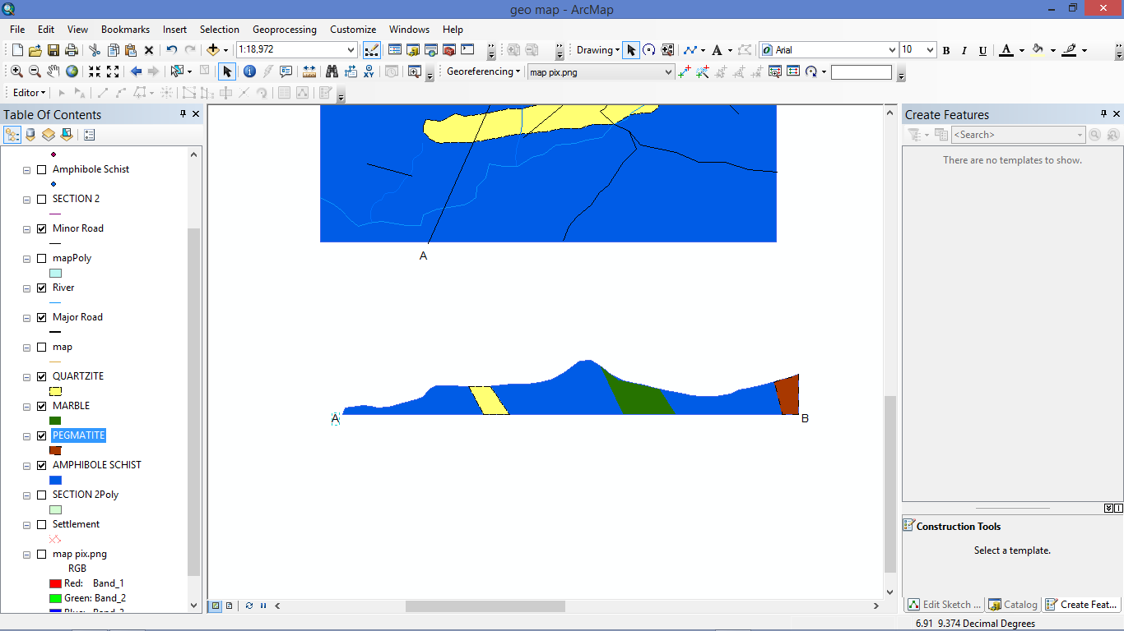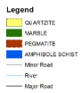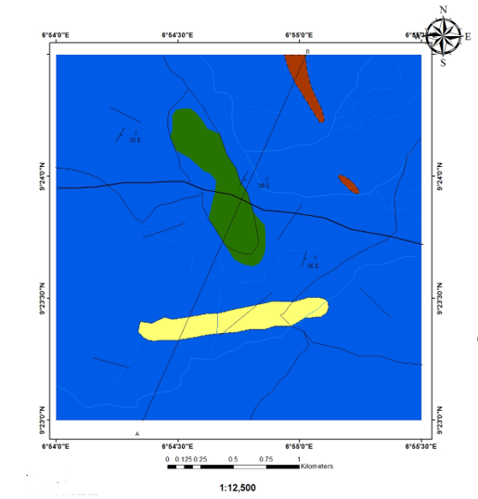

Figure 2: Geology map and cross section of Kwakuti

The major rock types in Kwakuti are Quartzite, Marble, Pegmatite and Amphibole Schist. Rocks in this area generally have a North-South trend and dip in eastern direction. The host rock is well exposed in the river Ketu plate (1). some of the rocks are highly weathered.

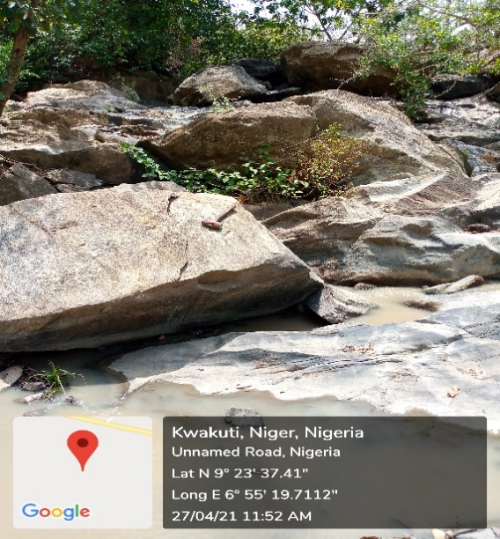 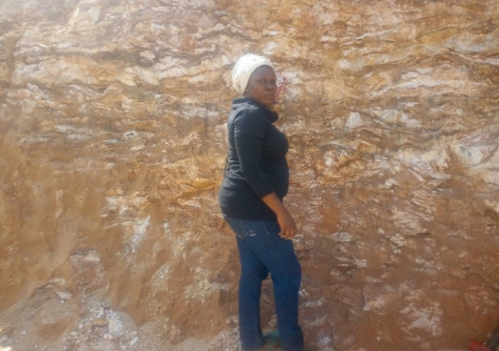

Plate I: Amphibolite along River ketu Plate II: clay overburden

The result from XRD analysis carried out on the marble, from the XRD refractogram in Figure 3, it shows that calcite (CaCO3) is the most abundant mineral of the total composition, while dolomite (CaMgCO3) is relatively low. XRD result of Kwakuti- marble also reveal the presence ofWollastonite and Akermanite which suggest the protolith be form under high temperature and low pressure in contact metamorphism of Amphibolte facies.

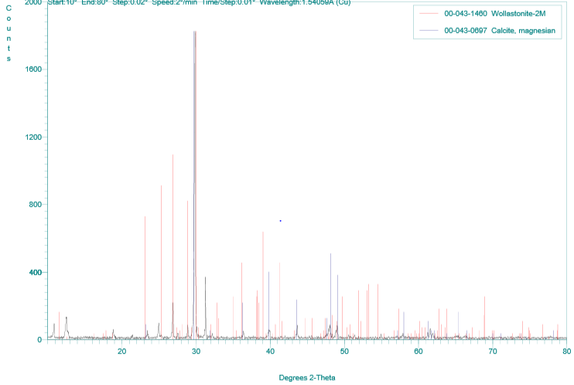

Figure 3: XRD refractogram pattern of Kwakuti marble

**X-Ray Fluorescence (XRF) Analysis Result**

The data for the major oxides, trace elements, rare earth elements of the Kwakuti marble are presented in Table 4.1, The Average and Standard Deviation of the Weight percent (Wt %) of the major element oxide of the marble. In major oxide of Kwakuti marble CaO has the value of 82.04% MgO 6.24. which makes it a calcitic marble.

The major oxides, trace elements, values of the Kwakutii marble are presented in Table 1

4.1: The major oxides value of the Kwakuti marble

|  |  |  |  |  |  |  |  |  |  |  |  |  |
| --- | --- | --- | --- | --- | --- | --- | --- | --- | --- | --- | --- | --- |
| **Oxide(wt%)** | **1** | **2** | **3** | **4** | **5** | **6** | **7** | **8** | **9** | **10** | **Range** | **Average** |
| SiO2 | 9.52 | 9.64 | 9.61 | 2.1 | 6 | 4.73 | 7.82 | 3.14 | 8.65 | 8.73 | 2.10-9.64 | 6.99 |
| Al2O3 | 1.23 | 1.74 | 1.29 | 0.6 | 0.95 | 0.93 | 1.15 | 0.58 | 1.43 | 1.01 | 0.58-1.74 | 1.1 |
| Fe2O3 | 0.49 | 0.56 | 0.39 | 0.27 | 0.36 | 0.47 | 0.49 | 0.32 | 0.67 | 0.56 | 0.27-56 | 0.46 |
| MgO | 4.49 | 4.47 | 5.7 | 0.95 | 5.49 | 3.6 | 8.29 | 9.38 | 6.08 | 13.98 | 0.95-9.38 | 6.24 |
| CaO | 81.3 | 80.13 | 79.79 | 93.03 | 84.17 | 87.28 | 79.04 | 83.22 | 79.96 | 72.43 | 72.43-93.03 | 82.04 |
| P2O5 | 0.5 | 0.49 | 0.48 | 0.56 | 0.51 | 0.57 | 0.51 | 0.51 | 0.5 | 0.42 | 0.42-0.57 | 0.5 |
| SO3 | 0.94 | 0.92 | 0.94 | 0.99 | 0.94 | 1.11 | 0.86 | 0.87 | 0.92 | 0.89 | 0.86-1.11 | 0.94 |
| MnO | 0.001 | 0 | 0 | 0 | 0 | 0 | 0 | 0 | 0.005 | 0.002 | 0.001-0.005 | 0.0008 |
| K2O | 0.05 | 0.03 | 0.04 | 0.05 | 0.34 | 0.02 | 0.02 | 0.04 | 0.06 | 0.04 | 0.02-0.07 | 0.07 |
| Na2O | 0.09 | 0.02 | 0.03 | 0.01 | 0.03 | 0.01 | 0,01 | 0,02 | 0.01 | 0.01 | 0,01-0.09 | 0.02 |
| SUM% | 98.61 | 98 | 98.27 | 98.56 | 98.79 | 98.72 | 98.19 | 98.08 | 98.29 | 98.07 | 98.0-98.7 | 98.36 |

4.2: Trace Elements, Values of the Kwakutii Marble

|  |  |  |  |  |  |  |  |  |  |  |  |  |
| --- | --- | --- | --- | --- | --- | --- | --- | --- | --- | --- | --- | --- |
| **Trace ppm** | **1** | **2** | **3** | **4** | **5** | **6** | **7** | **8** | **9** | **10** | **Range** | **Average** |
| Ni | 18.7 | 17.7 | 14.1 | 14.7 | 12.2 | 14.8 | 13.9 | 25.1 | 14.1 | 18.3 | 12. .2-25.1 | 16.36 |
| Cu | 11.4 | 11.5 | 14.2 | 8.8 | 11 | 8.5 | 14.7 | 14.2 | 13 | 18.4 | 8.5-18.4 | 12.57 |
| Zn | 23.4 | 25.1 | 32.3 | 25.7 | 23.7 | 19.2 | 24.9 | 30.6 | 27.3 | 33.6 | 19.2-33.6 | 26.58 |
| Pb | 1.3 | 0 | 0.3 | 0 | 3.2 | 0 | 0 | 2.5 | 0 | 0 | 0.3-3.2 | 0.73 |
| Ag | 0.01 | 0.08 | 0.01 | 0.02 | 0 | 0.001 | 0.01 | 0.022 | 0.009 | 0 | 0-0.08 | 0.0162 |
| Nb | 4.6 | 0 | 0 | 7.8 | 0 | 0 | 0 | 6.8 | 2.7 | 0 | 2.7-7.8 | 2.19 |
| Mo | 0.17 | 0.1 | 0.2 | 0.16 | 0.23 | 0.13 | 0.23 | 0.14 | 0.18 | 0.22 | 0.1-0.23 | 0.176 |
| Rb | 0 | 9 | 3 | 0 | 0 | 0 | 3 | 0 | 0 | 2 | 0-9 | 1.7 |
| Au | 0.0011 | 0 | 0 | 0.0045 | 0 | 0.0042 | 0 | 0 | 0 | 0.0048 | 0.0011-0.0048 | 0.00145 |

Comparison of the chemical composition of Kwakuti marble with typical calcitic and dolomitic marbles; the Kwakuti marble compare favourably with typical calcitic marbles from different environments, the high CaO and the low MgO of the Kwakuti samples is due to the calcite and dolomite is major constituents of marble and often coexist in chemical equilibrium. Lime stone of which the marble is formed is inpure lime stone, with high silica, compare to other calcitic marble, this may be attributed to the association of lime stone with the sandstone, amphibolite facie of metamorphism, presence of wollastonite in the trace element can further support this.

Figure 4.2 ternary diagram classification system for marbles from (Storey and Vos (1981) that presents the kwakuti marbles as pure calcite and silliceous dolomitic calcite with two samples plotting between pure dolomitic calcitic and siliceous calcite.

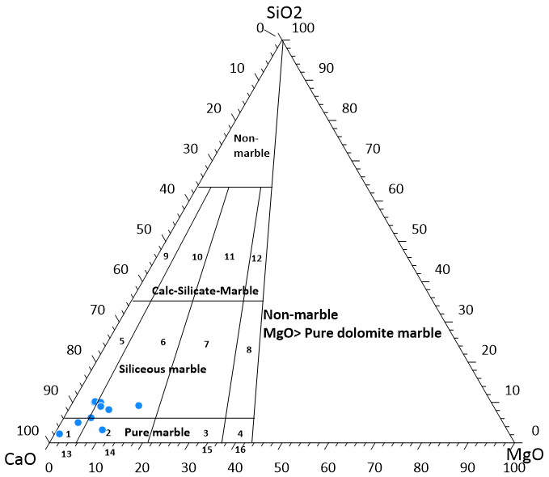

Figure 4.2 ternary diagram classification system for marbles from (Storey and Vos (1981)

**Key**

1. Pure calcite 6. Siliceous dolomitic calcite 11. Calc-silicate calcitic dolomite
2. Pure dolomitic calcite 7. Siliceous calcite dolomite 12. Calc-silicate dolomite
3. Pure calcitic dolomite 8. Siliceous dolomite 13. Calcite Marble
4. Pure dolomite 9. Calc-silicate calcite 14. Dolomite calcite marble
5. Siliceous calcite 10. Calc-silicate dolomite marble 15. Calcitic dolomite marble

16. Dolomitic Marble

**Industrial Specification for the Study Marble**

Marble has high economic values classified by 6 broad categories namely: metallurgical, chemical, environmental, construction, refractory and agriculture (Scott and Durham, 1984), each of this group requires a specification for the marble to be useful.

Table 4.5: Comparison of Kwakuti marble with specific industrial applications for uses

|  |  |  |  |  |  |  |  |  |
| --- | --- | --- | --- | --- | --- | --- | --- | --- |
| Industries |  | SiO2 | Al2O3 | Fe2O3 | MgO | CaO | P2O5 | Citations |
| Agriculture |  |  |  |  | >52 | |  | Ofulume 1993 |
| Chemical  Sodium carbonate |  | <3 |  |  | >70 | |  |  |
| Bleaching powder |  | <1.5 | AL,Fe,Mn <2 | | <2 | <90 |  | Okunola 2001 |
| Calcium carbide |  |  |  |  | <0.5 | >90 |  |  |
| Pesticide |  | <2 |  |  | <1 | >80 |  |  |
| Peper, paints,plastic |  |  | <1 | <1 |  |  | <1 | Byton19980 |
| Portland cement |  | <5 |  |  | 3-3.5 | >43 |  | Boynto and Gutvchick 1990 |
| Metallurgical |  | 1-1.5 |  |  |  | >65 |  | Okunola 2001 |
| Refractory liming |  | 2-4 |  |  |  | >58 |  |  |
| Kwakuti |  | 6.99 | 1.1 | 0.46 | 6.24 | 82.04 | 0.5 |  |

Comparing the study marble to standard and specification it revealed that the Kwakuti marble is well suitable for agricultural productions.

**REFERENCES**

Ako, T.A, Onoduku, U.S. and Abdulfatai I.A. (2012). Economic Evaluation of Burum Takalafia marble deposit, Federal Capital Territory, Abuja, Nigeria. *Research Journal of Science and IT Management,* 01, 23-32.

Boynton, R. S. (1979). Chemistry and Technology of Limestone. John Wiley and Sons Inc., New York 300.

Boynton, R. S. (1980). Chemistry and Technology of Limestone., John Wiley and Sons Inc. New York, 300.

Boynton, R.S. and Gutschick, K. A. (1990). Chemistry and technology of lime and limestone. New York, Wiley, 578p

Fatoye, B. F., & Gideon,Y.B. (2013). Geology and Occurrences of Limestones and Marble in Nigeria. *Journal of Natural Sciences Reasearch*,3(11),60-65.

Grant, N. K. (1978). Structural distinction between a metasedimentary cover and an underlying basement in the 600myr. Old Pan-African domain of Northwestern Nigeria, West Africa. *Bulletin of Geological Society of America*, 89, 50-58.

Ikudabo (2019). The Petrographic and Chemical Characteristics of Kwakuti Marble.

Ofulume, A.B., (1993). An assessment of the suitability of Jakura marble for use as flux in steel making. J. Min. Geol. 19(1) pp 1 – 9.

Okunlola, O.A. Geological and compositional investigation of Precambrian marble bodies and associated rocks in Burum and Jakura areas, Nigeria. Ph.D Thesis, University of Ibadan, Nigeria, 2001; 193.

Onimisi, M., Obaje, N. G. and Daniel, A. (2013). Geochemical and Petrogenetic Characteristics of the Marble Deposit in Itobe Area, Kogi State, Central Nigeria. *Advances in Applied Science Research*, 4, 44-57.

Scott, P.W. and Durham, A.C. (1984). Problems in the Evaluation of limestone for diverse markets. Sixth Industrial minerals international congress, Toronto, pp 1 – 21.

Storey, C.C. and Vos, M.A. Industrial Minerals of the Pembroke-Renfrew Area, Part 1: Marble; Ontario Geological Survey, Mineral Deposits Circular 21, 1981; 132