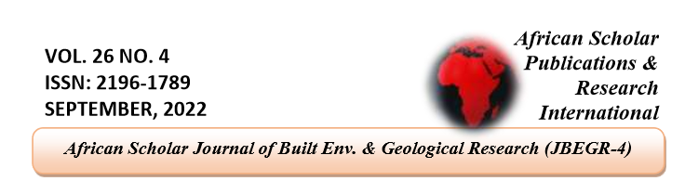

Assessment of Nupe Cultural Features in a Multmedia Studio in Bida, Niger State.

Jiya John Ninma; & Charles Makun
Department of Architecture, School of environmental technology, federal university of technology Minna, Niger state.
Abstract
The constant evolution of culture has created new hybrids between art, film, media, advertising, journalism, architecture, and many other spheres that have an impact on human culture. These hybrids sometimes call for a paradigm shift or at least challenge our cultural philosophies or ideologies. As a result of technological transformation through industrialization, most public buildings in Nigeria are beginning to lack its indigenous Architecture within their cultural context. In addition, Studies have shown that most public buildings in Nigeria are lacking indigenous people's spatial needs and cultural values and they are profound among the minority ethnic groups. As such, a public building such as a media house ought to reflect the culture of its location. This study focuses on evaluating the application of Nupe cultural features in the design of a multimedia studio in Bida. Media houses were selected randomly in Bida, Niger state to know how modernization has influenced the rich culture of the Nupe people. The research method employed in this study is the qualitative research method and the process of observation has been employed for gathering data. An observation schedule was used as an instrument for data collection and these data were sampled using the non-random sampling method. These data were analyzed through content analysis and the findings showed that the cultural feature has not been properly adopted in multimedia designs. The study concludes that a public building such as a media house should reflect the culture of its location and this can be achieved by prioritizing cultural artistic inputs on building by professionals and by extension, promoting the culture and art of its people.
KEYWORDS: Nupe cultural features, Hybrids, Public building, Multimedia.

Introduction
Cities like Barcelona, Prague, Timbuktu, and Cairo are home to magnificent architectural masterpieces steeped in culture and history (Alitheia capital, 2011). In these cities as with many others, a connection exists between building form and art from the classical tradition to the energetic and spontaneous modern art. Each movement is interpreted through paintings, sculptures, and works of architecture (Arts or The Western World, n.d.). These works of architecture, often more visible in public buildings (temples, courthouses, palaces, and civic centres), reflect the connection between the traditional architecture of centuries past and today's postmodern forms, enhancing the character and heritage of these cities and making their indigenous architecture a national symbol. Culture symbolises the structures and understanding of a specific group of people, integrating linguistic similarities, beliefs, food, collective habits, songs, and arts. (Zimmerman, 2017) Generally, Media provides an outlet for the discussion of important issues, acts as a watchdog for government, business, and other institutions, and acts as an entertainment outlet, education, and information (University of Minnesota library, 2016). The platforms available for mass media includes newspapers, radio, newspaper, magazines, books, video games, and internet media which includes blogs, podcasts, and video sharing (university of Minnesota library, 2016). All the platforms are being used by every sector of an economy all over the globe. Over time, media has affected the way we relate socially, economically and politically. In other words, we can say that the media affects our cultural values because they affect how we live and interact. It is therefore of interest to investigate and understand why indigenous architecture recognized through architectural styles, elements and building techniques which once existed from cultural and historical influences is almost extinct in Nigeria. The majority of today's building stock, especially in urban areas, are merely "functional" buildings with no reflection of the socio-cultural past. Before the coming of colonialism throughout African countries, the indigenous building forms and styles were largely a product of their environment and socio-cultural activities (Osasona, 2019). We adopted the building forms and styles and neglected our cultural values. There is a need for strategies on how cultural values can be restored through the media by architecture. Thus, the study seeks to examine the cultural features of media houses in Nigeria.

LITERATURE REVIEW
Concept and Definitions of Culture
Liman (2016) defined culture as the total of everything that contributes to the formation of practical, physical, and mental dimensions of a people's way of life. Muhammad (2015) on the hand believes culture encompasses social relations, and an unending past of shared relationships of individuals living within a communal environment. Atik et.al (2017) went further to state that culture is an intricate factor that includes awareness, trust, arts, ethics customs, and somewhat other competencies and conducts acquired by man as an associate of the social order. When all these definitions are analysed one, begins to see those cultural considerations do not stop at social gatherings, dancing, and singing but a conscious way to shape the environment within a society for the use of man to achieve comfort while enjoying these activities therefore leading to a need to plan these places of comfort for optimum enjoyment.

Elements of Culture
Lee (2016) states that language, Signs, symbols, values, norms, and social control within a society are those elements that make up culture, agreeing with this while exploring further, Franke et.al (2017) further posited that elements of culture refer to apparatuses, artifacts, skill, semantic, faith, learning, outlooks, ethics and social organization that make up a group. Brown (2018) on the other hand views elements of culture as beliefs, attitudes, artifacts, design, storytelling, rites, and symbolic actions. John (2016), Lee (2016), and Franke et.al (2017) all agree that elements of culture can be categorically grouped into Material / Non-material and primary and minor elements.

Material and non-material elements of culture
Scarpaci (2016) enthused that material culture refers to the human items, possessions, and places that individuals adopt to explain preferences from others in a cultured way. They may comprise homes, localities, capitals, colleges, cathedrals, local communes, sanctuaries, masjids, places of work, workshops and plants, tools, means of production, goods, and products. Visible sides of a culture expose its members' behaviours and view it elaborates on the ways that individuals within a certain society view and interact with that society (John, 2016). Idang, (2015), Teles da-Silva, and Farbiaz (2017) further postulate that certain things can be recognized as cultural elements only when those items have successfully given relevance to an aspect widely believed to affect the lives of individuals within a community. For example, when a rock situated in a field has no worth when converted into materials that can build a home, office, or fence. Material culture plays a significant role in architecture as it helps the architect to define, regulate and shape the design process according to the influences of the material elements within his disposal. Non-material culture refers to items, which are divine ideas that people have about their culture, including beliefs, values, rules, norms, morals, language, organizations, and institutions (Kaur and Kaur, 2016). Most times the non-material cultural concept goads toward religion, which consists of a set of ideas and beliefs about God, worship, morals, and ethics (Hicks and Beaudry, 2010). These beliefs would normally determine how people and the cultural practices within that society respond to its religious topics, issues, and events.

Concept of Cultural Identity
Identity comprehensively explains how other people within a social space can view someone. Hence, identity is all the qualities, beliefs, and ideas, which differentiate someone from another in a particular group (Madan, 2006). Some definitions of cultural identity have placed the burden of identification on the state but (Hyenen, 2009, Hyett, 2011, Rapaport and Duncan 2012) all agree that to appropriately define cultural identity the condition for identification should be the common factors within the community that binds these group of people making them recognizable as one group or another. Koivunen and Marsio, (2007) view cultural identity as the link between an individual and the public. Hayrynen (2007) agreeing with this definition elaborated further that cultural identity encompasses evident, unseen, and anticipated cultural behaviors characteristic to a particular group, which might spur a person's sensitive capabilities and behavior.

Role of architecture in cultural identity
There has to be an equilibrium between stability and break such as to permit the people to engross new advances and new demands without suffering from identity diffusion (Vale, 2012). While Bloom (2010), Rapoport and Duncan (2012) believe the made surroundings, can act as a tool to reflect cultural identity by adopting new technologies and developments Hetherington, (2017) prefers the society to have a fluid changing structure that is less impacted by the advent of new technologies and developments.

Integrating cultural identity in architecture
Building patterns, settlement arrangements, and social gathering activities are major considerations, which shape elements used in integrating cultural identity in architecture (Mangena, 2010). Likewise, a variety of factors are known to influence that contribute to the architecture of cultures such as weather, food, and language, these factors have undergone variations creating a heritage that continue to give a more developed architectural system. Dana, (2012) rightly opined that; design has become the essence to portray ideas, and driving origination and originality to achieve cultural identity. Architecture on the other hand is one of the means of cultural integration, achieved through designing buildings that have cultural elements reflected on them. Architecture as a means of cultural integration has adjusted more openly and speedily to variations in the world around, (Ozorhon, 2016). Integrating cultural identity in contemporary architecture can be achieved in multifaceted ways but a prominent method is utilizing elements from traditional architecture such as the forms prominent within the people in constructing individual buildings, building materials used in such construction, and the method or pattern of roof adopted in covering the building (Asfour, 2016). Boussa, (2017) also highlights that other means include borrowing from traditional architecture in the form of bringing to prominence historical events such as wars and arts and telling the story by painting it or making motifs of these events on the walls of the cultural centres.

Nupe Cultural Features
According to isa et. al; (2015), The basic structure of the Nupe compounds is made up of several small individual courtyard units which are linked up together by alleys. A typical compound is made up entrance hut (katamba), sleeping rooms (kata), the courtyard, (zhempa), the animal pen (ega,) the granaries (edo), the kitchen (katagi), the hearth (yekun) and the toilets and baths (shikpata). However, each culture has what it emphasizes as the basic requirement for fulfilling their daily spatial transaction. The Nupe are prolific decorators, indeed! Not only does the scope of what engages their creative attention include structures not normally classified as “architecture” (e.g. granaries), it also encompasses wall openings, structural posts, and accessories like doors and windows.
As with the Hausa, door and window openings are reinforced with earth moldings. These are further embellished with terracotta platelets – giama tetengi (Dmochowski [7]). The elaborate, generally unpainted, relief mural (both geometric and zoomorphic in motif, despite Islam being the predominant religion here, too) is hardened by the use of an infusion from locust-bean pods. (Denyer 1978). This sculptural treatment of walls is not limited to exteriors, alone: interiors – particularly wives' rooms and inner walls of encircling verandas – are similarly treated. Rooms invariably have the added dimension of enamel and porcelain plates and dishes being embedded in them. According to Osasona (2007), a particular house at Zanchita, near Bida, sports such embedded crockery around the entrance to its katamba (the reception-hut). Apart from the aspect of masonry sporting artwork, Nupe houses on a circular floor-plan could also display artistic ingenuity, within their formal configuration: the roof junction – an area of potential structural stress – in the process of being secured against structural failure, is usually also imbued with some form of ornamentation. Where a wooden plug is used to stabilize the junction, it could be carved – and used in conjunction with interesting weave-patterns of the thatch brought together at that point; alternatively, a terracotta pot – with surface incisions and other beautifying engravings – could be placed upside-down over the junction, to prevent rain-water seepage.
Complementing all other artistic endeavors already discussed, the Nupe also have recourse to the use of colour, the prevalent ones being black, red, and, more lately, white (Dmochowski 1990). These pigments are traditionally sourced from various plant extracts, earth, and animal deposits.

METHODOLOGY
Research method
The research method employed in this research is the qualitative research method. A descriptive research design is employed which is a scientific method that can be used in observing and describing the nature of a subject. The first phase included a desk study of relevant materials on cultural development. Thereafter, the research adopted a primary source of data collection for the case study stage. This includes the derivation of first-hand information with data obtained through physical observation. The researcher for the physical observation and extraction of data developed an observation guide. This was structured to enable the researcher to collect relevant information for analysis. Desk study for the research covers the review of relevant literature, reports, journals, and manuals by security bodies as well as literary works from experts on culture. Elements considered in structuring the observation guide are shown in the table below.
Table 1: Variables used in assessing the Case Studies
S/N | PARAMETERS
1 | Form of building
2 | Concept adopted
3 | Methods adopted in exhibiting the culture of the place
4 | Building materials used
5 | Accessibility to the cultural centre
Source: Author, (2022)

A no-random sampling technique was adopted in this study, which involves the intentional selection of specific samples relevant to the subject of judgement. These samples were selected to be subjected to observation by the researcher in line with the drafted observation schedule in order to extract information relevant to this study. The following are the listed samples selected to be observed as shown in table 2 below.
Table 2: list of sample media houses
S/N | PARAMETERS
1 | Newsline printing press, minna
2 | New Nigeria newspaper, kaduna
3 | Nigeria television authority minna
4 | Search fm 92.3 minna
5 | Softcom head office, lagos
6 | Heigdain world studio, Zhejiang china.
Source: Author, (2022)

DATA ANALYSIS BUILDING FORM
The building forms involve the shape and configuration of a building on site. The media centers observed showed that the building forms used in the designs were all rectangular as shown in Table 1 and Figure 1 respectively.

Table 3: list of sample media houses
Names | Present | Absent
Newsline printing press,
New Nigeria newspaper
Heigdain world studio
Nigeria television authority
Search fm 92.3 minna
Softcom head office

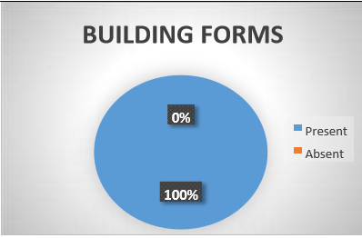
Figure 1: building form within the observed media houses.
CONCEPT ADOPTED.
Zeayther and Mansour, (2017) on their part postulate that concept involves the presentation of an idea in a simple and logical order. The table and figure below shows that there were no defined concept used in the designs

Table 4: list of sample media houses
Names | Present | Absent
Newsline printing press,
New Nigeria newspaper
Heigdain world studio
Nigeria television authority
Search fm 92.3 minna
Softcom head office

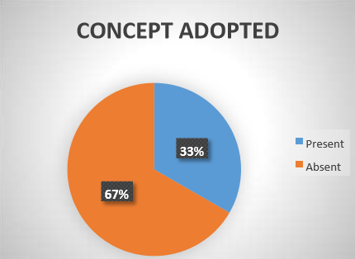
Figure 2: Building concept within the observed media houses.
METHODS ADOPTED IN EXHIBITING THE CULTURE OF THE PLACE
The cultural method adopted entails the cultural identity adopted. The table and chart below show that 67% of the buildings observed adopted the cultural identity of their location.
Table 5: list of sample media houses
Names | Present | Absent
Newsline printing press
New Nigeria newspaper
Heigdain world studio
Nigeria television authority
Search fm 92.3 minna
Softcom head office

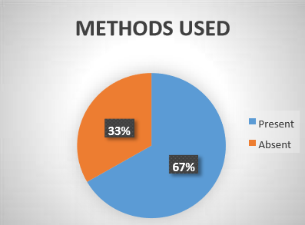

Figure 3: Building concept within the observed media houses.

BUILDING MATERIALS USED. Building materials are the materials used in the construction of a building. The media house observed showed that 67% of buildings lack the usage of building material of the location.
Contemporary building materials were used for construction.
Table 6: list of sample media houses
Names | Present | Absent
Newsline printing press
New Nigeria newspaper
Heigdain world studio
Nigeria television authority
Search fm 92.3 minna
Softcom head office
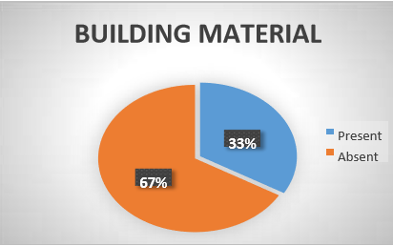

Figure 4: building materials used.
ACCESSIBILITY TO THE CULTURAL CENTRE.
Accessibility involves the proximity of the building to people and how they can easily gain access it. It is noticed that the buildings shown in the table and chart below are quite accessible.
Table 7: list of sample media houses
Names | Present | Absent
Newsline printing press
New Nigeria newspaper
Heigdain world studio
Nigeria television authority
Search fm 92.3 minna
Softcom head office
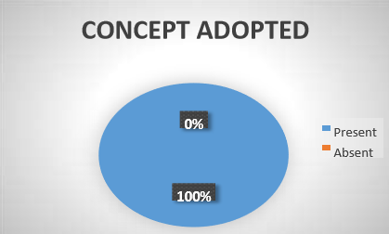

Figure 5: building materials used.
FINDINGS
Case studies undertaken within Nigeria and other countries showed that cultural identity can be achieved in architectural proposals by adopting cultural elements such as decorations on walls i.e. motifs, symbols in the form of conceptual adoption, and building materials from the area's traditional architecture and methods of construction. The study concluded that strategies, which can be adopted by architects to express cultural identity in their work, include integrating popular elements of the place under study. For the Nupe people, these include the circular and rectangular house form, the use of local building materials and construction techniques, the masks popular amongst the local traditions, the tribal masks and murals, and paintings on walls seen in one of the gates to the entrance of a traditional ruler.

CONCLUSION AND RECOMMENDATIONS
It is the view of this research that the following recommendations if properly adhered to can help to develop a cultural center with a properly infused identity of the place they are to be located. I) Architects should as the case of professionalism investigate and explore the cultural elements of the place in which they intend to propose to appropriately understand and portray the culture of the place.
1. Every culture should be encouraged to develop, research, and document all aspects of its culture to guide against loss of cultural identity and set a standard that can be referred to by future generations.
2. Media centre which remains a place of enlightenment, and social interaction while serving as a media centre should exhibit on its façade aspects of the architecture of the past and present so that it serves as a constant reminder to the people of their culture and cultural identity.
3. Cultural studies should be encouraged from the start of architecture programs in higher institutions of learning in the form of compulsory electives and group studio works to have a pool of knowledge amongst training architects who already are knowledgeable about requirements for culturally related designs.

References
Alitheia capital. (2011, July). Where is the "indigenous Nigerian Architecture"? Volume 17.
Aliyu, S. O., Isa, M. B., & Momoh, S. A. (2018). integration of cultural values in the design of event centre in minna, niger state, Nigeria. ABTU Journal of environmental technology. Arts or The Western World. (n.d.). Retrieved from www.learner.org/resoures/series
Asfour, O.S. (2016) Bridging the Gap between the Past and the Present: A Reconsideration of Mosque Architectural Elements. Journal of Islamic Architecture, 4(2) 77-85.

Askarizad, R. (2019) Influence of Socio-Cultural Factors on the Formation of Architectural Spaces, (Case Study: Historical Residential Houses in Iran). A Journal of Urban Planning & Design and Architecture JUPDA 1(2), 44-54.
Atik, M., Işıklı, R. C., Ortaçeşme, V., and Yıldırım, E. (2017). Exploring a combination of objective and subjective assessment in landscape classification: Side case from Turkey. Applied Geography, 83, 130-140.
Boussa, D. (2017). Urban Regeneration and the Search for Identity in Historic Cities. Sustainability, 10(2) 48. Retrieved from http://dx.doi.org/10.3390/su10010048 on 07/03/2020
Bloom, W. (2010) Personal Identity, National Identity, and International Relations. Revised Edition Cambridge University Press.
Dana, I. (2012). Rediscovering Culture: The Unexplored Dimension of European Democratic Identity. Journal for communication and culture. 2(1) 88-104
Denyer, S., African Traditional Architecture, Heinemann: New York, p. 144, 1978.
Dmochowski, Z.R., An Introduction to Nigerian Traditional Architecture, 2, Ethnographica Ltd.: London, p. 3.20, 1990.
Dmochowski, Z. R., An Introduction to Nigerian Traditional Architecture, 2, Ethnographica Ltd.: London, p. 3.22, 1990.
Finch, P, (2015). Architecture Can Create Identity. Architect’s Journal. (208) 27.
Franke, R. H., Hofstede, G., and Bond, M. H. (2017). National culture and economic growth. The Blackwell handbook of cross cultural management, 5-15.
Hetherington, K. (2018) Expressions of Identity: Space, Performance, Politics. 6th Edition London: Sage.
Hicks, D and Beaudry, M.C, (2010). Introduction. Material Culture Studies: A Reactionary View. The Oxford Handbook of Material Culture Studies. Oxford: Oxford University Press. 1-21.
Idang, G.E, (2015) African Culture and Values. University of South Africa Press. UNISA 16(2) 97-111.
Kaur, A, Kaur, M, (2016) The Study of Components of Culture: Values, Norms, Material Objects, Language and Culture Change. International Journal of Science Technology and Management IJSTM 5(12) 140-152.
Lee, J. A. (2016): The Essential Morphological basis for Human Culture. Current Anthropology 4: 297.
Liman, S. H. (2016). Traditional Mechanism to Eliminate Violence against Women: A Perspective from Nigeria. Journal of Islamic Studies and Culture, 4(1), 82-89.
Mangena, C.N. (2010). The Integration of Local Cultural Identity and Tradition into Built Environment: A Case of Cultural Centre in Lobamba, Swaziland. Unpublished MSc Thesis submitted to the University of KwaZulu-Natal Durban, South Africa. minnesota, u. o. (2016). understanding media and culture: an introduction to mass communication. minneapolis, mn.
Memmott, P., and Keys, C. (2016). The emergence of an architectural anthropology in Aboriginal Australia: The Work of the Aboriginal Environments Research Centre. Architectural Theory Review, 21(2), 218-236.
Muhammad, I. B. (2015). The Cultural Landscape Values of a Nupe Community in Nigeria Unpublished Doctoral Dissertation submitted to Universiti Teknologi Malaysia.
Osasona, C. O. (2007). Indigenous art and Nigerian contemporary. WIT Transactions on The Built Environment,, 95, 129-139.
Osasona, C. O. (2019). Indigeous art and Nigerian contemporary residential architecture. Structural studies, repairs and naintenance of heritage architecture X, Volume 95, 129-139. doi:q0.2495/STR07131
Scarpaci, J. (2016). Introductory Essay Material Culture and the Meaning of Objects. Material culture. 48. (1) 1-9.

Teles da Silva, J, Farbiarz, J.L (2017) Creating from Natural Materials: Huni Kuin Material Culture. Strategic Design Research Journal. 10(1) 47-56.
Thomas, D. C., and Peterson, M. F. (2016). Cross-cultural management: Essential concepts. Sage Publications.
Zeayter, H., and Mansour, A. M. H. (2018). Heritage conservation ideologies analysis–Historic urban Landscape Approach for a Mediterranean Historic City Case Study. HBRC journal, 14(3), 345356.
Zimmermann K.A (2017) what is Culture? www.livescience.com. Retrieved on 15/10/2019.

