FUNDING URBAN MANAGEMENT IN POOR COUNTRIES: A CASE OF MINNA, NIGERIA

BY

ALIYU M KAWU & GIDEON S OWOYELE

Department of Urban and Regional Planning

Federal University of Technology, Minna 920003, Nigeria

(+2348068015046, geokaws@yahoo.com); (+2348065686012, owoyele4real@yahoo.com)

Abstract
Urban areas in developing countries are daily faced with a number of problems which has remained obstacles to their development and the wellbeing of their people especially the poor. This paper emphasizes the roles of city authorities in urban management especially the funding of infrastructure which have become engines of urban growth and sustainability. Current and possible avenues for the generation of funds needed for functional urban infrastructure are explored here. In doing this, specific highlight on the various avenues usually overlooked by the city authorities and which when well explored as in developed countries of today can sustain cities and the nation at large, were looked into.
Keywords: development / infrastructure / management / sustainability / urban

Introduction
It is normal to read or hear that local governments or even urban areas in Nigeria lack adequate resources to finance the basic needs of their people. Projects are often suspended or not implemented at all due to lack of finance. This often happen in a system where these areas mostly depend on single source of revenue for their expenditures. Human and societal needs are insatiable, but there are certain necessities of life that need to be provided for an individual or group of individuals to function properly and coherently. Rural local governments can be said to lack adequate resources to finance some physical projects due to the nature and the scale of the main socio-economic activities of their people; which is mostly in the exploitation of nature as in the different types of primary production. However, with the level of activities taking place in urban areas and the obvious advantages of economy of scale, it is quite surprising that urban areas cannot meet the needs of their people even in the basic provision of primary health care, water, education, energy and security of lives and

A PAPER PRESENTED AT THE 2ND ANNUAL CONFERENCE 2008 WITH THE THEME: PRESERVING THE ENVIRONMENT; ORGANISED BY THE SCHOOL OF ENVIRONMENTAL TECHNOLOGY, FEDERAL UNIVERSITY OF TECHNOLOGY

MINNA 920003, NIGERIA BETWEEN 27TH – 29TH FEBRUARY, 2008

property. This is not a healthy situation for the growth and development of any nation. More pathetic is the fact that these necessities of life and livelihood can be and are indeed provided by individuals and private organisations even in the least developed parts of the world, and that their continuous inadequate provision or total absence; especially water, maternal and child health care services has been a recurrent source of ill health and untimely death to millions of people especially women and children. As Hardoy, Mitlin & Satterthwaite (2001) pointed out ‘at any one time, close to half of the urban population in Africa, Asia and Latin America is suffering from one or more of the main diseases associated with inadequate provision for water and sanitation. These diseases account for a high proportion of infant and child deaths.

Research Issue
Local government authorities are charged with responsibilities which include the provision of health care, primary/basic education, sanitation, environmental protection and management, etc. These are tasks that need continuous flow of adequate resources for them to be able to discharge them effectively and efficiently. However, many of these bodies are not well financed and are also not so keen to explore other avenues to source for additional resources and carry out these fundamental tasks. Many do not have in place effective accounting system deserving of a body charged with these responsibilities. For example Mabogunje (2005:18) pointed out that …..
Most municipal authorities will agree that they have a special role in ensuring that all residents within their jurisdictions including the urban poor are well serviced, that the quality of the services provided meet appropriate standards, that they monitor and supervise the supply of these services and plan for their sustainable growth. But to live up to all of these responsibilities, they are expected to mobilize ample financial resources. However, for many reasons not unconnected with lack of transparency and corruption, most of them have not been able to mobilize internal financial resources from their citizens through taxes, rates and fees and have had to concentrate only on statutory subventions from higher levels of government. This, of course, impairs their capacity to effectively promote local economic development and inhibits them from being able to deliver much needed services to their citizens especially the poor.

Aside from the obvious low level of accountability, the local government authorities are also constrained by other factors which are daily inhibiting their ability to generate funds for their various activities. For example, lack of socio-economic data about the population they are entrusted with, unreliable population and housing census figures in terms of number of houses, revenue generating ventures, man-power needs, etc. But, perhaps the most pressing of these problems is limited knowledge about potential and existing revenue generating ventures and avenues which if well utilized will serve as a continuous source of fund for local government administration and sustainability.

This paper highlights these sources of revenue for effective and efficient local government development and administration. It emphatically gives a case study of urban local governments which are not only growing with responsibilities, but as analysis shows, are also faced with complex issues of urban management and administration.

Aim and Objectives
This paper is aimed at exploring different avenues open to city managers to generate funds and resources for the provision of urban infrastructures. This aim is achieved through a review of the functions of local government areas and a field work on available and possible avenues for the generation of needed resources for urban infrastructure provision and management.

Methodology
Sources of Data: Secondary data (e.g. text books, journals, research projects, etc.) were consulted for this work in order to draw out clear answers to the question of the functions of local government councils and their sources of finance especially urban local governments in developing countries. Primary data was sourced from the field through interviews and administration of structured questionnaires to the personnel of local government councils, business and industrial / manufacturing outlets, etc. Personal observation of completed and on-going projects was also utilized.
Mode of Data Analysis: Descriptive statistical analysis was used, using simple statistical variables like percentages and frequencies, etc.

Functions of Urban Local Government
Urban development is seen as a development effort primarily directed towards the urban sector. It is often seen as more than technological developmental programmes designed for particular target groups. Urban development is therefore a determined and conscious attempt to focus on the general uplift of man’s living conditions in the urban areas of a particular country. Most people do agreed that it is mostly concerned about the standard of living urban dwellers; and how this standard can be truly improved, lies wholly in the hands of both the government and the people especially through urban local governments; which can only function effectively when it has adequate resources.

The Local Government: Local government is the third tier of government in a federal system, and it is about the only government administrative body that is so close to the people. Post independent, Nigeria saw improvements in the structure and functions of local governments. The role assigned to local government was to provide effective programmes of economic and social growth. This was halted by the crisis of 1966-1970. The pattern of local government during the civil war was based on the principle of sole administration which replaces the local councillors; and was supported by force and the emergency situation of the period.

Before independence, local government throughout Nigeria were under the native authority system. The Oba or Emir has been a constitutional monarch ruling with the support of the council made up of title holders and representatives of certain societies. Towards 1950, the eastern regional government introduced a three tier system of local government tailored after the English and Welsh models consisting of the country (countries), the districts and the urban areas. The countries dealt with services related to education, maintenance of roads and bridges while districts were in charge of markets, dispensaries and sanitary services, local councils took charge of the maintenance of streams and footpaths. After independence; however, there has been changes and reforms in the functions and administration of local governments.

Responsibilities of Local Governments: What distinguished the 1976 local government reform from all the previous reform exercise is the formal recognition of local government as constitutional, a distinct level of government with define boundaries; clearly stated functions and resources. Some of the principal characteristics of a local government are:-
- To provide a channel of communication between local communities.
ii) To facilitate the exercise of democratic self-government close to the local levels of the society and to encourage initiative and leadership potentials.
- To mobilize human and material resources through the full participation of members of the public in their local government development programmes.

Other tiers of government make their own contributions in the execution of these goals particularly in the rural areas. For example; rural development is best treated as a regional planning issue. The roles of federal, state and local governments in rural development are: National physical development plan e.g. housing policy (federal level); Regional plan (federal and state levels; Sub-regional plan (federal and state levels); urban plan (federal and state levels); Local plan (local and state levels); Town plan, rural plan (local level).

For the Local government areas; it should be noted that local governments are close to people so they know the real needs of every community. They therefore fashion out the best programmes to provide for any urban setting. What they do to the urban areas; however, depends on the economic base of such areas. However, the federal use the state to implement all urban development plans so also the state uses the local government to execute the plan made by the state. For example;
1. Establishment of community development objective e.g. Elimination of poverty.
2. To conduct research on growth and development of cities and urban areas.
3. To make development plans and programmes.
4. To increase public understanding and acceptance of planning programmes.
5. To promote technological services to other government agencies and private groups e.g. rural water projects, community centres, etc.
6. To administer land use control, zoning and sub-division regulations.

The Need for Effective Local Government Financing
Studies have shown that; one major administrative problem today for many councils is their inability to collect fully the revenues due to them. In most council there are huge gaps between reported and projected revenues. In this setting, fundamental issues to be addressed in the context of local government fiscal reforms are to redesign the current revenue structure and to strengthen financial management. The third tier of federal administration, the local government constitutes the take-off base in local administration and functions as a planning and implementation outfit. The local government therefore should delve into other revenue yielding areas like tourism, effective revenue collection, provision of public arenas and lecture halls, etc. this has become very important for them because of their increasing roles. For example; health centres, community centres, libraries, reading rooms, schools, markets, etc; are built and managed from local government resources. Local government services should also attract highly motivated staff that is able to turn the people around in a new policy direction. Multiplicity of programmes and diverse agencies demand that orderliness and sanity be maintained in the whole situation. Hence, there is the need for a more positive regulatory approach, an approach that requires a broader regional responsibility and control of plan formulation and implementation, Fjeldstad (2005).

Field Findings
Local government councils derive their revenue from statutory allocations from the federal accounts, 10 per cent internally generated revenue of state government and from their own internally generated revenue sources. Money is said to be the back-bone of any organization charged with the responsibility of promoting socio-economic development at the grassroots level as well as providing a wide range of social services and infrastructure support in such areas like primary education, basic health care delivery and social welfare among others. Chanchaga and Bosso local government councils; that make-up a large part of Minna metropolis, derive their revenue from three (3) main sources namely: Statutory allocation from the federal government, the 10% state government revenue allocation and internally generated revenue. This write-up is mainly concerned about the latter.

Internal Revenue Generating Sources: There are numerous avenues through which local governments council in Nigeria generate revenue. For example; through:
a) Fines: Towing of vehicles fines and fees; Fines on overdue or lost of library books
b) General License: Bicycle licensing fees; Car licensing fees ; Dog licensing fees; Cart or Truck license fees; Motorcycle license fees; Bus or commercial vehicle fees;
c) Food Control: Slaughter fees; Abattoirs fees; Bathing house license fees; Kiosk license fees; Bake license fees; Business Registration license fees;
d) Security: Auctioneer license fees; Goldsmith and Gold sellers license; Dane gun license fees; Hunting license;
e) Social: Marriage registration fees; Entertainment drumming and temporary booth permit fees; Control of noise permit fees; Cinematograph license fees; Naming of streets registration fees; Mobile sales promotion license fees, etc.
f) Health: Dislodging of septic tanks charges; Night spoil disposal and depot fees; Registration of septic tank; Dislodging license fees; Health outfit Registration; Impounding of animal fines.
g) Economic: General contracting registration fees; Tender fees; Sand dredging licensing fees; Trade licensing fees; Petty traders licensing fees; Sand, granite, and iron rod seller licensing fees.

Sources of Finance in Chanchaga and Bosso Local Government Areas
Despite the enormous task of managing urban areas; revenue collection is limited to very few ventures and activity areas. This is a disturbing situation as Mahi (2002) puts it most of taxes and user charges are not buoyant and derived from a narrow tax base. It is also complicated with weak revenue planning and administration. However, high dependency on transfers from central government in the past had created unstable flow of revenue for local government and had caused a significant problem for local government, especially in their budgeting process.

Field survey identified the following sources of internally generated revenue for the study area to include collection of tax and rates, radio and television license, licensing of bicycles cart and truck pushers, establishment, maintenance and regulation of slaughters houses and slabs, markets and motor parks. The local governments in the study area were able to carry-out many projects in the areas of education, health care, road construction and renovation, etc. However, most of these were achieved through subventions and supervision by the higher governments. See plates 1, 2, 3 and 4.

Other sources of revenue include: revenue from tenement rates; revenue accruing from the control and regulation of the following:
1. Outdoor advertising and handling
2. Movement and keeping of pets of all kinds
3. Shops and kiosk
4. Restaurant, bakeries and other places of sale of food in the public
5. Laundries
6. Revenue accruing from the establishment of farms, agricultural product and other natural resources.
7. Provision of health services.

In order to raise the revenue base of the council the local government diverse means to generate revenue. The council resorts to roadblock for revenue drive and demand for tax clearance receipt. The local government also go into transportation business in a bid to generate revenue. However, the council setup revenue mobilization committees to enlighten and educate the people on the need to pay their taxes and rates designing measures around at checking tax evasion. Evolving new methods and strategies for effective and increase revenue generation, collecting and identifying new sources of taxation.

Discussion of Findings
The role of urban areas in national development cannot be over-emphasized. This is more apparent today as the world and especially developing countries become more urbanized. Hence, to restructure and better the national economy, we must restructure the urban areas as they are becoming the main places hosting human lives and activities today. The identification of new sources of revenue for urban development is an avenue that needs further exploration. Coupled with this is the issue of accountability in all aspects of effective and efficient collection of revenue to cater for the people. In fact, it was observed that instead of tax evasion and similar forms of non-compliance to revenue regulations; accountability on the part of revenue officials appears to be the main hindrance to adequate resource mobilization and invariably the much needed financial stability of local government councils. Field findings was however able to elicit formidable solutions to this and similar problems bedevilling government institutions across the length and breadth on the country.

It was also recognized that many aspects or avenues of revenue generation are left untapped and there is virtually no plans to identify and fully utilized these potential sources in the future. For example, property tax; which is a major source of income, commercial vehicle operators collects daily dues from their members but is not remitted to Councils. Property tax; as suggested by Fjeldstad (2005) has some attractions as a local revenue base since it is imposed on immobile assets and therefore is difficult to avoid at least in principle. But, problems of valuation and tax enforcement often occur due to political interventions and administrative weaknesses. Furthermore, harsh enforcement mechanisms may result in intervention from politicians facing complaints from their constituents. But if these problems can be properly handled, it can proof to be the highest revenue source for the council. Mfune (2001) reported that ‘in large towns, this is a major source of revenue. It is estimated that in Blantyre and Lilongwe City Assemblies it (property rates) can constitute 82% and 72% respectively of the budget.
On the issue of accountability, field findings have shown greater hope on science and technology as against cultural/religious approach. For example modern technology has not only made communication efficient, it has also made it reliable. These achievements have also created many activity areas that were not in existence before now and are hence out of the jurisdictions of many revenue officials. Recently, we have mass influx of communication outlets which serve as source of employment to many people. For example, internet services, telephone and telecom services, computer business outlets, satellite and cable television viewing centres, etc. In the sector of transportation, there is the advent of commercial motorcycle operations, road and even air transport has also reached many areas which were hitherto inaccessible to them. These are all ventures that are using infrastructures of the local government but are not; in many cases contributing to their provision and maintenance.

Accountability can best be achieved through the use of same telecom technology in the form of electronic payment popularly known as e-payment. A version of e-payment can easily transfer fund between bank accounts or to a particular bank account. We also have e-lodgment; ‘whereby all banks will be tax collecting banks and any tax payer will be free to go to any bank in the rural areas to pay tax. The moment the tax payer made lodgment, it will reflect here at the headquarters of the board’ (Ojo, 2007). These are avenues that should not be overlooked, because they allow easy tracking of compliance and defaulters. It also saves time and resources to all the parties involved. This is aside from making finance available for use instead of sending staff to harass business operators.

Recommendations and Conclusion
These avenues for the collection of revenue and insurance of accountability; if utilized would solve a lot of funding problems hindering the execution of urban projects in this country. There is virtually overall compliance in all aspects of internally generated revenue – people pay these taxes without complains. However, the display of adequate and appropriate sense of accountability is still expected of revenue officials. Reliance on one source of revenue is not the best practice to be adopted. Even oil rich nations explore other avenues. These same areas of additional revenue generation; are the brains behind the richness of urban local governments and municipal authorities in both developed/rich and middle income nations; where e-payment is fully applied everywhere from personal tax to toll gates, etc. Paramount to this is the assurance of good working environment for these systems that technology has made possible today e.g. constant and efficient power supply, observance of law and order, and the immediate prosecution of defaulters without fear or favour.
Although, near absence of adequate data can be blamed for many of these inactivity by the local government councils. However, technology has provided solutions to this. For example; geo-referenced data are now computer based and can be used to track properties and their owners for effective resource mobilization. The same technology can be helpful in assessing commercial ventures and even vehicles more accurately; not just for revenues but for necessary urban management especially in urban security and disaster management. Accountability on the parts of all concerned can be assured by utilizing recent innovations in banking and accounting institutions.

The government should act as a powerful catalytic agent for the introduction of technological changes in the public wealth production processes. It should allocate and make efficient use of public resources for urban research, credit, education, roads and other infrastructure in the urban areas. Appropriate price incentives and other macro economic policies, should be put in place, as these are supportive of urban enclaves and agricultural sector development which sustain them. What government should not do is to get involved in direct production, processing, distribution and marketing of agricultural outputs and inputs and other primary and secondary sectors as is the practical way, and thus encroach on the legitimate and relatively more efficient functions of private farmers and companies.

Public involvement is highly recommended in tackling issues of urban infrastructure finance. Coupled with this is a much needed change in policies and their application to people oriented programmes. In this light, there is the need for policy formulation to be all-inclusive and to inculcate flexibility in defining principles including those usually taken for granted as household names. For example; governance, as Bengs (2005) put it should ‘stand for networking, flexibility and stakeholders’ co-operation or even for popular mobilization’. This is usually opposed to government which ‘stands for hierarchy, rigidity, and top-down command’. Finally, when designing urban policies it is important to proceed beyond simplistic ideas, dichotomies and ideals and recognize that the idea of public interest is still relevant. After all; the ideas of sustainable development is almost per definition an issue, which is incomprehensible without the recognition of public interest.

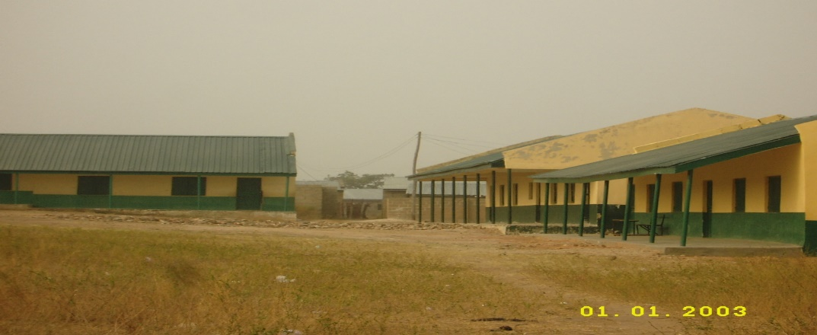
Source: Field Survey October, 2007
Plate 1: A Primary School Behind Federal Prison Yard, Minna Central

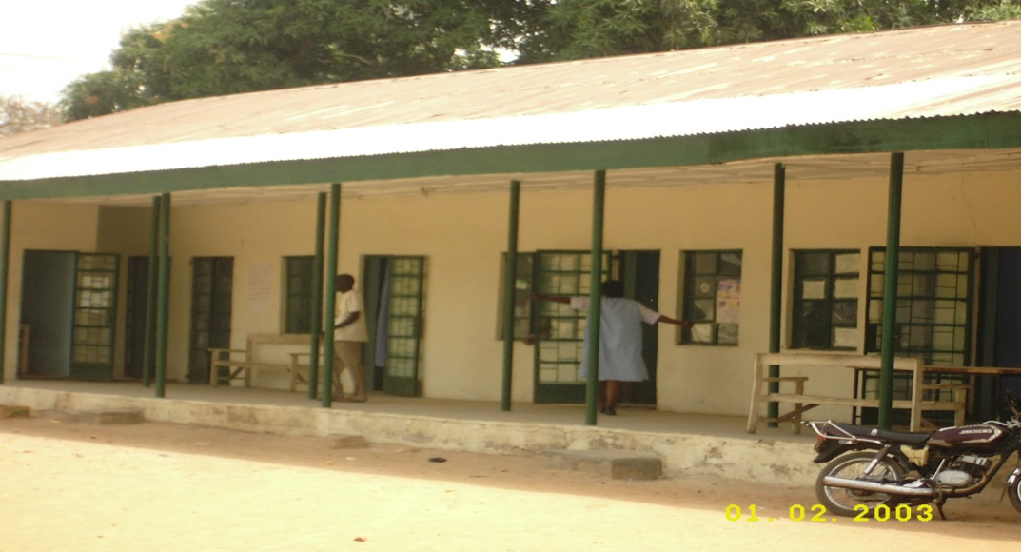
Source: Field Survey October, 2007
Plate 2: Sabon Hasibitin Mata (A Maternal Clinic) in Chanchaga

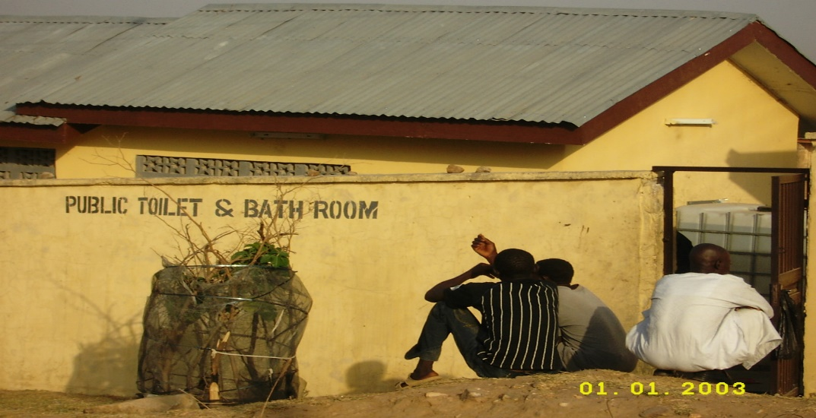
Source: Field Survey October, 2007
Plate 3: Public Convenience (Toilets and bathrooms) in Chanchaga

References
Bengs, C. (2005). ‘Urban policy and sustainability in the Nordic countries’. In Formas,
Sustainable Urban Development in Sweden: State of the Art 2004. Stockholm: Swedish Research Council, Formas; 92-105.

Fjeldstad, O. H. (2005). New challenges for local government Revenue enhancement.
Formative Process Research on the Local Government Reform in Tanzania; Project Brief No. 2. Norwegian Institute for Urban and Regional Research (Accessed 15TH February, 2008 from http://www.repoa.or.tz).

Formas, (2005). Sustainable Urban Development in Sweden: State of the Art 2004.
Stockholm: Swedish Research Council, Formas.
ROCESS RESEARCH
Hardoy, J. E., Mitlin, D. & Satterthwaite, D. (2001). Environmental Problems in an
Urbanizing World: Finding Solutions for Cities in Africa, Asia and Latin America. London: Earthscan.

Mabogunje, A. L. (2005). Global Urban Poverty Research Agenda: The African case.
Being text of a Paper presented at a Seminar on ‘Global Urban Poverty: Setting the Research Agenda. Woodrow Wilson International Center for Scholars, Washington DC: December 15, (Online Accessed 23 February, 2006), www.WilsonCenter.org

Mahi, R. (2002). Managing Local Revenue in Indonesia. A paper Prepared for: CAN
DECENTRALIZATION HELP REBUILD INDONESIA? A Conference Sponsored by the International Studies Program, Andrew Young School of Policy Studies, Georgia State University, Atlanta May 1- 3, 2002 (Accessed 10th February, 2007 from http://www.google.com.ng/search?q=problems+of+revenue+generation+by+local+governments&hl=en&start=0&sa=N

Mfune, M. N. K. (2001). Revenue Generation: the bottom line in the ledger Presentation on
Revenue Generation: the bottom line in the ledger Paper presented during the 9th Session of AFRICAN LOCAL GOVERNMENT ACTION FORUM (ALGAF) on May 4 2001 by Mr. M. N. K. Mfune, Principal Finance Officer, Department of Local Government, Office of the President and Cabinet, Lilongwe, Malawi (Accessed on 20TH February, 2008 from http://www.mdpafrica.org.zw/ALGAF%202002-06

Ojo, A. (2007). CBN owes Niger N51 million - Revenue Chairman State monthly revenue
now N210m. (Accessed 10th February, 2007 from http://dailytrust.com/index2.php?option=com_content&do_pdf=1&id=6504.

