Integrated Mode Selection and Bandwidth Allocation Scheme (MS-BAS) for D2D Networks

ABSTRACT
As the steep growth in mobile data traffic continues to gain lots of attention in recent years, discussions of the next generation of mobile networks - the fifth generation (5G), have gained significant traction both in the academia and industry. In addition to more capacity, stringent requirements for improving energy efficiency, decreasing delays, and increasing reliability have been envisioned in 5G. Many solutions have been put forward, one of them being Device-to-Device (D2D) communications where users in close proximity can communicate directly with one another. Interference management between Cellular User Equipment (CUE) and D2D user Equipment (DUE) is considered to be one of the most critical issues when D2D is introduced to cellular network because D2D users share the same licensed spectrum with cellular users. This work considers an overlaying network scenario where a Mode Selection and Bandwidth Allocation Scheme (MS-BAS) is developed to mitigate cross-tier interference, while delivering an average data rate of more than 50 Mbps across the network, indicating an over 12% improvement when compared with the existing Selective Overlay Mode Operation (SOMO). The results obtained show the efficacy of the algorithm in significantly mitigating cross tier interference in the network.
Keywords: Interference mitigation, cross-tier, D2D communication.
1.0 INTRODUCTION
With an ever-growing number of connected devices using the cellular network (Safaei, 2017), service providers are faced with the challenge of improving spectrum reuse, throughput, energy consumption, coverage, and reduction of end-to-end latency. Network performance would be driven up if closely located user pairs are allowed direct communication with each other, rather than through the traditional Up-link and Down-link communication channels of the Base Stations (BS). Additionally, the creation of new peer-to-peer services and location-based applications would all be driven by an efficient Device-to-Device (D2D) communication system, which incidentally, is one of the identified enabling technologies for the next generation cellular network, 5G. This, of course, comes with its challenges, chief among which is interference between the User Equipment (UEs). With enabled Device to Device communication between devices in proximity, there would be an introduction of interference between D2D User Equipment (DUEs) and other D2D Users, known as Co-Tier Interference, as well as interference between D2D users and traditional Cellular User Equipment (CUEs), the Cross-Tier Interference.

Amongst the numerous problems inherent with the Macro-D2D Heterogenous Network: handover, neighbor discovery, security, interference, mobility management, etc.; this research focuses on the mitigation of cross-tier interference in the two-tiered network, by developing schemes towards the optimization of throughput.

In this work, a Mode Selection and Bandwidth Allocation Scheme was developed to mitigate cross-tier interference in the network, and the performance of the scheme was evaluated through simulations on MATLAB and comparison with related works.

2.0 INTERFERENCE MANAGEMENT
Interference is an undesired signal picked by neighboring receivers. It has a mathematical relationship with signal-to-interference-plus-noise ratio (SINR), throughput and transmit power as expressed below:
- $Interference ∝transmit Power$
- $Interference ∝\frac{1}{throughput}$
- $Interference ∝\frac{1}{SINR}$
- $Interference ∝\frac{transmit power }{SINR* throughput}$
Enabling D2D links within a cellular network pose a big threat of interference to the cellular links in the network. D2D links can cause interference between cellular users and D2D users, resulting in an increase in co-tier interference. Cross-tier interference is also possible with D2D communication underlaying cellular communication. Interference can be mitigated through mode selection, optimum resource allocation, and power control. Setting the maximum transmit power limits of the D2D transmitter is an effective technique of limiting the interference between DUEs and CUEs. A general scenario of interference in D2D underlayed cellular networks is depicted in Figure 1:
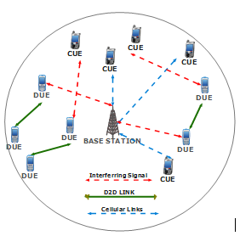
Figure 1: An interference scenario in D2D underlayed cellular network [Source]

Some interference mitigation techniques are briefly described below;

Bandwidth Allocation
The easiest way to coordinate the cross-tier interference between the cellular and device tier is to use bandwidth allocation, which will simplify the interference between DUEs and CUEs. Cho et al. (2013a) use bandwidth allocation, where the spectrum band was divided into two parts, as shown in Figure 2. One part would be dedicated to CUEs and the other part would be assigned to DUEs. However, dedicated channels for D2D communication will lead to inefficient use of the available channels depending on the number of D2D terminals and the proportion of available spectrum for them.
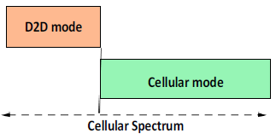
Figure 2: Spectrum Allocation [Source]

Power Control
Although higher transmit power of D2D users can provide wider coverage and better signal quality, it can, at the same time, cause tremendous interference to the cellular network. The power control (PC) mechanism is one approach to deal with cross-tier interference generated from DUEs to the cellular network for both the UL and the DL case, as well as the co-tier interference between DUEs in a two-tiered cellular network with D2D communication. It coordinates the interference imposed by DUEs to the cellular network and the interference from a DUE to a neighboring DUE by controlling the transmit power levels of DUEs to improve system capacity, coverage, and reduce power consumption. To meet these goals, PC schemes aim at maximizing the transmit power and at the same time limiting the generated interference [what is the deficiency of the scheme?].

Mode Selection
It is possible to avoid the effect of cross-tier interference between the cellular and D2D user or co-tier interference among DUE with a proper mode selection (MS) algorithm. Although D2D candidates may be in range for direct communication with each other, it may not be optimal for them to work in D2D mode because of the interference imposed on DUE or CUE. In this sense, D2D MS algorithm decides on the optimal communication mode so that the overall network throughput is maximized and the QoS requirements of the communication links are satisfied. Each of the communication modes affects the amount of interference between cellular users and D2D users or between multiple DUEs.
2.1 Related Works
Gadiraju and Garimella (2017) proposed the resource management scheme in overlay D2D network where bandwidth is allocated to D2D overlay devices by the base station, based on the bandwidth resource blocks earmarked for D2D mode. The challenge is the maximization of the reserved bandwidth if not optimally utilized. When the resource block assigned for D2D mode is exhausted the base station assigns subsequent UE to CUE mode. Equations (1) and (2) were used to compute both line of sight (LOS) and non-line of sight (NLOS) pathlosses for the transmissions.
$P_{LOS}=65+21\log_{10}(d)$ (1)
$P_{NLOS}=71.1+34\log_{10}(d)$ (2)
Simple MS could be performed based on the path loss, received signal strength over the D2D link or the distance between the terminals. However, these schemes do not reflect exact channel quality or interference issues. MS has been performed based on the channel quality.
A more sophisticated MS strategy was proposed by Doppler et al. (2010), which takes the link quality of both D2D and cellular users, the interference situation (cross-tier interference from DUE to cellular network) for each possible mode and the load situation of the cell into account for a multi-cell scenario. The MS strategy proposed in Doppler et al. (2010) is as follows. Initially, the D2D terminals send probing signals to each other and estimate the received signal powers. Then, the D2D terminal estimate interference plus noise power in both uplink and downlink. Next, the obtained information is sent to the eNB, when it can decide about the amount of resources it would allocate to the DUE in UL/DL based on cellular load as well as the maximum transmit power of DUE for the different direct modes. Then, eNB estimates the expected SINR for each communication mode and the expected throughput based on SINR and available amount of resources for each communication mode. Finally, the communication mode with the highest throughput is selected. The result of the study provides an improvement of 50% in sum-rate with limited interference to the cellular network. However, PC was not considered in this scheme and it was assumed that the BS has all the Channel State Information (CSI) available to choose the best resource sharing mode.
Different from the other works in this section, the authors of Lei et al. (2014), considered a dynamic MS procedure to limit the cross-tier interference between cellular and D2D users. They proposed three routing modes (D2D, cellular and hybrid) for D2D communications underlaying cellular networks and then combined them with different resource allocation restrictions to result in seven communication modes to model both the semi-static and dynamic mode selection using Discrete Time Markov Chain (DTMC).

A very critical term related to interference avoidance is mode selection. Generally, distance between the D2D users and cellular users is considered for mode selection (Wen, et al., 2012). Also, distance between cellular user and the BS is an important parameter for selection of the communication mode in the network, thus avoiding interference. Jänis, et al. (2009) introduced MIMO transmission schemes for interference avoidance, resulting in a great enhancement of SINR. Due to interfering signals, the received signal contains three components: Desired signal, Outside interference signal, and D2D interference signal
Interference at the receiver must be minimized so that a higher value of SINR is achieved. This can be achieved by Modulation and Coding Scheme (MCS), which supports error-free reception of information. The D2D interference signals can be reduced, but interference from outside sources is hard to avoid.
Zhou, et al. (2015) takes into consideration a D2D underlaying communication network for interference cancellation, along with the transmission powers for maximizing the utility of the network. Significant gains are enjoyed by the users in terms of spectral efficiency. Wang, et al. (2012) proposed a novel interference coordination scheme for improving system throughput and efficient resource utilization in a multicast D2D network. Guo et al. (2015) concentrated on managing interference between D2D users and cellular users by discussing the range of an Interference Suppression Area (ISA) which classifies the strength of the interference between the cellular and D2D users and influences the system performance. Adequate adjustment of the range of ISA can help achieve optimal system performance.

Interference management using network coding is discussed in Wang, et al. (2015). In a cellular system with users undergoing cellular communication, along with D2D multicast communication, both sharing the same spectrum, the interference scenarios are evaluated in Wang, et al. (2012). Interference in such a scenario can be mitigated by power control, followed by optimal resource allocation. Thus, different approaches are adopted by different researchers for interference mitigation between D2D links and cellular links.
In this work, Mode Selection and Bandwidth Allocation techniques were combined into a scheme to mitigate the incidence of cross-tier interference.
3.0 RESEARCH SYSTEM MODEL
The research system model as shown in figure 3 captures transmission in cellular communication. It gives an illustration of D2D communication between a D2D user equipment (DUEs) and communication between a cellular user equipment (CUE) and its serving base station.
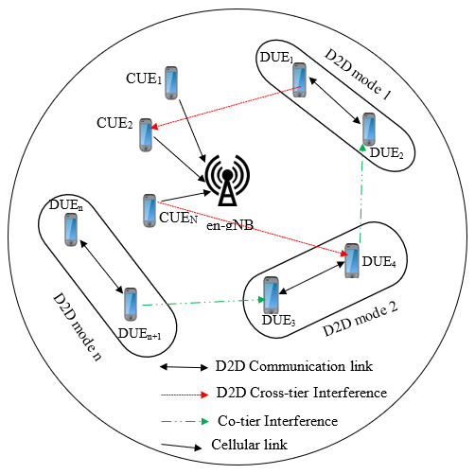
Figure 3: Research System Model

The simulation of the schemes on MATLAB was guided by the research system parameters in Table 1.
Table 1: System Parameters
No. | Parameter | Value
1. | Minimum transmit power of UE (DUE and CUE) | 0 dBm
2. | Maximum transmit power of UE (DUE and CUE) | 23 dBm (Rana et al., 2021)
3. | System bandwidth | 60 MHz
4. | Carrier frequency | 2.6 GHz (Rehman 2020)
5. | Thermal noise density | -174 dBm/Hz (Rana et al., 2021)
6. | Number of macrocells | 1
7. | Number of D2D pairs | 1 – 10
8.  9.  10. | Initial transmit power of CUE and DUE  Target D2D distance  Target SINR for DUEs | 20 dBm  10m  0 dB

3.1 Mode Selection and Bandwidth Allocation Scheme (MS-BAS)
The mode selection and bandwidth allocation scheme begins with the communication mode selection, which is determined based on receiver’s SINR and distance between transmitting UE and receiving UE. While the bandwidth allocation phase of the scheme is centered on the mode of UE communication, and the number of UEs in that mode. Being the primary users of the network, a greater priority is given to CUEs during bandwidth allocation; they receive a higher reserve of the bandwidth at 60%, while 30% is reserved for D2D communication. The number of UEs in D2D mode determines the allocation of the remainder 10% bandwidth.
Figure 4 is the block diagram of the MS-BAS
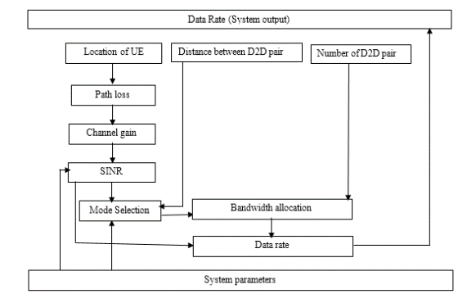
Figure 4: Block Diagram of the MS-BAS.

From Figure 4, the path loss block works with inputs from location of UE and specified path loss model to compute the propagation path loss between a transmitter and receiver. The path loss model for D2D communication is presented in (3) adopted from Gadiraju and Garimella (2017); and that of cellular communication is captured in (4), Jiale et al. (2018); Zhao et al. (2018); Hassan et al. (2018).
$L_{D2D}=65+21\log_{10}(d(m))$ (3)
$L_{cell}=15.3+3.7\log_{10}(d(Km))$ (4)
where d is the distance between the transmitter and the receiver.
The channel gain block computes the propagation channel gain based on computed propagation path loss between a transmitter and a receiver, using (5) Onu et al. (2018); Zhao et al., (2018); Divija and Ramamurthy (2017).
$G={10}^{{(- Path loss)/}_{10}}$ (5)
The SINR block computes the receiver’s SINR using specified thermal noise value from system parameters block, channel gain and SINR mathematical model in (6) (Junjie et al., 2021; Jiale et al., 2018; Xiaoqin, and Yang 2018).
${SINR}_{rx}= \frac{P_{tx}G_{p}}{\sum_{co=1}^{co=n}{{P'}_{tr}{G'}_{p}+\sum_{cx=1}^{cx=n}{{P'}_{tr}{G'}_{p}+}N_{o}}}$ (6)
where;
${SINR}_{rx}$ = receiver’s SINR,
$P_{tx}$ = desired transmit power,
$G_{p}$ = channel gain between transmitter and its receiver,
${P'}_{tr}$ = interfering signal transmit power,
${G'}_{p}$ = propagation channel gain of the aggressor and its victim,
$N_{o}$ = thermal noise,
$\sum_{co=1}^{co=n}{{P'}_{tr}{G'}_{p}}$ = summation of all co-tier interfering signals in the network, and
$\sum_{cx=1}^{cx=n}{{P'}_{tr}{G'}_{p}}$ = summation of all cross-tier interfering signals in the network.

The number of D2D pairs determines the D2D co-tier interfering signals in the network. For n^{th} D2D pairs, there would be (n – 1) D2D interfering signals. Likewise, the number of CUEs in the network determines the CUE co-tier interference.
The mode selection algorithm determines the mode of communication of all UEs in the network. The criteria for mode selection are based on the distance between D2D pairs, and computed D2D SINR. When the distance between the D2D pair is less than or equal to a target distance of 10m (Gadiraju and Garimella, 2017), the UE is assigned to D2D mode subject to reference computed SINR, otherwise it is assigned to cellular mode. When the reference SINR of UE is greater than the set target SINR of 0 (Gadiraju and Garimella, 2017), the UE is assigned D2D mode, otherwise, it is assigned cellular mode.
Equation (7) explains the mode selection mathematically.
$\left\{\begin{aligned}if d_{D2D} ≤ d_{target} and {SINR}_{computed}≥ {SINR}_{target} assign UE to D2D Mode \\ otherwise assign UE to CUE mode\end{aligned}\right.$ (7)
The bandwidth allocation block assigns bandwidth to both cellular and D2D communication modes. The allocation of bandwidth is centrally done by the base station based on the number of UE in cellular and D2D modes at a particular time. 60% of the network bandwidth is reserved for CUE mode, 30% of network bandwidth is reserved for D2D mode and the remaining 10% is allocated dynamically to either D2D or cellular mode based on the user traffic. When the number of DUEs is greater than or equal to the number of CUEs, the 10% dynamic network bandwidth is allocated to D2D mode; otherwise, it is allocated to cellular mode. The mathematical expression for bandwidth allocation by nodes to either D2D or cellular mode, within a macrocell is presented in (8) and (9).

$if N_{DUE}≥ N_{CUE}= \left\{\begin{aligned}{BW}_{D2D mode}=40\% of network bandwidth \\ {BW}_{CUE mode}= 60\% of network bandwidth\end{aligned}\right.$ (8)
$if N_{DUE}< N_{CUE}= \left\{\begin{aligned}{BW}_{D2D mode}=30\% of network bandwidth \\ {BW}_{CUE mode}= 70\% of network bandwidth\end{aligned}\right.$ (9)
where $N_{DUE}$ is the number of of DUE, $N_{CUE}$ is the number of CUE, ${BW}_{D2D mode}$ is the bandwidth allocated to D2D mode, and ${BW}_{CUE mode}$ is the bandwidth allocated to cellular mode.

The mode selection and bandwidth allocation scheme allocate spectrum to UEs based on the communication mode of the UEs. The DUEs operate in a different spectrum from that of the CUEs to avoid cross-tier interference.
The mode selection by UEs is divided into two stages: the idle and the active stages of mode selection.
The idle stage of the mode selection involves neighbor discovery, and populating neighborhood database. When a UE is powered on, it discovers its neighbors by broadcasting a Hello packet periodically. The Hello packet contains such information as Cell Identity (CID) of UE, Subscriber Identity Module (SIM) and International Mobile Equipment Identity (IMEI). Each UEs on receiving the hello packet will document the information contained in the hello packet in their neighborhood database and reply the UE that sends the hello packet directly with a hello reply packet. The hello reply packet contains same information as that of hello packet which is used by the receiving UE to also update its neighborhood database.

The active stage of mode selection involves exchanging packets between UEs in order to effectively communicate in D2D mode. When a UE has information for another UE, it first checks its neighbor table to get relevant information about the intending receiver. If the information about the receiver is not in its D2D neighbor database, it will communicate to the receiver in cellular mode. But when the receiver is found on its D2D neighbor database, it would first send to the receiver a wake-up packet. The receiver on receiving the wake-up packet will switch from idle stage to active stage and reply with a wake-up acknowledgement packet. The intending D2D transmitter will send a D2D initiation Packet directly to its receiver, following which the receiver would use the Initiation Packet to determine the distance between the DUEs, and then use the initial transmit power of the transmitting UE to compute received signal to interference plus noise (SINR) ratio. The received SINR is compared with the target SINR, and their distance apart compared with the target distance value, and send either D2D Initiate connect packet or D2D Initiate disconnect packet. When the computed SINR is greater than the target SINR, and their distance apart is not greater than the target distance, the receiving UE will send a D2D Initiate connect packet and the two UEs will proceed into D2D mode of communication and exchange information. Otherwise, the receiving UE will send a D2D Initiate disconnect packet and the two UEs will communicate in cellular mode. Figure 6 is the flowchart of the mode selection component of the interference mitigation scheme, which points out the various processes and decisions involved in communication mode selection for UEs.

After mode selection, spectrum is centrally allocated by the base station, based on the distributed traffic density of UEs on the network. UEs periodically update the base station with their current operating mode, so that it maintains an updated number of UEs in a particular mode (D2D or cellular) per time. The base station reserves 60% of the spectrum for CUEs, and 30% for D2D. The remaining 10% is dynamically allocated based on the conditions in equations (8) and (9) to minimize spectrum redundancy in the network. The number of DUE is limited by distance of D2D devices, which often accommodate less UE compare to CUE mode. To avoid large quantity of bandwidth been redundant; 30% of the system bandwidth was allocated to DUE; being the secondary users, as its fixed operating bandwidth. 60% of the system bandwidth was allocated to CUEs being the primary users, where number of UEs operating in such mode is not restricted by distance between transmitting and receiving user accommodating more UEs. The reserved 10% system bandwidth is to compensate the operating mode with the higher UEs per time. The system output of mode selection and bandwidth allocation scheme displays the data rate of DUE, CUE, both CUE and DUE, and average data rate of both DUE and CUE all computed at data rate block using equations (10), (11), (12) and (13)
${D_{D2D}}^{MSBAS}={BW}_{D2D mode}\log_{2}(1+ {SINR}_{D2D})$ (10)
${D_{CUE}}^{MSBAS}={BW}_{CUE mode}\log_{2}(1+ {SINR}_{CUE})$ (11)
${D_{UE}}^{MSBAS}={BW}_{D2D mode}\log_{2}\left(1+ {SINR}_{D2D}\right){+ BW}_{CUE mode}\log_{2}(1+ {SINR}_{CUE})$ (12)
$D_{UEs}^{Average} = \frac{\sum_{i= 1}^{i= p}{\left({D_{D2D}}^{1}\right)+ \sum_{i=1}^{i=n}{\left({D_{CUE}}^{1}\right)}}}{(p+n)}$ (13)

where:
${D_{D2D}}^{MSBAS}$ = data rate of D2D
${D_{CUE}}^{MSBAS}$ = data rate of CUE
$D_{UEs}^{Average}$= average data rate when considering both D2D and CUE
${SINR}_{D2D}$ = signal-to-interference-plus-noise ratio of D2D
${SINR}_{CUE}$ = signal-to-interference-plus-noise ratio of CUE
p, n = maximum number of iterations (D2D, CUE).

Table 2 is the Pseudocode for the Mode Selection and Bandwidth Allocation Scheme (MS-BAS).
Table 2: PSEUDOCODE FOR MS-BAS
1. | Initialization: Booting of UEs and base station
2. | Load input parameters into the memory of UEs and base station
3. | Idle State of UEs:
 | - Neighbor discovery using broadcast packet
 | - Update neighbor Table
4. | Active state of UEs:
 | - Exchange packets with discovered neighbors
 | - Compute:
 | - Path loss using (3) and (4)
 | - Channel gain using (5)
 | - SINR using (6)
- Decision:${ if D}_{D2D}<=D_{target} \left\{\begin{aligned}{Yes: then SINR}_{D2D} >={SINR}_{target} \\ No: then assign UE to CUE mode\end{aligned}\right.$
$${ if SINR}_{D2D} < ={SINR}_{target} \left\{\begin{aligned}Yes:then assign UE to D2D \\ No: then assign UE to CUE mode\end{aligned}\right.$$
5. | Base station updates Active UE Mode Table
6. | Base station Computes Number of Active DUE and CUE
7. | Bandwidth Request by UEs
8. | Decision:  $$N_{DUE}< N_{CUE}\left\{\begin{aligned}Yes:then B_{DUE}=30\% of Bandwidth \\ Yes:then B_{CUE}=70\% of Bandwidth\end{aligned}\right.$$  $$N_{DUE}≥ N_{CUE}\left\{\begin{aligned}Yes:then B_{DUE}=40\% of Bandwidth \\ Yes:then B_{CUE}=60\% of Bandwidth\end{aligned}\right.$$
9. | Compute data rate using equations (10) – (13)
10. | Output computed data rate
11. | End

Figure 5 is the Flowchart of the integrated Mode Selection and Bandwidth Allocation Scheme (MS-BAS). After communication modes have been assigned to UEs based on the design constraints (separation distance between UEs, and target SINR), bandwidth is allocated based on the number of UEs per communication tier.

Input system Parameters
Output: Data rate
Neighbor discovery
Update neighbor table
Exchange packets
Start
Compute SINR

D2D MODE
CUE MODE
Stop

$D_{target}≥ D_{D2D}$?
${SINR}_{D2D}≥ {SINR}_{target}$?
B_{DUE} = 40% of BW
B_{CUE} = 60% of BW

B_{DUE} = 30% of BW
B_{CUE} = 70% of BW

YES
NO
NO

YES

Compute $N_{DUE}, and N_{CUE}$

$$N_{DUE} ≥N_{CUE}?< NCUE$$
NO
YES

Figure 5: Flowchart of Mode Selection and Bandwidth Allocation Scheme
4.0 RESULTS AND DISCUSSIONS
The performance of the mode selection and bandwidth allocation scheme (MS-BAS) was compared with that of Selective Overlay Mode Operation (SOMO) for D2D communication, as presented in Gadiraju and Garimella (2017).
4.1 MS-BAS Simulation Results
The performance of the mode selection and bandwidth allocation scheme (MS-BAS) was analyzed based on varying distance between DUEs, and the number of D2D pairs. The results are presented in Figures 6 – 9. At constant number of D2D pair, the distance between DUE was varied and the corresponding MS-BAS data rate was computed. The evaluated performance of MS-BAS is presented in Figure 6.
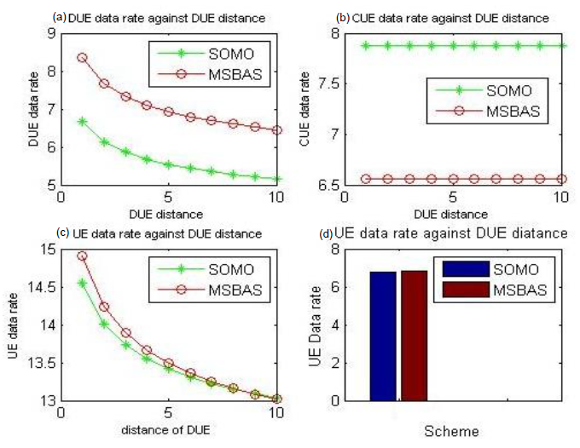
Figure 6: Benchmarked performance of MS-BAS based on varied distance of DUE.
Figure 6 shows data rate variation of DUE when $N_{DUEs}$ and $N_{CUEs}$ are 12 and 8 respectively, assuming 20 UEs. The distance between DUE ranges from 0 – 10 m. The range of distance used was in accordance with the adopted D2D target distance of 10m (Gadiraju and Garimella, 2017). $N_{DUEs}$ and $N_{CUEs}$ were kept constant and $N_{DUEs} > N_{CUEs}$.
Subplot (a) presents the data rate of DUE as DUE distance changed. As the distance between DUE increased, the data rate decreased. The change is attributed to increase in path loss due to increase in distance. As path loss increases, SINR and data rate decreases. The data rate performance of MS-BAS scheme at DUE distances ranging from 0 – 10 m, when compared outperformed that of SOMO.

Subplot (b) presents CUE data rate when DUE distance changed from 0 – 10m, and $N_{DUEs}$ and $N_{CUEs}$ were kept constant at 12 and 8 respectively. The result indicated that SOMO CUE data rate outperformed that of MS-BAS when compared. The higher CUE data rate of SOMO is due to the larger CUE mode operating bandwidth of 70%, compared to that of MS-BAS of 60% when ($N_{DUEs} > N_{CUEs}$).

Subplot (c) presents the entire UE (DUE and CUE) data rate when DUE distance changed from 0 – 10 m, and $N_{DUEs}$ and $N_{CUEs}$ were kept constant at 12 and 8 respectively. The result shows that MS-BAS outperformed SOMO.
Subplot (d) presents the entire UE (DUEs and CUEs) average data rate when DUE distance changed from 0 – 10 m, and $N_{DUEs}$ and $N_{CUEs}$ were kept constant at 12 and 8 respectively. The UE average data rate of SOMO and MS-BAS gave 7.09 Mbps and 7.26 Mbps respectively. MS-BAS average UE data rate performed better than SOMO by 2.34 %.
From results presented in Figure 4.1, when $N_{DUEs}$ and $N_{CUEs}$ are 12 and 8 respectively and DUE distance ranges from 0 – 10 m, MS-BAS tradeoff CUE data rate for DUE data rate. The entire UE average data rate of MS-BAS was slightly higher than that of SOMO.

In a bid to analyze the impact of the number of D2D pairs on the communication network with respect to interference, the distance of DUEs was kept constant and the number of D2D pairs were varied. The simulation results show the impact of increased number of D2D pairs on DUE, CUE and UE data rate performance, as presented in Figure 7.
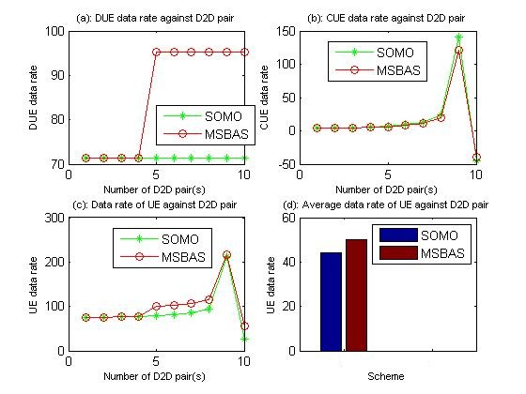
Figure 7: Performance of the Integrated MS-BAS with respect to number of D2D pairs
Figure 7 presents the data rate of DUE, CUE, entire UE (DUE and CUE), and average UE data rate when the DUE distance was kept constant and number of D2D pairs were altered from 1 – 10 pairs, assuming 20 UEs. The initial $N_{CUE}$ and $N_{D2D}$ were 18 and 2 respectively. As the number of D2D pairs increase by 1; $N_{DUE}$ increase by 2 and $N_{CUE}$ decrease by 2.
Subplot (a) shows that, when $N_{DUE}< N_{CUE}$ (4 D2D pairs, 8 DUE, 12 CUE), the MS-BAS DUE data rate is equal to that of SOMO. This is because when $N_{DUE}< N_{CUE}$, MS-BAS bandwidth would be 30% of system bandwidth and likewise SOMO bandwidth; both MS-BAS used the same DUE distance, D2D path loss, SINR, and data rate models. When the number of D2D pairs increased to 5 (10 DUE and 10 CUE); $N_{DUE}= N_{CUE}$ and MS-BAS bandwidth would change to 40% of system bandwidth, while SOMO bandwidth remains 30% of system bandwidth. Also, when number of D2D pair increased from 5 – 10 pairs ($N_{DUE}> N_{CUE}$); MS-BAS would use 40% of system bandwidth. The difference in operating bandwidth accounted for the two different data rate levels. MS-BAS operating at 30 % of system bandwidth when number of D2D pairs was four and below had same data rate with the SOMO scheme. But when MS-BAS operated at 40% of system bandwidth, from 5 – 10 D2D pairs, the data rate of MS-BAS scheme outperformed that of SOMO by 25%

Subplot (b) indicates that the MS-BAS CUE data rate and that of SOMO were the same within the range of 1 – 4 D2D pairs in the D2D network. However, at 5 – 8 D2D pairs, SOMO performed slightly better than the MS-BAS. At 9 D2D pairs, the performance of SOMO CUE data rate was better when compared with that of MS-BAS by 14.28 %, while MS-BAS performed better at 10 D2D pairs when compared to SOMO by 16.68 %.

Subplot (c) presents the data rate performance of all the UEs in the network. At each DUE distance, the data rate of DUEs and CUEs were summed up and plotted. The graphs show that the total UE data rate of SOMO and MS-BAS within range of 1 - 4 D2D pairs, were the same. However, from 5 – 10 D2D pairs MS-BAS data rate outperformed that of SOMO by 22.52 %, 21.82 %, 20.57 %, 17.72 %, 1.67%, and 53.93 % respectively. This outperformance results directly from the additional 10% bandwidth dynamically assigned to DUEs once the condition $N_{D2D} ≥N_{CUE}$ is met, from the formation of 5 D2D pairs upwards.

Subplot (d) presents the average entire UE (DUE and CUE) data rate, when number of D2D pairs increased from 1 – 10 and the DUE distance was kept constant. The average data rate of SOMO and MS-BAS stood at 44.08 Mbps and 50.17 Mbps respectively. The MS-BAS average data rate outperformed that of SOMO when compared by 12.14 %. Table 4.2 presents the data rate performance of mode selection and bandwidth allocation scheme when the number of D2D pairs were increased from 1 - 10.

Another scenario considered was when both the distance between DUE and the number of D2D pair was varied simultaneously. The result of the data rate performance of MS-BAS when compared to SOMO is presented in Figure 8.
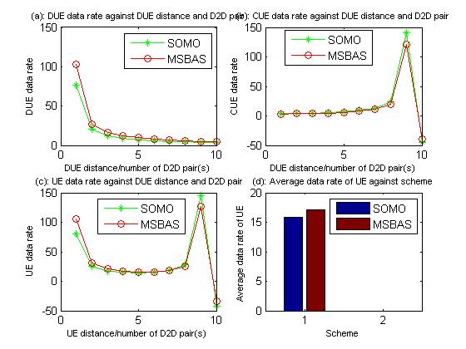
Figure 8: Data rate performance while varying DUE distance and number D2D pairs
Figure 8 presents four subplots which shows the data rate performance of MS-BAS when compared with SOMO, while simultaneously varying both DUE distance and the number of D2D pairs. Assuming 20 UEs in the network, with initial 1 D2D pair, 2 DUEs and 18 CUEs, and an initial DUE distance of 1 m, which increased by 1m in each iteration to 10 m. In each iteration also, the number of D2D pair increased with 1 D2D pair (2 DUE).

Subplot (a) presents the result of DUE data rate against varying DUE distance and D2D pairs. It shows that data rate decreases when both distance of UE and number of D2D pairs increases. When both distance of UE and number of D2D pairs are within the range of 1 – 10 m and 1 – 10 D2D pairs, MS-BAS data rate outperforms SOMO by 25%, 24.99%, 25.01%, 25%, 24.95%, 25.06%, 25%, 24.96%, 24.90%, and 38.32% respectively.

Subplot (b) presents the data rate of CUE when both distance of UE and number of D2D pairs were varied simultaneously. At ranges of 1- 9 m and 1- 9 D2D pairs, the performance of SOMO in terms of CUE data rate outperformed that of MS-BAS by 14.25%, 14.22%, 14.35%, 14.34%, 14.33%, 14.25%, 14.24%, 14.28%, and 14.29% respectively. While MS-BAS performed better than SOMO by 16.68% at 10m DUE distance and 10 D2D pairs.
Subplot (c) presents the results of the entire UE data rate at varying DUE distance and D2D pairs.
Within the ranges of 1 – 6 D2D pairs and 1 – 6 m DUE distance, the UE data rate of MS-BAS outperformed that of SOMO when compared by 23.77%, 20.19%, 16.79%, 13.01%, 8.79% and 4.13% respectively. SOMO UE data rate outperformed that od MS-BAS within the ranges of 7 – 9 D2D pairs and 7 – 9 m DUE distance, by 1.15%, 6.85% and 13.02% respectively. At 10m DUE distance and 10 D2D pairs, MS-BAS UE data rate outperformed that of SOMO by 22.25%.

Subplot (d) presents the average data rate of the entire UE, which was computed when DUE distance and number of D2D pairs was varied simultaneously. The average UE data rate of SOMO and MS-BAS gotten was 15.80 Mbps and 17.09 Mbps respectively. MS-BAS average UE data rate outperformed that of SOMO by 7.55%.

5.0 CONCLUSION
In this work, mode selection and bandwidth allocation techniques were integrated to mitigate cross-tier interference in a macro-D2D network. The mode selection sub-scheme focused on the UE separation distance and the receiver’s SINR to assign communication mode to UEs, while the bandwidth allocation sub-scheme allocated a fixed fraction of 60% to CUEs (being the primary users of the network), and 30% for D2D connections, while dynamically allocating the remainder 10% to deserving communication tier based on the number of UEs in that mode, to maximize data rate (throughput), and limit spectrum wastage, which is an inherent problem with overlay architecture.
The integration of the Mode Selection and Bandwidth Allocation Schemes (MS-BAS) lead to the attainment of better system performance against previous works. Therefore, the MS-BAS addresses the problem of cross-tier interference, while improving system throughput and avoiding spectrum redundancy.

REFERENCES
Divija, G., & Ramamurthy, G. (2017). Selective Overlay Mode Operation for D2D Communication in Dense 5G Cellular Networks. IEEE Symposium on Computers and Communications.
Doppler K, Yu C.H, Ribeiro C.B, and Jänis P, (2010) Mode selection for device-to-device communication underlaying an LTE-Advanced network,” IEEE Wirel. Commun. Netw. Conf. WCNC.
Gadiraju, D., & Garimella, R. (2017). Selective Overlay Mode Operation for D2D Communication in Dense 5G Cellular Networks. IEEE Symposium on Computers and Communications (ISCC).
Guo, B., Sun, S., & Gao, Q. (2015) Interference Management for D2D Communications Underlaying Cellular Networks at Cell Edge, ICWMC.
Hassan, T. U., Gao, F., Jalal, B., & Arif, S. (2018). Interference Management in Femtocells by
the Adaptive Network Sensing Power Control Technique. Journal of Future Internet, 10(3), 2015 -2028.
Jiale, Z., Shuangzhi, L., Dan, M., & Xiaomin, M. (2018). Research on Joint Mode Selection and Resource Allocation Scheme in D2D Networks. International Conference on Cyber-Enabled Distributed Computing and Knowledge Discovery, 429 – 432.
Junjie Tan, Ying-Chang Liang, & Gang Feng (2021). Deep Reinforcement Learning for Joint Channel Selection and Power Control in D2D Networks. IEEE Transactions on Wireless Communications, (20)2, 1363 – 1378.
Lei, L., Shen, X.S, Dohler, M., Lin, C., & Zhong, Z (2014) Queuing Models with Applications to Mode Selection in Device-to-Device Communications Underlaying Cellular Networks, IEEE Transactions on Wireless Communication, 13(12), pp. 6697–6715.
Onu, C., Bala. S., & Abolarinwa J. (2018). Enhanced Fractional Frequency Reuse in LTE A Heterogeneous OFDMA Network. ATBU, Journal of Science, Technology & Education (JOSTE), 6 (2), 18 – 27.
Rana, Z.A., Abdul, R.J., Shakir, M., Mohammad, Z.K., Abdulfattah, N. & Muhammad, R. (2021). Interference Mitigation in D2D Communication Underlying Cellular Networks: Towards Green Energy. Computers, Materials & Continua, 68(1), 45 – 58.
Rehman, S. U., Hussain, A., Hussain, F., & Mannan, M.A. (2020). A Comprehensive Study: 5G Wireless Networks and Emerging Technologies. International Electrical Engineering Conference (IEEC 2020), 5, 25-32.
Safaei, B, Mahdi, A, Monazzahy, H, Milad B and Ejlali, A., (2017). Reliability Side-Effects in Internet of Things Application Layer Protocols. International Conference on System Reliability and Safety; At: Milan, Italy.
Wang, Dongyu, Wang X, and Zhao Y. (2012) An interference coordination scheme for device-to-device multicast in cellular networks. IEEE Vehicular Technology Conference (VTC).
Wang, Shuang, et al. (2015) A Novel Interference Management Scheme in Underlay D2D Communication. 82nd IEEE Vehicular Technology Conference (VTC).
Wen S, Zhu X, Lin Z, Zhang X, and Yang D, (2012) Optimization of interference coordination schemes in device -to- device (d2d) communication. 7th International ICST Conference on Communications and Networking in China (CHINACOM), pp. 542–547.
Xiaoqin, L., Yang, X. (2018). Mode Selection and Resource Allocation Algorithm Based on Interference Control for D2D Communication. International Conference on Communications, Circuits and Systems, 10(1), 286 – 290.
Zhao, J., Li, S., Dan, M., & Xiaomin, M. (2018). Research on Joint Mode Selection and Resource Allocation Scheme in D2D Networks. International Conference on Cyber-Enabled Distributed Computing and Knowledge Discovery. 429 – 432.
Zhou L, Ruttik K, and Tirkkonen O. (2015) Interference Canceling Power Optimization for Device-to-Device Communication. IEEE 81st Vehicular Technology Conference (VTC).

