1. Introduction
The Bida basin is one of the younger sedimentary basins of Africa (Campanian – Maastrichitian) located in Nigeria between Sokoto (part Iullemmeden) and Anambra basins, it trend in northwest – southeast direction and regarded as the northwestern extension of Anambra basin ¹. The basin is bounded by monotonous Precambrian basement rocks of various mineralogical, textural and structural compositions (Figure 1), and has been suggested to have been a connection between the southern part of the Iullemmeden basin and northwestern part of Anambra basin in Nigeria.
The first major marine incursion in to the basin was suspected to have taken place during the early part of the uppermost Maastrichtian phase from the south via the Anambra basin. At the uppermost Maastrichtian period the peak of the marine transgression was reached during which very extensive Sandstones and thick Kaolinite beds of the Patti Formation in the southern Bida basin was deposited ². The end of Maastrichian phase marked the period of rapid regression ³ and formation of the Upper Ironstone members (Batati Ironstone and Agbaja Ironstone).
Stratigraphically, the northern sector of Bida basin is composed of Bida Sandstone, Sakpe Ironstone, Enagi Siltstone and Batati Ironstone ^{4, 5}. Sedimentation in the Bida basin was suggested to have started in the middle to late Maastrichian period with alluvia fan system and braided alluvial channels which flanked the north – west to south – east faulted- bounded margins of the basin. Sedimentation of northern Bida basin has been proposed by several workers. Among these works is Braide ⁶, he recognized typical alluvial fan surfaces comprising breccias, massive conglomerate, cross bedded pebbly sand and poorly sorted cross-laminated fine sandstone. Adeleye and Dessauvagie ⁷ recognized arkosic to feldspartic sandstone, sandy siltstone locally developed clay stone and breccias in the Doko Member and Jima Member of Bida sandstone, he inferred these Members to range from alluvial fan to braided river setting of non marine in origin and Campanian age. Sakpe Iron Formation consisting of Wuya Ironstone Member and Baro Ironstone Member, these members are composed of oolitic, pisolitic ironstone with small locally developed clay stone. Adeleye and Dessauvagie ⁷ recovered Turieta, fauna and fossil wood in the oolitic ironstone and suggest a marine origin for the oolitic ironstone and upper Campanian age. This study is aim at unravel the depositional environment and source characteristic of clay deposit in central Bida basin.

2. Materials and Methods
2.1. Fieldwork
A topographic base map on a scale of 1:200,000 (covering central Bida basin and the adjoining basement complex) was generated for the study area from mosaic topographic maps of Minna, Mokwa, Lafiagi, and Baro on scale 1:250,000. The study area covers about 15,207.5 square kilometers (110 x 138.25 kilometers). Cay samples were obtained from well exposed clay lithologic units, while pitting was adopted in grid pattern where there was poor exposure of clays. Sampling was done at different vertical intervals using a hammer and plastic shovel. Thirty chip clay samples were collected in the field, stored in cotton sample bags and well label for the laboratory analysis.
2.2. Laboratory Analysis
Geochemical characterization of thirty clay samples for major, minor and trace element geochemistry using an ICP mass spectrometer (Perkin-Elmer, Elan 6000) and inductively coupled plasma spectrograph on powdered, pressed pellets prepared from 3 – 5 grams samples. It was digested by weighing 0.2 gram aliquot in a graphite crucible mixed with 1.5 gram LiBo/LiB₂O₇ flux. The crucibles were placed in an oven and heated at 980º C for 30 minutes. The cooled bead was dissolved in 5% HNO₃ (ACS grade nitric acid diluted in demineralized water). Calibration standards and reagent blanks were added to sample sequentially. An ICP emission spectrograph (Specro Ciros Vision 735) was used for determining major oxides and some trace elements. Loss on ignition (LOI) was determined by measuring the weight loss after heating 1 gram at 95ºC for 90 minutes. The precision of REE data were normalized relative to the chondrite values. The analyses were carried out in the geochemical laboratory of the Activation Laboratories limited (Actlabs) Ontario, Canada.

3. Results and Discussion
Field evidence shows that seven clay occurrences are restricted to isolated hills in Nami, Gubaji, Lemu, Nakama, Batati, Kutigi, and Sapke areas, while Shegba and Kpaki are on flood plain and plain respectively (Figure 2). In hand specimen the clay colour varies between pure white and dirty white with occasional red/pink tint effect of the overburden laterite/ironstone.
- 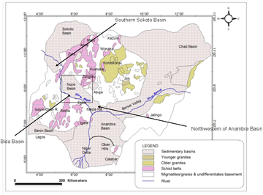
Download as
PPT
PowerPoint Slide
PNG
Larger image(png format)
View option
Figures index
NEW
Larger figure in new window
NEXT
View next figure
- Figure 1. Geological of map Nigeria showing the location of Bida basin and adjoining basement Complex rocks (Modified after [8])
- 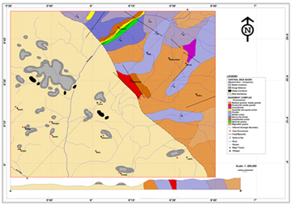
Download as
PPT
PowerPoint Slide
PNG
Larger image(png format)
View option
Figures index
NEW
Larger figure in new window
PREV
View previous figure
NEXT
View next figure
- Figure 2. Geology map of Central Bida basin and its adjoining northeast basement complex [9]
3.1. Chemical Composition of the Clays
The geochemical analysis result of thirty clay samples from the study area show high value of SiO₂ ranges between 54.9% to 87.4 %, moderately high Al₂O₃ ranging between 7.4 % to 29.7%, and a low value of Fe₂O₃ ranging between 1.13 % to 7.11wt %. Also, the samples are low in CaO, Na₂O and K₂O except for clay of Shegba which is slightly higher in K₂O. Lost in ignition (LIO), range between 3.56% to 11.95 in all the study clays (Table 1). Trace elements concentration of the clays (Table 2), show all of the study samples have similar contents.
The clays are enriched in Th, V, Sr, Co and depleted in Cr, Rb, Zr and Ba relative to Post Archean Australian Shale average (PAAS). The results of the rare earth element analyses of clay samples have similar concentration of REEs. Chonderite- normalized patterns are typical for the Post Archean Australian Shale (PAAAS) average with enrichment of LREEs (Figure 3). All samples show pronounced negative Eu anomalies ranging from 1.10 – 2.15 ppm.
- 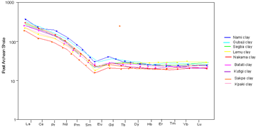
Download as
PPT
PowerPoint Slide
PNG
Larger image(png format)
View option
Figures index
NEW
Larger figure in new window
PREV
View previous figure
NEXT
View next figure
- Figure 3. Chondrite normalized rare earth elements plots of clays from the study area (After Taylor and McLenna, [10])
- Table 1. Percentage major oxides distribution of clays in central Bida basin
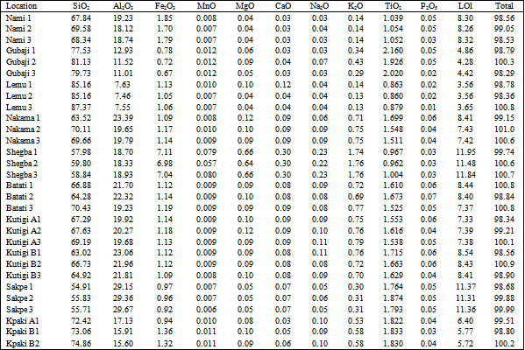
- Download as
PowerPoint Slide
Tables index
View option
Full Size Next Table
- Table 2. Trace elements distribution of clay in the study area
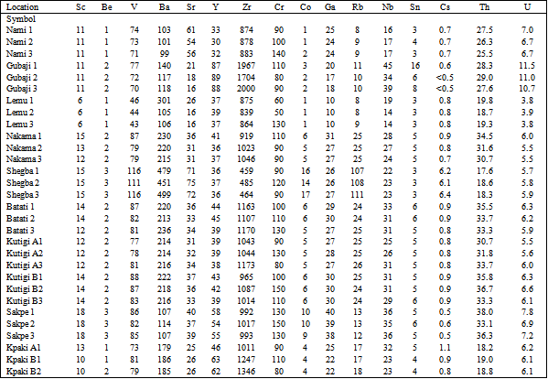
- Download as
PowerPoint Slide
Tables index
View option
Full Size Previous Table
In general, chondrite-normalized REE patterns display high light REE/heavy REE ratio between 2.34 and 19.511, flat HREE with negative Eu anomaly. The high light REE/heavy REE ratio and negative Eu anomaly suggest felsic source rocks, while low light REE/heavy REE ratio and no Eu anomaly mafic source rocks ¹¹. The clays in the study area have high light REE/heavy REE ratio and negative Eu anomaly confirming felsic source rocks.
The ratio of Cr/V play important role in differentiating felsic source from mafic source, the ratio of Cr/V less than 8 (typical of UCC and PAAS) signify felsic source while ratio above this figure signify mafic source ¹². Plot of Cr versus V suggest felsic source of the clays in the study area (Figure 4). Authigenic uranium values below 5 indicate oxic deposition environment, whereas value below 5 is anoxic deposition environment (Wignal and Myers, 1988). The study clays authigenic values ranges between -5.5ppm and 2.1ppm, suggesting the clays were deposited in an oxic environment. The source of this uranium is attributed to the leaching of uranium from accessory mineral in source rocks is concentrated in the clay sediments.
- 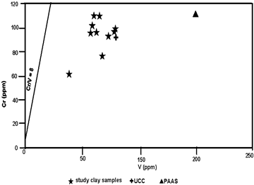
Download as
PPT
PowerPoint Slide
PNG
Larger image(png format)
View option
Figures index
NEW
Larger figure in new window
PREV
View previous figure
NEXT
View next figure
- Figure 4. Source discrimination plots of Cr versus V plots of study clays (After McLennan et al., [12])
3.2. Paleo Oxic/Anoxic Condition of the Clay
Oxic sediments reflect near sueface or continental environment regime (0 meter - %50 meters which include; flood plain, ox-bow lake, alluvial fan and braided channel) subanxoic (50 meters to 100 meters) reflect sub-marine environment and anoxic (>100 meters) reflect marine environment.
Abundance and ratio of redox sensitive trace elements are frequently utilized to assess the oxic/redox condition of modern and ancient sediments. The ratio of uranium to thorium as been used as a redox indicator ¹³, ratios of uranium to thorium below 1.25ppm suggest oxic conditions of sediment deposition while above 1.25ppm suggest anoxic conditions of sediment deposition. The study clays exhibit U/Th ratios ranging between 2.46ppm and 5.74ppm (average 3.85ppm), suggesting oxic environment of deposition. V/Cr ratios values above 2 suggest anoxic condition, while values below 2 suggest oxic environment of deposition ¹³. In the study clays, V/Cr ratio ranges between1.0ppm and 1.5ppm (average 1.1) suggesting oxic depositional environment of the clays.
3.3. Sedimentology and Environment of Deposition
Field evidences revealed most of the clay deposits are capped by thin layer of oolitic ironstone and locally developed ferruginised sandstone, suggesting stratigraphic position of the study clay to be a bed within the Batati Ironstone Formation. Sequence to previous workers observations and suggestions, the sediments supply of the Bida basin (Bida sandstone Formation and Sakpe Iron Formation) during the Campanian are favoured by marine incursion. The Enagi Siltstone Formation is fovoured by continental sediment supply during the Maastichian while Batati Ironstone Formation is by marine supply. It can be suggested that the basin has experienced two phases of marine incursion (during the upper Campanian and upper Maastrichian) (Figure 5).
- 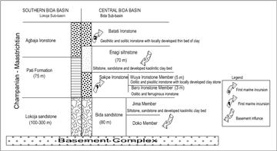
Download as
PPT
PowerPoint Slide
PNG
Larger image(png format)
View option
Figures index
NEW
Larger figure in new window
PREV
View previous figure
- Figure 5. Stratigraphy of Bida Basin showing the influence of marine incursion in to the basin (Modified after Adeleye and Dessauvagie, [7])

4. Conclusion
In conclusion, the provenance of clay deposit in the central Bida basin is a product of influx of weathered adjoining basement complex rock materials, deposited and chemically altered in non-marine environment of flood plain, alluvial fan and braided channel at the upper Maastrichian age that represent Upper cretaceous period.

