ANALYSIS OF GROUND WATER AVAILABILTY IN HAND-DUG WELLS OF MINNA AND BIDA METROPOLIS
*Adama, C.K. M.Sc., Department of Geography, Ibrahim Badamasi Babangida University, Lapai, Niger State
kolochristiana@gmail.com 08033608014
**Usman, M.N. M.Sc., Department of Geography, Federal University of Technology, Minna, Niger State
nmayadi@gmail.com 07068986557

***Isako, S.I. M.Sc., abubakrsadyyq@gmail.com 08063835291
****Obaje, N.G. PhD, Department of Geology, Ibrahim Badamasi Babangida University, Lapai, Niger State
Abstract
The study takes a look at the analysis of groundwater availability in hand dug wells in Minna and Bida, Niger State. The study analyzed the bedrock factors between the Basement Complex (Minna) and Sedimentary (Bida), described the seasonal variation of the bedrocks within a period of time and then prepared water table contour maps for Minna and Bida. Data for the study were collected through general study of the area, measurement of the well depth through the use of ropes and measuring tapes, location and elevation of wells through the use of a GPS and taking the readings of the physical parameters through the use of TDS meter. A total of forty sampling points were tested; twenty sampling points in Minna (both rainy and dry season) and twenty sampling points in Bida (both rainy and dry season). Results show that the average water depths in the wells of Minna are shallower (both in rainy and dry season) than those of Bida. The variations in water depths are higher during the wet season at both Bida and Minna.Provision for alternative reliable source of water should be made available to complement the wells in the Sedimentary Basins especially during the dry season.

Keywords: Ground Water Availability, Physical Parameters, Basement Complex, Sedimentary Basin.
1. Introduction
Water is the most essential commodity for all living creatures. Organisms cannot survive without water. Water is one of the most essential constituents of the human environments. Man needs it, in the first place for his physiological existence. It is used for many purposes e.g. agricultural, domestic, industrial and hydro-powers generation purposes. Water is a source of energy and governs the evolution and functions of the universe on the earth.
Water is one of the most important valuable natural resource and is essential for the maintenance of all forms of life. Water is important to life, without it life cannot go on (Yerima et al 2008). Human life as with animals and plant life on the planet is dependent on water (Domenico, 1972).
Water is a critical factor in any sustainable development project. Its constraints pose important risks for business and livelihood (Obaje, 2015). Inadequate access to clean drinking water is a major problem in many states in Nigeria. Niger State, like other states in Nigeria, is becoming heavily populated such that many of the inhabitants lack adequate pipe borne water because of the rising population and pressure on water infrastructure. There is more dependence on ground water as alternative supplies. Therefore, the development and efficient management of groundwater resources is a particular concern. The alternative for many who can afford it is to install hand pumps or deep wells (drilled and hand dug) to draw clean water from the ground depending on the depth of the water table. The depth to potable water tables generally depends on the geology as well as on the regional and local topography. Ground waters have unique features, which render them suitable for public water supply (Offodile, 2002).
Obaje (2015) reported that in many places of the world where water scarcity exists, it is not because of a physical lack of water, but because of the complexity of the geological bedrocks and the poor knowledge of these geological complexities. Geology is a significant determinant in both surface and groundwater availability and supply. In Niger State, the geology which is the bedrock on which water flow and in which water is stored is made up of crystalline basement rocks or sedimentary rocks in the geological sedimentary basin. Water availability in crystalline basement rocks is usually store in weathered layers (weathered basement) and in the fracture systems. Even though research has been carried out by Isah (2012), Baraje (2012), Suleiman (2014) on this topic in the study area, more need to be done for an update and for the fact that natural phenomena undergo changes over time. The aim of this research therefore is to analyse the ground water availability in hand-dug wells in basement complex (Minna) and sedimentary basin (Bida) and prepare water table contour maps for Minna and Bida metropolis.
2. The Study Area
The study was conducted in Minna and Bida areas of Niger State. Minna is the capital city of Niger State. Niger State is one of the 36 states of Nigeria, created out of the defunct North central geo-political zone located between longitude 3⁰30’ and 7⁰20 East of the Greenwich Meridian and latitude 8⁰20’ and 11⁰30’ North of the equator. The Provisional result of the 2006 National Population Census of Niger State is 3,950,249. There are three major ethnic groups in the study area namely Nupe, Gbagyi and Hausa.
Niger State covers a total land Area of 76,363km² or about 8.3 million hectares which represent 8% of the total land area of Nigeria. About 85% of the land is arable; the vegetation consists mainly of short and scattered trees. Soils are predominantly light and well drained. The state experiences distinct dry and wet season with annual rainfall varying from 1,100mm in the Northern part to 1,600mm in the Southern parts. The temperature ranges from 23⁰c to 37⁰c and daylight duration is averagely 8.5hours and it has a relative humidity of 40%. The dry season commences in November and ends in March while rainy season commences in April and stops in October.
Bida is a Local Government Area in Niger State; it has an area of 51 km² and a population of 188,181 at the 2006 Population Census. Bida is the second largest town in Niger State that is located southwest of Minna, capital of Niger State, and is a dry, arid town. Niger State, like other states on the same latitude, is covered by two major rock formations: the sedimentary and basement complex rock covered about 20% and the remaining 80% is covered by arable land that is good for farming. The sedimentary rocks to the south are characterized of sandstones and alluvial deposits, while to the north is the basement complex, characterized by granite outcrops or inselbergs which can be found in the vast topography of rolling landscape.
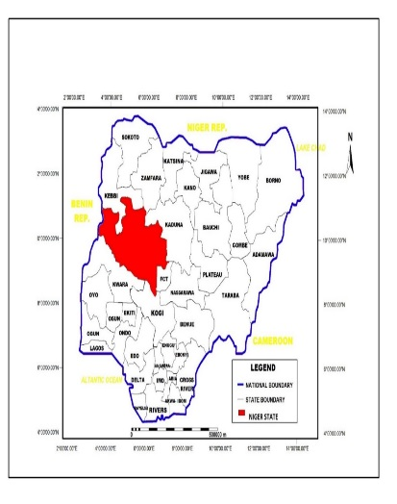

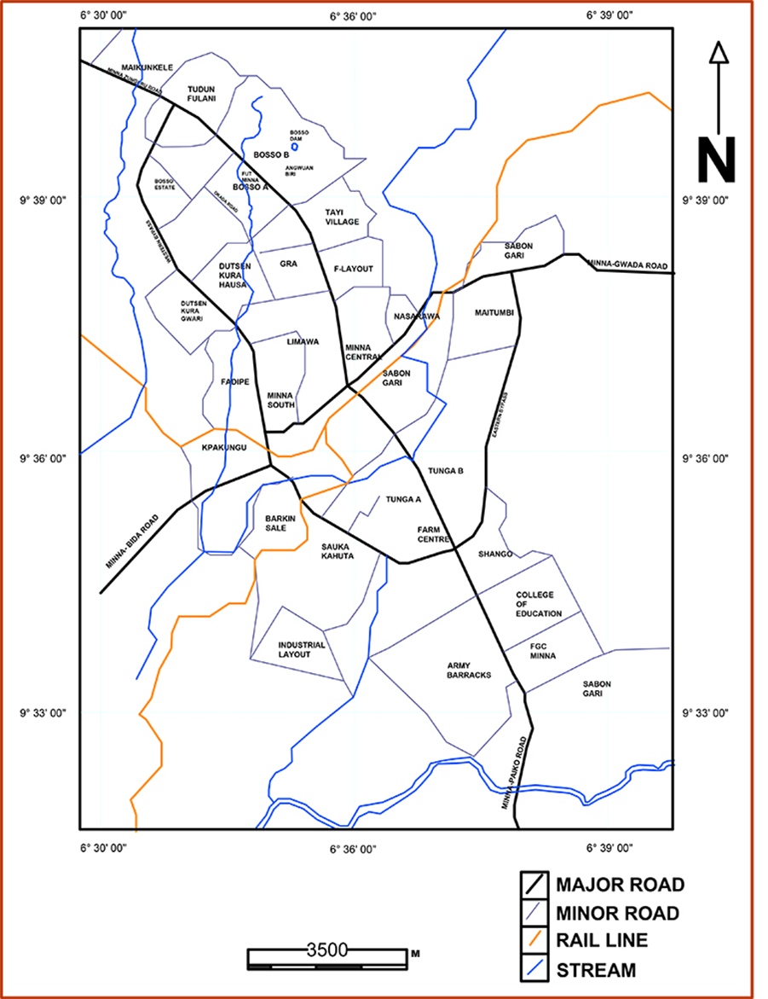
Figure 2.1: Map of Niger State showing Minna (down) and Bida (up) Metropolis
3. Methodology
A total of forty (40) water sampling points were tested throughout the research. Twenty sampling points was tested in the month of October in Bida and Minna. Ten sampling points each in Bida and Minna. This process was repeated in the month of January. The depths of the wells were measured, the coordinates were recorded and samples were taken in sterile bottles and the physical parameter analyses was carried out to compare the quality of water in Minna and Bida Metropolis. The coordinates of the well measured was used to prepare water table contour maps for Minna and Bida using Surfer 8 software.
4. Results and Discussion
4.1 Evaluate the water availability and supply within bedrocks
This study on bedrock correlation to availability of water and its physical parameters in hand-dug wells was conducted in Minna and Bida which are areas with basement complex and the sedimentary basins respectively.

Figure 4.1: Comparison of groundwater availability in the basement complex (Minna).
Field survey shows that the water levels of the wells during the wet seasons are shallow while the water levels during the dry seasons are deeper. This trend is seen from well 1 to well 9 while there is a slight reverse in the trend in well 10. This is because well 10 is located near a river which recharges the well. Though the depths of the water tables vary from one area to another in Minna, the characteristics of the basement complex rocks are similar in the wells that were sampled.

Figure 4.2: Comparison of groundwater availability in the sedimentary basin (Bida).
The trend recorded in the well 1 to well 6 in sedimentary basin (Bida) is similar to that of the basement complex (Minna) where the water levels are deeper during the dry season and shallow during the rainy season. The change in the trend in well 7 to well 10 is because these wells fall in the Eastern region of the study area where rivers and streams are found, these water bodies recharged the wells during the dry season when there is absence of rainfall.
The results for figure 4.1 and figure 4.2 shows that climate trends have high correlations with the ground water table. The increase in water table was observed in wells during the wet seasons which is attributed to the high rainfall, high infiltration and high recharge rate into the aquifer. The water table also influences the velocity of ground water flow in the area.

4.2 Describe the seasonal factors of the bedrocks

Figure 4.3: Groundwater levels in the Basement Complex (Minna) and the Sedimentary Basins (Bida) during the dry season.
Figure 4.3 shows the groundwater levels in the Basement Complex (Minna) and the Sedimentary Basins (Bida) during the dry season. It is observed that the wells in the Sedimentary Basins are deeper than those in the Basement Complex even though it’s the same season.

Figure 4.4: Groundwater levels in the Basement Complex (Minna) and the Sedimentary Basins (Bida) during the wet season.
The result shows that climate trends have high correlations with the ground water table. The increase in water table was observed in wells during the wet season which is attributed to the high rainfall, high infiltration and high recharge rate into the aquifer. The water table also influences the velocity of ground water flow in the area.
4.3. Water table contour maps for Minna and Bida
Water table contour maps were used to indicate groundwater flow directions. From field measurements of static water levels in wells, water table contour maps were constructed.
Grid vector maps were used to show direction and magnitude of data at points on the maps. The direction of the arrow points in the direction of the steepest descent. The magnitude of the arrow changes depending on the steepness of the descent.
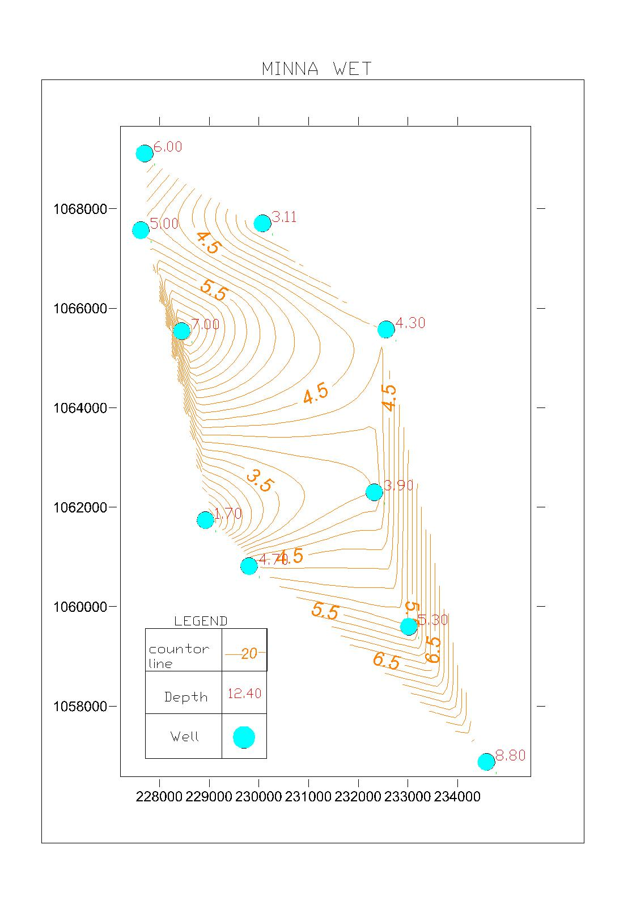
Fig.4.9: Water Table Contour Map for Minna during the wet season.

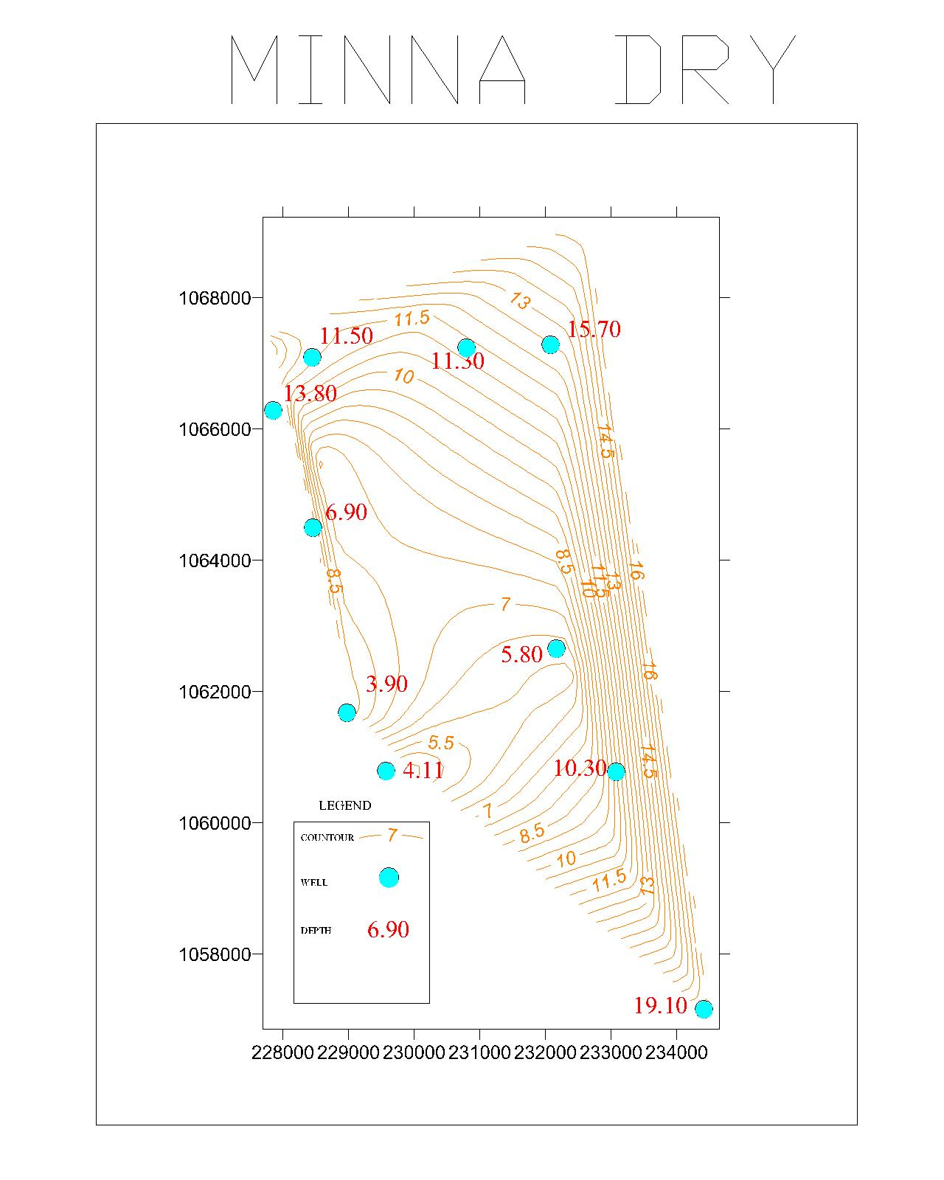
Fig. 4.10: Water Table Contour Map for Minna during Dry Season

Figure 4. 11: Water Table Contour Map for Bida during the Wet Season

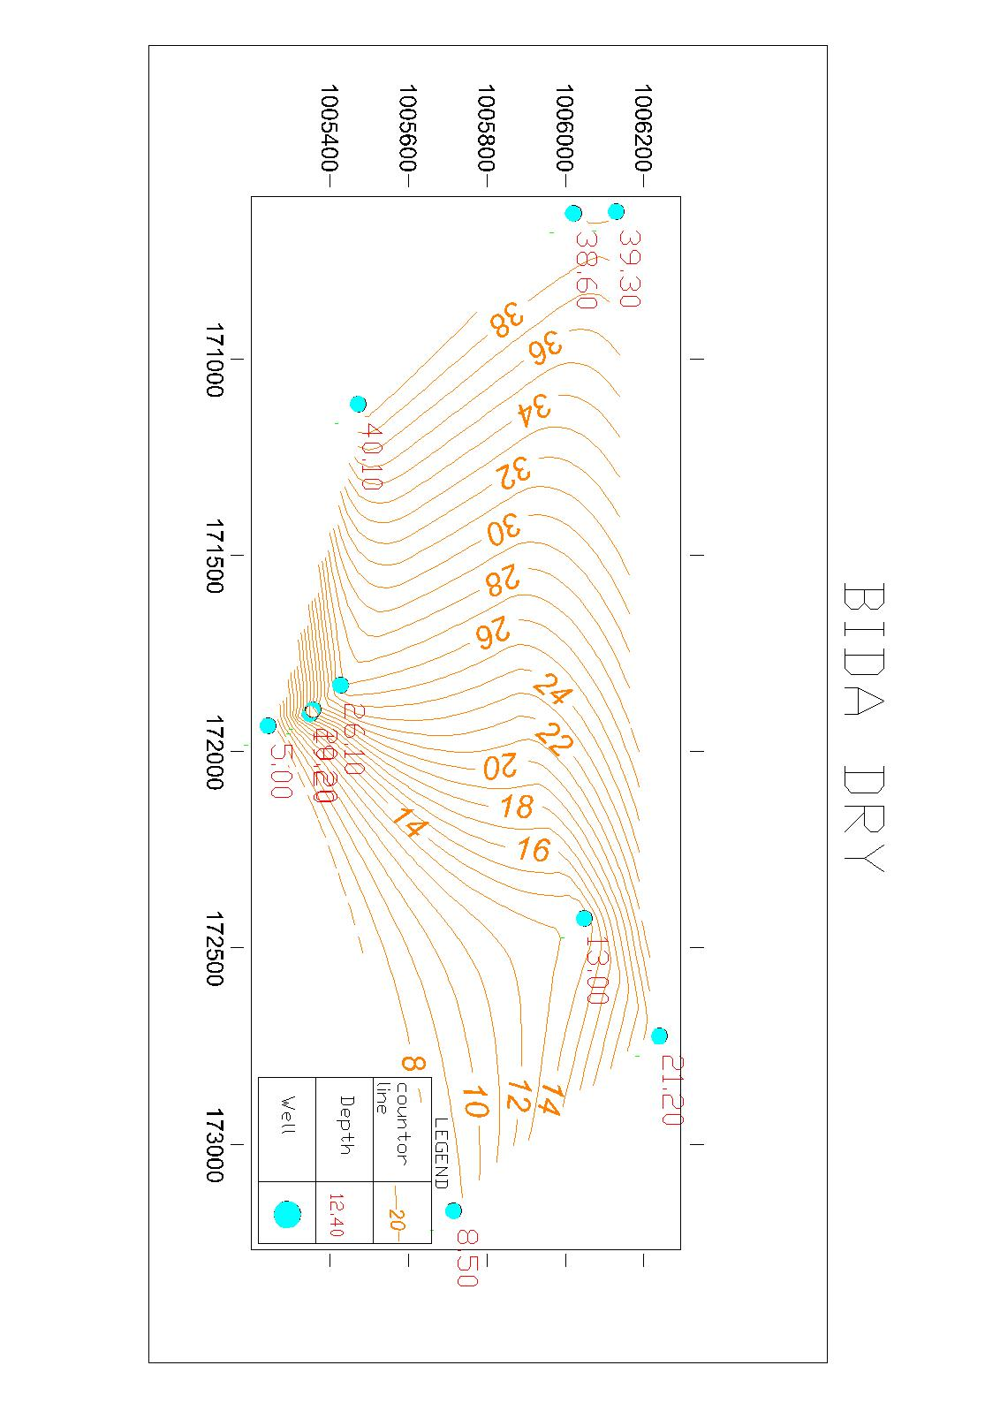
Fig. 4. 12: Water Table Contour Map for Bida during the Wet Season

CONCLUSION
This study analyzed the ground water availability in hand-dug wells in Minna and Bida. Based on the findings of the study, the water levels of the wells during the wet seasons are shallow in both the Sedimentary Basins and the Basement Complex while the water levels during the dry seasons are deeper. The wells in the Sedimentary Basins are generally deeper than those in the Basement Complex regardless of the seasons.

REFERENCES
Baraje, S. (2012. Sources and Accessibility of Water Supply in Zone B’ Districts of Niger State: Unpublished Undergraduate project. Department of Geography, IBB University Lapai. Nigeria.

Domenico, P.A (1972). Concept and models in Groundwater Hydrology, Newyork. McGraw hill

Isah, S. I. (2012. Sources and Accessibility of Water Supply in Zone B’ Districts of Niger State: Unpublished Undergraduate project. Department of Geography, IBB University Lapai. Nigeria.
Obaje, N.G. (2015). Bedrock Factors of Water Availability and Supply. Lecture Note.
Offodile, M.E. (2002). Groundwater Study and Development in Nigeria. University of Ibadan Press, Nigeria.
Suleiman, H. (2014). Using Hand-dug Wells to Estimate Depths of Underground Water in Bida. Unpublished Undergraduate project. Department of Geography, IBB University Lapai. Nigeria.

