Residential Location Choice: A Study of Household Preferences in Minna, Niger State, Nigeria
Santali Benjamin Ndako Aliyu
Department of Urban and Regional Planning, Federal University of Technology, Minna, Niger State
Abstract
Planners and policymakers are becoming more concerned with how to quantify the factors that affect households' decisions about where to live among Minna people as a result of concerns about the quality of urban life in cities. The study therefore examines the factors that determine resident’s choice of location in Minna, Nigeria, from the perspective of residential densities. In achieving this, the research methodology adopted Multistage sampling technique for cluster sampling. Simple Random Sampling was then used in each cluster for the administration of 588 questionnaires in the study area in order to assess the various attributes in choice of location. The data obtained was analysed using the Statistical Package for Social Science (SPSS) and MS Excel, thereafter, the results were presented in tables. The study therefore established that residential density and attribute of households is a critical factor that influence the RLC of households. Households residing in high density neighbourhoods pay more attention to economic (3.98) and transport (3.80) factors, while households in low density neighbourhoods do not consider economic (2.23) and transport (2.37) factor as a significant factor in RLC. The study also revealed that there is no significant relationship between the three residential densities regarding factors influencing RLC. The study therefore concludes that factors influencing RLC is not generic in space and hence can be affected by neighbourhood density and income levels of households.
Keywords: Residential, Location, Choice, Neighbourhood, Neighbourhood Density.

INTRODUCTION
Goal eleven (11) of the Sustainable Development Goals (SDGs) places a focus on creating inclusive, secure, resilient, and sustainable cities and human settlements. Furthermore, according to the urban residential location theory, tenants' residential preferences are influenced by the proximity to urban amenities, the availability of public transportation, and the associated expenses of commuting and lodging (Prashker et al., 2008). However, the complexity of people’s lives makes choice of location a decision that is influenced by a variety of factors such as physical and environmental factors, facilities and services, public security, and community/socio-economic factors (Beamish, Goss and Emmel, 2001).
If the locations of the elements evaluated for choice of residence are effectively planned, residential location choices in cities will be limited. The scenario that has existed in Nigeria's urban centres is further complicated by the fact that as cities develop in size and population, demand on the choice of residential site increases. As a result, the supply of infrastructural facilities does not increase at the same rate as its demand (Ubani et.al, 2017). In planning, provisions are made for similar facilities and amenities without taking into consideration these factors as different people have different factors that influence their decision to reside in an area, thereby, bringing together different income groups in the same location. It is important to note that choice of residential location is in many ways limited as it often depend on the type of housing available in a particular location at a particular time. Therefore, there is need for a study to be carried out on this course so that the factors influencing choice of location could be understood for better planning by policy makers. The aim of this study is to examine the factors influencing choice of residential location in Minna. In order to achieve this, attempt was made by investigating these factors for household choice of location in the study area.
THE STUDY AREA
Minna is a city in the north central region of Nigeria, it is the capital of Niger State, one of Nigeria's 36 federal states, and is the headquarters of Chanchaga Local Government Area with an estimated population of 201,429 people (2006 census) making it the biggest city in Niger State. As the administrative capital of Niger State, Nigeria, Minna, is situated on 243 metres above sea level at 9 62"N latitude and 6 55"E longitude. With a population of 201,429 according to the 2006 census, Minna is the largest city in Niger State and the capital of Niger State, one of Nigeria's 36 federal states. Minna also serves as the administrative centre for Chanchaga Local Government Area. The town has increased in size from its initial population of 202151 as of the 2006 Census due to the ongoing influx of people into the state capital. Minna was initially confined to Chanchaga LGA, However, over the years the city (Minna) has grown into the adjoining LGA of Bosso.
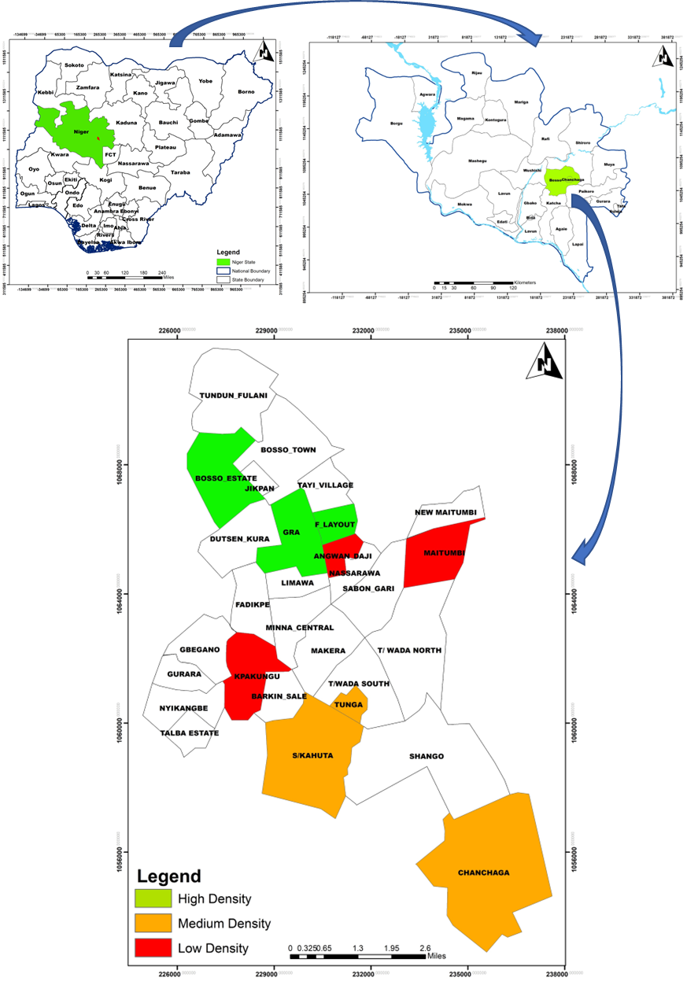
Figure 1: Map of the Minna showing the Selected Neighbourhoods

II. LITERATURE REVIEW
Concept of residential location choice
The specific home or apartment that a family chooses is referred to as its residential location (Sanit et al 2016). Residential choice is the process by which households choose where to reside and, when dissatisfied with their current residence, determine when and where to move (Poku-Boansi and Adarkwa, 2016). Giuliani (2004) claims that deciding on where to live entails conducting an assessment in which the ideal environment's requirements are weighed against the available options. An increasing number of urban residents are forced to choose the best place to live.
Determinants of household residential location choice
According to the literature, neither one specific factor nor the availability of certain local services affects household location selections. When a household choose where to live or stay, a variety of considerations are taken into account. The majority of studies on residential location choice in the pertinent literature are concerned with accessibility and transportation options, amenities, facilities, and features of the home environment, attachment to the neighbourhood, and the social, economic, and demographic characteristics of the people living there.
According to studies, residents' location choices seem to be primarily influenced by proximity to the city centre or their place of employment, as well as the quality and variety of local transit options. Based on their preferred modes of transportation, households and individuals situate themselves. Access to public transportation, ease of cycling or walking, low levels of traffic, and pedestrian friendliness are residential choice criteria characterised as travel behaviour and supportive of public transportation, according to Sinniah et al(2016) .'s study on residential location preferences. Wu (2006) discovered that factors like safety, closeness to the city, accessibility to public transportation, ease of travel to and from the workplace, sense of safety, and access to medical and educational facilities all affect where people choose to live.
Studies that examine how transportation issues affect where households live have produced a variety of conclusions. While some academics believe that transport variables are significant in determining where a household chooses to live, others believe that the high level of accessibility provided by private vehicles in metropolitan regions lessens the significance of transport factors.
Guiliano and Small (1993) discovered that households typically commute more than they need to in a study of commuting behaviour and residential location in Los Angeles, US. This shows that transportation, at least to the workplace, is not a significant driver of residential location. Transport variables, on the other hand, were discovered to be significant predictors of home movement and location choice in a more recent stated preference experiment conducted in Oxfordshire, UK. According to the study, an increase in the amount of time or money needed to commute to work or shop was a good indicator of family movement, or a "push factor." "People choose residential areas with a mix of shorter commuting times, cheaper transit expenses, lower density, and higher school quality," the scientists wrote in their conclusion (Kim and others, 2005).
Demographics are a significant factor in determining residential location preference (Givliamo and Small, 1991). A key factor in deciding where to live is the family or household cycle stage. Hazel and Moon (2009) argued that older age groups have less residence mobility than younger age groups do. Another element influencing selection for a place to live is income. This aspect of housing selection has drawn a lot of attention from scholars. According to Okesoto et al. (2014), there is a weaker association between income and housing price than there is between income and housing affordability. They come to the conclusion that there is no housing income elasticity.
According to Jin and Lee's (2018) Urbanism model, different income and age groups have distinct preferences for various aspects of residential site. They also stress the existence of residential segregation based on income in the case of Korea. According to a survey by Petkar and Macwan (2018), residential preference varies depending on personal preferences, family size, and economic level. That according Hensher (2001), households with higher incomes, kids, or two workers exhibit various home consumption patterns.
According to literature, social standing and relationships play a significant role in determining where a household resides. Social networks and social ties have been proposed as measures of social capital that are crucial for urban people to successfully navigate daily life in cities. Social capital is defined in the urban livelihoods paradigm as the networks of interpersonal support that exist inside and across households, extended families, and communities. People can use these networks to get housing as well as information about jobs and opportunities (Meikle, 2002).
Social connections, however less generalizable than other criteria, can play a significant role in a minority group's decision over where to live in a city. According to research by Guo and Bhat (2007), households in the United States "tend to locate in an area with a large proportion of other households with a similar household structure and household size as their own (Sinniah et al., 2016). Also mentioned was how having a car significantly reduces the importance of distance when deciding where to live. A person's sense of belonging in their environment has a significant impact on their level of contentment. When deciding where to live, it's crucial to be close to family, friends, relatives, or other social groupings, as well as to neighbours who share your values and socioeconomic position.
Fejiten et al. (2008) referred to the problem as "social space" and stressed the value of the depth of social networks in determining the best living situation. Although they are determined to be somewhat less relevant than other factors, social relations, described as "community preferences" in Petkar and Macwan, are offered as one of the factors that govern residential preference. Winstanley et al. (2002) demonstrated how familiarity and social relationships affect residential location choice in a study on residential mobility. They asserted that a lot of people find it difficult to leave comfortable environments to which they have grown used and attached. The cost of housing is a big role in where a household decides to live because most households make housing decisions based on their budgets. According to a significant Australian study, housing affordability has a significant role in determining where families choose to live. This, along with the desire to become homeowners, is one reason why people have relocated to the urban periphery (Burgess and Skeltys, 1992).
Researchers from Africa have also explored the theories underlying residential location preferences. According to a study by Acheampong and Anokye (2013) in Ghana, the most significant explanatory factors for RLC in two of Kumasi's peri-urban communities are family relationships, closeness to the workplace, relatively low land prices, and house rentals. According to the study, housing characteristics relating to the neighbourhood are much less essential than socio-cultural, housing, and accessibility concerns. In a similar vein, Nkeki and Erimona's (2018) findings discussed how socio-cultural cohesiveness and accessibility played a major part in influencing household decision-making over where to live in Benin City, Nigeria.
Choice of a family's primary residence is a concern that transcends municipal boundaries. Numerous research on household residential site preferences have been conducted in both developed and developing nations. Notably, these studies did not concentrate on the density of residential areas or neighbourhoods, which is why the current study was conducted.
III. METHODOLOGY
A combination of primary and secondary data sets was used in the investigation. The main information relates to the elements that influence where people choose to live. Specifically, the physical, social, economic, and environmental aspects that affect where people choose to live. The literature on the topic from different writers is included in the secondary data. Since the "household" is the unit of measurement for the study, the estimated number of households is 27,613. Sallant and Dillmann's (1994) sample size formula was used to calculate the study's sample size, which came to 588 with a 4% confidence interval. Using a multistage sample strategy, 588 questionnaires were distributed and returned completed. Using low, medium, and high residential densities, Minna was classified into clusters of low, medium and high density neighbourhoods. Three neighbourhoods were randomly chosen in each cluster; hence, a total of nine (9) neighbourhoods were selected for the study. Consequently, the respondents for the study were chosen using a simple random procedure. Kpakungu, Angwan Daji and Maitumbi were selected for high density neighbourhoods, Sauka Kahuta, Chanchaga, and Tunga from medium density neighbourhoods, while GRA, F-Layout and Bosso Estate were selected as low-density neighbourhoods.

IV. RESULTS AND DISCUSSION
Residential Location Choice in High Density Neighbourhoods in Minna
The factors that influence residential location choice of households residing in high density residential in Minna were assessed and the result is presented in Table 1. The result shows that economic factor (3.98) is the most significant factor that influence the RLC of households in the high-density neighbourhoods, including transport factor (3.80), security (3.20), and physical factor (3.15). Social factor (2.50) and infrastructure and amenities were not significant drivers of RLC in high density neighbourhoods in Minna. This invariably shows that households in density neighbourhoods in Minna pay less attention to social factors and infrastructure when making decisions on residential location, rather they are concerned about the economic implication and access to transport or mobility.
TABLE 1: Factors Influencing RLC in High Density Neighbourhood of Minna
Factors | Sum | Mean | Decision
Physical factor (Housing) | 1852 | 3.15 | Significant
Infrastructure and Amenities | 1664 | 2.83 | Not Significant
Security | 1880 | 3.20 | Significant
Social Factor | 1467 | 2.50 | Not Significant
Economic Factor | 2339 | 3.98 | Significant
Transport Factor | 2236 | 3.80 | Significant

Residential Location Choice in Medium-Density Neighbourhoods in Minna
The drivers of RLC in medium density neighbourhoods in Minna is presented in Table 2. Households in medium-density neighbourhoods in Minna pay significant attention to all the factors considered in this study. Table 2, shows that economic factor was the primary driver with a mean of 3.82, followed by security factor (3.77), infrastructure and amenities (3.51) and physical factor (3.45). Although, transport and social factor were the least rated factors, they were significantly considered when deciding the household’s choice of neighbourhoods. These shows that households in the medium-density neighbourhoods pay more attention to several factors when making decision for the choice of residential neighbourhoods as against the attitude of households in the high-density neighbourhoods with less consideration for social and infrastructure factors.
Table 2: Factors Influencing RLC in Medium-Density Neighbourhood of Minna
Factors | Sum | Mean | Decision
Physical factor (Housing) | 2029 | 3.45 | Significant
Infrastructure and Amenities | 2217 | 3.51 | Significant
Security | 2064 | 3.77 | Significant
Social Factor | 1887 | 3.21 | Significant
Economic Factor | 2246 | 3.82 | Significant
Transport Factor | 1882 | 3.20 | Significant
Residential Location Choice in Medium-Density Neighbourhoods in Minna
Table 3 shows the drivers of residential location choice in low density neighbourhoods in Minna. The result revealed that contrary to what was reported in high-density neighbourhoods, economic (2.23) and transport (2.37) factors are not significant factors considered for RLC among households in the low-density neighbourhoods. The primary factor considered by households in the low-density neighbourhoods are security (4.19), social factor (3.89), physical factor (3.86) and infrastructure (3.51). Households in low density neighbourhoods otherwise referred to as high income earners play down the issue of transportation cost and economic factors when deciding on residential location choice, but rather focused on security, social, physical, and infrastructural factors.
Table 3: Factors Influencing RLC in Low-Density Neighbourhood of Minna
Factors | Sum | Mean | Decision
Physical factor (Housing) | 2270 | 3.86 | Significant
Infrastructure and Amenities | 2464 | 3.51 | Significant
Security | 2064 | 4.19 | Significant
Social Factor | 2287 | 3.89 | Significant
Economic Factor | 1311 | 2.23 | Not Significant
Transport Factor | 1394 | 2.37 | Not Significant

The study examined the level of relation between the factors influencing residential location choice among households in various density (low, medium, and high) neighbourhoods in Minna. The Pearson product moment correlation was conducted, and the result is presented in Table 4. The result shows that correlation exist between the neighbourhoods’ densities, but the relationship is not significant. For example, Table 4 shows that the relationship between factors influencing RLC in high and medium-density neighbourhoods is 0.366 at a significant level of 0.477. This implies a weak level of corelation without significant impact. Similar trend can be observed across the interaction of the neighbourhoods. This shows that drivers of RLC varies from neighbourhood to neighbourhood based on density or level of income.

Table 4: Pearson's Correlations
Variable |  |  |  | HDN |  | MDN |  | LDN
1. HDN |  | Pearson's r |  | —
 |  | p-value |  | —
2. MDN |  | Pearson's r |  | 0.366 |  | —
 |  | p-value |  | 0.476 |  | —
3. LDN |  | Pearson's r |  | -0.808 |  | -0.010 |  | —
 |  | p-value |  | 0.052 |  | 0.985 |  | —
* p < .05, ** p < .01, *** p < .001

VI. CONCLUSION AND RECOMMENDATION

This study examined the factors influencing residential choice location in Minna using residential densities of neighbourhoods where households reside as background. The study concludes that factors influencing residential location choice of households varies across space and particularly across neighbourhood densities and income levels. The neighbourhood density and income level of households reflects the factors considered for RLC in urban cities. For example, households in low income areas of Minna, otherwise called high density neighbourhoods pay little or no attention to the infrastructure or social factors, but more attention to the economic and transport dynamics when it comes to RLC and vice versa for high income neighbourhoods otherwise called low density neighbourhoods.

Neighbourhoods should be provided with adequate basic infrastructure and services through proper designed policies. The provision and restoration of these infrastructures will enhance proper development in the city. Such infrastructure should also be provided at the fringes. Thus, when evenly distributed, it will improve proper development in the
community. Since the availability and condition of infrastructure and the factor responsible for choice of neighbourhood differ with densities, town planners should also take in to consideration the factors for each density when planning for new neighbourhoods.

REFERENCES
Burgess R and Skeltys N. (1992). Findings from the housing and location choice survey: an overview. Housing and Urban Development Division & Department of Health Housing and Community Services. Australia: Australian Government Publishing Service; 1992.

Fejiten P, Hooimeijer P, and Mulder CH. (2008). Residential experience and residential environment choice over the lifecourse. Urban Studies. 2008;45(1):141–162.
Hazel AM and Moon JK. (2009). Determinants of residential location decisions among the pre-elderly in central Ohio. Journal of Trans Lan. 2009;2(1):47–67.
Giuliani MV. Residential preferences and attachment across the lifespan. In: Spielberg C, editor. Encyclopedia of Applied Psychology. San Diego:Elsevier/Academic Press; 2004:259–266.

Giuliano G, and Small KA. (1993). Is the journey to work explained by urban structure? Urban Studies. 1993;30(9):1485–1500. 30. Kim JH, Pagliara F, Preston J. The intention to move and residential location choice behaviour. Urban studies. 2005;42(9):1621–1636.

Givliamo G, and Small KA. (1991). Sub centres in the Los Angeles Region. J Reg Sci U Eco. 1991;21(1):163–182.

Guo JY and Bhat CR.(2007). Operationalizing the concept of neighborhood: Application to residential location choice analysis’. Journal of Transport Geography. 2007;15(1):31–45.

Hensher DA. (2001). Measurement of the valiation of travel time savings. Journal of Transport Economics and Policy. 2001;35(1):71–98.

Jin J, and Lee H. (2018). Understanding residential location choices: an application of the UrbanSim residential location model on Suwon, Korea, International Journal of Urban Sciences. 2018;22(2):216–235.

Meikle S. (2002). The urban context and poor people. In: Carole Rakodi, Tony Lloyd-Jones, editors. Urban Livelihoods, A people Centered Approach to Reducing Poverty. 2002.

Okesoto JO, Oke GO, and Olayiwola KO. (2014). Residential location preference of Lagos Central Business District working population. American Journal of Social Issues and Humanities. 2014;4(1):45–55.

Petkar AS and Macwan JEM, (2018). Criteria analysis of residential location preferences: An urban dwellers’s perpsctive. International Journal of Urban and Civil Engineering. 2018;12(1):49–55.

Poku-Boansi M, and Adarkwa KK.(2016). Determinants of residential location in the Adenta Municipality, Ghana. Geo Journal. 2016;81(5):779–791.

Sanit P, Nakamura F, and Tanaka S, (2013). Location and mode choice decision mechanism analysis of multi-worker household in Bangkok, Thailand. Journal of the Eastern Asia Society for Transportation Studies. 2013; 10:1243–1257.

Sinniah, GK, Shah MZ, and Vigar G, (2016) Residential location preferences: new perspective. Transportation Research Procedia. 2016; 17:369–383.

Winstanley A, Thorns DC, and Perkins HC. (2002). Moving house, creating home: Exploring residential mobility. Housing Studies. 2002;17(6):813–832.

Wu W. (2006). Migrant Intra-urban Residential Mobility in Urban China. HousingStudies. 2006;21(5):745–765.

