Mitigating urban disasters: a study of abandoned mines in Zaria, Nigeria

By

Aliyu Kawu
O F F I C E
Department of Urban and Regional Planning
Federal University of Technology, Minna 920003, Nigeria www.futminna.edu.ng

C O R R E S P O N D E N C E
P O Box 4232, Minna 920001, Nigeria
aliyukawu@gmail.com, +234 (0) 8068015046, 8028597919

Abstract
Sand and especially mineral mining are accountable for the growth and development of many cities. Traditional settlements of northern Nigeria are punctuated with flourishing and mostly abandoned mining sites. These features have drawn attention of many due to their continuous threats to life and properties in the area. They are also noted to have limited urban livability and further constrained effective urban management. The existence of these features has also led to the growth and sustenance of city black spots of like illegal refuse dumps, insect breeding grounds, and, continuous gullying that challenges the safety of adjoining structures and communication routes. Through physical surveys, systematic sampling, and Focus Group Discussions (FGDs), this work looked at the innovative ways residents of Zaria and her environs are confronting these challenges by: a) engaging emerging trends in urban management through community efforts and other civic engagements to curtail this and similar environmental menace, b) highlighting how joint efforts geared towards environmental management have opened other ways of livelihoods and sustainable urban economic activities, and c) the wider application of similar gestures in addressing many urban issues confronting developing countries today. Top amongst the recommendations by this study is the endorsement of inclusive bottom-up approach to planning and management of cities. The inclusion of the local communities and the vulnerable groups – irrespective of their levels of deprivations is very crucial to disaster mitigation and management in both urban and rural areas.
KEYWORDS: environment / disaster / finance / inclusion / urban mining / vulnerability
- Introduction
The 21st century can be described as a period that leaves no one in doubt of the fact that mankind would be forced to rethink the ways he live on planet earth. The continuous of occurrence of disasters is one of such reminders (Tyler, 1993). While global attention to the phenomenon of climate change is not a recent one, emphasis is more on the negative trends that highlight the vulnerability of populations, environment and resources (Mabogunje, 1996; Hardoy, Mitlin, Satterthwaite, 2001; Simms & Reid, 2005; Adelekan, 2010). Easy access to information and the abundance of literatures that sees the global phenomenon in such angle has also helped to down play the need to explore possibilities and raising hopes of confronting mounting challenges. This domineering stance by academics and policy makers alike, has further limited avenues for harnessing opportunities for addressing the issues altogether. There is the need to have holistic view of disasters, climate and climate change as phenomena that can impact negatively or positively on human health and wellbeing as well as the ecosystem which constitute his habitat and life support system (Ayoade, 2003). This calls for detailed assessment of disaster related natural and human phenomena with the view of having innovative and lasting solutions.
Africa is primarily fed by peasant farmers working on small land holdings. These groups are also affected by natural and environmental disasters. The documentation of innovative approaches by these vulnerable farmers that feed millions of developing countries’ bourgeoning populations are mostly left out by many assessors of disaster events of recent times. Less attention is paid to site specific adaptation practices devised to counter weather uncertainties and disasters events by small-scale farmers (Kawu, 2012). Agriculturists in sub-Saharan Africa are also confronted with environmental problems of land degradation, urban expansion and disasters of different colouration. There is the need to document how vulnerable groups confronts disasters in this all important ecological zone that account for over 50% of Nigeria’s land mass (Udo, 1977) of over 923,000 km². This is what this study is out to highlight.
- Disasters and the urban environment
The main threat of climate and climate change related disasters in sub-Saharan Africa is not crop failure due to early cessation or excessive rainfall as would be expected. Flooding and erosion appears to be the main problem confronting both urban environment and farmlands downstream. flooding could be due to unusual events of rainstorms or prolong rains giving room for high run-off that eventually results into erosion and related hazards. Although a potential for disaster event, excess rain water or its accompanying flooding has been put to beneficial uses in many areas across the world (Tyler, 1993; Vania and Taneja, 2004; USAID, 2005; UN-HABITAT, 2006).
Rapid economic growth of cities in the grassland region of Nigeria during the periods preceding the political independence of the country, has led to the proliferation of abandoned mines and quarries sites across the mainly agrarian region. These features hitherto provided raw materials for both industries and local building materials for households. Hence, mining of minerals accounted for majority of cases of environmental degradation in the form of abandoned mines and mining pit with varying negative consequences on life and livelihood activities in many cities. Today cities like Jos and Zaria are faced with the problem of managing this environmental menace.
There are innovative ways through which urban agricultural practices, for instance, has improved food production. For example, Hong Kong still produces two-thirds of the poultry, half the vegetable, and 40% of the fish it consumes. Singapore produces all of it meat and fish and one-quarter of its vegetables (O’meara 1999, and Population Reports, 2001 and 2001, Bafani et al, 2012). As encouraging as these practices are, little attention has been given to the emergent scenarios where disaster spots in urban and rural environments are been converted to useful enterprise.
Studies carried out in this part of sub-Saharan Africa examined urban agriculture in it social, economic or aerial perspectives (Population Review, 2000 and 2001; Sani, 2002 and 2006). Those in the domain of urban agricultural sustainability are often tilted towards the assessment of initiatives directed at fighting food insecurity and its consequences (Umar and Kawu, 2011; Amosu, Bashorun, Babalola, Olowu, and Togunde, 2012; Kawu, 2012). Assessing urban socio-economic activities intensified by the need to confront urban disasters has the advantage of assisting the required change of urban threats to urban opportunities (Burra et al, 2003; Biau, 2008). This is the case examined here using Zaria as a case study.
  - Study area
The settlement of Zaria is located in the savannah (grassland) region of Nigeria. Zaria is long known as an administrative and educational metropolis hosting over a dozen institutions of higher learning including a university and many research outfits. Historically, Zaria has been an area of rapid socio-economic development leading to equally rapid urban expansion of which there was hardly efficient technology to monitor and effectively manage particularly during the 19th and 20th centuries ( Ukoje, 2004, Sani 2002 and 2006; Kawu, 2005 and 2012; Kawu, Ahmed and Usman, 2012). The small population size of the area before the country’s independent concealed the seriousness of urban environmental disasters lurking around. However, geometric growth and equally increasing pressure on land and environmental resources has driven many urban residents to vulnerable areas of the community.
- Data and methodology
Primary and secondary data were used for this study. While secondary data consists of published and unpublished works utilized for literature reviews and appraisal of best practices concerning the research theme, primary data were obtained on the field through the use of structured interviews of owners of farmlands in the research area. The instruments used for primary data collection includes a checklist for interviews, digital camera, Global Positioning System (GPS – Garmin GPSmap 76CSx model), used to record positions and measurements of farmlands, water reservoirs, and quarry sites. Satellite images acquired through Googlearth (Googlearth, 2012) were also used to update map and to observe research area. Two sample areas were selected for this research. These are Hanwa Low-cost and Yan-karfe (Lat. 11.07⁰N and Long. 7.41⁰E). Primary data was collected in five different points in the two neighbourhoods located in the south-eastern part of Zaria. Data analysis is mainly through descriptive statistics and research presentation is mainly through the use of charts.
- Discussion of results
  - The use of borrow pits
Borrow pits or abandoned laterite mining points came to being as a result of mineral and mostly sand mining in traditional cities of northern Nigeria. Large excavations found in Zaria and similar towns across the country as abandoned mine spoils have since raised concerns over the safety of people and livestock within their vicinity (Urquhart, 1977; Schwerdtfeger, 1980; Kawu, 2005 and 2012). Presently, these abandoned borrow pits located within the traditional town of Zaria (Birnin Zazzau) have been wrongfully converted to municipal waste dumps. This improper approach to managing abandoned mining sites and burrow pits have further endangering lives, the environment and properties in the areas. See plate I.
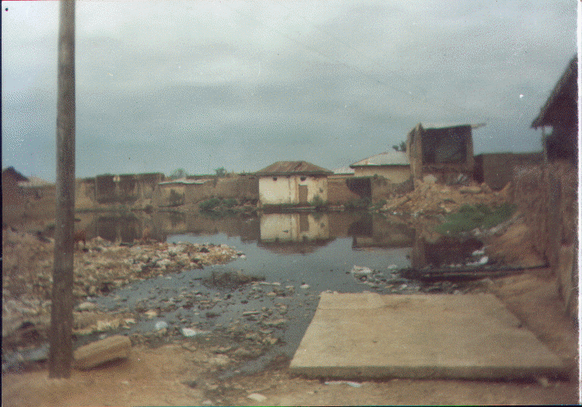
After: Kawu (2005:64)
Plate I: Land Degradation, Menace of Burrowed-Pits

  - Confronting environmental degradation
The traditional settlement of Zaria City (Birnin Zazzau) is dotted with abandoned mines which are increasingly forming obstacles to urban development and livelihood in virtually all the neighbourhoods of the ancient city. Some communities have resulted to dumping refuse and other household wastes into them only for them to become breeding grounds for disease vectors like household flies and mosquitoes. Some, filled by non-degradable wastes, have led to the expansion of accumulated rain water into houses thereby flooding the immediate households and further leading to the collapse of buildings and other structures on its way. This is a case of improper approach to managing the menace. Others residents have tried to salvage the feature and the environment through the conversion of these features to open space. Most often, the exercise fail because of indiscriminate dumping of refuse, erosion and sometimes inability to effectively respond to fast growing weed that often colonize the reclaimed spots.
  - Utilizing abandoned quarries
Abandoned mines at the city’s fast urbanizing peripheries are increasingly been put to innovative uses much in response to uncertainties of weather and climate related phenomena. In the past, these parts of the metropolis were hard hit by the disasters these abandoned urban menace regularly unleash. Many unsuspecting children and herdsmen often mistake the still waters as a shallow trench leading to sudden death of children and livestock. Today the same features are been used for food production in many different ways.
    - Irrigation
The normal irrigation practices known to farmers in Zaria metropolis and the Savannah region as a whole, is usually practiced along river banks especially after the rainy season. This annual practice utilizes accumulated rains from the uplands before it finally drains away to cultivate food and cash crops using both machine and manual labour. The phenomenon of climate change coupled with anthropogenic factors has led to sharp increase in run-off with considerable negative effects on urban streams and the age-long occupation of people.
Farmers at the urban peripheries of Zaria are responding to this by sourcing additional water from abandoned mines and quarries to irrigate crops. One of such abandoned sand mines is Stirling (named after the road construction company that excavated sand there in the late 1980s and early 1990s). Stirling is now a large reservoir of rain water that is now used effectively for intensive peri-urban agricultural practices all year round. This innovation has in most cases tripled annual agricultural output, increase income sources, and reduced the threats of weather uncertainties. The practice has also enhanced the introduction of crops and farming practices relatively unknown before in the metropolis. See plate II.
Although Stirling is located in Hanwa Low-cost, farmlands located at Yan-karfe, hundreds of metres away, are also benefiting from it. This is made possible through water management approaches devised by the farmers and owners of fish ponds in the area who are making use of this common resource. As the fish farmer harvests his stock, water is piped down to Stirling for use in irrigation farms surrounding it.
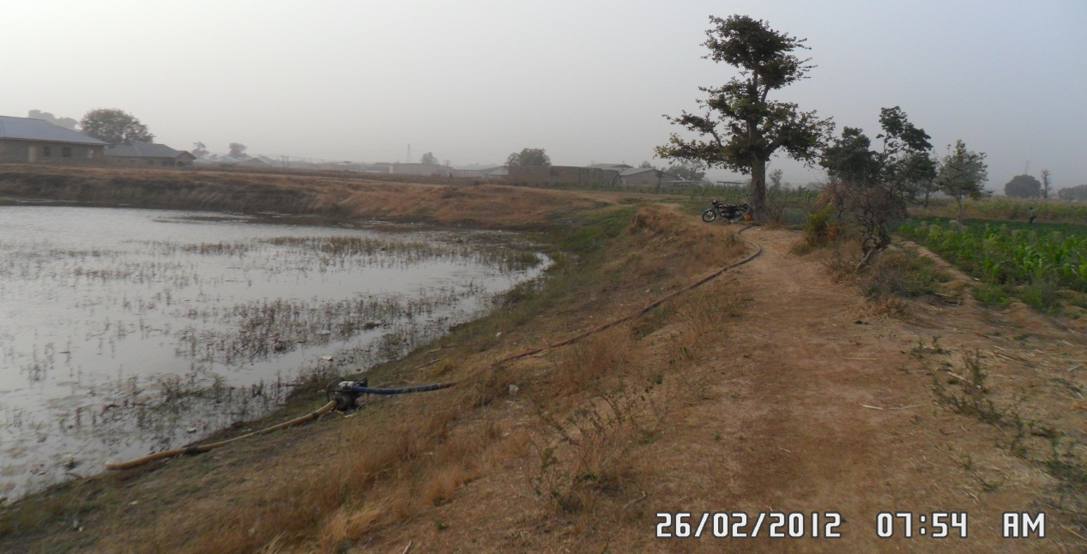
Source: Field Survey February 2012
Plate II: Stirling – a Man-made reservoir and a source of irrigation

    - Fish ponds
Due to the ability of granite to retain water, abandoned quarry sites underlain by these impervious rocks have become effective water receptacles during rainy season. These landmarks that in the past usually constitute insurmountable obstacle to urban development are now used fish farming and related activities. See plates III.
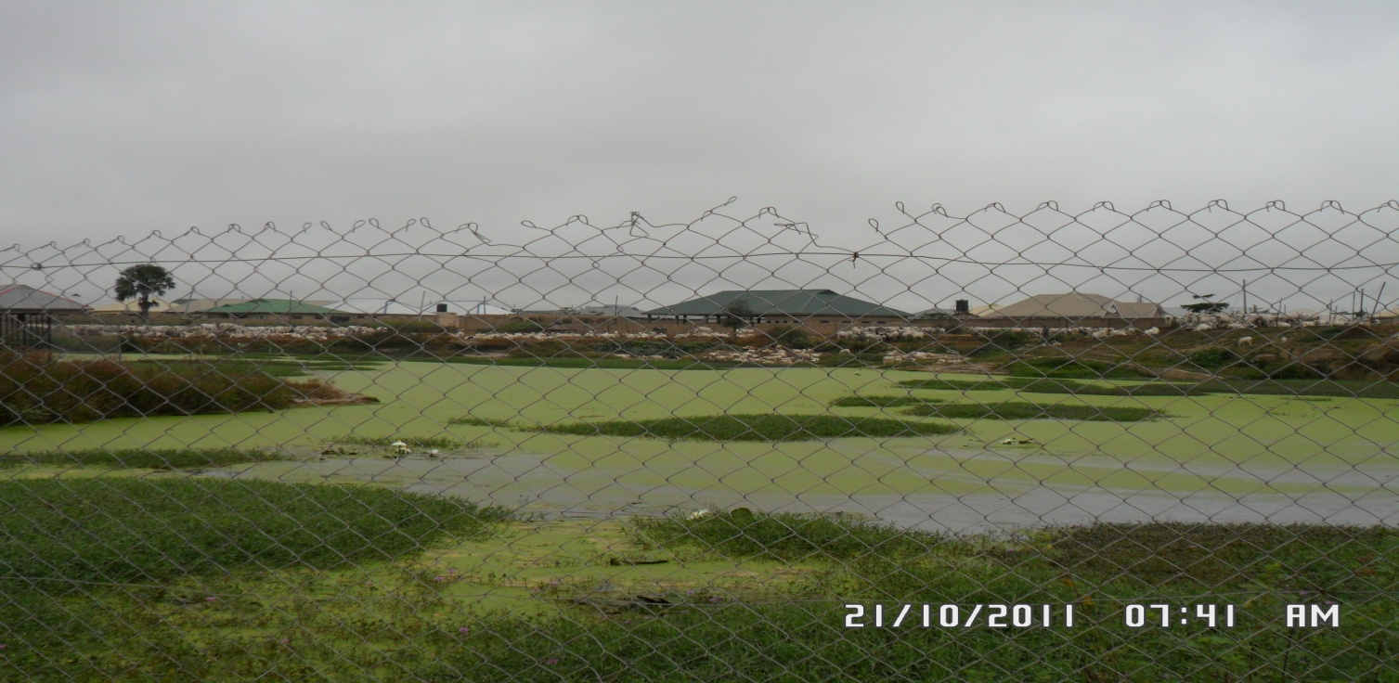
Source: Field Survey Oct, 2011
Plate III: A fish pond in Hanwa Low-cost, Zaria
There are two commercial fish ponds in Hanwa low-cost producing varieties of fish annually. Harvesting from these ponds located on the city’s precincts is usually during the months of November and December, almost immediately after the rains and in times for the Christmas and New Year festivities. Tens of tons of fish products particularly Cat fish (Siluriformes) is usually harvested every year from these farms.
    - Innovative irrigation practices
It has been noted that climate change adaptations ‘will include using crop varieties which can better cope with climate changes and relying more on the harvesting of water during the rainy season’ (Hailu, 2012). Irrigation and related agricultural practices in Zaria have given credence to this observation. For example, the utilization of abandoned sand mine - Stirling, is at present drawing wider attention. This is because of the novel innovations this single resource (formerly threats to urban livelihood) is been put to use today. It uses stretched throughout different aspects of urban agriculture, enhancement of livelihood to mitigate natural and man-made disasters.
      - Supplement for rains: Dry Spells occurs in almost every rainy season. Sometimes for a period long enough for crop to wither. This usually affects crop yield and can sometimes accounted for total loss of crop. Of recent, the frequency of this phenomenon in the Sahara region of Nigeria is disturbingly on the increase along with its devastating severity to crop and other human activities. Farmers have recently devised means of supplementing water from abandoned mines to irrigate crops during these dry spells. This has helped sustained intensive crop cultivation along these lands.

      - End of season farming: Ideally rainy season in Zaria can reach the end of October or even the beginning of November. Uncertain about this, farmlands close to Stirling are intensely cultivated by late September and early October so that if rain stops immediately, water from the borrow pits would be used to nurture the usually fast growing ephemerals like vegetables, tomatoes, and cowpeas lasting between 6 – 8 weeks before full-scale normal irrigation begin in the month of December. This practice has enabled peri-urban farmers especially to practice sustainable intensification on a continuous basis.

      - Dry-season farming: Irrigation also known as dry-season farming is another innovation by these farmers. Although, this is not new to this region, but the intensity, frequency and the locations in which this is continuously taken place is. Irrigation practices are mainly carried out during the dry season, usually close to the river banks and flood plains, with crops fed by streams and rivers mostly for one planting episode. However, with the use of borrow pits and abandoned quarries as reservoirs for rain water – as against rivers and streams, irrigation activities is almost on a continuous basis throughout the six months of the dry season. As one crop is harvested, another one is planted on a continuous basis. Through this approach, fast yielding crops are planted and harvested many times before the rainy season sets in. See plate IV.
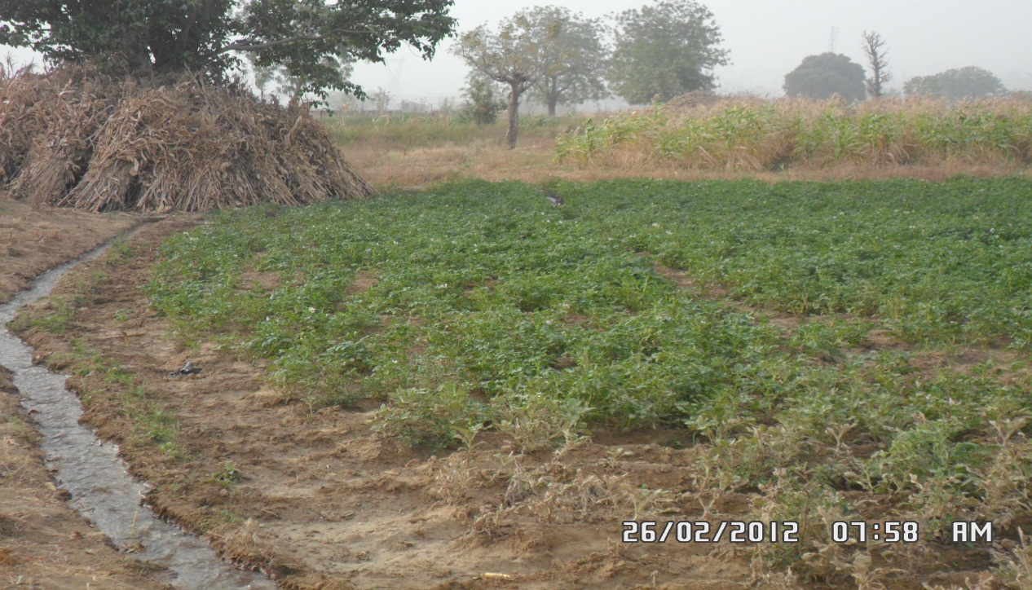
Source: Field Survey October, 2011
Plate IV: Intensive agriculture on a continuous basis
      - Checking insecurity: In the past, people were afraid of building houses close to these granite-underlined borrow-pits, because they are breeding grounds for mosquitoes and other disease vectors. They also pose a perpetual threat to children of those who live close to them. However, by piping this water to distant places – ‘Yan-karfe and its suburbs, farmers are now utilizing water from these same abandoned mines that were ‘death traps’ not too long ago for full-scale irrigation. Apart from the activity being taken away from its expected sites of river banks and floods plains, it is now helping in using former threats to urban productivity and wellbeing.
In this manner, urban farms are also engaging property owners in putting vacant lands to use instead of leaving them totally unused and uncared for, and in the process having to pay someone to watch over them. The continuous presence of people in the different ‘farmlands’ separating these properties either under construction, already built, or those yet to be occupied, ensures security in these sparsely populated areas which usually record desertions during work hours.

      - Introduction and adoption of new crops: Apart from increased intensity of dry season farming, innovative practices by peasant farmers in Zaria have also created additional room for the introduction of new crops. For example, in addition to growing vegetables, other crops like cowpea (Vigna unguiculata), maize (Zea mays) and potatoes (Solanum tuberosum) are gaining popularity amongst the commercially irrigated crops in Zaria. Some of these practices and the crops so introduced are totally alien to this environment because of the variations in climate and weather.

The introduction and continuous cultivation of Irish or White potatoes (Solanum tuberosum, Earth apple) into the region is of particular importance. Prior to this time, this crop is only cultivated on the Jos plateau (Lat. 9.57⁰N and Long. 8.53⁰E). Jos plateau experience much lower temperatures similar to what obtains in the temperate regions where Irish potatoes were brought to Nigeria. The crop is cultivated on the onset of the cold Harmattan (November – to – December). Water collected in the abandoned mine is utilized here. Helped by the lower temperature at that particular time of the year, farmers around Stirling are able to cultivate Irish potatoes and similar crops effectively. This is practice was unthinkable in the past due to the absence of rainfall in that particular time of the year when temperature is conducive for the crop. But the ponds nearby has provided farmers the water to cultivate other crop varieties.
      - Continuous cultivation: Unlike the mainstream river bank irrigation that provides opportunity for a single planting episode in a year, with the aid rain water reserved in abandoned quarries and communal water management, crops are now grown between three to four times before rainy season sets in every year. Crops that were not cultivated before are now amongst the most intensively farmed. Whereas normal irrigation gives opportunity for only once for virtually all the crops, abandoned mines seems to have tripled that opportunity within an irrigation period after each planning season. See table 1.
Table 1: Annual crop yield by irrigation method
Crop type | River side | Water from Stirling
Tomatoes | 1 | 3
Irish potatoes | 0 | 2
Spinarch | 2 | 4
Onions | 1 | 3
Maize | 0 | 3
Pepper | 1 | 3
Lettuce | 1 | 4
Carrots | 1 | 3
Source: Field Survey, Jan 2012

- Problems confronting innovations
The outskirts of Zaria are witnessing serious intrusion by uncontrolled housing development that is threatening to push out more friendly land uses. The continuous intrusion of roads into these farmlands is further creating issues of insecurity and sustainable livelihood of these peasant farmers. These un-tarred roads also cause serious erosion and other forms of land degradation
Lack of adequate protection by law of the land is another issue curtailing the institution of any legal action either by the farmers themselves or the urban authorities who also collect revenue from these farmers. By law, being a traditional settlement in existence before the introduction of modern planning by colonial masters, Zaria and similar traditional cities in Nigeria are not subjected to strict planning regulations as the case of their counterparts – the planned cities and neighbourhoods (Kawu, 2005; Kawu, Ahmed and Usman, 2012). Because of this, contraventions have become difficult to address. There is no legal code that has established standards for building and related activities in these areas or activities that are contrary to such rule.
Urban agriculture, despite its continuous importance is facing serious threat from lack of municipal waste management. Hanwa Low-cost in Zaria is not served by any waste management agency. Residents of these increasingly important neighbourhoods simply dump household wastes at any given space. This dangerous practice besides causing problems of ever accumulation of household wastes, it is also at present the most pressing threat to livelihood and biodiversity of cities and their fringes.
- Conclusion and Recommendations
The contributions of small-scale farmers in feeding growing population of this world cannot be over-emphasized. Respective urban authorities can intervene positively in order to address different problems faced by this group. Recognizing and protecting farmlands at urban fringes through adequate protection from land speculators can be of help. Areas used for innovative farming practices can be mapped as protected land in order to keep land speculators at bay.
Urban authorities need to seriously intervene in order to support these innovative farmers and their good initiatives that have turned degraded lands posing urban disasters into productive agricultural resource. If left unprotected, these innovative farmers may likely lose their farms to careless residential developers. When this happens, the menacing pits would be back with full vengeance at a time no innovative caretaker would be there to tame their rapid expansion and over-powering contents.
Both rural and urban authorities need to wake up to the challenges of urban disasters, climate change and food security. One way to ensure this is to the give proper recognition to the increasing role of farmers (both small and large scale) who are daily devising means to increase food production in spite amidst disasters and mounting human limitations. In this regard, a full recognition of the activities of associations formed by peasant farmers and their unique characteristics, by urban authorities would be a good start.
If the various ways these peasant farmers, apparently un-aided to turn degraded and dangerous urban land to productive lands is given the required assistance, it can be said that even in the face of climate change there is more opportunities for agricultural production in Savanna regions of Nigeria than ever before.

References
Adelekan, I. O. (2010). ‘Vulnerability of poor urban coastal communities to flooding in Lagos, Nigeria’. Environment and Urbanization, 22(2): 433 – 450.
Amosu, A. O., Bashorun, O. W., Babalola, O. O., Olowu R. A., and Togunde, K. A. (2012). Impact of climate change and anthropogenic activities on renewable coastal resources and biodiversity in Nigeria. Journal of Ecology and the Natural Environment, 4(8): 201-211, accessed 29 October 2012 at http://www.academicjournals.org/JEN, DOI: 10.5897/JENE11.104
Ayoade, J. O. (2003). Climate Change: a synopsis of its nature, causes, effects and management. Ibadan: Vantage Publishers.
Bafani, B., Esipisu, I., Kamadi, G., Mawire, W., Mitchell, D., Nabwowe, A., Njeru, C. and Taitt, A. (2012). ‘Urban agriculture: city farmers’. Spore 157: 13 – 17.
Biau, D. (2004). LCDs need sustainable urbanisation policies. Habitat Debate 10(3): 7.
Burra, S., Patel, S., and Kerr, T. (2003). Community-designed, built and managed toilet blocks in Indian cities. Environment and Urbanization, 15(2): 11 – 42.
Hailu, M. (2012). ‘Editorial: adaptation is a priority’. Spore 156:3. Available on http://spore.cta.int
Kawu, A. M. (2005). Development Control in Traditional Settlements: A Case Study of Zaria City. Unpublished MSc (URP) Thesis, Ahmadu Bello University, Zaria.

Kawu, A. M. and Shaibu, S. I. (2007) ‘Physical Planning and Sustainable Urbanization in Nigeria’. National Association of Sciences, Humanities and Education Research NASHER Journal; 5(1): 78 – 86.
Umar, A. A. and Kawu, A. M. (2011). ‘Examining the relationship between economic activities and water pollution in urban streams in Minna, Nigeria’. Environmental Technology & Science Journal (ETSJ), Federal University of Technology, Minna – Nigeria, 4(1): 50 – 59.
Kawu, A. M. (2012). Threats to and opportunities for livelihood innovations in the face of climate change: a case study of the Savanna regions of Nigeria. International Conference: Planet Under Pressure: New Knowledge Towards Solutions, London 26 – 29 March, 2012. Organized by the Global Change Research Programmes of the International Council for Science, and Environmental Change Institute, Oxford University Centre for the Environment, Oxford, UK: http://www.planetunderpressure2012.net/

Kawu, A. M., Ahmed, A., and Usman, A. S. (2012). Learning From Tradition: Elements and Practice of Urban Development Control In Zaria City, Nigeria. American International Journal of Contemporary Research 2(7): 205 - 213. Accessible from www.aijcr.com
Mabogunje, A. L. (1996). Environmental challenges of sub-Saharan Africa. Centre for Advanced Social Science CASS Monograph No 7. Malthouse Press Limited, Ikeja, Nigeria.
Mabogunje, A. L. (2005). Global Urban Poverty Research Agenda: The Africa case. Being text of a Paper presented at a Seminar on Global Urban Poverty: Setting the Research Agenda. Washington DC: Woodrow Wilson International Centre for Scholars, December 15. Retrieved February 23, 2006 from www.WilsonCenter.org.
O’meara, (1999). Reinventing cities for people and the planet. Washington DC: Woldwatch Institute.
Population Reports (2000). ‘Population and the Environment: The Global Challenge’. Population Reports, (27)3: 12, June.
Population Reports (2001). ‘Population growth and urbanization: Cities at the forefront’. Population Reports. Baltimore: John Hopkins University School of Public Health.
Hardoy, J. E., Mitlin, D. & Satterthwaite, D. (2001). Environmental Problems in an Urbanizing World: Finding Solutions for Cities in Africa, Asia and Latin America. London: Earthscan.
Sani, M. (2002). Assessment of Public Water Supply and the Applicability of Commercialization in Nigeria – Case Study of Zaria. Unpublished PhD (URP) Proposal, Ahmadu Bello University, Zaria.
Sani, M. (2006). Prospects and Urban Development Implications of Commercializing Water Supply: Case of Zaria, Nigeria. Unpublished PhD (URP) Thesis, Ahmadu Bello University, Zaria, Nigeria.
Satterthwaite, D. and Sauter, G. (2008). Understanding and Supporting the Role of Local Organizations in Sustainable Development. The Gatekeeper Series 137, IIED, London, England. www.iied.org/pubs/
Satterthwaite, D. (2009). ‘The implications of population and urbanization for climate change’. Environment & Urbanization, 21(2): 545 – 567.
Satterthwaite, D. (2010). ‘The consumption problem’. Tiempo, issue 74: 8, January. Accessible from http://www.tiempocyberclimate.org
Schwerdtfeger, F. W. (1980). Traditional Housing in African Cities: A Comparative Study of Houses in Zaria, Ibadan, and Marrakech. Hampshire: John Wiley & Sons Ltd.
Simms, A. & Reid, H. (2005). Africa – Up in Smoke? The Second Report from the Working Group on Climate Change and Development. New Economics Foundation, London, England. Available online at http://www.iied.org/climate_change/pubs.html#auis
Tyler, M. Jr. (1993). Environmental Science: Sustaining the Earth, 4th ed. Belmont: Wadsworth Pub. Company.
Udo, R. K. (1980). Geographical Regions of Nigeria. Ibadan: Heinemann Education Books.
Ukoje, J. E. (2004). Analysis of the Determinants of Environmental Conditions in Sabon Gari, Zaria. A PhD (URP) Thesis Proposal, Ahmadu Bello University, Zaria, March.
Ukoje, J.E (2011). Analysis of the Determinants of Participation of Stakeholders in Solid Waste Management in Zaria, Nigeria. Unpublished PhD (URP) Thesis, Ahmadu Bello University, Zaria.
UN-Habitat (2006). Meeting Development Goals in Small Urban Centres: Water and Sanitation in the World’s Cities 2006. United Nations Human Settlements Programme (UN-Habitat), Earthscan, London, England. www.earthscan.co.uk
Urquhart, A. W. (1977). Planned Urban Landscape of Northern Nigeria. Zaria: Ahmadu Bello University Press.
USAID, (2005). Case Studies of Bankable Water and Sewarage Utilities. Vol. II: Compendium of Case Studies. Retrieved March 7, 2011, from www.usaid.gov
Vania, F. and Taneja, B. (2004). People, Policy, Participation: Making watershed management work in India. Institutionalising Participation Series, International Institute for Development and Environment (IIED), London, England.

