GIS-Based Approach to Small Hydropower Potential Assessment Along River Ogun, Nigeria
Akande S.O¹, Sanusi Y.A¹, Sanni, L.M¹., Nda-Idris, A²., & Santali, B.N¹.

Department of Urban and Regional Planning
& Department of Geology
Federal University of Technology, Minna

Abstract
Electricity access is one of the challenges faced in Nigeria today; and this problem is more pronounced in the rural communities. Connecting rural communities to the national grid is always a problem due the financial and logistical constraints of extending power through difficult terrain. To meet the energy demands of this deprived vast rural population small hydropower plants are recommended to be built and installed. Small hydropower is a clean renewable and reliable energy alternative that meets the economic and environmental energy policy objectives. Improved technological development in GIS and remote sensing provides alternative methodologies for the assessment of theoretical hydropower potentials. This study provides a methodological pathway towards identifying small hydropower potentials for rural communities along the River Course. Input data for the study include Digital Elevation Model (DEM), precipitation and evaporation collected in raster, and population data. The study identified a total of 57 potential hydropower sites with a maximum energy potential of 5.80 mw site. Ogun River has 75380kW of potential energy distributed along the river course in Ogun State. The estimated energy potential is expected to support about 22,040, 16530, and 11020 households at 100% 75% and 50% performance respectively. The study concludes that small hydropower plants are viable option for reducing the energy deficit of the country and can also help in the attainment of sustainable development goals 7 (universal energy access for all). The study recommends that government must take advantage of emerging GIS and remote sensing technologies to identify, estimate, and develop small hydropower plants for rural electrification while pursing and encouraging energy democratisation and decentralization.
Keywords: Electricity, Small hydropower potential, GIS, and Rural Electrification

1.0 INTRODUCTION
Hydropower is undoubtedly one of the most sustainable, reliable, clean, and renewable energy sources that serves both energy and national environmental policy objectives (Kusre et al., 2009). It is a major renewable energy source for electricity production due to its reliability and it produces less greenhouse gas emission. Hydropower energy system comes with numerous advantages among which are low operation and maintenance cost, less greenhouse gas emission, high efficiency (above 60%), and longer life span (Hatata et al., 2019).
Small hydropower (SHP) is one of the numerous off-grid alternatives to electric grid extension that provides communities outside the grid network with electricity and usually serve as supplement in urban areas or large cities (Eshra et al., 2021). No universally acceptable definition of small hydropower exists, however, the smallness of hydropower ranges from 1-10MW in literature (Khare et al., 2019; Morales et al., 2014; Paish, 2002). According to Ghorbani et al. (2020) small hydropower is one of the most popular renewable energy sources with very little or no environmental and social implication compared to large scale hydropower system (Yadoo and Cruickshank, 2012). Despite the numerous advantages of small hydropower and abundant water resources in Nigeria; SHP potential remains relatively untapped (Adedeji, 2016).
Nigeria has abundant hydropower potentials yet has failed to utilise these resources maximally. About 12.4% of Nigeria’s landmass is covered with water (Ita et al., 1985), yet only about 20% (IEA, 2014) of Nigeria’s electricity generation comes from hydropower, which are mostly large hydropower plants (e.g., Kainji, Shiroro, and Jebba). In the face of abundant water resources, Nigeria, is facing serious crisis in electricity generation and this has serious implication on the level of electricity access in the country. According to the International Energy Agency (2016), electricity access in Nigeria stands at 55% in urban areas and 36% in rural areas, while about 134 million people (76 percent) rely on traditional biomass for energy.
Access to clean electricity is critical to the achievement of SDGs goal 7 (affordable and clean energy) and goal 13 (Climate Action) as well as the development many sectors of a nation including education, water, industrialization, and health. Hence, meeting and achieving most of the SDGs, particularly goals 7 and 13 requires concerted efforts towards the generation and distribution of electricity to all citizens in the rural and urban areas of the country. Small hydropower according to Paish (2002), are now the greatest alternative, providing a considerable, long-lasting, and cost-effective source of energy with minimal environmental impact.
In other to ensure energy access for all by year 2030, rigorous attempt towards energy decentralisation and adoption of programmes that promotes energy mix (on-grid and off grid energy solution) must be pursued (PPEO, 2017). The urban-rural dichotomy in energy access must in Nigeria must be balanced and this can be achieved through the use of off grid energy solutions, particularly small hydropower. According to Energy Commission of Nigeria (ECN, 2004), only twelve of the thirty-six states of the country has been surveyed for SHP potential; these states have a total SHP potential 734.2MW identified over 277 SHP potential sites. However only about 5% of the SHP potential has been harnessed in only four states in the country (ECN, 2004). The recent advancement of in technology and geographic information system (GIS) has provided a cost effective and fast approach to small hydropower survey and assessment using remote sensing data. This study is therefore an attempt to showcase a pathway towards effective survey and viability assessment of small hydropower potentials for electricity generation along Ogun River using GIS and remote sensing technology.
2.0 Study Area
River is one of the most prominent rivers in Ogun State among which are River Oyan, Oshun, and Oni. The river runs from Osun state in the north to the south in Lagos state before emptying into the Atlantic Ocean. However, the focus of this study will be on the stretch of the river within Ogun State (Figure 1). River Ogun within Ogun State traverses five local government areas (LGAs) of the state; Abeokuta north, which is partly urban and partly rural, Abeokuta south (100% urban), Ifo, Obafemi-Owode and Odeda. River Ogun is a permanent river and its mostly recharged through rainfall. Ogun State experienced at least 9 months of rainy season from March to November and intermittent rain for the rest of the year (Azodo, 2014). It is also instructive to know that Ogun State is the home to many industries in Nigeria and hence there is high competition for residential and industrial energy use. The seemingly inadequate energy access for urban residential and industrial is likely accountable for the low or no level of energy access experienced in many rural communities in the State.
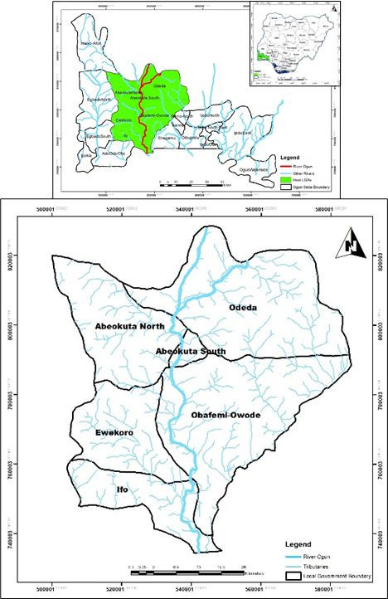
Figure 1: River Ogun and Tributaries in the Context of Ogun State

3.0 Methodology
3.1 Data Types and Sources
1. Shuttle Radar Topographical Mission of 0.00083 by 0.00083 degrees resolution was downloaded form United States Geological Survey (www.usgs.com) (DEM)
2. Shapefiles of communities within 2km radius of River Ogun was downloaded from OpenStreetMap (www.openstreetmap.com)
3. The energy access level of the communities was determined through survey
4. Per capita annual consumption in Ogun State in 2016 and 2017 was sourced from Ibadan electricity Distribution company (IBEDC)
5. Monthly precipitation and evaporation dataset was downloaded from Dieulin et al. (2017)
3.2 Procedure for Spatial Analysis of SHP Potential Sites
The procedure for small hydropower potential sites identified in this study is depicted in Figure 2. The steps involved in the procedure is presented in the following order
- A DEM of 0.00083 by 0.00083 degrees resolution was loaded into ARCGIS 10.8 environment
- The DEM was masked with a 2km buffer vector shapefile of River Ogun
- The resulting DEM of the area was filled for void to derive a resulting DEM without sink
- The result of step three (DEM without sink) was used to estimate the flow direction of the area which is called FD
- The direct runoff data set was resampled according to the masked DEM using the resample function in ARCGIS
- The resampled data was converted to integer to aid processing
- The output of the flow direction (FD) and the direct runoff dataset (integer) were loaded as input data for the calculation of flow accumulation and the resulting raster was labelled “m”
- Focal statistics analysis function was carried out on the masked DEM of the study area to derive a DEM labelled Minimum neighbours (MN)
- The minimum neighbours (MN) were deducted from the initial Masked DEM of the area to derive the head “h” which is the difference in height of neighbouring cell
- The amount of runoff per raster (flow rate) labelled “m” was multiplied by the head (difference in height) to arrive at a raster called “mh”
- The result of step 10 labelled “mh” was multiplied by the value of gravity labelled “g” to derive to energy potential of the cells in kilojoules.
- The output in kilojoules was transformed to kWh and MW h by using the calculation factor (1/3.6 * 10¹²)
3.3 Method of Data Analysis
Spatial analysis and descriptive analysis were the analytical tools used for data analysis. The spatial analysis tools used include fill, flow direction, flow accumulation, resample, buffer analysis, focal statistics, and map algebra function in ARCGIS 10.8 environment. The spatial analytical techniques were used to identify small hydropower potential sites at various stages of the analysis. In addition, simple descriptive analytical tools such as frequency, minimum, maximum, and mean were also computed for easy understanding of the data. To estimate the energy potential of the potential sites in joules, the advanced energy equation advanced by Carroll et al. (2004) which is mathematically expressed in equation (1) was adopted.
E= m * g * h equation (1)
Note: The output dimension is in Joules which then has to be transformed to kWh and MW h by using the calculation factor (1/3.6 * 10¹²)
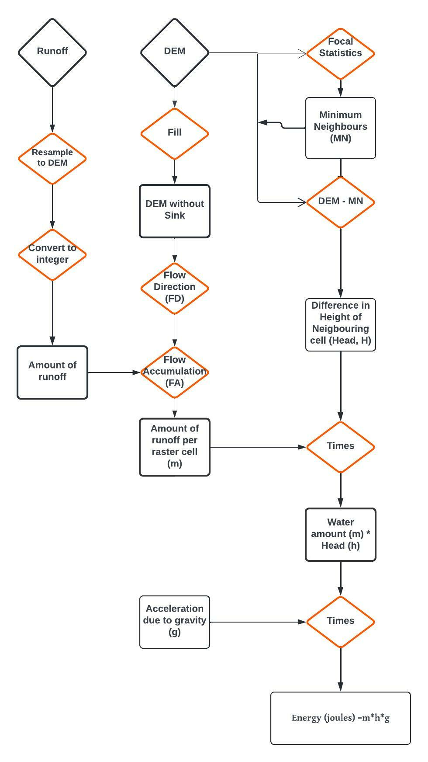
Figure 2: Flow Chart of the Research Methodology
Source: Adapted by the Author (2022)

3.4 Minimum Electricity Threshold Required to Meet SDG 7
Energy reliability, affordability, and sustainability are the key goals of Sustainable Development Goal 7. However, it does not set the minimum per capita energy threshold to be achieved to ensure energy access for both residential and non-residential sector. Hence, there is no universally acceptable electricity consumption threshold; electricity access threshold varies across countries and continents of the world. For example, Moss et al. (2020) proposed a minimum energy benchmark of 1000kwh per capita per annum inclusive of residential (300 kWh) and non-residential (700 kwh) electricity consumption for the achievement of SDG 7. IEA (2015) also proposed a minimum threshold of 250 and 500 kWh/year for rural and urban households (assumed to be five persons) respectively. Similarly, Brecha (2019) also argued that a minimum electricity threshold of at least 400kwh is closely to meeting the outcomes of SDG 7. Based on the economic dynamics and rural nature of most communities within two-kilometre radius of the identified SHP potential sites in Ogun State, IEA (2015) minimum threshold value of 250kWh per household (5 persons) will be adopted as the minimum energy threshold for energy analysis in this study.

4.0 RESULTS AND DISCUSSION
4.1 Characteristics of River Ogun
River Ogun stretches for 118.1km from north to south within Ogun State boundary and it is the longest and biggest river in the State (Table 2). The minimum elevation along the river path is 1.003m and a maximum 103.9m above sea level. The vertical difference between the start point of the river in the north and the finish point is about 102.9m. This significant difference in vertical height along the river channel will provide good head (gradient) required for the development of hydropower plant. The maximum slope along the river channel is 7.02^{O} which is also good for small hydropower development. The North-South profile of River Ogun is depicted in Figure 3. The Figure shows the undulating nature of the river channel and the flow direction of water from the north at (7° 24’ 12.9605” N, 3° 30’ 29.6205” E) to south (6° 38’ 39.0696” N, 3° 22’ 51.5256” E).

Table 2: Physical Characteristics of River Ogun
Characteristics | Value
Start Position: | 7° 24’ 12.9605” N, 3° 30’ 29.6205” E
End Position: | 6° 38’ 39.0696” N, 3° 22’ 51.5256” E
Minimum Elevation on Path: | 1.003 m
Maximum Elevation on Path: | 103.897 m
Vertical Difference (Start to Finish): | 102.9 m
Path Length: | 118.1 km
Straight-Line Distance: | 85.153 km
Minimum Slope/Tilt: | -0.05°
Max Path Slope: | 7.02° [104.13 km along path]
Flow direction | North to South
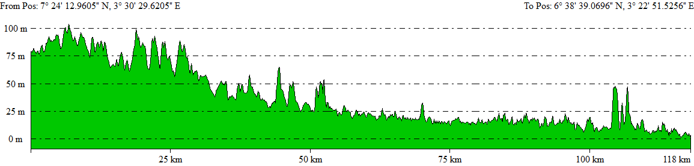
Figure 3: Profile A-A Showing the Section of River Ogun from the North to South

4.2 Quantity of Discharge and Slope along River Ogun
The quantity of discharge (flow rate) and the difference in vertical difference in elevation called “head” or “gradient” are the primary factors for energy potential estimation in run off river. The higher the vertical difference in elevation and quantity of discharge, the higher the potential energy generated. Table 3 shows the characteristics of discharge and head along River Ogun. The result shows that a minimum slope of 0.3 metre at Ifo LGA and a maximum slope of 24.3 metre was identified along the river at Abeokuta South LGA. The average annual discharge ranges from 82.8m³ in Odeda to 183.4m³ in Ifo. The quantity of discharge increases as the river flows towards the south in Ifo LGA. The analysis revealed that there is a wide variability in head and discharge distribution along the river course. Hence, the river can support the generation of varying level of electricity.
Table 3: Slope and Quantity of Discharge along River Ogun
River | Min head | Max head | Min Monthly  Q/Discharge (m³) | Max Monthly  Q/Discharge (m³) | Annual  Mean  Q/Discharge m³
Odeda | 0.7 | 18.2 | 4.1 | 368 | 82.8
Abeokuta North | 0.9 | 14.1 | 4.94 | 612 | 132.5
Abeokuta South | 0.4 | 24.3 | 9.77 | 617 | 168.8
Obafemi-Owode | 0.4 | 13.1 | 10.5 | 635 | 172.5
Ifo | 0.3 | 16.2 | 11.7 | 658 | 183.4

4.3 Distribution of Small Hydropower Potential Sites Along River Ogun
The study identified a total of 57 small potential hydropower (SHP) sites along River Ogun (Table 4). The small hydropower potential sites were distributed across five local government areas of Ogun State. Majority of the potential sites (21) were identified along the river channel in Odeda local government area (LGA) which is one of the adjoining LGA to the State Capital Abeokuta. Obafemi Owode LGA had 11 SHP sites and Ifo had 10 SHP sites along River Ogun. Abeokuta North and Abeokuta South had 6 and 9 SHP sites respectively; these two LGAs are the home to the State capital Abeokuta.
The energy potential available in the 57 potentials were also classified into three; namely 0.500-1.000mw, 1.001-3.000mw, and above 3.000mw. Table 4 shows that at least 15 potential sites can support 0.5000-1.001mw of electricity, 34 sites can support 1.001-3.000mw, while only 8 sites can support above 3.000mw of electricity. The distribution of the potential sites across five LGAs in Ogun state shows that communities from different LGAs are likely to benefit from the SHP sites when developed. It can also serve as a tool to stimulate development across different LGAs of the state. The distribution pattern of the SHP potential sites is presented in Figure 4.
Table 4: Characteristics of Stream Network in Ogun Watershed
LGAs | 0.500-1.000  MW | 1.001-3.000  MW | 3.001-5.798  MW | No Hydropower Site
Abeokuta North | 0 | 5 | 1 | 6 (10.5%)
Abeokuta South | 4 | 5 | 0 | 9 (16%)
Ifo | 2 | 7 | 1 | 10 (17.5%)
Obafemi-Owode | 0 | 8 | 3 | 11 (19%)
Odeda | 9 | 9 | 3 | 21 (37%)
Total | 15 (26%) | 34 (60%) | 8 (14%) | 57 (100%)

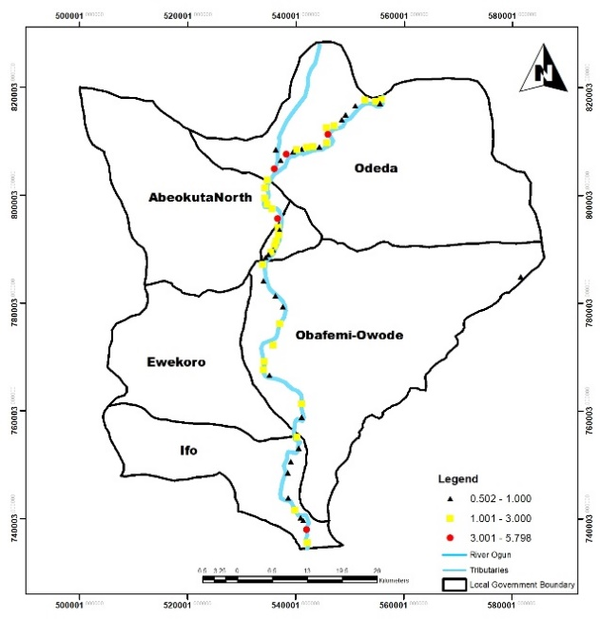
Figure 4: Categories of SHP Potential Sites along River Ogun
4.4 Estimated Small Hydropower Potentials Identified Along River Ogun
The estimated electricity potentials estimated per sites along River Ogun ranges from 0.502mw in Ifo LGA to 5.798mw in Abeokuta North LGA (Table 5). The variability in the energy potential estimated across the sites is a function of the available head and the rate of flow at the discharge point. Table 5 shows that a total of 13.48mw of electricity potential can be generated from six potentials sites along the river in Abeokuta North, 9.94mw from nine (9) potential sites in Abeokuta South which is 100% urban and doubles as the state capital. The maximum electricity potential of 30.05mw was estimated along the river in Odeda LGA from twenty-one (21) potential sites. A total of 75.38mw what of energy was estimated from a total of 57 sites along the river course and across five LGAs.
Table 5: Estimated Energy Potentials of the Identified SHP Sites
River | Min Pwr  (mw) | Max Pwr (mw) | Total SHP  Potential (mw)
Abeokuta North | 1.106 | 5.798 | 13.48
Abeokuta South | 0.510 | 2.096 | 9.94
Ifo | 0.502 | 3.133 | 10.53
Obafemi-Owode | 0.535 | 1.906 | 11.38
Odeda | 0.513 | 3.284 | 30.05
Total |  |  | 75.38

4.4 Energy Access Situation of Communities along River Ogun
The study examined the energy access situation of communities located along two kilometres radius of River Ogun in other to assess the viability of potential SHP sites. The study identified a total of fifty-seven rural communities and one urban centre (Abeokuta) the state capital of Ogun State (Table 6). The result shows there are at least 25 rural communities (hamlet/village) along 2 kilometres radius of River Ogun, 16 in Obafemi-Owode, 13 in Ifo, 3 in Abeokuta North and one town (Abeokuta) in Abeokuta South LGA. Interestingly, none of the rural communities located along the river within 2 kilometres distance are connected to the national grid or any off-grid electricity system, and hence had no access to public energy supply. Abeokuta on the other hand is connected to the national grid. The vast population of communities along the river course without access to electricity provides the requisite demand for the potential energy within reasonable distance. The distribution of the communities along the river course is depicted in Figure 5.
Table 6: Energy Situation of Communities along River Ogun
River | Communities | Development Status | Energy Access Status
Abeokuta North | 3 (5%) | Rural | Not Connected
Abeokuta South | 1 (2%) | Urban | Connected
Ifo | 13 (22%) | Rural | Not Connected
Obafemi-Owode | 16 (28%) | Rural | Not Connected
Odeda | 25 (43%) | Rural | Not Connected
Total | 58 (100%)

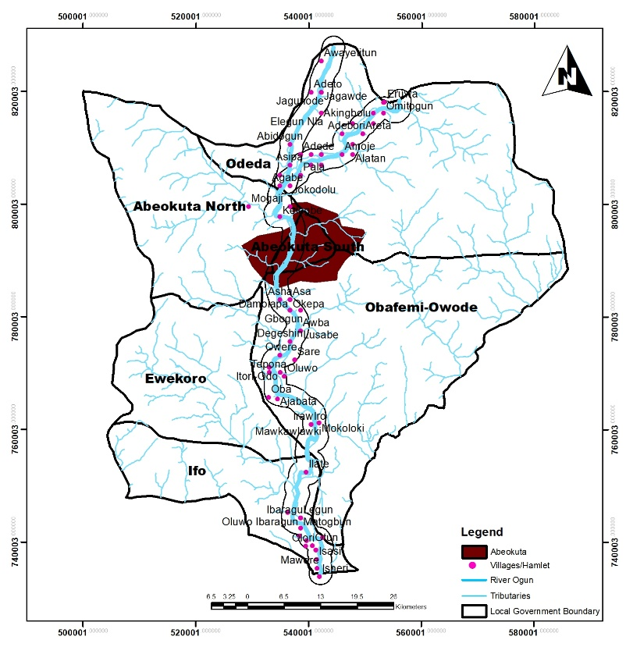
Figure 5: Communities within two kilometres Radius of River Ogun

4.5 Projected Household Population to be Serviced with Electricity
The study provides an insight into the possible number of households (average of five members) that can be provided with a minimum energy threshold of 250kWh per anum. This is equivalent to an average daily electricity access of 0.68kWh per capita and 3.4kWh per household per day. Based on this standard, the number of households to be served was estimated at 100%, 75% and 50% performance of the potentials identified. The result shows that at maximum performance capacity of 100% for a household of five, 22,040 households can be powered with electricity, 16531 households at 75% performance and 11020 households at 50% performance of the SHP potentials. This shows that a minimum of 11020 households can be lifted out of energy poverty with a minimum access to 250Kwh per annum per household. This can also serve as an inclusive approach towards connecting communities (mostly rural) far away from national grid due to topographical or logistical constraints into public energy system through off-grid system using SHP.
Table 7: Projected Household Population to be Serviced with Electricity
River |  | No of Households to be served
 | Energy Potential (kWh) | 100% | 75% | 50%
Abeokuta North | 13480 | 3942 | 2956 | 1971
Abeokuta South | 9940 | 2906 | 2180 | 1453
Ifo | 10530 | 3079 | 2309 | 1539
Obafemi-Owode | 11380 | 3327 | 2496 | 1664
Odeda | 30050 | 8786 | 6590 | 4393
Total | 75380 | 22040 | 16530 | 11020
5.0 Conclusion and Recommendations
The results have shown that GIS and remote sensing data can provide the requisite technology needed to identify potential sites in a cost-effective manner and within a reasonable period of time. This is a much better approach to the traditional water resources assessment approach using discharged data at outlet of watershed. Therefore, spatial identiﬁcation and quantiﬁcation of small-scale hydropower potential is expected to be an important addition to the ﬁeld of spatial electriﬁcation planning. The available small hydropower potentials estimated are enough to stimulate efforts towards identifying small hydropower potentials in the country with a view to harnessing same for electrification, particularly in rural areas off the national grid. These will ensure equitable provision of electricity all irrespective of location and level of development. Small hydropower has become more important than ever in many countries of the world including China, Germany, Spain, and India among others particularly with its attendant low carbon footprint.

It is also evident that small hydropower can be used to reduce the level of energy poverty for a minimum of 11020 households as well as reducing the carbon footprint of the communities. Harnessing the small hydropower potential across the country provides a huge prospect for the attainment of SDGs 7 and 13 and facilitate the achievement in education, health, and production, thereby leading to increase wellbeing of the population and higher gross domestic product for the country. This study therefore concludes that achieving inclusive energy access in Ogun State and the country at large requires the promotion of energy mix through on-grid and off-grid approach of which small hydropower is one. Hence, energy democratisation and decentralisation must be pursued rigorously to provide the requisite environment for the promotion of off-grid energy systems, particularly SHP. The government must also take advantage of the technological advancement, particularly in GIS and remote sensing for small hydropower assessment in order to facilitate the identification and estimation of small hydropower potentials in a cost effective and sustainable manner.

References
Adedeji, A. A. (2016). Spatial Exploration and Analysis of Electricity Poverty: A Case Study of Ibadan, Southwestern, Nigeria. University of Leicester.
Azodo, A. P. (2014). Electric power supply, main source and backing: A survey of residential utilization features. International Journal of Research Studies in Management, 3(2), 87-102.
Brecha, R. (2019). Electricity access threshold for meeting non-energy SDG targets. European Journal of Sustainable Development, 8(4), 90-90.
Dieulin, C., Mahe, G., & Paturel, J-E., Soundouss, E., & Rouché, N., & El-Mansouri, B. (2017). Monthly rainfall gridded dataset for Africa for the period 1990-1999 at the half a square degree, interpolation Inverse Distance Weighted.
Energy Commission of Nigeria (ECN) (2004). Guide book on Small Hydro power Development in Nigeria; Planning, Policy and Financing issues
Eshra, N. M., Zobaa, A. F., & Aleem, S. H. A. (2021). Assessment of mini and micro hydropower potential in Egypt: Multi-criteria analysis. Energy Reports, 7, 81-94.
Ghorbani, M. A., Deo, R. C., Kim, S., Hasanpour Kashani, M., Karimi, V., & Izadkhah, M. (2020). Development and evaluation of the cascade correlation neural network and the random forest models for river stage and river flow prediction in Australia. Soft Computing, 24(16), 12079-12090.
Goyal, M. K., Singh, V., & Meena, A. H. (2015). Geospatial and hydrological modeling to assess hydropower potential zones and site location over rainfall dependent Inland catchment. Water Resources Management, 29(8), 2875-2894.
Hatata, A. Y., El-Saadawi, M. M., & Saad, S. (2019). A feasibility study of small hydro power for selected locations in Egypt. Energy Strategy Reviews, 24, 300-313.
Ibadan Electricity Distribution Company (IBEDC), (2017). Ibadan Electricity Distribution Company Annual report. Ibadan: IBEDC
International Energy Agency (IEA). (2016). World Energy Outlook 2016: Executive Summary. World Energy Outlook, 1–8.
International Energy Agency (IEA). (2015). World Energy Outlook 2015: Methodology for Energy Access Analysis, 8. https://doi.org/10.1787/weo-2014-en.
International Energy Agency (IEA) (2014). The World Energy Outlook 2014: Outlook for African Energy to 2040. International Energy Agency: Paris, France.
Ita, E. O., Sado, E. K., Balogun, J. K., Pandogari, A., & Ibitoye, B. (1985). Inventory survey of Nigeria inland waters and their fishery resources. Part 1. A preliminary checklist of inland water bodies in Nigeria with special reference to ponds, lakes, reservoirs and major rivers.
Khare, V., Khare, C., Nema, S., & Baredar, P. (2019). Introduction to energy sources. Tidal energy systems. Elsevier, Amsterdam, 1-39.
Kusre BC, Baruah DC, Bordoloi PK, Patra SC. (2010). Assessment of hydropower potential using GIS and hydrological modeling technique in Kopili River basin in Assam (India). Applied Energy 87: 298–309. DOI: 10.1016/j.apenergy.2009.07.019
Memarian, H., Balasundram, S. K., Abbaspour, K. C., Talib, J. B., Boon Sung, C. T., & Sood, A. M. (2014). SWAT-based hydrological modelling of tropical land-use scenarios. Hydrological sciences journal, 59(10), 1808-1829.
Morales, S., Corredor, L., Paba, J., & Pacheco, L. (2014). Stages in the development of a small hydropower project: Context and implementation basic criteria. Dyna, 81(184), 178-185.
Moss, T., Bazilian, M., Blimpo, M., Culver, L., Kincer, J., Mahadavan, M., ... & Webber, M. (2020). The Modern Energy Minimum: The case for a new global electricity consumption threshold. Energy for Growth Hub.
Omani, N., Srinivasan, R., Karthikeyan, R., & Smith, P. K. (2017). Hydrological modeling of highly glacierized basins (Andes, Alps, and Central Asia). Water, 9(2), 111.
Paish, O. (2002). Small hydro power: technology and current status. Renewable and sustainable energy reviews, 6(6), 537-556.
Pandey, A., Lalrempuia, D., & Jain, S. K. (2015). Assessment of hydropower potential using spatial technology and SWAT modelling in the Mat River, southern Mizoram, India. Hydrological Sciences Journal, 60(10), 1651-1665.
Poor People’s Energy Outlook (PPEO) (2017). Financing National Energy Access: A Bottom Up Approach. Practical Action Publishing: Rugby, Warwickshire, United Kingdom
Sammartano, V., Liuzzo, L., & Freni, G. (2019). Identification of potential locations for run-of-river hydropower plants using a GIS-based procedure. Energies, 12(18), 3446.
Stehr, A., Debels, P., Romero, F., & Alcayaga, H. (2008). Hydrological modelling with SWAT under conditions of limited data availability: evaluation of results from a Chilean case study. Hydrological sciences journal, 53(3), 588-601.
Yadoo, A., & Cruickshank, H. (2012). The role for low carbon electrification technologies in poverty reduction and climate change strategies: A focus on renewable energy mini-grids with case studies in Nepal, Peru and Kenya. Energy Policy, 42, 591-602.

