**Efficiency and Food Security Status: Evidence from fluted pumpkin (*Telfairia occidentalis*) farmers in Nigeria**

**By**

**Ayodeji Alexander Ajibola Coker, Abigail John Jirgi and Halima Anave Omolori**

**Department of Agricultural Economics & Farm Management, School of Agriculture & Agricultural Technology, Federal University of Technology, Minna, P.M.B. 65, Minna, Gidan-Kwanu, Niger State, Nigeria**

Paper presented at the West Africa Centre for Crop Improvement (WACCI) International Conference on Food and Nutrition Security in Africa, held from October 3-4, 2018 at the University of Ghana, Legon, Accra, Ghana

**ABSTRACT**

**Study unearths relationship between technical efficiency and food security status among fluted pumpkin farmers in Nigeria. A total of 157 respondents were sampled at 95% confidence limit. Respondents were fairly technically efficient with mean efficiency index of 84%, Estimated 58% of respondents were food insecure, Farmers technical efficiencies were positively related to their food security status. - Study recommended enhanced technical efficiency through extension support and optimum input combination.**

**Aim and Objectives of Study**

**Aim of Study:** To determine the effect of technical efficiency of fluted pumpkin farmers on their food security status in Niger State, Nigeria.

**Objectives of the Study:**

* 1. describe the socio-economic characteristics of fluted pumpkin farmers;
  2. determine the technical efficiency and food security status of respondents; and
  3. ascertain the effect of respondents’ technical efficiency on their food security status.



**INTRODUCTION**

* **Recent global statistics suggest an increase in the population of chronically undernourished persons from 777 million in 2015 to 821 million currently (FAO, 2017 and 2018).**
* **The recent outcome represents a reversal of trends, more so that the situation is particularly worrisome in sub-Saharan Africa.**
* **USAID (2018) noted the high incidence of malnutrition in Nigeria, with 32% national average stunting rate for children under five, while FAO (2016) revealed that food insecurity situation was prevalent in the North.**
* **Orewa *et al*. (2009) and Obayelu, (2010) attributed causes of food insecurity attributed to factors like low productivity and output, wide spread poverty and technical inefficiency.**
* **Fluted pumpkin (*Telfairia occidentalis*) is one of the key vegetables grown in Nigeria, particularly in the Southern and Middle belt regions, including Niger State**
* **The edible parts of the plant are leaves, shoot and petioles. However, it is mainly grown for its leaves and also for medicinal purpose**
* **It serves as rich source of antioxidant, antimicrobial properties, minerals (mainly iron), vitamins (A and C) and protein (Akoroda, 1990; Kayode and Kayode, (2011))**

**METHODOLOGY**

**Study Area**

* + The study was undertaken in selected Local Government Areas of Niger State, Nigeria
  + Niger is the largest state in Nigeria by land mass
  + The state is located in the Guinea Savannah Vegetation agro-ecological Zone of Nigeria
  + Niger State lies within Latitude 8O 20´ and 11O 30´ of the equator and Longitudes 3O 30´ and 8O 20´, with a projected population of 5,337,148 (Omolori, 2017)
  + Niger State is largely agrarian, with major crops grown being rice, yam, maize, vegetables, groundnut and cowpea.

**Sampling Technique and Sampling Size**

Multi-stage random sampling procedure was employed to select 157 fluted pumpkin farmers from a frame of 258 farmers using Yamane (1967) formula, as adopted by Eboh (2009) at 95% confidence level and 5% precision level.

**Method of Data Collection**

Primary data were utilised for this study using structured questionnaires. Data collected covers demographic characteristics of the farmers, household monthly expenditures on food and non-food items, input and output data, including prices.

**Data Analytical Techniques**

The analytical techniques comprise descriptive statistics, food security index, stochastic frontier function and Logit model.

Source: Aisha (2017)

RESULT AND DISCUSSIONS

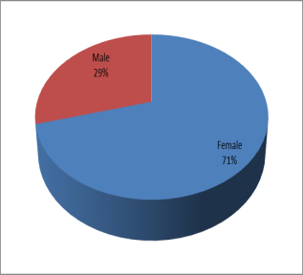

* Most (56.1%) respondents owned less than 0.3 hectares of land (Figure 3)
* Only 41% had extension contact (Fihure 4)

Socio-economic Characteristics of Respondents

**Gender of Respondents**

**Estimated 70% of fluted pumpkin farmers are women (Figure 1)**

**FAO (2011); UNIDO (2011) and AfDB (2014) noted that 70 percent of Africa’s smallholder farmers are women, and are responsible for more than 90 percent of Africa’s agricultural production.**

**Age of Respondents:**

* **Most (57.2%) respondents fall within the age bracket of 37-48 years (Figure 2).**
* **Most fluted pumpkin farmers are in their active and productive stage**

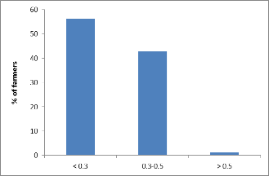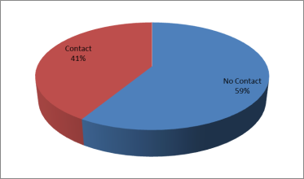

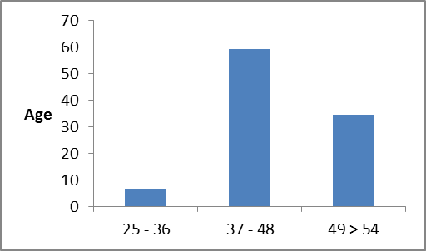

Figure 1: Gender of respondents

Figure 3: Farm size of respondents

Figure 4: Extension contact by respondents

Figure 6: Food security status of respondents

Determinants of food security status

Food security status

Technical efficiency of respondents

Figure 2: Age of respondents

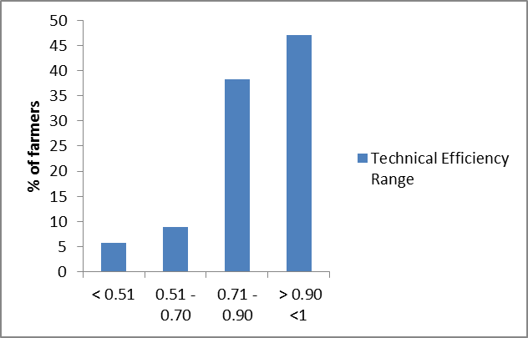

* Technical efficiency, labour, household size, agrochemicals and extension contacts had positive relationship with food security status of respondents (Table 7)
* Capital items, age, education and incomes had negative relationships with food security status of respondents (Table 8)

**Food Security Status of Respondents**

* **About 60% of respondents are food insecure (Figure 6)**
* **Food security line ₦41,733.72 ($116.85), food security gap - 13.6% and severity of food security - 8.2%**
* **Amaza *et al.* (2009) reported food security index of 58.0%, while Akinyele (2009) reported food security gap and severity of 15.0% and 11.0% respectively**

**TECHNICAL EFFICIENCY OF RESPONDENTS**

* **Most (47.1%) of the fluted pumpkin farmers were close to efficiency frontier (0.90 <1) (Figure 5)**
* **Mean technical efficiency stands at 84%, implying that fluted pumpkin farmers were fairly efficient and close to the frontier.**
* **Ayanwale and Abiola (2016) obtained a mean technical efficiency of 0.75 for fluted pumpkin in Edo State, Nigeria**
* **Norton *et al.* (2015) affirmed that small holder farmers are efficient but not productive.**
* **Determinants of technical efficiency/inefficiency were Capital input, hired labour, agro-inputs, education, extension contact.**

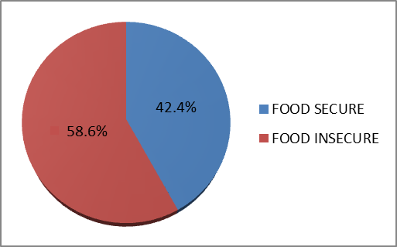 

Figure 5: Technical Efficiency range of respondents

Figure 6: Food security status of respondents

Table 7: Logit regression on effect of technical efficiency on food security

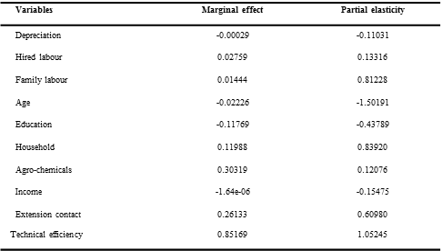

**CONCLUSION AND RECOMMENDATIONS**

**Conclusion:**

* **Majority of fluted pumpkin farmers were women in their active ages, owned less than 0.3 hectares, with weak extension contact.**
* **Most of the fluted pumpkin farmers were food insecure, but close to being technically efficient**
* **Respondents’ probability of being food secured will increase with their technical efficiencies.**

**Recommendations:**

* **There is need to improve food security of farmers through enhanced technical efficiency**
* **Enhance extension support towards ensuring optimum input usage and combinations**
* **Incentivize youths to take up fluted pumpkin production.**

Table 8: Estimates of marginal effect and partial elasticity