Cost-Benefit Analysis (CBA) for Policy Support: Evidence from Niger State

By Dr. Balaraba Sule and Assoc. Prof. Ayodeji A.A. Coker

# 1.0 Background

One of the cardinal objectives of the Feed the Future (FTF) Nigeria Agriculture Policy Project (NAPP) is to support policy processes and engagements through research and capacity building. The Nigeria Agriculture Policy Activity (NAPA) is an extension of NAPP in the FTF targeted states in Nigeria, including Niger State. The goal of NAPA is to promote inclusive agricultural productivity growth, improved nutritional outcomes and enhanced livelihood resilience, through improved policy enabling environment. One way, this goal is being achieved is through the enhancement of national capacity to generate and analyze data for evidence-based and improved policy decision making within the Agriculture Sector. In line with this goal, and sequel to the outcome of needs assessment, a cost-benefit analysis (CBA) training was organized for relevant stakeholders in Niger State, covering targeted Ministries, Departments and Agencies (MDAs) and relevant Commodity Associations.

The four-day training was held at the Niger State Ministry of Women Affairs and Social Development, from April 25th to April 28th, 2022. The training comprised eight modules, and covered all aspects of CBA, including risk analysis and the application of CBA to policy analysis. The training was facilitated by Mrs. Balaraba Sule (Ph. D), a graduate of the MSU NAPP Scholar program and Lecturer, Agricultural Economics, Ibrahim Badamasi Babangida University, Lapai, Niger State and Ayodeji A.A. Coker (Ph.D.), an Associate Professor of Agricultural Finance and Project Analysis at the Federal University of Technology, Minna, Niger State.

Thirty (30) stakeholders participated in the training, comprising; Planning and Technical Officers of Niger State Ministries of Agriculture & Rural Development, Livestock & Fisheries, Education, Health, as well as Women Affairs & Social Development. Other beneficiaries were from the Niger State Bureau of Statistics, Chamber of Commerce, Industries, Mines & Agriculture, Niger State Agricultural Mechanization Development Authority, Niger State Planning Commission, and Office of the State Head of Service. Participants from the private sector comprised relevant staff of the All-Farmers’ Association of Nigeria (AFAN), Catfish Farmers’ Association of Nigeria (CFAN), the National Association of Small & Medium Enterprises (NASME) and National Association of Women in Agriculture (NAWIA). Over 30% of the participants were females.

# 2.0 Training approach and objectives

The aim of the training was to create awareness and build capacities of targeted stakeholders in using CBA techniques to strengthen policy processes, through efficient fiscal management, accountability and increased transparency, towards ensuring effectiveness and sustainability of policy interventions in Niger State. It was participatory (involving both theoretical and practical sessions) and included plenary and syndicate sessions. Two modules were taught every day, each day starting with a review of activities done the day before. At the close of the training, participants were expected to:

* understand the basic concepts of CBA;
* develop and analyze enterprise/project budgets;
* acquire relevant skill sets for the conduct of financial and economic analysis of public/agricultural policies, programs and projects;
* undertake risk analysis; and
* select project alternatives to support policy decisions.

To ensure training effectiveness, the training was preceded by a Training of Trainers session facilitated by Prof. Eric Crawford (MSU). Cross section of participants at the training is shown in Figure1.

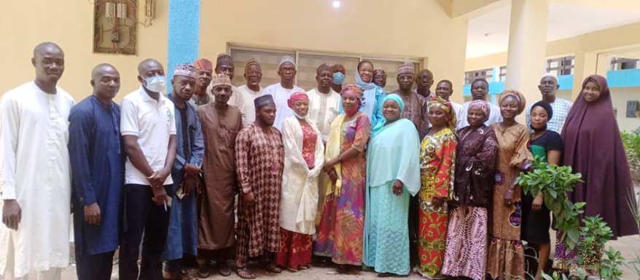

Figure 1: Photograph of dignitaries and participants at the official opening of the training

# 3.0 Syndicate Group Exercises/Assignments

During this session, participants were divided into four groups and encouraged to deliberate and come up with project proposals, expected to leverage on CBA techniques, for consideration by their respective MDAs and Organizations. This element of the training was designed to enable trainees practice what they had learned, for use in the policy programming of the State. The criteria for proposals included (1) relevance and (2) probability of take up and integration into the State’s planning and fiscal framework for the incoming fiscal year. Thus, participants were guided to ensure that proposals were borne out of actual needs within the relevant MDAs/State, premised on available documentation, their experiences and field engagements. The proposed project proposals by the syndicate groups are detailed in Table 1.

**4.0 Training Evaluation**

A pre- and post-evaluation of participants’ knowledge and skills were done to determine the level of change and obtain feedback on the effectiveness of the training. Presentations were delivered in power point for clarity and easy comprehension/future access by participants. An analysis of the results of the pre-and post-evaluations administered on the trainees, put the average scores at 17.97% and 59.97% respectively. The paired t-test of significance indicated that there was statistical difference between the pre and post training evaluation scores, implying that the training may have enhanced participants’ knowledge of CBA and its application in enterprise and project analysis.

Table 1: Proposed Projects with CBA Content

|  |  |  |
| --- | --- | --- |
| **S/No.** | **Proposed Projects** | **Participating Institutions** |
| 1 | Reactivation of Selected School Farms for Post-Basic Students' Exposure to Agribusiness Opportunities | * Niger State Ministry of Education |
| * Ministry of Agric. & Rural Development. |
| * Ministry of Livestock & Fisheries |
| * Niger State Agricultural Mechanization Development Agency |
| 2 | Empowerment of Gender-Based Violence Survivors in Rabbitry in Selected Local Government Areas | * Women Affairs and Social Development |
| * Planning Commission |
| * Office of Head of Service |
| 3 | Demonstration of Food Supplements for Treatment of Fresh Pulmonary Tuberculosis Patients for Morbidity Reduction | * Ministry of Health |
| * Ministry Of Commerce and Investment |
| 4 | Establishment of Model Fish Feed Mill for Quality Feed Production | * All Farmers' Association of Nigeria (AFAN) |
| * Nigeria Association of Small and Medium Enterprises (NASME) |
| * Niger State Chamber of Commerce, Industry, Mines and Agriculture (NCCIMA) |
| * Catfish Farmers Association of Nigeria (CAFAN) |
| * Nigeria Association of Women in Agriculture (NAWIA) |
| * Ministry of Livestock and Fisheries |

# 5.0 Follow-up Engagements and Next Steps

Following the successful conduct of the training, a WhatsApp Forum was created to follow-up the progress of participants in obtaining buy-in of their organizations for the proposed proposals, while simultaneously providing technical support for their development. Visits were paid to some of the targeted MDAs to monitor the progress of the trainees in deploying the CBA techniques on-site. At the time of this brief, two out of the four proposals have received the approval and support of their MDAs (50% achievement). These are:

1. Re-activation of Selected School Farms for Post-Basic Students’ Exposure to Agribusiness Opportunities in Niger State; and
2. Empowerment of Gender-Based Violence Survivors in Rabbitry in Selected Local Government Areas in Niger State.

The next step will involve a follow-up on the progress of the other two proposals, while continuing to provide technical assistance to trainees for the development of the approved ones.

# 6.0 Deployment of Knowledge Acquired by Trainees

Based on the follow-up engagements with the MDAs and Commodity Associations, the key achievements noted, so far, were the awareness created (particularly in the Planning Department) for a change mantra towards the deployment of CBA for evidence-based policy decision making processes; the need for accountability and fiscal prudence, given the dwindling public resources, in the wake of competing interests and associated economic challenges. Apart from a few Directors and Commodity Association Heads, most of the trainees were middle-level staff. While the awareness is already created (and is currently being disseminated) and knowledge/skills acquired, these categories of trainees are generally not in the position to significantly influence change towards policy by evidence as pushed through the training. Thus, the deployment of the CBA concept and ideas is yet to attract the desired momentum within the targeted MDAs. Dr. Balaraba Sule delivering a lecture during the training session (Figure 2).

* 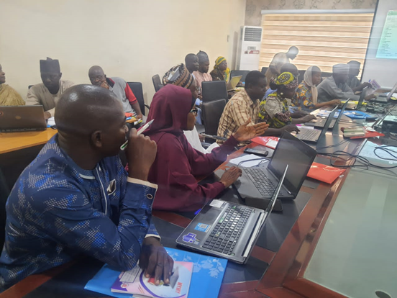
* Figure 2: Dr. B.A Sule during one of the training sessions

# 7.0 Policy Recommendations

To fully entrench the concept and ideas of CBA techniques for evidence-based policy making and guarantee the achievements of state, national and global development outcomes (food and nutrition security, job creation, improved livelihood, etc.), we recommend the following:

* There is need to engage the Heads of the MDAs and Commodity Associations to communicate and discuss the outcomes of the CBA capacity engagement. A communique detailing recommendations from the training, follow-up actions and the intentions of the donor will be a good first step;
* It is imperative to organize a simplified version of the CBA training for the Management Staff of targeted MDAs (Planning & Budget, Finance, Agriculture, Livestock & Fisheries) and select members of the Niger State House of Assembly to influence desired change from the top;
* It may be necessary to work with select and proven Advocacy Organizations to push for a “Legislative Session” with the Niger State House of Assembly;
* There is need to urgently support the development and dissemination of “Fact Sheets” and “Policy Briefs” on leveraging CBA techniques for Evidence-based policy to relevant stakeholders;
* Communication outlets can be deployed to reach targeted stakeholders, through conduct of Evidence-based Policy Day, radio programs, printing of shirts, video graphics, etc.
* For approved project proposals, a mechanism for follow-up technical support with project preparation and implementation should be put in place;
* There may be need to consider a special CBA capacity building grant to follow-up on the successes so far recorded.

This work was a product of collaborative research funded by the CGIAR Research Program on Policies, Institutions, and Markets (PIM) and the USAID Nigeria mission under the Feed the Future Nigeria Agricultural Policy Activity. The contents are the responsibility of the authors and do not necessarily reflect the views of the funding agencies.

Copyright © 2022, Michigan State University, and the International Food Policy Research Institute. All rights reserved. This material may be reproduced for personal and not-for-profit use without permission from but with acknowledgment to MSU, and IFPRI.

Published by the Department of Agricultural, Food, and Resource Economics, Michigan State University, Justin S. Morrill Hall of Agriculture, 446 West Circle Dr., Room 202, East Lansing, Michigan 48824.