Manuscript ID: ICCAUA2022EN0039

Assessment of the Service Delivery at the Internally Displaced Persons’ Camps (Idps) in the Federal Capital Territory, Nigeria
Owoeye Olusegun Idowu¹, Danlami Gideon and Ohadugha C. Bernhard
Department of Urban and Regional Planning
Federal University of Technology, Minna
E-mail: olu.idowu@futminna.edu.ng, Email: danlamigideon@gmail.com, Email: chuks@futminna.edu.ng

Abstract
Exploitation of natural resources by man has triggered conflict which has made man to flee from his original place of abode to seek shelter in other places within the country as IDPs or outside the country as refugees. Surprisingly, unlike the refugees, IDPs remains the major concern of their home country. Systematic random sampling technique was used to sample 331 households in Kuchigoro and Durumi camps. This study is aimed at assessing the types of service delivery in the IDPs camps in the FCT. With a view of determining the effectiveness of the services delivered to the IDPs in FCT. The following objectives were considered for the study: Identify the socioeconomic characteristics of the camps, assess the types of service delivery in the camps, and examine the effectiveness of service delivery in the IDPs camps. The study however, discovered that, electricity in Kuchigoro camp (96.8%) is not available in the camp likewise in Durumi camp (99.5%) is not available in the camp which is an indication that the camps are suffering from energy poverty. The study concludes that concludes that, the IDPs in Abuja camps does not have access to service delivery in areas of electricity supply, potable water supply, healthcare, education, relief materials and security services and therefore, recommend a sustainable good governance strategy in line with the relevant goals of the SDGs; also, sustainable physical planning principles be introduced in the arrangement of space at the camps; in the provision of basic services, partnership with the non-governmental organizations should be encouraged for better service delivery.

Keywords: Disaster; Standards; Resources; Political; Displaced
- Introduction
Internally displaced persons have attracted global interest owing to the level of its occurrence; and the adverse effect that it has on the social, cultural, political and economic life of the affected persons (IDMC, 2014). In the early 1950s, it was predominant to hear issues of refugees owing to the rise in conflicts between nations. This gave birth to the United Nation High Commission on Refugees (UNHCR) which began operation in 1950 (UN-Habitat, 2015). This Commission was saddled with the responsibility of protecting and supporting the refugees (UNOCHA 2014). Thus, Internally Displaced Persons (IDPs) is on the front position of both national and international discussions and policies in most affected countries and regions of the world.
IDPs are caused by either artificial or natural disaster which has made many flee the borders of their communities. Not like refugees, IDPs are affected by conflicts or natural disaster, but have not gone out of their countries borders into another. It has been argued that the rise in the number of IDPs can be attributed to two broad factors which are man induced and natural disaster (UNHCR, 2005; UNOCHA, 2014; Azazi, 2011 and UNCHR, 2015).
Principally, the man’s induced causes are war and urbanization coupled with crime and violence such as terrorism, communal/ethnic clashes, and electoral crisis and so on. Furthermore, exploitation of natural resources by man has triggered conflict have made man to flee from his original place of abode to seek shelter in other places within the country as IDPs or outside the country as refugees (UNCHR, 2015). Surprisingly, unlike the refugees, IDPs remains the major concern of their home country (UNHCR, 2005)
Failure of government at all levels in service delivery has contributed to violence across the countries in the world (UNCHR 2016). Omar (2009) observes that poor service delivery in the areas of potable water supply for dinking and domestic use, poor waste disposal practice, poor healthcare and insufficient housing, poor educational facilities, inadequate recreational facilities, telecommunication facilities and electricity are attributed to different countries including Nigeria cities. These problems are exacerbated by uncontrolled population growth resulting from increase in the rate of rural urban migration without expansion of the available infrastructure (UN-Habitat 2015). Omar (2009) admitted that poor service delivery is largely a factor of poor planning; he further stressed that, good plans and policies are bedevilled by poor implementation. He argued further that this problem is noticeable owing to lack of transparency and accountability in governance, insufficiency of skilled and professional manpower in local governments and the weak connection between the urban areas and the local government (Omar 2009). This study assessed the forms and effect of the services provided at the two IDPs camps at the Federal Capital Territory (Kuchigoro and Durumi camps). The scope covers the investigation on the socioeconomic characteristic of IDPs in each of the camps, forms of services made available at the camps and the performance of the services provided in meeting the needs of IDPs.
1.1 Governance and Service Delivery
This problem is visible, owing largely to lack of transparency and accountability in governance, inadequacy of skilled and professional manpower in local governments and the tenuous relationship between the urban areas and the local governments (Omar 2009), which have exposed the urban areas to insecurity. In the same vein, UN-Habitat (2017) added that, urbanization contributes to land erosion within the urban areas and sometimes causing flood and making residents to compulsorily flee their place of abode. Studies by the United Cities and Local Governments (UCLG, 2013) shows that more than 40% of waste is collected in large amount in the affluent part of the urban areas and dumped in poorly managed landfills. This most at times backs the water ways and in turn causes flood which have led to so many internally displaced persons issue across the world (UN-Habitat 2017)
Good governance practices are tools to effective security of our urban areas, Danmole (2004) retracted that good urban governance means that the city government must and are also accountable to residents, including the poor. Thus, this means inclusiveness and participation by each group and stakeholders (Danmole, 2004). It could be said that tackling insecurity is fundamental issue of good governance of urban and rural areas. Good governance and safe cities are reciprocal; where residents are free from fear, and where safety is guaranteed for the citizens, interaction with public institutions becomes possible.
If Governance is well delivered to the citizens there will no need for violence in the urban areas which will in turn cause displacement of persons. Because according to (Adebayo et al., 2011), addressing urban violence is the duty of good governance if it involves the use of solidarity practice, city consultation process and institutional reforms which leads to citizenship participation.
The main factor of urban violence which leads to displacement is the inability of the state institutions to regulate and ultimately manage the legitimate use of force. Therefore Muggah (2014) noted that there are three interlocking factors that are playing a vital role in fostering city fragility must especially in the sub-Sahara African regions and the world at large which are rapist and unregulated urbanization: failure in national and city level governance and the monumental shift in internet connectivity and empowerment (globalization).
The importance of this theory to this study is summed up in the observation of Muggah (2014) who noted that where governance failure is persistent political violence can form both an overt and convert from coercion and control. Thus, an outbreak of violence in any city usually leads to displacement of persons to the place where it is perceived to be safe. This theory is significant because of its ability to point out the role of governance in urban centres to avert out brake of violence that may lead to displacement of persons.
1.2 Internally Displaced Persons around the World
Around the world today, over 40 million people have been forced to leave their places of residence due to natural disaster or clashes that result into, into violence, loss of lives and properties, and some human right abuses either within their country as internally displaced persons (IDPs) or outside their country as refuges (World Bank 2015). The year 2013 in Iraq, thousands of displaced people remained at risk inside the country; only a very small number were able to flee abroad. In some African humanitarian crisis, there can be ten internally displaced persons for every refugee. Currently there are estimated 1.4 million people displaced by conflict in Uganda, at least 1.5 million in the Democratic Republic of Congo (DRC) and 1 million in Sudan. But only 30,000 displaced people in Uganda have gone on to become refugees, while the numbers for the DRC and Sudan are 469,000 and 703,000 respectively. A significant number of people live in continued displacement where return has not been possible. (World Bank 2015)
United Nations (2015) asserts that, forced displacement is humanitarian crisis: but it also produces developmental impact short and long term, negative and positive affecting human and social capital, economic growth, poverty reduction efforts, environmental sustainability and societal fragility. War et al., (2004) viewed that, either refugees or IDPs both are burden on the host community from whichever angle you view it. In other words, the negative impacts outweigh the positive contribution. The losses incurred by the displaced populations themselves reinforce perceptions of vulnerability and dependency, and thus assumptions of the burden they might impose. This corroborates the view World Bank (2015) which argued that finding sustainable solutions to displacement situations constitutes a significant development challenge for the countries with refugees and IDPs, and for the international community including the World Bank.

2. Study Area
The Federal Capital Territory is in the geographical centre of the nation with co- ordinates 9°4N 7°29E / 9.066667°N 7.483333°E respectively and occupies a total area of about 8000sq.km. It is bounded on the north by Kaduna state, on the west by Niger state, on the east and south-east by Nasarawa state and on the south-west by Kogi state. It falls within latitude 7 45' and 7 39'. FCT experiences two weather conditions in the year just like many other Nigeria states. These are the rainy season which begins around March and runs through October, the dry season (usually characterized by bright sunshine) which begins from October and ends in March. Within these periods, there is a brief period of harmattan occasioned by the northeast trade wind, with a resultant dusty haze and intense coldness and dryness. Nevertheless, the high altitude and undulating terrain of the FCT act as a modulating influence which makes the weather always clement.

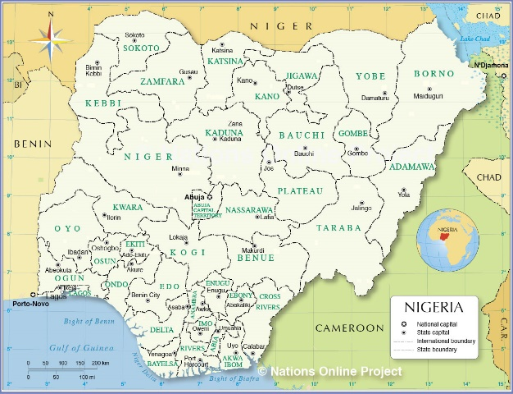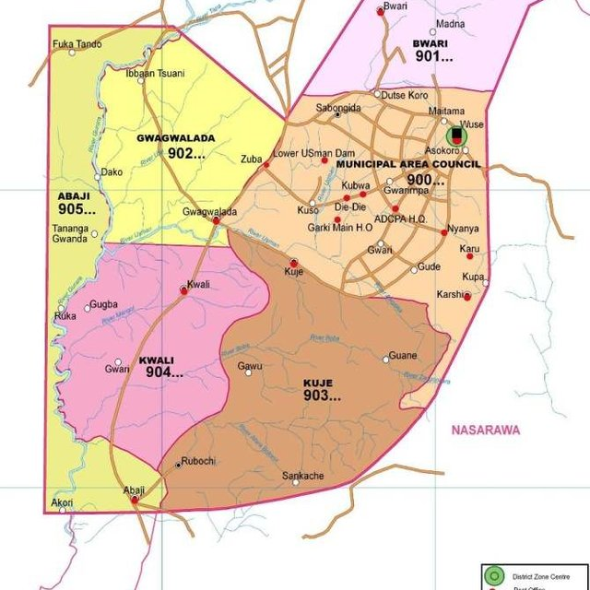
Figure 1: Map of Nigeria Figure 2: Map of FCT, Abuja

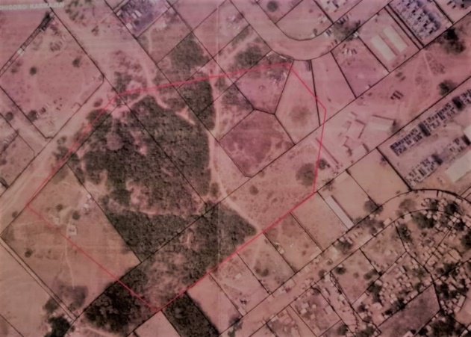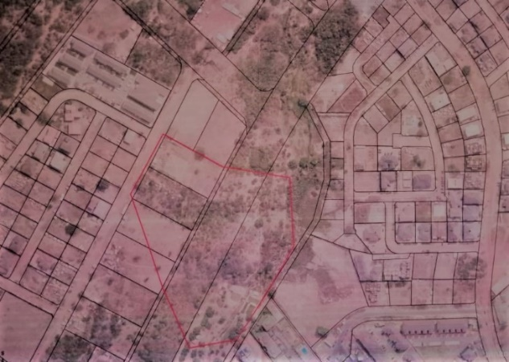
Figure 3: Google Earth Image of Kushigoro Camp Figure 4: Google Earth Image of Durumi Camp
Kuchigoro/Karmajiji and Durumi are both suburbs of the Federal Capital Territory both villages are in Abuja Municipal Areal Council (AMAC). Kuchigoro/Karmajiji camp which is just 5 minutes’ drive from the central area is located immediately after the city gate along the outer southern express way (OSEX) which is popularly known as the Airport Road. Durumi which is bounded by Kaura District to the North is also 10 minutes’ drive from the central area. The predominant settlers of both settlements are the Gbagyi’s who are well known with farming as their primary source of leaving. However, other Nigerians are fund amidst them who are workers in the city of Abuja.
The Nation’s states Capital has become a home to Internally Displaced Persons from different part of the country like Borno, Yobe and Adamawa. This is hinges to the fact that, the displaced persons feel a sense of more protection in the capital city. Abuja has a total number of displaced persons to be 15,154 with 2,510 households (IDMC, 2018; Camp Management 2019). These displaced persons are spread in Kuchigoro/Karmajiji and Durumi IDPs camps in FCT.

Methodology
This study used both primary and secondary sources of data. The primary data were collected directly from the field by the researchers with the aid of a well-structured questionnaire. The secondary data, on the other hand, were obtained from published and unpublished sources such as books, journals, conference proceedings, working papers, reports and monographs. The systematic random sampling technique was adopted for this study. A total of 331 respondents were sampled. The data was analysed using Statistical Package for Social Sciences (SPSS). The analysed data are presented in form of tables.

- Results Discussion
4.1 Socio-Economic Characteristics of the IDPs Camps
This section highlights the socio-economic characteristics of the displaced persons such as camps, age, state of origin, sex, marital status, and reason of displacement, period of stay in the camp, as well as education attainment, occupation and income level of the displaced person in the camps. It provides the respondents view or opinion on the likely situation of the study area.
Table 1: shows the socioeconomics characteristics of the study area. The study area comprises of Kuchigoro and Durumi Camps. The Kuchigoro camp has about 62% of the IDPs while the Durumi camp has 37% of the IDPs. This shows that there are more displaced persons in Kuchigoro camp than Durumi, because of the available space to house the IDPs in the study area. 98.6% and 74.8% of the displaced persons in the Kuchigoro and Durumi camps are from Borno state respectively. This implies that most of the IDPs who are camped in Abuja are from Borno state, it is so because of the insurgent activities in the area. Consequently, 59.3% of the IDPs in Kuchigoro camp are within the ages of 28-37 while 29.6% who are in Durumi camp are within the ages 18-27 this implies that the IDPs in Abuja is composed of young and active work force.
Research also shows that 58.3% of the IDPs in Kuchigoro camp are female also, 61.7% in Durumi are also female. This shows that male who happens to be household heads are worst hit by the insurgency. Furthermore, 58.3% and 64.3% of the women in Kuchigoro and Durumi camps are widowed. This percentage, corroborate the reason for the high percentage of women to men in the camps.
96.7% and 92.2% of the respondents in Kuchigoro and Durumi camps were both displaced by Boko Haram. However, 60.6% of the displaced persons have lived in the camp for about 2-4 years unlike the Durumi camp (84.3%) who have lived in the camp for about 5-7 years. This is because of the proximity of Durumi to the central area of Abuja and the attention it is getting from philanthropist and nongovernmental organisation.
The educational attainment of the two camps shows that 0.5% of the people camped in Kuchigoro have attained tertiary education while 2.6% of the respondents in Durumi have attained tertiary education. In addition, 35.2% and 13.9% have attained Islamic and Bible schools in Kuchigoro and Durumi respectively. The predominant occupation of the IDPs in Kuchigoro is (59.7%) farming while 61.7% of the IDPs in Durumi are artisans. Therefore, they are faced with low level of income with about 11.1% of the respondent in Kuchigoro earning about 61-80,000 monthly while 8.7% in Durumi camp earns between 21-40,000 respectively.
Table 1: Socio Economic Characteristics of the IDPs
Camps
Respondents | Kuchigoro |  | Durumi
 | Frequency | Percentage | Frequency | Percentage
Camps | 216 | 62.0 | 115 | 37.0
State
Borno | 213 | 98.6 | 86 | 74.8
Adamawa | 2 | .9 | 15 | 13.0
Yobe | 1 | .5 | 14 | 12.2
Total | 216 | 100.0 | 115 | 100.0
Age
18-27 | 16 | 7.4 | 34 | 29.6
28-37 | 128 | 59.3 | 25 | 21.7
38-47 | 10 | 4.6 | 27 | 23.5
48-57 | 59 | 27.3 | 3 | 2.6
58 above | 3 | 1.4 | 26 | 22.6
Total | 216 | 100.0 | 115 | 100.0
Sex
Male | 90 | 41.2 | 44 | 38.3
Female | 126 | 58.3 | 71 | 61.7
Total | 216 | 100.0 | 115 | 100.0
Marital status
Single | 45 | 20.8 | 19 | 16.5
Married | 46 | 21.3 | 11 | 9.6
Divorced | 44 | 20.4 | 11 | 9.6
Widowed | 126 | 58.3 | 74 | 64.3
Total | 216 | 100.0 | 115 | 100.0
Reason of displacement
Farmers/headers clash | 4 | 1.9 | 106 | 92.2
Boko haram | 209 | 96.7 | 5 | 4.3
Others | 3 | 1.4 | 4 | 3.5
Total | 216 | 100.0 | 115 | 100.0
Duration of stay in the camp
Less than 1 year | 85 | 39.3 | 14 | 12.2
2-4 years | 131 | 60.6 | 4 | 3.5
5-7years | 85 | 39.3 | 97 | 84.3
Total | 216 | 100.0 | 115 | 100.0
Educational attainment
Primary school | 115 | 53.2 | 79 | 68.7
Secondary | 12 | 5.6 | 14 | 12.2
Tertiary | 1 | .5 | 3 | 2.6
Islamic or bible school | 76 | 35.2 | 16 | 13.9
Non formal | 11 | 5.1 | 3 | 2.6
Total | 216 | 100.0 | 115 | 100.0
Occupation
Student | 17 | 7.9 | 8 | 7.0
Civil servant | 3 | 1.4 | 4 | 3.5
Farmer | 129 | 59.7 | 32 | 27.8
Others | 67 | 31.0 | 71 | 61.7
Total | 216 | 100.0 | 115 | 100.0
Income
5-20000 | 145 | 67.1 | 85 | 73.9
21-40000 | 43 | 21.8 | 13 | 8.7
61-80000 | 24 | 11.1 | 20 | 17.4
Total | 216 | 100.0 | 115 | 100.0

4.2 Form of the services available in the IDPs Camps
The result in Table 2 was obtained from the research shows that 97.6% of the respondents in Kuchigoro camp acknowledged that waste management facilities are not available in the camp while only 19.9% acknowledged the availability of the facility. 89.0% of the respondents in Durumi camp also, acknowledged the non-availability of the facility but 11.0% acknowledged the availability of the facilities in their camp. The respondent who acknowledged the availability of the facilities maybe because of their lack of knowledge about what waste management facilities
More so, electricity in Kuchigoro camp (96.8%) is not available in the camp likewise in Durumi camp (99.5%) is not available in the camp which is an indication that the camps are suffering from energy poverty. Water supply facilities in Kuchigoro camp is (61.6%) not available also in Durumi camp, (67.0%) water supply facilities are not available. The implication of this is that water supply in the study area is provided by philanthropies and religious organisations
Consequently, sewage disposal facilities in Kuchigoro camp are (84.3%) not available also in Durumi camp, (99.5%) of the respondent indicated that the facilities are not available in the camp. However, in the aspect of drainage facilities in Kuchigoro camp, (53.0%) admitted that the facilities are not available in the camp while in Durumi camp, (98.3%) of the respondents indicated that the facilities are also not available in the camp. This, however, is an indication that service delivery in the areas of sewage disposal and drainage facilities in the camps is very poor; hence, the IDPs are vulnerable to disease outbreak; thus, a threat to their wellbeing since the camps are haphazardly arranged with no trace of physical planning.
Security in Kuchigoro camp is (96.3%) not available as well as Durumi (94.8%). Access road in Kuchigoro camp (84.7%) is not available also in Durumi (95.8%) security facilities are not available. This shows that security service by the government is not available in the two camps as well as access road thus, the lives and properties of the IDPs is vulnerable to both internal and external attacks.
Furthermore, Education facilities in Kuchigoro camp is (57.0%) not available and Durumi (80.9%) is also not available. Education been a cardinal indicator of human development index is lacking in the study area which exposes them to weak capacity and low productivity. Healthcare is equally (95.8%) not available in Kuchigoro camp while in Durumi camp, (80.9%) of the respondents indicates the non-availability of then facility. Relief materials in Kuchigoro is (91.6%) not available as well as (90.4%) in Durumi. This shows that the camps are not supplied with relief materials.
Table 2: Form of Services/Facilities available at the IDPs Camps
Variable /Facilities | Response | Kuchigoro |  | Durumi
 | Availability | Frequency | Percentage % | Frequency | Percentage %
Waste Management | Available | 43 | 19.9 | 12 | 11.0
 | Not Available | 172 | 79.6 | 103 | 89.0
Total |  | 216 | 100.0 | 115 | 100.0
Electricity | Available | 7 | 2.3 | 1 | .5
 | Not Available | 209 | 96.8 | 114 | 99.5
Total |  | 216 | 100.0 | 115 | 100.0
Water supply | Available | 83 | 38.4 | 38 | 33.0
 | Not available | 133 | 61.6 | 77 | 67.0
Total |  | 216 | 100.0 | 115 | 100.0
Sewage Disposal | Available | 34 | 15.7 | 1 | .5
 | Not Available | 182 | 84.3 | 114 | 99.5
Total |  | 216 | 100.0 | 115 | 100.0
Drainage System | Available | 102 | 47.0 | 3 | 1.7
 | Not Available | 114 | 53.0 | 112 | 98.3
Total |  | 216 | 100.0 | 115 | 100.0
Security | Available | 8 | 3.7 | 8 | 5.2
 | Not Available | 208 | 96.3 | 107 | 94.8
Total |  | 216 | 100.0 | 115 | 100.0
Access Road | Available | 33 | 15.3 | 5 | 4.2
 | Not Available | 183 | 84.7 | 110 | 95.8
Total |  | 216 | 100.0 | 115 | 100.0
General Security | Available | 52 | 24.1 | 18 | 15.0
 | Not Available | 164 | 75.9 | 97 | 85.0
Total |  | 216 | 100.0 | 115 | 100.0
Education Facility | Available | 5 | 2.4 | 50 | 43.0
 | Not Available | 211 | 97.7 | 65 | 57.0
Total |  | 216 | 100.0 | 115 | 100.0
Health Care | Available | 9 | 4.2 | 23 | 19.1
 | Not Available | 207 | 95.8 | 92 | 80.9
Total |  | 216 | 100.0 | 115 | 100
Relief Materials | Available | 18 | 8.4 | 11 | 9.6
 | Not Available | 198 | 91.6 | 104 | 90.4
Total |  | 216 | 100.0 | 115 | 100.0

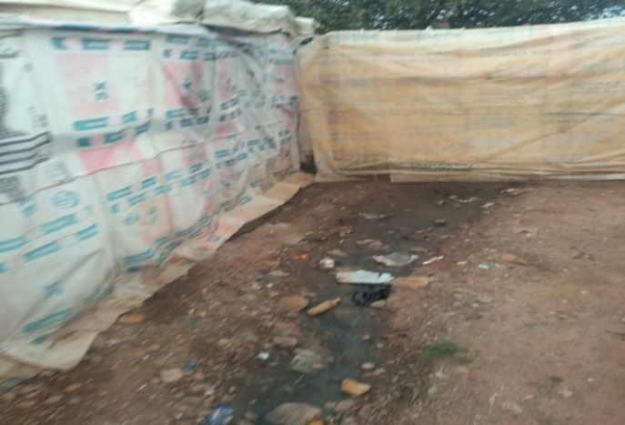
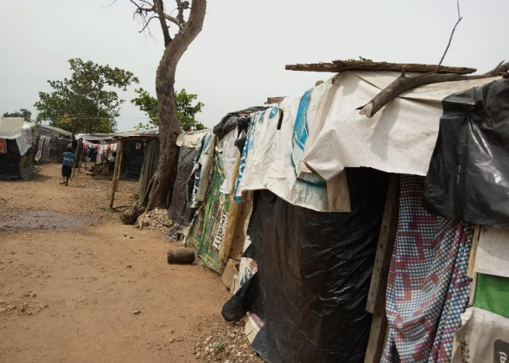

Plate I Shelter Condition at Kuchigoro Camp Plate II Drainage System at Kuchigoro Camp

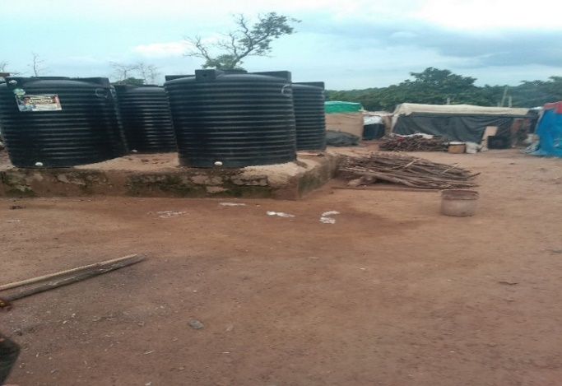
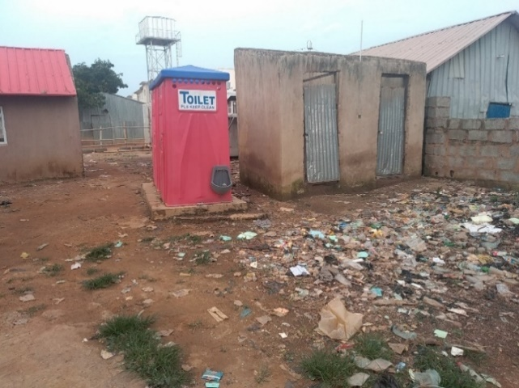

Plate III Toilet Facility at Kuchigoro Camp Plate IV: Water Storage in Durumi Camp
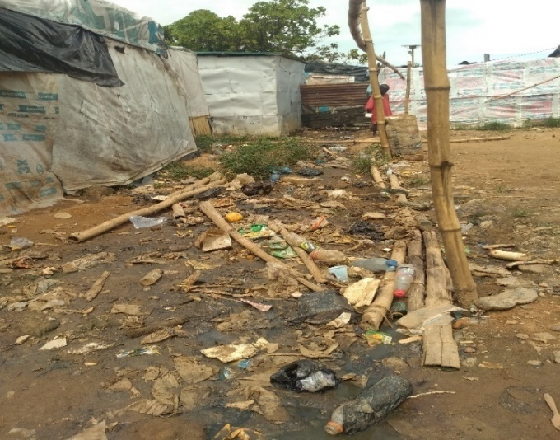
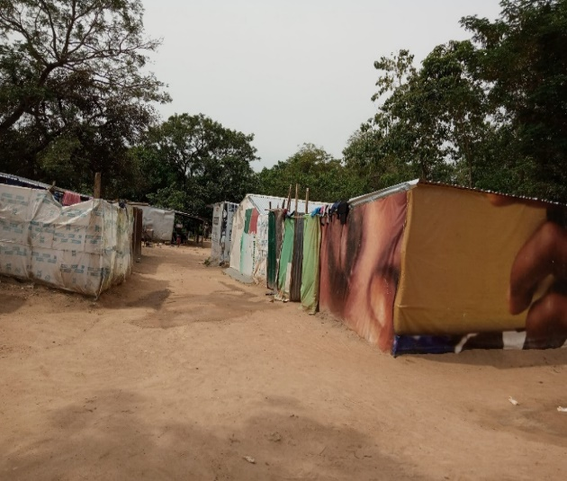

Plate V Shelter Condition at Durumi Camp Plate VI: Environmental Quality at Durumi Camp

  - Performance of Services in the Camps
The performance of services in IDP camps in Abuja is summarized using Likert scale rating and ranking. The variable, whose performance is greater than the total average score of a camp, has the lowest level of performance. As Table 3 indicates, food provision in Kuchigoro (4.154) and Durumi (4.037) scores the highest as such the camps are faced with food insecurity. Consequently, accessibility (2.803) in Kuchigoro camp is sufficient because it is the variable with the lowest score in the camp; while in Durumi camp, electricity scores the lowest (3.180) indicating that electricity is also not a challenge even though not available.
Table 3: Performance of Services in the Camps
Facility | Durumi camp | Kuchigoro camp
 | Mean | Mean
Water supply | 3.350 | 3.788
Electricity | 3.145 | 3.180
Education | 3.316 | 3.502
Healthcare | 3.744 | 3.862
Security | 3.009 | 3.410
Accessibility | 2.803 | 3.530
Relief Materials | 3.744 | 3.770
Food Provision | 4.154 | 4.037
Shelter | 3.504 | 3.631
Sanitation | 3.214 | 3.475
AVERAGE | 3.398 | 3.618

Conclusion and Recommendation
The issue of service delivery to internally displaced persons at the camps at the FCT, Abuja cannot be over emphasized. Hence the research concludes that, the IDPs in Abuja camps does not have access to adequate service delivery in areas of potable water supply, healthcare, education, relief materials and security services. In view of this situation, the study recommended a sustainable good governance strategy in line with the relevant goals of the SDGs; also, sustainable physical planning principles be introduced in the arrangement of space at the camps; in the provision of basic services, partnership with the non-governmental organizations should be encouraged for better service delivery.
Acknowledgements
This research did not receive any specific grant from funding agencies in the public, commercial, or not-for-profit sectors.

Conflict of Interests
The authors declare no conflict of interest.

References
Azazi, O. A. (2011), Northern Nigeria, the Prosperity Agenda and National Security. A Paper Presented at the Northern Transformation Impact Submit Sponsored by Arewa Transformation and Empowerment Initiative at the Arewa House, Kaduna, Kaduna State on May 10 – 12.
Danlami, G. (2021). Assessment of Basic Service Delivery to Internally Displaced Persons (IDPS) Camps in the Federal Capital Territory FCT, Nigeria. M.Tech Dissertation Submitted to the Department of Urban and Regional Planning, Federal University of Technology, Minna.
Danmole, B. (2004). Effect of concept mapping technique on senior secondary school students' achievement and retention of ecology concepts. Journal of the Science Teachers Association of Nigeria. 39. 32-38.
Internal Displacement Monitoring Centre (IMDC, 2014). Understanding the root causes of displacement.
Internal Displacement Monitoring Centre (IMDC, 2018). Understanding the root causes of displacement.
Muggah, R. (2012). Deconstructing the Fragile City: Exploring Insecurity, Violence and Resilience
Omar, N. (2009). Urban governance and service delivery in Nigeria. Development in Practice, 19(1), 72-78.
UN-Habitat (2015). Report on Internally Displaced Person a Case of Nigeria. Accessed from www.unhabitat.org on 5/5/2019.
UN-Habitat (2016). Report on Internally Displaced Person a Case of Nigeria. Accessed from www.unhabitat.org on 5/5/2019.
UN-Habitat (2017). Report on Internally Displaced Person a Case of Nigeria. Accessed from www.unhabitat.org on 5/5/2019.
United Cities and Local Government (UCLG, 2013): Report on Internally Displaced Persons in Africa. Accessed from www.ucgla.org on 5/5/2019.
United Nation High Commission on Refugees (UNCHCR, 2005): English Manual and Guideline on world about IDPs and Refugee
United Nation High Commission on Refugees (UNOCHA 2014): Handbook for Repatriation and Regeneration Activities.
United Nation High Commission on Refugees (UNOCHA 2015): Handbook for Repatriation and Regeneration Activities.
United Nationals High Commission for Refugees (UNHCR), 2005
United Nationals High Commission for Refugees (UNHCR), 2015
United Nationals High Commission for Refugees (UNHCR), 2016
United nations (UN) (2009) Report on Internally Displaced Persons in Nigeria.
Weerasekera, D. R. (2015) Longitudinal Vs. Cross-Sectional Analysis. Department Of Statistics, University of Colombo
World Bank report on IDPs a case of Nigeria 2015

