Development Journal of Science and Technology Research (DJOSTER), Volume 9, Number 1, 2020

HYDROGEOCHEMISTRY OF HAND-DUG WELLS OF PART OF THE SOUTH-WESTERN TALLUS SETTLEMENT OF MINNA RIDGE, NORTH-CENTRAL NIGERIA

I. A. Abdulfatai*, W. G. Akande, T. A. Ako, A. A. Alabi, I. A. Goro,
A. Suleiman, A. Momodu

Geology Department, Federal University of Technology, Minna, Nigeria *Corresponding Author: fatai.asema@futminna.edu.ng +2348057467043

Abstract

Groundwater hydrogeochemistry of water from hand-dug wells of part of the south-western half of Minna Ridge, North–Central Nigeria has been carried out with the aim to accessing the quality of the water for various domestic purposes especially drinking through physico–chemical and microbiological analysis with APHA (1998) procedures. The results were compared with available standards for drinking water quality (Nigeria Standard for Drinking Water Quality, 2007 and the World Health Organization Standard for Drinking Water Quality, 2006). All the physical parameters determined were generally within tolerable limits except total dissolved solids, conductivity, turbidity, colour and suspended solid values that are higher in some wells than the Nigeria Standard for Drinking Water Quality (2007). In some cases high concentrations of magnesium ion, iron ion and chromium ion were recorded attributable to weathering and dissolution of either the mineral biotite or hornblende or both from the host rock. The high concentration of nitrate and nitrite in some wells could be attributed to poor sanitary habit especially in the southern part where wastes from an abattoir are discarded into open drains. The high total coliform and E-coli recorded in some wells could be as a result of proximity of sceptic tanks and soak-away to these wells. Hydrochemical facies analysis shows that water from the studied area is of the Ca-Mg-Cl water type. Water from the wells in the area investigated is not fit for drinking purposes as they contain at least four contaminants and at most eleven contaminants. They can have negative impact on human health. The water may be for other domestic purposes. Lining of wells with concrete, boiling of water before domestic purposes, sitting of wells far away from septic tanks and good hygiene practice have been advocated for better water quality.

Keywords: Hydrogeochemistry, Minna, APHA, Water standard, Hydrochemical facies

1.0 Introduction

Lack of portable sources of water supplies such as pipe borne water and water boreholes has led many to depend on shallow wells as their source of water supply for domestic purposes. Pritchard et al. (2008) noted that shallow wells are usually found in the valleys with high groundwater table usually between one to four meters below ground level and that infiltration of rain and river water plays a main part in groundwater recharge. These wells are however easily prone to pollution as a result of practices that are directly or indirectly related to human activities

7

even though natural processes could also be a factor. Increase in industrialization and agricultural activities; urbanization, infiltration of polluted water, indiscriminate disposal of all kinds of wastes pose serious pollution threats on groundwater quality (Kehinde, 1998; Adelana et al., 2003, 2004, 2005; Ajala, 2005; Ocheri, 2006; Adelana et al., 2008; Eni et al., 2011; Musa and Ahanonu, 2013). The geology of an area also influences groundwater quality. Water being universal solvent dissolves part or whole of almost everything it comes in contact with especially with increase in temperature. The ions from minerals dissolved from aquifers either remain in water or combine with ions from other minerals to form new mineral which might either be beneficial or harmful. Once ions are dissolved, water could carry these from one place to another depending on the permeability of the aquifer. The geology of the area shows that it is part of the basement complex and has been studied by various researchers. The studied area is part of the larger part studied by Ajibade and Woakes (1976) which consists of migmatized gneisses, schist, quartzite, amphibolites, non-fractured granite and diorite. This particular area studied composed of rocks of mainly granodioritic composition (Alabi, 2011). The main mineralogical compositions of Minna granodiorite according to Alabi (2011) include microcline (40%), quartz (30%), plagioclase (15%), biotite (15%) and hornblende (5%).

The study area is part of Bosso area of Minna and falls within Latitude 9°38'4.18"N to 9°40'30.78" and Longitude 6°31'35.8" to 6°33'55.6". The area is accessible by major roads such as Minna–Zungeru road and Bahago bypass road with other minor roads and foot parts. Rainy and dry seasons characterise the climate of the area with the total annual rainfall ranging between 1270 mm and 1524 mm and this occur between April to October (McCurry, 1973). The highest temperatures are recorded in March with an average of 35 ºC while the lowest is in August with an average of 25 ºC (Ajibade, 1982). The Vegetation of the area is of the guinea savannah type. The area studied has a dentritic drainage pattern. It is drained by streams and rivers that form tributaries to River Chanchaga. The settlement pattern is nucleated while the major occupation of the inhabitants is agriculture. Many are also employed by Nigeria government and other private organizations. The studied area is part of the larger area studied by Amadi et al. (2014) for water quality of shallow aquifers but only one sample was analysed from the part this current research focused on. This study however seeks to analyse more samples for more details about the groundwater geochemistry of part of the western half of Minna Ridge which is part of Bosso.

2.0 Methodology

The methods used for this research include both field mapping and laboratory procedures. The field work involved the acquisition of data for the construction of flow pattern. Global Positioning System (GPS) was used to obtained coordinate values for all wells. Measuring tape was lowered into the well and as it touches the top of the water, values for static water level below ground level were obtained and the tape was then released into the base with the aid of a weight attached to the tape to determine depth of wells. These were used to determine the static water level above sea level (SWL). SWL values were determined for 28 wells and these values were used to construct flow net. The field works also involved sampling for laboratory analysis. Standard water sampling procedure according to APHA (1998) was followed. A total of 15 water samples from wells were taken for analysis. The laboratory analyses which include both chemical and bacteriological analysis were done in accordance with APHA (1998) procedure. The samples were analyzed at the water quality section, Federal Ministry of Water Resources Regional Laboratory, Minna, Nigeria. The entire exercise was carried out between September and November of 2014. The results were compared with the World Health Organization (WHO)

8

(2006) and Nigeria Standard for Drinking Water Quality (NSDWQ) (2007) to determine their suitability for consumption. Comparisons were made to either NSDWQ (2007) or WHO (2006) or both where available. The ranges and means of values obtained were quoted where there is no basis for comparison.

3.0 Results

The data acquired was used to construct flow net as shown in Figure 1 to determine recharge and discharge points. A total of 15 groundwater samples were analysed as shown in samples map in Figure 2. The samplings were restricted to the settlement on the western talus of the Bosso Ridges. The results of physical parameters (Table 1) show that total dissolve solid (TDS) have concentration values ranging from 21 to 1310Mg/L and a mean of 642.5Mg/L. The range of conductivity is between 319 to 1953Mg/L and the mean is 706.5Mg/L. The dissolve oxygen has values ranging between 5.70 to 7.25Mg/L and a mean of 6.79Mg/L. The temperature of various water samples varies from 25.6 to 25.7°C with a mean of 25.62°C. Turbidity values range from zero to 38.3NTU with a mean of 4.02NTU. The values for colour range from zero to 396TCU with a mean of 46.8TCU. The values for suspended solid have a range of zero to 277Mg/L and the mean is 23.3Mg/L. The range of pH value is from 6.35 to 7.25 while the mean is 7.0. The concentration values recorded for hardness ranges from 114 to 4463Mg/L and the mean is 25.63Mg/L. The values for total alkalinity range from 16 to 66 Mg/L with a mean of 34 Mg/L. The chemical and microbiological parameters are shown in Tables 2 and 3. The results of chemical parameters show that the concentration values for calcium hardness have a range between 42 to 410Mg/L while the mean is 166Mg/L. The magnesium hardness has a range from 3 to 299Mg/L and the mean is 93.3Mg/L. The values for chloride ions range from 14.9 to 190.9Mg/L and the mean is 75.4Mg/L. The values for sulphate ions range from 28 to 120Mg/L with a mean of 62.3Mg/L. There was zero record of carbonate ions in all the samples analysed. The values for bicarbonate ions range from 16 to 66Mg/L and the mean is 39.9Mg/L. The concentration of fluoride ions ranges from 0.43 to 1.83Mg/L with a mean of 0.70Mg/L. The concentration values for sodium ions are from 5 to 196Mg/L and the mean is 86.7Mg/L. Potassium ions have a concentration that range from 3 to 71Mg/L with a mean of 28Mg/L. The concentration values for calcium range from 16.8 to 164Mg/L and the mean is 66.5Mg/L. Magnesium ions have concentration values that range from

9

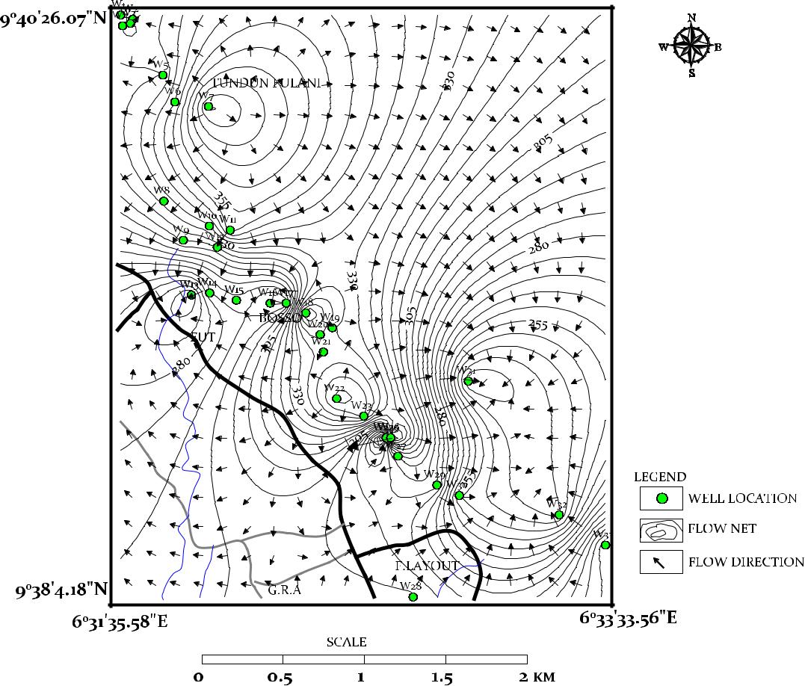

Fig 1: Groundwater flow pattern of part of Bosso

10

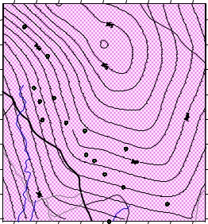
9⁰40'30.78"N
 | TUNDUN FULANI
 | W7
MAIKUNELE | W8
 | W9 | W11
 |  |  | BOSSO
 | W13 |  |  |  |  | lLEGEND
 | FUT |  | W16
 |  |  | W19 |  |  | SETTLEMENT
 |  |  |  |  | W31 | MAJOR ROAD
 |  |  | W22
 |  |  |  | W23 ABATTOIR |  | RIVER
 |  |  |  | W27 |  | MINOR ROAD
 |  |  |  |  | W30 | WATER SAMPLE LOCATION
 |  |  |  |  |  | W33
 |  |  |  | F.LAYOUT
9⁰38'4.18"N |  | G.R.A |  | W28
6⁰31'35.58"E |  |  | MOBIL |  |  | 6⁰33'55.6"E
 |  |  |  | SCALE
 |  | 0 | 0.5 | 1 | 1.5 | 2KM

Fig.2: Samples map of the study area

Table 1: Physical properties of samples
Locations | Total | Conductivity | Dissolve | Temperature | Turbidity | Colour | Suspended | pH | Total | Total
 | Dissolve | (µS/cm) | Oxyygen | (ºC) | (NTU) | (TCU) | Solid |  | Hardness | Alkalinity
 | Solid |  | (Mg/L) |  |  |  | (Mg/L) |  | (Mg/L) | (Mg/L)
 | (Mg/L)
W1 | 317 | 473 | 6.30 | 25.7 | 38.3 | 396 | 45 | 6.99 | 162 | 28
W2 | 655 | 977 | 5.70 | 25.6 | 2.1 | 1.44 | 3 | 7.03 | 168 | 64
W3 | 496 | 740 | 7.08 | 25.6 | 1.34 | 73 | 2 | 7.21 | 402 | 33
W4 | 214 | 319 | 6.5 | 25.7 | 7.5 | 125 | 10 | 7.25 | 114 | 34
W5 | 265 | 396 | 6.64 | 25.6 | 8.9 | 91 | 12 | 7.11 | 153 | 23
W6 | 673 | 1004 | 7.23 | 25.6 | 0.34 | 15 | 1 | 7.19 | 256 | 66
W7 | 1018 | 1520 | 6.88 | 25.6 | 0.12 | 1 | 0 | 6.9 | 380 | 42
W8 | 840 | 1253 | 7.18 | 25.6 | 0.12 | 0 | 0 | 6.94 | 256 | 45
W9 | 571 | 852 | 7.16 | 25.6 | 0.11 | 0 | 0 | 7.11 | 257 | 41
W10 | 392 | 584 | 7.27 | 25.6 | 0.12 | 0 | 0 | 6.97 | 208 | 36
W11 | 313 | 466 | 7.25 | 25.6 | 0.34 | 0 | 0 | 6.85 | 152 | 16
W12 | 1310 | 1952 | 6.64 | 25.6 | 0.21 | 0 | 0 | 6.56 | 446 | 24
W13 | 1308 | 1953 | 5.95 | 25.6 | 0.45 | 0 | 0 | 6.55 | 428 | 26
W14 | 365 | 544 | 6.92 | 25.7 | 0.32 | 0 | 0 | 6.8 | 172 | 16
W15 | 603 | 901 | 7.15 | 25.6 | 0 | 0 | 277 | 7.25 | 130 | 16
Mean | 642.5 | 706.5 | 6.79 | 25.62 | 4.02 | 46.8 | 23.3 | 7 | 245.6 | 34
Range | 214- | 319-1953 | 5.70- | 25.6-25.7 | 0.11-38.3 | 0-396 | 0-277 | 6.35- | 114-446 | 16-66
 | 1310 |  | 7.25 |  |  |  |  | 7.25
NSDWQ, | 500 | 1000 | 5 | - | 5 | 15 | 500 | 6.5- | 150 | 100
2007 |  |  |  |  |  |  |  | 8.5
WHO, | 1000 | 1200 | <4 | - | 5 | 15 | 500 | 6.5- | 500 | 50
2006 |  |  |  |  |  |  |  | 8.5

11

Table 2: Chemical properties of water samples

Location | CalciumHardness(Mg/L)
W1 | 42
W2 | 128
W3 | 147
W4 | 83
W5 | 84
W6 | 136
W7 | 344
W8 | 144
W9 | 212
W10 | 185
W11 | 129
W12 | 147
W13 | 410
W14 | 169
W15 | 130
Mean | 166
Range | 42-410
NSDWQ, | -
2007
WHO, | 100
2006

MagnessiumHardness

120

40

255

31

74

120

36

112

45

23

23

299

72

3

147

93.3

3-299

-

-

(Mg/L)

Chloride ion(Mg/L) | Carbonateion(Mg/L)
43.9 | 0
57.9 | 0
35.9 | 0
16.9 | 0
14.9 | 0
67.9 | 0
148.9 | 0
128.9 | 0
52.9 | 0
45.9 | 0
42.9 | 0
189.9 | 0
190.9 | 0
41.9 | 0
51.9 | 0
75.4 | 0
14.9- | 0
190.9
250 | -
250 | 150

Sulphate ion(Mg/L) | Bicarbonateion(Mg/L) | Flouride ion(Mg/L)
30 | 28 | 0.57
58 | 64 | 0.83
75 | 33 | 1.18
44 | 34 | 0.43
35 | 23 | 0.57
90 | 66 | 0.66
100 | 42 | 0.6
54 | 45 | 1.83
41 | 41 | 0.45
43 | 36 | 0.47
28 | 16 | 0.51
110 | 24 | 0.97
120 | 26 | 0.68
36 | 16 | 1.0
71 | 75 | 0.74
62.3 | 39.9 | 0.7
28- | 16- | 0.43-
120 | 66 | 1.83
100 | - | 1.5
450 | 150 | 2 (1.5)

ion

(Mg/L) Sodium

40

56

77

24

18

91

135

125

80

37

59

196

196

67

69

86.7

5-196

200

200

Potassiumion(Mg/L) | Calcium ion(Mg/L)
5 | 16.8
41 | 51.3
5 | 58.9

- 33.3

- 33.6

- 54.5

- 137.9

- 57.7

37 | 84.9
3 | 74.1

- 51.7

- 58.9

- 164.3

- 67.7

- 52.1

- 66.5

3- 16.8-
- 164

--

200 75 -

200

Magnessium(Mg/L)

29.3

9.76

62.2

7.56

18

29.3

8.78

27.3

10.9

5.61

5.61

72.9

17.6

0.73

35.9

22.8

0.73-
72.9

20

50

ion
Nitrate(Mg/L) | Nitrite(Mg/L)
31.7 | 0.31
29.3 | 0.1

- 0.017

- 60.02

- 90.29

- 30.18

- 20.06

- 40.21

- 40.081

- 50.3

- 70..08

- 0.053

- 0.44

- 90.45

- 70

- 20.2

13.6- | 0-
198 | 0.45

- 0.2

- 0.2

0.73 to 72.9Mg/L and the mean is 22.8Mg/L. The concentration values for nitrate range from 13.8 to 196Mg/L with a mean of 59.2Mg/L while that of nitrite range from zero to 0.45Mg/L with a mean of 0.2Mg/L. The concentration values for zinc range from zero to 0.61Mg/L and the mean is 0.23Mg/L while that of chromium is from zero to 0.06Mg/L with a mean of 0.02Mg/L. The concentration values for copper range from zero to 2.42Mg/L with a mean of 0.7Mg/L while that of iron ions is from zero to 0.84Mg/L with a mean of 0.13Mg/L. The coliform bacteria have concentration values from zero to 84cfu/100ml with a mean of 11.87cfu/100ml. The concentration values for E-coli bacterial range from zero to 52cfu/100ml and the mean is 6.45cfu/100ml while that for Faecal Streptococci Ranges from zero to 51cfu/100ml with a mean is 6.40cfu/100ml. Figure 4 shows the hydrochemical facies diagram (Piper diagram) of the studied area. All the parameters used for the construction of the diagram plotted in the region of Ca-Mg-Cl region of the of the diamond shaped diagram.

12

Table 3: Chemical and biological properties of water samples
Location | Zinc | Chromium | Copper | Iron | Total | E-Coli | Faecal
 | (Mg/L) | (Mg/L) | (Mg/L) | (Mg/L) | Coliforms | (cfu/100ml) | Streptococci
 |  |  |  |  | (cfu/100ml) |  | (cfu/100ml)
W1 | 0.08 | 0.06 | 0.27 | 0.84 | 10 | 6 | 5
W2 | 0.17 | 0.04 | 0.63 | 0.19 | 0 | 0 | 0
W3 | 0.31 | 0.02 | 0.09 | 0.11 | 0 | 0 | 0
W4 | 0.18 | 0.02 | 0.07 | 0.2 | 14 | 8 | 6
W5 | 0.16 | 0.01 | 0 | 0.17 | 84 | 52 | 51
W6 | 0 | 0 | 1.24 | 0.03 | 0 | 0 | 0
W7 | 0.14 | 0.01 | 2.09 | 0.02 | 0 | 0 | 0
W8 | 0.26 | 0.02 | 1.44 | 0 | 0 | 0 | 0
W9 | 0.23 | 0.01 | 0 | 0 | 0 | 0 | 0
W10 | 0.15 | 0.01 | 0.08 | 0 | 0 | 0 | 0
W11 | 0.3 | 0.01 | 0.06 | 0 | 4 | 1 | 1
W12 | 0.19 | 0 | 2.24 | 0.1 | 0 | 0 | 0
W13 | 0.28 | 0 | 2.42 | 0 | 0 | 0 | 0
W14 | 0.61 | 0.01 | 0.02 | 0.1 | 66 | 30 | 33
W15 | 0.43 | 0.01 | 2.04 | 0.12 | 0 | 0 | 0
Mean | 0.23 | 0.02 | 0.7 | 0.13 | 11.87 | 6.45 | 6.4
Range | 0-0.61 | 0-0.06 | 0-2.42 | 0-0.84 | 0-84 | 0-52 | 0-51
NSDWQ, | 5 | 0.05 | 1.3 | 0.3 | 10 | 0 | -
2007
WHO, | 3 | 0.05 | 1 | 0.3 | 0-10 | 0 | -
2006
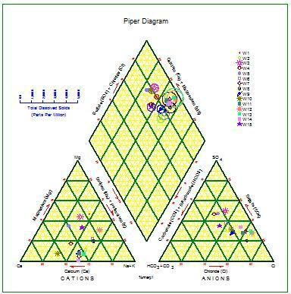

Fig. 4: Hydrochemical facies of the studied area

13

4.0 Discussion

Figure 1 shows that groundwater in the studied flow from higher elevation to lower elevation. The flow pattern diagram shows that North-East (NE) to South-West (SW) serve as the main recharge area while north – west (NW) to south – east (SE) serve as the discharge area. The NW to SE of the region are characterised by high land. The flow is from area of high topography (NE and SW) to areas of lower topography (NE and SW). There is higher TDS in the majority of the wells (W2, W6, W7, W8, W9, W12, W13, W15) when compared with the NSDWQ (2007). However, only three wells (W7, W12, and W13) have TDS values above the WHO (2006) drinking water standard. The mean TDS is above NSDWQ (2007) but below WHO (2006). The high TDS recorded in some wells could be attributed to the fact that majority of wells in the area investigated are either not lined or covered or both and also dissolution of mineral substances in water. The conductivity is higher in W6, W7, W8, W12 and W13 when compared with NSDWQ (2007) and WHO (2006) but W6 and others well are within the permissible limit of WHO

(2006). This high conductivity recorded in some of these wells could have been as result of presence of dissolves ions in water of those wells. Others are however within the permissible limit for drinking water. The concentration values for dissolve oxygen exceed the permissible limit in all samples. Turbidity values for W1, W4 and W5 are higher than the NSDWQ, (2007). This could be as a result of suspended mineral matters. The colour values for W1, W3, W4, W5 and W6 are higher than the NSDWQ (2007). The mean colour value is above NSDWQ (2007). The suspended solid is higher only at W15 than the NSDWQ (2007). The suspended solid and pH values range for all wells are within both NSDWQ (2007) and WHO (2006). The values for total hardness exceed NSDWQ (2007) in all samples except W4 and W15 but all are within the permissible limit of WHO (2006). The concentration values for total alkalinity are within the permissible limit except for W2 and W6 that exceed the limit set by WHO (2006).

Carbonate, bicarbonate, chloride, sodium and calcium ions are within the permissible limit. Sulphate ions have concentration values that are higher than the NSDWQ (2007) at W12 and W13 but all the values are however within the WHO, (2006). The concentration values for fluoride ions signify that they are within the permissible limit except at W8. The concentration values for calcium hardness are within the safe limit of WHO (2006) only at W1, W4, and W5. The values for magnesium ions are higher in W1, W3, W6, W8, W12 and W15 than the NSDWQ (2007). These high magnesium ions in some of the wells could be as a result of weathering of hornblende (amphibole) and clay minerals from the surrounding rocks. Drinking water from these well can have a laxative effect on the consumer. The values recorded for nitrate ions are higher W3, W7, W8, W12, W13 and W14 than the WHO (2006). The values recorded for nitrite at W1, W5, W8, W10, W13 and W14 are higher than the permissible limit. Proximity of soak away and sceptic tanks to wells, discharge of abattoir waste (figure 5) into open drains/streams and poor sanitary condition noticed in the area especially in the southern part of the studied area could be the reasons for the high values of nitrate and nitrite ions in some wells. These wastes could contaminate groundwater by leaching and from effluent streams. Consumption of water with high nitrate can cause methemoglobinemia (blue baby syndrome), breathing problem and reduction in the oxygen level of the blood. The values for both chromium and iron ions exceed the permissible limit only at W1. This could be as a result of weathering of ferromagnesian minerals from the surrounding rocks. The values of copper ions at W7, W8, W12, W13 and W15 are higher than both NSDWQ (2007) and WHO (2006). There is however no basis for comparison for magnesium hardness.

14

The results of microbiological parameters show that total coliforms bacterial at LI, W4, W5 and W14 are higher than the NSDWQ (2007). The concentration values of E-coli exceed the standard at well W1, W4, W5, W11 and W14. There is however no basis for comparison for faecal streptococci. Table 4 shows wells and the parameters (represented with asterisks in the table) that exceed the standard set by either WHO (2006) or NSDWQ (2007) or both.

The results of hydrochemical facies analysis show the water from hand dug wells in the studies area is Ca-Mg-Cl water type. This could have resulted from the mixing of highly saline water from surface sources such as domestic waste and septic tanks and ion exchange processes.
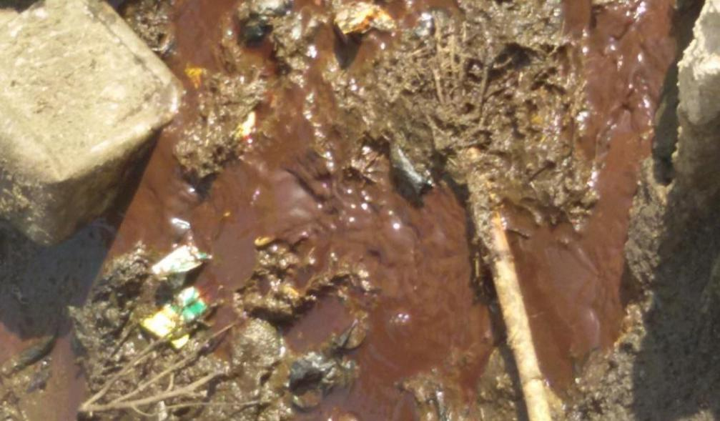

Fig. 5: Discharge of abattoir waste into open drains

Table 4: Parameters that exceed either WHO 2006 or NSDWQ 2007 or both (represented as asterisks).

 | PARAMETER | LI | W2 | W3 | W4 | W5 | W6 | W7 | W8 | W9 | W10 | W11 | W12 | W13 | W14 | W15
 | TDS (mg/L) |  | * |  |  |  | * | * | * |  |  |  | * | * |  | *
 | Conductivity |  |  |  |  |  | * | * | * |  |  |  | * | *
 | (µS/cm)
 | Dissolved | * | * | * | * | * | * | * | * | * | * | * | * | * | * | *
 | Oxygen (mg/L)
 | Turbidity | * |  |  | * | *
 | (NTU)
 | Colour (TCU) | * |  | * | * | * | *
 | Suspended |  |  |  |  |  |  |  |  |  |  |  |  |  |  | *
 | Solid (mg/L)
 | Total Hardness | * | * | * |  | * | * | * | * | * | * | * | * | * | *
 | (mg/L)
 | Calcium
 | Hardness |  | * | * |  |  | * | * | * | * | * | * | * | * | * | *
 | (mg/L)
 | Total Alkalinity |  | *
 | (mg/L)
 | Sulphate |  |  |  |  |  |  |  |  |  |  |  | * | *
 | (mg/L)
 | Chromium | *
 | (mg/L)
15

 | Fluoride |  |  |  |  | *
 | (mg/L)
 | Iron (mg/L) | *
 | Calcium | * | * | *
 | (mg/L)
 | Magnesium | * |  | * |  | * |  | * |  | *
 | (mg/L)
 | Nitrate (mg/L) |  |  | * | * | * |  | * | * | *
 | Nitrite (mg/L) | * |  |  | * | * | * |  | * | *
 | Copper (mg/L) |  |  |  | * | * | * | * | * | *
 | Total Coliforms | * |  | * | * |  |  |  |  | *
 | (cfu/100ml)
 | E-Coli | * |  | * | * |  |  | * |  | *
 | (cfu/100ml)
5.0 | Conclusions

The investigated area is characterised by high land that trend in approximate NW – SE direction while the NE – SW serve as the plains inhabited the humans. These plains serve as the recharge area while the high land serves as the discharge area. The wells tested have concentration values of at least four tested parameters above the permissible limit with highest being W1 with eleven tested parameters above the permissible limit. Hydrochemical facies analysis indicates the well water from the studied is of Ca-Mg-Cl water type. The geology of the area and anthropogenic activities have great influence on the qualities of the water in area. This is because the parameters found to be above permissible limit as a result of these activities. The water from the wells in the investigated is not recommended for drinking as the presence of some of the tested parameters in excess can cause one ailment or the other. The water can however be used for other domestic activities (such as washing, flushing of toilet) after boiling.

Acknowledgement

The authors would like to thank Yusuf, A. O., Salawudeen, O. T. and Felix, J. B., for the positive role they played during the execution of this research.

References

Adelana, S. M. A., Abiye, T. A., Nkhuwa, D. C. W., Tindinugaya, C., Oga, M. S. (2008). Urban groundwater management and protection in Sub-Saharan Africa in: Adelana, S. M. A. and MacDonald, A. M. Applied groundwater studies in Africa, International Association of Hydrogeologists, selected papers, p.222-259.

Adelana, S. M. A., Bale, R. B., Olasehinde, P. I., Wu, M. (2005). The impact of anthropogenic activities over groundwater quality of coastal aquifer in Southwestern Nigeria. Proceedings on Aquifer Vulnerability and Risks. 2nd International Workshop and 4th Congress on the Protection and Management of Groundwater. Raggia di Colornoparma.

Ajala, O. (2005). Environmental impact of urbanization, culture and the Nigeria in: Fadare et al(eds) Globalisation, Culture and Nigerian built Environment, Faculty of Environmental Design and Management, OAU, p.192-199.

Ajibade, A. C. (1982). The origin of Older Granites of Nigeria: some evidence from the Zungeru region, Nigeria. Journal of Mining and Geology, 19(1), 223-230.

16

Ajibade, A. C. and Woakes, M. (1976). Proterozoic Crustal Development in the Pan-African Regime of Nigeria. In: C. A. Kogbe (Ed.), (pp. 57-63). Geology of Nigeria. Rock-view, Nigeria, LTD.

Alabi, A. A. (2011). Geology and Environmental Impact Assessment and Benefit of Granitic Rocks of Minna Area, Northwestern Nigeria. Ethiopian Journal of Environmental Studies and Management, 4(.4), 39-41.

APHA (1998). Standard Methods for the Examination of Water and Wastewater, 20th edn.
American Public Health Association, Washington, DC.

Eni, D. V., Obiefuna, J., Oko, C., Ekwok, I. (2011). Impact of Urbanization on Sub-Surface Water Quality in Calabar Municipalty, Nigeria. International Journal of Humanities and Social Sciences, 1(10), 167-172.

Kehinde, M .O. (1998).The impact of industrial growth on groundwater quality and availability in: A. Osuntokun (eds) Current Issues in Nigerian Environment, Ibadan Danidan Press.

McCurry, P. (1976). The Geology of the Precambrain to Lower Paleozoic rocks of Northern Nigeria. A Review In: C. A. Kogbe (Eds.). (pp. 15-39). Geology of Nigeria, Elizabeth Publishing Co. Lagos.

Musa, J. J. and Ahanonu, J. J. (2013). Quality assessment of shallow groundwater in some selected agrarian communities in Patigi Local Government Area, Nigeria. International Journal of Basic and Applied Science, 1(3), 548-563.

Ocheri, M. I. (2006). Analysis of water consumption pattern in Makurdi metropolis. Journal of Geography and Development, 1(1), 71-83.

Pritchard, M., Mkandawire, T., O’Neil, J. G. (2008). Assessment of groundwater quality in shallow wells within the Southern Districts of Malawi. Physics and Chemistry of the Earth, 33, 812-823.

World Health Organization (2006). Guidelines for Drinking Water Quality; First addendum to third edition. World Health Organization, Geneva, 515.

