Quantification and Chemometrics Characterisation of Nutritional Data of Selected Raw and Branded Tomatoes

Esther, U., *Salau,R.B., Salihu,S.O.Zalihat,A. and Alheri,A.

Department of Chemistry, Federal University of Technology, P. M. B. 65, Minna,
Niger State, Nigeria

Article Information Abstract
Article # 02017 Tomatoes offer great nutritional and health benefits to humans. The nutritional, Received: 11th May 2021 physical, and chemical characteristics of tomatoes in raw and company processed Revision: 24th July 2021 forms were evaluated for their nutritional qualities. Three varieties of raw tomatoes Acceptance:29th July 2021 and ten brands of processed tomatoes were sampled. The proximate, vitamins, and
Published: 3rd August 2021 phenolic composition, as well as Physico-chemical parameters, were carried out
Key Words  Characterisation,  Chemometrics, Raw and processed tomatoes Anti-oxidant, Phenolic compound, Vitamins,  Health benefit | using standard techniques. The datasets were subjected to both statistical and Chemometrics techniques.The proximate values (%) were in ranges of: Fat (0.29 – 11.31); Protein (6.65 – 20.15); Fibre (0.92 – 15.70) Ash 0.08 –3.18); Carbohydrate (53.07 – 80.53). The physicochemical parameters values are in ranges: pH (2.25– 4.83); Conductivity (3.73 –12.97), Titratable acidity (0.11 –1.07); Total soluble solids (15.23–40.70). The vitamins and phenolic values are in ranges: Vitamin A (0.47 –8.20); vitamin C (1.31–18.49); Phenolic (0.041– 0.360). The raw tomatoes have a more prominent content of vitamin C. With the aid of biplot(loading/score) of the Principal Component Analysis (PCA), the Zaria and Minna varieties as well as processed brands (5, 7, and 10) are characterized by substantial carbohydrate content. The dendrogram of Hierarchical Cluster Analysis (HCA) revealed closed substitutability of Kano variety and brand 5, as a result of both samples having equivalence of nutritional content. This suggests that brand 5 got its raw tomato from Kano varieties and could therefore be used as a substitute of each other when

consumption choice has to be made .
*Corresponding Author: Salau,R.; rasaqsalau@futminna.edu.ng

Introduction
Tomatoes are valued vegetables that are widely consumed for their healthy and beneficial nutritional content (Eke-Ejiofor, 2015). Tomato (Lycopersicon esculentum) belongs to the solanaceae, tomatoes which are cultivated widely in home gardens and large farms for fresh consumption and commercial processing (Aditiet al., 2011). It is typically over 90% water and, once they are harvested, begins to undergo higher rates of respiration, resulting in moisture loss, quality deterioration, and potential microbial spoilage (Abdullahiet al., 2016).
Tomato has many nutrients with secondary metabolites that are important for human health (Demirbas, 2010 and Katırcıet al., 2018). Its consumption reduces the risk of certain types of cancer, cardiovascular, osteoporosis, and chronic degenerative diseases (Bhowmiket al., 2012; Hernández et al.2008 and Chang et al., 2006). The unique mineral contents are a pointer to the benefits offered by the tomatoes (Demirbas, 2010;
Hernández et al., 2008 and Melø et al., 2008). The proximate content of foods plays an important role in predicting their nutritional values. Fats, proteins, and carbohydrates constitute the major structural components of foods. Carbohydrates are a vital source of energy for most organisms, including humans. Moisture content information is a useful measurement in the storage, processing, and preservation of food. Proteins are organic compounds essential for body repair and health maintenance. Ash content is an inorganic residue remaining after the complete oxidation of organic matter. Ash value is an indication of mineral presence (Idris et al., 2019; Okello et al., 2018 and Salau et al., 2012).
The major quality perception of fruits is hinged upon the measures of the physicochemical properties such as pH, total soluble solids, and titratable acidity (Tehranifar et al., 2010). These values are indicators of maturity, storage capacity, spoilage, flavour, and taste (Zhao et al., 2020; Deng et al., 2019 and Tehranifar et al., 2010).
Antioxidants are chemical agents that inhibit the destructive and pathogenic tendency of oxidation in the living system. In oxidation, free radicals are formed analogously to reactions of scavenging nature. Foods and other biological systems experience lipid pre-oxidation, autoxidation processes, and other types of oxidations. Food antioxidants in foodstuffs can protect them from these attacks, conserving their consumption safety properties organoleptic properties, and texture (Carocho et al., 2018).
Chemometrics is the use of mathematics and statistical method to improve the understanding of chemical information. It is applied to solve descriptive and predictive problems in chemistry (Brereton et al., 2018). Chemometrics is a veritable tool in the interpretation, analysis, and visual presentation of complex multivariate data (Munck et al., 1998). Its use in food chemistry has assisted in obtaining better information about the composition of a food product as well as its physical and chemical properties (Salauet al., 2020; Salau and Hasan, 2019, Hassan et al., 2019, Salau and Hasan, 2018 and Salau et al., 2018).
The chemometrics methods involve the selection of data, the building of suitable models and adapting the model to give solutions to complex data problems (Munck et al., 1998). Unsupervised pattern recognition techniques of chemometrics such as the Cluster Analysis (CA) and Principal Component Analysis (PCA) are much revealing in terms of groupings and close neighborhood of the food sample respectively. Chemometrics has been extensively applied to varying categories of food samples (Salau and Hasan, 2019).

Materials and Methods
Sample collection
Three species of raw tomatoes which include KanoIndia species, Minna-Gwari species, and Zaria species and ten brands of company processed tomatoes designated as Brand1 to 10 were sampled in triplicates across markets in Minna city.

Sample preparation
The raw tomatoes were cleaned, weighed, and then divided into two parts and their hardness and pH were determined using a durometer and potentiometer respectively. The one part was blended into a paste and moisture was determined while the other part on which vitamins analysis was to be carried out was then sliced using a sharp knife which was then dried. The dried tomato was crushed into a powder using a clean mortar and pestle. The powdered sample was then stored at room temperature before the analysis. For the processed tomato, the tomato paste was also divided into two parts; one part was used for moisture determination while the other part was dried for vitamin determination. The dried samples were stored at room temperature for analysis.

Proximate analysis
Proximate analysis for crude fat, crude protein, crude fiber, carbohydrate, and ash content were carried out according to the method described by Abdullahi et al. (2016) and Joel et al. (2020).

Analysis of phenolics and vitamins
The phenolic content was determined by the FolinCiocalteu method as described by Katırcı et al. (2018) while Vitamin A and C were determined according to the method described by Abdulahi et al.(2016).

Physico-chemical parameters The pH and titratable acidity determinations were done using the method described by Joel et al. (2020), Total solid was obtained by difference (100- moisture content) as described by (Eke-Ejiofor, 2015), Moisture content was determined by the difference between the accurately weighed samples before and after drying in an oven at 105 °C as described by Abdullahi et al.(2016) while the determination of electrical conductivity of the tomato samples was carried out using a conductivity meter.

Statistical analysis
The statistical package of social sciences (SPSS) software version 21.0 was used. The results were evaluated using analysis of variance (ANOVA) and were presented as the mean value ± SD (standard deviation of the mean) for the samples. Differences among the means were assessed using Duncan’s Multiple Range Test to determine which mean values were significantly different at p<0.05.

Chemometrics analysis
Chemometrics software package, The Math works
Incorporations’ MATLAB version 4.0 for windows, and the Eigenvectors Research Incorporations’ PLS_ Toolbox version 6.2 were used for PCA and CA.

Results and Discussion
The physicochemical parameters

The nutritional, physical, and chemical parameters of three species of raw and ten brands of processed tomatoes differed significantly (p<0.05) due to different varieties and brands.
(7%) recommended by Codex Alimentarius  Commission (CAC, 2011). Total soluble solids (15.23–40.70) with brand6 having the least and brand7 the highest. The total soluble solid (15.23– | level of 20 to 22% required by the Codex Alimentarius Commission (CAC, 2011). The higher total soluble solid might be due to lower moisture content as reported by Eke-Ejiofor (2015).
40.70) of the samples were higher than the standard

Table 1: Physico-chemical properties of the tomato samples

S/N | Sample | pH | Conductivity uS/cm | Titratable (%) | Acids | Total Soluble  Solids
1 | KI | 4.79±0.01e | 3.73±0.01ª | 0.41±0.01ª |  | 28.42±0.01^{k}
2 | MG | 4.85±0.01^{h} | 5.72±0.01^{d} | 0.77±0.01^{b} |  | 18.17±0.02^{h}
3 | ZU | 4.79±0.00^{f} | 6.48±0.00^{f} | 0.41±0.01ª |  | 15.81±0.01^{d}
4 | B1 | 4.78±0.01e | 8.87±0.01^{i} | 0.18±0.00ª |  | 17.53±0.01^{g}
5 | B2 | 4.68±0.00^{c} | 6.72±0.00^{g} | 0.31±0.01ª |  | 18.65±0.01^{i}
6 | B3 | 4.86±0.01^{h} | 8.34±0.00^{h} | 1.02±0.01^{b} |  | 15.21±0.01^{b}
7 | B4 | 2.25±0.00ª | 9.87±0.00^{k} | 1.02±0.01^{b} |  | 17.27±0.01e
8 | B5 | 4.72±0.00^{d} | 12.97±0.00^{m} | 1.04±0.00^{b} |  | 15.23±0.03ª
9 | B6 | 4.56±0.00^{b} | 6.36±0.00e | 1.04±0.00^{b} |  | 15.61±0.01^{c}
10 | B7 | 4.86±0.01^{h} | 5.25±0.00^{c} | 1.07±0.00^{b} |  | 40.61±0.01^{l}
11 | B8 | 4.73±0.01^{d} | 9.03±0.01^{j} | 1.02±0.01^{b} |  | 18.15±0.05^{h}
12 | B9 | 4.88±0.01^{i} | 9.92±0.00^{l} | 0.11±0.01ª |  | 19.01±0.01^{j}
13 | B10 | 4.83±0.00^{g} | 3.93±0.00^{b} | 0.44±0.03ª |  | 17.41±0.01^{f}
Values are reported as mean ± standard error of means. Values with the same letter on the column are not significant while values on the same column with different alphabetic superscripts are significant at p≤0.05 DMRT test. Key: KI = Kano-India variety, MG = Minna-Gwari variety, ZU= Zaria- UTC variety, B1–B10 are processed
Table 1 shows the physical and chemical parameters (%). The physicochemical parameters values are in ranges. pH (2.25–4.83) with brand 4 having the least and brand 10 the highest. The pH (2.25–4.83) indicated the hygienic qualities of raw and processed tomato brands (CAC, 2011). Conductivity (3.73– 12.97) with Kano-India species having the least and brand 5 the highest. The highest electrical conductivity was found with processed brands. This could be as a result of the processing mechanism. Titratable acids (0.11–1.07) with brand 9 having the least and brand 7 the highest. Titratable acidity (0.11–1.07) did not exceed the maximum acidity tomato brands 1-10

Proximate Composition
Table 2 shows proximate composition (%). The proximate values are in ranges: Moisture (0.74– 11.84) with brand 7 having the least and brand 6 the highest. The moisture contents values (0.74 – 11.84) with brand 5 having the highest moisture. These were low compared to the values (69.00 – 84.85%) reported by Eke-Ejiofor (2015). These decreases in the moisture of the processed tomatoes increase the shelf life, hence being beneficial to the consumers (Joel et al., 2020). Crude fat (0.29–11.31) with brand 3 having the least fat and Minna-Gwari species the highest (11.31%). The fat content of the fresh tomato (Minna-Gwari species) is higher than all the processed brands and as well as its raw counterparts. The reason might be due to different geographical locations and differences in processing methods. Crude protein (6.66–20.15) with brand1 having the least and Minna-Gwari species the highest. The crude protein was higher in some of the raw than all the processed brands. The difference in crude protein contents could be attributed to species differences as well as differences in the processing

Sampl  es | Moisture (%) | Crude Fat (%) | Crude Protein (%) | Crude Fibre (%) | Ash (%) | Carbohydrate (%)
KI | 4.77±0.01^{b} | 9.08±0.00^{f} | 19.26±0.01^{k} | 11.57±0.01^{i} | 2.28±0.00^{j} | 53.07±0.00ª
MG | 5.68±0.01^{d} | 11.31±0.00^{m} | 20.15±0.01^{l} | 3.91±0.01e | 2.26±0.05^{j} | 56.68±0.00^{c}
Table 2: Proximate composition of tomato samples conditions of the pastes. The higher protein content of the raw tomato in this study is at variance with the one reported by Abdullahi et al. (2016) as his study was based on processed tomato. Crude fiber (0.92– 15.70) with brand 10 having the least and brand 8 the highest; Ash (0.08–3.18) with brand 10 having the least and brand 5 the highest. The ash content in both raw and processed brands differed significantly, however, one of the processed tomatoes has higher ash content than others. This might be as a result of the addition of salt to the processed and high water content of the raw. The crude fiber content of raw tomato is significantly lower than the processed brands' tomato. This could be a result of the high water content of the raw tomato. Abdullahi et al.(2016) reported a similar observation. Carbohydrate (53.07–80.53) with Kano-India species having the least and brand 3 the highest. The Carbohydrate percentage content in the raw tomato is lower than the processed brands. This might be as a result of high water contents in raw tomatoes.

ZU | 5.78±0.01e | 9.81±0.00^{l} | 13.35±0.05^{i} | 1.03±0.01^{b} | 1.43±0.00^{f} | 68.58±0.00^{i}
B1 | 7.93±0.01^{j} | 9.11±0.00^{g} | 6.66±0.01ª | 2.92±0.01^{d} | 2.01±0.00^{i} | 71.39±0.00^{k}
B2 | 8.18±0.01^{k} | 9.67±0.00^{i} | 11.39±0.01^{g} | 11.68±0.01^{j} | 1.54±0.00^{g} | 68.96±0.00^{j}
B3 | 5.47±0.01^{c} | 0.29±0.00ª | 10.07±0.01^{d} | 2.60±0.00^{c} | 1.07±0.00^{d} | 80.53±0.00^{m}
B4 | 7.03±0.01^{h} | 8.57±0.00^{d} | 9.19±0.01^{c} | 6.75±0.01^{h} | 1.46±0.00^{f} | 66.91±0.00^{h}
B5 | 8.37±0.01^{l} | 9.73±0.00^{k} | 10.07±0.01^{d} | 11.94±0.01^{k} | 3.18±0.00^{k} | 56.73±0.00^{d}
B6 | 11.84±0.01^{m} | 6.82±0.00^{b} | 8.32±0.01^{b} | 11.94±0.01^{k} | 0.86±0.00^{c} | 60.25±0.00e
B7 | 0.74±0.01ª | 8.58±0.00e | 10.51±0.01e | 3.94±0.01^{f} | 0.52±0.00^{b} | 75.74±0.01^{l}
B8 | 7.52±0.01^{i} | 9.73±0.00^{j} | 10.94±0.01^{f} | 15.61±0.01^{l} | 1.69±0.00^{h} | 54.45±0.00^{b}
B9 | 5.99±0.01^{f} | 9.19±0.00^{h} | 12.26±0.01^{h} | 4.23±0.01^{g} | 1.39±0.01e | 66.98±0.00^{g}
B10 | 6.52±0.01^{g} | 7.76±0.00^{c} | 17.93±0.01^{j} | 0.92±0.01ª | 0.08±0.00ª | 66.79±0.01^{f}

Values are reported as mean ± standard error of means. Values with the same letter on the column are not significant while values on the same column with different alphabetic superscripts are significant at p≤0.05 DMRT
test
Key: Kano = Kano-India variety, Minna =Minna-Gwari variety, Zaria= Zaria UTC variety

Anti-oxidant vitamins and phenolic compounds  Phenolic and vitamins (antioxidants) are shown in Table 3. The highest value of vitamin A, C, and Phenolic were found in Brand 9, Kano-India species, and Brand 7 respectively. Vitamin A, C, and | Phenolic are important quality parameters used in assessing tomato paste. They act as antioxidants, preventing the oxidation of some fatty acid components, and play an important vital role in the body's metabolism.

Table 3; Antioxidants content of the tomato samples

Samples | Vitamins A (mg/100g) | Vitamins C (mg/100g) | Phenolic content (mg/100g)
KI | 0.47±0.00ª | 18.49±0.01^{j} | 0.25±0.01^{f}
MG | 1.28±0.02^{d} | 10.60±0.10^{h} | 0.11±0.00^{d}
ZU | 1.93±0.00^{g} | 15.89±0.01^{i} | 0.16±0.00^{c}
B1 | 1.89±0.00^{f} | 2.61±0.01^{b} | 0.20±0.00^{d}
B2 | 3.57±0.00^{i} | 1.31±0.01ª | 0.46±0.00^{j}
B3 | 1.06±0.00^{c} | 7.81±0.01^{f} | 0.04±0.00ª
B4 | 4.28±0.00^{j} | 7.91±0.01^{f} | 0.24±0.00^{f}
B5 | 5.62±0.00^{k} | 8.51±0.01^{g} | 0.12±0.00^{b}
B6 | 0.76±0.00^{b} | 5.31±0.01e | 0.22±0.02e
B7 | 1.81±0.00e | 4.62±0.02^{d} | 0.36±0.00^{i}
B8 | 6.55±0.00^{l} | 5.35±0.05e | 0.32±0.00^{g}
B9 | 8.20±0.00^{m} | 3.81±0.00^{c} | 0.34±0.00^{h}
B10 | 2.32±0.00^{h} | 2.65±0.05^{b} | 0.32±0.00^{g}
Values are reported as mean ± standard error of means. Values with the same letter on the column are not significant while values on the same column with different alphabetic superscript are significant at p≤0.05 DMRT test.
Key: KI = Kano-India variety, MG = Minna-Gwari variety, ZU= Zaria UTC variety, zB1–B10 are processed
tomato brands 1-10.

Principal component analysis  PCA Biplot for physicochemical parameters The studied physicochemical parameters data has a computational matrix of dimension (13 X 4). It was auto-scaled before applying the PCA procedure. Ward’s method was followed (Salau and Hasan,  2019). Two principal components resulted from the | retained the maximum variability of the food samples. The PCA biplot in Figure 1 is a simultaneous loading and score plot. The biplot reveals the correlation of the physicochemical parameters with tomato samples. It is revealed in Figure 1 that samples 13 and 8 are characterized by acidity and conductivity respectively.
pre-processed data. These two principal components
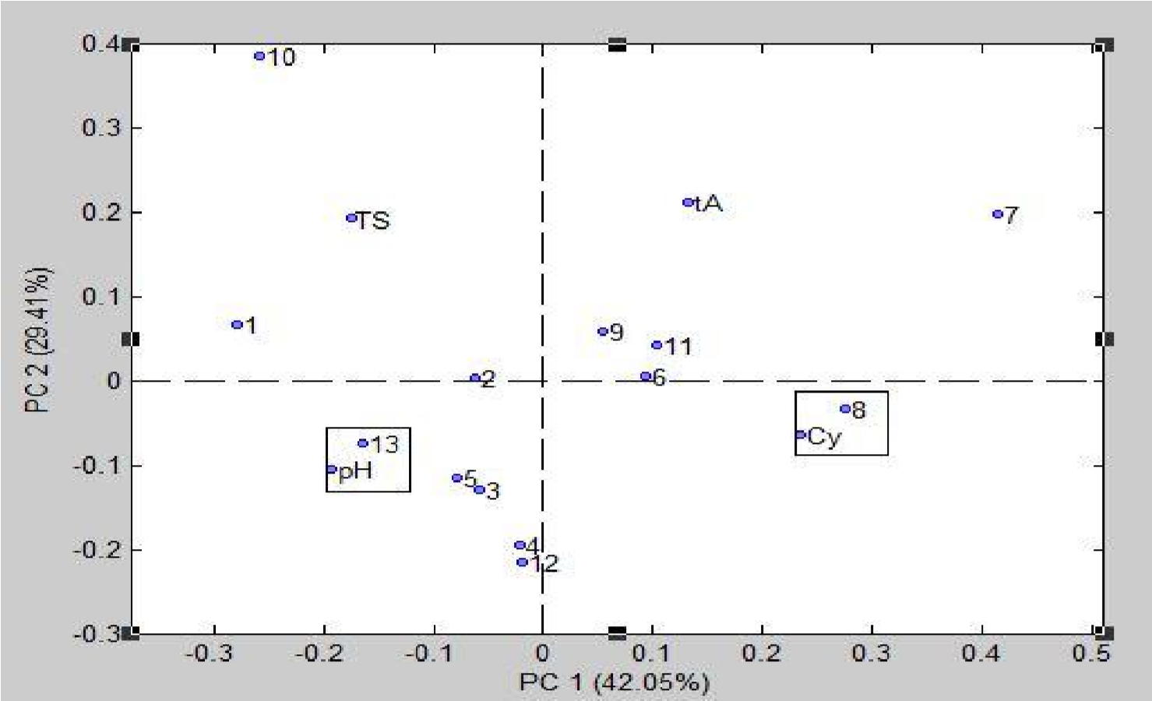
Figure 1: PCA Biplot (Score/Loading) of physico-chemical properties of tomato samples
Key ; 1 : Kano variety, 2 : Minna variety, 3 : Zaria variety, 4 : Brand 1, 5 : Brand 2, 6 : Brand 3, 7 : Brand 4, 8 : Brand 5, 9 : Brand 6, 10 : Brand 7, 11 : Brand 8, 12 : Brand 9, 13 Brand 10 and TS : Total soluble, tA : titratable acidity, Cy : vitamin C.

PCA Biplot for antioxidant and proximate composition  The antioxidant and proximate Compositiondata has a computational matrix of dimension (13 X 9) and 2PCs are retained. In Figure 2, it is observed that brand 4 and brand 9 are characterized by high Crude | fat, Ash, Vitamin A and Moisture are at the positive plane (0.0 to 0.5 weighting values) of the PC1. Similarly, Brand 8 is characterized by Crude fiber which is crowed at the negative and opposite plane of the biplot. The brand displays anti-correlation behaviour relative to other samples
.

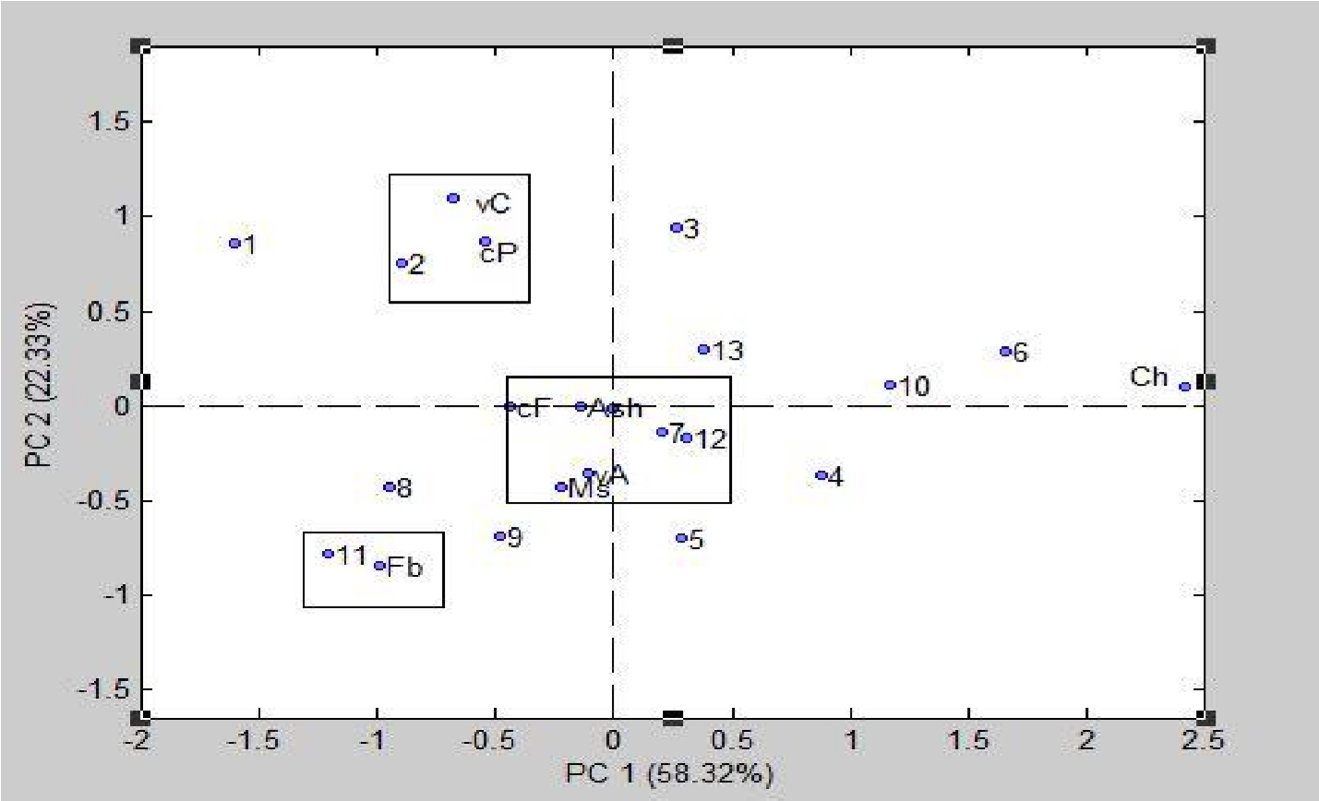
Figure 2: PCA Biplot (Score/Loading) for Antioxidant and Proximate Composition of tomato samples Minna variety is characterized by Vitamin C and Crude protein. while samples (1, 3, 4, 5, 6, 8, 9, 10, and 13) have moderate content as they could not be correlated with any of the nutritional contents.

Hierarchical Cluster Analysis  The similarity and closeness of the foods are illustrated by cluster analysis (Brereton et al., 2018). Hierarchical Cluster Analysis was performed on all the nutritional datasets. The output is illustrated in | form of a dendrogram which is presented in Figure 2. The similarities or closeness of the foods are measured by the variances of the weighted distance between the centers of clusters. Ward’s method was adopted (Salau and Hasan, 2019).

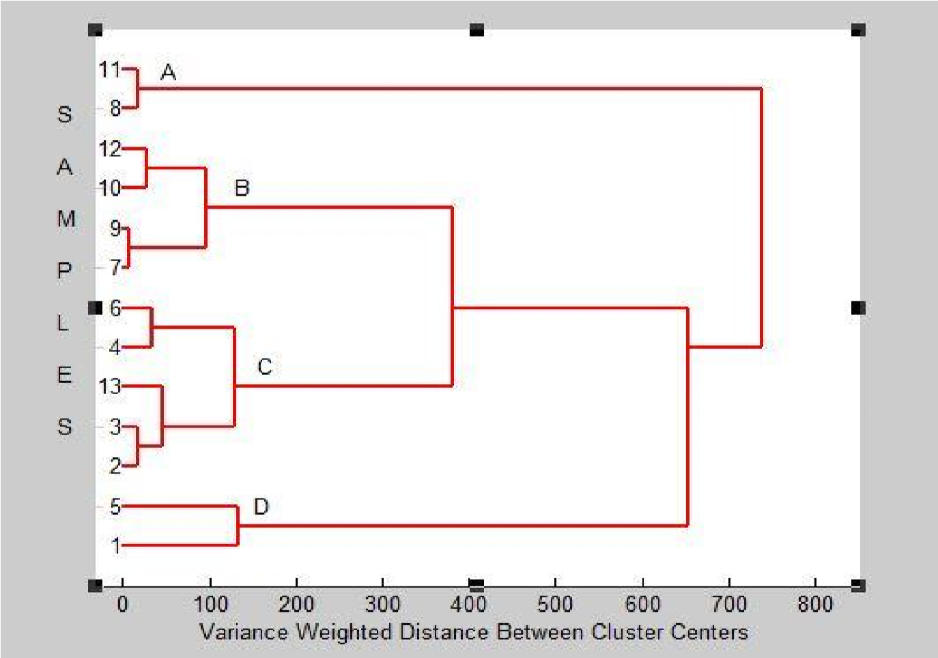
Figure 3: HCA dendrogram for all the studied nutritional datasets of tomato samples
Key ; 1 : kano variety, 2 : Minna variety, 3 : Zaria variety, 4 : Brand 1, 5 : Brand 2, 6 : Brand3, 7 : Brand 4, 8 : Brand 5, 9 : Brand 6, 10 : Brand 7, 11 : Brand 8, 12 : Brand 9, 13 Brand 10.

Four major groupings A, B, C, and D of 2, 4, 5 and 2 membership sizes respectively, can be observed based on the similarity of foods in each grouping. Cluster analysis on the samples reveals information about closely related foods which can be predicted as a substitute. Three close substitute pairs revealed are (9 and 7) > (8 and 11) > (2 and 3). Each of the pairs is equivalent in terms of nutritional content. Consumption of Minna variety (2) is of the same quality as consuming Zaria (3) variety. In cases of non-availability or dislike for one tomato, the similar tomato in terms of nutrients value can still serve the same purpose and provides a similar level of nourishment.

Conclusion
The physicochemical parameters are all within the range of acceptable value. The moisture content of the studied raw and processed brands is low. Hence, the total solids are conversely high. Both raw and processed have similar values in most parameters. However, the antioxidant content showed a significant difference. The presence of antioxidant vitamin C is more pronounced in raw samples. This implies that they could protect the body cell against cancer and heart disease.
Hierarchical Cluster Analysis (HCA) in raw and processed tomato brands reveals established close neighborhood of Kano variety and brand 5. This close substitutability implies that the company may have sourced their raw tomatoes from the Kano variety. Principal Component Analysis (PCA) revealed the unique characterizations of brands 10, 5, Minna variety, and brand 8 respectively with pH, conductivity, protein, and fibres.

References
Abdullahi, I.I., Abdullahi, N., Abdu, M.A. and
Ibrahim, S.A. (2016).Proximate, Mineral and Vitamin Analysis of Fresh and Canned Tomato. Journal of Biosciences and Biotechnology Research, 13(2), 1163-1169.

Gupta, A.,Kawatra, A. and Sehgal, S. (2011). Physical and Chemical Properties and Nutritional Evaluation of Newly Developed Tomato Genotypes.
African Journal of Food Science and Technology, 2(7), 167-172.

Bhowmik, D., Kumar, K. S., Paswan, S. and Srivastava, S. (2012). Tomato-A Natural Medicine and its Health Benefits. Journal of Pharmacognosy and Phytochemistry, 1(1), pp. 33-43.

Brereton, R. G., Jansen, J., Lopes, J., Marini, F., Pomerantsev, A., Rodionova, O., and Tauler, R. (2018). Chemometrics in Analytical Chemistry— part II: Modeling, Validation, and Applications. Analytical and bioanalytical Chemistry, 410(26), 6691-6704.

Codex Alimentarius Commission (CAC) (2011). Technical Specification for Tomato Paste. CODEX STAN 57, 1-6.

Carocho, M., Morales, P., and Ferreira, I. C. (2018). Antioxidants: Reviewing the Chemistry, Food Applications, Legislation and Role as Preservatives. *Trends in Food Science & Technology, 71, 107-120.

Chang, C. H., Lin, H. Y., Chang, C. Y. and Liu, Y.
C. (2006). Comparisons on the Antioxidant Properties of Fresh, Freeze-dried and Hot-air-dried Tomatoes. Journal of Food Engineering, 77(3), 478485.
Demirbas, A. (2010). Oil, Micronutrient and Heavy Metal Contents of Tomatoes. Food Chemistry, 118, 504–507

Deng, L. Z., Pan, Z., Zhang, Q., Liu, Z. L., Zhang, Y., Meng, J. S., ... and Xiao, H. W. (2019). Effects of Ripening Stage on Physicochemical Properties, Drying Kinetics, Pectin Polysaccharides Contents and Nanostructure of Apricots. Carbohydrate Polymers, 222, 114980.

Eke-Ejiofor J. (2015). Comparative Evaluation of Lycopene Content and some Chemical Properties of Commonly Consumed Brands of Tomato Paste in Port –harcourt, South-South, Nigeria. Journal of Food and Nutrition Sciences, 3(2), 35-38.

Goodson, A. (2018).Evidence-Based Benefits of Manganese.https://www.healthline.com/nutrition/m anganase-benefits . Accessed on 15th April, 2020.

Hassan, A., Salau, R. B., and Tijani, J. O. (2019). Evaluation of Nutritional Composition and Chemometric Characterization of some Varieties of Date Fruits. Journal of Science, Technology, Mathematics and Education, 15(1), 23-36.

Hernández, M.S., Rodríguez, E.R. and Díaz, C.R. (2008). Chemical Composition of Tomato (Lycopers icon esculentum) from Tenerife, the Canary Islands. Food Chemistry, 10(6), 1046–1055.

Idris, O. A., Wintola, O. A., and Folayan, A. J. (2019). Comparison of the Proximate Composition,
Vitamins (Ascorbic acid, α-Tocopherol and Retinol), Anti-nutrients (Phytate and Oxalate) and the GC-MS Analysis of the Essential Oil of the Root and Leaf of Rumexcrispus L. Plants, 8(3), 51.

Joel, N., Anselm, U.O. and Oluwafunmike, O. (2020). Comparative Evaluation of the Qualities of some Selected Tomato-paste Brands Sold in Kano Market. Journal of Food. Stability, 3 (1), 1-11.

Katırcı, N., Isık, N., Güpür, C., Guler, O.H.,
Gursoy, O. and Yilmaz, Y. (2018). Differences in Antioxidant Activity, Total Phenolic and Flavonoid Contents of Commercial and Home-made Tomato Pastes. Journal of the Saudi Society of Agricultural Sciences, 30(40), 1-7.

Madell, R. (2020). Phosphorus in Your Diet. https://www.healthline.com/phosphorus-in-diet#food-source. Accessed on 15th April, 2020.

Melø, R., Gellein, K., Evje, L. and Syversen, T. (2008). Minerals and Trace Elements in Commercial Infant food. Food and chemical toxicology, 46 (10), 3339-3342.

Munck, L., Nørgaard, L., Engelsen, S., Bro, R., and Andersson, C. (1998). Chemometrics in Food Science - A demonstration of the Feasibility of a Highly Exploratory, Inductive Evaluation Strategy of Fundamental Scientific Significance. Chemometrics and Intelligent Laboratory Systems, 44(1), 31-60.

Okello, J., Okullo, J. B. L., Eilu, G., Nyeko, P., and Obua, J. (2018). Proximate Composition of Wild and On-farm Tamarindusindica LINN fruits in the Agro-ecological Zones of Uganda. J Nutr Health Food Eng, 8(4), 310-317.

Salau R. B. ,Bisiriyu M. T., Zalihat A., Alheri A., Aremu M. O., Olushola I. O. and Mohammed A. K. (2020). Evaluation and Chemometric Analysis of the Mineral Profile of Locally Prepared Soups in Minna, Niger State, Nigeria. Journal of Chemical Society of Nigeria, 45(1), 21 -28.

Salau, R. B., and Hasan, M. N. (2019). Quantitative and Chemometric Study of Patterns, Distributions and Health Status of Chromium, Cobalt, Nickel and Molybdenum in Selected Malaysian Dishes. Journal of Science, Technology, Mathematics and
Education, 15(1), 8 -22.
Salau, R. B. and Hasan, M. N. (2018). Development of Food Informatics Software: A mineral Deficiency Disease-Food Guide System. i-Manager's Journal on Software Engineering, 13(2), 1-8.

Salau, R. B., Nwakife, C. N., Bisiriyu, M. T., Jibril, M. J., and Oyewunmi, A. H. (2018), Quantification, Correlation and Hierarchical Cluster Analysis of the Mineral Content Data of Citrus Fruit Varieties. Paper Presented at the 41st Annual International Conference of the Chemical Society of Nigeria, Ibadan. September 16 – 21. Book of proceedings . Pp. 142-146.

Salau, R. B., Ndamitso, M. M., Paiko, Y. B., Jacob. J. O., Jolayemi, O. O. and Mustapha, S. (2012). Assessment of the Proximate Composition, Food Functionality and Oil Characterization of Mixed Varieties ofCyperusesculentus (Tiger Nut) Rhizome Flour. Continental Journal of Food Science and Technology, 6(2): 13 – 19.

Tehranifar, A., Zarei, M., Nemati, Z., Esfandiyari, B., and Vazifeshenas, M. R. (2010). Investigation of
.

physico-chemical Properties and Antioxidant Activity of Twenty Iranian Pomegranate (Punicagranatum L.) cultivars. ScientiaHorticulturae, 126(2), 180-185.

Zhao, Y. M., Patange, A., Sun, D. W., and Tiwari,
B. (2020). Plasmaactivated Water:
Physicochemical Properties, Microbial Inactivation Mechanisms, Factors Influencing Antimicrobial Effectiveness, and Applications in the Food Industry. Comprehensive Reviews in Food Science and Food Safety, 19(6), 3951-3979

