DEVELOPMENT OF OBJECT-ORIENTED SPEECH RECOGTNITION FOR INFORMATION RETRIEVAL SYSTEM IN LIBRARIES

ILYASU ANDA
Department of Library and Information Technology,
School of Information & Communication Technology
Federal University of Technology, Minna, Niger State Nigeria
Email: ilyasu.anda@futminna.edu.ng

ALIYU UMAR ALIYU
Department of Library and Information Technology,
Federal University of Technology, Minna, Niger State Nigeria
Email: aliyuumar120@gmail.com

MUSA, BABA ADAMU
University Library Services unit,
Federal University of Technology, Minna, Niger State Nigeria
Email: adamu.musa@futminna.edu.ng

CHUKSIBE, PRISCA OLUCHI
Department of Library and Information Technology,
Federal University of Technology, Minna, Niger State Nigeria
Email: pochuksibe@futminna.edu.ng

ABSTRACT
Speech helps to deliver the thoughts and messages between humans. Human are trying to develop an intelligent system that can recognize and accept commands via speech, which is known as human computer interface. In this day and era of computer system, library automation is becoming steadily more important because computerized machines can handle recurring tasks faster and more effectively than librarians. The developed system that has the capabilities to listen, understand and respond to user queries in the library is called “object-oriented speech recognition system for information retrieval services”. This research work mainly focuses on reducing human efforts in libraries and provides a steady system that can replace traditional information retrieval tools. The aim of this research work was to develop a system that has capabilities to listen, understand and respond to user queries in the library called object-oriented speech recognition system for information retrieval system. In this work, I therefore present some ideas in speech recognition technology, its applications, benefits, types of speech recognition technology based on model and utterances. See sharp (C#) programming language is used to give excellent result. The structured system analysis and design was adopted for the study. Fact finding techniques adopted include questionnaire, interview, and observation.

Keyword: Object Oriented, Speech-Recognition, Retrieval System, Library

- INTRODUCTION
Today Information centers and libraries have developed and adopted different technologies in their working environments and one of them is speech recognition technology that provides efficient and flexible service delivery. Certainly, the software will ease the work of librarians and also provide effective and efficient services. This system will surely replace the use of catalogue, index, and other information retrieval tools, because it’s more efficient compare to manual processes.
Today with the technological breakthrough to solve queuing system in public libraries and information centers, computer specialist and software developers have been in research on speech technology since 1960, for the purpose of eliminating the use of mouse or keyboard, to replace them with speech or voice recognition technology as an alternative input to the system. This is very applicable to library particularly when it’s adopted to replace information retrieval tools such as catalogue, index, abstract and bibliography. We are now in information age and new information retrieval system techniques are needed to go hand to hand with the information curiosity, people needs quick response to their queries and others don’t know how to use catalogue card to search for a book in the library.
It is believed that the success of any library depends on its power in providing and retrieving information to it users. The speech recognition system is all about systems that can mimic human beings, a system that can listen, comprehend and respond to user queries. Speech is the physical production of sound using our tongue, lips, palate and respiratory system to communicate ideas. Speech technology is the process whereby user will utter some words to command the computer to perform some operations based on the inbuilt commands. For centuries computer specialist and software engineers have tried to develop machines that can understand and produce speech as humans do so naturally, and speech recognition system is one of the software that can listen, think, understand and respond like human being.
Dina (2013) stated that the reliability and efficiency of speech technology have brought tremendous advancements and improvements which have enabled libraries, information centers, and service providers use it to respond to user queries in real time.
Anusuyaetal (2009) stated that the main goal of speech recognition area is to develop techniques and systems for speech input to machine. Based on major advances in statistical modeling of speech, automatic speech recognition systems today find widespread application in tasks that require human machine interface. With the advent of this software information retrieval system become easier than before, because it takes less time to retrieve a book in the library using speech recognition system, the system will provide the book and it location in the library. These improvements in speech technology insure the total replacement of all data input devices. Human beings have long been inspired to create computer that can understand and talk like human. Development of object oriented speech recognition system for information retrieval system to serve as a retrieval tools born out of over increasing in the numbers of people seeking information in the library or information center. These has however help people of any kind seeking information in the library to locate books using voice commands as a convenient means. Libraries with thousands of collections, users find it difficult in locating books using catalogue cards.
Statement of the Problem
Libraries and information centers in Nigeria have been lagging behind when it comes to implementing information and communication technology. Thousands of people end up wasting their precious time on a daily basis queuing up for one service or the other in libraries and information centers. It is believed that people are in need of quick responses to their information needs on daily basis however, the present traditional information retrieval systems are very slow, tedious and sometimes they are not user friendly. The librarian in charge of user query service may not be able to answer user query efficiently. This is what prompted the development of object oriented speech recognition system for information retrieval system to serve as a retrieval tools that can help people to locate books in the library using voice commands. Libraries with thousands of collections, users find it difficult in locating books using catalogue cards.
Objective of the research are:
- To develop a system that helps the ability to allow library information retrieval.
- To develop suitable system that will replace catalogue card, index, and abstract.
- To achieve more efficient means of controlling and manipulating a computer that is less physically and cognitively tasking than other alternative input techniques.
- To develop a system that will reduce total dependency on catalogue cards and human being in locating documents.
- To implement an interesting application using small vocabulary word recognition system.
- LITERATURE REVIEW

Technology has revolutionized every aspect of human life, in libraries, the procedure of digitizing and automating a library allows different technological breakthrough that affect some important sections in the library and replacing catalogue cards, index and abstract is one of the next target of software engineers by replacing it with voice commands. Automatic recognition of speech by machine has been the main objective for the researchers in the past sixty years Suman K. (2015)
According to Dina Darwish (2013) the speech signal is the speedily and the most natural (natural words that has no modifications or adjustment) process of communication between humans. This actual information motivated computer scientist, software engineers and other technological researchers to come up with a machine that can mimics human voice, and also a system that can understand and respond to users (interact with users).
Applications of speech recognition can be seeing from the following perspective
- From medical perspective;
According to Vrinda (2013) speech recognition system is applicable to people with health issues such as cripples, partially blind people, elderly people and other people with different disabilities all these constraints have to be eliminated entirely. Speech technology can help us tackle these issues.
Judith Mischke (2016) stated that AZ Damiaan hospital, Belgium acquired a humanoid robot called “Pepper” that have speech recognition and synthesis abilities and can help patients efficiently and perfectively. Softbank Robotics also said the French and EU laboratories collaborate together and developed a robot called Romeo, the daily helper.
The machine can help elderly people in doing some domestic works 24/7. The robot cannot perform any operation without receiving commands from his master.
- From security perspective; the system is one of the latest technology that brought tremendous improvement in security sector in developed countries such as US, CHINA, FRANCE, RUSSIA, NORTH KOREA, GERMANY etc.
Lockwood Reed (2004) stated that US Army Communications/Electronic Research Development and Engineering Centre (CERDEC) initiated the development of the system in 1979 to control their Tactical Military Environment. The system is very suitable and it provide flexibility within the security sector. With the use of voice recognition system, security threat can be minimal because computer will ensure the authenticity of variety of people within a shortest period of time and it can also ease the work of security personnel such as air force in working with different security hardware such as military aircraft, unmanned drone and others. Speech recognition system can be guidance to troops in battle ground by directing them to their target location.
- From educational perspective; The speech technology is also helpful to handicapped people who might otherwise require somebody to help them control their environments. The uses of speech recognition system and voice recognition in educational level provide a greater achievement to both student and staff. Today Universities in developed countries like United Kingdom (UK), (University of York) and some Universities in the United State of America (US) has also start implementing voice recognition system to provide efficient and effective service delivery. In developing countries speech recognition is gradually adopted in their educational line to ease the work of information provision, retrieval and dissemination.
Skynews (2017) reported that Chinese research firm developed humanoid machine called “KEEKO” that have the capability to interact with children, the machine is solely developed to teach and tutor pre-nursery and nursery school kids. This technology is similar to speech recognition software for information retrieval system because KEEKO has such capabilities to listen, understand and respond to user queries.
GMANews(2016) reported that TOSHIBA unveils humanoid robot at Berlin trade fair, the machine is been developed to interact with users, listen, understand and respond to questions and this machine understands English, Japan, German and Chinese. According to Campanella (2016) Hanson robotics created humanoid robot called “Sophia” that have speech capabilities (listen, think, understand and respond).
The machine also has the capability to make over 60 facial expressions. In October 2017 UN Deputy Secretary Amina Muhammed interact with Sophia Right now Sophia was granted citizenship in Saudi Arabia. Similarly, some of the functionalities of Sophia and that of this system are similar i.e Listen, think, understand, and respond to human voice.
- From financial and other business institutions perspective
The speech and voice technology will or surely revolutionized all financial and business sectors globally, because some financial institutions in developed and developing countries adopted it fully. DailyMail(2014) reported that banks in turkey , US, and UK will soon adopt voice recognition system to replace PINs(Personal Identification Numbers). SoftBankRobotics (2013) initiated the development of humanoid robot called NAO, the machine has speech recognition capabilities, with microphones and loudspeakers, the robot can communicate with people naturally.
- METHODOLOGY
The structured system analysis and design approach was conducted in a more pragmatic way that emphasizes better provision of information that is immediately usable in the resolution of factual problems, which may not have application beyond the immediate study.
The tools and methods used in this research work are research instrument for gathering users input for the design to produce user friendly system, which are primary source of data. Observation and questionnaire were also used to evaluate the developed system to asserting the functionality and observed user ability of every part of the system. The use of speech recognition in libraries and information centers has been observed in order to fully understand how the system will effectively and efficiently function and a well structure questionnaire was administered to facilitate collection of data and the system were demonstrated offline.
3.1 Research instrument
The primary source of data used in this research work is;
- Observation
The use of speech recognition in libraries and information centers is been observed in order to fully understand how the system will effectively and efficiently function.
- Questionnaire
A well structure d questionnaire was administered to facilitate collection of data. The questionnaire is divided into two parts. Section A comprising of the demographic details of respondent and section B comprising of structured questions to obtain data.
3.2 Methods of data analysis and presentation
The data retrieved from the respondents were analyzed using simple percentage frequency counts, and tabulation. Therefore, from the questionnaire the data generated were properly analyzed using descriptive statistics and frequency tables. However, in order to present data about the current system such as how the system functionality is, the flows identified and the Structured System Analysis and Design (SSAD) method were used. The analysis and design define a system graphically by making use of a set of process models. Entity – Relationship Diagram, Use Case Diagram and Sequence Diagram were used as a process model for data presentation.
3.3 General overview of speech recognition modeling process
Input
Language
Feature Extraction
Speech Analysis

Speech
Recognized
Language Conversion
Speech Engine

Figure:1 Overall block diagram of the speech recognition system

The speech analysis block diagram in figure1 shows the various units that made up the developed system. The proposed model is primary to remove noises, unwanted sounds, silence and ending point detection from the input speech audio, which are necessary to improve reliability and the performance or operation of the system. The feature extraction block is use to remove the unwanted and redundant information and retains only the useful information. Language conversion unit is used to capture the properties of a language and to predict the next word in the speech sequence. Then finally speech recognition engine block is to convert the input audio into machine language and then respond to user accordingly.
3.4 System Modelling
Figure:2 speech recognition Use Case Diagram Model

Figure:3 speech recognition sequence Diagram Model process
Figure:4 Speech recognition of Entity Relationship Diagram Model process
System Modeling: The Speech Recognition System was modelled with the entity-relationship diagram, use-case diagram, activity diagram and the sequence diagram using object oriented design paradigm. The entity-relationship diagram, use-case diagram and sequence diagram of the system are shown in Figures 2, and 3, respectively.
- Result and discussion
Figures 5, and 6 shows the impact of the speech Recognition system for both library patrons and administrators using appropriate software and hardware techniques. Figure 5 shows the administrator login page. Is the first page that pops up when the program starts by running the Microsoft Visual Studio Solution. It consists of admin username, password and login space and “make your enquiry” space for general users to click. Admin can change password, add an item, remove an item, move an item from one room or store to another. Figure 6 shows an interface with menu panel consist of HOME, ENQUIRE, LOGIN and EXIT clicking spaces. Each Icon can be click and a page will display i.e. ENQUIRE icon, which means make an enquiry, will go directly to the speech recognition starting page and Figures 7 show the system flowchart for Speech Recognition system.
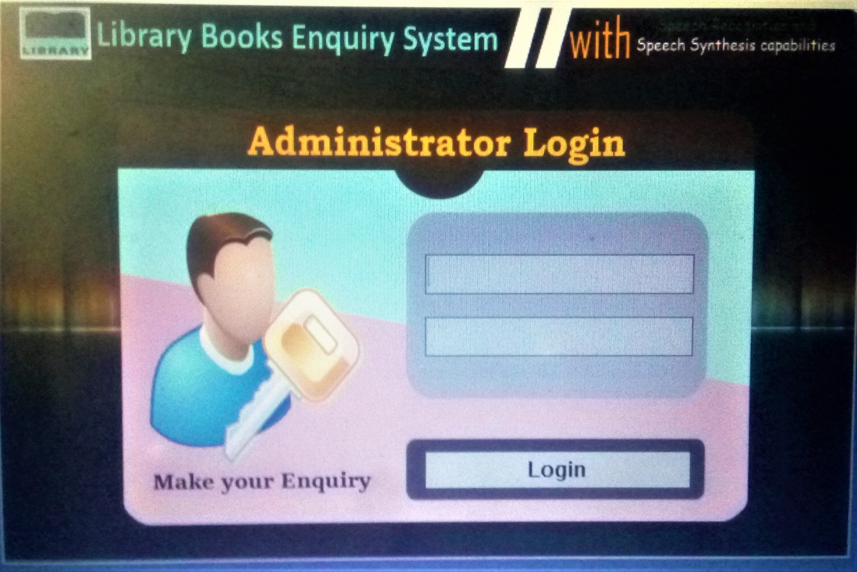
Figure 5: Administrator login interface

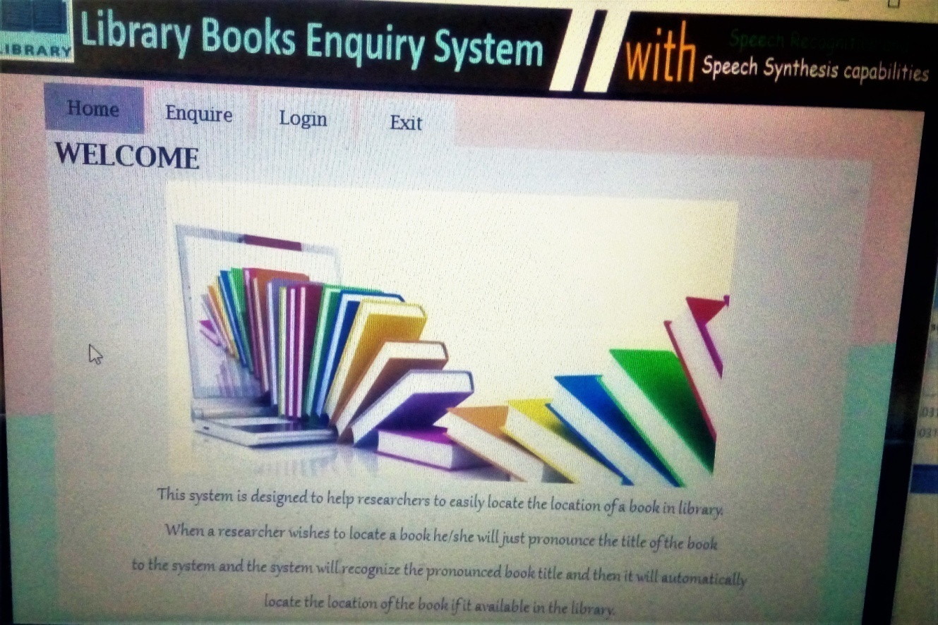
Figure:6 Manu panel
Figure:7 Flowchart of the speech Recognition
4.1 System Testing
System Testing is the type of testing to check the behavior of a complete and fully integrated software product based on the software requirement specification (SRS) document. The main focus of this testing is to evaluate Business/Functional/End-user requirement. This type of testing is to be carried out after Integral Testing and before Acceptance Testing. The purpose of this test is to evaluate the system’s compliance with the specified requirements.
An example of system testing that has been conducted in this system is putting an expression into the system and when the system finished searching, the result will be one of the following:
1. If the expressed item is valid, the result will display and also the system will immediately respond and tell the validation of the item i.e book and move to the next stage.
2. But if the query is invalid, it will just ignore it or display error in some circumstances.
4.2 Validation Testing
Validation Testing shows in table 1 ensures that the software actually meets the client's needs. In this testing, invalid input can be used so that it can be observed how the system will react. The purpose of validation testing is to prevent the system from providing unprecedented errors to the user.
Examples of Validation Testing of the System

BOOKS |  | ERROR RETURN
Separated words “introduction…. To…..java” instead of IntroductionToJava |  | Invalid expression
Expression of unavailable book |  | Choose a book
Table 1: Validation Testing

Rating Scale | Q1 | Q2 | Q3 | Q4 | Q5
A | 5 | 4 | 8 | 6 | 2
B | 8 | 6 | 3 | 6 | 2
C | 2 | 3 | 3 | 1 | 6
D | 0 | 1 | 0 | 0 | 3
E | 0 | 1 | 1 | 2 | 2
TOTAL | 15 | 15 | 15 | 15 | 15
Table 2: Summary of the Evaluation Result

Table 3: Result summary evaluation of Speech Recognition System from Respondents

System Evaluation
Upon the completion of Acceptance Testing, participants for the user acceptance test were required to complete the system evaluation questionnaire that attempts to assess the usability of the prototype while verifying that the system truly delivers its required functions. Participants of the System Evaluation
A random sample of fifteen (15) students from Bosso campus Federal University of Technology Minna, Niger state were given the questionnaire to evaluate the system prototype.
4.4 Evaluation Result Analysis
The results gathered from the decisions made by the respondent are summarized in the table 2 above. An analysis on the results obtained from system evaluation was carried out to determine the feedbacks from users with regards to the effectiveness, performance and usability of the system.
The result obtained from evaluating the system reveals that the system is efficient, pleasing in appearance, impressive, has lots of functionalities and is user-friendly, as it is clear that at least 75% of the participants rated the system with either A or B in all the questions except in question three (3). The lowest rating is given in the last question, because of the problem speech recognition is entitled with. One of the problems is, it might not respond properly in a noisy environment.
- CONCLUSION
On this paper, the importance of automated retrieval system, speech recognition applications, types of speech recognition system and different speech recognition perspectives has been discussed. The developed software provides an easy and time saving method of locating books and other information materials no matter how bulky the collections are. Graphical user interface was also incorporated to make sure that the system is user friendly. This research paper is shoreless and I am expecting more breakthroughs in the near future to rededicate the effort in the development of large vocabulary speech recognition system with speaker independent capabilities.

- RECOMMENDATION
Based on the conclusions, the following recommendations were made;
- It will be of great benefit if Libraries and information centers design and adopt speech recognition system to replace or assist traditional information retrieval tools i.e. catalogue, index and abstract.
- Users of the library should be enlightened properly about the importance of speech recognition in library because the technology will improve services and reduce stress in locating books in the library collections.
- Adopting this system will be a great achievement and will improve Current Awareness Services and Selective Dissemination Services effectively and efficiently.

REFERENCES

Anusuya M.A. and. Katti S.K (2009) Speech Recognition by Machine: International Journal of Computer Science and Information Security,Vol. 6, No. 3, 2009.
Suman K. Saksamudre, Shrishrimal P.P and Deshmukh R.R (2015). A Review on Different Approaches for Speech Recognition System: International Journal of Computer Applications (0975 – 8887) Volume 115 – No. 22, April 2015.
Lockwood Reed, (2004) the Requirements And Applications Of Speech Recognition Technology For Voice Activated Command And Control In The Tactical Military Environment; 2004 Command And Control Research Technology Symposium. Us Army CERDEC.
MsVrinda and Mr. ChanderShekhar (2013) speech recognition system for English language. International journal of advanced research in computer and communication engineering vol.2, issue 1, January 2013.
Judith Mischke (2016) Introduction of new humanoid robot by AZ Darmiaan Hospital Belgium. From www.medicaldaily.com/patients-paper-robot-az-damiaan-389949.
Kirti Khanna (2016) “How speech recognition can help you in better customer service” From https:www.therealpbx.com/blog/call-center-solutions/speech-recognition-customer-service.
Suma Swamyand and Ramakrishnan K.V (2013) an efficient speech recognition system; department of electronics and communication engineering, research scholar, Anna University, Chennai.
Ganesh Sivaraman and K Samudravijaya (2011)Hindi Speech Recognition and Online Speaker Adaptation; International Conference on Technology Systems and Management (ICTSM) 2011 Proceedings published by International Journal of Computer Applications® (IJCA).
Apple (2011) SIRI: from https://www.apple.com/newsroom/2011/10/04Apple-launches-iphone-4s-ios-5-cloud.

Bbc.co.uk/accessibility (2009) from www.bbc.co.uk>factsheet_VR_intro.pdf.

Magnus Stenman (2015) an evaluation of Google speech. Automatic speech Recognituion Thesis Umea University 2015 from www.diva-portal.org>FULLTEXT01

Neild Barry (2016) retrieved from https:/www.cnn.com/travel/article/hotels-robot-future travel/index.html
Jonathan Ocllaghan (2014) Banks to adopt voice recognition software in US and UK retrieved from https://www.dailymail.com.uk/sciencet

Mclean (2016) IBM used NAO as a concierge at Hiltons Hotel across the United State; Retrieved from https://www-03-ibm.com/press/us/en/pressrelease/49307.wss
SkyNews(2017) keeko robots in china was retrived from www.skynews.com.au/tech/techinnovation/2017/04/30/machines-begin-caring-for-human-in-china.html

