**Structural and microstructural analyses of neutron-irradiated Ba0.88Ca0.12Ti0.975Sn0.025O3 ceramic**

**U. AHMADU1, A. B. USMAN1, A. M. MUHAMMAD2, O. I. OLARINOYE1 AND**

**M. AGIDA1**

*1Department of Physics, Federal University of Technology, P.M.B., 65, Minna, Nigeria*

*2Centre for Energy Research and Training (CERT), Ahmadu Bello University, Zaria, Nigeria.*

*\*Corresponding author: u.ahmadu@yahoo.com,*

**ABSTRACT**

Co-doped barium calcium stannate titanate (Ba0.88 Ca0.12 Ti0.975 Sn0.025 O3) ceramics was synthesized via solid state reaction and sintered at 1100 °C/3 h. The ceramics were irradiated with thermal neutrons of up to 1.4 × 1010 n/cm2 using a 5 Ci Am-Be source having an average flux of 2.7 × 104 n/cm2.s. Structural analysis of the ceramics indicate a majorly polycrystalline material with a minor secondary phase. The 2*θ* positions were observed to shift slightly to higher values but the microstrain remained constant with increase in fluence. The average crystallite size is ∼ 38 nm with anisotropy observed in lattice expansion. Rod-like grains, porous regions and agglomerations were observed in all the specimens together with a general increase in grain size with increase in fluence. The average grain size is ∼ 1 μm. Chemical analysis using EDS indicates slight deviation from nominal ones for some irradiated samples. It is concluded that the structural and microstructural changes observed would not affect the performance of the devices based on this material when used in radiation environments of neutrons since the maximum fluence has not exceeded the order of magnitude of threshold for radiation damage.

***Keywords*:** ceramics; neutron irradiation; lattice parameters; grain size; nuclear reactors

**1.0 INTRODUCTION**

Recently, Barium titanate (BaTiO3 or BT), particularly under doping conditions, has had numerous applications across different sectors from energy to electronic components. It is used in multilayered ceramic capacitors (MLCCs) (Heng and Xinhua, 2016) and its outstanding ferroelectric and piezoelectric properties are of great interest in sensors, microactuators and ferroelectric random access memory (FeRAM), among others (Heng and Xinhua, 2016 ; Nada *et al*., 2016).BT has tetragonal crystal structure from room temperature up to the Curie temperature (Tc, 120 °C) above which its ferroelectric behavior disappears as it transforms into cubic phase (Frattini, 2012; Nada *et al*., 2016). It has low piezoelectric constant and structural instability sets in at a relatively low transition temperature (120 °C) which hampers its diverse applications (Aksel and Jones, 2010).Several methods/techniques have been developed to improve the structural stability, among other properties. These include partial/whole substitutions of the Ba2+ or Ti4+ sites with ions of different or same charge and comparable sizes (Matsuura *et al*., 2014; Maitra *et al*., 2013; Rao *et al*., 2013; Nath and Medhi, 2012; Cai *et al*., 2011; Choi *et al*., 2010; Vitayakorn, 2006; Paunovic *et al*., 2004).

One of the significant applications of BT-based ceramics is in their application in devices such as actuators, sensors in particle accelerators and reactors in outer space environments which contain abundant nuclear radiation (Nath and Medhi, 2014; Medhi and Nath, 2013). Here, the major concern is in the stability of BT-based devices. Nuclear radiations, in particular neutrons, are of special interest because they interact with the atomic nuclei of materials by causing atomic displacements and dislodging atoms from their lattice sites (Holbert, 2006). This eventually results in the production of vacancy-interstitial pairs which subsequently leads to defects that can cause irreversible changes in the structural and electrical properties of BT-based ceramics. The extent of such damage depends on radiation parameters such as energy, dose, nature of the material and its structural phase (Ogundare and Olarinoye, 2016). Nuclear irradiation of BT-based ceramics has been established to alter the piezoelectric, dielectric and microstructural and structural properties (Nath and Medhi, 2014; Medhi and Nath, 2013); (Lefkowitz, 1958; Wittels and Sherrill, 1957). The earliest work reported is on single crystalline BT irradiated at about 100 oC with an integrated fast neutron flux of 1.8 × 1020 n/cm2 in which it was observed that the tetragonal single crystals had been transformed to perovskite-type cubic single crystal normally stable at 120 oC. Measurements of lattice parameters indicated anisotropic expansion had occurred (Wittels and Sherrill, 1957). Similarly, the ferroelectric character of BT and BT-type materials were altered significantly after pile irradiation of between 1 × 1015 n/cm2 and 1 × 1018 n/cm2 with decrease in dielectric constant and shifts in lattice constants observed (Lefkowitz, 1958). Other reports have indicated that the radiation damage threshold of some pressure transducers constructed using BT is 7.6 × 1010 n/cm2 for bulk damage to occur (Holbert *et al*., 2004). However, work on neutron irradiated co-doped BT (Ba0.88Ca0.12Ti0.975Sn0.025O3) (BCST) is rarely found in literature to the best of our knowledge despite the significance of this compound. The present authors have however, reported work on gamma irradiation of the compound (Ahmadu *et al*., 2016). In the present work, co-doping of BT by substitution of Ba2+ and Ti4+ sites with 0.12 mol of Ca2+ and 0.025 mol of Sn4+ at different levels of thermal neutron fluence was carried out. Substitution of Ba2+ by Ca2+ has been reported to effectively inhibit grain growth, improve electromechanical properties and the transition temperature which in leads to structural stability but decreased dielectric constant (Matsuura *et al*., 2014; Choi *et al*., 2010; Paunovic *et al*., 2004). On the other hand, substitution of Ti4+ by Sn4+ leads to an increase in piezoelectric and dielectric properties and a decrease in transition temperature (Nath and Medhi, 2012). These simultaneous substitutions are expected to lead to structural stability fundamentally and to an improvement in other structure-dependent properties. Thus results of structural and microstructural properties have been presented.

**2.0 MATERIALS AND METHODS**

The precursor materials used for the synthesis and their details have been reported in our earlier work [20]. Stoichiometric amounts of the materials were used for the synthesis according to equation (1).

 (1)

Details of the preparation and synthesis conditions have also been reported in our earlier work (Ahmadu *et al*., 2016). Meanwhile, sintered and pelletized samples were irradiated in a low neutron flux irradiation facility (Onoja *et al*., 1995) which exists as a 750 mm by 800 mm paraffin cylinder having at its centre a 5 Ci Am-Be isotopic neutron source (diameter 30 mm, and height 48 mm.) with average thermal neutron flux of 2.7387 × 104 n/cm2.s which has six irradiation ports arranged symmetrically around the source. These provide opportunity for simultaneous irradiation of six samples at a time. For the purpose of this work, five groups of pellets of the samples were placed in a polythene bag and lowered into the ports with the aid of a thread. The pellets were brought out after successive irradiation times of 0.1 hr, 1 hr, 9 hrs, 72 hrs and 144 hrs to attain 8.1 × 106, 9.72 × 107, 8.75 × 108, 6.99 × 109 and 1.4 × 1010 neutron fluences and subsequently labelled as BCST-06, BCST-07, BCST-08, BCST-09 and BCST-10 respectively. Literature survey revealed that BT has a flux threshold of 2.1 × 104 n/cm2.s and experiences bulk damage at neutron fluence of 7.6 × 1010 n/cm2 (Holbert *et al*., 2004). These informed the choice of the neutron fluences used in the present study. The neutron fluence was determined using equation (2).

 (2)

where () is the neutron flux integrated over a certain time period and is the neutron flux in n/cm2.s while *dt* is the time period of exposure in seconds.

**2.1 Characterisation**

X-ray Diffractometer (D8 Advance, BRUKER AXS, 40 kV, 40 mA) with monochromatic CuK $α$ (λ = 1.54060 Å) over a step scan mode of step size 0.034° and counts accumulated for 88 s at each step for 2*θ* values ranging from 20° to 90° was used to characterize the structural phase composition of the pristine and irradiated ceramics.

The ceramics were mounted on an aluminum stage with the aid of carbon adhesive tape and coated with AuPd (Gold-Palladium) using a sputter coater. High Resolution Scanning Electron Microscope (HRSEM, Zeiss) coupled with an Energy Dispersive Spectrometer (EDS) were employed to record and analyze the surface morphology and elemental compositions of the pristine and irradiated ceramics. The instrument was operated at a voltage of 20 kV and images were captured at 5 kV.

**3.0 Results and Discussion**

**3.1 Crystal Structure Parameters**

X-ray diffraction patterns of the synthesized BCST ceramics at room temperature exposed to different neutron fluence are depicted in **Fig.1**. The peaks in the XRD spectra indicate that the pristine and irradiated BCST ceramics are polycrystalline and compares well with JCPDS no: 00-005-0626 file for tetragonal phase BaTiO3. However, a minor peak around 47.5° 2*θ* was observed and identified as orthorhombic CaTiO3 phase (JCPDS file no: 00-022-0153). Other diffraction peaks are evident though with very low intensities whose match could not be found as shown in the XRD spectra.

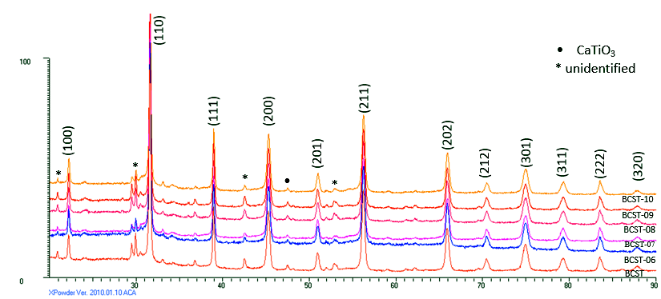

**Fig.1**. X-ray diffraction patterns of as-sintered and irradiated (Ba0.88Ca0.12Ti0.975Sn0.025)O3 ceramics

The XRD patterns of the irradiated ceramics suggest a consistent phase and composition with the pristine sample. That is, the neutrons do not deteriorate the perovskite structure of barium titanate-based ceramics over the range of fluence studied.

Table 1. SAMPLES, PEAK POSITIONS (*2θ***)** AT **(**110) PEAK, D-SPACINGS (*d*) AND THE MICROSTRAIN (*ε)* OF AS-SINTERED AND IRRADIATED BCST CERAMICS

|  |  |  |  |
| --- | --- | --- | --- |
| Sample | 2*θ* (degree) | *d* (Å) | *ε (%)* |
| BCST | 31.582 | 2.83064 | 0.333 |
| BCST-06 | 31.597 | 2.82933 | 0.325 |
| BCST-07 | 31.593 | 2.82968 | 0.333 |
| BCST-08 | 31.596 | 2.82944 | 0.333 |
| BCST-09 | 31.599 | 2.82918 | 0.338 |
| BCST-10 | 31.616 | 2.82767 | 0.324 |

Table 1 shows the experimentally determined and computed XRD parameters of the samples. It is observed that the prominent peak (110) slightly shifts towards higher 2*θ* angles with increase in fluence level compared to pristine sample, while the corresponding *d*-values remain constant for the same peak irrespective of level of fluence. Substitutions at the A-site of perovskite materials by ions of smaller size have been linked to changes in unit cell lattice parameters (Zhang and Qu, 2012; Yun *et al*., 2007). Similarly, slight shifts in the peak positions (in the XRD data, not shown) may be attributed to A-site defect induced by neutrons. However, the microstrain values calculated using equation (3) (Saleem *et al*., 2012) appear to be unchanged before and after irradiation. This suggests that the microstrain induced as a result of irradiation is insignificant and is irradiation independent. However, ferroelectric and dielectric properties of BT-based ceramics are reported to decrease when microstrain increases (Nath and Medhi, 2014; (Medhi and Nath, 2013). This parameter thus shows that these two properties are unchanged.

 (3)

where *ε* is the microstrain, *θ* the Bragg diffraction angle,and *β* the full width at half maximum (FWHM).

C:\Users\DR. UMAR\Desktop\AML graphics\Fig2_001ed.tif

**Fig. 2.** Variation of *β* and *τ* against neutron fluence

The calculated average crystallite sizes using the most intense peak for all the samples and determined from equation (4) (Dash *et al*., 2014) is approximately 38 nm. It can be observed from the plot of *τ* (average crystallite size) against irradiation fluence (**Fig. 2**) that *τ* generally increased with increase in level of fluence. The increase in *τ* values after neutron exposure is due to oxygen vacancies induced by the neutrons (Henriques *et al*., 2014; Miclea *et al*., 2005); (Hsiang *et al*., 1996). The result also suggests an increase in level of crystallization as corroborated in the slight decrease in *β* (**Fig. 2**).

 (4)

where *β* is the FWHM of the diffraction peak in radians, *θ* the Bragg diffraction angle and *λ* the wavelength of the X-ray used.

The lattice constants *a* and *c* of the pristine and irradiated ceramics were calculated from the XRD data using (100), (200) and (201) diffraction peaks. The calculated *c/a* ratio (1.0022) of the tetragonal phase of the pristine sample shows that it is weakly tetragonal in contrast with the JCPDS reference data of BaTiO3 (*c/a* = 1.0110) prepared at higher temperature. **Fig. 3** depicts the plot of the lattice constants and *c/a* ratio versus neutron fluence. It can be seen that there is decrease in *a* values and the *c/a* ratio with increase in fluence while *c* values increased. This imply an increase in tetragonality of the BCST ceramics upon exposure making it less prone to get center of symmetry which typically takes away the tetragonality of perovskite titanates and subsequently leads to loss of ferroelectric and piezoelectric characteristics. Increase in *c/a* ratio leads to increase in polarizability which results in increased ferroelectric properties (Mady, 2011). Therefore, it is expected that irradiation would not alter the ferroelectric properties of the BCST ceramics. These analyses indicate that in spite of the variations, the ceramics retain essentially their ferroelectric and piezoelectric properties.

C:\Users\DR. UMAR\Desktop\AML graphics\fig 3 latice param600dpi ed.tif

**Fig. 3**. Variation of lattice parameters *a, c* and *c/a* ratio with neutron fluence

Variations observed in the lattice parameters are due to displacements of host atoms upon energy exchange with the neutrons which have been found to lead to lattice distortion and anisotropic expansion (Toacsan *et al*., 2007; Wittels and Sherrrill, 1957). This is consistent with the slight shifts in peak positions to higher 2*θ* values. These changes support the observation that the structural phase of BCST ceramic remains unchanged after irradiation and this is obvious from the XRD patterns. Overall, it is expected that the ferroelectric, piezoelectric and polarizability properties will remain the same or there would be a slight increment.

The anisotropic lattice expansion observed in the ceramics implies a change in cell volume. For the pristine specimen, the calculated value was found to be 64.20 Å3 which subsequently increased by 0.123 %, 0.025 % and 0.025 % in BCST-07, BCST-09 and BCST-10, respectively, after irradiation. BCST-06 slightly decreased in value by 0.002% and is due to interstitial ions or ions larger in size as a result of their displacement from lattice sites by neutrons (Henriques *et al*., 2014; Toacsan *et al*., 2007).

**3.2 Microstructural Characterization**

The results of microstructural characterizations of pristine and irradiated specimens of the ceramics are shown in **Fig. 4(a-f).** The microstructure in **Fig. 4** (b, e) are relatively brighter than the others and might be due to strong reflection in the visible region but has not been reported. There is non-uniform distribution of grains and agglomerations as a result of clustering in all the specimens and some porous regions are apparent.

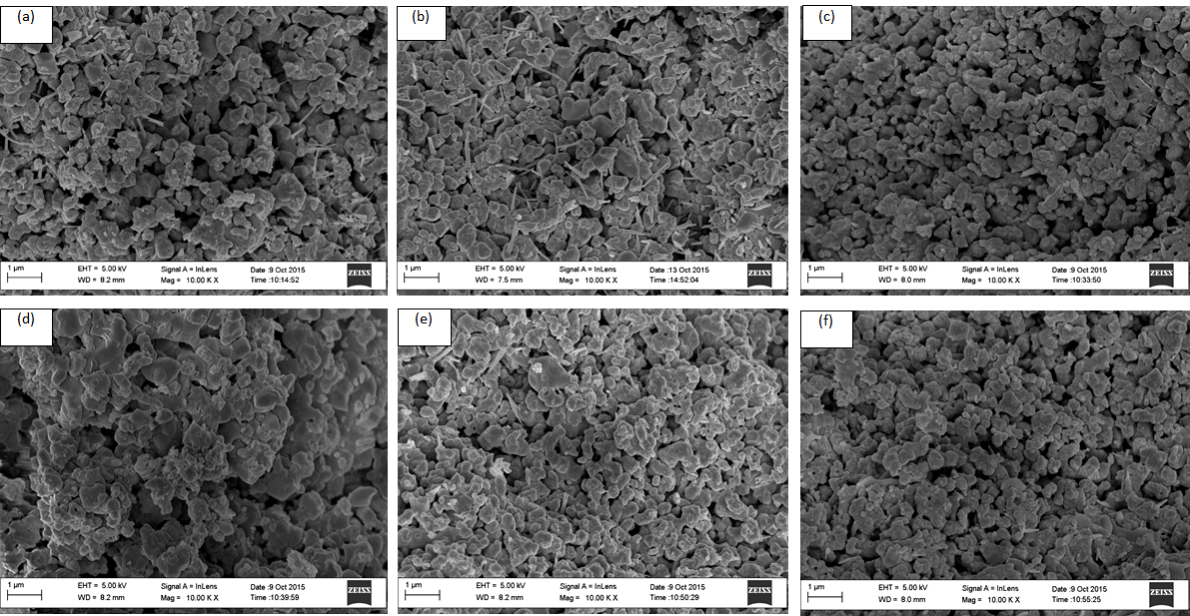**Fig. 4**. HRSEM micrographs of (a) as-sintered (b) BCST-06 (c) BCST-07 (d) BCST-08 (e) BCST-09 and (f) BCST-10

The average grain size determined using Imagej software for about 100 grains is ∼1 µm (**Fig. 5**) and is smaller than those observed in traditional BT ceramics sintered at higher temperature (1450 °C) (Medhi and Nath, 2013). Rod-like grains are also visible which reduce drastically with increased fluence. There is increase in average grain size with increase in fluence level which agrees well with the XRD results of crystallite size which are found to increase with increase in fluence, except for BCST-08 which decreased. Ferroelectric and dielectric properties are expected to increase with increase in grain size and have been corroborated by the decrease in microstrain (Nath and Medhi, 2014; Medhi and Nath, 2013; Cai *et al*., 2011).

C:\Users\DR. UMAR\Desktop\AML graphics\Fig5_001ed.tif

**Fig. 5**. Variation of grain size of BCST ceramic with neutron fluence

**3.3 Chemical Composition**

Qualitative and quantitative EDS analysis for the pristine and irradiated samples show similar chemical compositions. **Fig. 6** is a representative EDS spectrum of the pristine BCST ceramic as they are all similar, while Table 2 is the result of the quantification analysis. The spectrum reveals the presence of Ba, Ca, Ti, Sn, O, C, Au and Pd. The carbon (C) is attributed to the carbon tape background while the AuPd (Gold-Paladium) is from the coating used to make it conducting for the measurement. Table 2 also shows the quantitative comparison of nominal and EDS derived compositions of pristine and irradiated BCST ceramics where the elements have been normalized to 100%. There is evidence of Al impurity in virtually all the irradiated ceramics except in BCST-06 and BCST-09 in which Ce is additionally present in the latter. Presence of Al/Ce could be attributed to contamination during the process of irradiation, temperature furnace and from the crucible used during synthesis. Generally, the normalized EDS results are higher compared to the nominal ones. This is attributed to the displacement of lattice atoms to interstitial sites which, commutatively, leads to clustering and eventually manifests itself in inhomogeneities. Further, oxygen deficiency in the ambient during sintering can also lead to this discrepancy (Badapanda, 2010).The overlap seen in Ba and Ti makes it difficult to differentiate between them in the quantification results and has been reported (Korkmaz and Kalaycioglu, 2012).

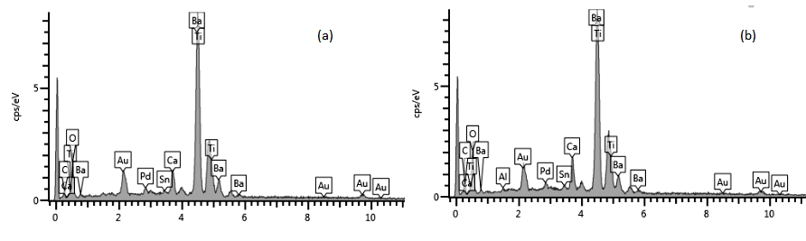**Fig. 6**. EDS spectrum of (a) pristine BCST ceramic (b) irradiated BCST ceramic

Table 2: ELEMENTAL COMPOSITION OF PRISTINE AND IRRADIATED BCST CERAMICS

|  |  |  |  |  |  |  |  |  |  |  |  |  |  |  |  |  |  |  |  |  |  |  |  |  |  |  |  |  |  |  |  |  |  |  |  |  |  |  |  |  |  |  |  |  |  |  |  |  |  |  |  |  |  |  |  |  |  |  |  |  |  |  |  |  |  |  |  |  |  |  |  |  |  |  |  |  |  |  |  |  |  |  |  |  |  |  |  |  |  |  |  |  |  |  |  |  |  |  |  |  |  |  |  |  |  |  |  |  |  |  |  |  |  |  |  |  |  |  |  |
| --- | --- | --- | --- | --- | --- | --- | --- | --- | --- | --- | --- | --- | --- | --- | --- | --- | --- | --- | --- | --- | --- | --- | --- | --- | --- | --- | --- | --- | --- | --- | --- | --- | --- | --- | --- | --- | --- | --- | --- | --- | --- | --- | --- | --- | --- | --- | --- | --- | --- | --- | --- | --- | --- | --- | --- | --- | --- | --- | --- | --- | --- | --- | --- | --- | --- | --- | --- | --- | --- | --- | --- | --- | --- | --- | --- | --- | --- | --- | --- | --- | --- | --- | --- | --- | --- | --- | --- | --- | --- | --- | --- | --- | --- | --- | --- | --- | --- | --- | --- | --- | --- | --- | --- | --- | --- | --- | --- | --- | --- | --- | --- | --- | --- | --- | --- | --- | --- | --- | --- |
|  | |  |  |  | | --- | --- | --- | |  | Nominal Composition [at. %] | Normalized EDS derived Composition [at. %] |  |  |  |  |  |  |  |  |  |  |  |  |  |  |  |  |  | | --- | --- | --- | --- | --- | --- | --- | --- | --- | --- | --- | --- | --- | --- | --- | --- | | Sample | Ba | Ca | Sn | Ti | O | Total |  | Ba | Ca | Sn | Ti | O | Al | Ce | Total | | BCST | 17.60 | 2.40 | 0.50 | 19.50 | 60.00 | 100 |  | 22.31 | 4.70 | 0.40 | 26.64 | 45.95 | - | - | 100 | | BCST-06 | 17.60 | 2.40 | 0.50 | 19.50 | 60.00 | 100 |  | 19.78 | 3.51 | 0.63 | 23.08 | 53.04 | - | - | 100 | | BCST-07 | 17.60 | 2.40 | 0.50 | 19.50 | 60.00 | 100 |  | 16.53 | 3.05 | 0.51 | 20.02 | 58.92 | 0.97 | - | 100 | | BCST-08 | 17.60 | 2.40 | 0.50 | 19.50 | 60.00 | 100 |  | 17.50 | 3.35 | 0.42 | 19.15 | 58.90 | 0.68 | - | 100 | | BCST-09 | 17.60 | 2.40 | 0.50 | 19.50 | 60.00 | 100 |  | 16.26 | 2.67 | 0.47 | 19.59 | 59.36 | 0.74 | 0.88 | 100 | | BCST-10 | 17.60 | 2.40 | 0.50 | 19.50 | 60.00 | 100 |  | 21.22 | 5.83 | 0.59 | 25.02 | 46.56 | 0.78 | - | 100 | |  |  |  |

**4.0 CONCLUSION**

Prepared and sintered samples of Ca and Sn–doped Ba0.88 Ca0.12 Ti0.975 Sn0.025 O3 were irradiated at different fluence levels. Slight shifts were observed in the 2*θ* peak positions to higher values with increase in fluence level. The observed microstrain is insignificant and irradiation independent. There was increase in crystallite size as neutron fluence increased and the average crystallite size was calculated to be ~38 nm suggesting a slight increase in crystallization. Lattice parameters (*a* and *c*) show slight anisotropic expansion and the c/a ratio slightly increased implying that the piezoelectric, ferroelectric and polarizability properties might slightly increase or remain the same. A general increase in unit cell volume was observed and the microstructure of some of the irradiated specimens looks brighter relative to the pristine specimen and some of the irradiated ones. Non-uniform distribution of grains, rod-like grains, porous regions and agglomerations were observed in all the specimens at differing degrees. There is increase in grain size (average ~1.0 µm) with increase in fluence level while the ferroelectric and dielectric properties expected to increase as a result. Chemical analysis (EDS) showed that all the nominal elements are present except the presence of some impurities which were generally accounted for. Higher concentrations of elements were obtained for EDS-derived measurements and are due to defects resulting in inhomogeneities in the microstructure, among others. Overall, the result shows that although there are some slight changes in structural and microstructural properties, the essential physical properties of the BT-based materials, i.e., piezoelectric, ferroelectric and dielectric properties remain virtually the same and thus device performance is expected to be stable.

**Acknowledgement**

This work was funded by the Tertiary Education Trust Fund (TETFUND) under project no: TETFUND/FUTMINNA/’2014/044.

**References**

Ahmadu, U., Ahmad, A.S., Usman, A.B., Muhammad, A.M. and Isah, K.U. (2016). “Structural

and microstructural study of gamma ray-irradiated co-doped barium titanate

(Ba0.88Ca0.12Ti0.975Sn0.025O3)”,Process. Appl. Ceram. 10:79-85.

Aksel, E., and Jones, J.L. (2010). “Advances in Lead-Free Piezoelectric Materials For Sensors and Actuators”, Sensors, 10:1935-1954.

Badapanda, T. (2010). “Structural, Electrical and Optical Study of ‘A’ Site Deficient

Heterovalent Ion Doped Barium Zirconium Titanate Perovskite”, Ph. D

Dissertation, National Institute of Technology,Rourkela-769008.Orissa India,

Cai, W., Fu, C.L., Gao, J.C. and Zhao, C.X. (2011). “Dielectric properties and Microstructure of

Mg doped barium titanate ceramics”, Adv. Appl. Ceram. 110:181-185.

Choi, Y.K., Hoshina, T., Takeda, H. and Tsurumi, T. (2010). “Effects of Ca and Zr additions and

Stoichiometry on the electrical properties of barium titanate-based ceramics”, J. Ceram.

Soc. Jpn. 118 (10): 881-886.

Dash, S.K., Kant, S., Danlai, B., Swain, M.D. and Swain, B.B. (2014). “Characterization and

Dielectric properties of barium zirconium titanate prepared by solid state reaction and

high energy ball milling processes”, India J. Phys. 88(2):129-135.

Frattini, A., Di Loreto, A., de Sanctis, O. and Benavidez, E. (2012). “BCZT ceramics prepared

from activated powders”, Procedia Mater Sci. 1:359-365.

Heng, W. and Xinhua, Z. (2016). “Perovskite Oxide Nanocrystals-Synthesis, Characterization, Functionalization, and Novel Applications”, in: Likun P. (Ed.), Perovskite Material

-Synthesis, Characterisation, Properties and Applications, InTech, :155-170.

Henriques, A., Graham, J.T., Landsberger, S., Ihlefeld, J.F., Brennecka, G.L., Brown, D.W., Forrester, J.S. and Jones, J.L. (2014). “Crystallographic changes in lead zirconate titanate

due to neutron irradiation”, AIP Advances. 4:117125.

Holbert, K. E. (2006). “Radiation Effects on Materials: Displacement Damage Lecture from

Nuclear Concepts” for the 21st Century course,Arizona State University, U.S.A.

Holbert, K.E., McCready, S.S., Heger, A.S., Harlow, T. and Spearing, D.R. (2004).

“Performance of piezoresistive and piezoelectric sensors in pulsed reactor

experiments”, Topical Meeting on Nuclear Plant Instrumentation, Controls and Human

-Machine Interface Technologies, Columbus, Ohio.

Hsiang, H-I., Yen, F-S. and Chang, Y-H. (1996). “Effects of doping with La and Mn on

the crystallitegrowth and phase transition of BaTiO3 powders”,J. Mater. Sci.

31:2417-2424.

Korkmaz, E. and Kalaycioglu, N.O.(2012). “Synthesis and luminescence Properties of BaTiO3:

RE (RE=Gd3+,Dy3+, Tb3+, Lu3+) phosphors”, Bull. Mater. Sci. 35 (6): 1011-1017.

Lefkowitz, I. (1958). “Radiation-Induced Changes in Ferroelectric Properties of Some Barium

Titanate-Type Materials”, J. Phys. Chem. Solids. 10: 169-173.

Mady, H.A. (2011). “XRD and Electric properties of lead barium titanate ferroelectric ceramic”,

Aust. J. Basic Appl. Sci. 5(10):1472-1477.

Maitra, S., Banerjee, M., Mukherjee, S. and Singh, P.K. (2013). “Synthesis and Characterisation

of Cobalt Oxide Doped Barium Strontium Titanate”, J. Aust. Ceram. Soc.49 (1):

79-83.

Matsuura, K., Hoshina, T., Takeda, H., Sakabe, Y. and Tsurumi, T. (2014). “Effects of Ca

substitution on room temperature resistivity of donor-doped barium titanate

based PTCR ceramics”, J. Ceram. Soc. Jpn.122 (6): 402-405.

Medhi, N. and Nath, A.K. (2013). Gamma ray irradiation effects on ferroelectric and

piezoelectric properties of Barium Titanate Ceramics”, J. Mater. Eng. Perform. 22:

2716-2722.

Miclea, C., Tanasoiu, C., Miclea, C.F., Spanulescu, I. and Cioangher, M. (2005). “Effect of

neutron irradiation on some piezoelectric properties of PZT type ceramics”, J. Phys.

IV France. 128:115–120.

Nada, F.A., Ahmed, G. and Ekram, H.E. (2016). “Perovskite Nanomaterials-Synthesis,

Characterization, and Applications”, in: Likun P. (Ed.), Perovskite Material

-Synthesis, Characterisation, Properties and Applications, InTech, **:** 111-112.

Nath, A. K. and Medhi, N. (2012). “Density variation and piezoelectric properties of

Ba(Ti1−xSnx)O3 ceramics prepared from nanocrystalline powders”.Bull. Mater. Sci.

35 (5): 847–852.

Nath, A.K. and Medhi, A. (2014). “Effect of gamma ray irradiation on the piezoelectric and

ferroelectric properties of bismuth doped barium titanate ceramics”. Indian J Phys.

Ogundare, F.O. and Olarinoye, I.O. (2016). “He+ induced changes in the surface structure and

Optical properties of RF-sputtered amorphous alumina thin film”, J. Non-Cryst.

Solids. 432: 292-299.

Onoja, A., Umar, I.M., Funtua, I.I., Dim, L.A. and Elegba, S.B. (1995). Design, Construction

and Characterization of a Low Neutron Flux Irradiation Facility”, Nig. Journ. of Phys.

7: 76-80.

Paunovic, V., Zivkocic, Z., Vracar, L., Mitic, V., Miljkovic, M., 2004. “The effect of additive on microstructural and electrical properties of BaTiO3”, Serb. J. Elect. Eng. 1 (3)”: 89-98.

Rao, M. V.S., Ramesh, V.K., Rames, M.N. V. and Rao, B.S. (2013). “Effect of Copper Doping

on Structural, Dielectric and DC Electrical Resistivity Properties of BaTiO3”, Adv

. Mate. Phys. Chem. 3:77-82.

Saleem, M., Fang, L., Wakeel, A., Rashad, M. and Kong, C.Y. (2012). “Sample Preparation and

Characterization of Nano Crystalline Zinc Oxide Thin Films by Sol gel Method on

Glass Substrate”, World J. Condens. Matter Phys. 2: 10-15

Toacsan, M.I., Ioachin, A., Nedeku, L. and Alexandru, H.V. (2007). “Accelerate ageing of PZT

-type ceramics”, Prog. Solid State Chem.35: 531-537.

Vitayakorn, N. (2006). “Dielectric properties of Bismuth doped Barium Titanate (BaTiO3)

Ceramics”, J. Appl. Sci Res. 2 (12):1319-1322.

Wittels, M. and Sherrill, F.A. (1957). “Fast Neutron Effects in Tetragonal Barium Titanate”, J.

Appl. Phys. 28:606.

Yun, S., Wang, X., Li, B. and Xu, D. (2007). “Dielectric properties of Ca-substituted barium

strontium titanate ferroelectric ceramics”. Solid State Commun. 143:461 - 465.

Zhang, C. and Qu, Y-F. (2012). “Dielectric properties and phase transitions of La2O3- and

Sb2O3-doped barium strontium titanate ceramics”, Trans. Nonferrous Met. Soc. China.

22:2742-2748.-