CHAPTER ONE
INTRODUCTION
1.1 Background of the Study
Whatever is human-made tends to become obsolete over time due to physical factors such as chemical degradation, physical damage, etc. However, the process of obsolescence is not limited to materialistic and physical factors. Social, cultural, technological and political factors (such as technology innovation; variation in customer demands; change in existing legislation; social pressures; advancement of knowledge; inflation of currency; civil unrest or conflict of interests; etc.) can also drive obsolescence. Moreover, climate change is another and newest element which is acting as an additional driver of obsolescence in a number of ways both directly and indirectly.
Obsolescence occurs due to physical deterioration, wear and tear, technological advances, changes in the economic conditions users' requirements, design, appearance, taste, legal, and social needs. Once the building is obsolete cause by the defect of varying physical deterioration and ageing of various components and building of various ages.
Obsolescence is a significant decline in the competitiveness usefulness or value or of an article, Cowan and Bryon (2005). Obsolesces occurs generally due to change or due to changes in user preference requirements or styles it is distinct from fall in value (depreciate) due to physical deterioration or normal tear and wear. Obsolescence is also an old fashioned and no longer useful, it is not necessarily age, however but change that is the chief cause of obsolescence.
Housing which is also known as residential property is one of the three basic needs of mankind and it is the most important for the physical survival of man after the provision of food (Olayiwola, et al,. (2005). It encompasses all the ancillary services and community facilities which are necessary to human well-being and sustainable development. It is a package of services, including land, utilities and services and access to employment and social amenities as well as the structure or shelter itself. Although housing is an integral part of human settlement that fulfills basic need, and has a profound impact on the quality of life, health, welfare as well as productivity of man; large proportion of urban residents in developing countries do not have access to decent housing at affordable cost. Residential property delivery involves series of processes by which housing resources such as land, labour, finance and building materials are combined to produce new residential property units. According to Agbola and Alabi (2000), these could also involve the upgrading of existing units as well as distribution of both new and existing housing to consumers.
Property value is the money obtainable from a person’s willing and able to purchase property which it offered for sale by a willing seller, allowing for reasonable time for negotiation and with the full knowledge of the nature and users which the property is capable of being put. Real property has no value if it has no utility, if it is not scarce and if it is not effectively demanded. Real property has significance only as it satisfies man’s need and desires. It is this man’s collective desire for real property that gives rise to value. (Kuye, 2003).
The research was undertaken to find out the impact of obsolescence on residential property in Kontagora, Niger State. Therefore, the outcomes from this research helped the researcher to understand the flaw of component of material that causes obsolescence on residential property. Such results may also help authors in future to know the preventive ways to treat the obsolescence in residential property in order to get high value for the property.
1.2 Statement of the Problem
Obsolescence is a serious threat for built property given its immobile, long lasting and capital significance minimizing obsolescence is important for the presentation of the change of physical, economical and societal investment involved. Residential properties are constructed in circumstances of high uncertainty concerning their medium to long term lives. Andre and Vander flier, (2011).
However, the act of construction is a commitment to physical durability and spatial fixity. This, together with the fact that most buildings are durable, means that they have to function in changing political, economic, social and technological conditions. The result is that every building undergoes a process of obsolescence as it exhibits a diminishing capability to meet evolving user expectations through time. In recent decades, the process of building obsolescence has been particularly problematic for residential property, as building life spans have become increasingly transient (Gann, 2000). Technological advances and changing occupier needs have resulted in many residential buildings being demolished after only 20 years life (Khalid, 2003). Furthermore, due to rapid innovation and development, future residential buildings are likely to enjoy even shorter useful life spans. Such a trend is considered to represent a widespread inefficiency in the use of physical resources, the costs of which are borne by property owners, occupiers and non-users. The trend has implications for the way in which residential buildings are designed and managed.
Previous studies of residential property obsolescence have focused almost entirely upon the financial impact for the property owner (Khalid, 2003). However, the limitations of this traditional approach have become increasingly apparent (Pinder and Wilkinson, 2000). Therefore, the research that was discussed in this work suggested that building obsolescence in residential property was examined from the perspective of the building occupants.
1.3 Aim and Objectives
The aim of this study is to examine the effect of physical obsolescence on the residential property values in Tudun-Wada and Nassarawa areas of kontagora.
1.3.1 Objectives
The objectives of this study are to;
- Identify the factors that cause various forms of obsolescence on residential property in Tudun-Wada and Nassarawa areas of Kontagora
- Identify the types of changes that occur in the physical decay on the residential property within the study area.
- Examine the rental values of residential property across the study area.
- Assess the impact of the level of obsolescence on residential property value in the study area.
1.4 Research Questions
- What are the factors that cause various forms of obsolescence on the residential property within the study area?
- What are the types of changes that occur on physical decay on residential property in the study area?
- What is the rental values paid for the residential property in the study area?
- What is the impacts level of obsolescence on residential property value in the study area?
1.5 Significance of the Study
This research study can help the diverse spectators from the environmental field in general, and the built environment in particular, to better convinced what obsolescence is and how is being occurred in different ways such as socially, environmentally, economically, spatially, technologically. Understanding of varying implications and different dimensions of obsolescence will assist skill managers as well as environmental practitioners and consultants to consider the built environment from different angles to assess and then manage obsolescence. This research is also significant in helping property developers to overcome practical difficulties and reduced the risk of building obsolescence on residential property and to know the effective ways of minimizing obsolescence on residential properties or building.
1.6 Justification for the Study
This research focuses on the needs and expectations of the occupants of residential properties, the rationale is that in most residential buildings tenants comprise the majority of occupants; hence their needs and expectations should take precedence. The needs and expectations of different occupants may vary enormously, placing a wide variety of potential demands upon residential properties; it is the need for the property developer to build a standard residential property to avoid obsolescence on the property so that it will command high value for the owner of the property.
The presence of obsolescence on residential property has an impact on the value of the property. Obsolescence occurs due to physical deterioration, wear and tear, changes in taste, users’ requirement, design and social need. This research was taken to explore the effect of obsolescence on residential property value and adopted the possible ways in minimizing and controlling the obsolescence.
However, the need for this research also analyzed the impact and causes of physical obsolescence on the residential property value.
1.7 Scope of the Study
The scope of the study is limited to Tudun-Wada and Nassarawa areas of Kontagora, Niger State, specifically looking at effects of physical obsolescence on residential property value. Reason behind these two case studies was that Tudun-Wada is one of the old areas in Kontagora, while Nassarawa area is one of the developing areas in Kontagora and along the road of Federal College of Education (FCE) and both areas are having different rental value. The research covered the period between 2009-2018, this period is chosen because it is the time after global economic crisis which the property market returns is stable, the choice of these periods was determined in comparing the rate of physical obsolescence as it affects the rental value of the property in the study areas.
1.8 The Study Area
Kontagora is made up of territory originally divided between various minor chiefdoms (Aguarra, Dakka-Karri, Kambari, Dukawa, and Ngaski) which were conquered by the [[Fula people]] between 1858 and 1864, and turned into the emirate of Kontagora, a dependency of the [[Sokoto Caliphate]]. Following a well-armed attack, starting on 31 January 1901, the emirate fell under [[British Empire|British]] rule, becoming a province first in the [[Northern Nigeria|British Protectorate of Northern Nigeria]] and then in the British colony of Nigeria, until independence in 1960.
Kontagora now consists of Kontagora emirates, containing the chiefdom of Wushish, the territories of Sarkin Bauchi, and the chiefdom of Kagara, all administratively grouped into the Mariga, Magama, and Rafi Local Governments.
Kontagora, town and traditional emirate, northwestern Niger state, western Nigeria, on the south bank of the Kontagora River. Umaru Nagwamatse, an adventurer of the ruling Fulani house of Sokoto (186 miles [299 km] north), was named sarkin sudan (“king of the blacks”) in 1859 by Ahmadu Zaruku, Sokoto’s sarkin musulmi (“commander of the faithful”). Umaru then conquered a region mostly inhabited by the non-Muslim Kamberi people, founded the town of Kontagora (from kwanta gora—“lay down your gourds”) as his kingdom’s headquarters in 1864, and established himself as the first emir of Kontagora. Throughout his rule, continuing to 1876, he enlarged the emirate by conquests of Kamuku, Kamberi, Dakarki (Dakarawa), Dukawa, Yauri, Nupe, and Gbari (Gwari) towns and captured many slaves. In the first reign (1880–1901) of his son, Emir Ibrahim Nagwamatse, sarkin sudan, Kontagora again became notorious for slave raids that severely depopulated the region and left numerous walled towns in ruins, many of which are still visible (despite a 1949–57 government-sponsored resettlement program). Ibrahim’s capture of the Zarian town of Birnin Gwari (98 miles [158 km] northeast) in 1899 forced the emir of Zaria to seek the protection of the British, a move that brought the first great Fulani emirate under British control. After Ibrahim threatened the British post at Jebba, 98 miles (158 km) south-southwest, in 1900, British forces occupied Kontagora town (1901) and removed him from office. Although he was reinstalled as emir in 1903, his territory, which had been incorporated as Kontagora province, and his powers were greatly reduced. When the province was broken up in 1925, the emirate became a separate division of Niger province; it was incorporated into North Western state in 1967, and since 1976 it has constituted an area of 13,219 square miles (34,237 square km) in Niger state. (Kontagora Emirate Council 2018)

1.8.1 Location and Distance
Kontagora is located 10.40 latitude and 5.47 longitudes and it is situated at elevation 339meters above sea level. It operates on the WAT time zone, which means that its follow the same time zone as Minna.
The distance from Kontagora, approximately to the state capital in km is 187km (Source ministry of transport.)
1.8.2 Climatic Condition
Kontagora emirate, just like any other area in the middle belt zone, experiences hot and humid weather. The dry and heavy rainfall last for six or more months.
1.8.3 Population
Kontagora lies on the highway between Jebba and Kaduna and is also a junction for local roads. Population. (2006 census) local government area, 151,944. Kontagora have the land area in square kilometer (SQKM), as 2,179.3
1.8.4 Economic Base
The town is a collecting point for cotton and peanuts (groundnuts). In addition to these cash crops, Kontagora has considerable local trade in sorghum, millet, cowpeas, tobacco, beans, shea butter, gum arabic, kola nuts, sorghum beer, brass wares, gold artifacts, locally dyed and woven cotton cloth, cattle, goats, chickens, and guinea fowl. Modern industry includes a plant that manufactures plastic sacks. Besides the palace of the sarkin sudan, the town has a federal advanced teacher-training school and a hospital. Kontagora lies on the highway between Jebba and Kaduna and is also a junction for local roads. (K.E.C 2018)
1.8.5 Educational Institution
Kontagora is one of the emirate in Niger state with relative educational advantage. Apart from numerous primary school, there are also functional post primary institutions in the area. The area also hosts a federal collage of education (FCE) in Kontagora town and school of health technology in Tugan Magajiya. (K.E C 2018)
1.8.6 Communications and Transportation System
Postal and telephone services are available at the Kontagora post office while GSM operators have established their presence in the area.
Transportation System
Kontagora, the head quarter of the emirate is located on the Lagos- Kano highway and blessed with numerous intra-city transport facilities. Both private and commercial vehicle ply through the town north and south of the country. The town is usually considered as a stop-over point for refueling as well as feeding for passengers. Taxi cabs are also available in Kontagora as well as commercial motor cyclists. (Ministry of Transport 2018)
1.8.8 Medical Facilities
To provide enhanced health care delivery, a well-equipped general hospital is located in Kontagora town. Furthermore, a lot of private clinics and hospital abound in the area to compliment the effort of the government for providing health for all.
1.8.9 Investment Opportunities
The people of Kontagora emirate and their socio-economics activities cannot be divorced from each other. This is for the fact that they are very enterprising and self-reliant. As a result of vast and fertile soil in the area, the people engaged mainly agriculture. Kontagora is also reach in mineral resources all of which could be tapped for industrial purposes. (K.E.C 2018)
1.9 Limitation of the Study
The major constraint to the research is retention of some information for the study area which are being hold by the respondent’s due to the privacy of their data, and also the time series data collected was faced with challenges due to lack of record keeping policy which make must of the rent to be a projected rent. Also the geographical terrain and culture is also a limitation for the study.

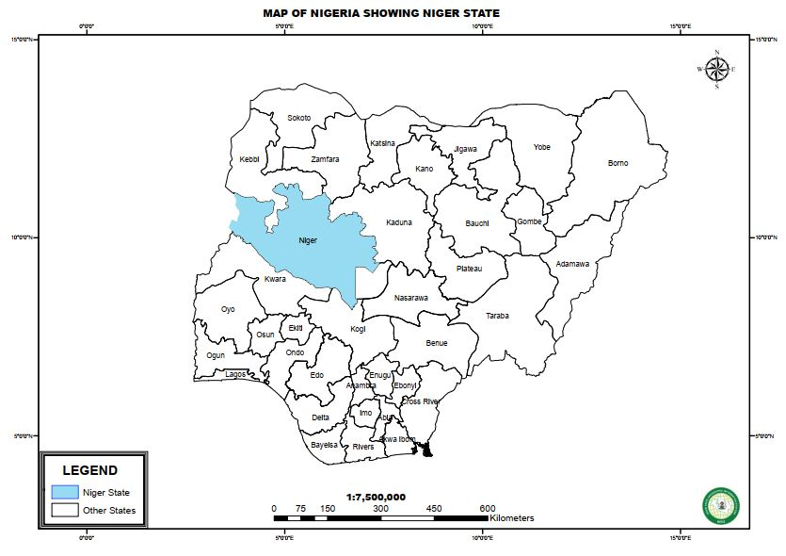

Figure 1: Map of Nigeria showing Niger State
Source: Niger State Geographical Information System NIGIS, (2019)

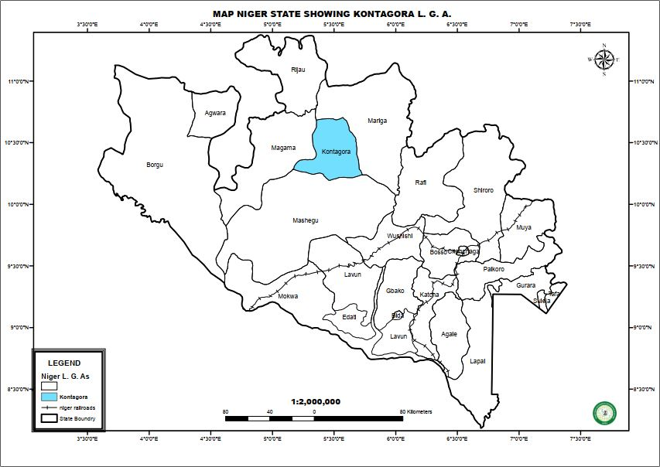

Figure 2: Map of Niger State showing Kontagora
Source: Niger State Geographical Information System NIGIS, (2019)

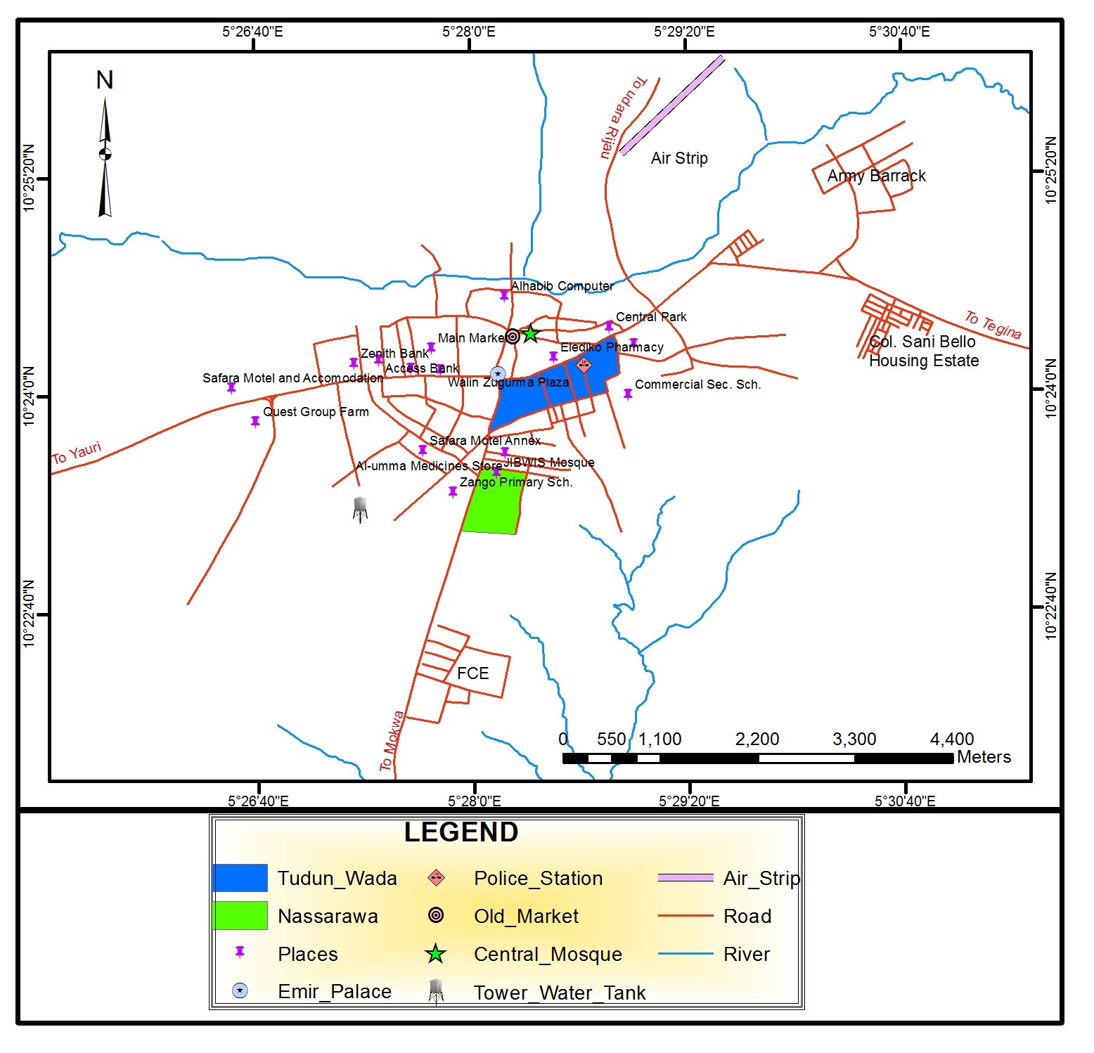
Figure 3: Map of Kontagora showing the Study Area
Source: Niger State Geographical Information System NIGIS, (2019)

CHAPTER TWO
2.0 LITERATURE REVIEW
2.1 Concept of Obsolescence
Ageing and obsolescence building keep on increasing for the past century in our country. An observation of buildings in any town will expose an array standard of physical ageing and condition. Many of the buildings are also being used for a purpose of another use than what it has been originally designed for, these may lead to obsolescence on such property. (Thomsen and Meijer, 2006).
Obsolescence is not a natural phenomenon but a function of human action. Buildings are complex man-made items and can only survive by means of regular reinvestments during its long service life. As a result the total life cycle costs will generally be a multiple of the initial building costs (Boussabaine and Kirkham, 2004). These high costs demonstrate the relevance of avoiding and minimizing obsolescence and the need for knowledge on how to achieve that.
Today, the demand for new building already diminished and many town have become ignored and need some form of urban revival. However, such of the regeneration is more likely from renewal and modernization through the development of rural sites.
Many traditional structures have lower failure rates and costs less to maintain than some of the newer forms of the building. With the increasing level of prosperity, standards in buildings, life styles demand to improve quality, space and other. This leads to both the desire for new building and to the renewal of existing structure. (Van Kempen et al. 2006).
More of the renewal of the building is cause by the obsolescence building that letdown the structure and the physical condition. There is considerable degree of confusion surrounding the definition of obsolescence. A detail study on the definition of obsolescence was carried out in this chapter to make a clear understanding on building obsolescence. (Thomsen and Vander flier, 2009).
There are two impacts of the obsolescence on a building which are curable obsolescence and incurable obsolescence. Reflection of them was given separately in this chapter.
Obsolescence itself can be divided into different categories. As this thesis was undertaken to carry out the types of obsolescence, it is necessary to understand the definition and differences of each type of obsolescence. Hence, the chapter also defined different types of obsolescence, this can provide a guidance to differentiate each type of obsolescence and eliminate the misconception of different types of obsolescence.
Obsolescence is a state of being which occurs when an object, service or practice is no longer wanted even though it may still be in a good working order (Hoesli & Macgregor 2000). Obsolescence is much more difficult to control since it is concerned with the prediction of changes in fashion technological development innovation in the design and the use of building. Obsolescence is not depreciation. Both of them are two different terms. However, they are related.
According to Bullier et al. (2011) depreciation is an accounting terms and have a formal definition of ‘depreciation’ Depreciation is the measure of the wearing out, consumption, or other reduction in the useful economic life of a fixed asset whether arising from use, afflation of time or obsolescence through technological or market changes.

This definition is comprehensive and clearly stated what the depreciation is. Besides, the reader can understand the differentiation between the depreciation and obsolescence. Base on this definition, reader can understand the depreciation is a loss in the existing use value of the property and it occurs as the result of the building becoming obsolete. This implies that obsolescence is the cause of the building and depreciation is the effect of the obsolescence.
To clarify, obsolescence is the process of becoming antiquated, old fashioned, outmoded, or out-of-date. It describes a decline in utility that not result directly from physical usage, the action of the elements or the passage of time (Mansfield & pinder ,2008).
Obsolescence also related to decay of tangible and intangible things that all products have an irresistible tendency to become old, but the speed of ageing is different for different objects and circumstances.
Obsolescence is much more difficult to control since concerned with the prediction of changes in fashion, technological development, innovation in the design and the use of buildings. Obsolescence occurs due to physical deterioration, wear and tear, technological advances, changes in the economic conditions and user requirement. The design, appearance, taste, legal, and social needs will also have an impact to the building. (Cowan and Bryon 2005)
2.2 The impact of obsolescence on residential property
The impact of obsolescence on a building can be classified into curable obsolescence and incurable obsolescence. Curable obsolescence is one that can be control by the building owner through choice of the construction materials, preserve high standards of

maintenance and refurbishment (Van Kempen et al., 2006). But, it can only be managed to some certain extent. The factors of curable obsolescence include
- Construction faults
- Level of deterioration
- Poor standard of services
Normally, curable obsolescence can be easily taken care off by means of maintenance or repair.
Incurable obsolescence being the results of unfortunate changes is less easily controlled by the building owner. The greatest that can be done is to integrate flexibility into the design of a building to make alterations and revisions easier in the future. The treatment of incurable impact of obsolescence requires the introduction of new characteristic into a building, which may not be similar with the existing structure.
2.3 Types of obsolescence
Several literatures provide the distinctive types of obsolescence. Basically, the obsolescence is a sub-category of property depreciation besides deterioration. Deterioration occurred through normal wear and tear or environmental factors such as weather and related to passage of time (Hoesli & Macgregor, 2000). While obsolescence, as has been defined previously; is a loss or decline of utility and not directly linked to time. As far as the literature concerns, there are several types of obsolescence associated with the property. As mentioned by Reed and Wilkinson (2008), the identification and measures of each form of obsolescence is a conscientious process as the effect is of varying degree and it happens in a different period of time. They further explain a coinciding between each type of obsolescence where it creates a ‘grim’ area for form of property obsolescence. In general, the obsolescence can be
separated into three (3) elements which are the Physical, Functional and Economic or External Obsolescence (Reilly, 2012; Reed and Wilkinson, 2008).

2.3.1 Physical Obsolescence
This type of obsolescence involves the reduction of property value as a result of the normal wear and tear and the age factor of a building (Reilly, 2012). Reed and Wilkinson, (2008) added that the types of physical obsolescence in which it consists of curable physical deterioration, incurable physical deterioration (short life items) and physical deterioration (long life items). Physical deterioration occurs more slowly than other forms of obsolescence, but it is predictable and curable provided the building is well maintained. The physical obsolescence is not as significant as functional and social obsolescence.
2.3.2 External Obsolescence
This type of obsolescence is difficult to cure and hard to measure (Pomykacz, 2009). External obsolescence decreases the value of residential property by external forces or factor outside the property. There are (3) categories of external obsolescence including locational, economic, and social obsolescence. Locational obsolescence is originated from changes in the geographical landscape such as proximity to negative environmental area or absence of land use controls (Reed et al., 2008). Whereas, economic obsolescence is referred to the condition of property market in regard to demand and supply (e.g. Over-supplied market) and it brings impact in a broader market and range of properties. Social obsolescence is associated with society changing taste perception (Kraus et al., 2009).

2.3.3 Functional Obsolescence
This is defined as decrease in value as a result of incapability of the property to function for its intended use or designed (Reilly, 2012). It relates to the structure flaws, materials or design of the building, as to against the highest and the best use together with cost effective functional design requirement at the valuation date (Reed and Wilkinson 2008) and embedded to defects within the property. Besides, Hoesli & Macgregor (2000) opined that functional obsolescence as the inability of the structure to accommodate flexibility of usage such as floor to ceiling heights and the floor plan. The building originally was built functionally adequate at the time of construction. As time passed, the same building will no longer become functionally adequate as a result of change in design standards, mechanical system and construction materials.
Under the functional obsolescence, two features influencing property including technological and functional component can be found. Technological obsolescence is referred to as obsolescence due to rapid advancement of the computer. For instance, wireless technology may not be suitable in a building with restriction in design and construction. Technological obsolescence may also relate to the inadequate technological facilities inside building as to compare with the current state of the art technological building. Where, the absence of facilities will create a mismatch between the client’s demand and services offered by property and thus technological obsolescence may occur (Hoesli & Macgregor, 2000). Functional components are related to the building obsolescence and aesthetic obsolescence.
2.4 Effects of Obsolescence on Residential Properties
The effect of obsolescence on residential properties is been seen or can be said to be a major problem which eldest building faces, this effect like making the building look
worn out and when this happens, it can be said that the building has reached its old stage and once the building is obsolete, which is also caused by defect of varying physical deterioration of ageing of various component of the building of various age. (Bole and Reed 2009)
The rapid decline of building and their components can be attributes to many diverse causes:
- An emphasis upon costs without considering the consequences of costs in use.
- Inappropriate design and detailing of buildings and their components.
- Use of materials and components that have insufficient data concerning their durability.
- Constructional practices on site that were poorly managed, supervised and inspected.
- A lack of understanding of the various mechanisms of deterioration.
- Insufficient attention given to the maintenance of building stock.
- Inappropriate use by owners and occupies.
Whereas the rate of effect of obsolescence can be controlled by the designer through the correct choice of material, methods of construction and appropriate standards of maintenance, obsolescence cannot, other than through the ability to provide a flexible and adaptable design result to smooth easier revision and renewal at same later date.
2.5 Obsolescence and the Built Environment
In the context of built environment, obsolescence can be defined as depreciation in value and/or usefulness of a human-made system as a whole (e.g., a building, transport infrastructure, etc.) or its component (e.g., a boiler of the building) due to an impairment
of desirability and/or function. This loss of value or amenity could be from a multitude of causes such as: new inventions, current changes in design, technological development, improved process of production, and change in use or end-user demands, climate change (e.g., global warming). Other social factors may also play a role, for instance, instability in politics of a country or tightening of environmental legislation can render a part of a given built environment, e.g., a property or built asset less desirable and valuable for a continued use. t is generally not age as much, but change that is the chief cause of obsolescence. (Nwoko, 2010).
Many ancient buildings are still useful and may perhaps serve their functions better because of their age. For instance, churches, mosques, shrines, monuments and historical buildings are known to have been constructed many centuries ago and are deemed even more functional and useful in their old age in their respective usage when compared with when they were originally constructed. In summary, obsolescence in buildings refers to the gradual process (or a condition) of a building of not being able to meet up with the contemporary standards in terms of functionality, statutorily, physically, and/or economically with in a particular place or time causing the building to be obsolescent (Nwoko, 2010).
2.6 Obsolescence and the Life Cycle of Buildings.
Obsolescence is commonly regarded as the beginning of the end-of-life stage of buildings. Sources about the life cycle of buildings show a diversity of terms. The building and property development communities commonly refer to the development cycle, consisting of the development phase, including the design and the construction phase, and the usage phase, consisting of the actual use and the reuse or end-of-life phase (De Jonge and Arkesteijn, 2008). Sources regarding the life span, building
pathology and kindness of buildings more often refer to the physical life or real life, being the period of physical existence, including the usage and end-of-life phase. This is in line with most national building stock statistics that in general only state abstraction from the residential stock, in some countries subdivided by withdrawal by demolition and/or disaster, absorption with other buildings and loss of function The usage phase has now a formal definition of the service life, being ‘the period of time during which a building or its parts meet or exceed performance requirements’ (ISO, 2000).
Bradley and Kohler (2007) state that the end of the service life can be the end of the physical life but can also be just the indication of the expected time prospect. They also refer to the economic life, being ‘an expected period of time over which the costs and benefits of buildings are measured for purposes of making decisions about design and management’, adding that this term when used for accounting or financial or other legal requirements is not necessary related to the likely service life time (Bradley and Kohler, 2007). Examining the influence of decline, several authors render the life cycle as a function of a building’s performance capacity over time (Awano, 2006; Miles, Berens, and Weiss, 2007) Following Miles et al., illustrate obsolescence as the extending deviation over time between the declining performance and the gradually rising expectations. More specifically look at the economic performance of buildings, from the first investments in the development phase, the regular operation in the firmness phase, the growing obsolescence in the weakening phase through the final end of life.
2.7 Obsolescence and Service Life
Maintenance is required to preserve a building’s initial performance capacity. Without preservation, the performance will not meet the demand and eventually drop below the limit of acceptance of users or residents and the predictable service life will not be reached, resulting in serious loss of effectiveness. In practice, both the demand and the limit of acceptance will gradually rise over time as a result of improved technology, rising standards and growing prosperity. Improvement and renewal are required to answer the accordingly rising expectations. By adding performance capacity the period of highest efficiency can be significantly extended and the service life sustained. Assessment of the loss and benefits of alternative interferences in this way is part of current professional property and facility management (Boussabaine and Kirkham, 2004). Apart from capability, financial ability and insight of firmness play a vital role. For some building categories and functions with a short life cycle (e.g. retail and industrial facilities), regular renovation and reworking are accepted preconditions to sustain its market position and/or accommodate changing needs. But in many other cases renewal and improvement is less obvious, due to a lack of financial means and/or urgency. For example in the residential sector, typically non-profit landlords maintain and improve their stock in a regularly planned way; most private landlords lack the means for extensive reinvestment, institutional landlords lack the urgency as they generally will sell their residences before they need major improvements, while the majority of owner-occupiers lack both means and urgency (Oxley, 2004; Meijer and Thomsen, 2006). As a result, major improvements in the owner-occupied sector are generally combined with the purchase and financing by a new owner.
In the last decade, sustainability and more particularly energy efficiency is of growing importance for the market position of built property. Improving the energy performance has become a strong motivation for additional investment in structural improvement of buildings and dwellings, imposing threats as well as opportunities for the existing older stock (Van der Flier, 2010).

2.8 Obsolescence and Demolition
The end of life phase is a normal part of the life cycle of buildings. Without an adequate cure, obsolescence will eventually result in the end of the service life, generally by demolition. Exceptions are esteems and other structures with heritage or other necessary values that no one may demolish. In addition, there are empty out-of-service structures on valueless land that no one will demolish (Power, 2010). Even if obsolescence is defined as a condition that justifies demolition, there are other solutions like restoration, reuse and transformation to extend the service life of buildings. On the other hand, obsolescence is not a necessary condition for demolition, and invented obsolescence is not necessarily always the true reason for demolition. Apart from obsolescence, there can be many reasons to -or not to - demolish. To what degree these reasons become critical motives depends on the interests and nature rights and the capacities of the party involved.
2.9 Obsolescence of Building Stocks
Obsolescence is not a natural phenomenon but a function of human action. Buildings are complex man-made objects and can only survive by means of regular reinvestments during its long service life. Building obsolescence relates to a property development being devalued due to the building component.
Obsolescence is an essential consideration during the assessment of value (Reed 2007). Although there has been an increased attention placed on the demand for sustainable buildings such as via the use of rating tools (Reed et al. 2009), the future income benefit of residential properties including capital expenditure may be misunderstood if obsolescence is not effectively recognized and dealt with in property management. Although there are many forms of obsolescence, possibly the physical, functional and
economic impairments remain the core types observed in property and result in decline, which in turn is a loss in property value (API 2007). Obsolescence may affect the land and/or building component in varying degrees, as well as commencing at different times and affecting the highest and best use (Lipscomb 2002). For example obsolescence may commence in the initial design phase, wear and tear may start before construction has even started (Bole and Reed. 2009). Understanding exactly what obsolescence is and how it affects a property value is critical although arguably not fully understood either inside and/or outside the property field (Laronge and Vandell, 2001).
Most classifications of obsolescence are based on the nature of causes and/or on the effects. Regarding the causes, the most acknowledged and widely applied difference is between physical factors, related to material processes, and behavioral factors, related to human actions, and the interfaces between them. Where most of the attention was originally pointed at the physical decay of the buildings and building parts, the awareness of the behavioral and environmental impact has gradually grown and is nowadays acknowledged as decisive for most processes of obsolescence (van Kempen et al., 2006). The effects are commonly divided in technical and economical obsolescence regarding the scale; obsolescence can appear separately or combined on the level of building materials, parts and elements, constructions, separate buildings, blocks, quarters and neighborhoods. It can be regarded as a range of diseases, spreading over and commonly affecting different levels of scale, i.e. timber disfigure and lacking maintenance can destroy the market position of dwellings and cause filtering processes, while reversely the entry of more vulnerable residents can seriously hamper maintenance investments.
Regarding the building category, there are essential differences between residential and non-residential buildings. Apart from differences in purpose, use, funding, management
and legislation, housing is a rather stable function with long life cycle expectation, where non- residential functions like office, retail, leisure, trade and industry often have a short cycle of usage and adaptation and consequential different exposure for obsolescence. Building types, shapes and functions are often interrelated, sometimes very strong as e.g. water towers and churches, posing strong limitations for reuse and transformation; sometimes less curbing or in different facilitating a wide range of functions, like manor houses converted in offices and back again in residences, and warehouses converted in apartments, the origin of lofts, space and structure being the main determining factors. Tenure is decisive for property management and control. In this regard there are essential differences between rented and owned property, as well as between profit and non-profit and between single and joint ownership. (Itard and Meijer, 2008). This holds in particular for residential property, as social and institutional landlords are as a rule organization with trained professionals but limited control on usage and care, whereas single owner-occupiers generally lack any expertise but have in principle full control on usage and care.
2.10 Causes of Obsolescence
Obsolescence can have a wide range of causes. This is reflected in the available literature, showing a confusing variety of categorizations like physical, economic, financial, functional, location, environmental, political, market, and style and control obsolescence. Most of the literature focuses on a specific causal factor, subsequent explanation and a problem solving concept. One main causal factor, inherent to the word obsolete, is acknowledged overall in the literature; the factor of time (i.e. age and the aging process). But age alone is not a decisive clarification, considering the huge diversities in occurrence of obsolescence between and within buildings and building types. (Laronge and Vandell 2001) Why some old houses are still varying for standard
while others are demolished for more clarity and a better understanding, it is first necessary to order the subject by distinguishing the major characteristics, the nature of causes and effects, the different levels of scale, the building category and building type, and the kind of tenure and control.
Several authors have tried to develop a causal explanatory grouping of decay and obsolescence. Most of the attention was originally placed on the physical decay of the buildings and building parts, but the awareness of the behavioral and environmental impact has gradually grown. The TOBUS software of Allehaux and Tessier (2002) assesses the functional performance of residential buildings using five criteria: flexibility, divisibility, maintainability, compliance with user needs and with regulations. In the property valuation domain, obsolescence is more or less synonymous to discounting and depreciation. From this source, the most acknowledged and widely applied causal distinction is between physical factors, related to material processes, and behavioural factors, related to human actions, and the interactions between them.
Van Kempen et al. (2006) came out with the statement stated that obsolescence is determined by environmental and non-environmental factors. Any material or component will decline because of environmental factors such as radiation (solar and thermal), temperature ranges, water (rain, condensation, snow, and ice), air contamination, biological factors (micro-organisms, fungi, and bacteria) and stress factors (physical action of wind, hail). The non-environmental factors are generally the stresses that are imposed by humans in their various activities of living, working and playing. Examples are permanent loading, fatigue loading, impact, abrasion, chemical attack, normal wear and tear, and abuse by the user. The rate of causes of obsolescence can be forecast within bearable levels of precision using the lives of the respective
building components. However, it must be remembered that considered deviation exists in the lives of even the same building component provisional upon a wide range of the different circumstances. Building types, shapes and functions are often interrelated, sometimes very strongly (e.g. water towers and churches) posing strong restrictions for reuse and transformation. Sometimes these factors are less restrictive or facilitate a wide range of functions (e.g. manor houses converted in offices and then back again into residences, and warehouses converted in apartments which of course is the origin of lofts). (Van Kempen et al. 2006).
Tenure is important for property management and control. There are essential differences between rented and owned property, as well as between profit and non-profit and between single and joint ownership. (Itard and Meijer, 2008). This holds in particular for residential property, as social and institutional landlords are (as a rule) organizations with skilled professionals but have limited control on usage and care. Single owner-occupiers generally lack any expertise, but have (in principle) full control on usage and care. Small landlords and condominium owners take a middle position, with limited control on usage and care and often lacking professional support. Similar relations can be found in non-residential property like shopping centers. Building type (when compared to building category and tenure) has a stronger influence on the usage and the appreciation of property. Detached, terraced, multi-story, high-rise etc. have a significant influence on the property value. The inventory above is not exhaustive; real estate agents will immediately add size, location, situation, architecture, services and facilities illustrating the complex influences on property value development as itself a determining variable of obsolescence.

2.11 Measures to Control Obsolescence
The various types of obsolescence identified above have their preventive measure which when properly adopted could go a long way in arresting their occurrence. The major measures are thus identified by Udechukwu (2006) as follows:
- Sound Maintenance Policy and Implementation
The risk of Physical obsolescence can mainly be minimized by sound maintenance programmes. Maintenance include preventive, repairs or corrective maintenance, routine maintenance and construction. Construction includes the following: expansion, replacement, remodeling, alteration, conversion, restoration, renovation, rehabilitation, refurbishment among others. This is essential in any policy of conservation. It is the need for regular or routine inspection to detect signs of despair, the institution of repair programmes, care in the selection of materials and the method of construction. Keeping building in sound condition is very much a question of attending to detail and taking action quickly to prevent the spreading of decay. (Udechukwu, 2006)
- Simplicity in Design and Layout
If a building is simple in design and layout, it is more likely to be adaptable to a wide range of possible uses as against one which is highly specialized and tailored to a particular use. Also, in term of style, the less developed the ornamentation of a building, the more likely it is to resist change in fashion. This accounts for the long-lived nature of any building. It must also be functionally harmonious to stand the test of time. (Udechukwu, 2006)
- Forward Planning
Economic obsolescence can be prevented through analysis and about future of event thereby making adequate provision to guide against their adverse effects.
Forward planning in it concerned physical obsolescence has to do with the choice of durable materials that could withstand intensity of use and environmental factors capable of destroying the structure easily. (Udechukwu, 2006).
- Elasticity
The major cause of obsolescence is due to change in demand resulting in the need for larger or smaller premises than those available. Whereas functional obsolescence due to old fashioned services and equipment can often be simply corrected, adjustment in size can seldom be managed easily. Elasticity is more related to simplicity of design in that space requirement can be varied according to users’ requirement. (Udechukwu, 2006).

- Preservation of Homogeneity
Misuse is an example of mismanagement, which will hasten obsolescence. It follows that the preservation of uniform standards in the use of property, the selection of tenants and the repair and management will help prevent avoidable decline. This policy is to be effective where the building is large and is in the same control over a long period, for then it is possible to regulate, not isolate property but an entire neighborhood.
The problem of obsolescence should be avoided as much as possible in order to prevent the total loss in the value of property which is a form of investment. However, where it cannot be totally avoided, necessary measures should be taken to minimize its risk. (Udechukwu, 2006).

2.12 Residential Properties
Residential properties are used wholly or substantially to provide living accommodation, or residence for individuals or families. (Kuye, 2003), Identified that residential properties are of various types as follows:
- Tenement Properties: These are properties usually design such that each consist of double row of rooms separated by a corridor or passage the walls can be mud or sandcrete block works. It is particularly known in Nigeria as “face me, I face you”. They are usually let on a room and parlour basis, while the occupant shares common entrance to the house as well as other common area such as passage, kitchen, bathroom and toilet. They are also referred to as “rooming apartment”.
- Flat: A self-contained accommodation unit on one floor in a block of other units.
- Maisonette: This is a two family house having quarters with separated entrance for two families usually storey with separated apartment on each floor.
- Terrace Bungalow: This is a self-contained single storey accommodation unit in a row of three or more units.
- Semi-datached Bungalow: A self-contained storey accommodation unit in a two family apartment separated by a party wall.
- Detached Bungalow: This is a self-contained single storey accommodation unit on its own ground.
- Terrace House: A self-contained accommodation unit on more than one floor in a row of three or more units.
- Duplex: A self-contained accommodation unit on more than one floor in a two family residence, separated by wall, it can be described as semi-detached house

- Detached House: A self-contained accommodation unit on more than one floor on its own ground.
- Mansion: This is a luxury accommodation; it is a very large imposing residence with many self-contained dwelling units.
Chika (2006) has classified residential property accommodation as follows:
- Bungalow: This is a dwelling unit on a single or ground floor. A bungalow could be detached where the unit is standing alone on the plot of land or semi-detached where two or more with a definite separating wall are located within the plot.
- Flats: Here there are several accommodation units within a building. Each unit will however have its own separate convenience contained within it. Flats could be a ground single, two or more story building and there could be one or two flats on each floor.
- Tenement Building: This is usually referred to as “face me, I face you”. It also has several bedrooms each serving as an accommodation unit (and at times sitting and bedroom) within a single building.
- Maisonette: This has several units within a building like flats. It however differs from a flat in that it is on two floors. Like duplex, it will usually have bedroom on the top floor and the sitting and convenience on the lower floor. A building containing marionettes will usually have several floors and every two floors will hold a marionette.

    - Factors affecting Residential Property
Residential buildings constitute the largest urban land use and consist of many types like tenement, flats, and bungalows, duplex, semi-detached among others. (Oyebanji, 2003) identifies the determinants of residential property location as follows:
- Environmental Quality: A combination of other factors for decision determines the quality of an environment. The type and quality of houses around, facilities available like drainage system, refuse disposal system, electricity, water supply and socio-cultural background of the people living there in are factors that contribute to make an environment what it is. The more the quality of an environment the more attractive it is to property developers.
- Accessibility: This is another major factor that is significantly important in the choice of residential location. The level of technology is helping to improve transport system in many cities.
- Amenities: The quality and quantity of amenities like water, electricity, communication, drainage, among others which a site can offer makes it attractive to residential developers.
- Security: Security as a determinant factor for decision on residential location is a function of many considerations. Absence of hoodlum activities and security of lives and property jointly determine the consideration of site for residential development.
  - Nature of Property Value
Millington (2005) sees property value as the money obtainable from a person(s) willing and able to purchase property when it is offered for sale by a willing seller, allowing for reasonable time for negotiation and with the full knowledge of
the nature and uses which the property is capable of being put. Ajibola et al, (2013) considered property rental values as an essential aspect of property markets worldwide and determined by a variety of factors and the determination of those factors is a significant part of property valuation. Therefore, the usefulness and uniqueness of real property lies in its ability to command effective demand, satisfaction of wants, relative scarcity and its heterogeneous characteristics.
Value is a word of many meanings; the truth of this dictum is demonstrated by the dozens of different meaning applied to this term in popular usage. In broad sense, value means capacity to satisfy wants and there are as many kind of value as there are classes of wants, thus there are aesthetic value, political value, social value, economical value, and market value, spiritual value e.t.c. property value is an economic value or market price of property object. In this regard, economic value of property is an object value, as it determined by forces outside the property e.g. demand and supply. (Kuye, 2003)
2.13.1 Types of Real Property Value
There are two basic types of real property values. These are Rental Value and Capital Value
1, Rental Value: This is the periodic income flow receivable by a willing lessor paid by an able lessee in consideration for a lease. That is, the right to use of the property at a particular point in time, in line with the landlord and tenant covenants. Rental value is the worth of a property (usually in monetary terms) at a particular point in time, if the owner is willing to lease it to a lease for a period of time with adequate consideration given. There is close relationship between rent and value. Rent can be defined as the sum payable by a tenant to his landlord for the use of his property, usually per annum. It is that rent that a property might be expected to reasonably command in the open market at any given time subject to the terms of the relevant lease (Millington 2005).
Chike (2006), defined rental value, “as the amount of money obtainable by landlord in granting the use and enjoyment of their property for a definite period of time”. He outlines the following approaches in determining rental value:
- By reference to rent currently paid
- By comparing with similar properties
- By considering rent as a proportion of profit
- By considering rent as a percentage of depreciated replacement cost.
2. Capital Value: According to (Kuye, 2003), capital value is the amount of money which can be obtained for all interest in a property at a particular time from person willing and able to purchase it.
The Nigerian Institution of Estate Surveyors and Valuers (NIESV) defines capital value as “the most probable price at which an interest in a property might reasonably be expected to be sold by private treaty at the date of the valuation, assuming that there are willing seller and able purchaser and a reasonable period within which to negotiate the sale, taking into consideration the nature of the property and the state of the market.
Chike (2006), further defined capital value as the worth of an interest in property for outright sale. In other words, capital value is the amount of money obtainable on outright sale of a property. it is the summation of annual income of a particular property throughout its life cycle (in perpetuity) valuing the worth for life.

2.13.2 Factors affecting property values
Real property has no value if it has no utility, nor scarce or effectively demanded neither is the utility derived from the brick and mortar alone but in some unique characteristics packaged in its location, neighborhood and infrastructure which are equally desired by the consumers. Ge and Du (2007) opine that property value is an essential aspect of property markets worldwide and determined by a variety of factors and the determination of those factors is a significant part of property valuation. Various studies have examined factors affecting property values and have identified the following, age, location, size, neighbourhood characteristics, economic activity, population, transport etc. [Kauko, (2003), Oyebanji, (2003), Kuye, (2003), Joslin, (2005) ]. (Kamali, et al. 2008) group the variables determining property values into; environmental variables, neighbourhood variables, accessibility (location) variables and property variables.
2.14 Maintenance of Residential Property
A building fabric is designed to be durable but will need proper maintenance to keep it in good condition. This is to state that buildings’ lifespan can be enhanced through the practical application of appropriate maintenance procedures. Maintenance can simply be defined as a means of preserving, or keeping, an item or equipment in a specified operating condition or keeping a building in a condition appropriate to its use. The effectiveness of maintenance management depends significantly on proper deployment of resources, in the form of spare parts and other maintenance materials necessary tools and instruments and manpower (El Haram and Horner 2002). Maintenance activities are moving from a reactive and expensive mode (e.g. breakdown maintenance, failure-finding maintenance and corrective maintenance) to a proactive-based, cost effectiveness and high service level type of maintenance. New maintenance techniques and approaches (preventive/proactive maintenance) allow the maintenance to be performed in a more cost effective manner in comparison to the reactive-based maintenance approaches (Kit-fai et al: 2002). It is indeed desirable to carry out as little maintenance as possible and as infrequently as possible while at the same time preserving the availability of the services facilities, the building elements and the whole building. The preceding sentence warrants that maintenance should be carried out only when necessary to ensure the continued, safe and profitable use of the building at acceptable levels of satisfaction or when there is potential to extend the life span of the building or its elements. But in fact all the three maintenance options are available and either one could be used depending on the nature of the need as long as it is cost-effective, or any combination of the three options since none is entirely satisfactory. Nonetheless, proactive maintenance is deemed to be more cost-effective than the rest, hence the best approach. For one to find the best maintenance strategy or a combination, details of every constituent item that makes a building would have to be looked into and a decision made on the optimum strategy for the particular item such that the best combination is attained considering all the constituent items of a building (Kitfai et al: 2002).
Cloete (2001) identifies three main benefits of a good maintenance programme. The first benefit he identifies is preservation and enhancement of property value. ‘Neglected maintenance can cause the greatest loss an owner can suffer on a real estate investment If, however a comprehensive maintenance programme is established, the property’s value will be preserved and enhanced during the course of normal operations’. The second benefit is ’tenant retention’. It was argues that tenant satisfaction due to the standard of maintenance of the building will result in lower vacancy rate and reduced expenses for turnover of rental space.
The third is ‘reduced operating costs’. IT was states that apart from the reduced maintenance and repair costs of a planned maintenance programme, other operating costs like electricity, insurance premiums, rubbish removal and the like, may be reduced.
Maintenance is required to maintain a building’s initial performance capacity. Without maintenance, the performance will not meet the demand and eventually drop below the limit of acceptance of users or residents and the expected service life will not be reached, resulting in serious loss of efficiency. In practice, both the demand and the limit of acceptance will gradually rise over time as a result of improved technology, rising standards and growing prosperity. Improvement and renewal are required to answer the accordingly rising expectations. By adding performance capacity the period of highest efficiency can be considerably extended and the service life prolonged. Assessment of the loss and benefits of alternative interventions in this way is part of current professional property and facility management (Boussabaine and Kirkham, 2004).
2.14.1 Factors Impacting on Maintenance of Residential Property
Every building is ultimately subject to obsolescence, and yet the rate at which the obsolescence process occurs is a result of a range of factors at work during the life of the building. Olubodun (2000) identifies these factors as; dwelling external influence where he mentions that, as an example, a defective unattended fence subconsciously impacts negatively on the concern towards the wellbeing of the building structure. Climatic exposure is also one of the external influencing factors; “Design integrity standard of a dwelling and this basically concerns itself with the effectiveness of the design as some are more strong than others in terms of wearing out of the structure-the method of construction plays an important role as well; Tenant’s lack of care as some would not respond as soon as the defect occurs or ever at all, therefore leaving the defect intensifying to the detriment of the structure; Influence of changing and evolving standards such as the heating systems and the type of concrete as compared to those that were used decades ago; Ageing influence which may sometimes be catalyzed by some of the mentioned factors; Vandalism-sometimes tenants or their close ones may vandalize properties leading to the premature obsolescence of the structures; Accidental damage may also play a role towards the early deterioration of a building structure; Dwelling orientation and soil condition (El Haram and Horner 2002). These may be observed by fracturing bricks and wall cracking”. From the point of view of a property or maintenance manager, each of these factors represents strategic influence, an understanding of which property inspectors must acquire in order to afford sound remedies to the defects encountered in the inspection of dwellings. The set of component factors for housing maintenance needs give an insight into the criteria available for those involved in determining maintenance budgets. But before the tenant occupies the building structure, there is usually a contract that gives the tenant the right to occupy the building and this contract would usually have applicable conditions both to the landlord and the tenant (occupant), and these are usually referred to as tenancy agreements and or leases.
2.14.2 Types of Building Maintenance on Residential Property
Chika, (2006) identified two major types of maintenance on residential property as planned and unplanned maintenance;

- Planned Maintenance
A planned preventive maintenance is work directed to the prevention of failure of facilities, carried out within the expected life of the facility to ensure its continued operation. Planned preventive maintenance can also be broken into running and shutdown maintenance.
Running maintenance involves a situation where work can only be done when the facility is in service, while Shutdown maintenance work can only be carried out when the facility is or taken out of service.
A planned corrective maintenance is work performed to restore a facility to operation or to an acceptable standard.
- Unplanned Maintenance
This is work resulting from unforeseen breakdown or damage due to external forces or causes. Furthermore, maintenance work has also been categorized as “Predictable” and Avoidable”.
Predictable maintenance being regular periodic work that may be necessary to return the performance characteristics of a product as well as that required for replacing or repairing the product after it has achieved a useful life span.
Avoidable maintenance work on the other hand is work require to rectify failures caused by incorrect design, and the installation or the use of faulty materials.

Figure 1: The Maintenance Chart of Residential Property
Building maintenance

Unplanned Maintenance

maintenance

Planned maintenance

Corrective maintenance

Corrective maintenance

Preventive maintenance

Restoration and Replacement

Routine Check and Service Cleaning

Restoration and Replacement

Source: Chika (2006)
The above chart shows the steps in carrying out maintenance work of any building property to main the initial building performance. The age of a building has an effect on its value and on its functionality as a building through its obsolescence; the older the building, the more attention is needed in terms of maintenance. Without the right building maintenance, any property is bound to become obsolete at an accelerated rate than with effective worthy maintenance. Maintenance of a building therefore is of vital importance to the well-being of the building.
2.15 Knowledge Gap
In Allehaux and Tessier (2002), Van Kempen et al; (2006). Research work identify that the most causes of obsolescence is based on physical and behavioural factor related to human action in the building property in different dwelling , but the empirical research did not show the effect of obsolescence on residential property values, which this study intends to fill. Udechukwu (2006), and Kit-fai et al (2006) appeared theoretically on measure controls of obsolescence and maintenance of residential property. However, this study also intends to assess obsolescence and it impacts on rental value of residential property in the study area.

CHAPTER THREE
3.0 Research methodology
The methodology for this research was developed based on the need of assessment of obsolescence on residential property values. The methodology identified types and sources of data required; methods of data collections; data analysis and presentation; sample population and size.
  - Method of data collection
The data that was used for this research was sourced from questionnaires and personal interviews of the occupant of the residential property in the study area, in order to acquire relevant information regarding the effect of obsolescence in the residential property.
Questionnaire
For this research, questionnaire was designed and distributed to collect relevant information on the effect of obsolescence on the residential property in the study area. The questionnaire was designed in an inquiry form purposely to seek the responses of occupant base on the objectives of the research.
  - Sources of Data
Primary source
The primary data that was collected from the occupant of residential property is to address issues related to the objectives of the research which include information about the impact and level of obsolescence on the residential property in the study area.

Secondary Sources
To assess the effect of obsolescence on residential property values, data was sourced from textbooks, journals which are both published and unpublished materials and internet publication, consider relevant to the study.
  - Sampling Population
The populations for this research comprise two different areas, which are the respondants of residential properties in Tudun-Wada and Nassarawa areas of Kontagora, Niger State.
Table 3.1: Total population of the study areas
Study Areas | Number of Housing Unit
Tudun-Wada | 596
Nassarawa | 452
Total | 1048
Source: Kontagora Frontier Forum (KFF, 2018)
  - Sampling Technique
For this research work, systematic random sampling technique was adopted due to the large size of the population under study in which every respondent in the defined population was given equal chance of being selected when administering questionnaires. This involved selecting one unit on a random basis and choosing additional basic unit at four spaced interval of residential houses. In using the random sampling technique, the sample size of the study was determined using koltari sample size.

3.5 Sampling Size
For the purpose of this research, kothari formular (2004) was adopted to determine the sampling size for the two study areas due to the large number of population under study. The number of questionnaires to be administered was determined, thus
Koltari formular (2004)
n = Z². P. q . N --------------------------------------------Equation 3.1
e² (N-1) + Z² . P. q

Where;
Z = Normal reduce variable of significance (1.96)²
P = frequency estimated for a sample of size n which is constant 9% = 0.09
q = 1-p
e² = margin of error consider 3% = 0.03
N = Population of household
Table 3.2: Sample Size of the Study Areas
Location | Population | Sample Size
Tudun-Wada | 596 | 221
Nassarawa | 452 | 197
Total | 1048 | 418

Table 3.3: Objective of the Study, Method of Data Collected and Analysis
Objective of the Study | Data Collected | Analytical Techniques
Identify the factors that cause obsolescence on the residential property in the study area. | Responds from the Questionnaire issued | Descriptive Statistics (likert scale)
Examine the changes that occur in the physical decay on residential property within the study area. | Responds from the Questionnaire issued | Descriptive Statistic
Examine the rental values of residential property across the study area. | Responds from the Questionnaire issued | Descriptive Statistic and (Anova)
Assess the impact of the level of obsolescence on residential property value in the study area. | Responds from the Questionnaire issued | Descriptive Statistic
3.6 Method of Data Analysis and Analytical Techniques
The study utilized quantitative data analysis. The study employed both descriptive and inferential methods of Analysis.
3.6.1 Descriptive Analysis: statistics such as total return, standard deviation, variance and coefficient of variation. The use of mean rental growth is to calculate the mean of the rental growth of residential properties.
Annual holding period of return (income return) was determined as follows:
IRt = $\frac{NIt}{CVt-1}$ …………………………………………. (3.2)
Where
IRt = income return for period t
Nit = net income received in period t
CVT – 1 = CV at the end of period t – 1
3.6.2 Inferential Analysis: inferential analysis featured the use of analysis of variance (ANOVA). This is used to establish the level of variation in rental growth rate.
Analysis of Variance (F – Statistics) The level of the overall significant difference in property rental value returns and amount collected across the study areas make the test relevant for the study. ANOVA model can be stated thus:
$ANOVA\left(F-ratio\right)=\left(\left(\frac{ε{\left(X\right)}^{2}}{n}- \frac{(ε{X)}^{2}}{N}\right)÷(K-1)\right)÷\left(\left(∈X^{2}-\frac{(ε{X)}^{2}}{N}\right)÷(N-K)\right)$ -----------------------------------------------(3.3)
3.7 Break down and Analysis adopted
A total number of 418 questionnaires were administered for both study areas but only 237 questionnaires were retrieved back, 134 for Tudun-Wada and 103 for Nassarawa area due to wrongly filled and some not returned.
The data obtained from the research were Analysis using both descriptive and inferential statistical analysis. Analysis of Variance (ANOVA) was adopted to check if there is any statistical significant difference in rental value of residential properties in the study areas.
The study employed descriptive statistical analysis to get frequency distribution table for better understanding and percentage to determine the proportion of variable used.

CHAPTER FOUR
4.0 RESULTS AND DISCUSSION

Table 4.1: Showng Factors That Causes Obsolescence on Residential Property In Tudun Wada Area of Kontagora, Niger State.
Various cause of obsolescence | Response |  |  |  |  |  |  | Descriptive statistics
 | SA | A | UN | D | SD | TOTAL | SUM | MEAN | RII | RANK
Poor maintenance habit of land lord | 41 | 43 | 16 | 14 | 20 | 134 | 469 | 3.50 | 0.70 | 1
Intensive use of the building | 28 | 26 | 32 | 20 | 28 | 134 | 408 | 3.04 | 0.61 | 4
Use of low quality material | 41 | 29 | 16 | 27 | 21 | 134 | 444 | 3.31 | 0.66 | 2
The use of unqualified contractor | 39 | 31 | 13 | 24 | 27 | 134 | 433 | 3.20 | 0.64 | 3
Change in taste of tenant | 27 | 18 | 24 | 41 | 24 | 134 | 385 | 2.90 | 0.585 | 5
Source: Field Survey 2019

Strongly Agree (SA), Agree (A), Undecided (UN), Disagree (D) & strongly Disagree (SD).
Descriptive analyses of the opinion on the factors that causes obsolescence in residential properties is presented in Table 4.1. Relative important index determined from average mean response of the opinion shows that poor maintenance habit of land lord leads to various form of obsolescence in the study area which has highest relative important index at 0.70, the use of low quality material when building the property as 2nd reason which causes obsolescence on residential property ranked as 0.66, the use of unqualified contractors ranked as 0.64 which is the 3rd causes of obsolescence, intensive use of the building as the 4th reason that cause obsolescence, while change in the taste of tenant ranks as 0.58 which is the last factor that lead to obsolescence in Tudun wada Area.

Table 4.2. Showing Factors That Causes Obsolescence on Residential Property in Nassarawa Area of Kontagora, Niger State.
Various cause of obsolescence | Response |  |  |  |  |  |  | Descriptive statistics
 | SA | A | UN | D | SD | TOAL | SUM | MEAN | RII | RANK
Poor maintenance habit of land lord | 11 | 10 | 17 | 37 | 28 | 103 | 248 | 2.40 | 0.48 | 4
Intensive use of the building | 19 | 24 | 17 | 23 | 20 | 103 | 308 | 299 | 0.59 | 3
Use of low quality material | 24 | 19 | 27 | 15 | 18 | 103 | 405 | 3.90 | 0.82 | 1
The use of unqualified contractor | 22 | 28 | 11 | 19 | 23 | 103 | 316 | 3.10 | 0.62 | 2
Change in taste of tenant | 26 | 19 | 14 | 23 | 19 | 103 | 321 | 3.11 | 0.62 | 2
Source: Field Survey 2019
Table: 4.2 shows that descriptive analyses of the opinion of factors that causes obsolescence in Nassarawa Residential Properties, which the relative index determined from average mean response of the opinion indicate that the use of unqualified contractor rank 1st as 0.82 is the major factor that causes obsolescence, use of low qualify material when building the property and change in taste of tenant to another use as 2nd causes of obsolescence ranked 0.62, intensive use of building ranked 0.59 as the 3rd causes of obsolescence, while poor maintenance habit of the landlord as the last factor that lead to obsolescence in the study area ranked as 0.48.

Physical Decay | Cracks on Wall | Roof Leaking | Peeling of Paint | Dampness | Total
Responses | 65 | 41 | 47 | 20 | 173
Percentage | 37.6 | 23.7 | 27.2 | 11.5 | 100
Table 4.3 Showing Various Types of Physical Decay on Residential Property in Tudun-Wada Area.
Source: Field Survey 2019
From Table 4.3 above shows that cracks on the wall is the major type of physical decay on residential property which has highest percentage as 37.6%, peeling of paints as the second decay with 27.2%, followed by roof leaking with 23.7% and lastly, dampness has 11.5% of decay on residential property.
Table 4.4 Showing Various Types of Physical Decay on Residential Property in Nassarawa Area.
Physical Decay | Cracks on Wall | Roof Leaking | Peeling of Paint | Dampness | Total
Responses | 30 | 14 | 26 | 21 | 91
Percentage | 33 | 15.4 | 28.6 | 23 | 100
Source: Field Survey 2019
From Table 4.4 above, it shows that cracks on the wall is the major type of physical decay on residential property which has highest percentage as 33%, peeling of paints as the second decay with 28.6%, dampness as third type of physical decay with 23% and lastly, roof leaking with 15.4% of decay on residential property.

A Trend of Rental Value from the Study Areas is presented on Figure 4.1
Figure 4.1. Trend of 1B/R Rental Values in Tudun-Wada and Nassarawa Areas
Source: Computed from Appendix II
The trend of rental value of 1B/R in Tudun-Wada and Nassarawa is presented in Figure 4.1. The figure reveals that, the rental trend in Tudun-Wada was stable for a period of three years 2009, 2010, 2011, then 2012 there was an increase of rental value due to demand of residencial houses in the study area, and later on became stable again from 2012 to 2016, however, the rental value dropped in 2016 due to appearance of obsolescence on the property and flowed stable between 2017 and 2018 showing the effect of obsolescence in the area. While in Nassarawa area, there was a zigzag stable rent from 2009 to 2013 where the rental value increased, however, in 2014, the rental was stable showing little fall in the rental value of 1B/R in the study area. These shows that effect of obsolescence have affected the rental value in the study area which draw the attention of the property owner to maintain the property in order to command high rental value in future.

A Trend of 2B/R Rental Values in both the Study Areas
Figure 4.2. Trend of 2B/R Rental Values in Tudun-Wada and Nassarawa Areas
Source: Computed from Appendix II
The trend of rental value of 2B/R in Tudun-Wada and Nassarawa is presented in Figure 4.2. The figure reveals that, there has been stable rental value from 2009 to 2011, it increased from 2011 to 2012 then maintained stability from 2012 to 2015, and however, the rental value drastically falls from 2016 to 2018 because of the appearance of obsolescence on the residential property. while in the Nassarawa area, an almost stable rental value was witnessed, with an increase from 2012 to 2016 at which the rent started falling in 2016 because wear and tears started appearing on the residential property, after maintenance has been taking place then the property now maintain a stable rental return from 2017 to 2018, revealing the effect of obsolescence in Tudun-Wada is higher than that of Nassarawa residential property.

A Trend of 3B/R Rental Values in both the Study Areas

Figure 4.3. Trend of 3B/R Rental Values in Tudun-Wada and Nassarawa
Source: Computed from Appendix II
The trend of rental value of 3B/R in Tudun-Wada and Nassarawa is presented in Figure 4.3. The figure reveals that, there has been an upward rental growth. In Tudun-Wada, there has been an increase from 2010 to 2012, the decreased from 2013 to 2015. It witness a balance, as the rent didn’t change from 2015 to 2017. However, due to the setting in of obsolescence, the rental dropped in 2017 while in Nassarawa area, there was an increase of rental value from 2009 to 2010, and witness a drop in 2010 to 2012, an increase was witnessed in 2012 and a continuous growth till 2018. This reveals that, 3B/R rental value in Nassarawa was not affected by obsolescence.

Table 4.5. Showing Rate of Returns on 1Bed Room Residential Property Rental Values in Kontagora.
Year | Tudun-Wada | Nasarawa
2009 | 2.17 | 2.28
2010 | 2.23 | 2.31
2011 | 2.62 | 2.73
2012 | 3.03 | 3.73
2013 | 3.17 | 4.09
2014 | 5.24 | 5.33
2015 | 5.33 | 5.50
2016 | 4.83 | 4.95
2017 | 4.24 | 4.29
2018 | 6.23 | 6.27
Source: Field Survey, 2019
The rate of returns on One Bed Room (1B/R) property rental value in Kontagora is presented in Table 4.5. This showed the annual trends in returns of 1B/R properties over a period (2009-2018). The returns in Tudun-Wada and Nassarawa maintained single digit returns on 1B/R rental value in the ten years periods. Also with the single digit rate of returns, obsolescence still show in the variantion which Nasarawa area have high retuns than the Tudun-Wada because almost all the residential properties in Nassarawa area new and have more modern facilities than that of Tudun-Wada. This means that rate of obsolescence in Tudun-Wada affect the rental income returns of the residential properties.

Table 4.6 Showing Rate of Returns on 2Bed Room Residential Property Rental Value in Kontagora
Year | Tudun-Wada | Nasarawa
2009 | 2.59 | 2.65
2010 | 3.23 | 3.73
2011 | 3.56 | 3.64
2012 | 6.53 | 6.84
2013 | 9.12 | 9.59
2014 | 8.09 | 8.21
2015 | 8.40 | 8.66
2016 | 7.86 | 7.95
2017 | 8.16 | 8.22
2018 | 9.04 | 9.11
Source: Field Survey, 2019
The rate of returns on Two Bed Room (2B/R) property rental value is presented in Table 4.6. This showed the annual trends in returns of 2B/R properties over a period (2009-2018). The returns in Tudun-Wada and Nassarawa Area maintained single digit returns on 2B/R property returns over the periods. Obsolescence still shows in the variation which indicate that Nasarawa area have high retuns than the Tudun-Wada. This means that rate of obsolescence in Tudun-Wada affect the rental income returns of the residential properties in the area because the properties in Nassarawa area are of new materials and more quality than that of Tudun-Wada.

Table 4.7. Showing Rate of Returns on 3Bed Room Residential Property Rental Value in Kontagora
Year | Tudun-Wada | Nasarawa
2009 | 3.09 | 3.26
2010 | 4.12 | 4.14
2011 | 4.97 | 5.01
2012 | 5.17 | 5.20
2013 | 5.27 | 5.50
2014 | 6.42 | 6.44
2015 | 7.29 | 7.45
2016 | 7.36 | 7.41
2017 | 7.29 | 7.31
2018 | 8.09 | 8.12
Source: field Survey, 2019
The rate of returns on 3B/R property rental value is presented in Table 4.7. This showed the annual trends in returns of 3B/R properties over a period (2009-2018). The return in Tudun-Wada and Nassarawa maintained single digit returns on 3B/R property return over the periods. In the table above there are differences on the rates of returns of rental value between the two study areas, due to rate of obsolescence on residential properties in Tudun-Wada, it affect the rental value of property.

Table 4.8. Analysis of Variance of One Bedroom Rental Value of the Study Areas.
ANOVA
Source of Variation | SS | Df | MS | F | P-value | F crit
Between Groups | 0.285605 | 1 | 0.285605 | 0.141207 | 0.711476 | 4.413873
Within Groups | 36.40685 | 18 | 2.022603
Total | 36.69246 | 19
Source: Computed from Table 4.5.
The result of analysis of variance in mean value of one bed room rental value of Tudun-Wada and Nassarawa Areas of Kontagora revealed that the F-statistics at (0.141207) is less than the P-value (0.711476); this is an indication that there is statistical difference in the rental value of residential property in the study area, which shows that the return in Nassarawa is higher than that of Tudun-Wada.
Table 4.9. Showing Analysis of Variance of Two Bedroom Rental Value of the Study Areas.
ANOVA
Source of Variation | SS | Df | MS | F | P-value | F crit
Between Groups | 0.20402 | 1 | 0.20402 | 0.031404 | 0.861322 | 4.413873
Within Groups | 116.9406 | 18 | 6.496698
Total | 117.1446 | 19
Source: Computed from table 4.6.
From Table 4.9. p-value of (0.861322) is higher than F-statistic (0.031404) this is an indication that there is statistical difference on the rental value of 2bed room residential property in the study area.

Table 4.10. Showing the Analysis of Variance of Three Bedroom Rental Value of the study areas.
ANOVA
Source of Variation | SS | Df | MS | F | P-value | F crit
Between Groups | 0.029645 | 1 | 0.029645 | 0.011293 | 0.916544 | 4.413873
Within Groups | 47.25045 | 18 | 2.625025
Total | 47.2801 | 19
Source: Computed from Table 4.7.
From Table 4.10. Indicates that there is statistical significant difference for p-value as (0.916544) while the F-statistic as (0.011293) on 3bed room rental value of the study areas.
From the analysis of variance of 1bed room, 2bed room, 3bed room, it all shows that the rate of physical obsolescence on residential properties in Tudun-Wada affected the rental values in the area, which has statistical differences with that of Nassarawa area.
Table 4.11. Impact on the Level of Obsolescence in the Study Areas
Impact on Obsolescence | Tudun-Wada | Nassarawa
Void Property | 21 (25.6%) | 8 (18.6%)
Income/Return | 30 (36.6%) | 17 (39.5%)
Occupants | 24 (29.3) | 15 (34.9%)
Life Span | 7 (8.5%) | 3 (7%)
Total | 82 (100%) | 43 (100%)
Source: Field Survey 2019
From Table 4.11. Shows that income return from both study areas shows that the income return with 36.6% in Tudun-Wada and 39.5% in Nassarawa, meaning the returns are affected by the said percentage through obsolescence.
A void property are periods of time when a property is vacant, having long periods where the property is empty is far from ideal since if a property is without a tenant, it is not bringing in any rental income. Void periods are inevitable. This happens to most property owners during the lifetime of their investment, which means the properties that are not occupied due to obsolescence which Tundu-wada have 25.6% and Nasarawa 18.6%. Also if urgent maintenance work is not carried out such as renovation, repainting, refurbishment e.t..c in some of the selected properties 29.3% are likely vacating in Tudun-wada, the said percentage of occupant may likely vacate their properties, and Nasarawa have 34.9%, this means that the occupants in Nassarawa are only 15 in number. This does not mean Nasarawa have higher impact, Tudun-wada have higher impact with 24 occupants. In the aspect of life span 8.5% impact on obsolescence in Tudun-wada and 7% impact on obsolescence in Nassarawa area.
4.1 Summary of Findings
- The study discovered the following as causes of Obsolescence on Residential Property which includes poor maintenance habit of the landlord, the use of low quality material, and the use of unqualified contractors.
- It was discovered that physical decay has affected the residential property values as this causes a decrease in the value of the property.
- From the analysis, it was observed that the returns on residential properties are statistically significant differences, the differences is due to the rate of obsolescence on residential properties in Tudun-Wada area.
- It was discovered that the level of obsolescence has negative impact on the residential properties which lead some of the properties of being void, low returns and short life span.
- The study reveals that most of the occupants of residential properties in both study area occupied one and two bedroom apartment than the three bed room rental apartment.

CHAPTER FIVE
5.0 CONCLUSION AND RECOMMENDATION
5.1 Conclusion
In conclusion, poor maintenance of the residential properties lead to an increased rate of obsolescence of the same properties, it is of vital importance to the management of these properties, as maintenance is one of the most fundamental strategic issues in taking care of property. There is no doubt that obsolescence has a negative effect on residential property values. This research work has analyzed data and made comparison between two neighborhoods and established the fact that the rate of obsolescence affects the rental property values. In light of the fore going the research has thrown more light on the need to embark on effective and adequate maintenance culture in order to keep a property in a state of commanding its rent. It is therefore expected that property owners as well as the tenants or occupiers of a building should always carry out regular inspection of their property so as to ensure a good preventive maintenance.
  - Recommendation
For every research that aimed at solving problem, there must be a recommendation capable of improving the situation for better life of human and the building in this case the following recommendations are identified.
- Property owner or developer should avoid the use of low quality material and unqualified contractors in constructing their building as this may lead to obsolescence on the building.
- Landlord should endeavor to increase the standard of the property in order to attract tenants to pay high amount of rental value.
- Property owners should endeavor to carry out adequate maintenance to keep the Property in a state of commanding high rental value and advocate a legal backing for misuse of building when it is leased out to tenants.
- Adequate maintenance and management culture should be imbibed by developers, property owners, tenants to save the building from having negative impact and being obsolete.
- Feasibility and Viability studies should be carried out by property developers before developing residential properties

REFERENCES
Agbola, O. and Alabi, K. (2000): Effective Housing Policy and Sustainable Development. International Journal of Humanities and Social Sciences.
Ajibola M. O, Awodiran O. O, Salu-Kosoko O. (2013) Effects of Infrastructure on Property Values in Unity Estate, Lagos, Nigeria. International Journal of Economy, Management and Social Sciences, 2(5) May, Pages: 195-201
Allehaux, D. and Tessier, P. (2002). Evaluation of the functional obsolescence of building services in European office buildings. Energy and Buildings 2002(34), 7.
Andre, T. and Vander Flier, K. (2011): Understanding Obsolescence: A Conceptual Model for Building. Building Research and Information.
Australian Property Institute (2007), Valuation of Real Estate, R. Reed (ed.), Australian Property Institute, Canberra.
Awano, H. (2006) “Towards Sustainable use of the Building Stock”. Urban Policy Development Workshop Paris.
Bole, S. & Reed, R.G. (2009), ‘The value of design’ in Architectural Science Review, vol.52, no.2, pp.169-175.
Boussabane, A. H, Kirkham, R.J (2004) “Whole lifecyle Costing: Risk & Risk Responses”. Black Well Publishing ltd, Oxford.
Bradley, P. E and Kohler, N. (2007) Methodology for the Survival Analysis of Urban Building Stocks. Building Research and Information 35(5), 14.
Bullier, A., Sanchez, T., Ernest, D., & Pancrazio, L. (2011). Assessing green value: A key to investment in sustainable building.
Chika, E.U. (2006), Introduction to Estate Management. Treem Nigeria Ltd, Palmgrove Lagos.
Cloete, C. E (2001) Principle of Property Maintenance. South Africa Property Trust. 2nd ed Business Print Centre Pretoria.
Cowan, P. and Bryon, J. R. (2005), America States that obsolescence is a significant decline in the competitiveness, usefulness or value of article.
Dejonge, H. and Arkesteijn, M.H (2008) “Corporate Real Estate Management”.
El-Haram M. A. and Horner M. W. (2002). Factors affecting maintenance costs. Journal of Quality in Maintenance Engineering. Vol. 8 No. 2, pp. 115-123.
Gann, D.M. (2000) Building Innovation: Complex Structures in a Changing World, Thomas Telford.
Ge, X. J. and Du, Y. (2007) Main Variables Influencing Residential Property Values Using the Entropy Method, the Case of Auckland. Paper Presented at the Proceedings of the 5th International Structural Engineering and Construction Conference. Shunan, Japan
Hoesli, M., & Macgregor, B.D. (2000). Property Investment: Principle and Practice of Portfolio Management. Essex: Pearson Education Limited.
International Standard Organizarion. (2000). Iso 15686-1 Building and Constructed Asset. Services Life and Planning Part 1: General Principle. Iso, Geneva.
Itard, L. & Meijer, F. (2008) “Towards a Sustainable Northern European Housing Stock: Figures, Facts & Future”. Sustainable Urban Areas, 22 IOS Press, Delft.
Joslin, A. (2005) An Investigation into the Expression of Uncertainty in Property Valuation. Journal of Property Investment and Finance Vol. 23, No. 3, pp. 269 – 285.
Kamali, K. M., Hojjat, S. A., and Rajabi, . A. (2008) Studying Noise Effect on Property Valuation.
Kauko, T. (2003) Residential Property Value and Locational Externalities – on the Complementarity and Substitutability of Approaches. Journal of Property .
Khalid, G. (2003) Hedonic Price Estimation of the Financial Impact of Obsolescence on Commercial Office Buildings, PhD, University of Reading.
Kit-fai, P.; Kwai- sang, C; Hentry C.W.L; and Man-fai, C. (2004) An Effective Centred Approach to Maintenance Management: A Case Study Journal of Quality in Maintenance Engineering. Vol 8 No 4, Pp346-368.
Kontagora Emirate Council. KEC (2018): History of Kontagora Local Government Area.
Kraus, S., Reed, R. & Wilkinson, S. (2009), ‘Affordable housing in the context of social sustainability’ in Proceedings of the ISA International Housing Conference, 1-4/09/09, Glasgow.
Kuye, O. (2003) Principle and Practice of Property Valuation Lagos.
Laronge J.A. & Vandell K.D. (2001), ‘Solving the Functional Obsolescence Calculation Question? Part 2’ in The Appraisal Journal, April, pp.152-160.
Lipscomb, J.H. (2002), ‘Second-Generation Industrial Buildings: Value Determinants’ in The Appraisal Journal, July, pp.298-30
Mansfield, J.R & Pinder, J.A (2008), “Economics” and “Functional” Obsolescence; Their characteristic and impact on valuation practice, Journal of Property Management, Vol. 26 (3),pp191-206.
Miles, M.E. Berenes, G.L and Weiss, M.A (2007) “Real Estate Development: Principle and Process”. 3ed (U.L Institute, E.d) Urban Land Institute, Washington D.C.
Millington, A. F. (2005) Introduction to Property Valuation. Fifth Edition. The Estate Gazette. London.
Nwoko, A. (2010) ‘The nature of obsolescence’, Ezine@Articles, 9 February, Real Estate: Property Management [online] ezineatricles.com/The-Nature-of-Obsolescence (accessed 13 April 2018).
Olayiwola, A., Adeleye, O., Ogunsshakin. F. (2005): Determinant of Market Value of Residential Properties in Ibadan Metropolies Nigeria. Journal of Economics and Sustainable Development. ISSN 2222/1700 (Paper).
Olubodun, F. (2000) A Factor Approach to the Analysis of Components’ Defect in Housing Stock. Journal of Structural Survey Vol. 18, No 1, Pp 46-48
Oxley, M. (2004) “Economics Planning and Housing”. Palgrave Macmillan, London.
Oyebanji, A.O. (2003), Principle of Land Use Economics. 1st ed Mushin Lagos.
Pinder, J. and Wilkinson, S. J. (2000) The Obsolescence of Office Property: A New Research Agenda, In Proceedings 16th Annual Conference of the Association of Researchers in Construction Management, 6-8th September, Glasgow.
Pomykacz, M. (2009): ‘Defining and Supporting Entrepreneurial profit, Entrepreneurial Incentive and Eternal Obsolescence’ in the Appraisal Journal, fall pp. 384-356.
Power, A. (2010): Housing and Sustainability: Demolition or Refurbishment? Urban Design and Planning.
Reed, G.W. and Wilkinson, S.J. (2008), How green can you go? Increasing the value of your home through sustainability, John Wiley and Sons, Brisbane.
Reed, R.G., (2007), ‘Valuation Module’ in Your Building, CRC, Melbourne, www.your building. org.
Reed, R.G., Bilos, A., Wilkinson, S.J. & Werner-Schulte, K. (2009), ‘International comparison of sustainable rating tools’ in Journal of Sustainable Real Estate, vol.1, no. 1.
Reilly, R.F. (2012). Functional Obsolescence and Economic Obsolescence consideration in property Tax Valuation. INSIGHT. SUMMER 2012 www.willimette.com
Thomsen, A., and van der Flier, K. (2009). Replacement or renovation of dwellings: the relevance of a more sustainable approach. Building Research & Information
Thomsen, A; and Meijer, F (2006) Sustainable Housing Transformation, Quality and Improvement Strategies of the Ageing Private Housing Stock in the Netherlands.
Udechukwu, C. E (2006) Introduction to Estate Management, Treem publishers, Lagos.
Van Kempen, R, Murie, A, Knorr Siedow, T. and Tosics I. (2006) Regenerating Large Housing Estate in Europe. 2006 ed (Restate, Ed.) Restate/Urban and Regional Research Centre Utrecht, Utrecht University.
Vander flier, K. (2010) Upgrade or Replace, the Effect of the Energy Performance of Building Directive (EPBD) on the choice between improvement and or replacement.

APPENDIX 1
FEDERAL UNIVERSITY OF TECHNOLOGY, MINNA
SCHOOL OF POST GRADUATE STUDIES,
DEPARTMENT OF ESTATE MANAGEMENT AND VALUATION

Research Questionnaire
This questionnaire is designed to collect data for a research which aim is to assess the effects of Obsolescence and its impact on Residential Property values in Tudun Wada and Nassarawa Area of Kontagora, Niger State.
This questionnaire is designed to help in completing the Thesis. You are please requested to complete the questionnaire; all information provided will be treated with strict confidentiality and used for academic purpose only.
Thank you.
Usman Jamila
Mtech/SET/2017/7083

Instruction: Please indicate your option by ticking (√) the box in respect of the following statements.
SECTION A. (PERSONAL DATA OF RESPONDENT)
- Gender of Respondent
  - Male b. Female
- Marital Status
- Married b. Single c. Divorce
- Qualification of the respondent
- BSC/HND b. OND c. SSCE d. Others
- Occupation status of respondent

a. Civil servant b. Farming c. Trading d. Other

- Location of the property
- Tudun-wada b. Nassarawa
- For how long have you been in the area?
- Less than 5 years b. 6-10 years c. 11-15 years
d. 16years and above
- What type of property do you occupy?
- 1Bed room b. 2Bed room c. 3Bed room d. Other
- What is your occupancy status in the apartment?
- Landlord b. Tenant
SECTION B. RESEARCH QUESTION
The responses of research question 1 are categorized as follows:
SA Strongly Agree A Agreed UN Undecided
D Disagreed SD Strongly Disagree

Tudun Wada Occupants Nassarawa Occupants
S/N | ITEMS | RESPONSES
 |  | SA | A | UN | D | SD
Q1 | What are the factors that cause obsolescence on residential property in the study area
A | Poor maintenance habit of the landlord
B | Misuse/ intensive use of the building
C | Use of low quality of building materials
D | The use of unqualified contractors
E | Change in taste of tenant in the type of building

Q2. What types of physical obsolescence affect your Residential Property?
a. Roof leaking
b. Cracks on wall
c. Peeling-off of paint
d. Dampness
Q3a. How much do you pay as rent in 1 bedroom property?
Year | 2009 | 2010 | 2011 | 2012 | 2013 | 2014 | 2015 | 2016 | 2017 | 2018
Rent

Q3b. Amount of rent paid in 2Bed Room property
Year | 2009 | 2010 | 2011 | 2012 | 2013 | 2014 | 2015 | 2016 | 2017 | 2018
Rent

Q3c. Amount of rent paid in 3Bed Room property
Year | 2009 | 2010 | 2011 | 2012 | 2013 | 2014 | 2015 | 2016 | 2017 | 2018
Rent

Q4. What is the impact of obsolescence on residential property?

APPENDIX II
Tudun-wada 1B/R Property Rental Value (in Thousand Naira)
2009 | 2010 | 2011 | 2012 | 2013 | 2014 | 2015 | 2016 | 2017 | 2018
12,000 | 12,000 | 12,000 | 15,000 | 15,000 | 15,000 | 15,000 | 15,000 | 13,000 | 13,000
12,000 | 12,000 | 12,000 | 15,000 | 15,000 | 15,000 | 15,000 | 15,000 | 13,000 | 13,000
15,000 | 15,000 | 15,000 |  | 18,000 | 18,000 | 18,000 | 18,000 | 15,000 | 15,000
15,000 | 15,000 | 15,000 | 18,000 | 18,000 | 18,000 | 18,000 | 18,000 | 15,000 | 15,000
10,000 | 10,000 | 10,000 | 15,000 | 15,000 | 15,000 | 15,000 | 15,000 | 12,000 | 12,000
10,000 | 10,000 | 10,000 | 15,000 | 15,000 | 15,000 | 15,000 | 15,000 | 12,000 | 12,000
10,000 | 10,000 | 10,000 | 15,000 | 15,000 | 15,000 | 15,000 | 15,000 | 12,000 | 12,000
13,000 | 13,000 | 13,000 | 16,000 | 16,000 |  | 16,000 | 16,000 | 14,000 | 14,000
12,000 | 12,000 | 12,000 | 16,000 | 16,000 | 16,000 | 16,000 | 16,000 | 14,000 | 14,000
10,000 | 10,000 | 10,000 | 15,000 | 15,000 | 15,000 | 15,000 | 15,000 |  | 12,000
13,000 | 13,000 | 13,000 | 18,000 | 18,000 | 18,000 | 18,000 | 18,000 | 15,000 | 15,000
12,000 | 12,000 | 12,000 | 17,000 | 17,000 | 17,000 |  | 17,000 | 15,000 | 15,000
13,000 |  | 13,000 | 15,000 | 15,000 | 15,000 | 15,000 | 15,000 | 12,000 | 12,000
14,000 | 14,000 | 14,000 | 17,000 | 17,000 | 17,000 | 17,000 | 17,000 | 15,000 | 15,000
13,000 | 13,000 | 13,000 | 15,000 | 15,000 | 15,000 | 15,000 | 15,000 | 12,000
10,000 | 10,000 | 10,000 | 15,000 | 15,000 | 15,000 | 15,000 | 15,000 | 12,000 | 12,000

Nassarawa 1B/R Property Rental Value (in Thousand Naira)
2009 | 2010 | 2011 | 2012 | 2013 | 2014 | 2015 | 2016 | 2017 | 2018
15,000 | 15,000 | 15,000 | 15,000 |  |  | 18,000 | 18,000 | 18,000 | 18,000
15,000 | 15,000 | 15,000 | 15,000 | 15,000 | 18,000 | 18,000 | 18,000 | 18000 | 18,000
15,000 | 15,000 | 15,000 | 15,000 | 15,000 | 18,000 | 18,000 | 18,000 |  | 18,000
15,000 | 15,000 | 15,000 |  | 15,000 | 18,000 | 18,000 | 18,000 | 18,000 | 18,000
 | 15,000 | 15,000 | 15,000 | 15,000 | 18,000 | 18,000 | 18,000 | 18,000 | 18,000
18,000 | 18,000 | 18,000 | 18,000 | 18,000 | 20,000 | 20,000 | 20,000 | 20,000
18,000 | 18,000 | 18,000 | 18,000 | 18,000 | 20,000 | 20,000 | 20,000 | 20,000 | 20,000
13,000 | 13,000 | 13,000 | 13,000 | 13,000 | 16,000 | 16,000 | 16,000 | 16,000 | 16,000
13,000 | 13,000 | 13,000 | 13,000 | 13,000 | 16,000 | 16,000 | 16,000 | 16,000 | 16,000
20,000 | 20,000 | 20,000 | 20,000 | 20,000 | 22,000 | 22,000 | 22,000 | 22,000 | 22,000
20,000 | 20,000 | 20,000 | 20,000 | 20,000 | 22,000 | 22,000 | 22,000 | 22,000 | 22,000
17,000 | 17,000 | 17,000 | 17,000 | 17,000 | 20,000 | 20,000 | 20,000 | 20,000 | 20,000
23,000 | 23,000 |  | 23,000 | 23,000 | 24,000 | 24,000 | 24,000 | 24,000 | 24,000
23,000 | 23,000 | 23,000 | 23,000 | 23,000 | 24,000 | 24,000 |  | 24,000 | 24,000
15,000 | 15,000 | 15,000 | 15,000 | 15,000 | 18,000 | 18,000 | 18,000 | 18,000 | 18,000
15,000 | 15,000 | 15,000 | 15,000 | 15,000 | 18,000 | 18,000 | 18,000 | 18,000 | 18,000
22,000 | 22,000 | 22,000 | 22,000 | 22,000 | 24,000 | 24,000 | 24,000 | 24,000
22,000 | 22,000 | 22,000 | 22,000 | 22,000 |  | 24,000 | 24,000 | 24,000 | 24,000

Tudun-Wada 2B/R Property Rental Value (in Thousand Naira)
2009 | 2010 | 2011 | 2012 | 2013 | 2014 | 2015 | 2016 | 2017 | 2018
75,000 | 75,000 | 75,000 |  | 85,000 | 85,000 | 85,000 | 85,000 | 60,000 | 60,000
65,000 | 65,000 | 65,000 | 70,000 | 70,000 | 70,000 |  | 70,000 | 50,000 | 50,000
65,000 | 65,000 | 65,000 | 70,000 | 70,000 | 70,000 | 70,000 | 70,000 | 50,000 | 50,000
70,000 | 70,000 | 70,000 | 85,000 | 85,000 | 85,000 | 85,000 | 85,000 | 70,000 | 70,000
70,000 | 70,000 |  | 90,000 | 90,000 | 90,000 | 90,000 |  | 70,000 | 70,000
65,000 | 65,000 | 65,000 | 75,000 | 75,000 | 75,000 | 75,000 |  | 60,000 | 60,000
65,000 | 65,000 | 65,000 | 80,000 | 80,000 | 80,000 | 80,000 | 80,000 | 65,000 | 65,000
70,000 | 70,000 | 70,000 | 80,000 |  | 80,000 | 80,000 | 80,000 | 60,000 | 60,000
70,000 | 70,000 | 70,000 | 85,000 | 85,000 | 85,000 | 85,000 | 85,000 |  | 70,000
75,000 | 75,000 | 75,000 | 80,000 | 80,000 | 80,000 | 80,000 | 80,000 | 70,000 | 70,000
70,000 |  | 70,000 | 75,000 | 75,000 | 75,000 | 75,000 | 75,000 | 65,000 | 65,000

Nassarawa 2B/R Property Rental Value (in Thousand Naira)
2009 | 2010 | 2011 | 2012 | 2013 | 2014 | 2015 | 2016 | 2017 | 2018
75,000 | 75,000 | 75,000 | 75,000 | 85,000 | 85,000 |  | 85,000 | 80,000 | 80,000
75,000 | 75,000 | 75,000 | 75,000 | 90,000 | 90,000 |  | 90,000 | 85,000 | 85,000
80,000 | 80,000 | 80,000 | 80,000 | 90,000 | 90,000 | 90,000 | 90,000 | 85,000 | 85,000
90,000 | 90,000 |  | 90,000 | 110,000 | 110,000 | 110,000 | 110,000 | 100,000 | 100,000
100,000 | 100,000 | 100,000 | 100,000 | 115,000 | 115,000 | 115,000 | 115,000 | 80,000 | 80,000
110,000 | 110,000 | 110,000 | 110,000 | 110,000 |  | 110,000 | 110,000 | 100,000
90,000 | 90,000 | 90,000 | 90,000 | 100,000 | 100,000 | 100,000 | 100,000 | 90,000 | 90,000
80,000 | 80,000 | 80,000 | 80,000 | 90,000 | 90,000 | 90,000 | 90,000 | 90,000 | 90,000
80,000 | 80,000 | 80,000 |  | 90,000 | 90,000 | 90,000 | 90,000 | 80,000 | 80,000
75,000 | 75,000 | 75,000 | 75,000 | 85,000 | 85,000 | 85,000 | 85,000 | 75,000 | 75,000
70,000 | 70,000 | 70,000 | 70,000 | 90,000 | 90,000 | 90,000 | 90,000 | 85,000 | 85,000
70,000 | 70,000 | 70,000 | 70,000 |  | 90,000 | 90,000 | 90,000 |  | 100,000
100,000 |  | 100,000 | 100,000 | 110,000 | 110,000 | 110,000 | 110,000 | 80,000 | 80,000
90,000 | 90,000 | 90,000 | 90,000 | 100,000 | 100,000 | 100,000 | 100,000 | 100,000 | 100,000
80,000 | 80,000 | 80,000 | 80,000 | 90,000 | 90,000 | 90,000 | 90,000 | 80,000 | 80,000
85,000 | 85,000 | 85,000 | 85,000 | 90,000 | 90,000 | 90,000 | 90,000 | 85,000 | 85,000
70,000 | 70,000 | 70,000 | 70,000 | 80,000 | 80,000 | 80,000 | 80,000 | 70,000 | 70,000
65,000 | 65,000 | 65,000 | 65,000 | 75,000 | 75,000 | 75,000 | 75,000 | 65,000 | 65,000

Tudun-Wada 3B/R Property Rental Value (in Thousand Naira)
2009 | 2010 | 2011 | 2012 | 2013 | 2014 | 2015 | 2016 | 2017 | 2018
90,000 | 90,000 |  | 110,000 | 110,000 |  | 100,000 | 100,000 |  | 90,000
80,000 | 80,000 | 100,000 |  | 100,000 | 100,000 |  | 90,000 | 90,000 | 90,000
90,000 |  | 100,000 | 100,000 | 100,000 |  | 100,000 |  | 90,000
95,000 | 90,000 | 90,000 |  | 90,000 | 100,000 | 90,000 | 80,000 |  | 80,000
 | 100,000 |  | 110,000 |  | 100,000 |  | 100,000 |  | 80,000
90,000 |  | 90,000 | 110,000 | 110,000 |  | 90,000 |  | 100,000
 | 90,000 |  |  | 110,000 | 90,000 | 90,000 |  | 100,000
70,000 | 70,000 |  | 110,000 | 110,000 |  | 100,000 | 100,000 |  | 90,000

Nassarawa 3B/R Property Rental Value (in Thousand Naira)
2009 | 2010 | 2011 | 2012 | 2013 | 2014 | 2015 | 2016 | 2017 | 2018
100,000 |  |  | 90,000 |  | 120,000 | 140,000 | 150,000 | 150,000 | 150,000
130,000 | 130,000 |  |  | 120,000 | 130,000 |  | 150,000 | 160,000
 |  | 130,000 |  | 130,000 | 120,000 |  |  | 140,000
 | 140,000 |  |  | 140,000 |  | 140,000
110,000 |  |  | 120,000 |  |  |  | 130,000 |  | 130,000
 | 100,000 | 110,000 | 110,000 |  | 140,000 |  | 100,000 | 100,000
 | 130,000 |  |  | 140,000 |  | 150,000 |  |  | 150,000
100,000 | 112,000 | 112,000 | 112,000 | 130,000 | 130,000 |  | 150,000
100,000 |  | 120,000 |  |  | 140,000 | 140,000 | 140,000 | 140,000 | 140,000
110,000 | 110,000 | 110,000 | 110,000 | 120,000 |  | 130,000 | 130,000 | 140,000 | 140,000
 | 120,000 | 120,000 | 120,000 | 120,000 | 150,000 |  | 140,000 |  | 150,00
120,000 |  |  |  |  | 130,000 | 130,000 | 140,000 | 150,000 | 150,000

APPENDIX III
Occupancy Status of Respondent
Occupancy | Tudun wada | Nassarawa | Total
Land lord | 32(24%) | 81(79%) | 113(48%)
Tenants | 102(76%) | 22(21%) | 124(52%)
Total | 134(100%) | 103(100%) | 237(100%)
Source: field survey (2019)

Types of Building
Building | Tudun wada | Nassarawa | Total
Tenement | 85(63%) | 38(37%) | 123(52%)
Self-contain | 43(32%) | 56(54%) | 99(42%)
Duplex | 0(0%) | 2(2%) | 2(1%)
Bungalow | 4(3%) | 6(6%) | 10(4%)
Block of flat | 2(2%) | 1(1%) | 3(1%)
Total | 134(100%) | 103(100%) | 237(100%)
Source: field survey (2019)

Education Status of the Respondent
Education status | Tudun wada | Nassarawa | Total
BSC/HND | 18(13%) | 67(65%) | 85(36%)
OND/NCE | 83(62%) | 29(28%) | 112(47%)
SSCE | 25(19%) | 7(7%) | 32(14%)
None | 8(6%) | 0(0%) | 8(3%)
Total | 134(100%) | 103(100%) | 237(100%)
Source: field survey 2019
Occupation of the Respondents
Occupation | Tudun wada | Nassarawa | Total
Civil servant | 63(47%) | 81(79%) | 144(60%)
Farmer | 6(4%) | 0(0%) | 6(3%)
Trading | 28(21%) | 3(3%) | 31(13%)
Student | 37(28%) | 19(18%) | 56(24%)
Total | 134(100%) | 103(100%) | 237(100%)
Source: field survey 2019

How Long Have You Been Living in the Property?
Number of years | Tudun wada | Nassarawa | Total
Less than 5 years | 0(0%) | 12(12%) | 12(5%)
6-10years | 3(2%) | 36(34%) | 39(17%)
11-15 years | 23(17%) | 38(37%) | 61(26%)
16 years and above | 108(81%) | 17(17%) | 124(52%)
Total | 134(100%) | 103(100%) | 237(100%)
Source: field survey 2019

APPENDIX IV
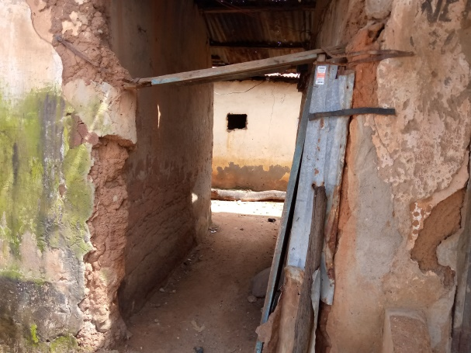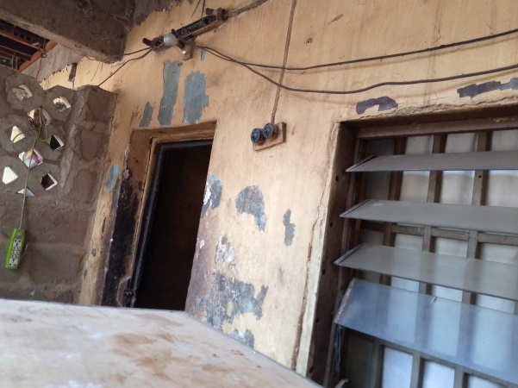
PLATE 1and 2 showing an obsoletestructure in Tudun Wada Area

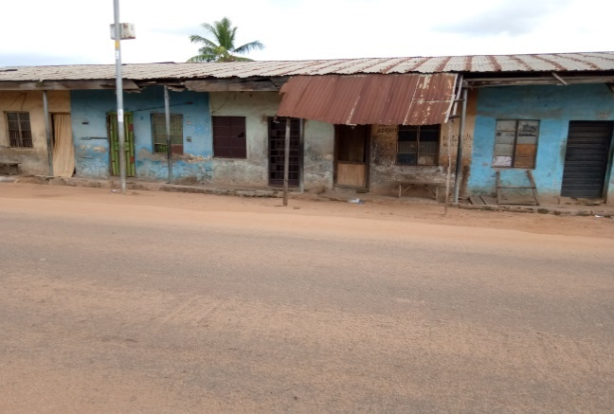
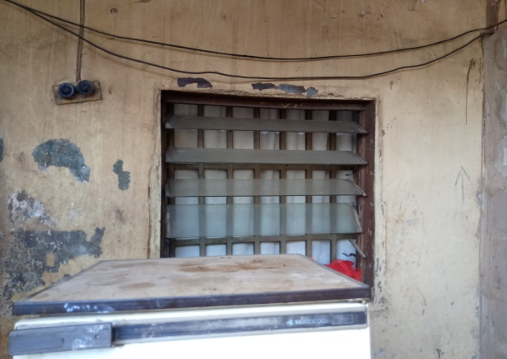

PLATE 3 and 4 showing an obsolete structure in Tudun Wada

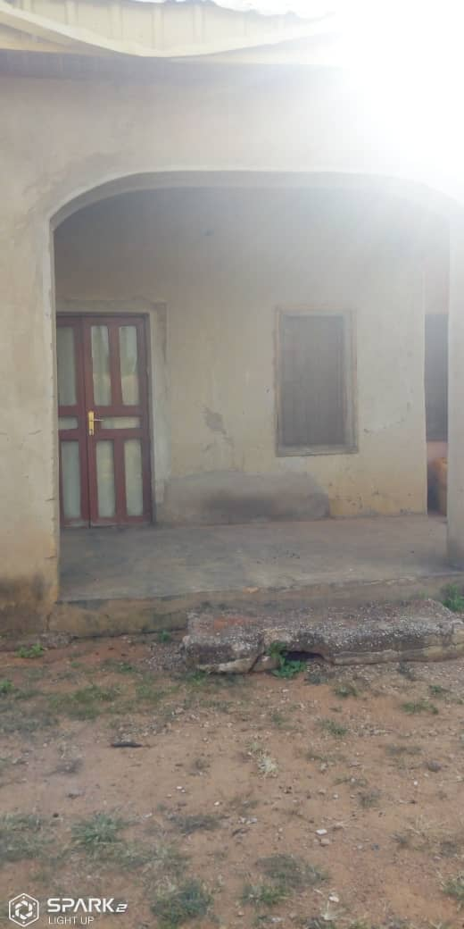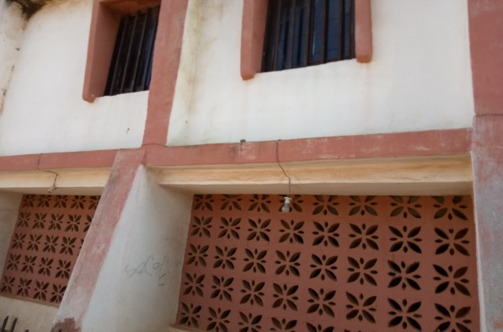

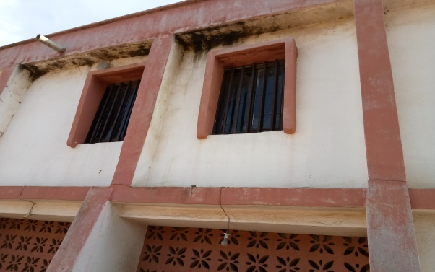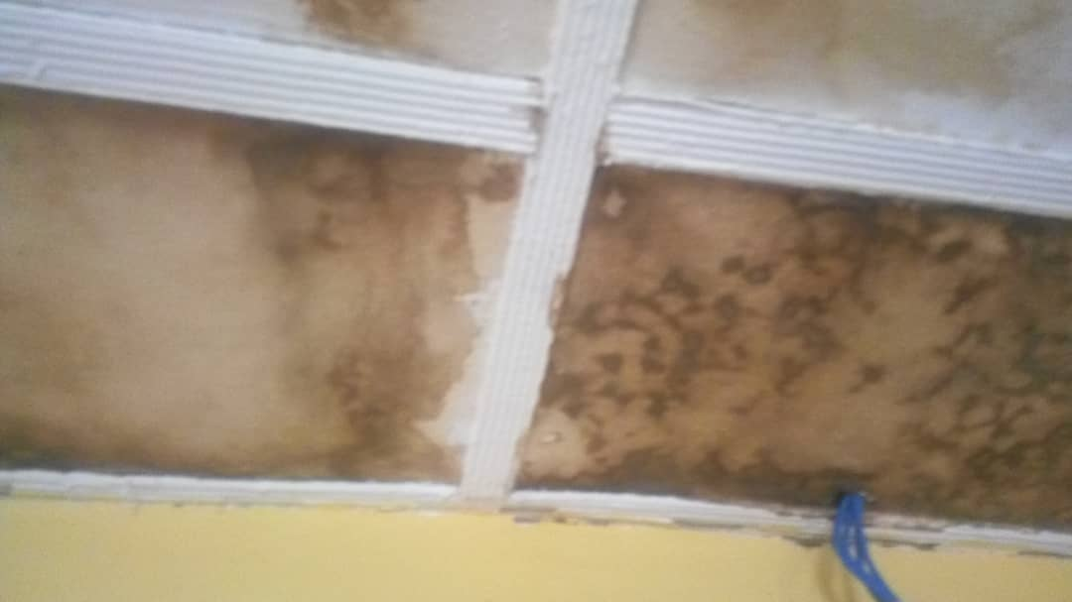
PLATE 5 and 6 showing some obsolete properties in Nassarawa

