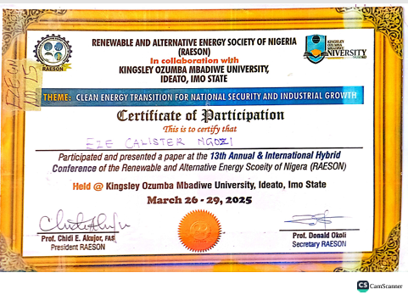

HARVESTING RENEWABLE ENERGY FOR A SUSTAINABLE FUTURE USING QUANTUM DOT TECHNOLOGY

AT

KINGSLY OZUMBA MBADIWE UNIVERSITY IDEATO IMO STATE

13TH ANNUAL AND INTERNATIONAL HYBRID CONFERENCE

Abstract
This paper explores the role of quantum dots in revolutionizing renewable energy technologies, addressing challenges such as stability and environmental impact. Renewable energy is essential for a sustainable future and advancements in nanotechnology have opened new possibilities for efficient energy harvesting. The result obtained indicates that quantum dots (QDs), display tunable electronic properties, discrete electronic state and high photon absorption efficiency. The novel properties allow for new design architectures such as immediate band, multiple exciton generation and multiple junction solar cell technologies. These mechanics have shown to derive quantitative gains in the solar to electricity conversion efficiency to surpass the Shockley and Quisser limit imposed on conventional cells. By integrating QD-based systems with solar photovoltaics and next generation batteries would paves the way for more efficient and sustainable energy solutions.

Keywords: Quantum dots, renewable energy, solar cell, nanotechnology.

Introduction
The global demand for clean and sustainable energy has driven the transition from fossil fuels to renewable energy sources.
quantum dot (QD) technology has emerged as a transformative tool, offering unparalleled capabilities to revolutionize energy harvesting and utilization.
Their tunable bandgaps, high absorption coefficients, and ability to enhance new device technology make them ideal candidates for next-generation photovoltaic devices
By harnessing the unique properties of quantum dots, we can significantly enhance the efficiency of renewable energy systems, reduce energy losses, and accelerate the development of sustainable energy technologies.
From improving the efficiency of solar cells beyond the Shockley-Queisser limit to enabling more cost-effective and flexible energy systems, quantum dot technology provides innovative solutions to address the limitations of traditional materials.
This paper explores how quantum dots are shaping the future of energy harvesting, focusing on their role in advanced solar cells and other renewable energy innovations.
Fossil Fuels
Fossil fuels are natural energy resources formed from the decomposed remains of ancient plants and animals, buried under layers of sediment and rock for millions of years.
These resources, which include coal, oil, and natural gas, are composed primarily of hydrocarbons and release energy when burned.
Fossil fuels are considered non-renewable because their formation takes geological time scales, far exceeding the rate of human consumption.
They have been the primary source of global energy for electricity, transportation, and industrial processes, despite their significant environmental and sustainability challenges.

Disadvantages of Fossil Fuels
Environmental Impact: Combustion of fossil fuels releases greenhouse gases like CO₂ and methane. These emissions trap heat in the Earth's atmosphere, causing global warming and leading to
Pollution: Burning fossil fuels produces air pollutants (e.g., sulfur dioxide, nitrogen oxides, and particulate matter). These pollutants cause smog, acid rain, and respiratory diseases, reducing air quality and harming ecosystems.
Finite Supply: Fossil fuels are non-renewable, with reserves depleting as consumption increases.
Economic Vulnerability: Price volatility in fossil fuel markets affects global economies, especially those dependent on energy imports.

The Transition to Renewable Energy
The environmental and economic challenges posed by fossil fuels are accelerating the global shift toward cleaner energy alternatives.

Renewable energy is energy that is generated from natural resources that can be replenished over time. These resources include sunlight, wind, water (hydropower), geothermal heat, and biomass.
Renewable energy sources are increasingly seen as sustainable replacements that can mitigate climate change, reduce pollution, and provide long-term energy security.
The most prominent among the renewable energy sources is solar energy, which harnesses the power of sunlight to generate electricity and heat.

Solar energy stands out due to its abundance, sustainability, and accessibility, as the sun provides an immense and virtually inexhaustible source of energy.

The solar energy spectrum is broad and encompasses photons with energies spanning from the ultraviolet (UV) region, through the visible light spectrum, to the infrared (IR) region, making solar radiation a rich and diverse energy source. as shown in Figure.1

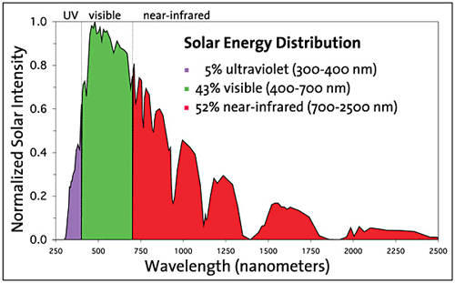
Figure 1: Solar energy distribution spectrum

Effectively utilizing this broad spectrum poses challenges for conventional photovoltaic materials, which have fixed bandgaps and can only absorb photons within a specific energy range

Solar Cell
A solar cell also known as a photovoltaic (PV) cell, is a device that converts sunlight directly into electricity through the photovoltaic effect. Semiconductors are usually the photo absorption materials in solar cells.
The photon-absorption in a semiconductor depends on the band gap $Eg$ of the material. When a photon with energy equal to or greater than the semiconductor's bandgap is absorbed, an electron jumps from the valence band to the conduction band, creating electron-hole pairs as shown in Figure 2.
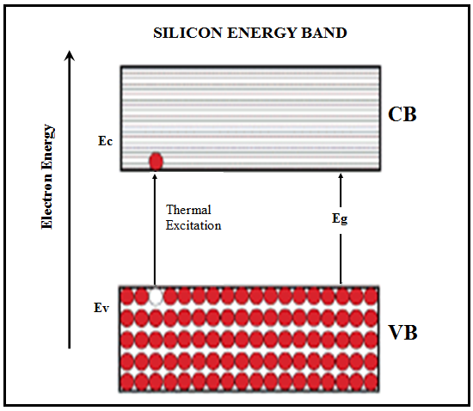
Figure 1.3: Semiconductor energy band diagram
This excitation is fundamental to the operation of semiconductor solar cells

Working principle of Solar Cell
When sunlight (photons) hits the solar cell, it is absorbed by the semiconductor material, typically silicon.

The energy from the photons excites electrons in the semiconductor, knocking them loose from their atoms.

An electric field in the solar cell directs the freed electrons, creating a flow of electric current.

The flow of electrons through an external circuit produces electricity that can be used or stored.
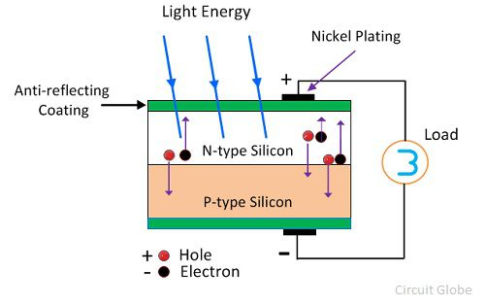
Figure 1.2: Basic operation of solar cell
Limitation of Conventional Solar Cells
In the conventional cell, band gap is a fixed parameter. .Only photons with energies equal to the material’s band gap are efficiently utilized to generate electrical energy.
Photons with energies less than the band gap are unable to activate the solar cell and hence are not utilized at all to generate electrical energy (transmission loss).
Photons having energies greater than the band gap are utilized to generate electrical energy, but the excess band gap energy is lost as heat (thermalization loss).
The inherent mismatch between the incident solar spectrum and the optical band gap of the absorber material that manifests in thermalization and transmission places an upper bound on the maximum power conversion efficiency to 31% often known as Shockley and Queisser limit
The solution is none but (a) increasing the photon absorption and (b) reducing the optical losses. These processes are more favorable in quantum dots QDs due to their combined advantages of discrete electronic states and tunable band gap.
Quantum Dots
A quantum dot (QD) is a nanoscale semiconductor particle that exhibits quantum mechanical behavior, where the motion of charge carriers (electrons and holes) is confined in all three spatial dimensions
The small size of QDs leads to “quantum confinement effect” which occurs when size of QD is comparable to bulk exciton Bohr radius (the average distance between the excited electron in the conduction band and the hole it leaves behind in the valence band)
This confinement results in (i) discrete, quantized energy levels in which electrons can only occupy specific energy states, similar to the atomic orbitals in atoms, often leading to QDs being referred to as "artificial atoms (ii) size-dependent bandgap where the bandgap increases as the size of the quantum dot decreases, leading to a blueshift in optical emission as shown in Figure 1.4.
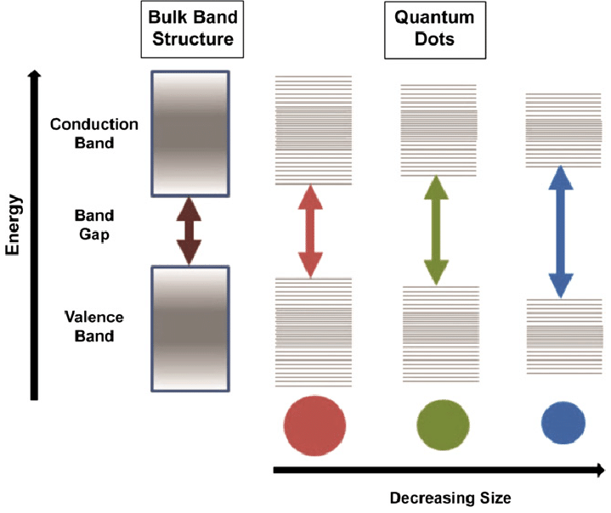
Figure1.4: Bandgap of quantum dots with decreasing size

- Mathematical formulation

In QDs, the electron and hole are confined such that they move freely within the dot but cannot go out, just like the particle in a box. Hence, QDs are real life particle in a box. We therefore used the particle in a model to study the effect of quantum confinement on the properties of QDs owing to their similarities. For particle confined in a potential well the energy level is expressed as
$$E= \frac{n^{2}h^{2}}{8mL^{2}}$$
However, we have made some adjustments to compensate for their discrepancies. Firstly, QDs are geometrically spherical in shape rather than square, hence the length of the box L is interchanged with radius R
$$E= \frac{n^{2}h^{2}}{8mR^{2}}$$
Secondly, there are two particles within the quantum dots (electron and hole) as shown in Figure rather than one seen in the particle in a box. The confinement energy of the electrons in QDs thus becomes:
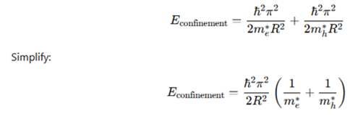

Figure 3.1: Exciton in the quantum box model
Thirdly, the masses of the electron and hole are replaced by their effective masses due to their interaction with the crystal lattice.
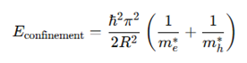
However, electrons in QDs do not move in a vacuum in contrast to the particle in a box, rather inside bulk semiconductor crystals. Therefore, energy gap of the bulk accounts for the baseline energy of the system. The energy gap of QDs is thus the energy gap of the bulk semiconductor and the confinement energy of both electrons and holes:
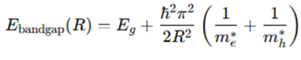
The simple models above show that discrete electronic states arise at conduction and valence bands and the energy gap of QDs becomes size dependent and larger with decreasing size due to the confinement of electrons and holes within the QDs

- Quantum Dots Solar Cell Technology

A quantum dot solar cell is a solar cell design that uses quantum dots primary absorbing photovoltaic material to enhanced light absorption and energy conversion efficiency compared to traditional solar cells
The discrete energy states and size-dependent optical properties of quantum dots (QDs) offer transformative advantages in reducing energy losses in conventional solar cells.
These unique features of QDs hold great promise for the development of highly efficient, next-generation solar cells via the following design architecture; multi junction solar cells, intermediate band solar cells and multiple exciton generation solar cells.

Multi Junction Solar Cells
Multi-junction solar cells are cells which consist of multiple stacked layers, each optimized to absorb a specific portion of the solar spectrum as shown in Figure 3.1. This mechanism improves the spectral utilization efficiency, allowing MJSCs to absorb and convert more sunlight into electricity across a wider spectrum
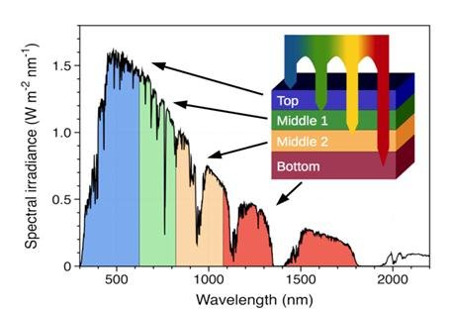
Figure 3.1: Multi Junction Solar Cell

3.1.1. Role of Quantum Dots in Multi Junction Solar Cells
The ability to adjust the bandgap of QDs by controlling their size enables the design of sub-cells in MJSCs that are precisely tuned to capture different wavelengths of sunligh as shown in Figure 3.2.
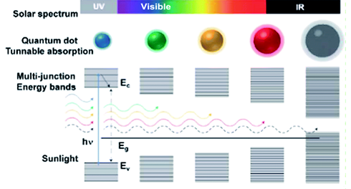
Figure 3.2: Multi junction energy levels
In this way higher-energy photons are absorbed in the higher-band gap semiconductors and lower-energy photons in the lower-band gap semiconductor.

Intermediate Band Solar Cells (IBSCs)
Intermediate band solar cells are cells designed to capture photons with energies lower than the primary bandgap of the material, thereby increasing the utilization of the solar spectrum

3.2.1. Role of Quantum Dots in Intermediate Band Solar Cells

Quantum dots create localized energy states within the bandgap of the host semiconductor due to quantum confinement effects.
These energy states act as an intermediate band, allowing sub-bandgap photons to excite electrons from the valence band to the intermediate band, and subsequently from the intermediate band to the conduction band as shown in Figure 3.3.
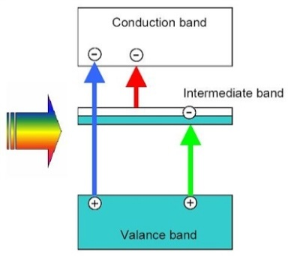
Figure 3.3: Intermediate Band Solar Cell (Luque and Martin, 2010)
This mechanism enables the absorption of photons with lower energy that would otherwise be unused.

Multi-Exciton Generation (MEG) Solar Cells
MEG refers to the process in which a single high-energy photon generates multiple electron-hole pairs (excitons) instead of just one, thereby increasing the photocurrent and improving the efficiency of solar cells as shown in Figure 3.4.
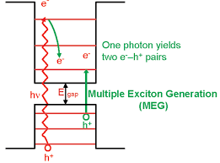
Figure 3.4: Multi Exciton Generation Mechanism

Role of Quantum Dots in Multi-Exciton Generation (MEG) Solar Cells
Quantum dots exhibit strong quantum confinement, which increases the Coulomb interaction between charge carriers. This makes it more likely for an absorbed high-energy photon to generate multiple excitons.
Quantum dots have a lower MEG threshold energy compared to bulk materials. In QDs, the energy required for MEG is closer to 2-3 times the bandgap energy, whereas in bulk semiconductors, it is much higher.
the wide separation between the quantized energy states in QDs can greatly increase in the optically excited hot exciton cooling time in QDs in contrast to subpicoseconds carrier relaxation time reported for the parental bulk.
The slow hot exciton cooling dynamics called phonon bottleneck makes it possible to exploit hot exciton created by the absorption of high energy photons to produce more excitons instead of losing its energy to phonon emission.

Conclusion:
In this presentation, it has been demonstrated that, the conversion efficiency of a solar cell with quantum dots included, could be improved through:
(i) multi-junction solar cells which utilize the entire solar spectrum reducing spectral mismatch losses seen in traditional (ii) intermediate band solar cells which allows the absorption of sub-bandgap photons minimizing transmission losses and
(iii) multi-exciton generation solar cells which utilizes high-energy photons to generate multiple excitons minimizing thermalization losses
By integrating QDs into these advanced designs, we move closer to unlocking the next generation of photovoltaic technologies capable of meeting global energy demands sustainably and efficiently.

REFERENCES
Adedokun, O; Titilope, K; Awodugba, AO (2016). Review on Natural Dye-Sensitized Solar Cells. Inter. J. Engineer. Technol. 2(2), 34-41.
Chapain, DM; Fuller, CS; Pearson, GL (2014). A new silicon p-n junction photocell for converting solar UKPENE, A. O; MORKA, J. C; MOLUA, O. C. Review on the Use of Dyestuff for Enhancement of Dye-Sensitized….. 1413 radiation into electrical power. J. Appl. Phys. 25: 676.
Edoardo, B (2000). “Diffusion capacitance identification of PV cells”. Proc 16th European photovoltaic solar energy conference. ISBN 902916182, 1-5 May 2000, Glasgow, Uk, pp.919 922.
Hagfeldt, A; Gratzel, M (1995). Light-induced redox reactions in nanocrystalline systems Chem. 95: 49-68.
Hagfeldt, A; Boschloo, G; Sun, L; Kloo, L; Pettersson, H (2010). Dye sensitized solar cells. Chem. Rev. 110: 6595-6663.
Hara, K; Arakawa, H (2003). Dye-sensitized Solar Cells, In: Handbook of photovoltaic science and engineering. In. Luque, A; Hegedus, S (Ed.), John Wiley & Sons, Ltd, ISBN: 0-471-49196-9.; pp.663-700. Haruna, I; Danladi, E; Gyuk, PM (2015). Development of organic dye sensitized solar cell incorporated with Ti02 nanostructures with low conversion efficiency for exploring solar energy concepts. Inter. J. Optoelectronic Engineer. 5(1): 16-19
Lagref, JJ; Nazeeruddin, MK; Graetzel, M (2008). Artificial photosynthesis based on dyesensitized nanocrystalline TiO2 solar cells. Inorganica Chimica Acta. 361(3): 735-745.
O’Regan, B; Gratzel, M (1991). A Low-cost high efficiency solar cell based on dye-sensitized colloidal TiO2 films. Nature, 353: 737-740.
Smestad, GP; Gratzel, M (1998). Demonstrating electron transfer and nanotechnology: A natural dye-sensitized nanocrystalline energy converter. J. Chem. Educ. 75(6): 752-756. Yella, A; Lee, HW; Tsao, HN; Yi, C; Chandiran, AK; Nazeeruddin, MK; Diau, EW- G; Yeh, C-Y; Zakeeruddin, SM; Gratzel, M (2011). Porphyrin synthesized solar cells with cobalt (II/III)- based redox electrolyte exceed 12percent efficiency. Sci 334, 629 Yen, CY;
Zakeeruddin, SM; Gratzel, M (2011). Porphyrin-sensitized solar cells with cobalt (ll/lll)-based redox electrolyte exceed 12 percent efficiency. Sci. 334:629-634.

