THERMAL, TRANSPARENCY AND WATER SENSITIVITY PROPERTIES OF BLEACHED, CROSS-LINKED CASSAVA STARCH FILM
J. Y. Jiya^{1, 2}, J. S. Enaburekhan¹, M. T. Jimoh¹, E. C. Egwim³, I. A. Joseph⁴
¹Department of Mechanical Engineering, Bayero University Kano.
²Department of Mechanical Engineering, Federal University of Technology, Minna.
³Department of Biochemistry, Federal University of Technology, Minna, Niger state.
⁴Department of Chemical Engineering, Federal University of Technology, Minna, Niger state
Abstract
This work investigated a novel study of the effect of bleaching and cross-linking cassava starch film. Native cassava starch was bleached with hydrogen peroxide (H₂O₂), cross-linking was carried out with oxidized sucrose while glycerol was added to enhance the plasticity of the film. Operating temperature and time of 90 ºC and 10 Minutes respectively with and addition of 0.5 ml of glycerol gave the best bleached, cross-linked cassava starch film. UV-visible spectrophotometer analysis revealed that the cassava starch film produced at the above reaction conditions retained 88.2 % of its transparency at 96 hours water immersion. The water solubility test shows that the film experienced 52.02 % weight loss after 96 hours immersion in water. The thermo-gravimetric analysis (TGA) shows a significant improvement on the thermal stability with Temperature peak (T_{p}) of 420.75 ºC, compared to 374.13 ºC T_{p} of the control sample (unbleached, uncross-linked) of the cassava starch film.
Keywords: bleached, cross-linked, transparency, water solubility, thermal stability
1.0 INTRODUCTION
Native starches possess numerous characteristics and advantages that presents them as excellent materials for non-food applications in industries. They possess biological and chemical properties like poly-functionality, non-toxicity and high reactivity to chemicals. Despite all these, they have several drawbacks including their hydrophilic properties that limit the development of industrial starch-based materials (Wang, et al., 2018).
Chemical modification, which involves etherification, esterification, oxidation, hydrolysis and crosslinking, is the most common method to improve the film forming capacity of starch. This method introduces new functional groups into the starch molecule and changes the physicochemical properties of starch. The most common method adopted in polysaccharide chemistry with a low cost is the cross-linking of starches (Ali & Syed, 2009). Generally, when bi-functional or multifunctional reagents capable of forming ether or ester linkages with hydroxyl groups introduce intermolecular bridges between polysaccharide macro-molecules, cross-linking occurs. Cross-linked starches have superior features compared to native starches, such as high mechanical and thermal properties, high water stability, resistance to high temperature and low pH, due to the stronger structure. The sequence in the procedure of modification has impact on the structure of the films (Canisag, 2015).
The performance characteristics of starch materials can therefore be improved by chemical cross-linking that fosters the formation of networks of molecules. In order to improve the properties of starch products, cross-linking has become a common approach, although the current trends are either toxic, very expensive or may not give the film the required properties. Aldehydes, especially Glutaraldehyde and formaldehyde have been the most commonly and frequently used chemicals for cross-linking of starch owing to the high efficiency of reaction (Parra et al, 2004) (Yang et al, 1996). Though highly reactive, they showed substantive improvement in both stability and mechanical characteristics. However, glutaraldehyde and formaldehyde are generally known for high toxicity and environmental hazards which consequently requires that controlled procedures with specialized equipment are employed for use in industrial applications (Di Stefano et al, 1999). Films from cross linked starch tend to be permeable to water vapor and have higher hydrophilic properties, which increased its thickness, permeability, solubility, and stability in acidic and alkaline medium (Monteiro, et al., 2017).
Non-toxic cross-linkers are currently in high demands as most available crosslinking agents possess toxicity issues associated with their high reaction efficiencies. Nevertheless, majority of the agents were void of the capacity to enhance tensile strenght and elongation at the same time. Narendra & Yiqi (2010) researched into the possibility of using citric acid, an inexpensive and non-toxic natural poly (carboxylic acid) as a cross-linker to enhance the stability and strength of starch films which yielded a strength of about 150% above the non-cross-linked starch films, and 35% loss in weight when immersed in formic acid for about 5 hours at 50ºC. However the elongation showed a limited extensibility. Wang, et al., (2018), in their study, employed oxidized sucrose to crosslink starch at 100, 110, 120 ⁰C revealing that the modification of the crystal structure increases the thermo-plasticity and water binding capacity of the film with excellent hydrophilic properties.
Although starch is an inexpensive, biodegradable and abundant source, industrial applications of starch films are limited due to their poor mechanical properties. This work presents the bleaching starch with H₂O₂, cross-linking of the starch films with oxidized sucrose, derived by periodate cleavage, having aldehyde groups in the structure which enables it to be used as a cross-linker in films, consequently improving the stability and strength of the films. The effects of process variables such as time, glycerol concentration and temperature on the transparency, thermal and water stability of the starch films were studied (Narendra & Yiqi, 2010).
2.0 MATERIALS AND METHODS
2.1 Experimental Materials
Cassava starch was gotten from local farmers in Bida, Niger State, Nigeria. Other materials used were distilled water, Sodium periodate (>98%), glycerol (99.8 %), sucrose, barium dichloride, and hydrogen peroxide (%) sourced from existingstandard laboratories.
2.2 Experimental Methods
The methods adopted in this work are as follows;
2.2.1 Preparation of Oxidized Sucrose
The oxidized sucrose was prepared according to the method reported by Wang et al. (2018). Periodate cleavage was adopted for the preparation of oxidized sucrose. 6.6g of sucrose was weighed into 250 ml reactor beaker followed by addition of 12.9 g of sodium periodate. 200 ml of distilled water was added to the reactor content and stirred for about 26 hours at room temperature. Complete precipitation was achieved by addition of 7 g barium dichloride to the reaction mixture at 5 ºC with constant stirring for a period of 60 minutes. The reactor content was then poured into a filter paper, thereafter, the filtrate containing polyaldehyde was stored at 5 ºC.
2.2.2 Bleaching of Cassava Starch with H₂O₂ and Cross-linking with Oxidized sucrose.
The starch film was prepared by measuring 50 ml of distilled water into a 250 ml beaker and heated on a hotplate magnetic stirrer until the temperature reaches 50 ºC. 3g of cassava starch was measured into the beaker and the temperature was allowed to attain 70 ºC before 0.5 ml of Hydrogen peroxide, H₂O₂ (30% V/V) was added for bleaching to improve the transparency, 0. 5 ml of the oxidized sucrose was added for cross-linking and further oxidation. 1.2 ml of glycerol was added to improve the plasticity. Five other experimental runs were repeated at varying time, temperature and amount of glycerol to obtain the cassava starch film (see Table 1).
2.3 Thermo-gravimetric Analysis (TGA)
The thermal stability of materials was analyzed with the help of TGA, since TGA helps to understand the trend of thermal degradation of a material on continuous exposure to heat (temperature) (Brown, 2007). 10 mg of each of the cassava starch film was weighed into crucible and placed in a TGA analyzer (PerkinElmer TGA 4000) with nitrogen purge of 40 cc/min. The heating rate was fixed at 10 ºC/min in order to imitate a slow pyrolysis condition while cooling water/algaecide mixture temperature was fixed at 15 ºC. Percentage weight retained was plotted against temperature. The data recorded was also subjected to derivative thermo-gravimetric (DTG) analysis in order to determine the rate of weight retained as function of differential temperature gradient.
2.4 Water Absorption Analysis
In determining the water resistivity of the films, the weight and percentage transmittance of the films were kept in-check as the films were soaked in water for several hours. Each film (of 2.2 cm height and 1 cm breadth) was weighed and its percentage transmittance was measured before immersing in water for several hours at intervals of 24 hours, until the film totally dissolved in water. Measurement of weight and percentage transmittance of each film after immersing in water was done by removing it from water and allowing the film to dry (Moritiwon et al, 2020).
2.5 Transparency Analysis
The transparency of the starch films was determined by measuring the amount of light that was able to pass through each film in the form of percentage transmittance. Prior to the percentage transmittance measurement, all films were scanned using spectrum mode of Shimadzu UV-Visible spectrophotometer, and peaks were observed within the range of 200 - 214 nm. Each film was cut to make a height of 2.2 cm and breadth of 1 cm, and placed in a cuvette (of 2.5 cm height and 1 cm breadth), which was then placed inside spectrophotometer and the percentage transmittance was measured at 214 nm. The higher the percentage transmittance, the more the transparency of the film (Moritiwon et al, 2020)..
3.0 RESULTS AND DISCUSSIONS
3.1 Mechanism of Oxidized Starch film
The presence of hydroxyl group (OH) in starch could be linked to its low thermal stability at high temperature, low water resistivity over a prolonged period and low transparency. In order to improve on these properties of starch film and make it fit for industrial applications, an alternative approach of starch film modification was carried out in this study. The mechanism of modification (Figure 1) involves the opening of the cyclic ring in sucrose in the presence of sodium periodate, this makes the oxidized sucrose available for bonding with starch molecule. The starch was first bleached with H₂O₂, the oxidized sucrose acting as cross-linker between the starches molecules to create a cleavage that improve on its mechanical properties. The introduction of glycerol help to improve create a stronger covalent bond between the oxygen atom from starch and the oxygen atom from glycerol which then replace the weak covalent bond in hydroxyl group of starch. This overall bonding could be linked to the improved plasticity of modified starch film.
Figure 1: Mechanism of modified starch film with oxidized sucrose, glycerol and hydrogen peroxide

Table 1. Changes in Transparency of the Films at various hours and intervals of 24 hours
 |  |  |  | Exposure Time (Hours)
Process parameters |  |  |  | 0 | 24 | 48 | 72 | 96 | 120
Samples | Temperature | Time | Amount of Glycerol (ml) | Degree of Transparency (%)
1 | 70 | 5 | 0 | 95.544 | 76.826 | 0 | 0 | 0 | 0
2 | 83 | 12 | 0.8 | 98.558 | 86.998 | 0 | 0 | 0 | 0
3 | 90 | 10 | 0.5 | 96.917 | 91.759 | 90.205 | 88.412 | 88.197 | 0
4 | 80 | 5 | 0.5 | 98.558 | 91.23 | 54.291 | 0 | 0 | 0
5 | 80 | 15 | 0.5 | 97.169 | 91.23 | 81.677 | 0 | 0 | 0

3.2 Transparency
As shown on Table 1 above, five different samples of oxidized starch films were produced at different conditions of temperature, time and amount of glycerol. The oxidized sucrose and hydrogen peroxide were kept constant due to almost fixed point effects during the preliminary experiment on the starch modification in this study as seen on table 1 above. Figure 2 shows the result of the transparency after the immersion in water and measurement were taken at intervals of 24 hours. From the preliminary study, starch film formation begins at temperature of 70 ºC. No glycerol was added to sample one (control sample), it has the least transparency of 95.54 %, after 24 hours immersion in water it transparency dropped to 76.82 %, at 48 hour water immersion the starch film experienced disintegrations (figure 3), hence it was no longer considered fit for transparency. Sample two and four both have the highest transparency of 98.56 % at 0 hour water immersion, after 24 hours in water the transparency of sample two dropped to 87 % while that of sample four dropped slightly to 91.23 %. On further immersion in water, sample two began to disintegrate (figure 4) while transparency of sample four dropped sharply to 54.29 %, sample four recorded disintegrations (figure 5) at 72 hours of water immersion. Sample three had a transparency of 96.72 % at 0 hour water immersion, a slight drop in transparency (91.76 %) was observed at 24 hours immersion in water, another slight drop in transparency (90.2 %) was also observed at 48 hours water immersion. Transparency of 88.41 % was recorded at 72 hours in water while there was no significant change in the transparency (88.2 %) at 96 hours water immersion, sample three experienced disintegration (figure 7) at 120 hours. For industrial application of cassava starch film were transparency is important, sample three is considered to be the best due to its ability to retain high percentage of it transparency up to 96 hours in water, however, previous studies failed to examined this important property of starch film.

3.3 Water Absorption Analysis
The water absorption analysis was carried out in order to determine the extent to which the film material can retain its properties before it completely dissolves in water. This can also be used to determine its area of application. The result in table 2 and figure 2 shows that sample one has the least percentage weight loss of 4.38 % at 24 hours immersion in water, on further immersion in water material completely dissolved in less than 48 hours. The result of sample three is of utmost interest as it experience only 14.38 % at 24 hours immersion in water, 23.28 % weight loss at 48 hours, 31.5 % weight loss at 72 hours in water and 52.05 % weight loss in water at 96 hours. The ability of sample three to retain high proportion of it weight in water over a long period could be attributed to the overall contributory effect of oxidized sucrose, hydrogen peroxide, glycerol as well as the high reaction temperature (90 ºC) which enhanced the proper bonding of the starch film. Pawinee and Natchanan (2019) reported that the water solubility of casaava starch film modified with glycerol ranges from 10 to 36 % in 24 hours of water immersion. This shows that there is significant improvement in the water solubility of the oxidized cassava starch film produced in this study and that it can be recommended for use where water solubility is less desired in starch film.
Table 2. Weight variation of the films at various hours at intervals of 24 hours
 |  | Process parameters |  |  |  |  | Exposure Time (Hours)
 |  |  |  |  |  |  | 24 |  | 48 |  | 72 |  | 96 |  | 120
Samples | Temperature (ºC) |  | Time (Min) | Amount of Glycerol (ml) | Degree of weight lost (%)
1 | 70 |  | 5 | 0 | 4.375 | - |  | - |  | - |  | -
2 | 83 |  | 12 | 0.8 | 50 | - |  | - |  | - |  | -
3 | 90 |  | 10 | 0.5 | 14.38 | 23.28 |  | 31.5 |  | 52.05 |  | 0
4 | 80 |  | 5 | 0.5 | 42.85 | 61.9 |  | - |  | - |  | -
5 | 80 |  | 15 | 0.5 | 18.18 | 30 |  | - |  | - |  | -

Oxidized Starch Film samples

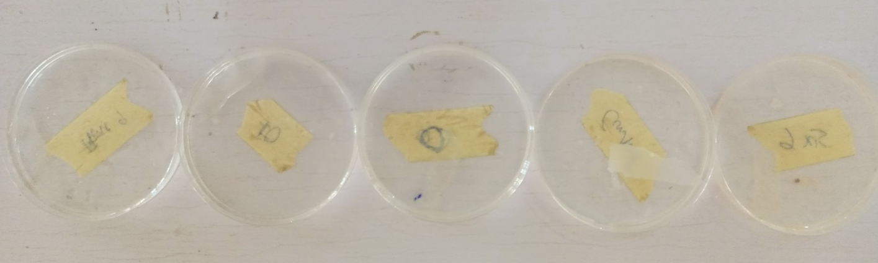
5
1
4
2
3
Figure 2. Nature of the films at 0 hour of water immersion
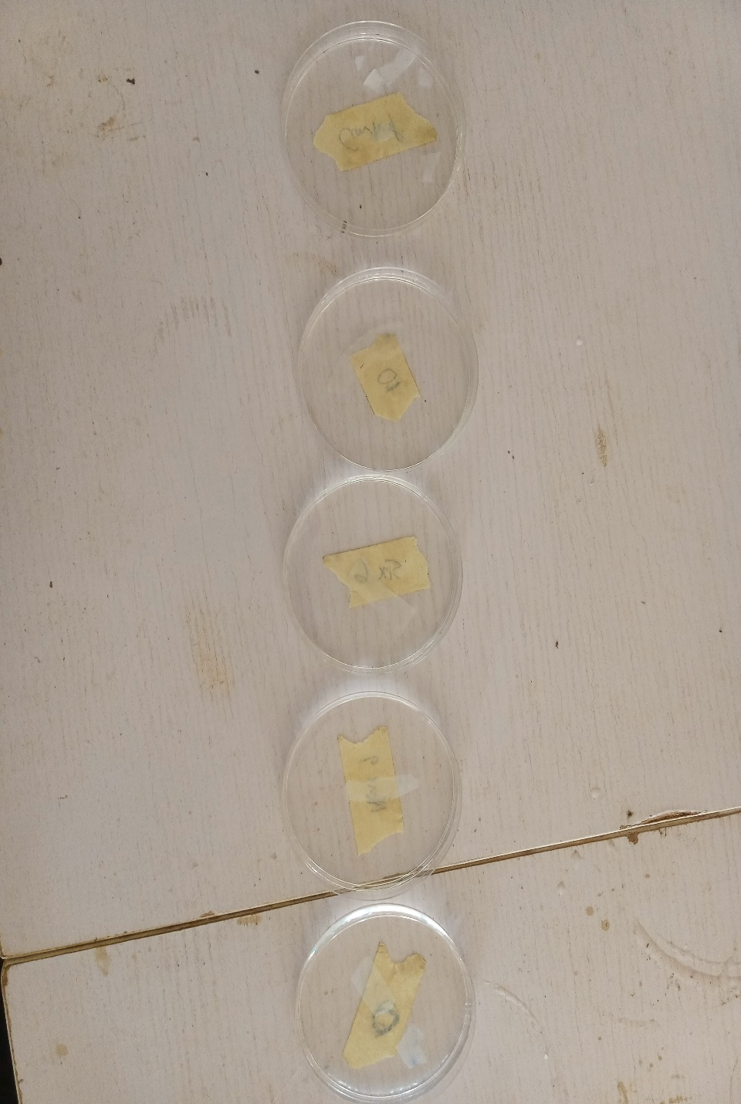
1
5
2
4
3
Figure 3. Nature of the films after 24 hours of water immersion
5
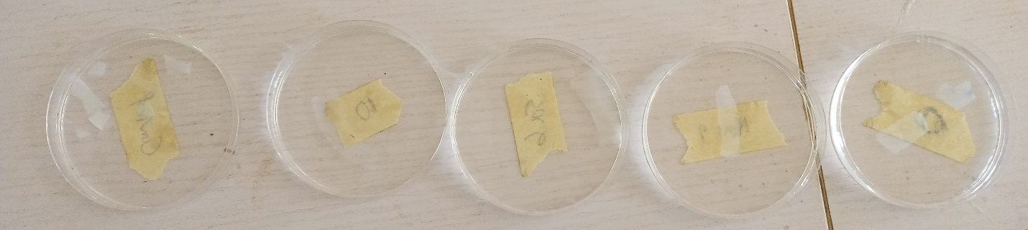
1
2
4
3
Figure 4. Nature of the films after 48 hours of water immersion
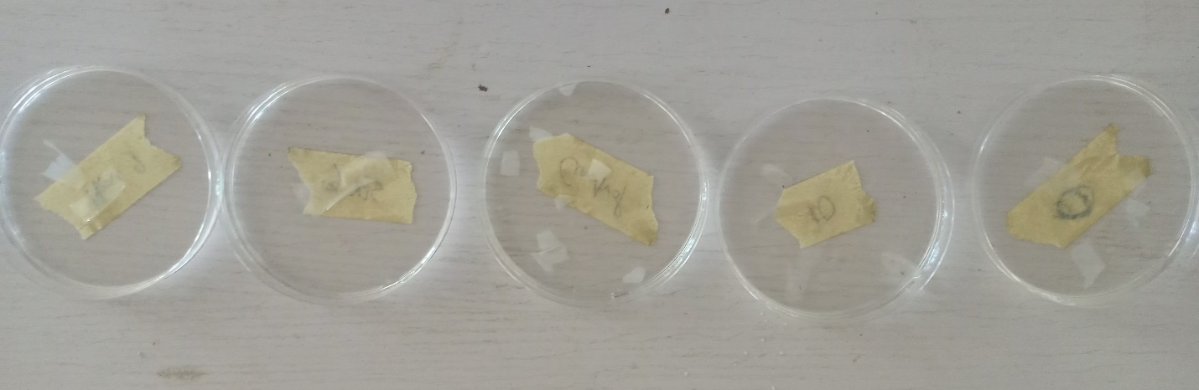
3
4
5
2
1
Figure 5. Nature of the films after 72 hours of water immersion
3
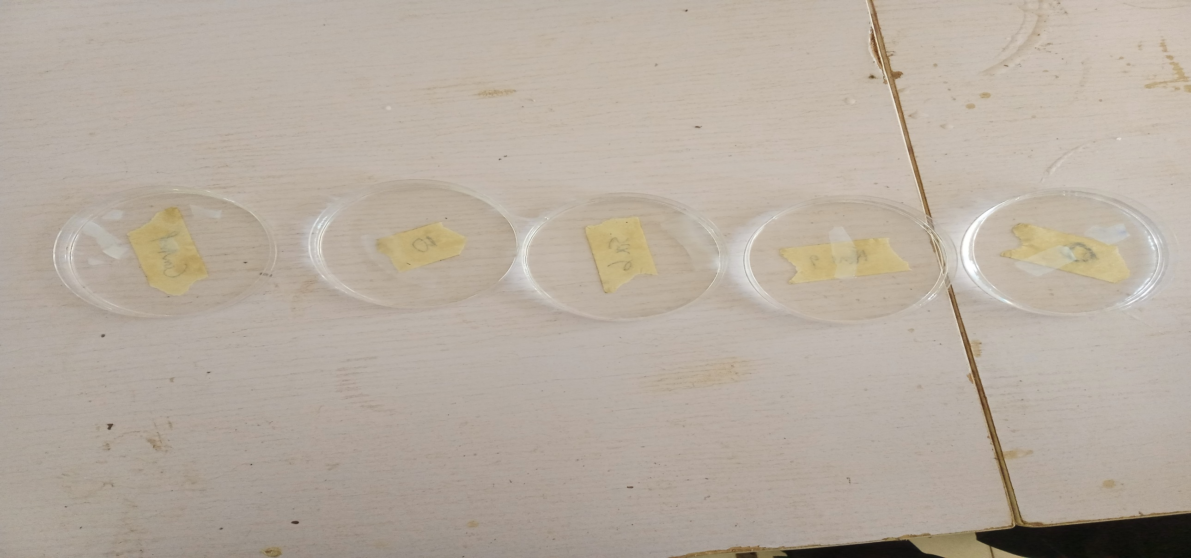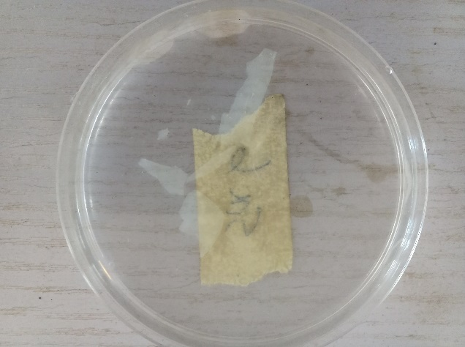
3
Figure 6. Nature of film (Sample 3) after 96 hours Figure 7. Nature of film (Sample 3) after 120 hours of water immersion of water immersion

3.4 TGA of Starch film
Thermal gravimetric analysis helps to understand the behavior of a material on exposure to heat (Brown, 2007). Table 3 below shows the percentage weight of starch film samples that are retained at different temperatures exposures. Sample 5 has the highest capacity to retain it 99 % of its weight at temperature of 150 ºC while both sample 3 and 4 have 98 % weight retention a same temperature. On further exposure of the samples to temperature up to 300 ºC, sample 5 has the highest weight retention of 98 % while sample 3 has the least weight retention of 82 %. Significant weight lost started on all the samples when the temperature was raised to 360 ºC and above.
Table 3: Weight variation of oxidized starch film on thermo-Gravimetric analysis
 | ` Weight Retained (%)
Temperature (ºC) | Sample 1 | Sample 2 | Sample 3 | Sample 4 | Sample 5
30 | 100 | 100 | 100 | 100 | 100
150 | 98.4 | 97 | 98 | 98 | 99
300 | 95 | 91 | 82 | 92 | 98
360 | 70 | 67 | 60 | 26 | 70
390 | 51 | 57 | 50 | 15 | 55

Figure 8 shows the graphical representation of the percentage weight retained at various exposure temperature of all the oxidized starch film samples. The thermal stability of starch film were not reported by earlier studies. The loss of moisture content of both uncross-linked and cross-linked starch film was first recorded at 150 ⁰C due to evaporation, this is referred to as first stage decomposition. Wang et al. (2018) reported first stage decomposition for both potato cross-linked and uncross-link starch film at 100 ⁰C. The polymer chain dehydration of the second stage decomposition for both starches were observed between 300 and 400 ⁰C. This is higher than the 150 and 300 0C second stage decomposition by Wang et al. (2018). The final stage decomposition temperature of 900 0C in this study is higher than the 600 ⁰C reported by Wang et al. (2018).
Figure 8: Mass retained against exposure temperature of cassava starch film
Figure 9 presents the DTG plots which provide information on the maximum weight loss rate in relation to the peak temperature (T_{P}). The T_{p} of the uncross-linked starch film in this is 374.13 ºC while that of the cross-linked samples are 385.51, 420.75, 324.42 and 385.32 ºC respectively. In contrast, it shows that the decomposition of uncross-linked starch film occurs before samples 2, 3 and 5. This implies that bleaching and cross-linking yields a better ordered structures of the starch, increasing its crystalinity and reducing rate of decomposition on heating. However the decomposition of the uncross-linked starch occurs after that of sample 4. This implies that bleaching and cross-linking led to a reaction that caused destruction of order of the starch structure, hence it readily decomposes with increase in temperature. Wang et al. (2018) reported Tp of 306.1 ºC for uncross-linked potato starch film and 265.6 to 275.7 ºC for cross-linked potato starch film. This shows that in terms of thermal stability, cross-linked cassava starch film in this study has better performance.
Figure 9: Derivative weight loss against Peak Temperature
4.0 CONCLUSIONS
Bleaching of cassava starch with H₂O₂ brought about improvement on the transparency of the film. In this study, oxidized sucrose (polyaldehide) was adopted for cross-linking of bleached cassava starch. Both bleaching and oxidation of the starch occurred at different operating temperature, time and amount of glycerol in order to produce bleached, oxidized cassava starch film. The sample 3 starch film synthesized at treatment temperature of 90 ºC, in 10 Mins with 0.5 ml of glycerol gave the best transparency ranging from 96.9 % at 0 hour water immersion to 88.2 % at 96 hours of continuous water immersion. The unbleached, unoxidized starch film has poor transparency retention on prolonged exposure to water as 95.54 % transparency was recorded at zero hour water immersion, 76.82 % transparency at 24 hours water exposure while further water exposure results into significant degradation of the film.
The unbleached, unoxidized starch film showed poor weight retention on prolonged immersion in water. 4.38 % weight loss was recorded at 24 hours water immersion after which significant degradation set in. Sample 3 has the best water stability with minimum weight loss of 14.38 % at 24 hours in water immersion and 52.05 % at 96 hours water immersion. The bleached, cross-linked cassava starch film of sample 3 in this study has the best thermal stability with Tp of 420.75 ºC while unbleached, unoxidized cassava starch film has lower thermal stability with 374.13 ºC.

5.0 REFERENCES

Ali, A., & Syed, S. R. (2009). An Overview of the Technology of Cross-linking of Starch for Non-food applications. Journal of Plastic Film and Sheeting, 25(1), 25-45.
Brown, M. E. (2007). Introduction to Thermal Analysis: Techniques and Applications. In M. E. Brown, Introduction to Thermal Analysis: Techniques and Applications (2nd ed.). Springer.
Canisag, H. (2015). Bio-Crosslinking of Starch Films with Oxidized Sucrose. Textiles, Merchandising and Fashion Design: Dessertations, theses and student Research. Retrieved from http://digitalcommons.unl.edu/textilesdiss/6
Di Stefano, F., Siriruttanapruk, S., McCoach, J., & Sherwood Burge, P. (1999). Glutaraldehyde: An occupational Hazard in hospital settings. Allergy, 1105-1109.
Monteiro, M., Oliveira, V., Santos, F., Neto, E. B., Silva, K., Silva, R., . . . Chiberio, A. (2017). Optimization of factors to obtain cassava starch films with improved mechanical properties. Journal of Physics: Conference series, 885.
Moritiwon, O. J., Afolabi, E. A., Garba, M. U., & Aboje, A. A. (2020). Experimental Investigation of fast Pyrolysis of Isoberlina doka-Derived Sawdust for Bio-Oil Production. Arabian Journal for Science and Engineering. , 37-45.
Narendra, R., & Yiqi, Y. (2010, February). Citric Acid Cross-linking of Starch Films. Food Chemistry, 118(3), 702-711. doi:10.1016/j.foodchem.2009.05.050
Parra, D., Tadini, C., Ponce, P., & Lugão, A. (2004). Mechanical Properties and Water vapour transmission in some blends of cassava starch edible films. Carbohydrate Polymers, 58(4), 475-481.
Wang, P., Feng, S., Shang, W. T., Zia, U.-D., Lei, C., Asad, N., . . . Hanguo, X. (2018). Synthesis and Characterization of Corn starch crosslinked with oxidized sucrose. Starch Starke journal. doi:10.1002/star.201800152
Yang, Y., Wang, L., & Li, S. (1996). Formaldehyde-free Zein fiber preparation and investigation. J. Appl. Polym. Sci., 59(3), 433-441.

