Application of Artificial Intelligence Tools for Sustainable Library and Information Science Research Practices among LIS Postgraduate Students in Federal University of Technology, Minna.
Dr. Miriam Ayinda Salubuyi
Federal university of Technology, Minna
m.salubuyi@futminna.edu.ng ; +2348034062394

Dr. Fatimah Jibril Abduldayan
Federal university of Technology, Minna ; +2347068155501
fj.dayan@futminna.edu.ng

Leah Yebo Gana
Federal university of Technology, Minna
tsadoleahyebo@gmail.com ;+2349034161942

Halimah Nene Tauheed
Federal university of Technology, Minna
halimahtauheed@futminna.edu.ng ; +2347035093191
Abstract
This study investigates the application and utilization of artificial intelligence (AI) tools by postgraduate students in Library and Information Science (LIS) for Sustainable Research practices in Federal University of Technology, Minna. To carry out this research, descriptive survey research design was used to gather the necessary data. Four research questions were formulated for the study. Total enumeration was used to adopt the total population of LIS postgraduate students in FUT, Minna. A close ended electronic questionnaire was developed which was used to collect data for this study. The data gathered from the questionnaire were analysed using descriptive statistics of percentages and charts. The findings shed light on the role of AI tools such as chatgpt, grammerly, chatbots, language translation services, Alexa and so on, in enhancing research efficiency, promoting environmental sustainability, and advancing social equity within the LIS community. The study also discusses challenges and barriers faced by students in adopting AI technologies, such as data privacy concerns, ethical considerations, and digital divide issues. Based on the empirical evidence, the study recommended that researchers should employ AI-powered tools to improve their research process and not over rely on AI tools; picking of the right AI tools based on their requirements; establishment of precise goals for AI applications; enlisting the expertise of Data Scientists and AI Specialists’ to effectively incorporate AI into their research and promotion of a collaborative research atmosphere. Overall, the research contributes to a deeper understanding of the intersection between AI and sustainability within the LIS education and research landscape.

Keywords: Artificial Intelligence, Postgraduate Students, Sustainability, Research, Library and Information Science

Introduction
Artificial intelligence (AI) is the imitation of human intelligence processes by computers, most notably computer systems. Expert systems, natural language processing (NLP), speech recognition, and machine vision are examples of artificial intelligence applications. According to Stryker & Kavlakoglu (2024), AI systems function by consuming massive volumes of labelled training data, analysing it for correlations and patterns, and then using these patterns to forecast future states.
AI is significant because of its potential to revolutionize how we live, work, and play. It has been successfully employed in business to automate functions previously performed by humans, such as customer service, lead creation, fraud detection, and quality control. Many of today's greatest and most successful organizations, including Alphabet, Apple, Microsoft, and Meta, rely on AI to enhance operations and outperform their competition. Parizio (2024) stated that, in many cases, AI can outperform humans in terms of efficiency and accuracy. It is especially beneficial for repetitive, detail-oriented jobs like reviewing huge quantities of legal papers to ensure that all relevant fields are completed correctly. The author further noted that, the power of AI to interpret enormous data sets, provides organizations with insights into their operations that would otherwise go unnoticed.

The fast-developing array of generative AI technologies is becoming increasingly significant
in industries such as education, marketing, and product creation. AI has expanded across a wide range of industry sectors and research fields. Here are a few of the more noteworthy examples: Healthcare, business, finance and banking, law, entertainment and media, journalism, software development, information technology, security, manufacturing, transportation, and education. According to Aranguena (2024), AI has several possible applications in educational technology. It can automate some portions of the grading process, freeing up instructors' time for other duties. AI tools may also evaluate students' performance and adjust to their specific needs, allowing for more personalized learning experiences where students can work at their own pace. AI tutors could help students stay on track and change the way they learn, potentially changing the role of educators. Postgraduate research is a formal area of study recognized by a university or institute of higher learning. It occurs after completing an undergraduate degree.

Statement of the Research Problem
Even though artificial intelligence (AI) has the potential to improve research productivity and results, there is a clear knowledge gap about the best ways to use these tools in LIS settings. Postgraduates in the discipline of Library and Information Science (LIS) are encountering greater difficulties in incorporating artificial intelligence (AI) capabilities into sustainable research procedures. This study intends to investigate how postgraduates are employing AI technologies in sustainable LIS research practices, with an emphasis on the advantages, disadvantages, and best practices for integrating AI. In order to improve information management, advance research methodologies, and give LIS professionals in the future the skills they need to use AI for sustainable development in the field, it is imperative that this issue be addressed.

Research Questions
The following research questions guided the study;
1. What specific AI tools are commonly used by LIS postgraduate students at Federal University of Technology, Minna?
2. To what extent do LIS postgraduate students at Federal University of Technology, Minna, currently use AI tools for conducting literature reviews and information retrieval?
3. What are the perceived benefits associated with using AI tools in library and information science research among postgraduate students?
4. What are the perceived challenges associated with the use of AI tools in library and information science research among postgraduate students?

Literature Review
The terms artificial intelligence, machine learning, and deep learning are frequently used
synonymously, particularly in marketing materials produced by businesses, but they have
different meanings. Succinctly put, Terzopoulos & Satratzemi (2019) stated that artificial intelligence (AI) is the general notion of robots mimicking human intelligence; machine learning and deep learning are particular approaches within this domain. Artificial intelligence (AI) describes computer programs that can execute sophisticated operations that were previously limited to human capability, like problem-solving, thinking, and decision-making. Zhang (2021) noted that word "AI" refers to a broad spectrum of technologies that underpin many of the products and services we use on a daily basis, ranging from chatbots that offer real-time customer care to apps that suggest TV series.

The term artificial intelligence (AI), which was first used in the 1950s, refers to a broad category of developing technologies, such as machine learning and deep learning, that seek to replicate human intelligence. It serves as the foundation for numerous significant discoveries and current developments in AI, such as ChatGPT and driverless cars. Artificial intelligence (AI) technology, in particular deep learning models like artificial neural networks, can analyze massive volumes of data considerably quicker than humans and produce predictions that are more accurate. A human researcher would be overwhelmed by the massive amount of data generated every day, but AI programs that use machine learning can take that data and swiftly transform it into knowledge that can be put to use.

Cognitive abilities like the following are key to programming AI systems:
- Education: In order to turn data into information that can be used effectively, this type of AI programming entails gathering data and developing rules, or algorithms. These algorithms give computers the step-by-step directions they need to do particular jobs.
- Logic: This part entails selecting the appropriate algorithm to provide the intended result.
- Self-rectification: In order to produce the most accurate results, algorithms in this area must constantly learn from their experiences and refine their algorithms.
- Originality: To create new text, music, images, ideas, and other media, this element makes use of neural networks, rule-based systems, statistical techniques, and other AI tools.

Using AI tools to acquire research knowledge and literature review

AI-powered research tools for reading, annotating, and taking notes can significantly improve the efficiency with which people acquire knowledge. According to Kundariya (2024), Such systems can present users with extracts from literature sources, with the most essential material highlighted, to assist them decide whether an item is worth reading. This allows the user to quickly find relevant material in research articles, decide which paragraphs to read in depth, and make notes on the subject. To make the most use of an AI-powered tool for research, users should critically evaluate the output without accepting it as 'the truth' and read the original text rather than depending just on AI-generated summaries.

Using AI for academic writing
Distilling difficult information from multiple sources and interpreting it with one's own original thoughts is an essential component of successful academic writing. Effective note-taking tools that can track source information and prevent plagiarism are essential for this procedure. Bin & Mandal (2019) AI-powered technologies not only assist researchers in taking and organizing pertinent notes for inclusion in their write-ups, but also in writing an article properly. Some AI systems assist researchers in paraphrasing sentences from their notes. Such tools are very valuable and useful for scholars from non-English-speaking nations.
AI for research planning and study design
AI-powered experimental design tools optimize parameters using machine learning methods. According to Ingley & Pack (2023), the automation of experimental design processes can assist researchers in saving time and effort while designing studies, allowing them to devote more time to data processing and interpretation. These AI solutions can also help to reduce human errors and R&D costs. Researchers must create models that consider a wide range of factors and characteristics in order to properly employ AI techniques for building experimental design models. Researchers can create optimal designs that maximize the effectiveness of their studies by entering particular criteria into such models.

Using AI for data analysis
Traditional data analysis methods according to Checco et al. (2021) relied on manual processes and had limited computational capabilities, but AI-powered data analysis tools have ushered in a revolution. Machine learning techniques are used in these technologies to understand, extract, and discover patterns in large datasets. This can help decrease time and costs while increasing the efficiency with which research output is generated.
To effectively employ AI tools for data analysis, researchers must first establish their project's objectives and describe the precise insights and outcomes they hope to obtain through the investigation. They must also collect useful data that is clean, well-structured, and ready for analysis.

Using artificial intelligence for peer review assistance
The volume of submissions for peer review is always increasing. Esplugas & Eur (2023) noted that, AI-powered peer review technologies have the potential to enable semi-automated peer review systems in which potentially low-quality or controversial studies are recognized and reviewers are matched with submissions based on their subject matter expertise. Although, AI cannot yet undertake peer review, AI technologies can be utilized efficiently in the peer review process to recommend acceptable journals for an article, perform initial quality control on submitted papers, and recruit reviewers.

Types of AI
According to Mario (2023), Professor Arend Hintze of the University of Michigan stated that AI can be categorized into four types. The categories are as follows:
- Reactive machines: These AIs are task-specific and lack memory. These kinds of machines simply respond to what is in front of them at any one time; they are unaware of past occurrences. As a result, they are unable to complete tasks outside of their constrained context and can only execute some sophisticated tasks within a very tight scope, such as playing chess.
- Limited memory: Since these AI systems are sentient, they can draw lessons from the past to guide their judgments in the future. This is how some of the decision-making processes in autonomous vehicles are built. Machines with little memory have a limited comprehension of the past. Compared to reactive machines, they are more capable of interacting with their surroundings.
- Theory of mind: Theory of mind is a term used in psychology. In terms of artificial intelligence, it describes a system that has emotional intelligence. In order for AI systems to become essential components of traditionally human teams, they must possess the ability to forecast behavior and infer human intents. "Theory of mind" machines are an example of an early artificial general intelligence.
- Self-awareness: AI systems that fall into this category are conscious because they possess a sense of self. Self-aware machines are aware of their own conditions. There isn't any AI like this yet. The most advanced artificial intelligence (AI) that exists theoretically is that of machines that are aware of themselves and the world around them. When most people talk, they mean this.

Advantages of AI
Every technological breakthrough has benefits and drawbacks. The advantages and disadvantages of AI are contested on many fronts.
The following are some advantages of AI as listed by Tableau (2024):
- Excellence in detail-oriented jobs: AI works well at tasks that require it to find links and subtle patterns in data that humans might miss. In the field of oncology, for instance, AI systems have proven to be highly accurate in identifying early-stage malignancies, such as melanoma and breast cancer, by indicating suspicious spots that require additional examination by medical specialists.
- Efficiency in data-heavy tasks. The amount of time needed for data processing is drastically decreased by AI systems and automation solutions. This is especially helpful in industries where regular data entry and analysis, along with data-driven decision-making, are crucial, such as banking, insurance, and healthcare. Predictive AI algorithms, for instance, can evaluate enormous amounts of data in the banking and finance industries to forecast market trends and assess investment risk.
- Time savings and productivity gains. Robotics and AI can increase productivity and safety in addition to automating tasks. For instance, AI-powered robots are being utilized more frequently in manufacturing to carry out monotonous or dangerous activities as part of warehouse automation, lowering the risk to human workers and boosting output all around.
- Consistency in results. Modern analytics tools process large amounts of data consistently while utilizing AI and machine learning, allowing them to continuously learn and adjust to new information. AI systems, for instance, have produced dependable and consistent results in language translation and legal document assessment.
Availability around-the-clock, scalability, process optimization, quicker research and development, sustainability, and conservation are further benefits of employing AI tools for research.

Disadvantages of AI
The following are some disadvantages of AI as state by Patron (2024):
- High cost: AI development can be highly costly. It costs a lot of money up front to build an AI model because it needs software, hardware, and infrastructure to be trained and store training data.
- Technical complexity: It takes a lot of technical expertise to develop, run, and troubleshoot AI systems, particularly in real-world production settings. Often, this information is not the same as what is required to create software that isn't AI.
- Talent gap: The issue of technical complexity is exacerbated by the fact that, despite the increasing need for experts with AI and machine learning training, there is a notable dearth of these specialists.
- Difficulty with generalization: AI models frequently perform exceptionally well on the particular tasks for which they were taught, but they have trouble with unfamiliar situations. The inflexibility of this can restrict AI's
- Job displacement: AI may result in job losses if businesses replace human labor with machines. This is a worry that is becoming more and more prevalent as AI models' capabilities advance and businesses use AI to automate processes.
- Security vulnerabilities: A variety of cyber threats, such as adversarial machine learning and data poisoning, can affect AI systems. For example, hackers can take private training data out of an AI model or fool AI systems into generating dangerous or inaccurate results. This is especially worrisome for security-sensitive industries like government and finance.
- Legal issues: AI brings up difficult issues with privacy and legal liability, especially in light of the regionally varied regulatory environment that is still developing for AI.

Pitfalls of using AI for academic research
AI cannot take the role of human researchers and has several drawbacks. The most relevant illustration of this is when generative AI creates academic references on its own rather than use actual articles. Instead than taking the role of academic scholars' critical thinking skills, AI-powered technologies should be used to supplement them. Jain & Alam (2020) noted that when researchers employ AI-assisted technologies to maximize their time and resources while conducting research-rather to having theses, publications, or grant applications written for them-they are most effective. Furthermore, researchers may become less innovative and creative as a result of AI tools. AI is predicated on input and current state of study. According to Patron (2024), Scientists must think critically, creatively, and innovatively if they want to advance science. Furthermore, copying and pasting content produced by AI alone may be plagiarism.

The top AI tools for researchers as listed by Simplilearn (2024), are:

- Google Scholar: This tool provides access to current research papers, scholarly literature, articles, conference papers, and theses. Scholars can also readily identify relevant publications and citations. Most significantly, its simple, user-friendly interface makes it an invaluable resource and useful tool.
- Scite: This is a popular AI-powered academic research tool that improves research efficiency. Its natural language processing and machine learning capabilities enable users to conduct better research on scholarly papers and assess citations.
- Trinka is a popular AI tool for improving grammar and language in academic and technical writing. It includes 3000+ grammar checks, tone, and style modifications to help researchers create error-free theses and projects. Trinka makes it easy to document scientific findings and write in a more technical tone and style.
- Elicit is a user-friendly AI tool for knowledge processing. This tool allows you to design and conduct qualitative research. This program allows a researcher to automate everything from textual data analysis to specifying significant topics, attitudes, and patterns. Elicit can also be used to generate summaries and graphics for efficient data analysis. Elicit is a valuable resource for researchers since it allows them to get deeper insights and make more educated judgments.
- Scholarly is an AI application that enhances academic research by automating reading, summarizing, and extracting information. It can assist you in recognizing figures, tables, and references from articles, as well as understanding the major principles. This application also has citation extraction features that allow users to organize and cite the sources utilized in their research. It also includes the literature review procedure, which allows you to save time and effort.
- Knewton's AI and machine learning algorithms provide individualized educational content. You can customize the tool for educational content based on individual needs and learning methods. This is a convenient and all-in-one instrument for academic study.

- IBM Watson provides AI-powered tools for academic study. This tool includes its own Watson Discovery and Natural Language Understanding capabilities. This program includes features such as data extraction, sentiment analysis, and language processing, which make the research process more efficient.
- Tableau is a strong tool for data analysis. Tableau's drag-and-drop interface enables users to quickly explore, comprehend, and find data, trends, patterns, and outliers. It can display everything from simple charts and graphs to complex maps, tree maps, and heat maps. Its user-friendly interface and extensive data visualization features make it a popular choice among data analysts, corporations, and researchers from various industries.

- Semantic Scholar is an AI-powered academic search engine that only displays relevant research papers. Its applications include computer science, neuroscience, and biomedical sciences. It also uses natural language processing and machine learning techniques to examine text. This tool can assist researchers in discovering and navigating relevant material, visualizing citations, and tracking academic articles. Some of the most popular features include extensive search capability and citation analysis.
- Mendeley is a user-friendly AI tool for organizing, sharing, and citing research publications. It simplifies PDF organization, bibliography creation, and document annotation. Furthermore, this technology allows scholars to work together on projects and find relevant publications based on their interests.

- Zotero is a tool intended specifically for academics and scholars to collect, organize, annotate, cite, and exchange research documents. This tool allows you to customize collections and automatically extract metadata from sources. Zotero contains 10,000 citation styles.

- Wordvice AI is a real-time, all-in-one text editor that uses cutting-edge AI technology. This AI research tool is intended to increase the overall quality of written material by making it more succinct, clear, and impactful. Wordvice AI distinguishes itself by focusing on academic and research writing, catering to the writing demands of students, researchers, and professionals who want high-quality editing to fulfill academic journal, conference, or professional publication standards.

- ChatGPT is designed to interpret and generate human-like writing, allowing for engaging conversations and instructive responses on a variety of topics. ChatGPT can help academic researchers in several ways. It can answer particular inquiries about the researcher's topic. It can also help in the early phases of a literature review by recommending relevant publications, authors, or trends. The AI chatbot can then help develop ideas for research questions, hypotheses, or experimental designs, provide simplified explanations for hard concepts, and improve manuscript grammar and word choice. Simplilearn (2024).

- Typeset.io offers established manuscript templates and automated formatting tools to conveniently meet journal and publisher criteria. Typeset.io is extremely effective for research collaborations because it allows multiple people to collaborate on the same manuscript simultaneously. It also has a citation management system and supports a variety of styles, automatically creating in-text citations and bibliographies. It also features a plagiarism detection feature and AI research writing tools to help you improve the quality of your paper. Simplilearn (2024).

- ChatPDF is a research AI tool that interacts with PDFs using chat-based commands. It reads and answers queries about the documents. Using ChatPDF is similar to conversing with a PDF document. When you submit an article in PDF format into the research software, ChatPDF provides a synopsis and proposes questions based on the complete text. The AI also generates semantic indexes for each text, making it one of the most effective AI tools for academic research.
- Research Rabbit is an AI tool for researchers, enables speedy and effective examination of scientific papers. It allows academics to create paper collections and receive regular recommendations for fresh literature based on their specific interests. ResearchRabbit also visualizes article and co-authorship networks, allowing academics to exchange collections with others to increase collaboration. Simplilearn (2024).
- QuillBot: QuillBot is an advanced writing and paraphrasing tool designed to improve the quality and efficiency of writing for a wide range of users, including students, professionals, and researchers. At its core, QuillBot uses state-of-the-art AI technology to rephrase and refine text, ensuring that the output is both original and stylistically appropriate. The tool features several modes, such as Standard, Fluency, and Creative, which allow users to tailor the text according to their specific needs and preferences. (Fitra, 2021).

- Grammarly is a paraphrase tool that can be used using the Google Chrome plugin. It can identify errors in grammar and spelling, identify improper sentence structure, and detect plagiarism. Since they allow students to complete a task and then rectify faults, these can be useful tools for the rules learning and error correction technique. The most effective tool available to users to check their typing for errors is Grammarly. Prepositional errors, irregular verb conjugations, improper noun usage, and misused words are all identified and corrected by Grammarly. (Fitra, 2021)

Methodology

This study employed descriptive survey research design. The population of the study is made up of 55 postgraduate students which includes Masters and Doctorate students in Library and Information Science Department. Total enumeration sampling technique was adopted to use the whole population as a sample for the study. As presented in Table 1.1;

 | F (%)
Masters Students | 30 (54%)
Doctorate Students | 25 (46%)
Total | 55 (100%)

Data was collected through an electronic questionnaire.

RESULTS

Table 1.2 Response rate of Respondents

 | Total Number (F%) | Response Rate (F%)
Masters Students | 30 (54%) | 26 (68.4%)
Doctorate Students | 25 (46%) | 12 (31.6%)
 | 55 (100%) | 38 (69%)

Figure 1.1 showing response rate of the respondents

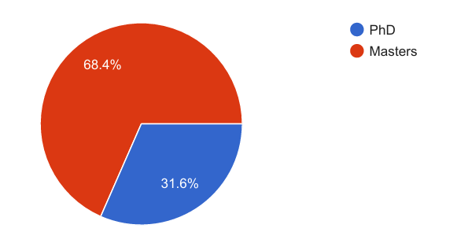
From table 1.2 and Figure 1.1, 26 (68.4%) of the respondents are Masters students, while, 12 (31.6%) are doctorate students.

Figure 1.2 showing the level of the postgraduate on their researches.

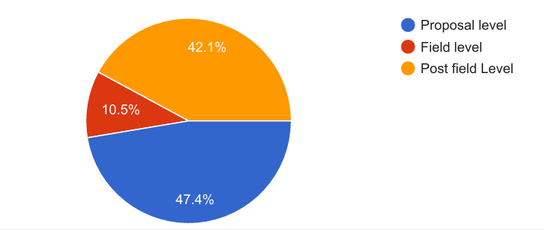
From figure 1.2, 18 (47.4%) are at their proposal level, 4(10,5%) are on field , while, 16(42.1%) are at their post field level.

Figure 1.3 showing specific AI tools are commonly used by LIS postgraduate students at Federal University of Technology, Minna?
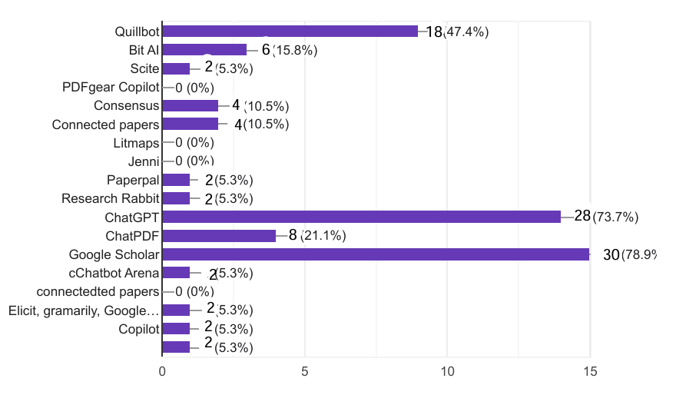
Figure 1.3 shows that google scholar is the most commonly used AI tool by LIS postgraduate students with 30 (78.9%) respondents. This is closely followed by ChatGPT with 28 (73.7%) respondents. Quillbot, ChatPDF, and Bit AI are being used by 18 (47.4%), 8(21.1%) and 6 (15.8%) respondents respectively. Consensus and Connected papers have 4 (10.5) users each, while, Paperpal, Research Rabbit, Copilot, cChatbot arena, Grammarily and Scite are the least used AI tools with 2 (5.3%) users. The two most used AI tools being Google scholar and ChatGPT could be because of their vastness and ease of use. This is pointed out by paperpile (2024) noting that, Google scholar, also thought of as the academic version of google is a free academic search engine that provides answers to researchers by searching the repositories of publishers, universities and scholarly websites. Ortiz (2024) also noted that, ChatGPT’s unique abilities of allowing users to have human-like conversations to complete various tasks, and assisting researchers with composing text, code and much more, sets it apart.

Figures 1.4 showing the extent to which LIS postgraduate students at Federal University of Technology, Minna, currently use AI tools for conducting literature reviews and information retrieval.
Figure 1.4a Automated Literature search
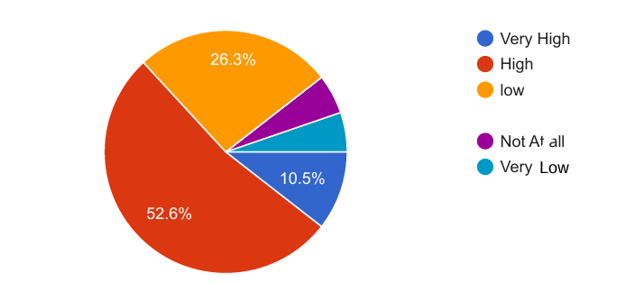
Figure 1.4a showed that 4 (10.5%) respondents answered very high to using AI tools for automated literature search, while, 20 (52.6%) answered highly to same. 10 (26.3%) of the respondents answered low to same. This result indicates that more of the respondents use AI tools for automated literature search. This could be because of the comprehensive coverage, efficiency, enhanced analysis and reduced human error associated with the use of automated literature search AI tools. Aranguena (2024).
Figure 1.4b Text Mining and Analysis
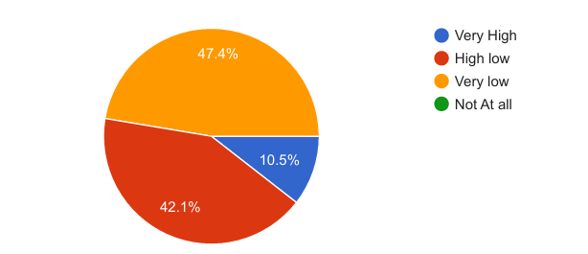
Figure 1.4b, shows that 4 (10.5%) and 16 (42.1%) respondents very highly and highly use AI tools for text mining and Analysis, while, 18 (47.4%) respondents very lowly use same. This result signifies a high use of AI tools for text mining and analysis. Using AI tools for text mining and analysis provide Real-time analysis, allowing for immediate insights and decision making. In addition, many AI tools offer advanced visualisation features, making it easier to interprete and communicate findings. (Simplilearn, 2024).

Figure 1.4c Citation and Reference Management
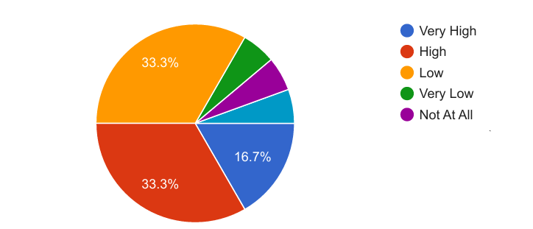

Figure 1.4c, shows that 13 (33.3%) and 6(16.7%) respondents very highly and highly use AI tools for text mining and Analysis, while, 13 (33.3%) respondents very lowly use same. This result signifies a high use of AI tools for citation and reference management. The search functionality and automated organization abilities of AI tools makes them very dependable tools for researchers to use for citation and organising references (Simplilearn, 2024).

Figure 1.4d Collaboration and Communication
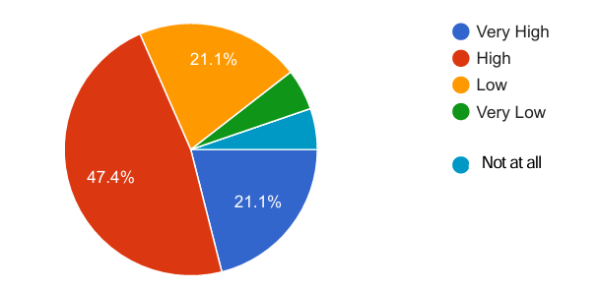
Figure 1.4d shows that a greater number of the respondents in 18(47.4%) and 8(21.1%) agree to the that fact AI tools are beneficial for collaboration and communication, while, 8(21.1%) respondents answered lowly to same.

Figure 1.5 showing perceived benefits associated with using AI tools in LIS Research

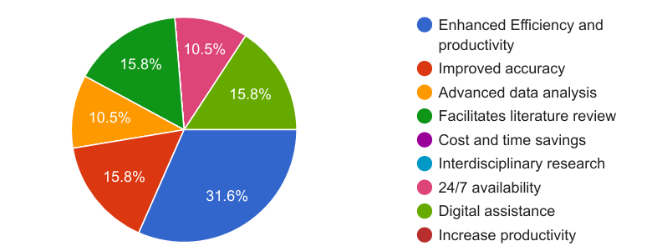
Figure 1.5 shows that majority of the respondents, 12(31.6%) believe that AI tools can enhance efficiency and productivity. While, 6(15.8%) respondents agreed that working with AI tools improves accuracy of research results, facilitates literature review and gives digital assistance to the user. While, the options of constant availability and advanced data analysis had 4(10.5%) respondents respectively.
Figure 1.6 showing perceived Challenges associated with Using AI tools in LIS Research
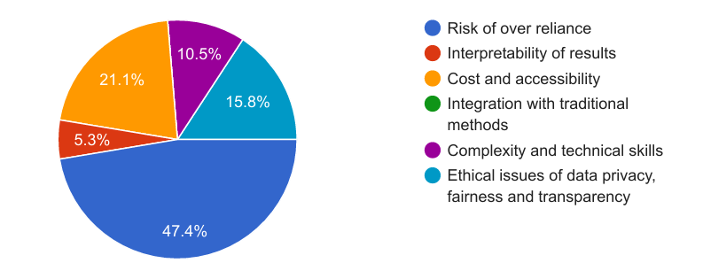
On the challenges that could be encountered in the use of AI tools by LIS postgraduate students, figure1.6 shows that, the risk of over reliance on AI tools had the highest respondents with 18(47.4%) respondents; closely followed by the option of high cost and accessibility with 8(21.1%) respondents. Ethical issues of data privacy and transparency, complexity and technical issues and interpretability of results had 6(15.8), 4(10.5%) and 2(5.3) respondents, respectively.

Recommendations
The following recommendations were to assist academic scholars in using AI more successfully:
1. Artificial intelligence (AI) must not be used to replace the critical thinking needed to do research; rather, researchers should employ AI-powered tools to improve the research process and maximize their time.
2. Whether AI is being used for data visualization, machine learning, or natural language processing, researchers should pick the right frameworks and tools based on their requirements.

3. Researchers should establish precise goals for AI applications, such as literature reviews, data analysis, and predictive modeling.

4. To promote a collaborative research atmosphere, researchers should devote time to studying AI ideas and sharing your knowledge with colleagues.

References
Aranguena, I. (2024). AI in Research: its uses and limitations. Research to Action. Retrieved from www. research to action.org/2024/04/ ai-in-research-its-uses-and-limitations.
Bin, Y., & Mandal, D. (2019). English teaching practice based on artificial intelligence technology. Journal of Intelligent & Fuzzy Systems, 37(3), 3381–3391. https://doi.org/10.3233/JIFS-179141.
Canbek, N. G., & Mutlu, M. E. (2016). On the track of Artificial Intelligence: Learning with Intelligent Personal Assistants. Journal of Human Sciences, 13(1), 592–601.
Checco, A., Bracciale, L., Loreti, P. (2021). AI-assisted peer review. Humanities Social Sciences Communication, 8(25). https://doi.org/10.1057/s41599-020-00703-8.
Esplugas,M. & Eur,S.H.J (2023). The use of artificial intelligence (AI) to enhance academic communication, education and research: a balanced approach. PubMed, 48(8), 819-822. Doi: 10.1177/17531934231185746.
Fitria, T. N. (2021a). Grammarly as AI-powered English Writing Assistant: Students’ Alternative for Writing English. Metathesis: Journal of English Language, Literature, and Teaching, 5(1), 65–78. https://doi.org/10.31002/metathesis.v5i1.3519.
Fitria, T. N. (2021b). QuillBot as an online tool: Students’ alternative in paraphrasing and rewriting of English writing. Englisia: Journal of Language, Education, and Humanities, 9(1), 183–196. https://doi.org/10.22373/ej.v9i1.10233.
Ingley, S.J. & Pack A. (2023) Leveraging AI tools to develop the writer rather than the writing. Trends in Ecology & Evolution, 38 (9), 785-787.

Jain, S., & Alam, M. A. (2020). Comparative Study of Artificial Intelligence-Based Teaching with Human Interactive Teaching: In E. C. Idemudia (Ed.), Advances in Business Strategy and Competitive Advantage68–100). IGI Global. https://doi.org/10.4018/978-1-7998-3351-2.ch005.
Kundariya, H. (2023) Edge AI: Driving next generation AI applications in 2024. Edge Industry Review. Retrieved from www.edgeir.com/edge-ai-driving-next-generation-ai-application in 2024-2023/020.
Klamma, R., Lange, P. de, Neumann, A. T., Hensen, B., Kravcik, M., Wang, X., & Kuzilek, J. (2020). Scaling Mentoring Support with Distributed Artificial Intelligence. Intelligent Tutoring Systems, 38–44. -https://doi.org/10.1007/978-3-030-49663-0_6.
Mario, S. (2023). Understanding the 4 types of AI, from reactive robots to self-aware beings, Medium. https://medium.com.
Patron, M. (2024) proceed with caution: The potential negative impact of AI on scientific research. Retrieved from www.mariecuriealumni.eu/newsletters/35th-mcaa-newsletter/special-issue-proceed-caution-potential-negative-impact-ai.
Patrizio, A. (2024). Physical AI explained: Everything you need to know. Retrieved from www.techtarget.com/whatis/ physical-AI-explained-everything-you-need-to-know.
Stryker, C. & Kavlakoglu, E. (2024). What is AI? Retrieved from www.ibm.com/topics/artificial-intelligence.
Simplilearn (2024) Types of artificial intelligence that you should know in 2024. Retrieved from www.simplilearn.com/tutorials/artificial-intelligence-tutorial/types-of-artificial-intelligence.
Tableau (2024) What are the advantages and disadvantages of artificial Intelligence (AI)? Retrieved from www.tableau.com/data-insights/ai/advantages-disadvantages.
Terzopoulos, G., & Satratzemi, M. (2019). Voice Assistants and Artificial Intelligence in Education. Proceedings of the 9th Balkan Conference on Informatics, 1–6. https://doi.org/10.1145/3351556.3351588.
Zhang, Z. (2021). The Impact of Digital Technologies on Entrepreneurship Education. 448 452. https://doi.org/10.2991/assehr.k.210407.088.

