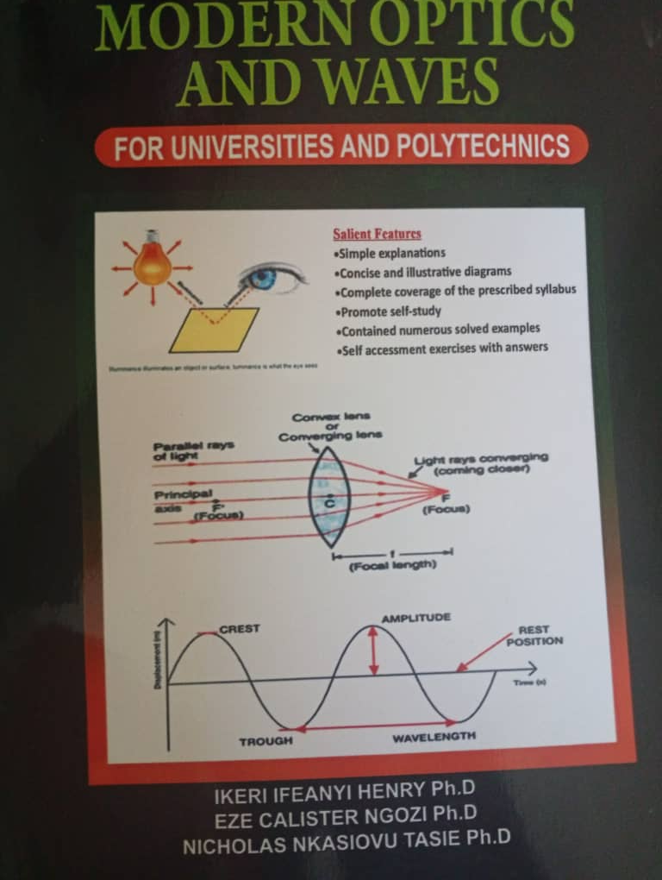
MODERN OPTICS AND WAVES

FOR

UNIVERSITIES AND POLYTECHNICS

Salient Features
• Simple explanations
• Concise and illustrative diagrams
• Complete coverage of the prescribed syllabus
• Promote self-study
• Contained numerous solved examples
• Self assessment exercises with answers

___________________________
IKERI IFEANYI HENRY (Ph.D)
EZE CALISTER NGOZI (Ph.D)
NICHOLAS NKASIOVU TASIE (Ph.D)

ii
PUBLISHED BY:
SOFIATA PUBLISHERS
63 Okporo Road
Rumuogba
Port Harcourt, Nigeria.

Copyright @ Ikeri Ifeanyi Henry
First Published in 2022

WARNING:
All rights reserved. No part of this book may be reproduced, transmitted or pirated in
any form or by any means, electronic or mechanical, including photocopying,
recording or information storage and retrieved systems without the prior written
permission of the authors, copyright owner and publisher.

ISBN:

Printed by
UlchDigi Prints & Services Nig.
13 Clifford and Georgewill Plaza, Uniport Junction,
Behind Kilimanjaro Fast-food,
Port Harcourt.
Tel: 08036675007

iii

DEDICATION

This book is wholly dedicated to Almighty God who for the wisdom and inspiration for
this textural material.

Iv

PREFACE AND ACKNOWLEDGEMENT
Modern optics and waves and is designed to meet the objectives of the National
University Commission (NUC) and National Board for Technical Education (NBTE)
for university and polytechnic students in science and engineering. The book is
specially written as a teaching aid to assist the students in tertiary Institutions in
grasping the elementary topics in physics.
The inspiration for this book arises from the author’s many years of teaching
experience, interaction with students and the key roles optics and waves played and
continue to in our daily life and advancement of mankind. The techniques adopted in
this book makes it invaluable not only to students and professionals but to all who wish
to understand the basic electronics. This book is written in a very simple and concise
manner in order to ensure easy reading and understanding
The book has been logically organized in six chapters, Chapter 1 provides reflection
and refraction at plane surfaces. Chapter two explains reflection at curve surfaces.
Chapter 3 describes refraction through thin lenses. Chapter 4 devotes to optical
instruments. Chapter 5 deals photometry and photometers. Chapter 6 treats concepts of
waves. Chapter 7 focuses on sound waves. Chapter 8 dwells on musical notes and
resonance. Chapter 9 provides insight on beats, Doppler Effect and electromagnetic
waves. Throughout chapters more attention is focused on the fundamental concepts,
large number of explicit diagrams and solved example to provide balanced coverage of
the book and to aid the readers grasp the subject clearly.
Exercises and problems have been provided at end of each chapters to help the students
prepared accordingly. Students should be able to evaluate their level of understanding
of the treated topics from their ability in solving such problems. A sound knowledge of
Advanced ‘level physics is required to understand fully the topics treated. This book is
therefore strongly recommended for science and engineering students of universities,
polytechnics, colleges of education, professionals and all lovers of knowledge.
v
TABLE OF CONTENTS

Dedication iii
Preface iv
Table of Contents vi
Chapter 1
1.0 REFLECTION AND REFRACTION AT PLANE SURFACES 1
1.1 Nature of Light 1
1.2 Natural and Man-Made Source of Light 3
1.3 Luminous and Non-luminous Object 3
1.4 Transparent, Translucent, and Opaque Objects 3
1.5 Properties of Light 3
1.6 Ray 4
1.7 Beam 4
1.8 Rectilinear Propagation of Light 5
1.9 Reflection of Light 5
1.10 Mirror 7
1.11 Plane Mirror 8
1.12 Formation of Images By Plane Mirror 8
1.13. Images Formed In Two Inclined Mirrors 9
1.14. Refraction of Light 11
1.15. Definition of Terms 12
1.16. Types of Refraction 12
1.17 Refractive Index 14
vi
1.18 Effects of refraction at a plane surface 16
1.19 Real depth, apparent depth and refractive index 19
1.20. Experimental determination of refractive index by real and
apparent depth method. 20
1.21 Refraction by a triangular prism and minimum deviation 22
1.22 Applications of Refraction of Light 26
1.23 Total Internal Reflection 28
1.24 Relation between critical angle and refractive index 30
1.25 Total internal reflection in nature 31
Chapter 2
2.0 REFLECTION AND REFRACTION AT SPHERICAL SURFACES 37
2.1. Spherical mirror 37
2.2. Characteristics of a Focus between Concave and Convex Mirror 40
2.3. Rules for Image Formation in a Spherical Mirror 40
2.4. Images formation by a Concave Mirror 43
2.5. Image Formation by Convex Mirror 47
2.6. Sign convention for reflection by spherical mirrors 48
2.7. Relationship between Focal Length and Radius of Curvature 49
2.8. The Mirror Formular 50
2.9. Magnification 53
Chapter 3
3.0 REFRACTION THROUGH LENSES 60
3.1. Lenses 60
3.2. Definition of terms 61
3.3. Image Formation in Lenses Using Ray Diagrams 62
vii
3.4 Nature, position and relative size of the image formed by a convex
lens for various positions of the object 64
3.5 Nature, position and relative size of the image formed by a concave
lens for various positions of the object 68
3.6 Lens Formula and Magnification 69
3.7 Magnification 72
3.8 Power of a Lens 75
3.9 Power of a Combination of lenses 78
3.10 Defects of Lenses or Lens Aberrations 82
Chapter 4
4.0 OPTICAL INSTRUMENTS 87
4.1. Human Eye 87
4.2. Structure of the eyes 87
4.3. Parts of the Eye and their Function 88
4.4. Working Principle of an Eye 89
4.5. Far Point 89
4.6. Near Point/Least Distance of a Distinct Vision 90
4.7. Power of Accommodation 90
4.8. Problems with Vision 90
4.9. Presbyopia 92
4.10. Astigmatism 92
4.11. The Camera 93
4.12. Parts of the Camera and Functions 94
4.13. The Simple Microscope/Magnifier 95
4.14. Magnification of Microscope 97
viii
4.15. The magnifying glass 99
4.16. The compound microscope 103
4.17. Telescope 105
4.18. Types of telescope 106
4.19. Parameters of Telescope 107
4.20. Astronomical telescope 109
4.21. Terrestrial Telescope 111
4.22. Galilean telescope 111
4.23. Keplerian Telescope 112
Chapter 5
5.0 PHOTOMETRY AND PHOTOMETERS 115
5.1. Photometry 115
5.2. Definition of terms 115
5.3 Relationship between 120
5.4 Inverse square law and Cosine law 121
5.5 Photometer and principle of photometer 124
5.6 Types Photometer heads 125
Chapter 6
6.0 WAVE AND WAVE PROPAGATION 131
6.1 Wave 131
6.2. Wave parameters 132
6.3 Types of waves based on particle direction 135
6.4 Types of waves based on ability to transmit 137
6.5 Principle of Superposition 137
6.6 Progressive (travelling) wave equation 138
ix
6.7. Wavefronts 141
6.8 Travelling (progressive) and stationary real (standing) waves 143
6.9 Harmonics and Overtones 144
6.10 Some properties of waves 145
Chapter 7
7.0 SOUND WAVE 151
7.1. Sound 151
7.2. Type of Sound Wave 151
7.3. Propagation of Sound Wave 151
7.4. Experiment to show that sound does not us travel through a vacuum 152
7.5. Factors Affecting the Speed of Sound 152
7.6. Echo 153
7.7. Applications of echoes 154
Chapter 8
8.0 MUSICAL NOTES AND RESONANCE 160
8.1. Musical Sound and Noise 160
8.2. Characteristics of musical notes 160
8.3. Musical instruments 162
8.4. Resonance 163
8.5. Different Types of Resonance 164
8.6. Vibrations of air in pipes 166
8.7. Vibrations in a closed pipe 166
8.8. Vibrations in an open pipe 168
8.9. Determination of the speed of sound in air using a resonance tube 169
8.10. Factors which affect the velocity of sound waves along a stretched string 172
x
8.11. The Relationship between the frequency of waves in a string and the
length and tension 172
8.12. Modes of vibration of a stretched string (the sonometer) 173
Chapter 9
9.0 DOPPLER EFFECT, BEATS AND ELECTROMAGNETIC WAVES 176
9.1 Source at rest and observer moving towards source 176
9.2 Source at rest and observer moving away from source 177
9.3 Observer at rest and source moving towards observer 177
9.4 Observer at rest and source moving away from observer 179
9.5 Applications of Doppler Effect 180
9.6 Beats 181
9.7 Applications of beats 183
9.8 Electromagnetic Waves 185
9.9 Electromagnetic Spectrum 187
9.10 Emission and Absorption of Electromagnetic waves 187
9.11 Electromagnetic Waves 189
9.12 Electromagnetic Spectrum 191
BIBLIOGRAPHY 195

xi
REFLECTION AND REFRACTION
AT PLANE SURFACES 1

1.1. Nature of light
Optics is an important branch of Physics, which is the study of light, its propagation,
properties and other phenomena. Light is radiant energy from a hot body that produces
the visual sensation upon the human eyes. It is a form of energy due to which we are
able to see the objects which emits light. Light is a form of energy that is transferred
from one place to another. A glance at the evolution of various theories of light put
forward by scientists will give not only an over view of the nature of light but also its
propagation and some phenomenon demonstrated by it.
1.1.1. Corpuscular theory
The corpuscular theory is the simplest theory of light in which light is assumed as the
tiny particles called ‘corpuscles’. The corpuscular theory is often referred to as particle
theory or Newton’s theory of light. sSir Isaac Newton (1672) gave the corpuscular
theory of light which was also suggested earlier by Descartes (1637) to explain the laws
of reflection and refraction. According this theory, light is emitted as tiny, massless
(negligibly small mass) and perfectly elastic particles called corpuscles. As the
corpuscles are very small, the source of light does not suffer appreciable loss of mass
even if it emits light for a long time. On account of high speed, they are unaffected by
the force of gravity and their path is a straight line in a medium of uniform refractive
index. The energy of light is the kinetic energy of these corpuscles. When these
corpuscles impinge on the retina of the eye, the vision is produced. The different size of
the corpuscles is the reason for different colours of light. When the corpuscles approach
a surface between two media, they are either attracted or repelled. The reflection of
1

light is due to the repulsion of the corpuscles by the medium and refraction of light is
due to the attraction of the corpuscles by the medium. This theory could not explain the

